SINHS ENROLLMENT AND ATTENDANCE MONITORING USING RFID WITH SMS NOTIFICATION

Aguillon, Jhon Robert

Delos Santos, Blezel Lee

Gonzaga, Percy III

Lamban, Mark

Nacion, Ivan Forrest D.

Salas, Kristopher Ray

Samson, Mark Anthony

Technological Institute of the Philippines - Quezon City

**TABLE OF CONTENTS**

CHAPTER 1 Introduction ………....................................... 3

Background of the Study ………....................................... 4

Project General Objective ………....................................... 4

Project Specific Objective ………....................................... 4

Significance of the Study ………....................................... 4

Scope of the Project ………....................................... 5

Delimitation of the Project ……………………………….. 6

CHAPTER 2 Theoretical Framework ………....................................... 7

Conceptual Framework ………………………………… 7

Review of Related Literature ………..……………………..... 8

Framework/Design Concept (Input, Process, Output) ……… 18

System Architecture ………………………………... 19

Definition of Terms ………………………………... 20

CHAPTER 3 Research Methodology ………..………….......……….. 22

Project Design ………..……….......………….. 22

Design Discussion ……………………………….. 23

Design Trade-Offs ……………………………….. 23

Project Development ………..………………………. 26

Project Evaluation ………..…….....……………... 29

Work Plan ………..…………………........ 30

Potential for Commercialization ………..………………. 32

Market Model ………………………... 33

Measurable Benefits …......…………………. 33

Three-Year Product Road Map …….......……………… 34

Go – to – Market Strategy ………........………….. 34

Business Model ……………………….. 35

CHAPTER 4 Result and Discussions ……….....…………..... 36

Respondents ……………………….. 42

Likert Scale ……………………….. 43

Summary of Results ………………………... 44

Multiple Constraint ………………………… 45

Project Trade off ………………………… 46

Computing Standards and Modern

Tools and Technique Applied ………………………… 46

System Requirements ………………………… 46

Project Description ……………………….. 47 Project Capabilities and Limitations ……………………….. 48

CHAPTER 5 Summary, Conclusion, Recommendations ……….............. 50

Summary of the Study ………………..……… 50

Conclusion …………………...…... 50

Recommendations …………………..…… 51

List of References ………………………………..…... 59

**List of Tables**

Table1: Summary of Constraints 23

Table 2: Quality 24

Table 3: Cost 24

Table 4: Completion Date 25

Table 5: Deliverables Work Breakdown Structure 30

Table 6: Three-Year Product Road Map 34

Table 7: Go-to-Market Strategy 34

Table 8: Business Model 35

Table 9: Total Number of Respondents 42

Table 10: Likert Scale 43

Table 11: Summary of Results 44

Table 12: Hardware Requirements 46

Table 13: Developmental Requirements 47

**List of Figures**

Figure 1: Conceptual Framework 7

Figure 2: IPO Research Paradigm 18

Figure 3: System Architecture 19

|  |
| --- |
| Figure 4: Rapid Application Development Model 26 |

Figure 5: ISO/IEC 9126 Software Quality Characteristics 29

Figure 6: Market Model 33

Figure 7: Login Interface 37

Figure 8: User Assigning Role 37

Figure 9: Home Page of Enrollment System 38

Figure 10: Admission Page 38

Figure 11: Enrollment Process 39

Figure 12: Add Employee Page 39

Figure 13: Attendance Monitoring Page 40

Figure 14: Simple Text Message 40

**Abstract**

*The paper discusses the development of Enrollment and monitoring system in San Isidro National High School using Agile Model* is a particular approach to project management that is utilized in software development. *It contains a module that is recommended for the teachers and faculty staff. The Recursive Algorithm is applied to allow the system to have a smaller input values and which obtain the result for the current input by applying simple operations to the returned value for the smaller input. The project also provides supplementary materials that a user can use in handling the system. The school chart contains current status of students from NCR to Antipolo City. The information displayed in the system is from the school in order to have the same input of data. The systems’ usability, design, and functionality were evaluated through a survey to teachers, Information Technology Professionals and Parents. We conducted the survey to measure the effectiveness of the system in order to meet the user requirements based from ISO/IEC 9126 standards. The result have a mean rate of 3.65 which is very good. The system provides a modular type of functionality where it follows a step by step procedure until the process is finish. Hence, the researchers were able to develop a LAN based system which will help the school accelerate the Enrollment procedures.*

*Keywords: Recursive Algorithm, Structured Analysis and Design technique, Likert Scale, ISO/IEC 9126, Schools, and LAN based network, Modular System Functionality.*

**Chapter 1 Introduction**

Enrollment system and attendance monitoring became popular in many schools today. Providing protection and security to the school. San Isidro National High School (SINHS) want to improve their process by limiting paper works and activities that cause delays in the enrollment process. They want to avoid manual processes such as manual writing of student info, sectioning and attendance list. All the school-related reports / documents come together and in one system. They want to avoid the heaps of schools document. The school wants the registrar to handle the student information properly. Schedule of sections yearly should be maintained. Assignment of the adviser per section in enrollment must be in order. Student always absent is one of the main problems of the school. The advisers wants the students to be monitored. If possible avoid attendance related problems. The school wants to have an ID that can be used to monitor students. They want to improve the entry and exit of students to school. The other problem of the school is how they can let the student’s parents be informed about their child. SINHS wants parents to know that their children are in a good situation.

**Background of the study**

Enrollment system and attendance monitoring are two issues that we need to work on. The aim of our research is to address the school issue related process. Not organized procedure is the problem we need to solve. In recent years this process has served as the registrar’s information to students and teachers. When we come up with a solution it improves their procedure. Improving and refining their process is our goal.

**Project General Objectives**

* To upgrade their enrollment system and attendance monitoring procedure.
* Help the school reduce their paper works.
* By June 2020 they would have implemented it.

**Project Specific Objectives**

* Assist the adviser monitor their students in class.
* The process of assigning section and adviser by year level is organized.
* Have an ID that the student can use to find out they are at school.
* Have an SMS that will tell the parents that their child come in and out the school.

**Significance of the Study**

The results of the study will be of great benefit to the following:

* **San Isidro National High School –** Withthecreation of the new school system it will improve their processes. Computerized system can hold more files in an organized way. It is 99% free from human error and cannot be tampered. System operation proceed faster, more efficiently and with greater accuracy.
* **Teachers** –Attendance monitoring is a gate pass management system by tapping in and out the card in the reader, presence of the students in the school will be monitor. It will help the teachers find out which students are absent.
* **Parents–** SMS Notification is an ideal way of communication between parents and school. Schools are using text to send parents quick alert on children upon entering and exiting the campus.
* **Students–** To provide reliable, secure and efficient way of recording student’s attendance.

**Scope of the Project**

* **Log-in/Log-out services** – refers to the user log-in/log-out where the operator enter their user ID and password in order to access the system. i.e. (Administrator’s module, Registrar’s module, Adviser’s module).
* **Administrator module** – allows the school administrator to manage sectioning, employees, year level, school year (set active school year).
* **Registrar module** – allows the registrar’s personnel to access the students credential, view list of enrolled students and input grades of the students.
* **Adviser module** – allows the school adviser to view the attendance of the students and generate reports related to the student’s information.
* **RFID Attendance monitoring** – this feature of the system allows the student to have an RFID where it will be used to monitor their attendance upon entry/exit in the school.
* **SMS notification** –another feature of the system where the parents of the student will receive an SMS notification regarding their child entry/exit in the school.

**Delimitation of the Project**

* **Grading Module –** This module is focus on the grading performance of the student for every grading period. Our system is focus on the final average of subject and the total average. The system we develop does not meet these requirements.
* **Accounting Module –** Thismodule is focus on the payment process made by the students upon enrollment. This will be the additional innovation that the system can make in the future.

**Chapter 2** **Theoretical Framework**

The study is in relation with the objective, that through the use of information technology, the student and faculty employees benefit from a faster, easier, convenient, efficient Enrollment system.

The enrollment system provides only offline services. This is in relation to the current stage of the school. The proponent make use of a time-tested design for the competitive development standards. Suitable methodology for each part of the module is based on the problem and beneficiary of the system. The aforementioned are considered key aspect in successfully delivering the project for the school.

**Conceptual Framework**

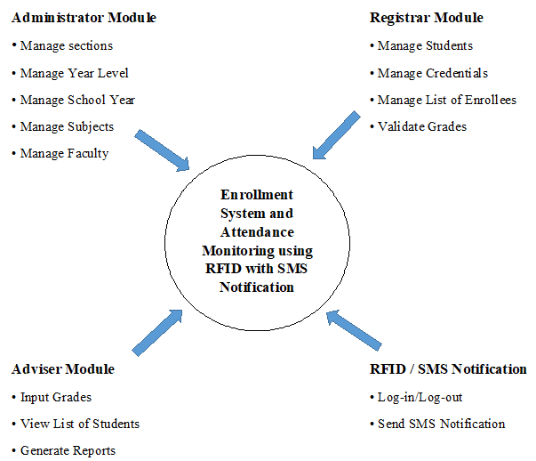

*Figure 1: Conceptual Framework*

**Review of Related Literature**

According to Srinidhi MB, & Roy, R. (2015). *A web enabled secured system for attendance monitoring and real time location tracking using Biometric and Radio Frequency Identification (RFID) technology. 2015 International Conference on Computer Communication and Informatics (ICCCI).* Attendance of students has become an important evaluation aspect in the current educational system in both colleges and schools. The traditional attendance monitoring system has several disadvantages. For example, passing the daily attendance sheet to a huge number of students in a class is very problematic and it hampers the attention of the students in the class. A roll-call is an unnecessary waste of time. Also, a student can intentionally register fake attendance record in the daily attendance sheet. If the teacher loses these documents, all the relevant attendance records are lost. Since the attendance record of the students is maintained on paper, it can be easily tampered. While analyzing the attendance, the teacher has to work-out a lot of calculations, which is pretty gruesome and time consuming. As an alternative to the traditional system, we propose a system which records the attendance of students, teachers and other institutional staff, without any human intervention Biometrics and Radio Frequency Identification (RFID) technology and an extension to this is provided by the Android application module which uses the installed system to track the RFID cardholders anywhere inside the campus. The registered users need to flash their RFID tag embedded identity card in front of the RFID reader as well as scan their fingerprint in the Biometric fingerprint scanner in order to confirm their original identity. The Biometric fingerprint scanner is included in the system to stop the fake attendance registered by the students. Once the fingerprint and the unique RFID tag number is matched with the record saved in the database of a particular individual, the attendance of the individual for the event is stored in the database automatically. Whenever a student enters or leaves the campus, an SMS is automatically sent to their parents’ mobile, informing them of the same. The system is provided with the feature of tracking any individual having the RFID tag embedded identity card anywhere inside the campus, using the installed RFID readers across the campus. The system can also calculate the percentage of attendance of students automatically. Parents are notified via e-mail, if their ward is lagging behind the minimum requirement of attendance. As mentioned earlier, students’ attendance record is very sensitive and has a high risk of being manipulated and keeping this in mind, the proposed system has been made totally safe, secure and the system is protected from all kinds of unauthorized user access. The security feature of the system has been designed by following the four-tier architecture. An android application for the students has also been developed, along with the web based system, through which the system can be accessed remotely from anywhere. This new feature helps our system to stand out among the rest of the attendance monitoring system. Another important feature of our system is the attendance performance graph which is generated for each individual, including students, teachers and other institutional staff depending on the individual’s attendance in a semester, in order to get a visual idea. Both desktop and android smart- phone version prototype of the system have been developed. These RFID tags will not only serve the purpose of identity card but also library cards, mess cards and other authorization cards required for various events and purposes within and outside the campus.

*RFID or (Radio Frequency Identification) is an innovation for the society and communities in terms of identification. It helps the user be easily identified and recognized.*

According to Sharma, T., & Aarthy, S. L. (2016). *An automatic attendance monitoring system using RFID and IOT using Cloud. 2016 Online International Conference on Green Engineering and Technologies (IC-GET).* In the world of technology there is no one who is not using the technology. But if talk about the Indian Education system still we are far away from technology. There is no improvement in this field. Even we have lot of tool and technology but any how we are avoiding this field from using the technology. If someone has used the technology then there are lot of work which are done by professors or lecturers. So some time we think if we are using technology and still we have to do work manually then what is the use of these technologies. Sometimes people don’t want to use technologies because of the high cost of that. After doing a lot of research that how can we use the technology at low cost we found RFID which is chipper in price and can be useful for the attendance. RFID stands for the Radio Frequency Identification. Another important quality is battery less tags system of RFID. RFID is mainly combination of tags, an antenna and IC chip which is having the Unique Identification number. To detect that we have the RFID Reader, Which will read the unique ID of the RFID card. Now the next thing is we are embedding the IoT (Internet of Things) in this. As our Moto is to use the technology in such a way so that we don’t needed to do work manually. After integrating IoT we can access the database from anywhere and anytime, anyone and any device. Basically The IoT allows people and things to be connected Anytime, Anyplace, with anything and anyone, ideally using any path/network and any service. Now the question arises that if we are doing this in the attendance system than there are lots of disadvantage of this system. The biggest drawback is if we are going to use this system than there are chances that students can mark proxies easily. So for that we are embedding video camera in that system. As every university or school has the image of their students in their database. So we will capture the image at real time and then comparing the image with the existing database. So after getting the comparison result we are retrieving the details of student which have the details like RFID unique no, Name, Branch, and Address. Now we have the result from image comparison and RFID reader. Here our main task starts, compare both the result and put the attendance as present we both the details are present. Here main point is that if someone wants to mark proxies of friend and taking RFID card of friend then only RFID reader will read that value as that student is physically not present so if any one detail is not found it will mark the attendance as absent. One more thing to remember is that if such case is happen (Someone is bringing friends RFID card) then system will automatically send an email to that student as warning that you are trying to break the rule and if next time happens then any action can be taken against you.

*This literature explains how the RFID procedure occur and what are the requirements must meet in order to use an RFID.*

According to Tintin, R. A., Troncoso, P. M. V., Carrion, M. V., & Rios, J. C. (2014). *Analysis on the implementation of the computerized registration and quota allocation process in the general education system in Ecuador: Case study. 2014 First International Conference on eDemocracy & eGovernment (ICEDEG).* In Ecuador, education is a mandatory duty that the State must satisfy; therefore, an educational model has been developed oriented to improve the access and quality of it. In Ecuador, the Ministry of Education started in 2010 with the implementation of the new model of education management – NMGE (as the Spanish abbreviation for “Nuevo Modelo de Gestion Educativa”). Within this process, this ´ year, started with the automated assignments of quotas for the one million 176 thousand 055 students in the mountain region, which started classes in September, last year. This assignment had a number of drawbacks, which will be analyzed in order to propose recommendations to improve the process.

*The technology we will acquire by this literature is the process of their enrollment how they done it and be able to come up with an idea of the process.*

According to Kuriakose, R. B., & Vermaak, H. J. (2015). *Developing a Java based RFID application to automate student attendance monitoring. 2015 Pattern Recognition Association of South Africa and Robotics and Mechatronics International Conference (PRASA-RobMech).* Truancy is a serious problem that affects almost all spectrums of higher education in numerous universities across the world. Study also states that there is a direct correlation between class attendance and academic performance or non-academic performance. A study done at the Central University of Technology also shows that poor academic performance may lead to students dropping out of the university altogether. Mandatory attendance monitoring for each and every class is seen as vital intervention to combat truancy. At the Central University of Technology, currently, attendance for each class is taken by manually signing on to an attendance register. This paper firstly looks at the disadvantages of manual attendance monitoring, secondly it analyses the different techniques currently used in automating attendance monitoring and finally proposes how Radio Frequency Identification (RFID) technology in conjunction with Java programing is used as a possible alternative to automate the attendance register.

*The RFID system consists of three main components, RFID tags, RFID readers and RFID middleware.*

According to Shah, S. N., & Abuzneid, A. (2019). *IoT Based Smart Attendance System (SAS) Using RFID. 2019 IEEE Long Island Systems, Applications and Technology Conference (LISAT).* The concept “Internet of Things” (IoT) has recently attracted growing attention from both academia and industry. IoT is a scenario where devices (even animals or people) are provided with unique identifiers and the ability to automatically transmit data over a network without requiring human-to computer interaction. RFID forms an essential block of IoT where RFID devices are wireless microchips used for tagging objects for automated identification. RFID systems consist of a reading device called a reader, and one or many tags. The frequency band in which each RFID system operates can be low, high or ultra-high frequency. The low-frequency band (LF) covers frequencies from 30 KHz to 300 KHz. Regularly LF RFID systems work at 125 KHz. The high band (HF) ranges from 3 to 30 MHz. Most HF RFID systems work at 13.56 MHz with reading ranges between 10 cm and 1 m. The ultra-high frequency band (UHF), recurrence band, covers the reach from 300 MHz to 3 GHz. The reader is a powerful device with a lot of memory and computational resources which could be connected to Raspberry Pi. The tags are usually of two major types; active or passive. In the active RFID systems, each tag has its own transmitter and power source. In most cases, the source of power is a battery. Active RFID systems frequently operate in the ultra-high recurrence (UHF) band and offer a range of up to 100 m. Passive RFID system doesn’t have a power source where it gets in power from the reader when the tag chip is brought close to it. Passive RFID systems can work in the low recurrence (LF), high recurrence (HF) or ultra-high recurrence (UHF) radio groups. RFID technology can help to identify and to monitor items (products, people, student, etc.) wirelessly within a specified distance (a few centimeters to hundreds of meters). In this paper, we describe the proposed Smart Attendance System (SAS) using RFID technology. Our framework utilizes RFID tags which allow school/college to monitor the student attendance in and out of the class, upload the data on Google Spreadsheet, send alert to parents using SMS/email and generate a report quickly. When RFID tags pass through the read-range zone of the RFID reader, the system will record data from the RFID tags to the database system which could be a central server at the school. In Addition to schools, SAS is an automatic integrated system used to assist in taking attendance in any organization. SAS provides organization, efficiency, and convenience utilizing the trending technologies of IoT. The ultimate benefits of this system to schools and organizations is to automate the attendance system and save time. It will prevent students from bunking classes through SMS sending feature to parents if they subscribe to the service. The framework will generate reports of student’s attendance in a click. It is a low cost, and portable IoT enabled RFID reader. The power supply system designed will automatically switch to batteries power if the AC power was removed. The size of the device is small. These two features make the system portable and easily packed and carried to the classroom or other places.

*The system provides a practical and efficient solution for monitoring student attendance on a largescale.*

According to Vamsikrishna, P., Sonti Dinesh Kumar, Shaik Riyaz Hussain, & Rama Naidu, K. (2015). *Raspberry PI controlled SMS-Update-Notification (Sun) system. 2015 IEEE International Conference on Electrical, Computer and Communication Technologies (ICECCT).* At present, notification systems are using either microprocessors or computers to display the messages. Using microprocessors 1 micro-controllers notifications can be displayed on led displays. But to interface a monitor screen using micro-controller is complex. Microcontroller cannot run multiple programs at a time. To overcome these problems, computer can be used to display notices on many monitors at a time. But, using a computer for this purpose is very expensive. Raspberry being a single board computer can be used here to solve these problems. Using Raspberry Pi multiple programs can be run at a time. Comparing to a computer, this is cost effective and very less power consuming. As this board is having inbuilt HDMI port interfacing with all kinds of monitors is simple. With this board, external devices can be interfaced using USB ports. Raspberry Pi can be used for multiple purposes according to our requirement. SUN system is a new type of notification system where Short Message Service (SMS) is used to send the notification to be displayed. Allowed authority will send SMS from their mobile; this will be updated on the monitor as a new notification. Raspberry Pi: Raspberry Pi is a single board computer. This board is as small as a credit card size, cost effective when compared to an actual computer, uses power rating of 5V, 700mA and it weighs not more than 50g. Raspberry Pi board comes in three models A, B, B+. B+ is the advanced version of the three. B+ model comes with 512 MB RAM. It runs on ARM 11 processor typically operates at 700MHz frequency. It has a SD card slot for installing a bootable Operating System using SD card. Operating Systems like Raspbian, Pidora, Raspbmc etc can be installed. It has four USB2.0 ports to connect to devices like keyboard, mouse, Wi-Fi adapter etc., according to our use to make it a full size computer. It has an Ethernet port to connect to network. GPIO pins are used to interface and control LEDs, switches, sensors and other devices. With the help of HDMI port, all kinds of monitors like LCD screens, projectors, TVs also can be connected. In this board, some additional features like camera connector are present to interface camera and an audio jack also available. With all these features, Raspberry Pi is not just limited to single use, it can be of wide use according to the application. GSMModule: GSM Modem with Sim900 module is built with Dual band GSM/GPRS. It works on frequencies 900 1 1800 MHz. It has a variable baud rate with range from 9600 to 115200. Baud rate can be configurable using AT commands. It operates on 12V regulated power supply. It has a SIM card slot to insert SIM and a receiving antenna to receive network signals. It has RS232 interface which allows it to connect devices like PC, Raspberry Pi, microcontroller etc. This module can perform the basic functions of a mobile phone like receiving and sending SMS, voice calls, and TCP/IP communication over GPRS based on various AT commands. A T commands can be sent via the serial port on Raspberry Pi, thus functions such as dialing and answering calls, sending and receiving messages and surfing online can be realized.

*This is a module for SMS notification where it uses raspberry and a gsm module, we look at it as another way of doing the SMS notification.*

According to Pavithra, B., Suchitra, S., Subbulakshmi, P., & Faustina, J. M. (2019). *RFID based Smart Automatic Vehicle Management System for Healthcare Applications. 2019 3rd International Conference on Electronics, Communication and Aerospace Technology (ICECA).* The need for a safer environment in the present situations is of prime importance. Safer environment entangled with the secure surrounding facilitates to gift a serene atmosphere. Recently, all over the world, the number of crime rates over children is increasing day by day. Parents are worried about their children due to mishaps and missing of children. To abate this problem and address the concern, IoT paradigm is embedded as the principle concept, which conglomerates with Radio‐Frequency Identification (RIFD) and Global System for Mobile Communication (GSM) technology to ensure technologically viable solutions. This RFID technology is used in the electromagnetic fields to automatically identify and track the tag attached to the objects. This tag acts as a transceiver, which does both transmission and receiving, which in turn works on both active and passive tags. The RFID device serves the same purpose as a bar code or a magnetic strip on the back of a credit card or ATM card; it provides a unique identifier for that object. The RFID device must be scanned to retrieve the identifying information, similar to the way a bar code or magnetic strip is scanned to get the information. The RFID reader's function is to interrogate RFID tags. Radio Frequency Identification consists of three components as RFID tag, RIFD reader. The information of child is send to their respective parents. With a numbers of students commuting a long distance to the school, school administrators and parents recognized the need for enhanced measures to ensure the safety of the children. This system should recognize each child and detect when every child boards or leaves the bus. Once the vehicle enters the gate the particular vehicle number will send to the management. The person who does not have this particular tag has to make an entry in the main gate, thereby efficiently avoiding trespassing in the school premises. Internet of Things (IoT) is the domain chosen for this project work. This system takes into consideration the Internet of Things (IoT) paradigm, which consists of different sensors that are connected to a micro-controller, which is responsible for the collection of the garbage in a smart manner. The GSM module is connected to the microcontroller which helps in alerting the user of the smart garbage system about the status of the dustbin, this can also be viewed through a webpage that is developed with integration to IoT. The IoT paradigm considers the network of connected devices which sense the environment with the help of embedded sensors, without the need for human intervention. IoT enables the devices to connect wirelessly with the system and react to the environment in a simpler and efficient means to seamlessly provide information about any IoT based system under consideration. The motivation behind the consideration of smart vehicle management system with vehicle tracking and child monitoring is the prime concern faced by parents in ensuring the safety and security of their school-going children. This necessitates the need for a system that guarantees to provide a better and safer environment for the school-going children. This paper is systematically organized into various sections. Section I gives the basic Introduction about the IoT concept and garbage management system with emphasis to the motivation behind the reason for choosing the concept and objective of the work.

*By using this RFID technology in the main gate we can monitor the traffic, avoid fuel loss and we can save time at the entrance.*

Input Development Process Output

Feedback/Evaluation

Part 1: Development of the system

* Student Profile
* Faculty Profile
* Average Grade of the Student
* Tracks/ Strand
* School Year
* System Requirements
* Review of Related Literatures

Part II: Assessment of the Development in terms of the following:

* Functionality
* Reliability
* Usability
* Maintainability
* Portability

RFID SYSTEM

* RFID Card

GSM Module

* Software Design and Development using Agile Model
* Planning
* Requirement Analysis
* Designing
* Building and Testing
* Data Gathering
* Survey/ Questionaire/ Interview Guide
* Analysis and Interpretation of the Result
* Attendance Detail
* Log in/Log out

1. Student Information
2. Contact Information

* Parents/Guardian Info

LAN BASED ENROLLMENT SYSTEM: PRE ENROLLMENT REGISTRATION PROCEDURE

* Data Display on LCD
* Data Output in the Data Server
* Parents/Guardian SMS Notification

*Fig 2: IPO Research Paradigm*

The paradigm in figure 2 shows the interaction of the Input-Process-Output (IPO) variables that used in the development and determination of the perceived features of the Enrollment system and RFID Attendance monitoring with SMS notification. The mentioned input process by way of validating in terms of acceptability to produce an accurate, efficient, reliable, and secure student enrollment and RFID attendance monitoring with SMS notification.

*Fig. 3: System Architecture*

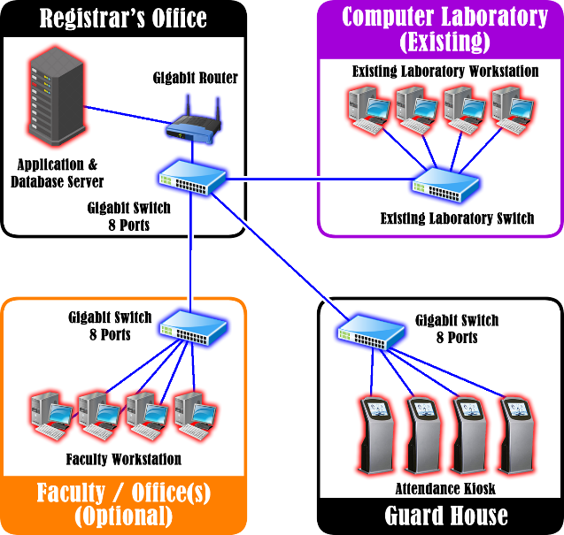

**Enrollment Process**

This project uses Application database server where all the data/information is stored. The server location on the registrar and from there the remote desktop will connect. Other option in remote desktop location is the faculty area where the entire teacher having advisory class will be able to access the system by using their username and password.

**RFID and SMS notification**

This is a separate module where there is a kiosk in the guardhouse for the students upon entering/leaving in the school premises. Upon entering the school, the student is mandatory to have an RFID tags in order to access the kiosk. By tapping in the RF modulator, his/her student information will appear this will verify that he/she already in the school and when leaving the school he/she is again required to tap out this will assumed that the student leave the school. In tapping in/out the kiosk server will send text messages to the Parents of the student to inform their coming/leaving in the school.

**Definition of Terms**

**Admin -** is a person who ensures that an organization operates efficiently.

**Application** - the action of putting something into operation.

**Attendance kiosk** - a small structure in a public area used for providing information often incorporating an interactive display screen or screens.

**Database** - is an organized collection of data. A relational database, more restrictively, is a collection of schemas, tables, queries, reports, views, and other elements.

**Gigabit Router** - is a **Router** that features a built-in switch that is capable of **Gigabit** Ethernet speeds.

**Gigabit switch** - connects multiple devices, such as computers, servers, or game systems to a Local Area Network (LAN).

**Module** - isa set of standardized parts or independent units that can be used to construct a more complex structure.

**Recursive Algorithm -** is a procedure or formula for solving a problem, based on conducting a sequence of specified actions.

**Registrar** - an official responsible for keeping a register or official records.

**RFID** - Radio-frequency identification (**RFID**) uses electromagnetic fields to automatically identify and track tags attached to objects. The tags contain electronically stored information.

**SMS Notification - SMS Notifications** are **text messages** sent in response to events or transactions. Often used for marketing, organization and public safety purposes.

**User Interface -** the means by which the user and a computer system interact, in particular the use of input devices and software.

**Chapter 3 Research Methodology**

This chapter presents the research methodology or the design section, it is where we can describe the different modules, gathering data from enrollment, and using RFID to create attendance monitoring that can send SMS notification to the parents of the student. The researchers need to find a ways or choose the proper technique in order to meet the requirements.

For the gathering of data, we would like to conduct a survey such as interviews and questioners. The main subject of this research is the Students, Parents and Teachers who will be trying to test how efficient are the system that we made. The method that we used in the project is the recursive algorithm in which the process on how the flow of our system functioned is applied.

**Project Design**

**SINHS Enrollment System and Attendance Monitoring using RFID and SMS notification** uses recursive algorithm which calls itself with "smaller (or simpler)" input values, and which obtains the result for the current input by applying simple operations to the returned value for the smaller (or simpler) input. This will help the registrar process its enrollment procedure and help the students ease the process of attendance using their ID tags. The system will be using PHP as its main language and MySQL as its database. Moreover this project use recursive algorithm to facilitate the registrar handling of records. Furthermore, the system use Photoshop incorporating the background design and icons and image for the module. Specifically there is three (3) main design module. The proposed system intended to help the teachers and student improving their operation in handling events and procedures.

**Design Discussion**

The Enrollment System and Attendance monitoring have different modules which is used to control the system. For the Design 1, the Enrollment system will be omitted. The attendance monitoring part of the system will not initiate.

For the Design 2, Attendance monitoring process will be omitted. The monitoring of attendance capabilities of the system will not be use.

For the Design 3, SMS notification will be omitted. The process to send notification to the parents of the student will not initiate.

**Design Trade-Offs**

***Table 1:*** *Summary of Constraints*

|  |  |  |  |
| --- | --- | --- | --- |
| **Design** | **Scope** | | |
| **Quality** | **Cost** | **Completion Date** |
| Design 1 : Enrollment System | Admission, Registrar | Php 39,800.00 | October 2019 |
| Design 2: Attendance monitoring | Attendance, RFID | Php 48,300.00 | September 2019 |
| Design 3: SMS notification | SMS | Php 5,300.00 | August 2019 |

**Trade-Off 1: Quality**

*Table 2:**Quality*

|  |  |
| --- | --- |
| **Design** | **Quality** |
| Design 1: Enrollment System | C:\xampp\htdocs\SINHS\img\sts_ok.png |
| Design 2: Attendance monitoring using RFID | C:\xampp\htdocs\SINHS\img\sts_ok.png |
| Design 3: SMS notification | C:\xampp\htdocs\SINHS\img\sts_ok.png |

Table 2 shows the total scope of project work, to determine the success of the project, all the quality must be met.

**Trade-Off 2: Cost**

*Table 3: Cost*

|  |  |
| --- | --- |
| **Design** | **Cost** |
| Design 1: Enrollment System | Php 39,800.00 |
| Design 2: Attendance monitoring using RFID | Php 48, 300.00 |
| Design 3: SMS notification | Php 5,300.00 |

Table 3 shows the amount of money it will take to execute the project. It only shows an estimated cost in order to complete the project.

**Trade –Off 3: Completion Date**

*Table 4:**Completion Date*

|  |  |
| --- | --- |
| **Design** | **Completion Date** |
| Design 1: Enrollment System | October 2019 |
| Design 2: Attendance monitoring using RFID | September 2019 |
| Design 3: SMS notification | August 2019 |

Table 4 shows the completion date in order to accomplish the project. It simply shows the possible dates for the project to finish.

**Project Development**

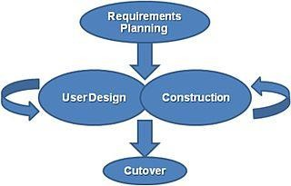

*Figure 4: Rapid Application Development Model*

# **Requirements planning phase**

In this phase, project planning and requirements must be addressed. The approval of the topic must be attained in order to move on the next phase. After being approved, the developers should provide a schedule for planning the process of the development in order to start the project as soon as possible. In planning the project, the developers look some issues on what happened right now in order to have an idea on how to begin the project. Aside from that, gathering of data is one of the requirements focusing by the researchers to provide a solution from the given questions. Time management is also important for the project to work and accomplish the task in the end of the development.

**User design phase**

For the user design phase, prototypes and models should be representing when the implementation of the project starts. There should be an interface design for the user to visualize and understand the idea of the application. Conceptual framework and System Architecture is also part of this phase to understand and modify the approved working model of the system. The developers think of what color combination will be use in the logo, style and background of the application. The design must compliment to the project’s concept and simple. Know the users of the application to focus on the usability and guidelines. The widgets and user interface must be consistent to maintain control when navigating the application. Design dialogs should recognize action for feedback and interfaces prevent error made by user.

# **Construction phase**

In the construction phase, the system should be executed here to process the development of the system using PHP and MySQL. PHP is the programming language use in this software and it is also flexible to other platform. Once every module of the application are completed it will be integrate as a whole to test the functionality if the user’s satisfied the objective. During the development of the project, the developers of the group work cooperatively to give feedback and suggestions. Modules were distributed and work to combine as a whole together with the design and documentation. Each assigned task has a deadline to check if it will be ready for testing.

# **Cutover phase**

Activities in this phase includes data conversion, testing, changeover to the new system, and user training. Where in the application that has been release will be tested by the beta tester. After thorough testing, the user will provide a comments and feedbacks whether the application meets the requirements and it can be improved by developer based on the user’s review. After the construction phase, the application will be inspect by the developers if there are bugs and errors. In addition to that, the objectives of the project must meet the requirements if there are no concerns then the application will be ready for actual operation.

# **Testing and Operating Procedure**

The system will be tested using a Computers that has the installed software. The system will be tested and reviewed by the developer, IT professional and teachers. The IT professional will check if the system is functioning well and has all the features that are needed by the user. The students will check the usability of the application and how it functions based on their way of using it. They will check the system if it has the right features that they need. The application is ready for operation, will be use by the target user. Evaluation was provided to measure if the requirements meet the standard. Users can give feedback and suggestions if there is something to improve, and then developer will address the issues.

**Project Evaluation**

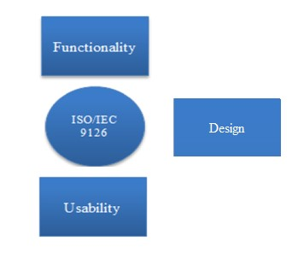

## *Figure 5: ISO/IEC 9126 Software Quality Characteristics*

We will be using ISO/IEC 9126 as a basis for our project evaluation. We will be evaluating the application in terms of design, usability, and functionality. We will be evaluating whether the application meets the needs and requirements of an IT professional and Teachers. Functionality is to test if all the required functions are available in the application. Usability, if it is easy to use. Design, if the design is consistent and will get the attention of the user.

# **Work Plan (Work Breakdown Structure)**

*Table 5: Deliverables Work Breakdown Structure*

|  |  |  |  |  |  |  |  |  |  |  |  |  |  |  |  |
| --- | --- | --- | --- | --- | --- | --- | --- | --- | --- | --- | --- | --- | --- | --- | --- |
| **Task** | ***August*** | | | | | | ***September*** | | | | | | ***October*** | | |
| 5 | 10 | 15 | 20 | 25 | 31 | 5 | 10 | 15 | 20 | 25 | 30 | 5 | 10 | 15 |
| 1. Chapter 1  (Introduction) |  |  |  |  |  |  |  |  |  |  |  |  |  |  |  |
| 1.1 Background of the Study |  |  |  |  |  |  |  |  |  |  |  |  |  |  |  |
| 1.2 Project Objectives |  |  |  |  |  |  |  |  |  |  |  |  |  |  |  |
| 1.3 Significance of the Study |  |  |  |  |  |  |  |  |  |  |  |  |  |  |  |
| 1.4 Scope and Delimitations |  |  |  |  |  |  |  |  |  |  |  |  |  |  |  |
| 2. Chapter 2  (Theoretical or  Conceptual  Framework) |  |  |  |  |  |  |  |  |  |  |  |  |  |  |  |
| 2.1 Research Paradigm |  |  |  |  |  |  |  |  |  |  |  |  |  |  |  |
| 2.2 Review of  Related Literature |  |  |  |  |  |  |  |  |  |  |  |  |  |  |  |
| 2.3 Framework/  Design Concept |  |  |  |  |  |  |  |  |  |  |  |  |  |  |  |
| 2.4 System  Architecture |  |  |  |  |  |  |  |  |  |  |  |  |  |  |  |
| 3. Chapter 3  (Research  Methodology or Operational framework) |  |  |  |  |  |  |  |  |  |  |  |  |  |  |  |
| 3.1 Project Design |  |  |  |  |  |  |  |  |  |  |  |  |  |  |  |
| 3.2 Project Development |  |  |  |  |  |  |  |  |  |  |  |  |  |  |  |
| 3.4 Market Model |  |  |  |  |  |  |  |  |  |  |  |  |  |  |  |
| 3.5 Three-Year  Product Road Map |  |  |  |  |  |  |  |  |  |  |  |  |  |  |  |
| 3.6 Go to Market Strategy |  |  |  |  |  |  |  |  |  |  |  |  |  |  |  |
| 3.7 Business Model |  |  |  |  |  |  |  |  |  |  |  |  |  |  |  |
| 4. Chapter 4  (Result and Discussion) |  |  |  |  |  |  |  |  |  |  |  |  |  |  |  |
| 4.1 Likert Scale |  |  |  |  |  |  |  |  |  |  |  |  |  |  |  |
| 4.2 Multiple Constraints |  |  |  |  |  |  |  |  |  |  |  |  |  |  |  |
| 4.3 Project trade-off |  |  |  |  |  |  |  |  |  |  |  |  |  |  |  |
| 4.4 Hardware Requirements |  |  |  |  |  |  |  |  |  |  |  |  |  |  |  |
| 4.5 Developmental Requirements |  |  |  |  |  |  |  |  |  |  |  |  |  |  |  |
| 4.6 Project Description |  |  |  |  |  |  |  |  |  |  |  |  |  |  |  |
| 4.7 Project Capabilities and Limitations |  |  |  |  |  |  |  |  |  |  |  |  |  |  |  |
| 5. Chapter 5  (Summary, Conclusion and Recommendation) |  |  |  |  |  |  |  |  |  |  |  |  |  |  |  |

**Legend:** Assigned Members

Aguilon Delos Santos Gonzaga Lamban Nacion All

Salas Samson

This is the Work Breakdown Structure of the project. It includes the specific task of each member that is assigned and needs to be accomplished on the allocated schedule.

# **Potential for Commercialization**

`This is the process of making the manual process of enrollment and attendance monitoring to be computerized. It will benefit the following:

* Developers of this system will be challenge on how this process help the school in terms of their daily and monthly transactions.
* The benefit of the products to the users is that they be able to transact properly and a faster way in the way the procedure is process.
* The targeted customers of our product are the people who are considering enhancing their manual process of enrollment.
* The business model in the product must have register to become a system participant. Registration and Attendance monitoring structure and SMS notification enable to create and deliver security and to generate trust. It includes teachers experience to manage student relationships to create the desire process.

# **Market Model**

Population of both male and female in the NCR who are 13 – 18 years old.

Population of both male and female in Antipolo who are 13 – 18 years old.

Population of both male and female in SINHS who are 13 – 18 years old

*Figure 6: Market Model*

The market model shows the population of both male and female in the NCR as of 2019 who are 13-18 years old. We assumed that 58.8% of the population in the NCR is 13-18 years old based from the National Statistics Office. The Total Available Market in the NCR is around 8.2M, next is the Estimated population of Junior High in Antipolo is around 4,452,232, and lastly the estimated population of High School in San Isidro is composed of 3,000.

**Measurable Benefits**

The system is primarily made to San Isidro National High School to enhance their manual procedures of Enrollment. It also adapts the RFID technology for their Attendance monitoring it helps the teacher monitor the students and generate monthly reports needed. The GSM module for the SMS transactions informing the parents about their child.

**Three-year Product Roadmap**

|  |  |  |  |
| --- | --- | --- | --- |
|  | Year 1 | Year 2 | Year 3 |
| Price | Free  System | Free  System | Free  System |
| Key Features | Add New  Features | Update  Interface | New  Interface for Online website |
| Performance | Can support Mac OS, Windows i5 and above. | New updates for the system | Support new version of Mac OS, and Windows. |

*Table 6: Product Roadmap*

This table shows all the innovations that can be with the applications for the next three years.

**Go – to – Market Strategy**

|  |  |  |
| --- | --- | --- |
| Offerings | Customer | Channel |
| System primarily for the school | SINHS | System platform and equipment |
| User friendly application | SINHS | System platform and equipment |

*Table 7: Go – to – Market Strategy*

This table shows that the researchers decided to make the system for SINHS. Users must be trained in order for them to know the capabilities of the system.

**Business Model**

*Table 8: Business Model*

|  |  |  |  |  |
| --- | --- | --- | --- | --- |
| **Key Partners**   * School   San Isidro National  High School   * User   Students and  Teachers | **Key Activities**   * Data   Information,  RFID and SMS  notification | **Value**  **Proposition**  - Guide the students and teachers  who are using the system. | **Customer**  **Relationship**  - Customer  Relationship Management is expected from us to  establish | **Customer**  **Segments**  SINHS |
| **Key Resources**  - Software | **Channels**  - System platform and equipment. |
|  | * Platforms * Budget * Time | school. | Institute |  |
| **Cost Structure**   1. Research and development expenses 2. Maintenance expenses | | **Revenue Streams**  - Total Students from 2019 to 2020 | | |

This table shows the business model of the system. It includes all the requirements and resources used to make the application possible.

**Chapter 4**

**Result and Discussion**

SINHS Enrollment System and Attendance Monitoring using RFID and SMS Notification is a LAN based module. It can run on Desktop Computer. This system will be used by teachers and students of the school. The system composed of different modules. SINHS Enrollment System fetches its data from Data Server.

The systems usability and functionality is evaluated based on the ISO/IEC 9126 to ensure the systems integrity. ISO/IEC 9126 developed a common understanding of the project’s objective and goals. The systems programming interface (SPI) is used in the application to ensure an efficient, functional, updated, and reliable application.

SINHS Enrollment System and Attendance Monitoring using RFID and SMS notification is designed to be user-friendly system for the user to not have difficulties in learning and understanding the modules. It has different modules from admission to assigning of adviser and section, the RFID attendance monitoring module is a process where the student uses RFID tags in order to enter the school premises. After the student enter the school an SMS notification will be send to their parents informing them that their child is in/out the school.

The programming language used to develop the system is PHP and MySQL is the back-end database. This programming language was utilized because it is open source, user friendly and object oriented which allows creating modular programs and reusable codes. The Enrollment module of the system enables the system process the enrollment of the students.

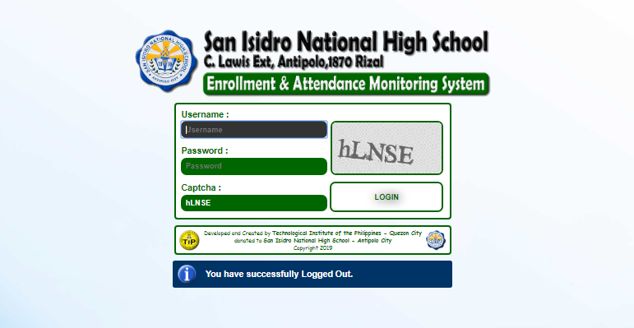

*Figure 7: Login Interface*

Figure 7 shows the log-in page where the user inputs their username and password in order to log in. The data is stored in “*ouser”* table in “*sinhs\_db”* database.

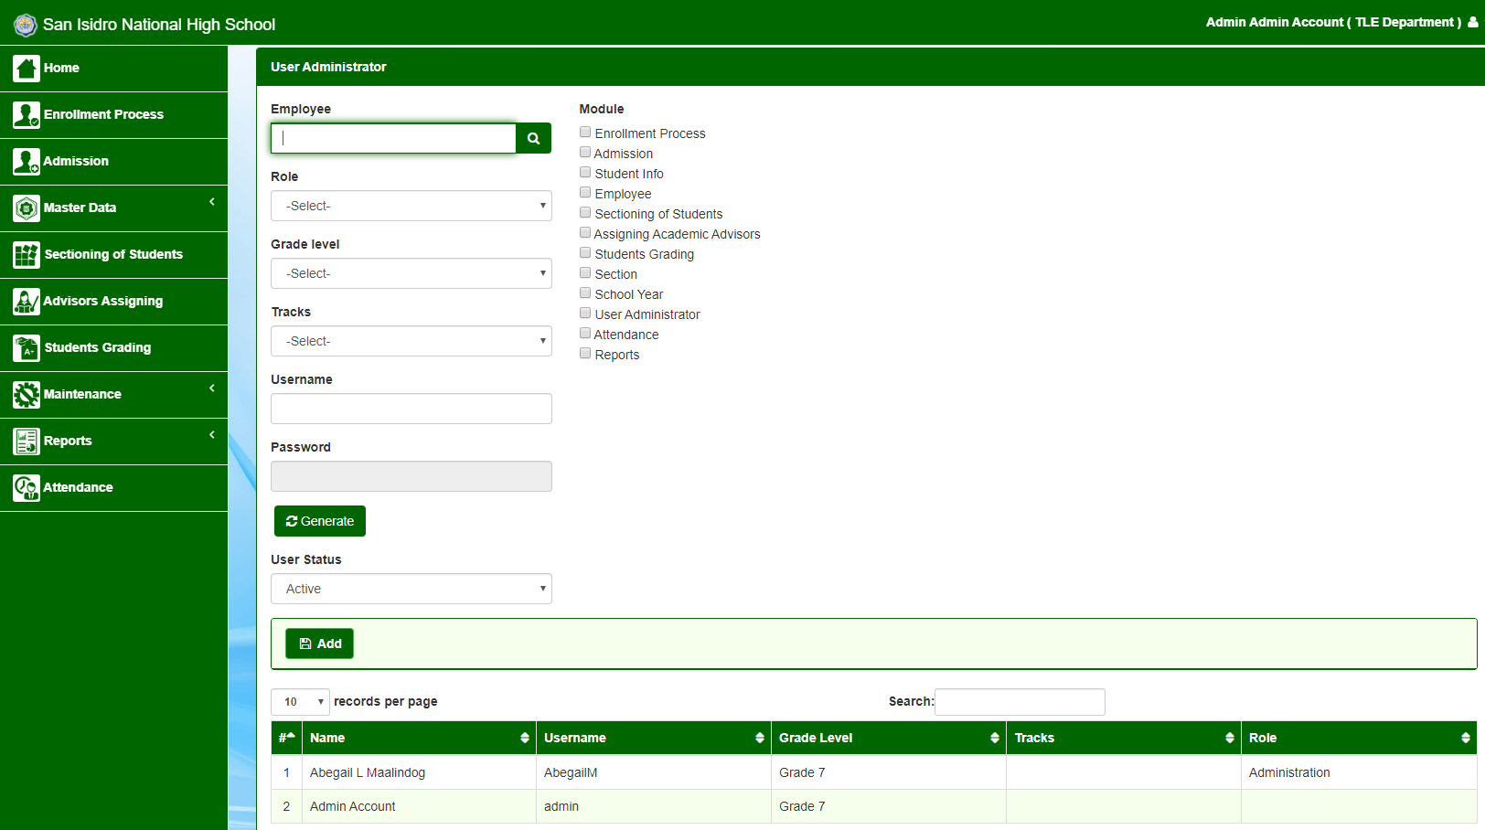

*Figure 8: User assigning role*

Figure 8 shows the assigning of role of the user i.e. *(Registrar, Adviser)* the changes in this module will reflect on “*oenr”* table in “*sinhs\_db”* database.

*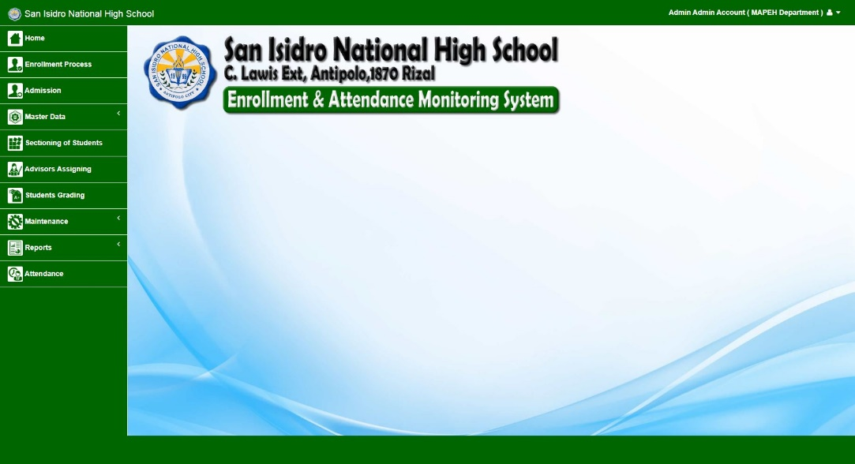*

*Figure 9: Home Page of Enrollment System*

Figure 9 shows the dashboard of enrollment system, after creating an account in “*ouser”* table the user gain access in the system. The dashboard shows the user capabilities for i.e. *“Registrar”* this account will able to encode students by year level, different year level different registrar account.

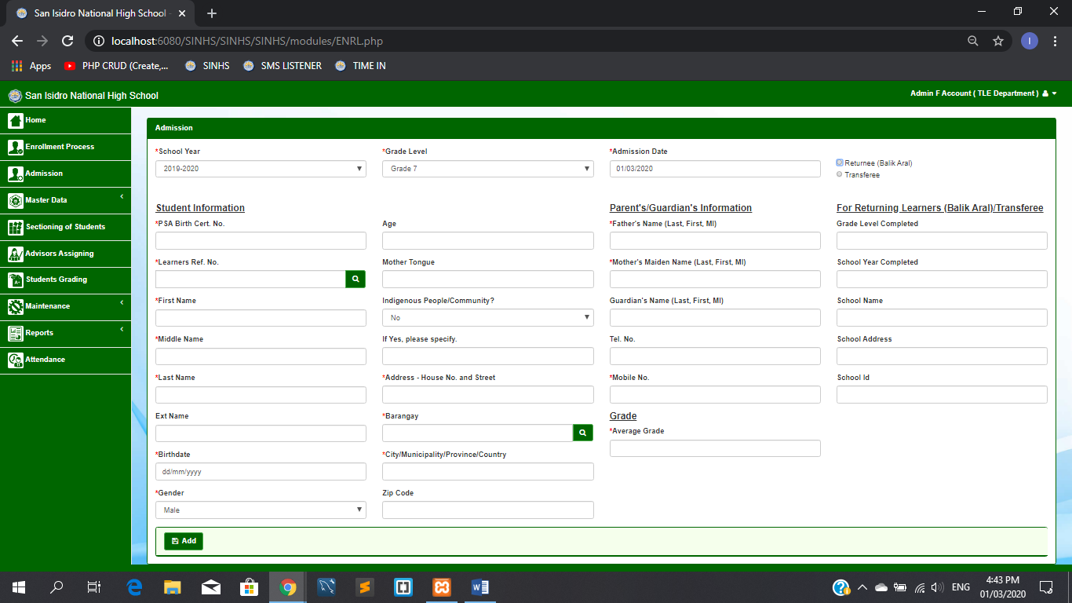

*Figure 10: Admission Page*

Figure 10 shows the admission page, this module will be access if you are the registrar user. The data that will be input here will be kept in “*oenr”* table where the student information is stored. The inputs has required fields to be accomplish in order for the student to be admit. This is done for information purposes.

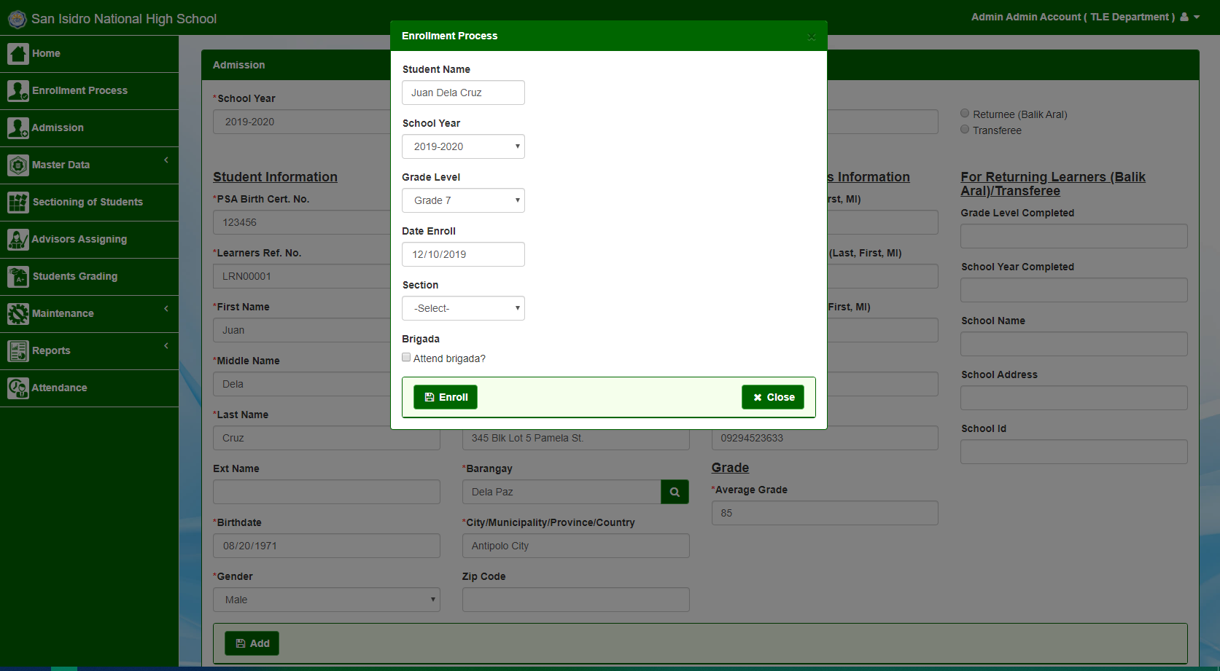

*Figure 11: Enrollment Process*

Figure 11 shows the admission of the student, “*brigade eskwela”* will be asked, after doing the brigade, student will be enrolled. Information will be stored in “*oenr”* table.

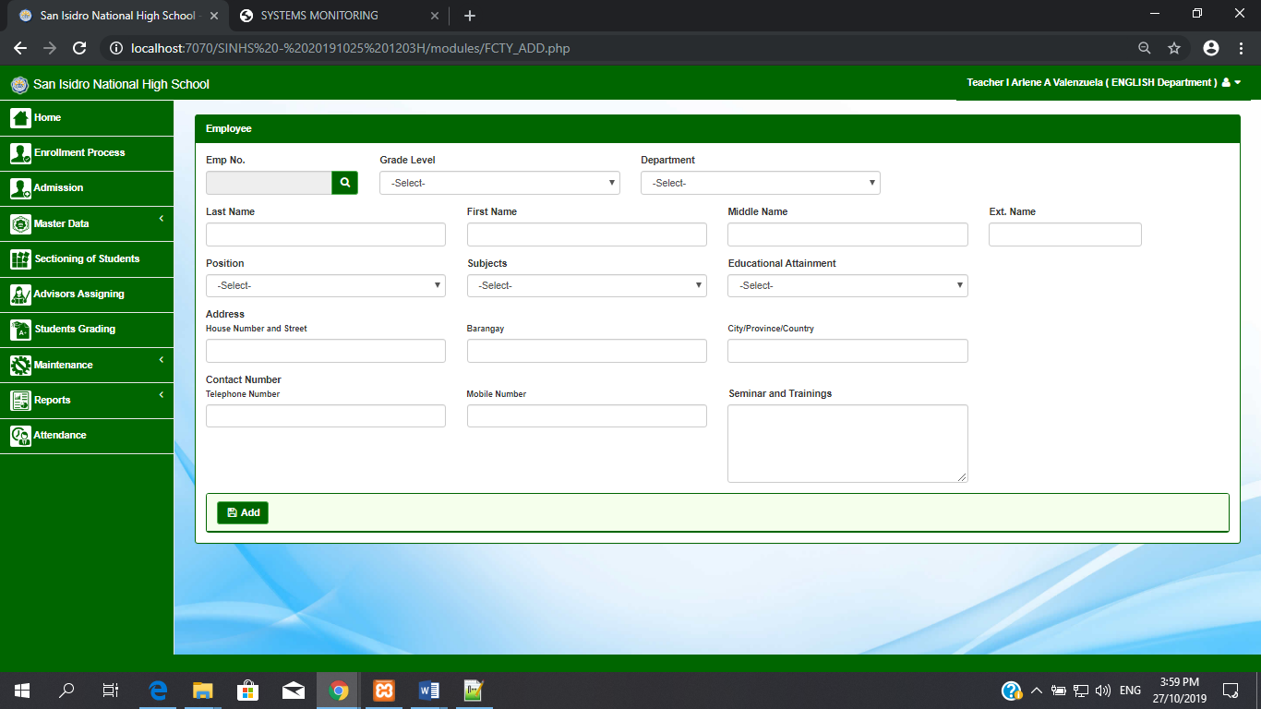

*Figure 12: Add Employee Page*

Figure 12 shows the module for adding teachers and faculty members, the information will be stored in “*ofme”* table. This module will help the Admin locate the adviser per year level.

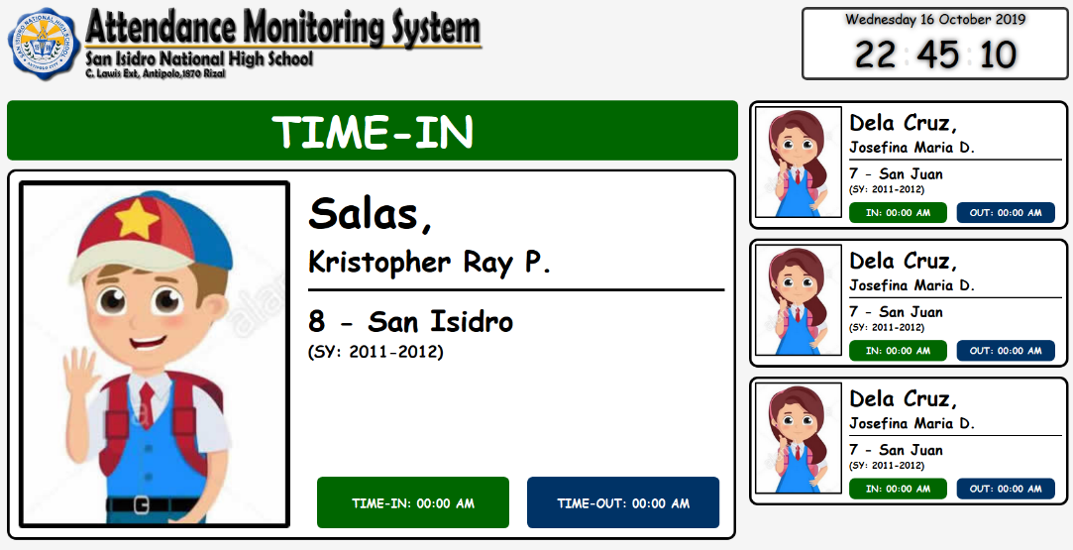

*Figure 13: Attendance Monitoring System Page*

Figure 13 shows the attendance monitoring system, the data gather here will proceed to the “*notif\_tmp”* table in the database. After the student log-in and log-out the que will be kept and be release if the que is done.

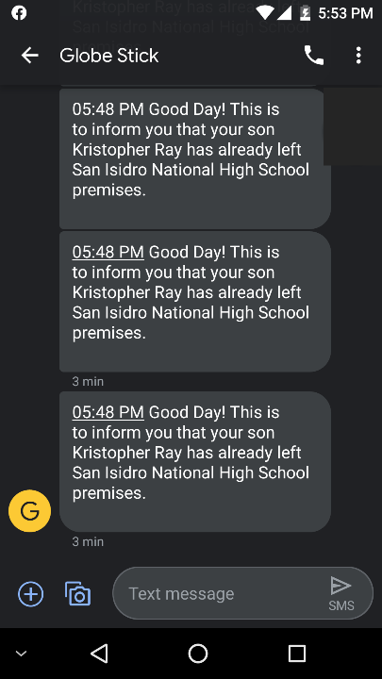

*Figure 14: Sample Text Messages*

Figure 14 shows the sample message that has been sent by providing the relevant information given by the student upon admission. The data of parents/guardian is fetch from the “*notif\_log”* table in the database. Student must give relevant contact information.

The developers of the system “SINHS Enrollment System and Attendance Monitoring using RFID and SMS notification” conducted a survey through questionnaires where the results led to measuring the acceptability of the system. The system was presented to the professionals and to the possible users who are interested in using the system.

The evaluation was based on ISO 9126. The criteria that are used in the evaluation of the application are functionality, design, and usability. These tests are selected as a basis to evaluate the system.

The respondents of the study are IT Professionals that will test the application according ISO 9126 standards. For the possible users of the system, there will be teachers and students who will evaluate the system.

Criteria:

This test will be used in evaluating the system and equipment procedure.

Functionality

1. Performance of Enrollment System
2. Reliability of RFID ( Radio Frequency Identification )
3. Consistency of SMS notification.

Design

1. Design of Enrollment System
2. Design of RFID procedure and application
3. SMS notification design

Usability

1. Enrollment system interface
2. RFID interaction
3. SMS notification application

**Respondents**

*Table 9: Total Number of Respondents*

|  |  |  |
| --- | --- | --- |
| **Type of Respondent** | **No. of Respondent** | **Percentage** |
| Teacher | 4 | 10 |
| Student/Parent | 32 | 80 |
| IT Professional | 4 | 10 |
| **Total** | 40 | 100 |

Table 9 shows the number of respondents and their percentage from all the respondents. It also shows the number of respondents per type/designation.

**Likert Scale**

The users scored the evaluation by giving one (1) as the lowest score and five (5) as the highest. The developers summarized the evaluation and tabulated the results.

*Table 10: Likert Scale*

|  |  |  |
| --- | --- | --- |
| **Scale** | **Rating** | **Interpretation** |
| 5 | 4.5-5.0 | Excellent |
| 4 | 3.5-4.4 | Very Good |
| 3 | 2.5-3.4 | Good |
| 2 | 1.5-2.4 | Fair |
| 1 | 1.0-1.4 | Poor |

Table 10 shows the equivalent rating and interpretation of the evaluation using Likert Scale. This will be used to evaluate the score that the application got from the evaluation of the respondents.

**Summary of Results**

*Table 11: Summary of Results*

|  |  |  |  |  |
| --- | --- | --- | --- | --- |
| **Criteria** | Teacher/Adviser | Student | IT Professional | Rating |
| **Functionality** | | | | |
| 1. **Performance of Enrollment System** | 3.75 | 3.84 | 3.75 | 3.78 |
| 1. **Reliability of RFID ( Radio Frequency Identification )** | 3.25 | 4.1 | 3.75 | 3.7 |
| 1. **Consistency of SMS notification.** | 3.25 | 4.1 | 3.5 | 3.62 |
| **Mean Rating** |  |  |  | 3.7 |
| **Design** | | | | |
| 1. **Design of Enrollment System** | 3.25 | 4.16 | 3.75 | 3.72 |
| 1. **Design of RFID procedure and application** | 3.5 | 3.75 | 3.25 | 3.5 |
| 1. **SMS notification design** | 3.75 | 3.69 | 3.25 | 3.56 |
| **Mean Rating** |  |  |  | 3.59 |
| **Usability** | | | | |
| 1. **Enrollment system interface** | 3.25 | 3.75 | 4 | 3.67 |
| 1. **RFID interaction** | 3.75 | 4.03 | 3.25 | 3.68 |
| 1. **SMS notification application** | 3.5 | 4.09 | 3.25 | 3.61 |
| **Mean Rating** |  |  |  | 3.65 |
| **Overall Mean Rating** | 3.7 | 3.59 | 3.65 | 3.65 |

Table 11 shows the results based on the criteria selected in the ISO 9126 to evaluate the system. The functionality has a result of 3.7, which is very good. The design has a result of 3.59, which is very good. The usability is also very good by having a mean rating of 3.65. The adviser/teacher, student, and IT professionals gave their ratings and the results have an overall mean rating of 3.65, which is interpreted as very good in the Likert Scale.

**Multiple Constraints**

# **Equipment**

Desktop Computer is one of the elements that is needed in developing a window system. It is required to have a desktop computer, which contains high enough specifications to run the system smoothly. The system does not require a high-end desktop device but it requires one that can run the application decently.

# **Economic**

This refers to the budget constraints that could limit the application to run smoothly. The application should be used in a desktop Computer, which has high enough processor and can use a fast internet connection because the application essentially needs an internet connection to run some of its modules.

# **Schedule**

Conflict of schedule is one of the major hindrances in developing a Desktop system, which requires a professional from a school. There are times where the contact person from a school has a busy schedule, which makes finding a time to ask suggestions about the application can be a challenge.

# **Project Trade Offs**

The developers used a user-friendly interface in developing the desktop module so that the user will easily understand the functionalities of each module. The developers used different layouts and approaches in developing the element. The videos were decided to be online along with the other contents to lessen the size of the element and to bring up to date information to the users of the system.

# **Computing Standards and Modern Tools and Technique Applied**

The researchers used the ISO/IEC 9126 testing standard to test the functionality and usability of the system. The researchers test if each of the components in every module performs its intended functions and performs it an appropriate response time. The researchers also evaluated if the design of the application is user-friendly and consistent to help the user easily use the system.

# **System Requirements**

## *Table 12: Hardware Requirements*

|  |  |  |  |  |
| --- | --- | --- | --- | --- |
| **Server Hardware Requirements** | | | | |
| **Classification** | **Description** | **Qty** | **Price** | **Total** |
| Processor | Intel Core i5 9400F 2.9-4.1 ghz 6-Core 6-Thread 9mb, 65W, DDR4 2666, LGA1151 | 1 | 7,500.00 | 7,500.00 |
| Motherboard | ASRock H110M DVS R3.0 (LGA1151) H110, ATX, 2\*ddr4 | 1 | 2,500.00 | 2,500.00 |
| Memory | 8gb ddr4 2666 Kingston HyperX Fury Black, CL16 1.35v | 1 | 2,500.00 | 2,500.00 |
| Storage | 1tb WDC Blue hdd, 64mb 7200rpm | 1 | 2,200.00 | 2,200.00 |
| Power Supply | Deep Cool DC 500watts PSU, DE500 v2 | 1 | 1,700.00 | 1,700.00 |
| CPU Case | Trendsonic Blade TG, atx | 1 | 1,500.00 | 1,500.00 |
| Software | Ubuntu 18.04.3 LTS | 1 | Free | Free |
| Monitor | 18.5" LG 19M38A, LED, vga, vesa | 1 | 3,200.00 | 3,200.00 |
| Keyboard/Mouse | Gigabyte KM6300, keyboard + mouse | 1 | 400.00 | 400.00 |
| GSM Modem | GSM Modem Stick | 1 | 1,500.00 | 1,500.00 |
| **Total** |  |  |  | **23,000.00** |

|  |  |  |  |  |
| --- | --- | --- | --- | --- |
| **Kiosk Hardware Requirements ( per Kiosk )** | | | | |
| **Classification** | **Description** | **Qty** | **Price** | **Total** |
| Processor | Intel Celeron G4900 3.1 ghz 2-Core 2mb HD610, 54W, LGA1151 | 1 | 2,500.00 | 2,500.00 |
| Motherboard | ASRock H110M DVS R3.0 (LGA1151) H110, ATX, 2\*ddr4 | 1 | 2,500.00 | 2,500.00 |
| Memory -- | 4gb ddr4 2666 Kingston HyperX Fury Black, CL15 1.2v | 1 | 1,300.00 | 1,300.00 |
| Storage | 1tb WDC Blue hdd, 64mb 7200rpm | 1 | 2,200.00 | 2,200.00 |
| Power Supply | Deep Cool DC 500watts PSU, DE500 v2 | 1 | 1,700.00 | 1,700.00 |
| CPU Case | Trendsonic Blade TG, atx | 1 | 1,500.00 | 1,500.00 |
| Software | Ubuntu 18.04.3 LTS | 1 | Free | Free |
| Monitor | 18.5" LG 19M38A, LED, vga, vesa | 1 | 3,200.00 | 3,200.00 |
| Keyboard/Mouse | Gigabyte KM6300, keyboard + mouse | 1 | 400.00 | 400.00 |
| RFID Reader | Heavy Duty RFID Reader | 1 | 1,500.00 | 1,500.00 |
| **Total** |  |  |  | **16,800.00** |

|  |  |  |  |  |
| --- | --- | --- | --- | --- |
| **Network Connectivity Requirements** | | | | |
| **Classification** | **Description** | **Qty** | **Price** | **Total** |
| Network Cable | 305M Ad-Link Cat6 UTP Cable High Quality Outdoor Black | 1 | 3,000.00 | 3,000.00 |
| Network Router | Dlink DIR 809, router, wifi AC750, dual band, gigabit, 3 antenna | 1 | 1,800.00 | 1,800.00 |
| Network Switch | Dlink DGS 108, 8 port, gigabit, switch hub, metal | 2 | 1,500.00 | 3,000.00 |
| **Total** |  |  |  | **7,800.00** |

## *Table 13: Developmental Requirements*

|  |  |  |  |  |
| --- | --- | --- | --- | --- |
| **Developmental Requirements** | | | | |
| **Classification** | **Description** | **Qty** | **Price** | **Total** |
| System Application | PHP  Visual Studio 2010 |  |  |  |
| Back-end Software | MySQL |  |  |  |
| System Image Design | Adobe Photoshop |  |  |  |
| Text Editor | Notepad++ |  |  |  |
| Documentation | MS Office 2010 |  |  |  |

**Project Description**

SINHS Enrollment and Attendance Monitoring System is a system that would cater enrollment in a faster and efficient way. All information of the students is stored in a database so that whenever they would enroll all their record and data can easily be retrieved and the students don’t need to fill up enrollment forms anymore. Student only needs to give their Learners Reference no. and all their information will be shown if they were already a resident in the school but for the freshmen, transferees and balik aral they still have to fill up forms and the data that they will present will be encoded in the system.

The Attendance Monitoring System will help school monitor the attendance of the student once they enter the premises of the school. The System uses RFID, RFID Scanners and Printers and GSM Modem to make it more efficient. This system can monitor student who entered the school and the parents would be at peace because they also can monitor if their son/daughter is already at school. The student needs only to tap their RFID’s at the scanner and their info will flash in the monitor, the system will store their time in and out in the database and with the GSM Modem installed in the system it would retrieve the no. of the student’s parent and send an SMS to them that their so/daughter has already log in at the school.

**Project Capabilities and Limitations**

SINHS Enrollment System is capable of storing data of the students, personal info, parents’ info and other information needed by the guidance such as religion, family background and other personal issues about the student. Information about subjects, teachers, course, and section are also store in the system. The students will give their learners reference no. and the system will retrieve the information, through this system the encoder can see what year the student is enrolling for, it can assign the sections, the subjects and the teacher assigned. The limitation of this system is that it does not process payments.

SINHS Attendance Monitoring System is capable of storing the attendance of the student from the time they time in and time out from the school premises. Time of their time in will be sent to their parents once they tap their RFID’s on the scanner. Record can easily be track because it was saved in a database. All Students attendance history will be saved. The limitation of this system is that it cannot determine if the student ask his/her friend to tap their ID. It cannot also determine if the student really goes to class or he/she is only loitering in school premises.

SINHS Enrollment and Monitoring System limitation will be the following the Grading system of the students, the Accounting and billing information. This limitation will be the future update of the system.

**Chapter 5**

**Summary, Conclusion and Recommendation**

**Summary of the Study**

This paper discusses the overall development of the Enrollment and Attendance monitoring system of San Isidro National High School. The system aims to provide knowledge on how enrollment and attendance monitoring process work based on the school’s policy. The users can also monitor the everyday attendance of the students and the yearly enrollment of the school.

The system also provides the systematic process of enrollment every school year as well as the necessary requirements for the students to enroll. The attendance monitoring system features a module that will show the process where the students have RFID that will be use in the module. GSM device that will send a notification to the parents or guardian of the students whenever they come in and go out in the school.

**Conclusion**

After the study was conducted and with the response obtained among the respondents, researchers concluded that the development of the system will be very helpful and significant, in terms of providing a new enrolment process, and improvement of the attendance monitoring of the school.

**Recommendation**

As the developer of the system we want to recommend the future programmer of the system to improve the process which will include grading system to closely monitor the academic excellence of the student. The system should cater enrollment up to senior high school and that the system can also add additional module for the students record regarding on their behavior. We also recommend that they upgrade their attendance monitoring system to biometrics so that they can be assured that the student has entered the school.

Reference

Srinidhi MB, & Roy, R. (2015).

*A web enabled secured system for attendance monitoring and real time location*

*tracking using Biometric and Radio Frequency Identification (RFID) technology.*

*2015 International Conference on Computer Communication and Informatics*

*(ICCCI).*

Retrieve from: <https://sci-hub.tw/10.1109/iccci.2015.7218103>

Eunice B. Custodio, Mayleen Dorcas B. Castro (2016)

[*Advancing Pre-Enrollment Procedure through Online Registration and Grade Evaluation System*](https://www.semanticscholar.org/paper/Advancing-Pre-Enrollment-Procedure-through-Online-Custodio-Castro/7a1a6deb36ba3fb6cc2a3b6c8739a514e8887bd5)

Retrieve from: <https://www.semanticscholar.org/paper/Advancing-Pre-Enrollment-Procedure-through-Online-Custodio-Castro/7a1a6deb36ba3fb6cc2a3b6c8739a514e8887bd5/figure/0>

Sharma, T., & Aarthy, S. L. (2016).

*An automatic attendance monitoring system using RFID and IOT using Cloud.*

*2016 Online International Conference on Green Engineering and Technologies*

*(IC-GET).*

Retrieve from: <https://sci-hub.tw/10.1109/get.2016.7916851>

Tintin, R. A., Troncoso, P. M. V., Carrion, M. V., & Rios, J. C. (2014)

*Analysis on the implementation of the computerized registration and quota allocation process in the general education system in Ecuador: Case study. 2014*

*First International Conference on eDemocracy & eGovernment (ICEDEG)*:

Retrieve from: <https://sci-hub.tw/10.1109/icedeg.2014.6819964>

NAZURA NAJMI BINTI MOHD ARIF (2018)

Attendance System using RFID

Retrieve from: <https://www.slideshare.net/nazuranajmi916/attendance-system-using-rfid>

CKSM STUDENT ATTENDANCE MONITORING SYSTEM WITH RFID TECHNOLOGY (2015-2016)

Retrieve from: <http://docshare.tips/student-monitong-using-rfid-technology-with-sms-notification-system-and-wireles-online-viewing_5772bb29b6d87f97328b46cf.html>

Kuriakose, R. B., & Vermaak, H. J. (2015).

*Developing a Java based RFID application to automate student attendance*

*monitoring. 2015 Pattern Recognition Association of South Africa and Robotics*

*and Mechatronics International Conference (PRASA-RobMech).*

## **Retrieve from:** [**https://sci-hub.tw/10.1109/RoboMech.2015.7359497**](https://sci-hub.tw/10.1109/RoboMech.2015.7359497)

## Enrollment System Complete Capstone Documentation **(2019)**

Retrieve from: <https://www.inettutor.com/source-code/enrollment-system-complete-capstone-documentation/>

Shah, S. N., & Abuzneid, A. (2019).

*IoT Based Smart Attendance System (SAS) Using RFID. 2019 IEEE Long Island*

*Systems, Applications and Technology Conference (LISAT).*

Retrieve from: <https://sci-hub.tw/10.1109/LISAT.2019.8817339>

# Online Students' Attendance Monitoring System in Classroom Using Radio Frequency Identification Technology: A Proposed System Framework (2012)

Retrieve from: <https://www.researchgate.net/publication/265054056_Online_Students'_Attendance_Monitoring_System_in_Classroom_Using_Radio_Frequency_Identification_Technology_A_Proposed_System_Framework>

Vamsikrishna, P., Sonti Dinesh Kumar, Shaik Riyaz Hussain, & Rama Naidu, K. (2015).

*Raspberry PI controlled SMS-Update-Notification (Sun) system. 2015 IEEE*

*International Conference on Electrical, Computer and Communication*

*Technologies (ICECCT).*

Retrieve from: <https://sci-hub.tw/10.1109/ICECCT.2015.7226113>

Pavithra, B., Suchitra, S., Subbulakshmi, P., & Faustina, J. M. (2019).

*RFID based Smart Automatic Vehicle Management System for Healthcare*

*Applications. 2019 3rd International Conference on Electronics, Communication*

*and Aerospace Technology (ICECA).*

Retrieve from: <https://sci-hub.tw/10.1109/ICECA.2019.8821986>

[Janvic Mateo](https://www.philstar.com/authors/1804764/janvic-mateo) (The Philippine Star) - May 31, 2018

*Student population soars to ‘historic’ 27.7 M*

Retrieve from: <https://www.philstar.com/other-sections/education-and-home/2018/05/31/1820117/student-population-soars-historic-277-m>