Assignment 6
jQuery selectors effects and animations
Student: Kurmashev Damir
Group: IT-2511
GitHub repository URL: [INSERT YOUR GITHUB REPOSITORY URL]
I rebuilt the party from the assignment picture and used jQuery to investigate the missing cake. The project includes all 20 cases and a second version with spotlight, guest profiles, movement between rooms and sorting. The thief is Zarina: she meets every condition in case 20.

Opening the project
Extract the ZIP and open index.html to start Task 2. Task1/index.html opens the selector task. Both pages also work offline. For GitHub Pages, upload the extracted contents into the repository root, with index.html directly at that level. In Settings > Pages, select Deploy from a branch, the main branch and / (root), then Save.
Choose a numbered case on the left. Clear removes the selection and restores full brightness. Reset party restores all 21 original guests, their rooms and their order. In Task 2, click a guest for their profile and move buttons, or use Sort by time in a room.

Source files
Location | Purpose
Task1/index.html and styles.css | Page structure and static layout for the selector task
Task1/data.js and app.js | Party array, jQuery rendering and the 20 case chains
index.html and Task2 files | Main entry page and the Task 2 copy of Task 1
Task2/motion.js | Spotlight, animated profile, moving and sorting
vendor/jquery-3.7.1.js | Full jQuery library with effects, stored locally

Party data on floor 2
The rows follow the picture from left to right within each room. Clothing is shown by the avatar ring; the AITU badge identifies students. The five item icons mean phone, glasses, bag, cup and cake crumbs.

Balcony
Order | Guest | Color | Arrival | AITU | Things
1 | Aigerim | green | 20:45 | Yes | cup, crumbs
2 | Aliya | black | 21:15 | No | phone, cup
3 | Madina | green | 22:10 | No | phone, bag, crumbs
4 | Ivan | black | 20:10 | Yes | cup

Hall
Order | Guest | Color | Arrival | AITU | Things
1 | Arman | yellow | 20:35 | No | bag, glasses
2 | Sophia | purple | 21:20 | Yes | phone
3 | Dias | green | 19:45 | Yes | Nothing
4 | Bekzat | purple | 20:55 | No | bag, cup, crumbs
5 | Aruzhan | blue | 21:50 | Yes | phone
6 | Saule | green | 21:25 | No | glasses

Building the page
data.js contains four room objects with id, name, floor and guests. app.js loops through floors 2 and 1, then appends each room and its guests with jQuery. The portraits are original inline SVG drawings, so every avatar is available offline.
var $card = $('<button>', { type: 'button', id: guest.id,
'class': 'guest ' + guest.color + (guest.aitu ? ' aitu' : '') });
$card.attr({ 'data-name': guest.name, 'data-time': guest.time,
'data-minutes': minutes(guest.time), 'data-things': guest.things.join(' ') });

Party data on floor 1
The rows follow the picture from left to right within each room. Clothing is shown by the avatar ring; the AITU badge identifies students. The five item icons mean phone, glasses, bag, cup and cake crumbs.

Kitchen
Order | Guest | Color | Arrival | AITU | Things
1 | Nurlan | red | 19:40 | Yes | phone, cup
2 | Emma | black | 20:15 | No | bag
3 | Timur | green | 21:05 | Yes | phone, bag, crumbs
4 | Sergey | yellow | 20:50 | No | Nothing
5 | Yerlan | red | 21:40 | Yes | glasses, phone
6 | Kamila | green | 20:05 | No | cup

Living room
Order | Guest | Color | Arrival | AITU | Things
1 | Daniel | blue | 19:55 | Yes | glasses
2 | Zarina | green | 21:10 | No | bag, phone, crumbs
3 | Natasha | yellow | 20:30 | Yes | Nothing
4 | Askar | black | 21:00 | Yes | phone
5 | Inkar | purple | 20:20 | No | bag

How the cases read the page
Each guest card has its name as an id, color and item classes, and data-* attributes for name, time, minutes, student status, items, room and original order. I convert HH:MM to minutes to compare arrival times numerically.
Before every case, renderHouse() rebuilds the page from the current party array. Each case then returns one jQuery chain that searches the DOM. After a move or sort in Task 2, syncModel() updates the array, so the next rebuild keeps those changes. Reset party returns to the original picture.

Case 1
Who is in the hall?
jQuery chain
$('#hall .guest');
Guests found: 6 - Arman, Sophia, Dias, Bekzat, Aruzhan, Saule.
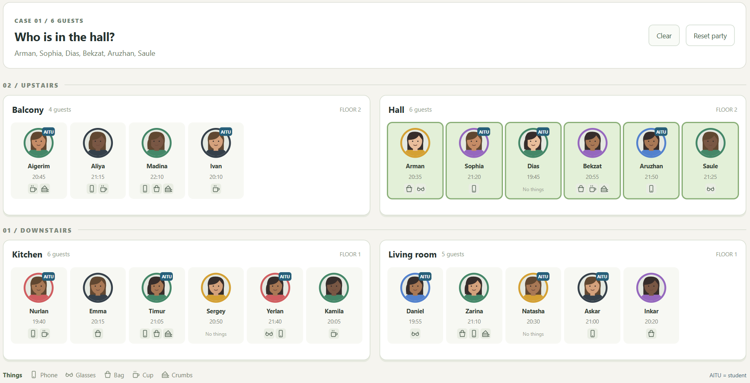
Case 1 result in Task 1
I start from the hall id and select its guest descendants. This limits the result to the six people in the hall.

Case 2
Who wears yellow or purple?
jQuery chain
$('.guest.yellow, .guest.purple');
Guests found: 6 - Arman, Sophia, Bekzat, Sergey, Natasha, Inkar.
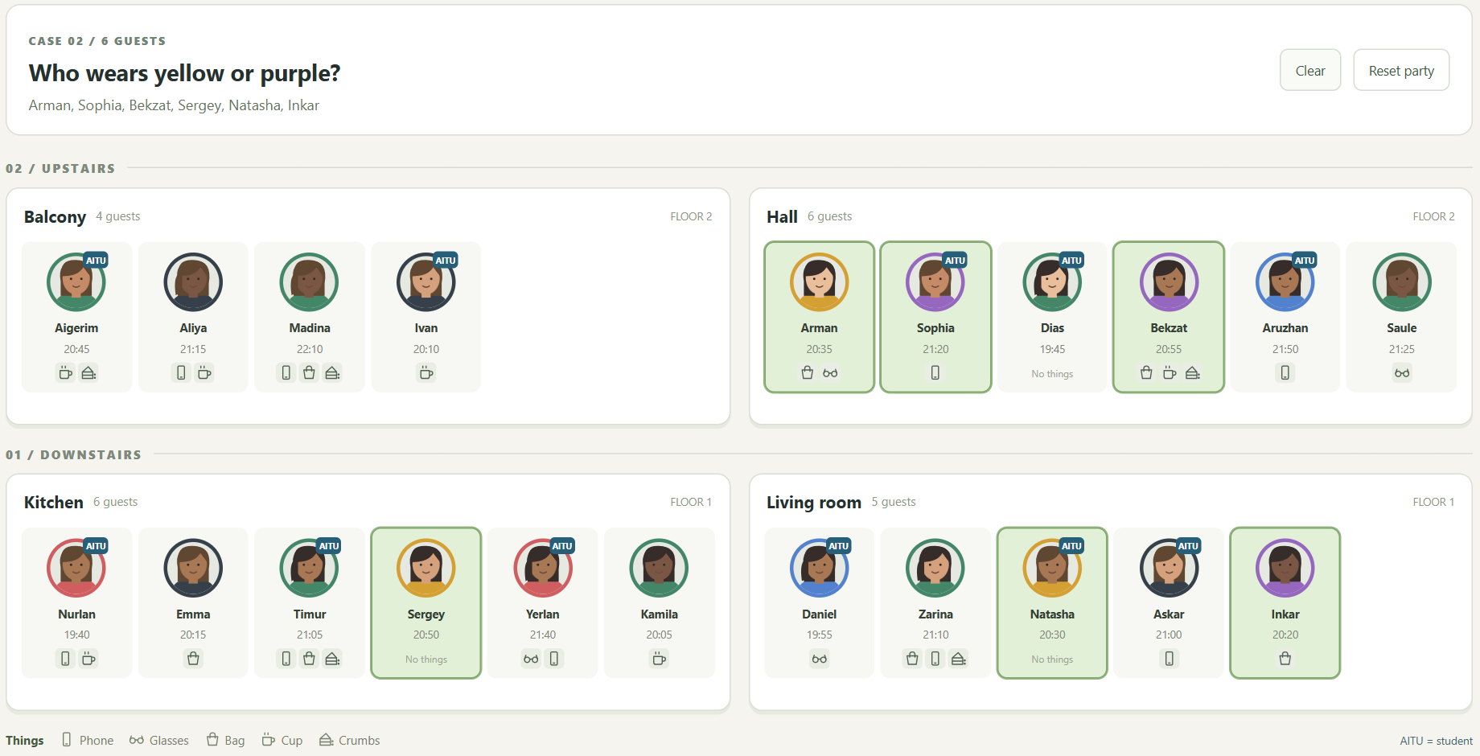
Case 2 result in Task 1
The comma joins two class selectors. A guest is included if their card has either the yellow class or the purple class.

Case 3
Which AITU students are upstairs?
jQuery chain
$('.floor[data-floor="2"] .guest.aitu');
Guests found: 5 - Aigerim, Ivan, Sophia, Dias, Aruzhan.
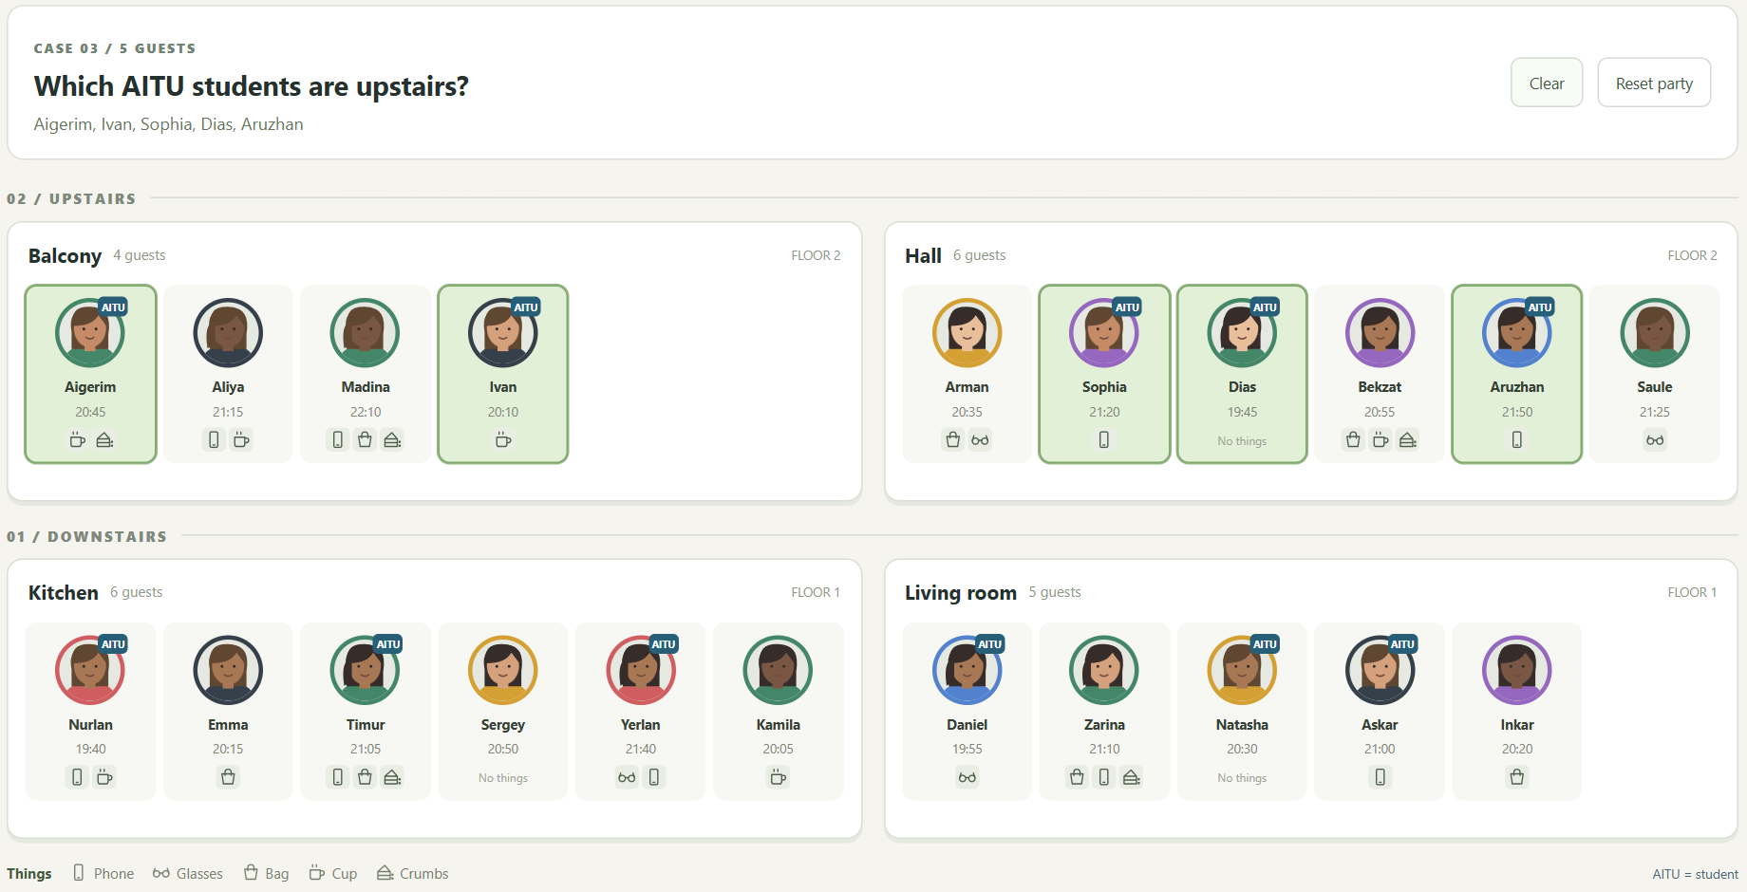
Case 3 result in Task 1
I first restrict the query to floor 2, then require both guest and aitu classes. Students downstairs are excluded.

Case 4
Who has glasses or a bag?
jQuery chain
$('.guest.has-glasses, .guest.has-bag');
Guests found: 10 - Madina, Arman, Bekzat, Saule, Emma, Timur, Yerlan, Daniel, Zarina, Inkar.
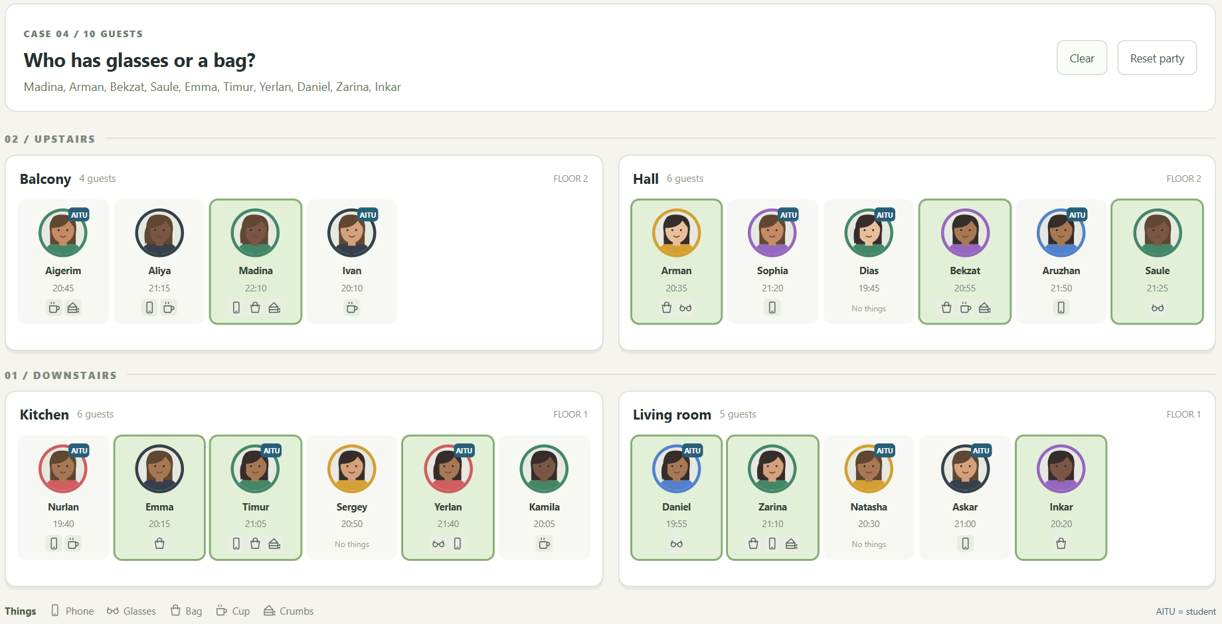
Case 4 result in Task 1
I combine the glasses and bag classes in one selector. jQuery returns each matching guest once, even if the guest has both items.

Case 5
Who came with nothing?
jQuery chain
$('.guest[data-things=""]');
Guests found: 3 - Dias, Sergey, Natasha.
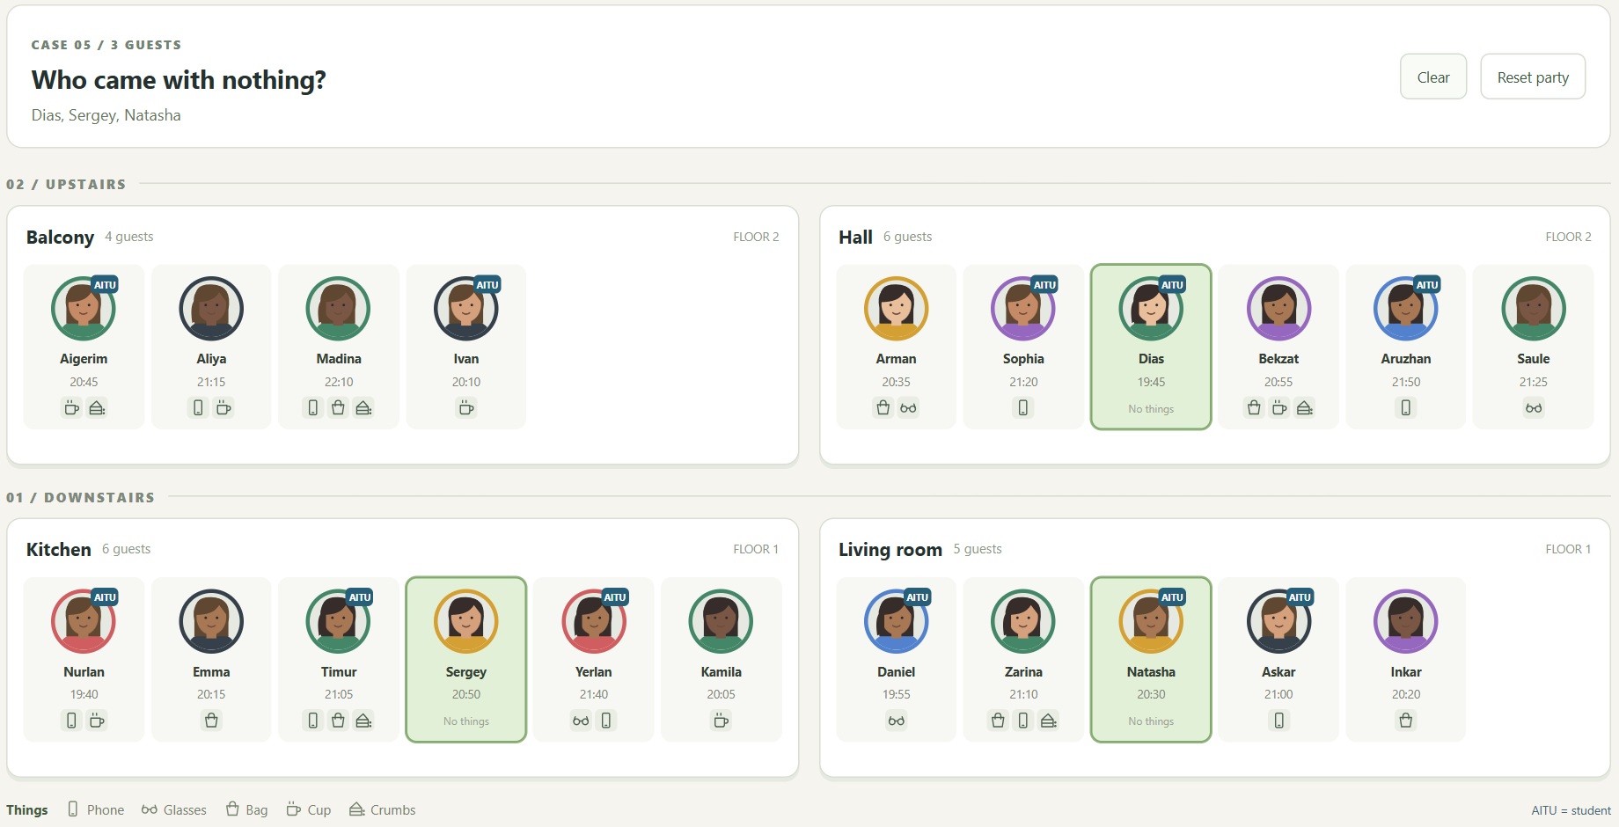
Case 5 result in Task 1
An empty data-things attribute means the guest has no items. This finds Dias, Sergey and Natasha.

Case 6
Who has a phone but no bag?
jQuery chain
$('.guest.has-phone:not(.has-bag)');
Guests found: 6 - Aliya, Sophia, Aruzhan, Nurlan, Yerlan, Askar.
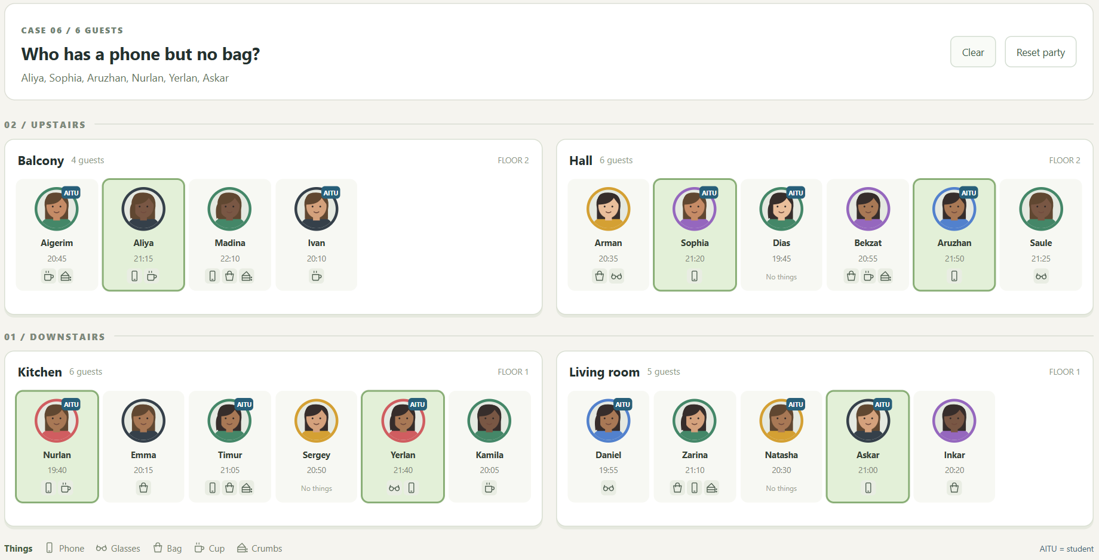
Case 6 result in Task 1
The card must have the phone class. The :not() part removes guests who also have a bag.

Case 7
Who arrived from 20:30 to 21:00 inclusive?
jQuery chain
$('.guest').filter(function () {
return +$(this).attr('data-minutes') >= 1230 && +$(this).attr('data-minutes') <= 1260;
});
Guests found: 6 - Aigerim, Arman, Bekzat, Sergey, Natasha, Askar.
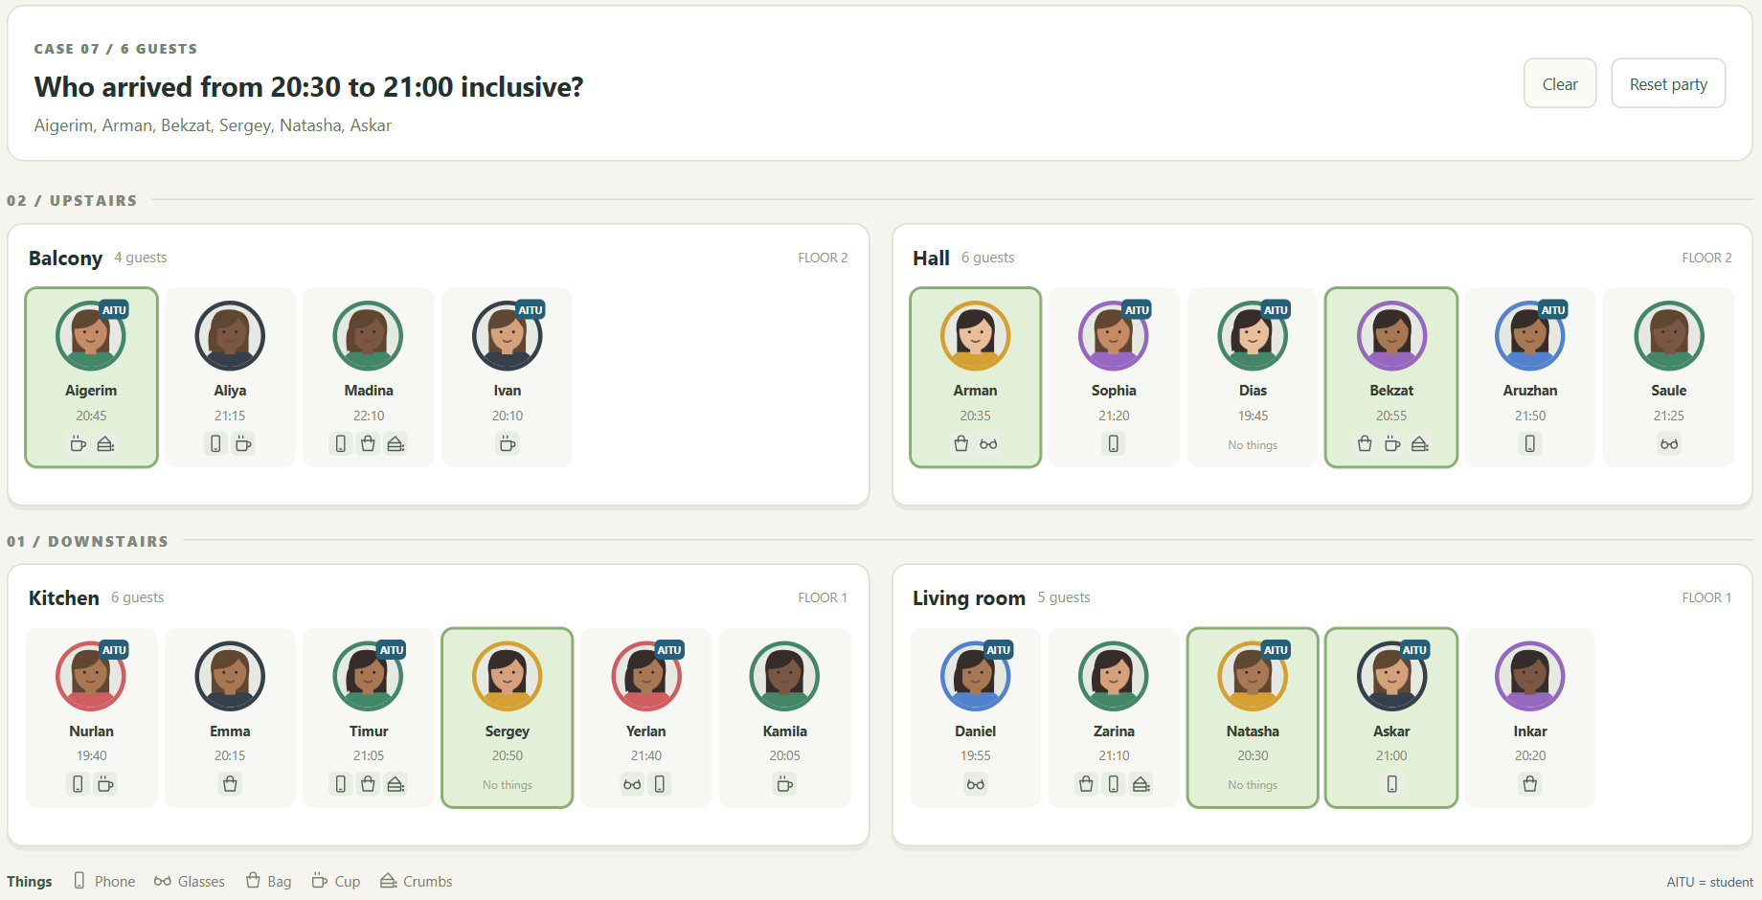
Case 7 result in Task 1
I read each card's data-minutes value and keep values from 1230 through 1260. The >= and <= checks include both boundary times.

Case 8
Who arrived after 21:00 and is not an AITU student?
jQuery chain
$('.guest:not(.aitu)').filter(function () { return +$(this).attr('data-minutes') > 1260;
});
Guests found: 4 - Aliya, Madina, Saule, Zarina.
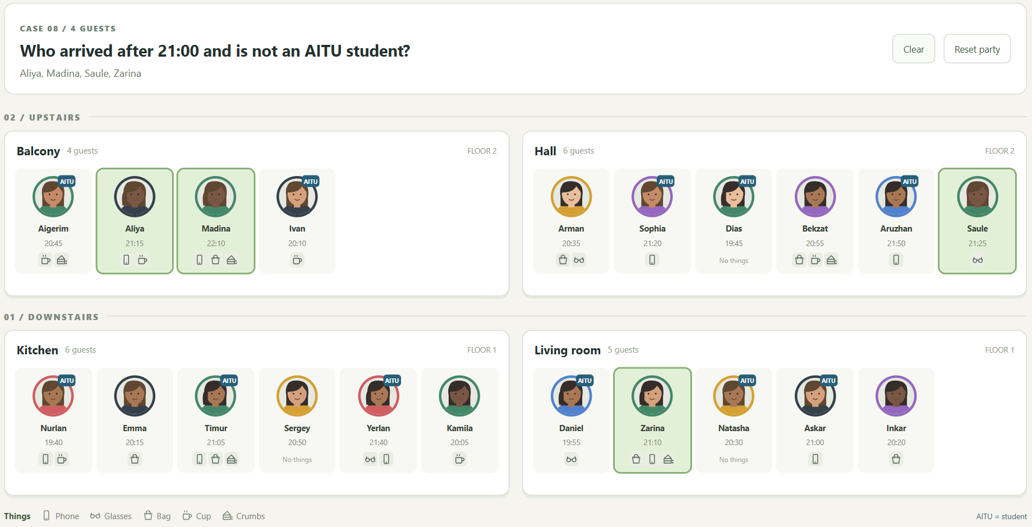
Case 8 result in Task 1
I exclude AITU students with :not(.aitu), then keep only arrivals strictly later than 1260 minutes, which is 21:00.

Case 9
Who stands right next to Askar?
jQuery chain
$('#askar').prev('.guest').add($('#askar').next('.guest'));
Guests found: 2 - Natasha, Inkar.
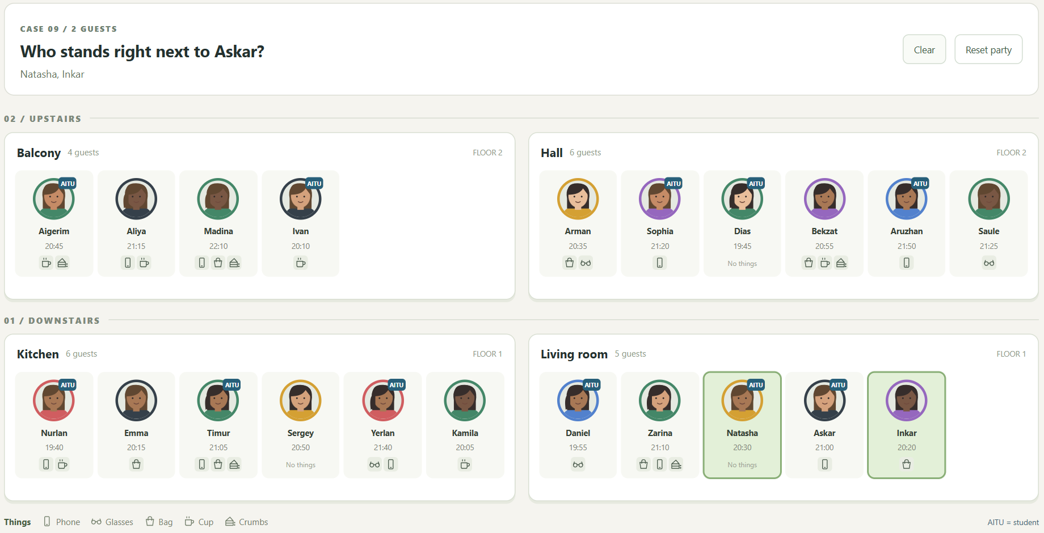
Case 9 result in Task 1
prev() and next() return Askar's immediate neighbours. add() combines the two results without selecting the rest of his room.

Case 10
Who stands last in each room?
jQuery chain
$('.guests > .guest:last-child');
Guests found: 4 - Ivan, Saule, Kamila, Inkar.
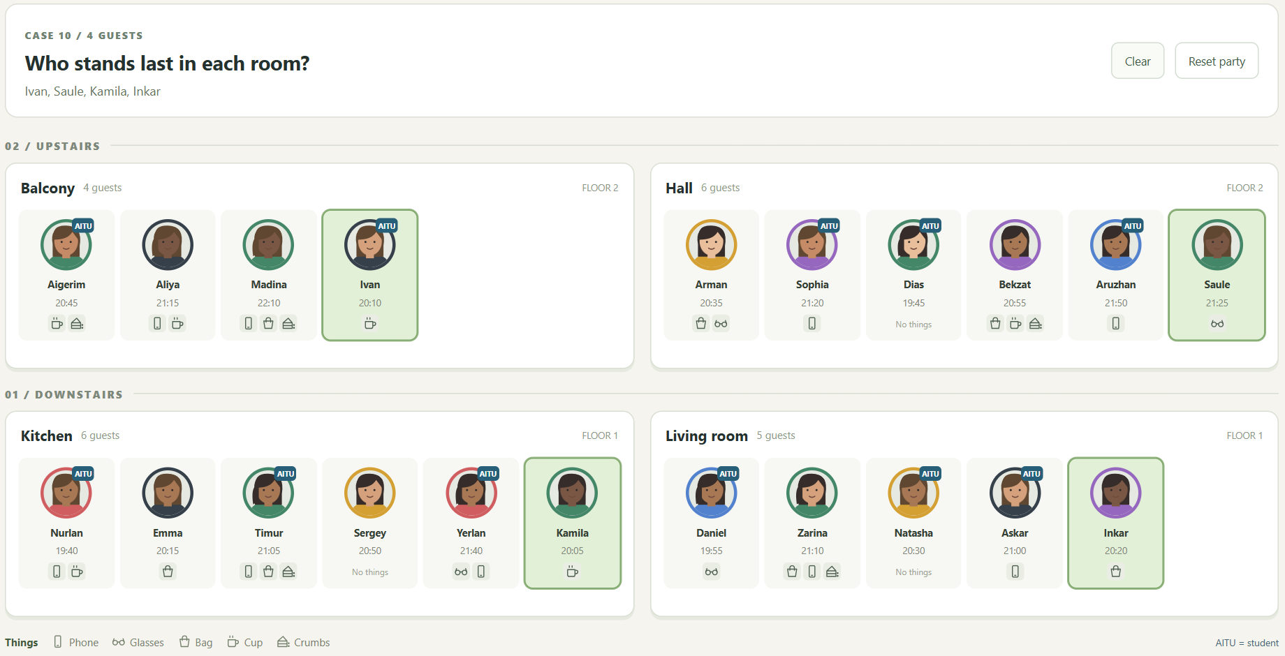
Case 10 result in Task 1
Every .guests container contains only guest cards when a case runs. :last-child therefore finds the last guest in every room.

Case 11
Who stands third in each room?
jQuery chain
$('.guests > .guest:nth-child(3)');
Guests found: 4 - Madina, Dias, Timur, Natasha.
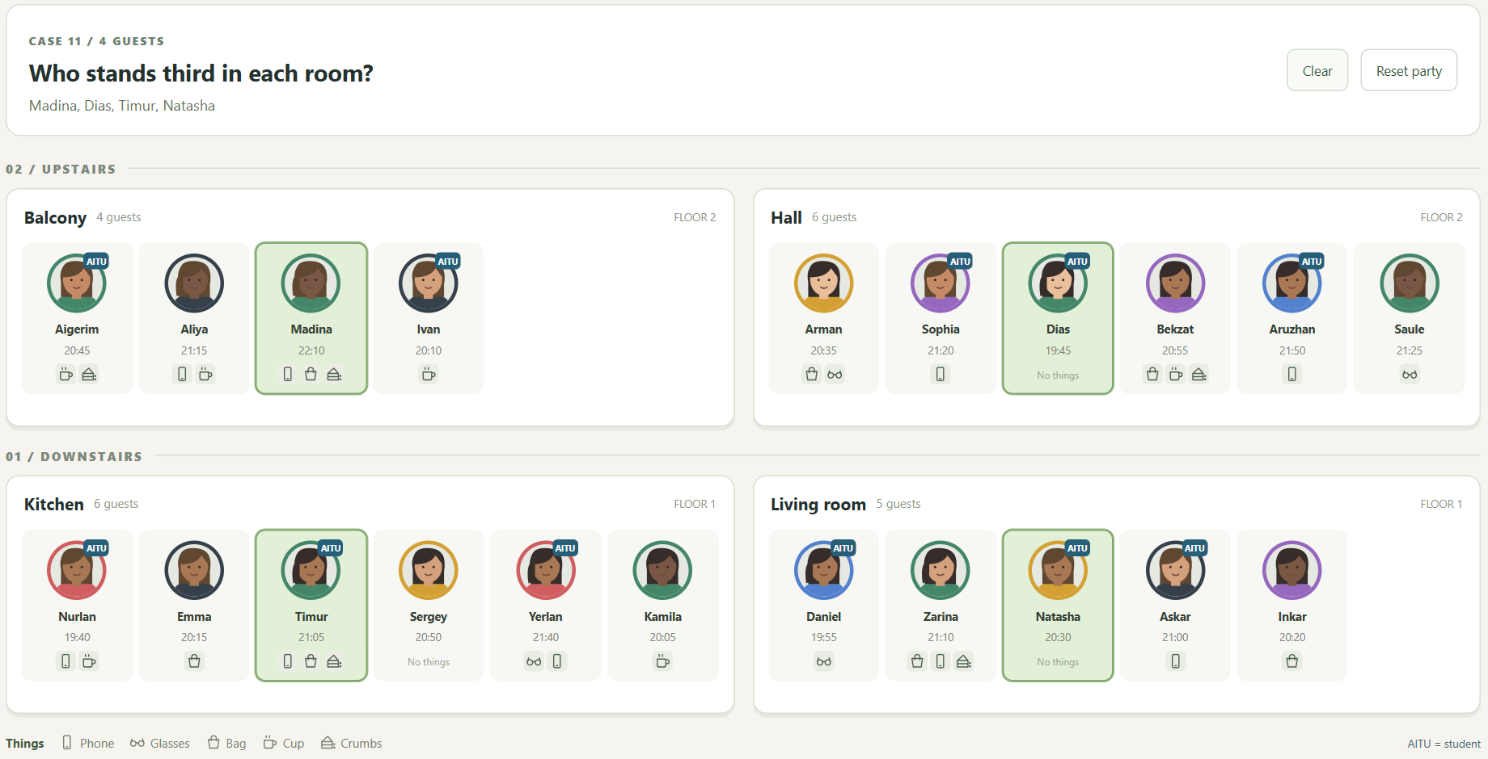
Case 11 result in Task 1
:nth-child(3) uses one-based numbering. It selects the third guest separately in every room.

Case 12
Who stands after Timur in his room?
jQuery chain
$('#timur').nextAll('.guest');
Guests found: 3 - Sergey, Yerlan, Kamila.
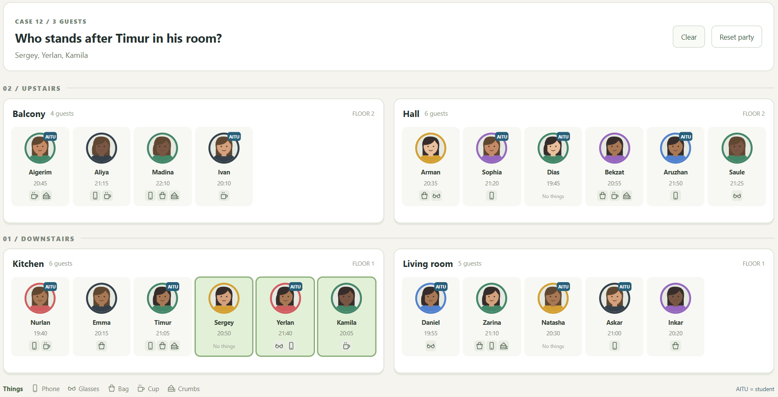
Case 12 result in Task 1
nextAll() selects all later siblings of Timur. It stays inside his room and does not include people in other rooms.

Case 13
Who stands right before someone in black?
jQuery chain
$('.guest.black').prev('.guest');
Guests found: 4 - Aigerim, Madina, Nurlan, Natasha.
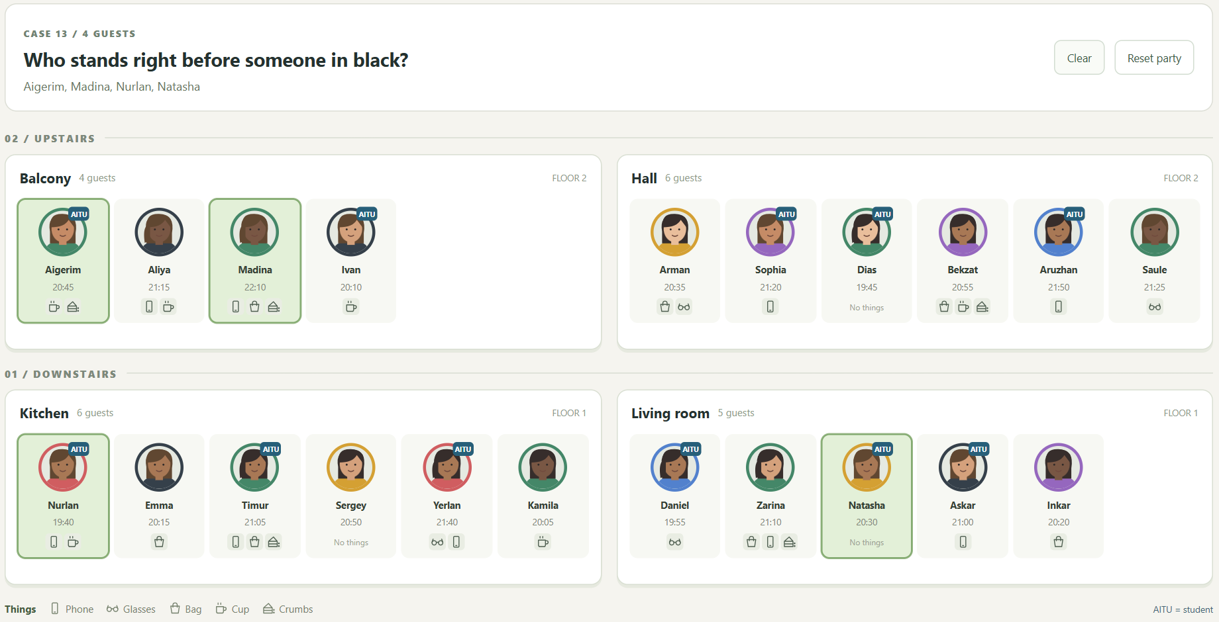
Case 13 result in Task 1
I select people dressed in black, then move one sibling backward with prev(). The selected card is the person before black clothing.

Case 14
In which room is Aruzhan?
jQuery chain
$('#aruzhan').closest('.room');
Rooms found: 1 - Hall.
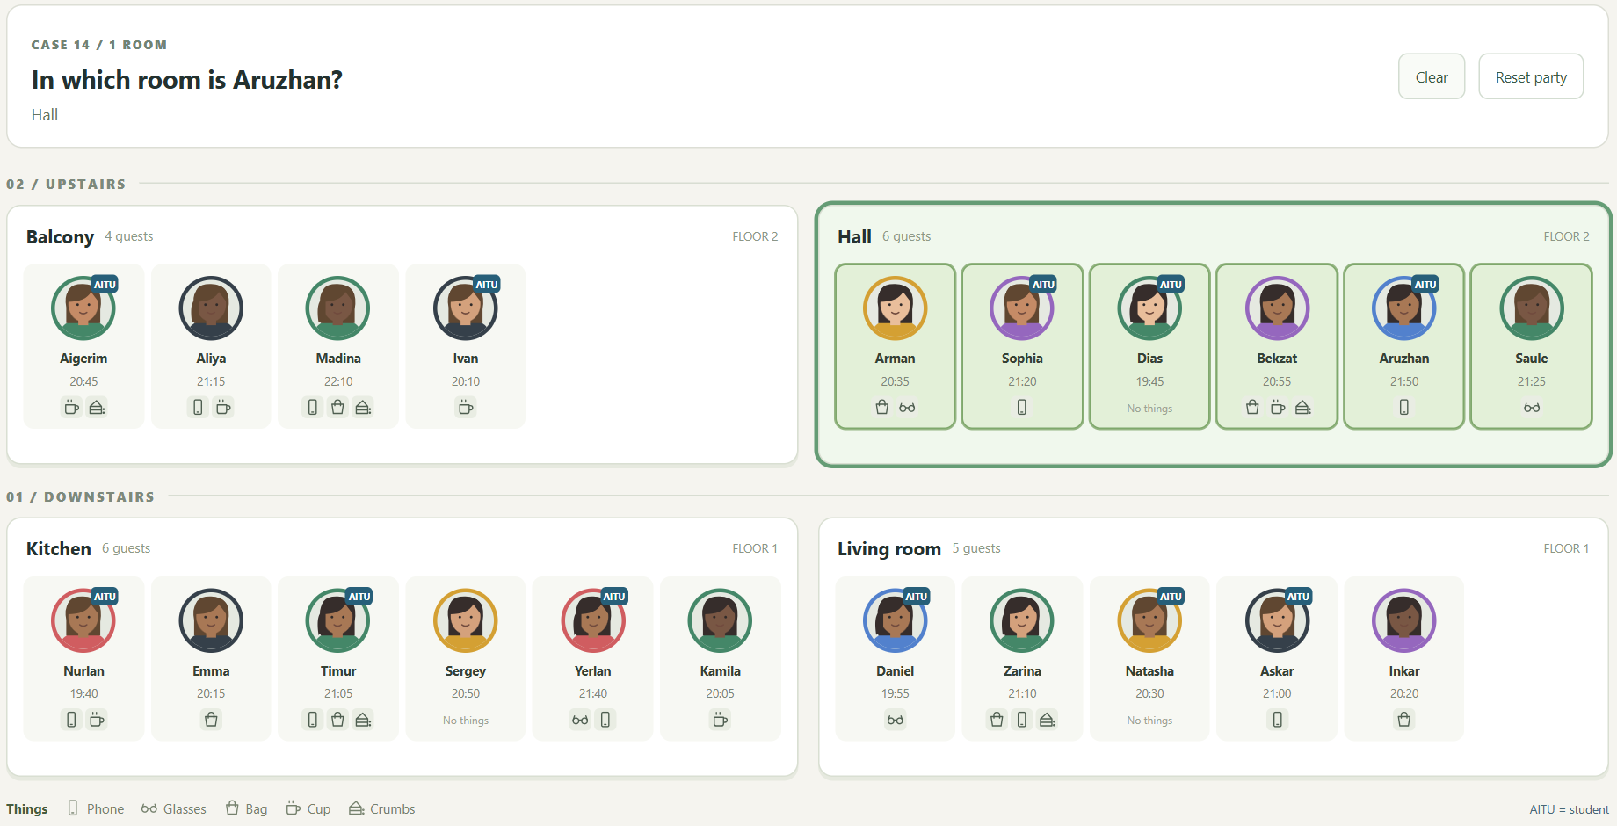
Case 14 result in Task 1
closest() moves from Aruzhan's card to its containing room. This case reports one room rather than one guest, so the whole hall is highlighted.

Case 15
Which rooms have fewer than six guests?
jQuery chain
$('.room').filter(function () { return $(this).find('.guest').length < 6; });
Rooms found: 2 - Balcony, Living room.
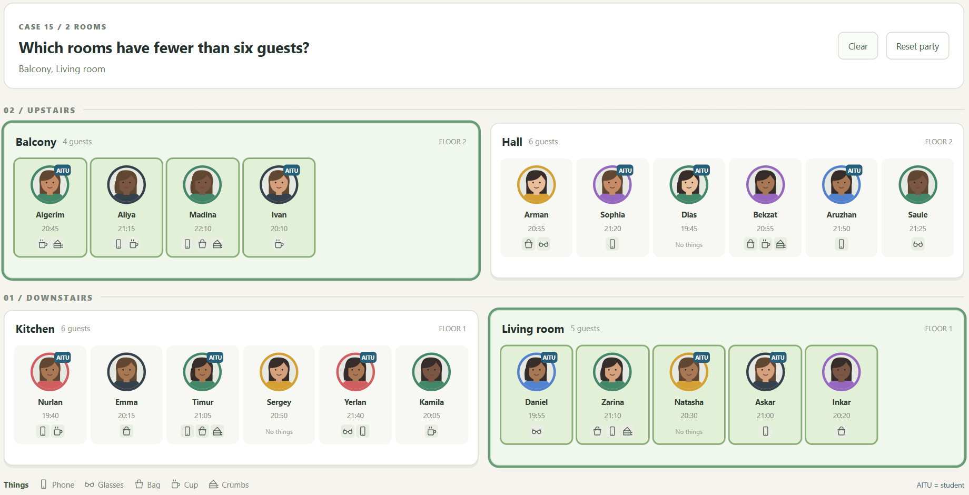
Case 15 result in Task 1
I filter room elements by the number of guest cards they contain. Four and five guests pass the test; six guests do not.

Case 16
Which rooms have a cup but no glasses?
jQuery chain
$('.room:has(.has-cup):not(:has(.has-glasses))');
Rooms found: 1 - Balcony.
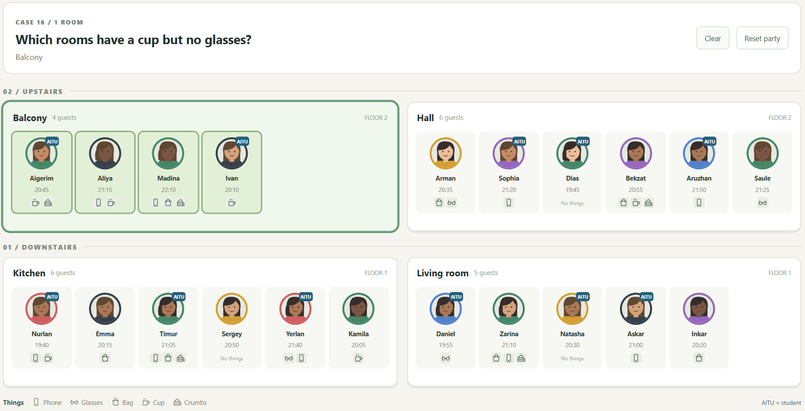
Case 16 result in Task 1
:has(.has-cup) requires at least one cup in the room. :not(:has(.has-glasses)) excludes any room containing glasses. Only the balcony passes both tests.

Case 17
Who came first to each room?
jQuery chain
$('.guest').filter(function () {
var time = +$(this).attr('data-minutes');
return !$(this).siblings('.guest').filter(function () {
return +$(this).attr('data-minutes') < time; }).length;
});
Guests found: 4 - Ivan, Dias, Nurlan, Daniel.
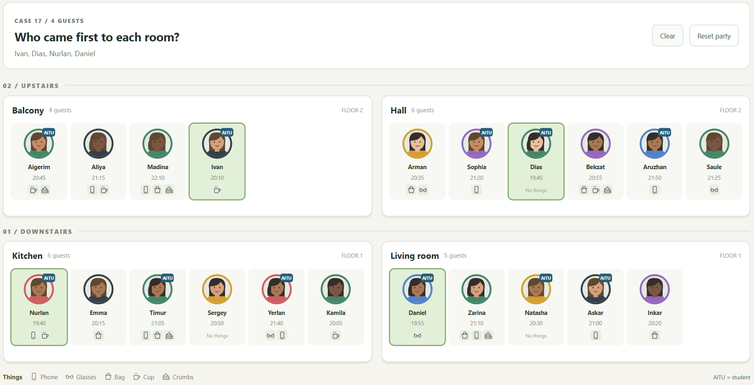
Case 17 result in Task 1
I compare each card's time with its siblings' times in the same room. A guest is the earliest when no sibling has a smaller time. This does not depend on the displayed order.

Case 18
Miras arrives between Askar and Inkar
jQuery chain
makeGuest({ id: 'miras', name: 'Miras', color: 'blue', time: '21:20', aitu: true, things:
['phone'] }, 5, 'living-room')
.hide().insertAfter($('#askar')).fadeIn(350);
Affected guest: 1 - Miras.
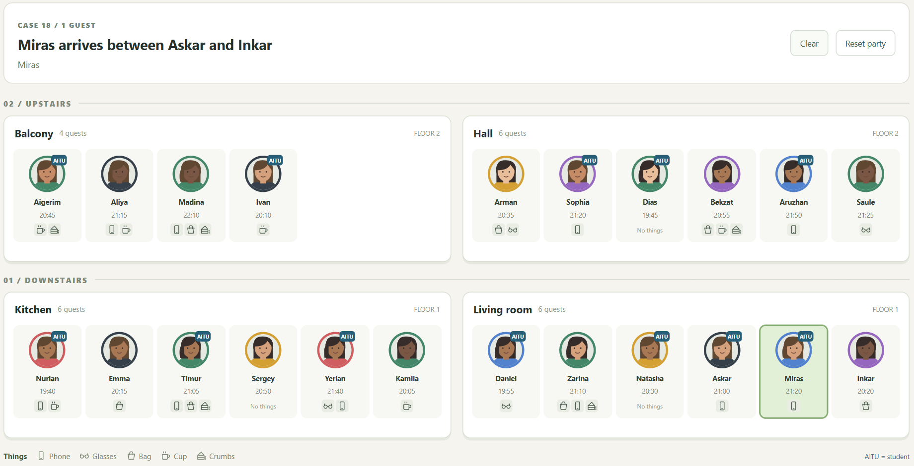
Case 18 result in Task 1
makeGuest() builds Miras's card with blue clothing, arrival 21:20, AITU status and a phone. insertAfter() places him immediately after Askar and before Inkar; fadeIn() reveals him. His card then jumps once.
The total becomes 22 guests. This case is rebuilt from the array before the animation, so running it again does not add duplicate Miras cards.

Case 19
Natasha leaves the party
jQuery chain
$('#natasha').animate({ top: -10 }, 150).animate({ top: 0 }, 170)
.fadeOut(350, function () { $(this).remove(); updateCounts(); });
Affected guest: 1 - Natasha.
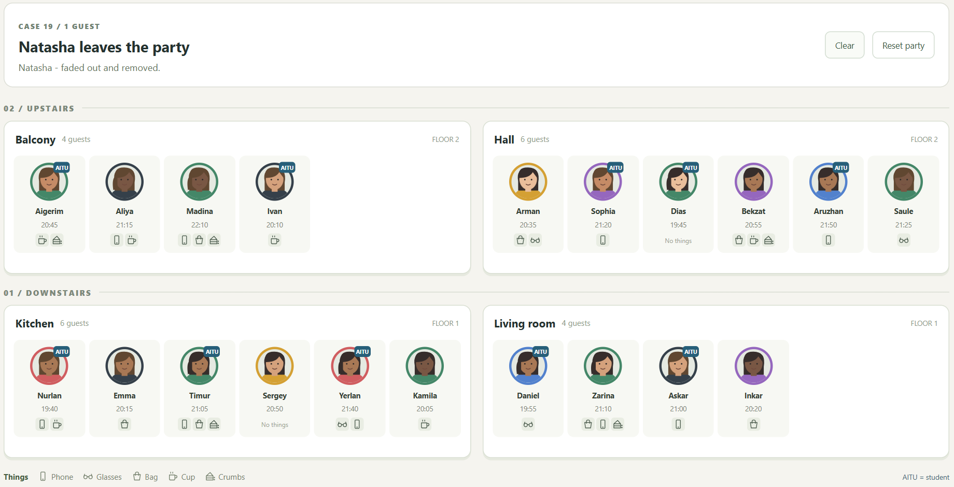
Case 19 result in Task 1
Natasha's card jumps once, fades out, and is removed in the fadeOut() callback. The screenshot shows the final state with four guests in the living room and no Natasha card.
The total becomes 20 guests. Starting another case rebuilds the page, which restores the original guest unless a later move or sort has saved the changed arrangement.

Case 20
Who took the cake?
jQuery chain
$('.floor[data-floor="1"] .guest.has-crumbs:not(.has-cup)')
.filter(function () { var t = +$(this).attr('data-minutes'); return t > 1260 && t <
1290; })
.filter(function () { return $(this).prev('.aitu').add($(this).next('.aitu')).length >
0; });
Guests found: 1 - Zarina.
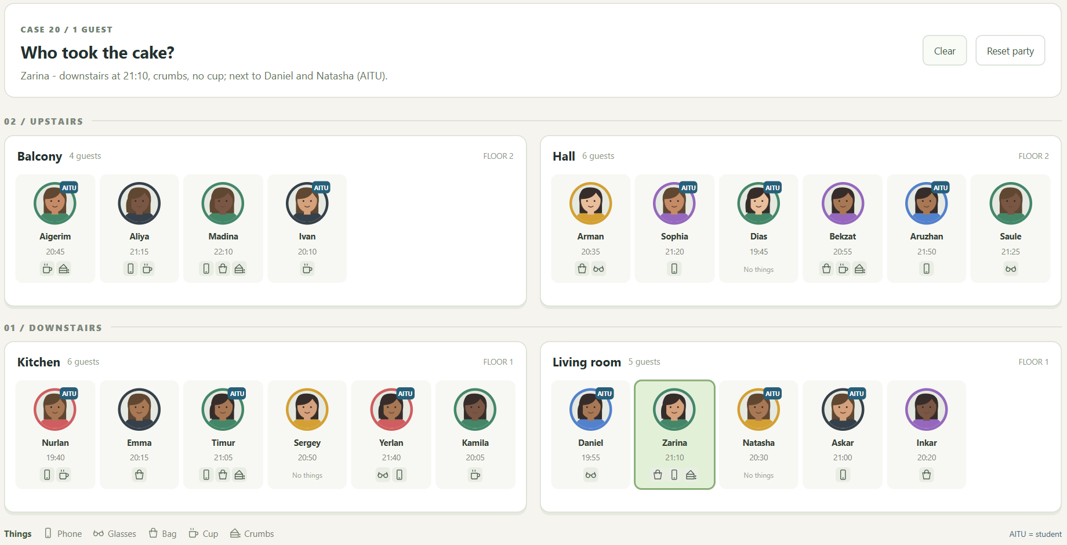
Case 20 result in Task 1
Zarina is downstairs in the living room. She arrived at 21:10, after 21:00 and before 21:30. She has crumbs and no cup. Her immediate neighbours Daniel and Natasha are AITU students. Timur has crumbs too, but neither of his neighbours is an AITU student.

Task 2 spotlight and clear
I continued in a copy of Task 1. When a case finds guests, only those guests remain bright. For a room result, I use find('.guest') to keep all people in the selected rooms bright. Other cards fade to opacity 0.2 in 300 milliseconds.
$('.guest').not($found).stop(true, true).fadeTo(300, 0.2);
if (!action) $found.css('opacity', 1);
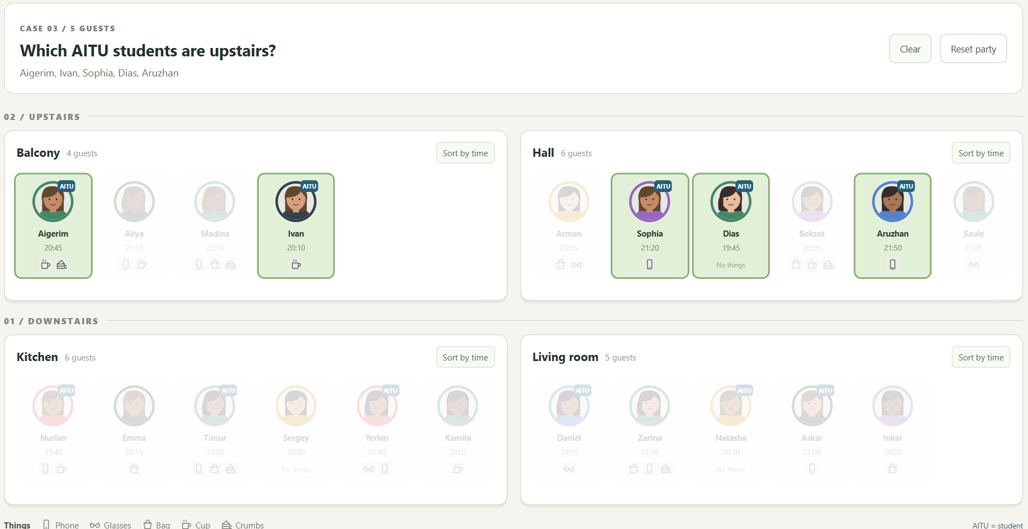
Case 3 keeps the five upstairs AITU students bright
Action | Observed result
Case 3 | 5 bright cards and 16 cards at opacity 0.2
Case 14 | All six hall guests stay bright; other rooms become pale
Clear | All 21 guests in the restored party return to opacity 1

Clear settles unfinished effects, clears the highlight, and sets opacity to 1. Cases 18 and 19 keep their own appearance or disappearance effect, so spotlight does not cancel their animation.

Task 2 guest profile
Clicking a guest creates one profile with their name, arrival time, student status, clothing, room and items written in words. The profile starts at the avatar's position and size, then grows to its full dimensions. There is one move button for each other room.
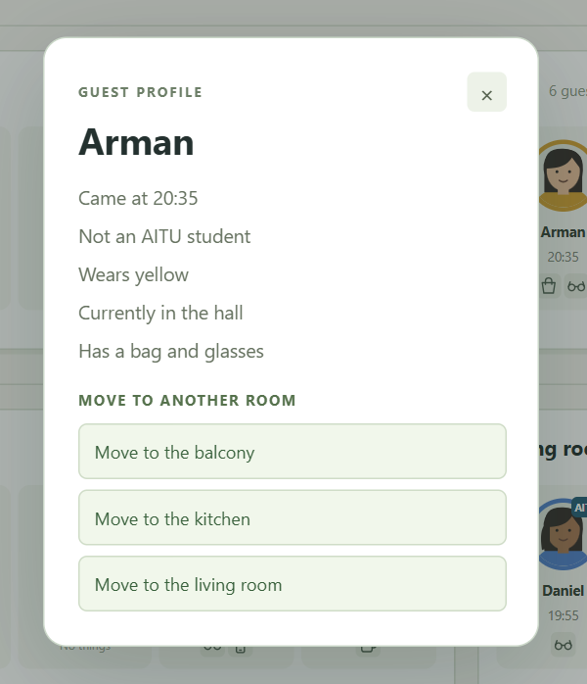
Arman profile with all information and three move destinations
$detail.css({ left: box.left, top: box.top, width: box.width,
height: box.height, opacity: 0 }).animate({
left: ($(window).width() - width) / 2, top: top,
width: width, height: height, opacity: 1 }, 280);
Esc and a click on the shaded background close the profile. Closing uses animate() to shrink it back into the same avatar. When I click another guest, the existing profile closes before the next one opens. A request counter prevents an older callback from opening a stale profile after rapid clicks.

Task 2 moving a guest
I open Arman's profile and choose Move to the balcony. A cloned guest card flies from the hall to the balcony over 650 milliseconds. The other cards slide to close the old gap, while a placeholder grows in the destination.
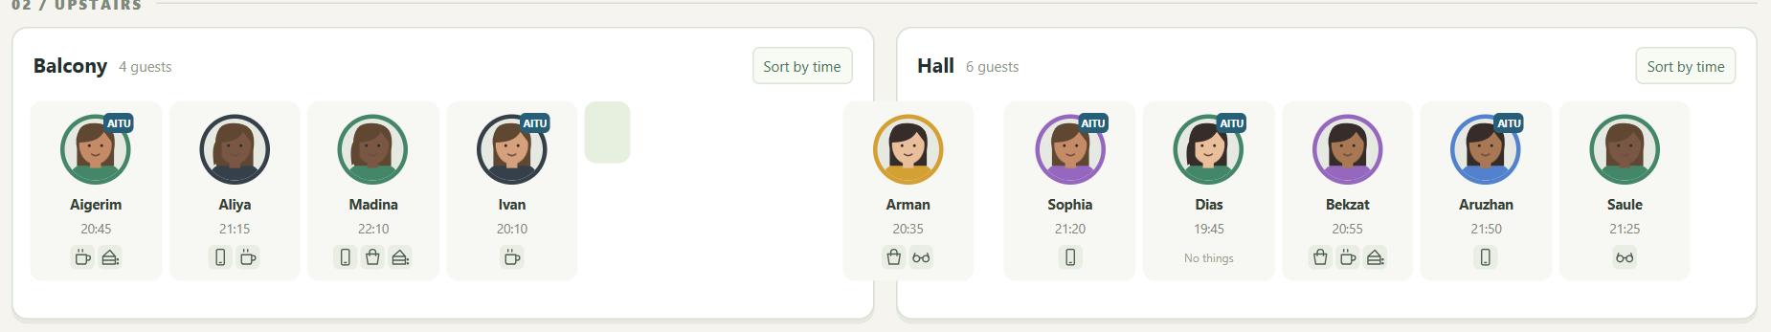
Arman in flight while the balcony opens a place for him
var $flying = $guest.clone(false).removeAttr('id').addClass('flight');
$guest.detach();
$slot.animate({ width: targetWidth, height: height }, 500);
$flying.animate({ left: destination.left, top: destination.top,
width: targetWidth }, 650, function () {
if (completeMove) completeMove();
});
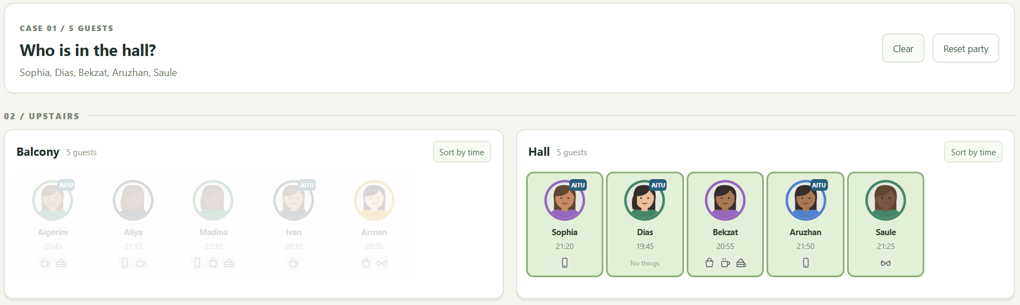
Case 1 after the move finds five hall guests and excludes Arman
The completion callback replaces the placeholder with the real card, updates the room and order attributes, and calls syncModel(). Arman becomes the last guest in the balcony array. The next case rebuild keeps him there, so case 1 no longer finds him in the hall.

Task 2 sorting by arrival time
Sort by time compares numeric arrival times inside the selected room. The living room becomes Daniel 19:55, Inkar 20:20, Natasha 20:30, Askar 21:00 and Zarina 21:10. The next click restores the original left-to-right order from data-order.
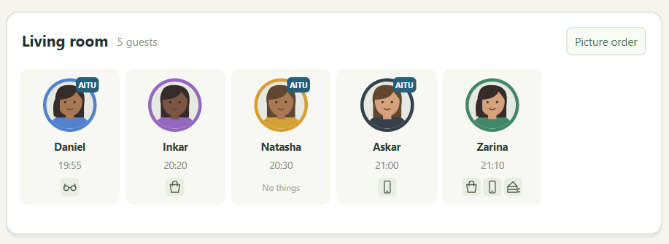
Living room in ascending arrival order
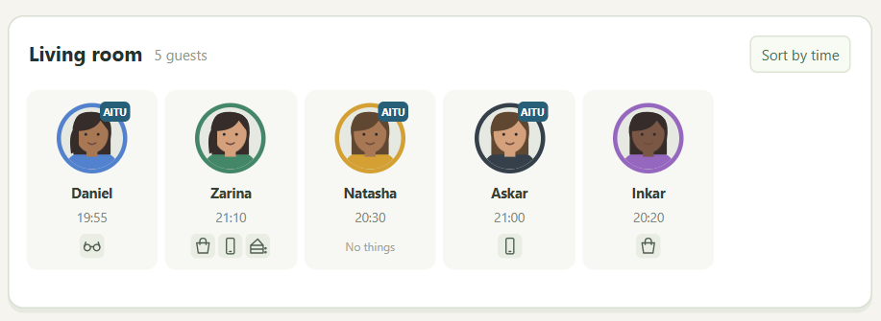
Living room restored to the picture order
var before = positions($cards);
$cards.stop(true, false).css({ left: 0, top: 0 });
room.sorted = !room.sorted;
// Sort the DOM cards by data-minutes or data-order and append them.
slideToLayout($cards, before, 420);
window.partyApp.syncModel();
I record each card's current offset before changing the DOM order. After reordering, I set a relative offset that keeps the card at its old visible position, then animate left and top to zero. If another click interrupts the animation, the next movement begins from the current visible position.
Five rapid clicks end in the sorted state. The checks found no remaining animation queues and every card ended at left 0 and top 0.

Verification and conclusion
Browser verification completed 60 checks with no JavaScript errors. Each of the 20 cases was checked in both tasks against the expected names or rooms. The checks also covered data fidelity, effects, updates to the array, rapid interactions, local file loading and mobile layout.
Check from the assignment | Actual result | Status
Case 3 then Clear | 5 upstairs students stay bright; Clear restores every card | Passed
Click a guest then Esc | Profile grows from the avatar and shrinks back on Esc | Passed
Move Arman to the balcony | Arman is last in the balcony; case 1 excludes him | Passed
Sort the living room twice | 19:55, 20:20, 20:30, 21:00, 21:10; then picture order | Passed
Sort 5 times fast | Sorted order; zero queued or unfinished animations | Passed
Rapid guest and case clicks | One latest profile; no duplicate cards or leftover clones | Passed
Open both local index files offline | Both tasks load and case 20 finds Zarina | Passed

How unfinished animations are handled
I use stop(true, true) when a new action must finish the old state, such as Clear or a case rebuild. Sorting and profile changes use stop(true, false) so the next animation can start from the current visible position. completeMove() finishes a move once, removes its clone and placeholder, and saves the destination before another action continues.
Event handlers are attached once with on(), including delegated handlers for rebuilt guest cards. CSS controls only appearance and layout. All interaction and animation use jQuery; there are no onclick attributes, CSS transitions, CSS animations or additional runtime libraries.

Conclusion
I learned how selectors and traversal answer different questions about the same DOM. next() and prev() depend on immediate neighbours, nextAll() finds every later sibling, and closest() finds the room containing a guest. I also learned to compare time as minutes, update the array after changing the page, and control jQuery queues so rapid clicks end in a consistent state.

References
Assignment 6 supplied task sheet, pages 1 to 5.
jQuery API documentation: https://api.jquery.com/
jQuery stop method: https://api.jquery.com/stop/
jQuery animate method: https://api.jquery.com/animate/
jQuery fadeTo method: https://api.jquery.com/fadeTo/

