**Module 2 Assignment 2: Exploring JavaScript Topics with EJS, Node.js, and Express**

Dathan Dominic Neal

Arizona State University

IFT 458/554: Middleware Programming & Database Security

Professor Dinesh Sthapit

September 4, 2023

All source codes include the terminal docked at the bottom with the displayed result when running the scripts. Thank you.

Calculator App:

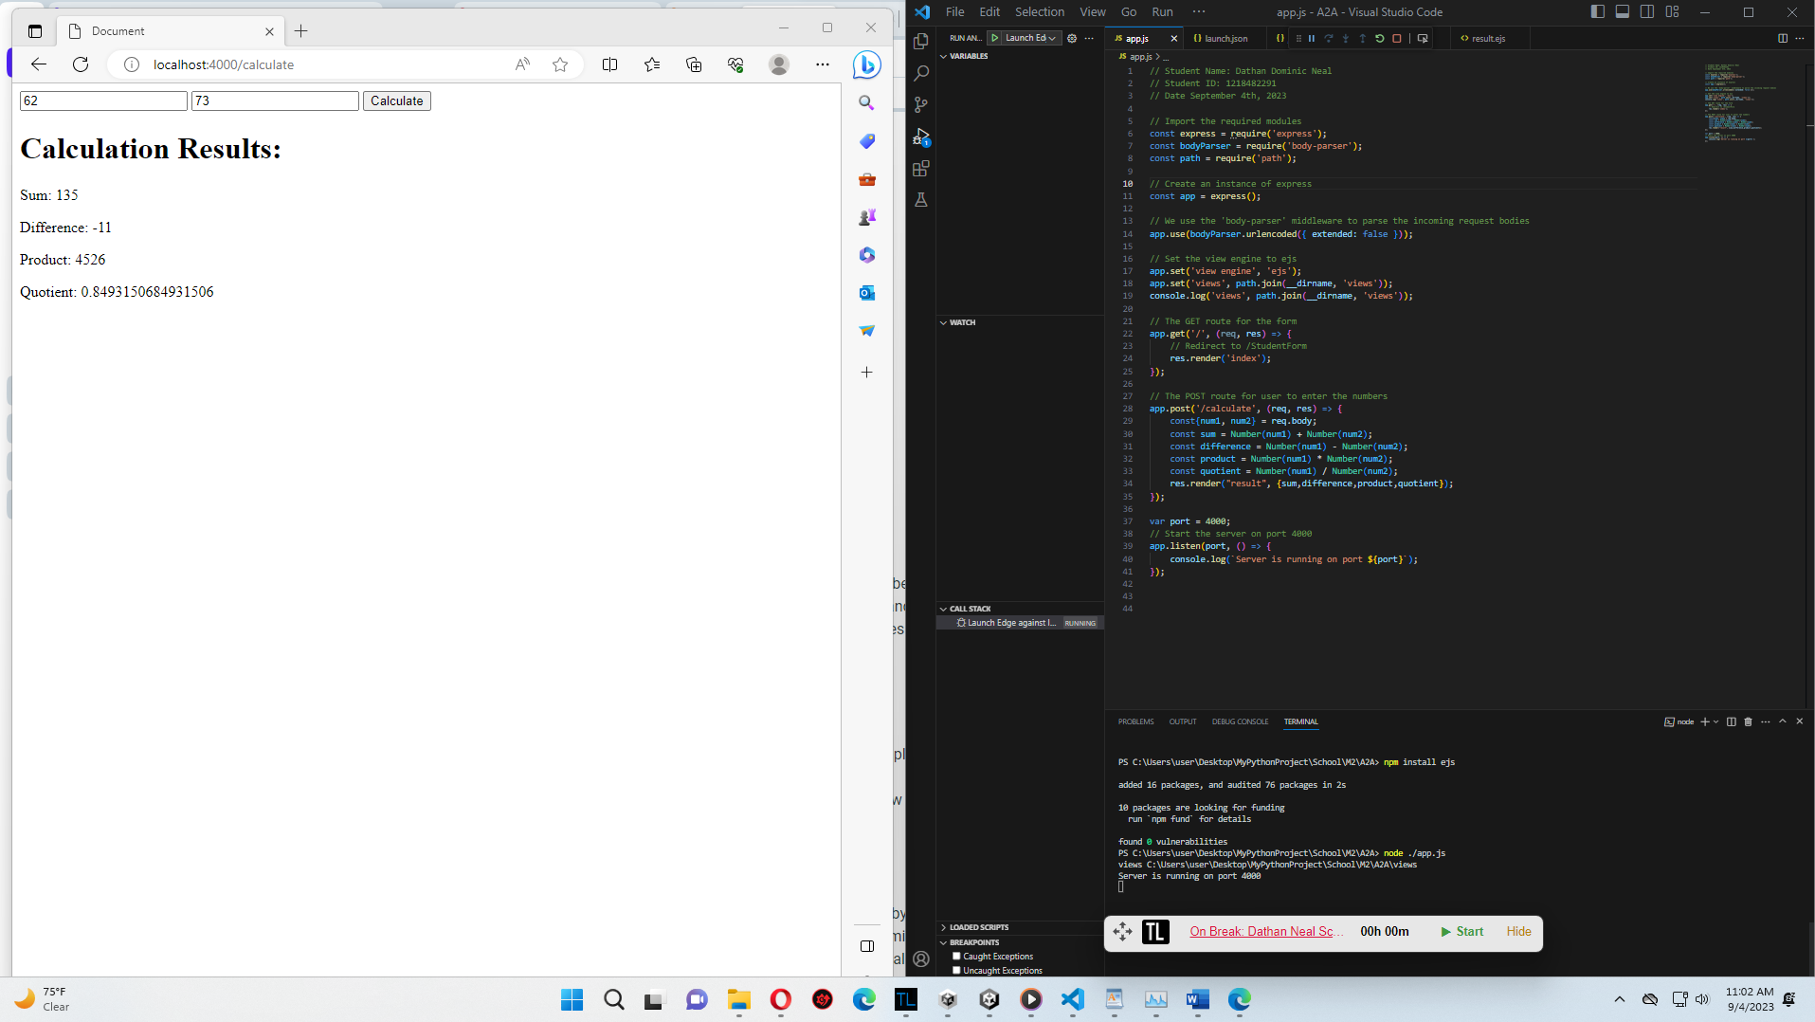Index.ejs file:

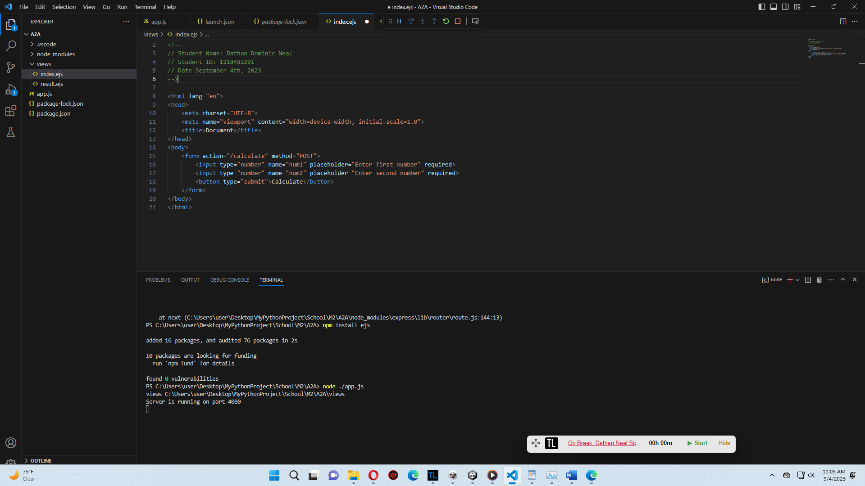

Result.ejs file:

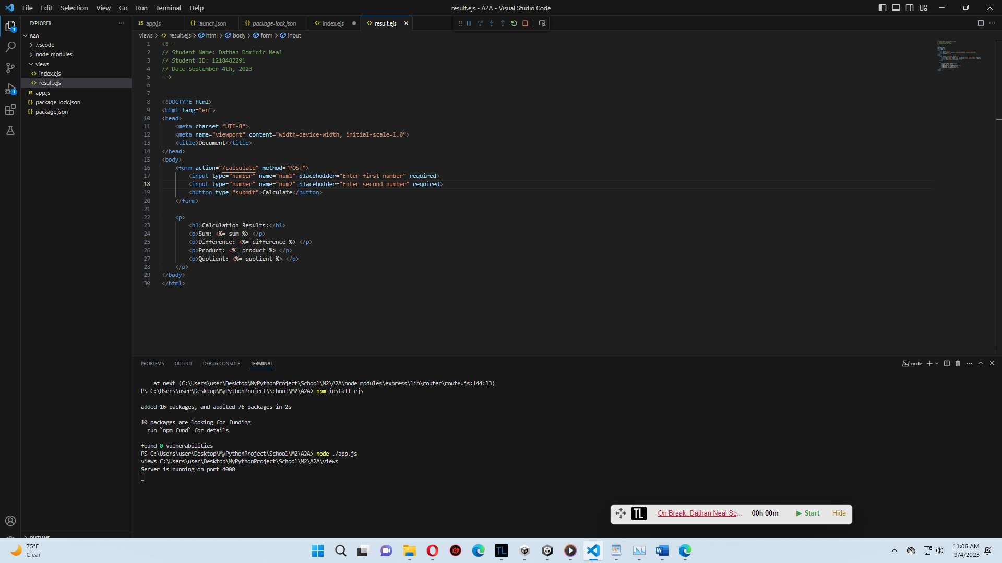

HTML Code analysis:

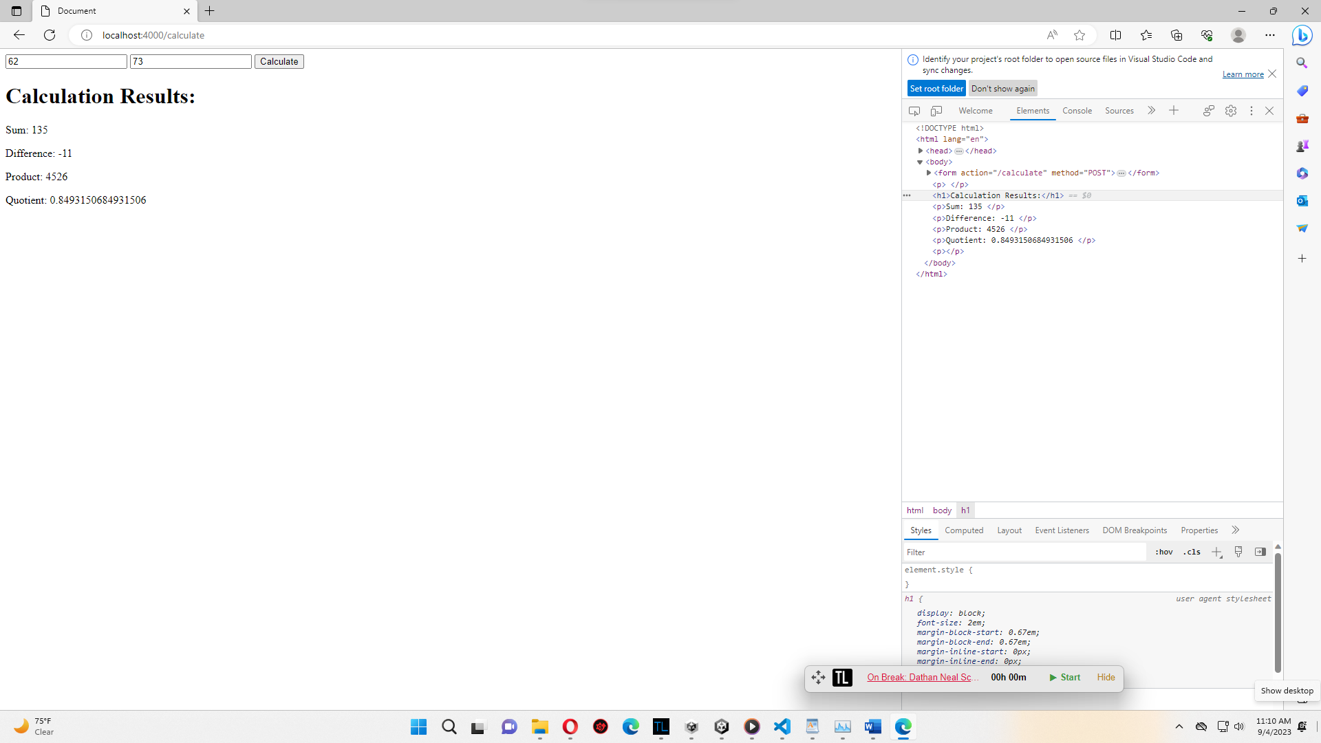

I initially had issues creating this application as my app.js file was incorrectly configured, but after viewing the instructions again, I got it set up correctly and functioning as intended. I also made the rookie mistake of not installing all the required modules in the beginning, as my EJS module was missing at first.

JavaScript code is included inside each paragraph tag for the mathematical answers. This is how the ejs file is able to communicate with the app.js file and its variables. The index.ejs sends the user’s inputted numbers to the app.js file to be used for calculations. When the post method is called, it runs through each calculation provided in the app.js file, then returns and renders the result.

The app.js file directly injects the given calculations inside of the tags, as we indicated in the result.ejs file. The dynamically created parts of this ejs file include the answers of each calculation. Without the calculations of the ejs file, no numbers will be shown.

The EJS template would be great for consolidating your website’s logic in a separate file and providing the developer with ways of running the logic when the end user initiates a GET or POST action. This could be beneficial in the area of online registration forms, as you can dynamically create/edit HTML information easily through the app.js file.

Extra Credit:

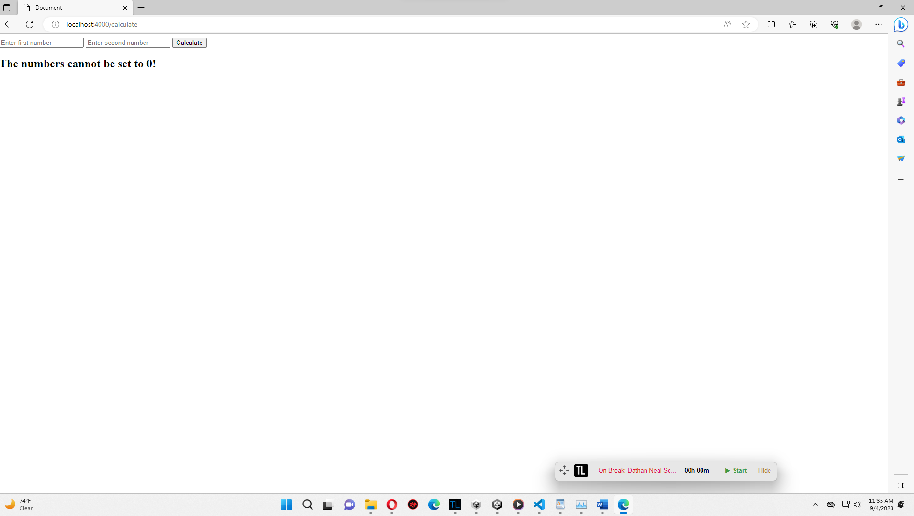

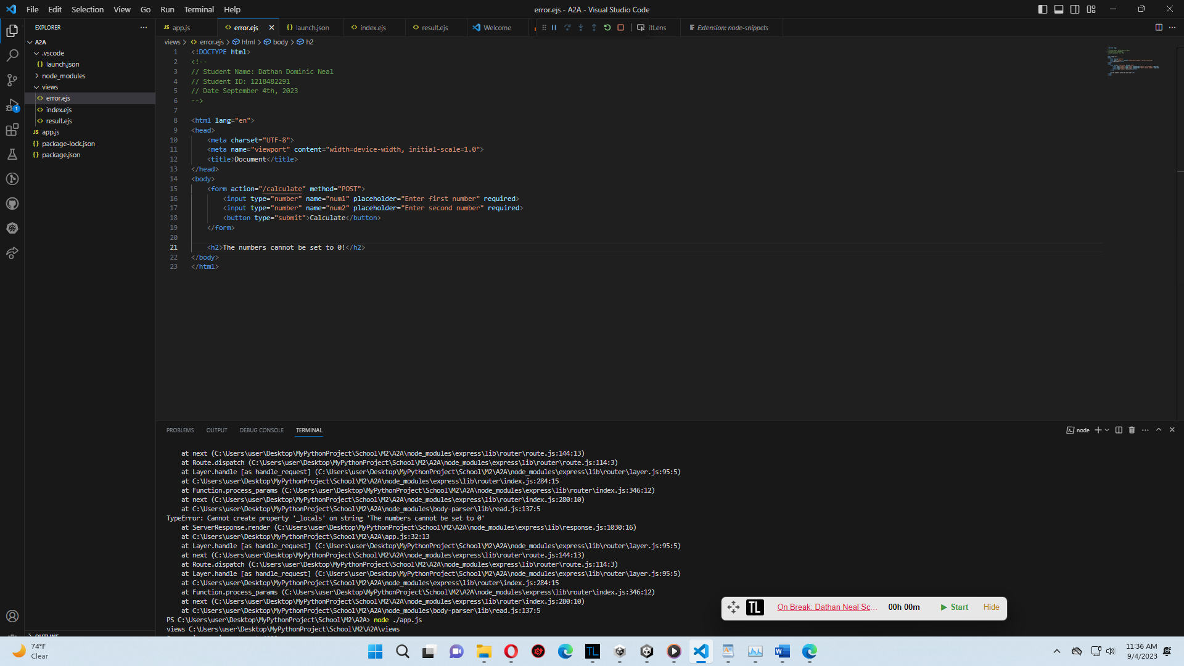

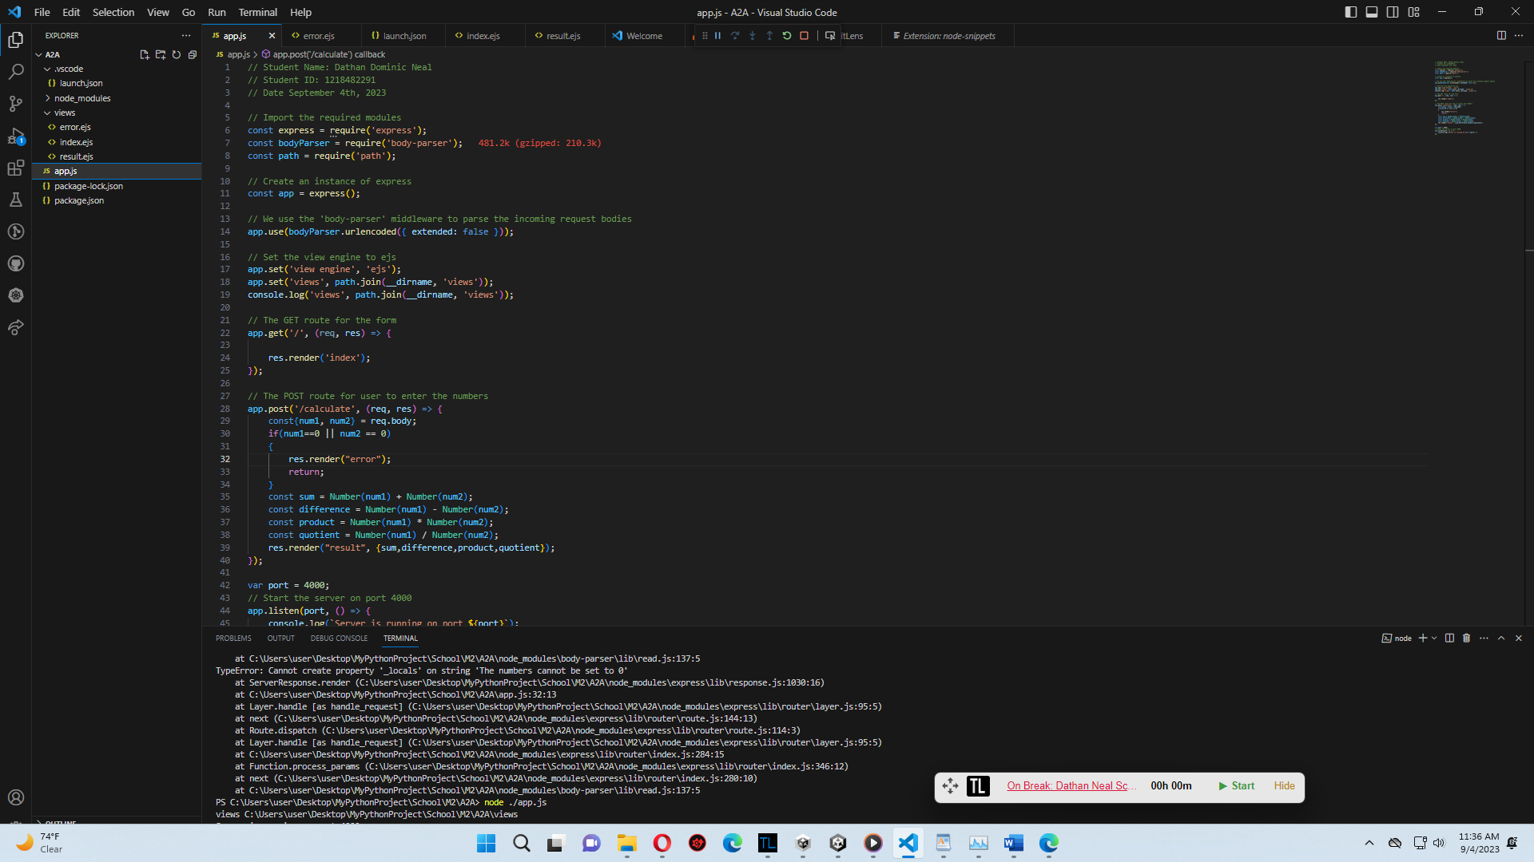

For the extra credit, I added a conditional statement in the POST method that checks if the user inputs the number ‘0’ in any field. If they do, it redirects them to an error page stating that 0 is not an allowed number.