**Module 2 Lab 1: Javascript**

Dathan Dominic Neal

Arizona State University

IFT 458/554: Middleware Programming & Database Security

Professor Dinesh Sthapit

September 4, 2023

Exercise 2 (EJS and Book List):

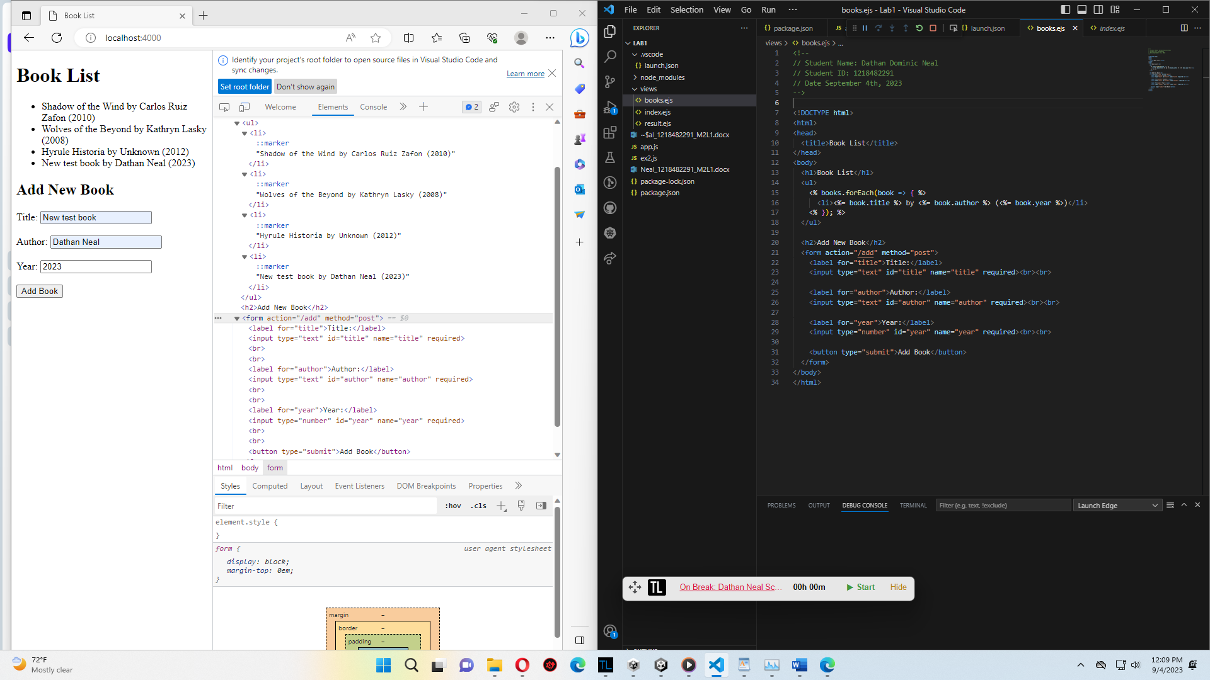

JavaScript Contents:

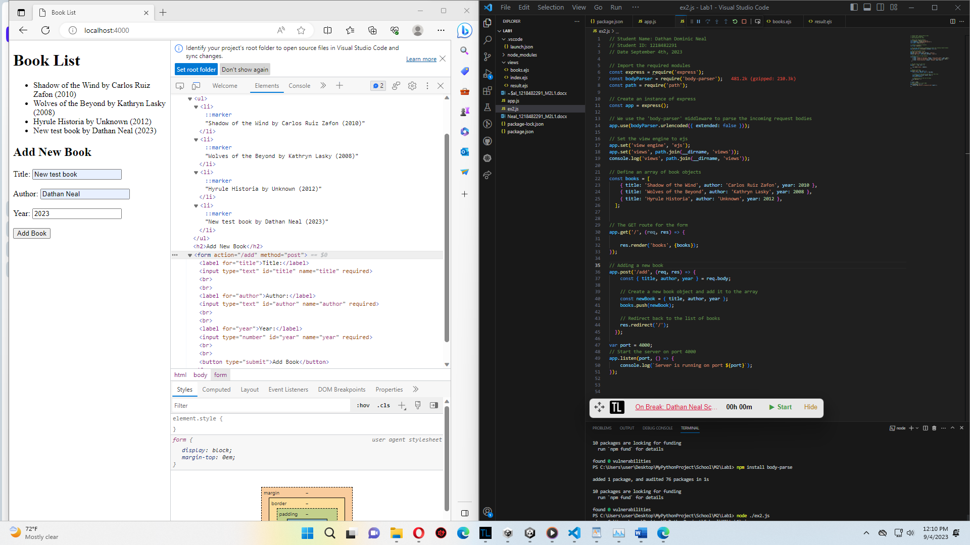

Exercise 3 (Before Clicking Submit):

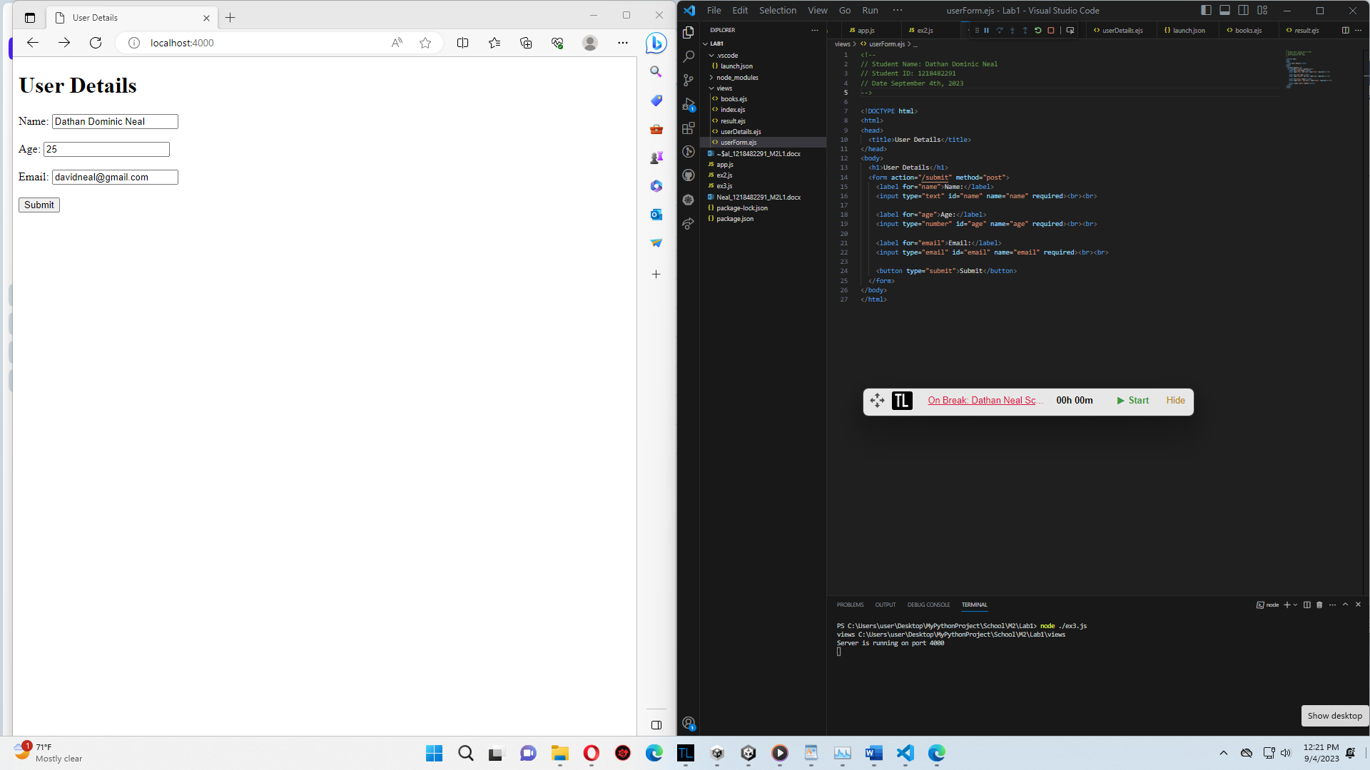

After Clicking Submit:

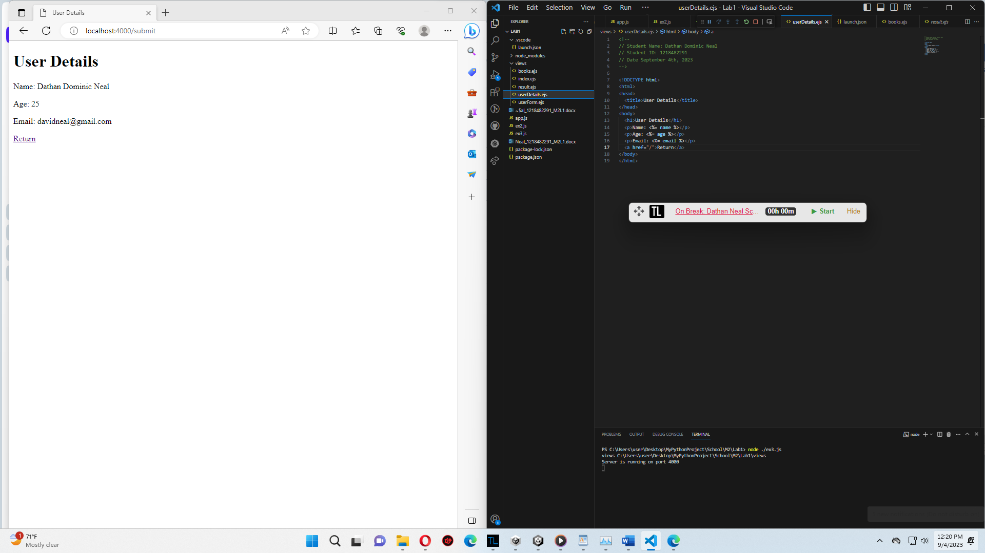

JavaScript file:

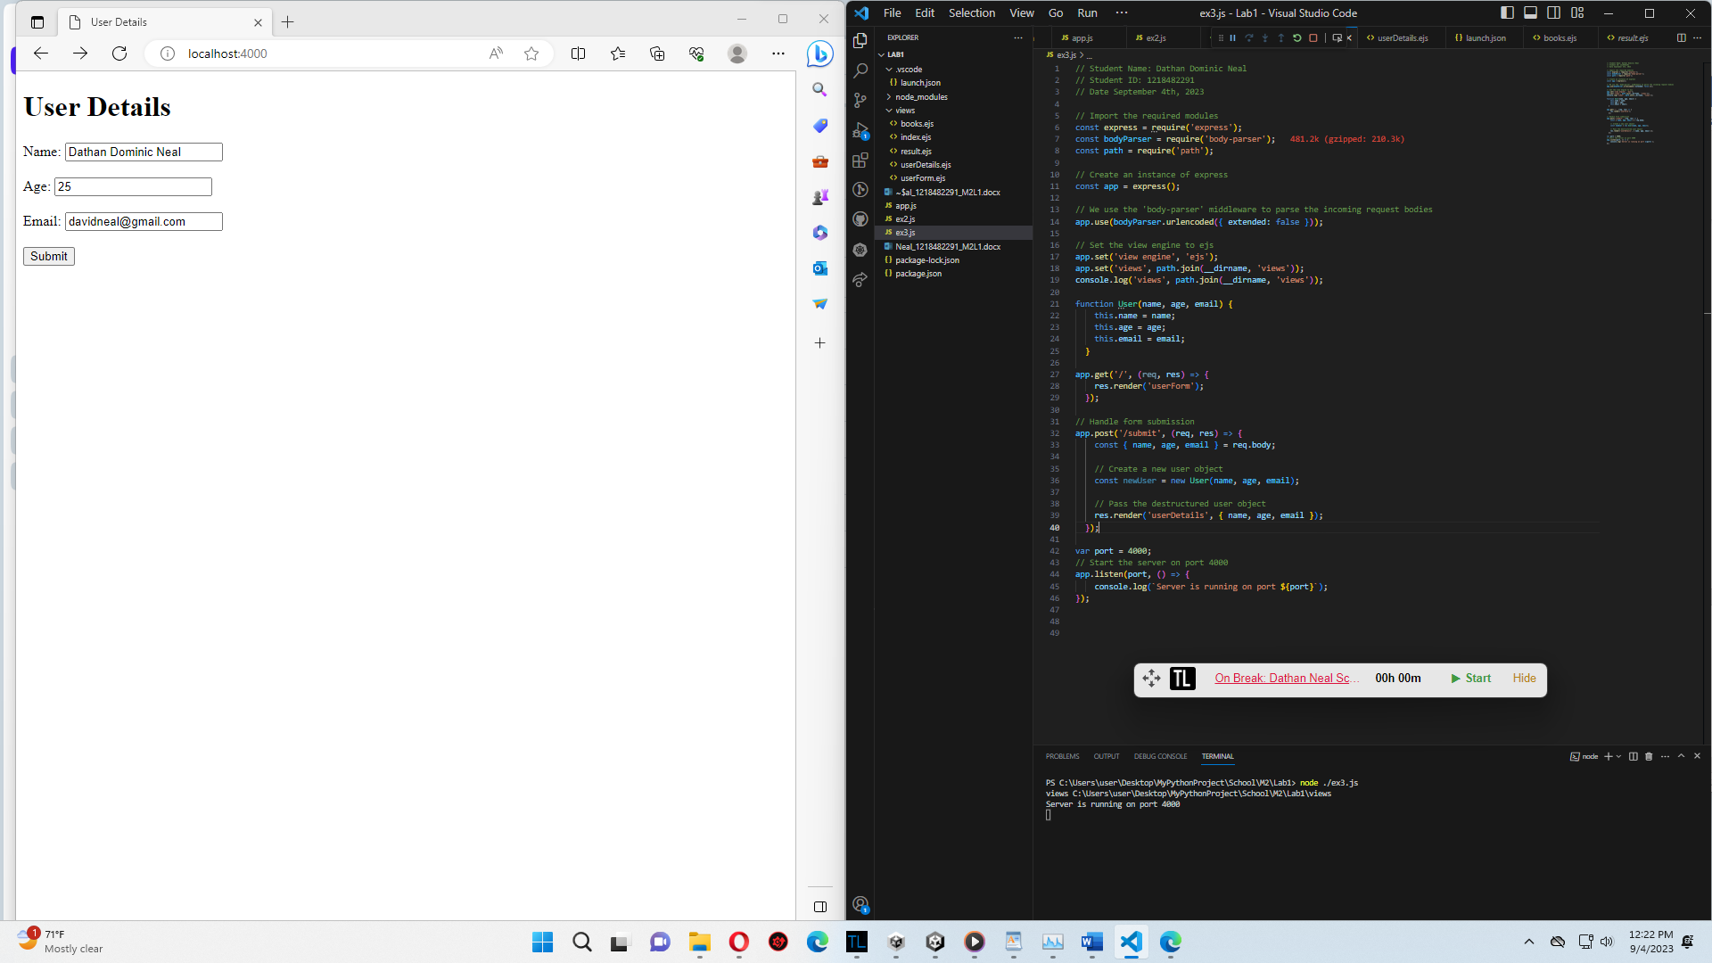

Exercise 4 (Fruit Lists JavaScript File):

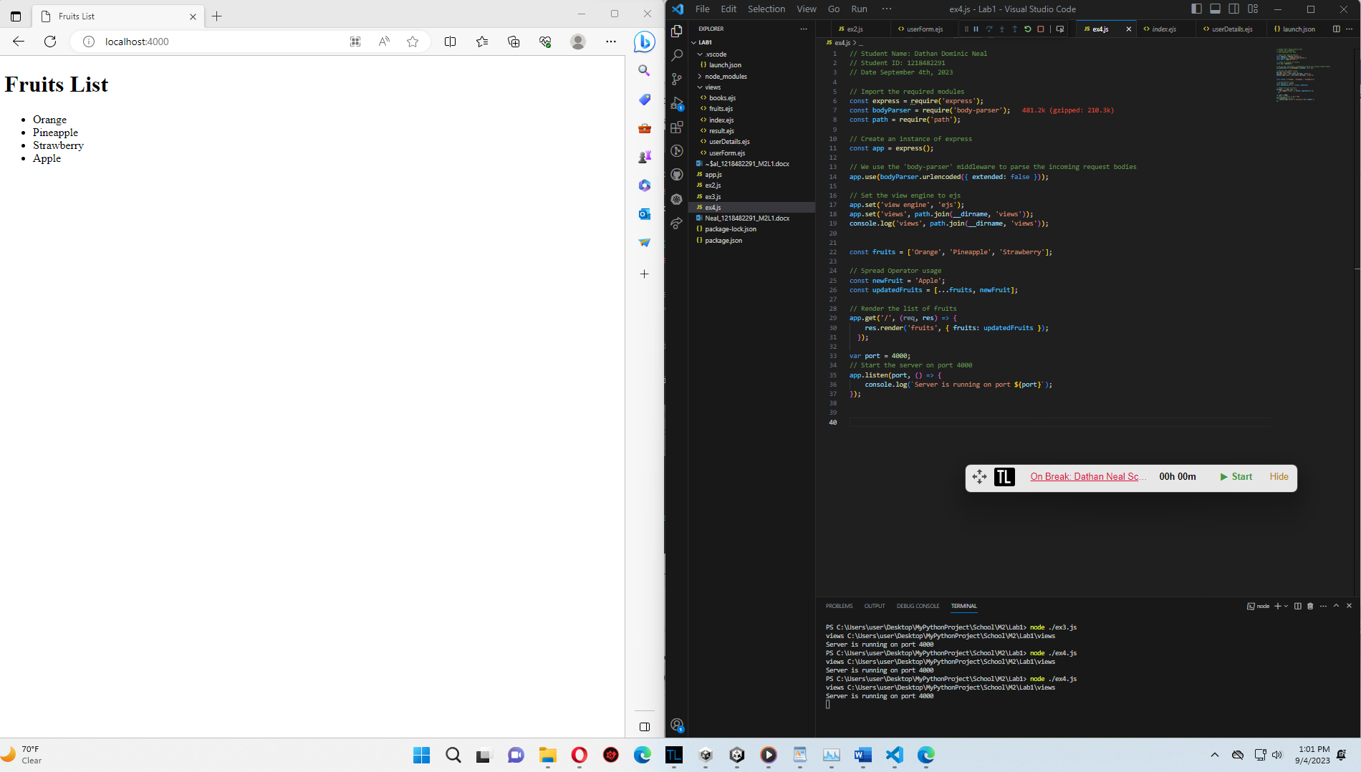

EJS File:

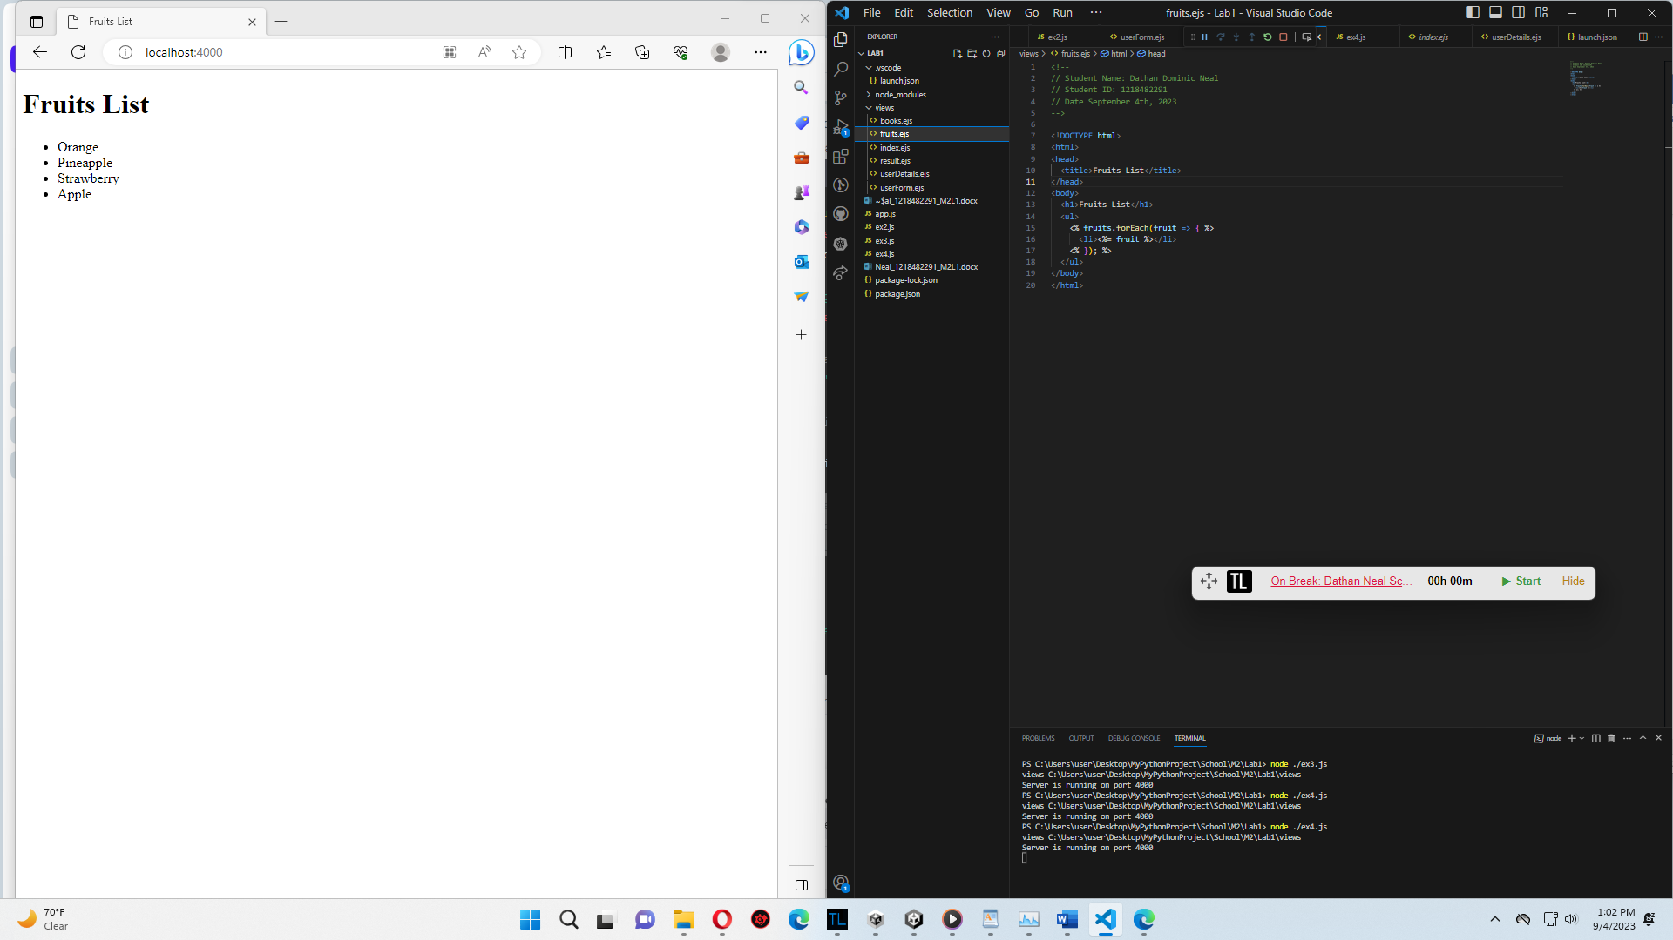

Exercise 5 (Before clicking button):

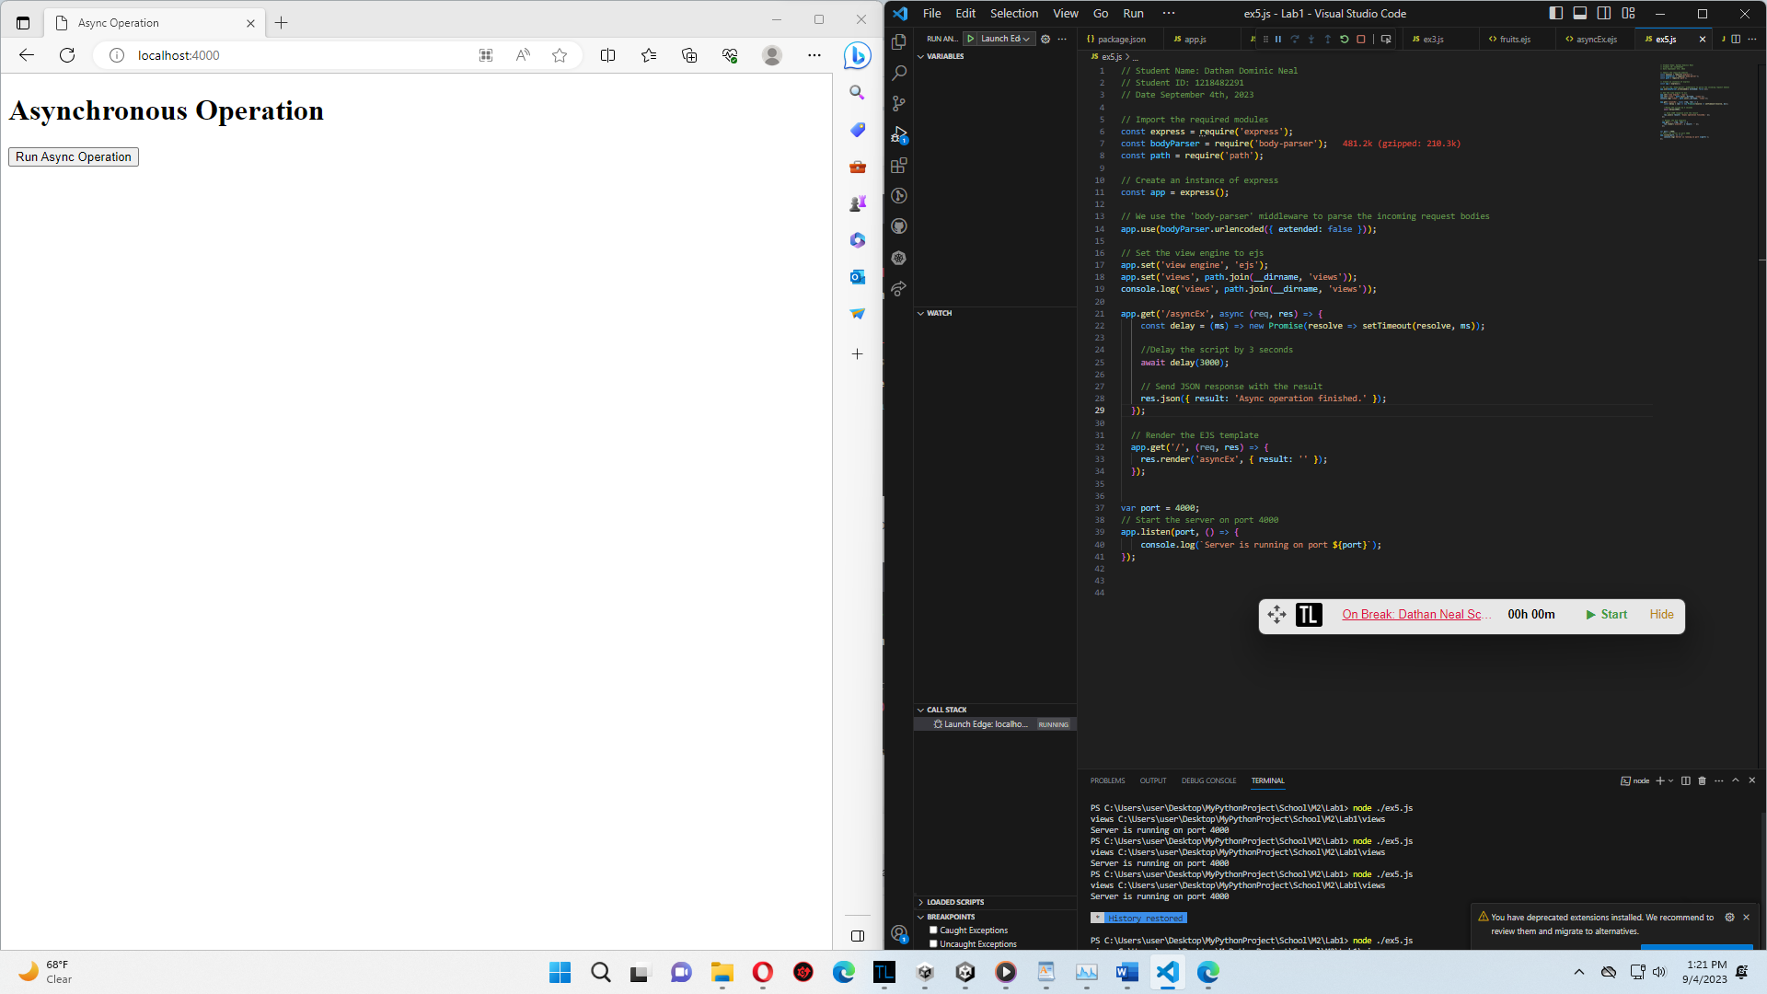

3 Seconds After Clicking Submit Button:

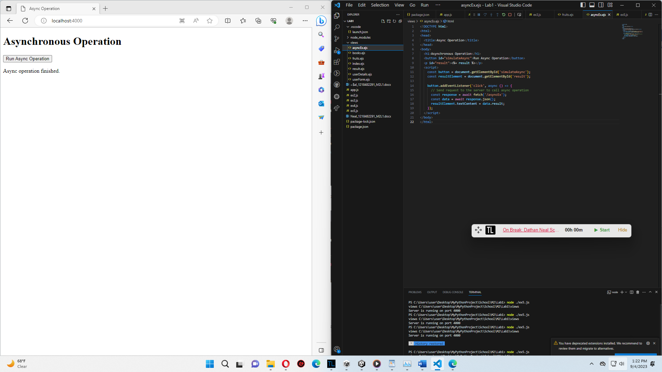

Exercise 6 (JS file and fetched URL of Google using Axios):

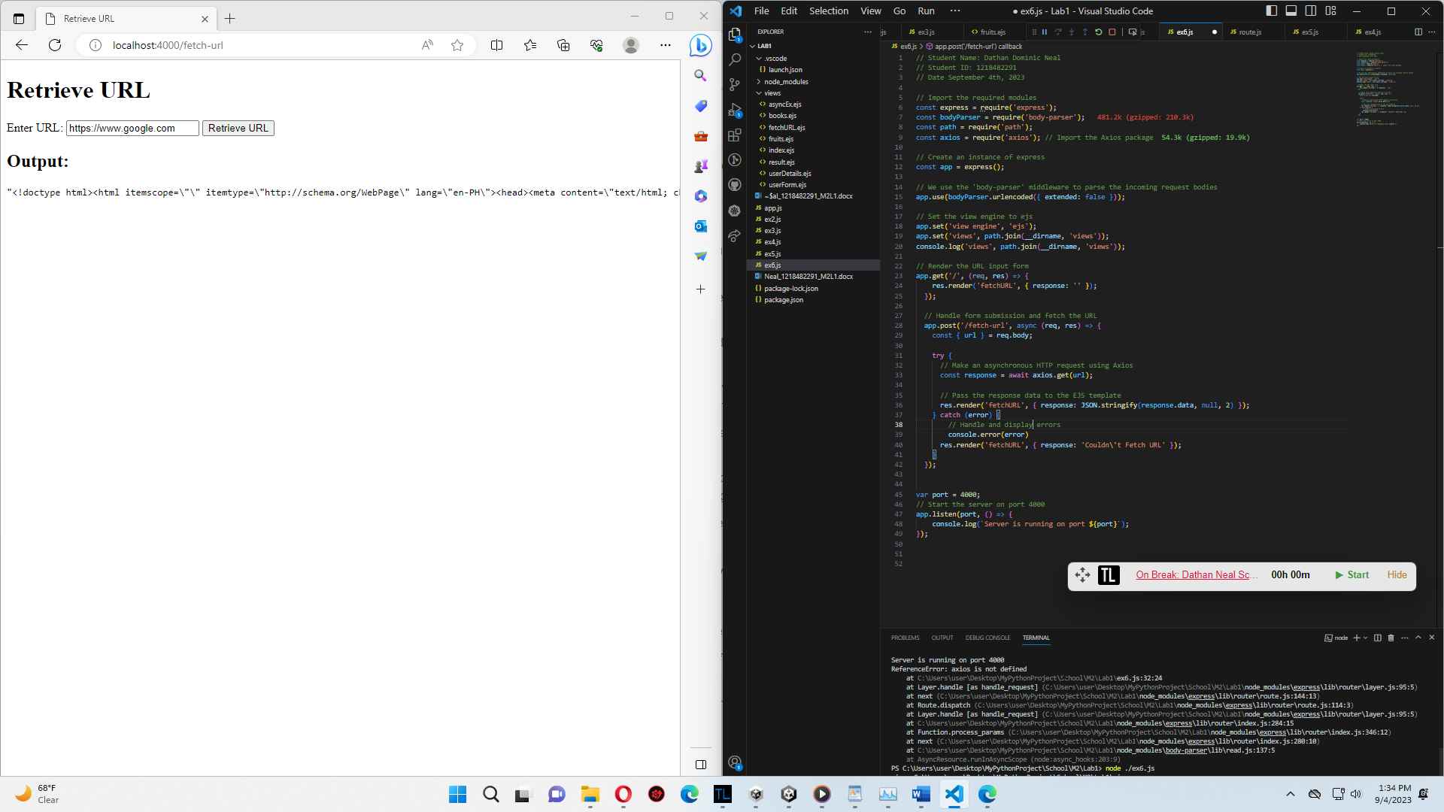

EJS file:

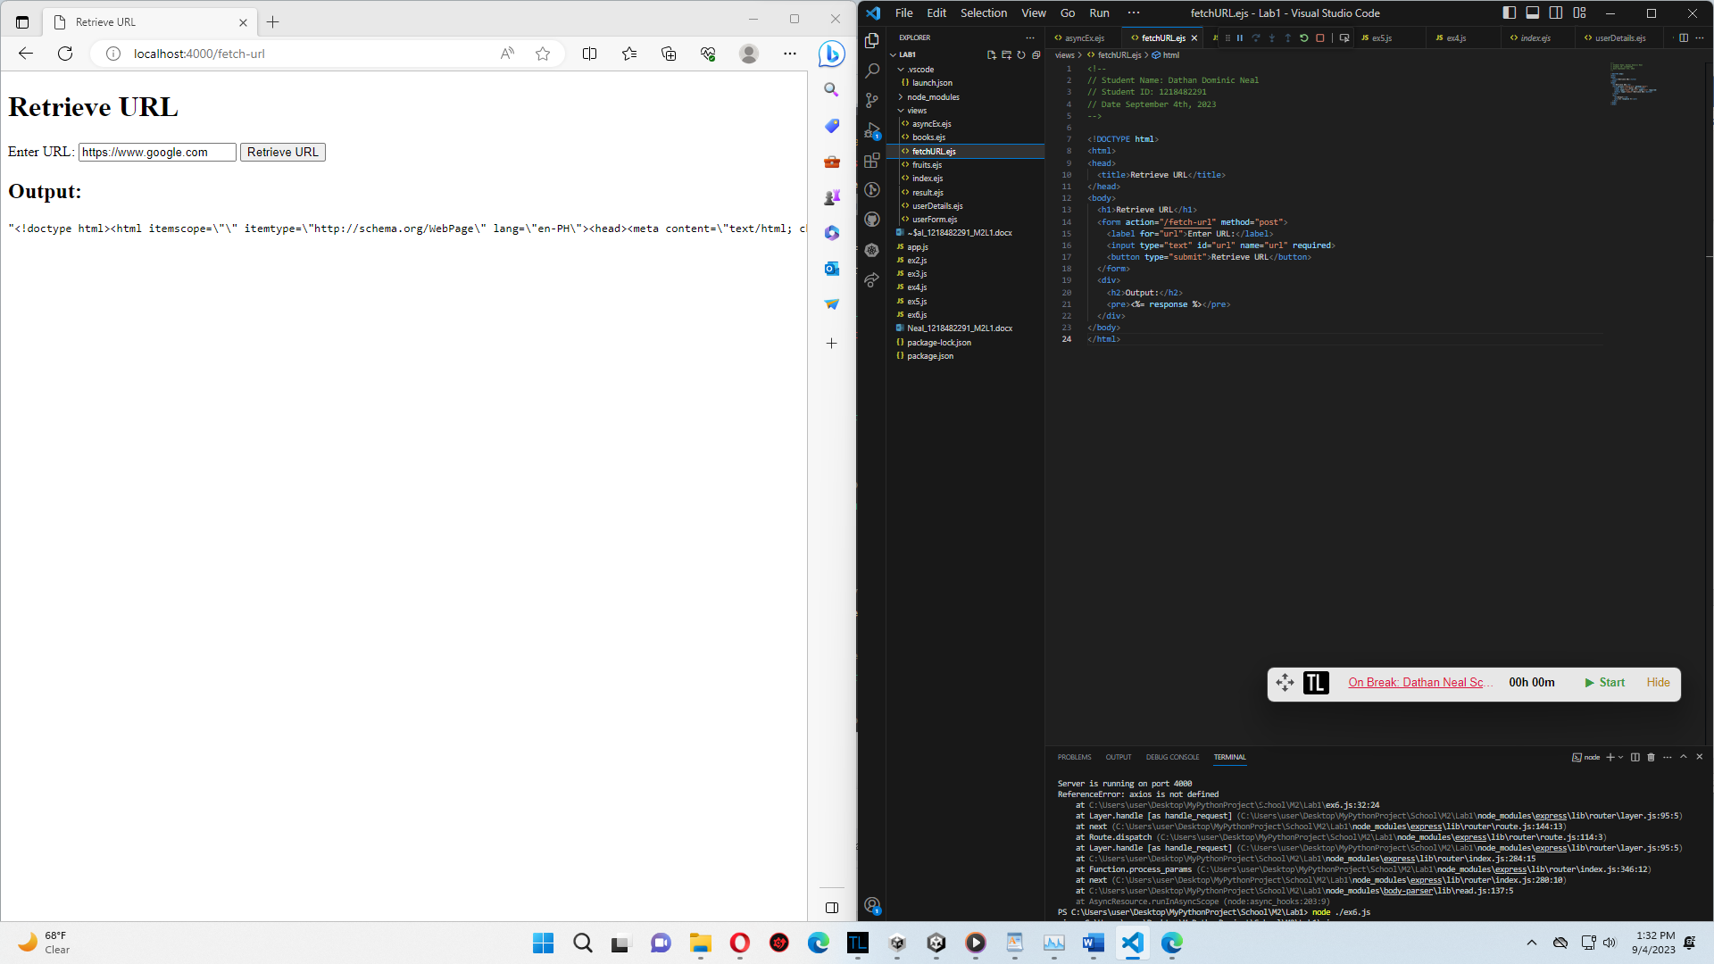

* (The Variables exercise with the calculations was uploaded with assignment 2 of module 1, per the instructions).
* Exercise 2 was relatively straightforward; using an array, I could set up my book list without any issues.
* Exercise 3 I had some difficulty setting up a constructor, but researching and referring back to the lesson material helped me set it up correctly.
* Exercise 4 I found it interesting because I knew nothing about the spread operator despite having some background in coding.
* Exercise 5 was somewhat tricky because I could not figure out how to get my Promise working for the longest time. After researching more about async and await methods and how to properly implement promises, I was able to set it up and display the desired output via an async call.
* Exercise 6 I had problems when it came to displaying the inputted URL information on the page. I figured out that my issue was because I had not initialized the Axios plugin correctly. After initializing it, my code worked immediately.