**Module 3 Activity 5: Data Access**

Dathan Dominic Neal

Arizona State University

IFT 458/554: Middleware Programming & Database Security

Professor Dinesh Sthapit

September 24, 2023

Random number utility code:

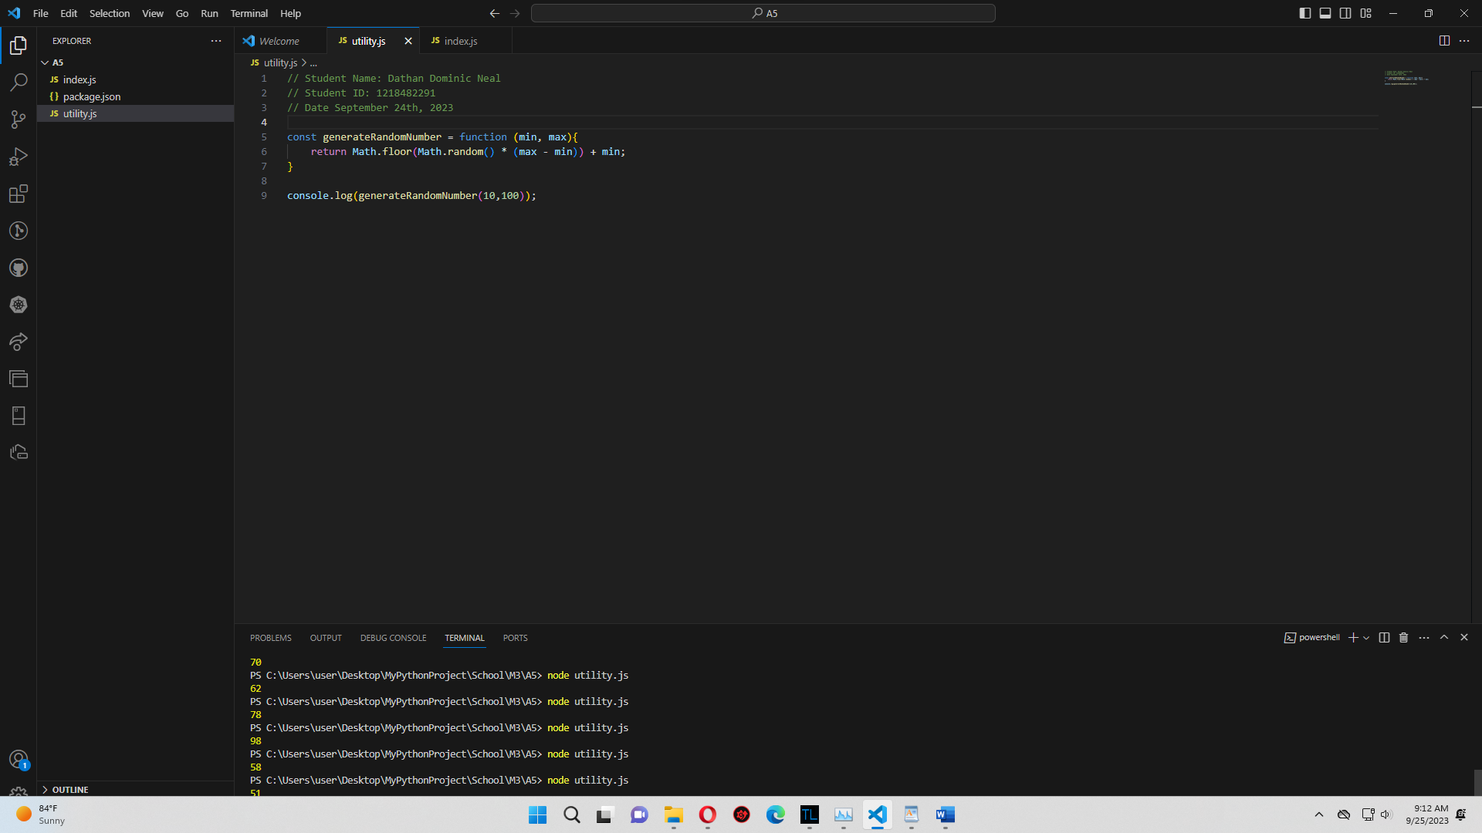

Using export and import:

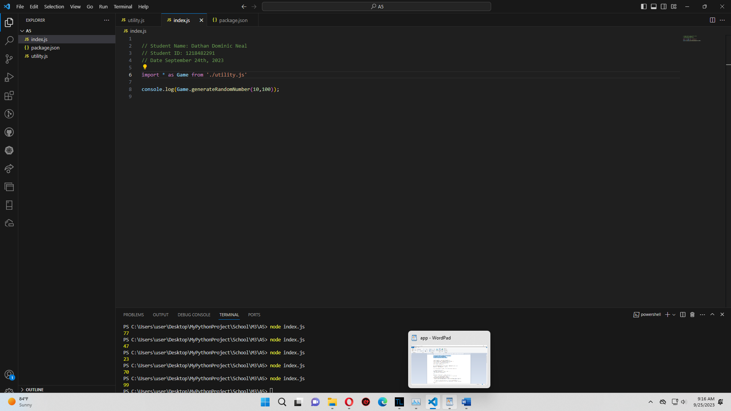

Printing data from JSON object:

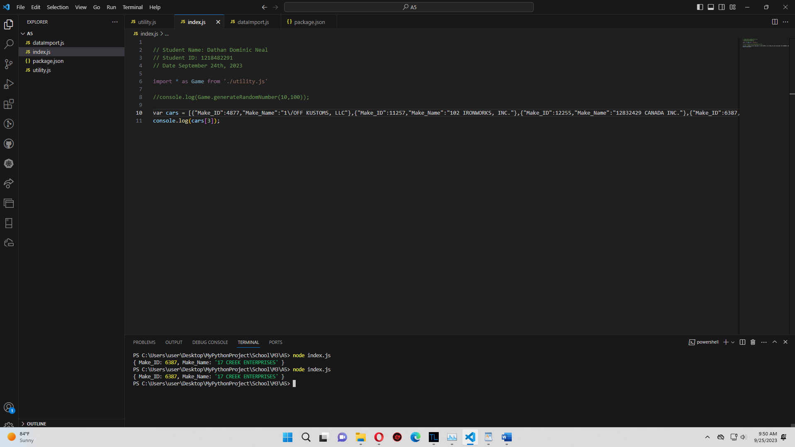

Using fetch to get Star Wars JSON data:

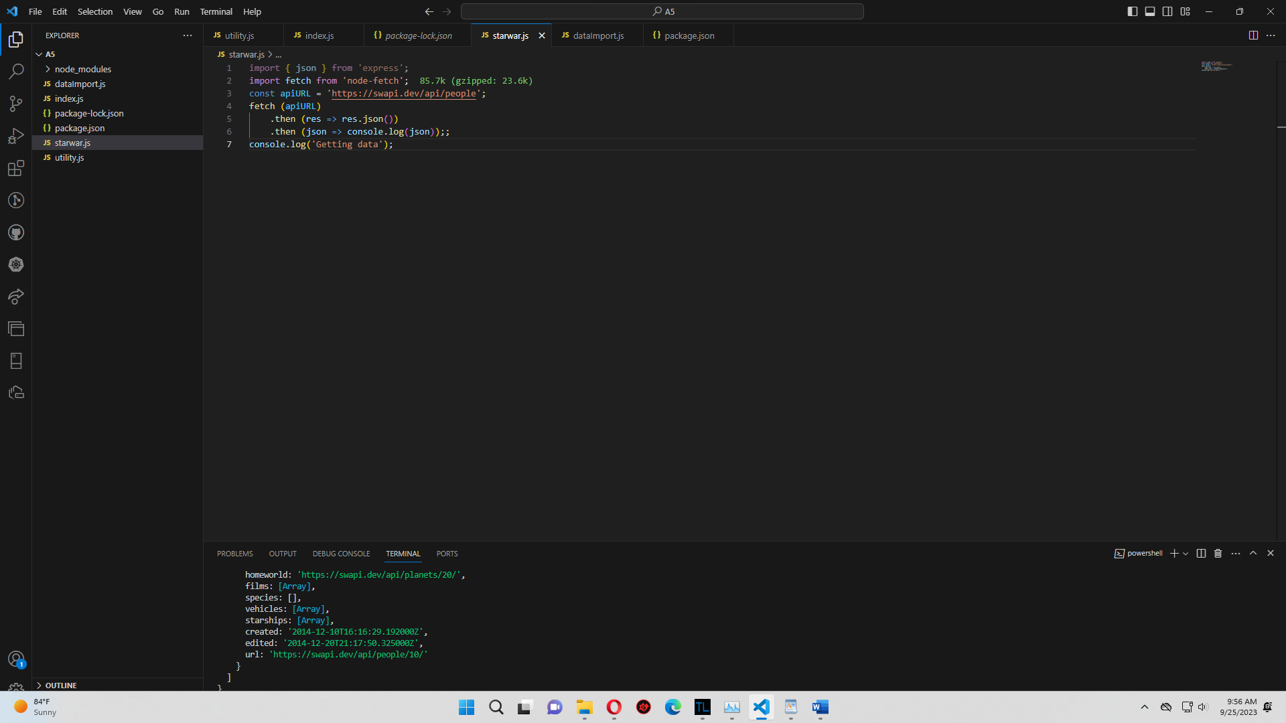

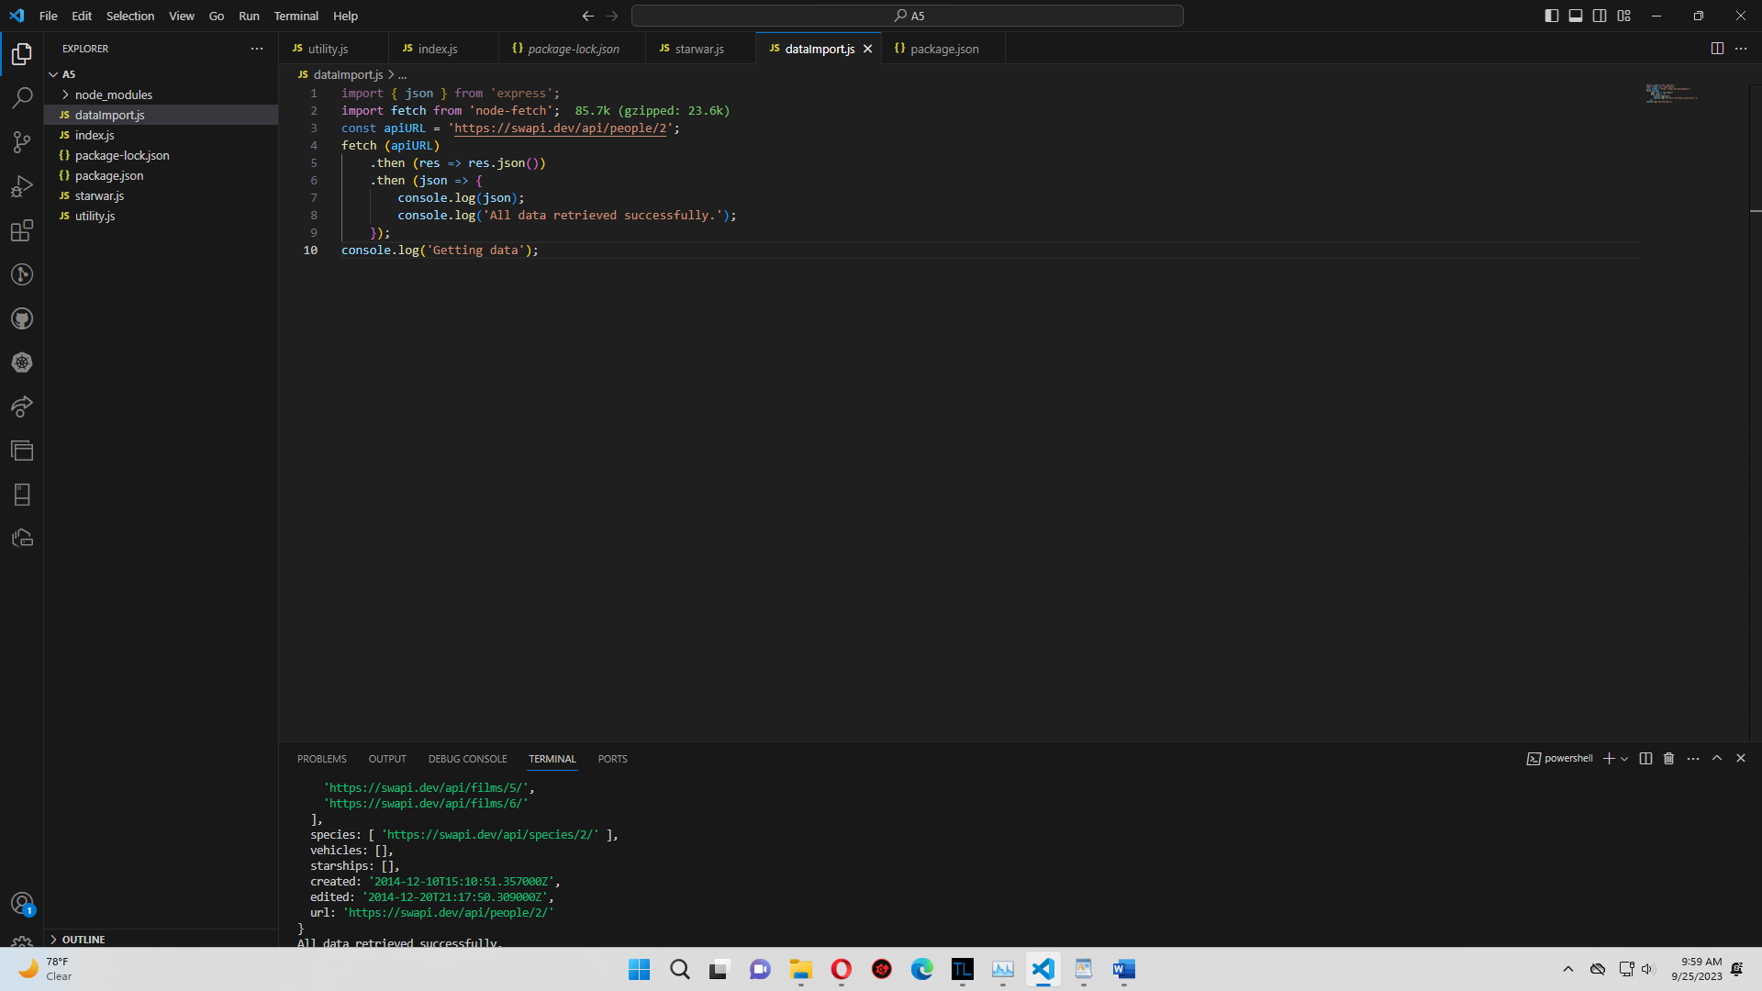

Content Negotiation:

