EXPERIMENT NO:2
PROGRAM

1) EXP 2.1

%{
#include<stdio.h>

int n = 0;
int k = 0,
i = 0,
o = 0,
num = 0;
%}

%%
if|else|while|int|switch|for|char {
printf("%s is a keyword\n", yytext);
k++;
n++;
}

_*[a-z]*[A-Z]+[0-9]*|_*[a-z]+[A-Z]*[0-9]* {
printf("%s is an identifier\n", yytext);
i++;
n++;
}

"="|"+"|"-"|"*"|"/"|"<"|">" {
printf("%s is an operator\n", yytext);
o++;
n++;
}

[0-9]+ {
printf("%s is a number\n", yytext);num++;n++;
}
(.) {}

"\t"|"\n" {exit(0);}
%%

int main() {
printf("Enter the input text: ");
yylex();
return 0;
}

int yywrap() {}

OUTPUT
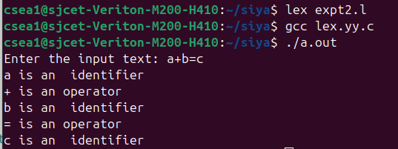

2) EXP 2.2
%{
#include <stdio.h>
#include <ctype.h>

int lines = 0;
int spaces = 0;
int words = 0;
int characters = 0;
int in_word = 0;
%}

%%
\n {
lines++;
characters++;
in_word = 0;
}

[ \t] {
spaces++;
characters++;
in_word = 0;
}

[a-zA-Z0-9_] {
characters++;
if (!in_word) {
words++;
in_word = 1;
}
}

. {
characters++;
}
%%

int main(void) {
yyin = fopen("myfile.txt", "r");
if (!yyin) {
perror("Error opening file");
return 1;
}
yylex();
fclose(yyin);
printf("This file contains:");
printf("\n\t%d lines", lines);
printf("\n\t%d spaces", spaces);
printf("\n\t%d words", words);
printf("\n\t%d characters\n", characters);
return 0;
}

int yywrap() {
return 1;
}

INPUT
myfile.txt
hello world

OUTPUT
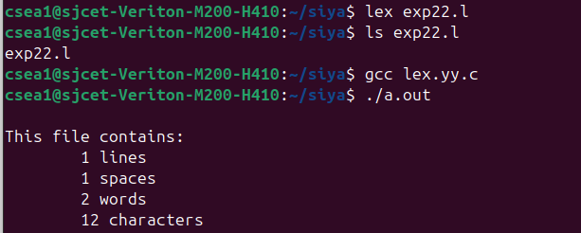

3)EXP 2.3
%{
#include<stdio.h>
#include<ctype.h>
%}

%%
abc {
printf("ABC");
}

. {
putchar(yytext[0]);
}
%%

int main() {
printf("Enter the String: ");
yylex();
printf("\nThe converted text: "); // Added output formatting
return 0;
}

int yywrap() {
return(1);
}

OUTPUT
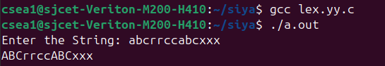

4)EXP2.4
%{
#include <stdio.h>
int v = 0;
int c = 0;
%}

%%
[aeiouAEIOU] {
v++;
}

[a-zA-Z] {
c++;
}
%%

int yywrap() {
return 1;
}

int main() {
printf("Enter the string of vowels and consonants:\n");
yylex();
printf("Number of vowels are: %d\n", v);
printf("Number of consonants are: %d\n", c);
return 0;
}

OUTPUT
