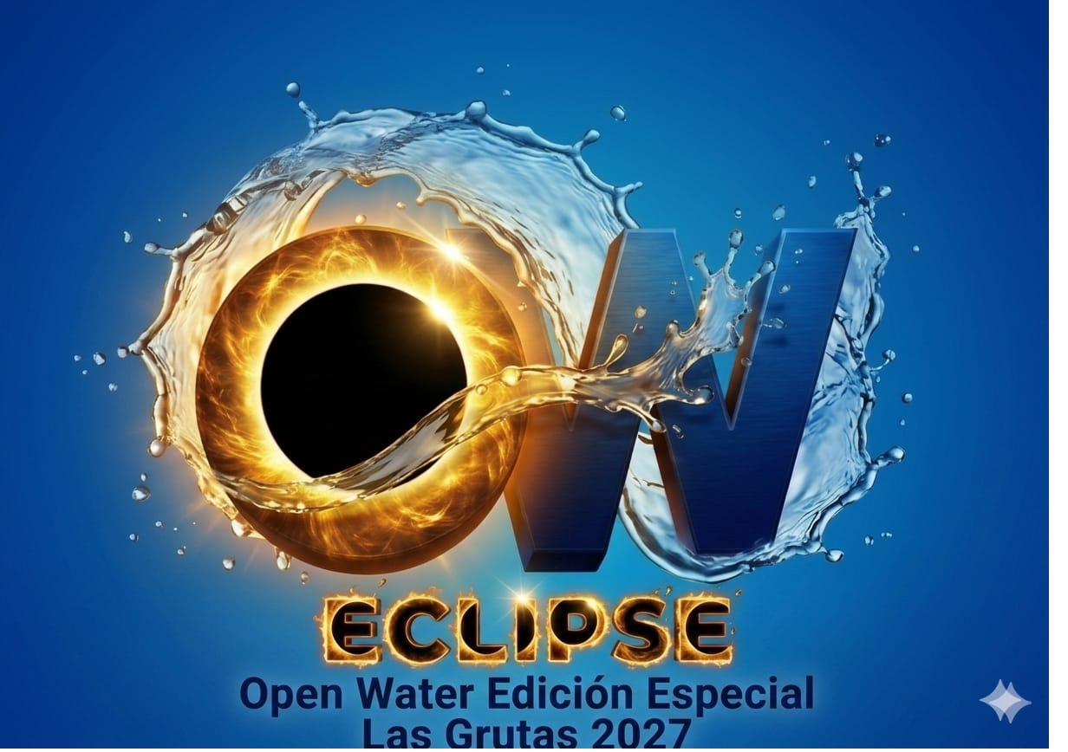

PROJECT SUBMISSION FOR INTERNATIONAL RECOGNITION
OWeclipse 2027
"Swimming Beneath the Eclipse"
Las Grutas · Gulf of San Matías · Patagonia, Argentina · 6 February 2027
PROPOSED GUINNESS WORLD RECORDS TITLE
Most people to complete an open water swim during a solar eclipse — a swimming competition held in the sea, starting at the exact instant of first contact of an annular solar eclipse and concluding before the eclipse reaches its maximum phase, certified in real time by an independent astronomer.

Field | Detail
Submitted by | Asociación Civil Open Water Río Negro
Proposal leads | Lucas Nogues · Juan Facundo Albacete Colombo · Bruno Grun · Lucas Puyen Lema
Event | OWeclipse 2027 — Open Water Special Edition
Date of first attempt | Saturday, 6 February 2027
Start time | 10:31:40 (local) — the exact moment of first contact
Course | 2,500 m marked sea course (measured at 2,508 m)
Astronomical event | Annular Solar Eclipse — 85.97% obscuration, magnitude 0.956
Purpose of document | Formal project in support of the application for a new Guinness World Records title

1. Executive Summary
This document constitutes the formal project submitted by the Asociación Civil Open Water Río Negro in support of its application for the creation and international recognition of a new Guinness World Records title: Most people to complete an open water swim during a solar eclipse.
The proposal is not speculative. It is anchored to a fully planned, funded and institutionally supported sporting event — OWeclipse 2027 — to be staged on Saturday 6 February 2027 at Las Grutas, on the shore of the Gulf of San Matías, in the Argentine province of Río Negro. On that morning, an annular solar eclipse will sweep across the southern cone of South America, and its path will pass directly over the venue. At 10:31:40 local time, at the precise instant the Moon makes first contact with the solar disc as observed from Las Grutas, several hundred swimmers will enter the Atlantic to complete a 2,500-metre marked sea course. They will leave the water before the eclipse reaches its annular phase, and will then witness the "ring of fire" from the shore through certified viewing glasses.
The record sought is a people-based, mass-participation record. It measures neither speed nor distance, but the number of individuals who successfully complete an open water crossing inside a temporal window whose boundaries are fixed not by an organiser, a rulebook or a stopwatch, but by celestial mechanics. It is, in this precise sense, unlike any record currently held in the Guinness World Records archive.

THE CENTRAL CLAIM OF THIS PROJECT
No open water swimming competition has ever been held, under independent international verification, within the temporal window of a solar eclipse. There is no precedent, no antecedent and no comparable attempt. OWeclipse 2027 therefore does not seek to break a record — it seeks to establish one, and to establish it in a form that is repeatable, comparable and beatable anywhere on Earth where the shadow of the Moon meets the sea.

The remainder of this document sets out the case for recognition in full: the criteria the proposed title satisfies (Section 3), the demonstrable absence of any precedent (Section 4), the astronomical basis of the challenge (Section 5), the operational and safety architecture of the event (Sections 6–8), the verification and evidentiary system (Section 9), and — critically — the long-term global framework that makes the title a durable and contestable one rather than a one-off curiosity (Section 10).

2. The Applicant and the Event
2.1 The Organising Body
The Asociación Civil Open Water Río Negro is a civil association constituted under Argentine law for the promotion of open water swimming in the province of Río Negro. It is the organising authority for OWeclipse 2027 and the party that will assume full responsibility before Guinness World Records for compliance with all guidelines, measurement criteria and evidentiary requirements attaching to the proposed title.
Persons responsible for the proposal
- Lucas Nogues
- Juan Facundo Albacete Colombo
- Bruno Grun
- Lucas Puyen Lema
2.2 The Event: OWeclipse 2027
OWeclipse 2027 — Open Water Special Edition — is an open water swimming crossing conceived as a single, indivisible convergence of sport, sea and sky. Its identity, its start time, its course and its safety plan all derive from one immovable fact: the annular solar eclipse of 6 February 2027, which will reach 85.97% obscuration directly above Las Grutas.
The event is designed so that sport and astronomical spectacle complement one another without risk. The swimmers set off exactly as the Moon begins to bite into the Sun, and they are out of the water before the sky reaches its deepest darkening — free, then, to watch the maximum of the eclipse from the beach with their certified glasses. It is, quite literally, swimming beneath the eclipse.

Strategic objectives of the event
- Historic benchmark: to be the first open water swimming competition, under international verification, contested beneath an annular solar eclipse, generating sporting and media resonance on a global scale.
- Tourism promotion: to position Las Grutas and the Gulf of San Matías as a destination of national and international significance for astrotourism and sports tourism.
- Sporting development: to encourage open water swimming through a 2,500-metre sea crossing accessible to experienced amateurs and elite athletes alike.
- Patagonian identity: to consolidate Río Negro as a stage for sporting events of the first rank, uniting the singularity of the Las Grutas sea with a unique celestial phenomenon.

Visual identity of the OWeclipse event — Open Water Special Edition, Las Grutas 2027.

3. Suitability of the Proposed Title
Guinness World Records requires that any new title be clearly defined, objectively measurable, verifiable by independent evidence, standardisable for future attempts, and capable of being broken. The proposed title satisfies each of these criteria without qualification. Each is addressed in turn below.

3.1 Clearly defined. The record counts one thing only: the number of individual swimmers who complete, in their entirety, a defined open water course, having started at the certified instant of first contact of a solar eclipse observed from the venue, and having finished before the onset of the eclipse's maximum phase. A participant either completes the course inside that window or does not. There is no partial credit, no discretionary judgement and no subjective element.
3.2 Objectively measurable. The result is a whole number: the count of valid finishers. Every swimmer is individually registered, uniquely identified, and recorded by an official synchronised timing system at both start and finish. The count is arithmetic, not evaluative.
3.3 Independently verifiable. Two independent verification layers apply. The first is sporting: qualified independent witnesses, continuous high-definition filming from shore, vessels and drones, official chip timing, and complete documentary records. The second is astronomical: an astronomer of Argentina's National Scientific and Technical Research Council (CONICET) will certify, in real time and by direct instrumental observation, the exact instant of first contact from the venue, and will authorise the start on that basis. Neither layer depends on the organisers' own assertion.
3.4 Standardisable. Solar eclipses are among the most precisely predictable events in nature. Their timing, path and magnitude are computed decades in advance to sub-second accuracy. Any future organiser, anywhere in the world, can therefore replicate the conditions exactly: a defined open water course, a start certified at first contact, a finish before maximum. The variables that differ between attempts — venue, water temperature, sea state, course geometry — are precisely the variables that already differ between attempts at every existing open water record, and are governed by the same body of established guidance.
3.5 Capable of being broken. The record is a count of participants. It can be exceeded by any organisation, in any ocean, at any future eclipse, that succeeds in bringing more swimmers safely across a course inside the same astronomically-defined window. The eclipse calendar guarantees a steady supply of future opportunities (see Section 10). The record is therefore not a closed curiosity but the opening entry in a series.

WHAT IS ACTUALLY BEING MEASURED
The record does not measure athletic speed. It measures organisational capacity under an immovable natural deadline. The challenge is to bring the greatest possible number of human beings safely across open sea inside a window that no human being can extend, postpone or negotiate. That is the difficulty, and that is the achievement.

4. The Absence of Precedent
This section addresses the point on which the applicants place the greatest emphasis, and which they submit is decisive: a competition of these characteristics, under these particular conditions, has never taken place.
4.1 What has existed before
Mass-participation open water swims are common and well established. Solar eclipses are observed, filmed, studied and celebrated by millions. Eclipse-adjacent events — festivals, gatherings, viewing parties, running races timed loosely to eclipse day, marathons and cycling events staged in the general vicinity of an eclipse path — have been held. But in every such case, the astronomical event is a backdrop, a marketing frame, or a coincidence of date. It does not govern the competition.
4.2 What has never existed
What has never existed is a sporting competition whose governing clock is the eclipse itself: whose start gun is fired not at a time chosen by a race director, but at the instant an independent astronomer certifies first contact; whose cut-off is not a duration set by regulation, but the arrival of the eclipse's maximum phase; and whose entire validity therefore rests on a temporal window drawn by orbital mechanics.

The four conditions that, in combination, are without precedent
(i) The medium: open water — the sea, not a pool, a lake or a river; an environment governed by tide, swell, current and temperature, in which mass participation carries genuine and irreducible risk.
(ii) The start: the competition begins at the certified instant of first contact of a solar eclipse observed from the venue — a moment determined by the Moon, not by the organisers.
(iii) The cut-off: a swimmer counts towards the record only if the entire course is completed before the eclipse enters its maximum phase. The window is fixed, finite and non-negotiable.
(iv) The verification: the astronomical trigger is certified in real time, on site, by an independent scientific authority (CONICET), and the sporting result by the full apparatus of international record verification.

Any one of these conditions, taken alone, is unremarkable. Their combination has, to the applicants' knowledge and after due search, never been assembled. OWeclipse 2027 will be the first occasion in recorded history on which a mass open water swimming competition is contested inside the temporal window of a solar eclipse under independent international verification.

A FIRST, NOT A VARIATION
The applicants are not proposing a variant of an existing title, nor a novelty subdivision of an established category. They are proposing the recognition of a new class of sporting achievement — one in which the boundary condition of the competition is set by an astronomical event, and in which human organisational capacity is measured against a deadline written by the solar system.
4.3 Why it has not been done before
The reason is structural rather than accidental. To stage such an event, four independently improbable conditions must coincide: an eclipse of sufficient magnitude; a path of annularity or totality that crosses navigable, swimmable coastal water; a coastline with the tidal, thermal and logistical conditions permitting mass open water participation on that specific morning; and an organising body with the technical, institutional and safety capacity to deliver it. At Las Grutas on 6 February 2027, all four conditions coincide.

5. The Astronomical Basis
On 6 February 2027 the band of annularity of the eclipse crosses the south of South America and traverses Argentine Patagonia, passing directly over the region of Las Grutas. There the Moon will cover 85.97% of the solar disc, leaving a brilliant "ring of fire" visible in the sky. It is an event that will not recur in the region for decades.
5.1 Eclipse data at Las Grutas (40°45′S, 64°59′W)
Parameter | Value
Type | Annular Solar Eclipse ("Ring of Fire")
Obscuration | 85.97% of the solar disc
Magnitude | 0.956
First contact (partial begins) | 10:31:39
Annularity begins | 12:05:53
Maximum eclipse | 12:09:40 (≈ 12:10)
Annularity ends | 12:13:26
Partial ends | 13:51:27
Total duration | 3 h 19 m 48 s · Annularity: 7 m 33 s
Mean cloud cover | 27% (historical average for the area)
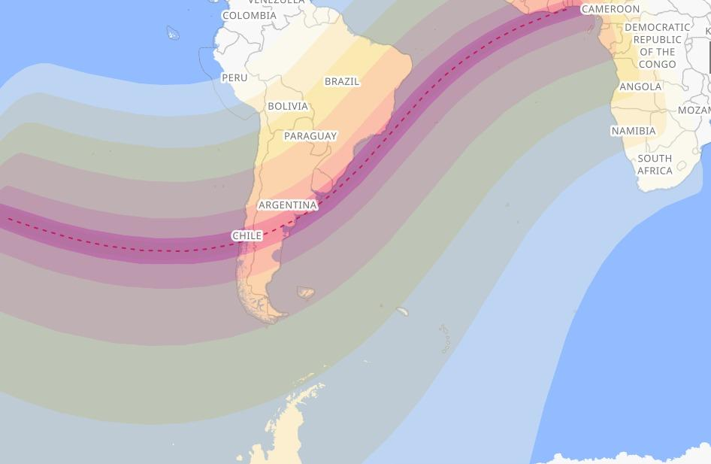
Track of the band of annularity across South America — the central line crosses Argentine Patagonia.
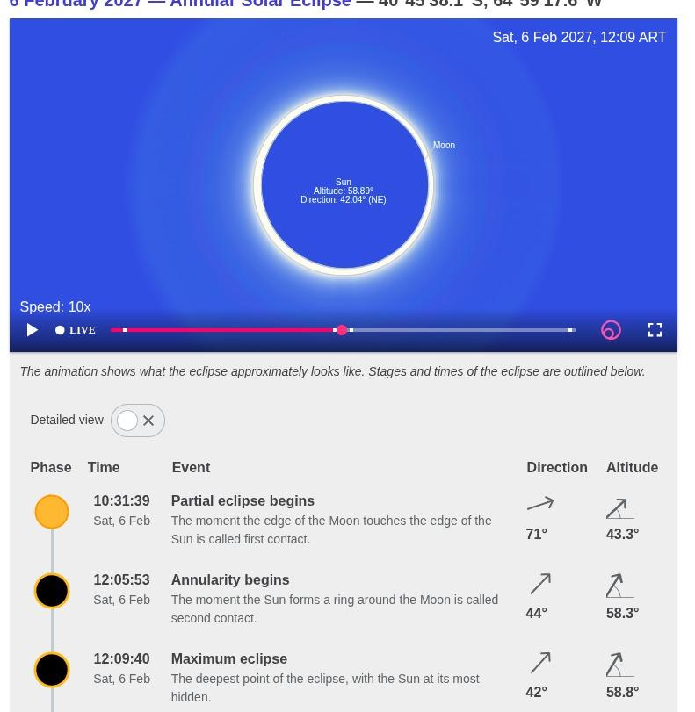
Simulation and phases of the annular eclipse as seen from Las Grutas.
5.2 The precision of the trigger
First contact at Las Grutas occurs at 10:31:39. The competition starts at 10:31:40 — one second later, the first full second of the eclipse. This is not an approximation and not a symbolic gesture. The start time is derived from official data published by international astronomical bodies and will be confirmed, on the morning itself, by direct instrumental observation.
The distinction matters for the integrity of the record. A predicted time is a computation; a certified time is an observation. The record requires the second. The CONICET astronomer acting as independent technical authority will verify the exact instant at which the partial eclipse becomes visible from the site, will officially certify that moment, and only then will authorise the start of the crossing.

6. The Course and the Attempt
6.1 The crossing
The crossing takes place entirely at sea, over a buoyed circuit of 2,500 metres in front of the beach at Las Grutas. The route takes advantage of the morning's rising tide, which assists the swimmers' progress and improves safety conditions. The event is designed to be completed in approximately one hour, with the start at 10:31:40 — at the very onset of the eclipse — and all swimmers out of the water before 11:30.
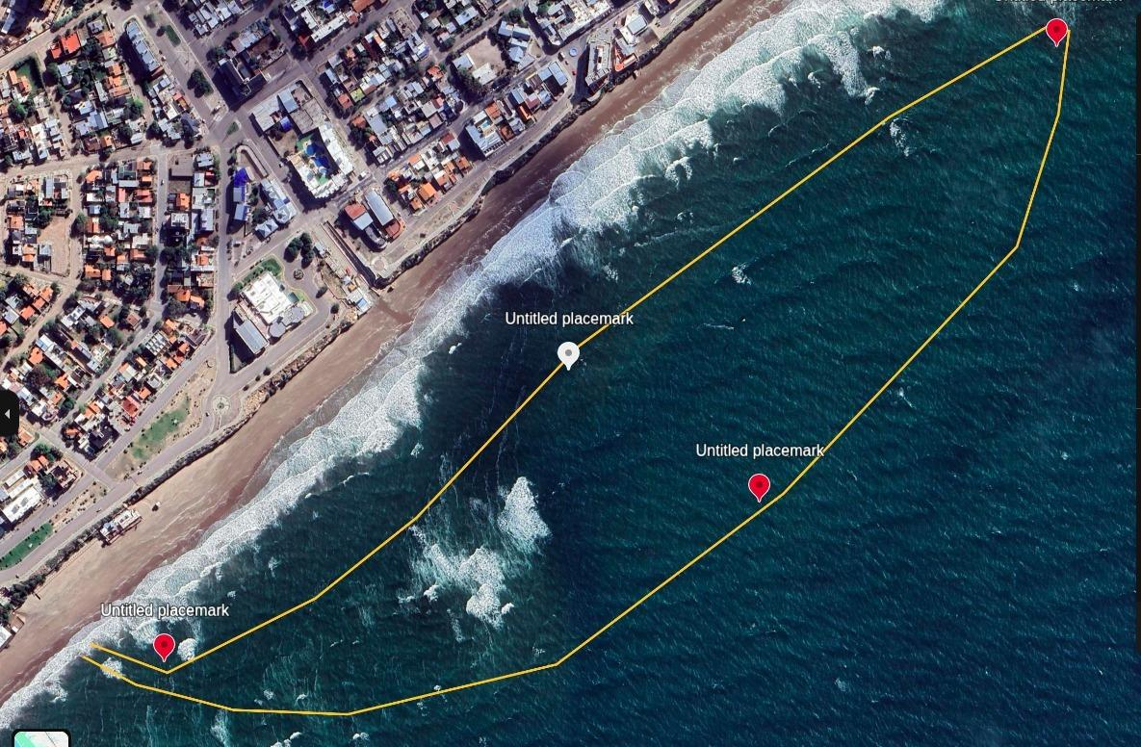
Layout of the swim route along the Las Grutas coast. Total circuit length: 2,508 m.
6.2 Course profile
- Distance: 2,500 metres (circuit measured at 2,508 m).
- Setting: the Argentine Sea — Gulf of San Matías, waters of great clarity and wide tidal range.
- Tidal condition: start on a rising tide; high water occurs at 12:10, coinciding with the maximum of the eclipse.
- Swimmer profile: open water swimmers, triathletes and experienced amateurs accustomed to swell and current.
6.3 Conditions of validity for the record
For a participant to be counted towards the record, all of the following must hold:
(a) Registration and identification. The swimmer must be individually registered before the event and must carry the unique identification assigned by the organisers.
(b) Certified start. The swimmer must begin at the mass start authorised by the independent astronomer at the certified instant of first contact.
(c) Complete course. The swimmer must cover the established course in its entirety, passing every control point, without external propulsion or assistance beyond that permitted by the rules.
(d) Finish inside the window. The swimmer must cross the finish line before the onset of the maximum phase of the eclipse, as recorded by the official synchronised timing system.

The official result of the record will be determined solely by the number of participants who satisfy all four conditions. No other factor — position, time, category or age — bears upon the count.

7. Timeline — Sea and Sky in Concert
The schedule below is the operational heart of the project. Every element of the event is subordinated to it, and it is this schedule that makes the record both possible and safe. The swimmers set off exactly as the eclipse begins; they are out of the water before the sky reaches its greatest darkening; they then watch the maximum from the shore.

Time | Milestone | Detail
10:31:39 | First contact | The Moon makes first contact with the solar disc, as certified on site by the CONICET astronomer.
10:31:40 | Start — "Swimming Beneath the Eclipse" | The competition begins at the exact instant the eclipse commences over Las Grutas. The record window opens.
≈ 11:30 | Close of race (approx.) | Swimmers leave the water and receive their finisher medal, before the maximum of the eclipse. The record window is closed.
12:05:53 | Annularity begins | The "ring of fire" forms in the sky. Swimmers observe from the shore with certified glasses.
12:09:40 | Maximum eclipse + high water | Culminating point: 85.97% of the Sun obscured, and full tide.
12:13:26 | Annularity ends | The ring closes; the partial phase resumes.
13:51:27 | End of the eclipse | The Sun recovers its complete form.

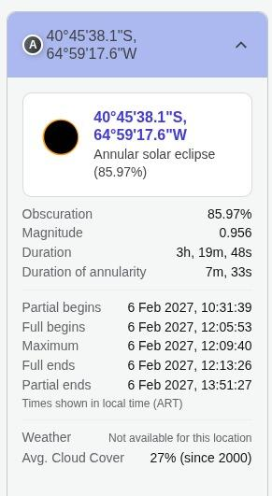
Astronomical summary of the eclipse at Las Grutas.
7.1 Accreditation
Accreditation of participants takes place on Friday 5 February, from 14:00 to 19:00. Individual registration, unique identification and the issue of timing devices are completed at this stage, so that the count of eligible starters is fixed and documented before the morning of the attempt.

8. Safety and Assistance Architecture
Safety in maritime waters is the absolute priority of OWeclipse. The event operates under a specific Operational Safety Plan (Plan de Seguridad Operacional) for sea swimming, with particular attention to tides, swell and visibility conditions during the development of the eclipse.
The applicants draw the attention of Guinness World Records to a point of substance: the safety architecture is not an adjunct to the record attempt but a constitutive part of it. The record measures how many people can be brought safely across open sea inside a fixed astronomical window. A safety failure is therefore not merely an operational failure — it is a failure of the achievement itself.

8.1 Measures in force
- Official lifeguards: the lifeguard corps of the Las Grutas beach, together with personnel of the Argentine Naval Prefecture (Prefectura Naval Argentina).
- Assistance flotilla: fast rescue craft, jet skis and support kayakers deployed along the length of the buoyed circuit.
- Signage and marking: the route marked with high-visibility buoys and reference vessels.
- Medical assistance: ambulance and medical team stationed on the beach, at both start and finish.
- Tidal control: permanent monitoring of the rising tide; exit from the water scheduled before the maximum of the eclipse.
- Post-race services: hydration, healthy lunch, and distribution of certified glasses for safe observation of the eclipse.

8.2 The eclipse and in-water visibility
A specific and, so far as the applicants are aware, entirely novel operational question arises in this event: the progressive reduction of ambient light while several hundred swimmers are at sea. The schedule resolves it. During the record window — from 10:31:40 to approximately 11:30 — the eclipse remains in its early partial phase, and the reduction in illumination is modest. The deep darkening associated with annularity occurs from 12:05 onwards, by which time every swimmer is on the beach. The record window is thus deliberately positioned in the interval in which the astronomical condition is real but the light conditions remain fully safe for mass open water participation.

A NOTE ON THE DESIGN OF THE WINDOW
The choice to close the record window before maximum is not a limitation of the record — it is the record. Bringing every participant across the line before the sky darkens is precisely the organisational feat the title is intended to measure, and is the reason the title can be safely replicated by other organisations at future eclipses.

9. System of Verification and Evidence
The Asociación Civil Open Water Río Negro undertakes to comply in full with any and all guidelines established by Guinness World Records for this attempt. The verification system set out below is offered as the applicants' proposed framework and will be adjusted in whatever manner Guinness World Records may direct.
9.1 Sporting verification
- Individual registration of all participants.
- Unique identification of each swimmer.
- Start and finish control at fixed, monitored points.
- Official synchronised timing, chip-based, referenced to the certified start instant.
- Continuous high-definition filming from the shore, from vessels and by drone.
- Supplementary photographic records.
- Qualified independent witnesses.
- Complete documentation of the event.
- Any further evidence Guinness World Records may deem necessary.
9.2 Astronomical verification — certification of the eclipse
While the start time of the solar eclipse is established beforehand using official data published by international astronomical bodies, the effective commencement of the record attempt will be certified in real time by an astronomer from Argentina's National Scientific and Technical Research Council (CONICET), who will act as an independent technical authority throughout the event.
This professional will verify, by direct observation and with the appropriate scientific instruments, the exact instant at which the partial solar eclipse becomes visible from the site of the event. Once the effective onset of the astronomical phenomenon has been confirmed, the astronomer will officially certify that moment and authorise the start of the swim.
Their technical certification, together with the audiovisual records, the official timing and the remaining documentation of the event, will form part of the evidence submitted to Guinness World Records to attest that the attempt began precisely with the onset of the solar eclipse as observed from the venue.

9.3 The evidence chain
Stage | Evidence produced | Independent party
Accreditation (5 Feb) | Register of participants; unique IDs; timing devices issued | Event notary / independent witnesses
First contact (10:31:39) | Instrumental observation record; signed certification of the instant | CONICET astronomer
Start (10:31:40) | Synchronised timing start; video from shore, vessels and drones | Timing provider; independent witnesses
Course | Continuous filming; control-point records; safety flotilla logs | Prefectura Naval; independent witnesses
Finish (before max.) | Chip finish times for every valid finisher; finish-line video | Timing provider; independent witnesses
Compilation | Final count of valid finishers; complete evidence dossier | Submitted to Guinness World Records

10. Beyond 2027 — A Repeatable Global Title
The applicants wish to make clear that they are not seeking a commemorative entry attaching to a single event in a single country. They are seeking a title that will outlive the event that inaugurates it.
10.1 Predictability as the foundation of comparability
Solar eclipses are astronomical phenomena of perfect predictability, recurring at intervals in different regions of the planet, and computed decades ahead with a precision unmatched by any other natural event that could serve as a boundary condition for a sporting record. This is what makes the proposed title standardisable in a way that records dependent on weather, tide alone, or seasonal conditions can never be.
Every future organiser knows, today, exactly when and where the next opportunities will fall. The eclipse calendar is, in effect, the fixture list of this record.

10.2 The structure of a future series
Because the trigger is astronomical rather than local, the record can be contested wherever the shadow of the Moon crosses swimmable coastal water. The applicants anticipate, and actively wish to encourage, a succession of attempts by other organisations in other countries, each seeking to bring a greater number of swimmers safely across a course inside the same astronomically-defined window.

Element | Fixed by the title | Free to the organiser
Start | Certified instant of first contact at the venue | —
Cut-off | Before the onset of the maximum phase | —
Count | Number of swimmers completing the full course | —
Medium | Open water (sea, or comparable open water body) | Choice of venue and coastline
Course | Defined, measured, marked, with control points | Length and geometry, per local safety
Verification | Independent astronomical certification + GWR evidence | Choice of qualified certifying body

This structure is deliberate. The elements that must be identical between attempts, in order that the counts be comparable, are fixed by the title. The elements that must vary, in order that the record be safely attemptable in different seas and climates, are left to the organiser under the same body of open water guidance that already governs mass-participation swimming worldwide.

THE AMBITION
That every future solar eclipse whose path crosses navigable coastal water becomes an opportunity — for a swimming federation, a coastal town, a scientific institution — to bring their community into the sea beneath a darkening sky, and to be counted. Las Grutas 2027 is intended to be the first entry in a long ledger, not the only one.
10.3 Value beyond sport
The title further carries considerable value for scientific outreach and education. It promotes a sporting event intimately bound to an astronomical phenomenon of international significance, and fosters a genuine meeting of science, sport, tourism and community. Each participant receives certified viewing glasses; each is briefed on the phenomenon; each leaves the beach having experienced an eclipse not as a distant spectacle but as the governing condition of their own physical effort. Few sporting formats carry so direct an educational dividend.

11. Institutional Support and Partnership
OWeclipse 2027 enjoys the backing of public institutions and leading companies of the region, which accompany an event of international projection combining sport, astrotourism and the promotion of Patagonia. The authorities and government bodies of the province are further called upon to join the project in the following areas:
- Safety and traffic: coordination with the Naval Prefecture, lifeguard services and local security forces.
- Health logistics: provision of medical personnel and ambulances on the beach.
- Official dissemination: inclusion of the event in the official calendars of tourism, sport and astrotourism.

11.1 Prizes, categories and the swimmer's kit
The competitive structure of the event is set out below. It is recorded here for completeness; it does not bear upon the record count, which is a simple tally of valid finishers.
Category | Division | Prizes | Recognition
Elite | Women and Men | Trophies + cash prizes (to be confirmed) | Finisher medal for all who complete
Amateur | Women and Men | Trophies for the first three | Finisher medal + eclipse glasses

OWE swimmer's kit
- Official OWeclipse event shirt.
- Certified glasses for safe observation of the eclipse.
- Finisher medal for all who complete the crossing.

12. The Request
We respectfully request that Guinness World Records assess this project and determine whether the proposed title — Most people to complete an open water swim during a solar eclipse — meets the conditions necessary to be incorporated as a new official title, recognised internationally and open to attempt by organisations anywhere in the world.
Should it be deemed suitable, we should be grateful to receive the specific guidelines, measurement criteria, evidence requirements and any other rules necessary to organise the attempt of 6 February 2027 in accordance with the standards established by your organisation. The applicants undertake, without reservation, to adapt every aspect of the event — course, timing, verification, documentation — to whatever form Guinness World Records may specify.

IN SUMMARY
A competition of these characteristics, under these conditions, has never been held. The conditions are not arbitrary: they are astronomical, and therefore precise, predictable and reproducible. What is asked is not the recognition of a single morning in Patagonia, but the creation of a category in which that morning is merely the first entry — and in which every future eclipse that crosses the sea becomes an invitation to the world's swimmers to be counted.

We thank you sincerely for the time devoted to considering this project and remain at your disposal to provide any further information, documentation or clarification that may be required.

Lucas Puyen Lema
Juan Facundo Albacete Colombo
Bruno Grun
Lucas Nogues
On behalf of the Asociación Civil Open Water Río Negro
Río Negro – Argentine Republic
Email: _______________________
Contact telephone: _______________________

