THE UNIVERSITY OF BAMENDA


DEPARTMENT
COMPUTER ENGINEERING
NATIONAL HIGHER POYTECHNIC INSTITUTE

IMPLEMENTATION STRATEGIES FOR DEFENDING AGAINST EVASION ATTACK IN ADVERSARIAL MACHINE LEARNING

A Master thesis Submitted to the Department of Computer Engineering in the National Higher Polytechnic Institute of the University of Bamenda in Partial Fulfillment of the Requirements of the Award of a Master of Engineering Degree in computer engineering

BY:
DONFACK NGOUFACK ELVIS ROCHENEL
REGISTRATION NUMBER: UBa25EP194

SUPERVISOR(S):
Dr. Nsangou Mouchili Dr. Ateh Kevin
(PhD) (PhD)

June, 2026

© Copyright by DONFACK NGOUFACK ELVIS ROCHENEL, 2026
All rights reserved

DECLARATION OF ORIGINALITY OF STUDY

I, MALWARE DONFACK NGOUFACK ELVIS ROCHENEL, Registration Number: UBa25EP194, in the Department of Computer Engineering, National Higher Polytechnic Institute, The University of Bamenda hereby declare that this work titled "Implementation Strategies for Defending Against Evasion Attacks in Adversarial Machine Learning on IoMT Data" is my original work. It has not been presented in any application for a degree or any academic pursuit elsewhere. I have acknowledged all borrowed ideas nationally and internationally through citations.

Date: _______________ Signature of author: _______________

ACCEPTANCE OF DISSERTATION

Having met the stipulated requirements, this dissertation entitled "Implementation Strategies for Defending Against Evasion Attacks in Adversarial Machine Learning on IoMT Data" has been accepted by the Postgraduate School of The University of Bamenda in partial fulfillment of the requirements for the award of a Master of Engineering (MEng) Degree in Computer Engineering (Option: Software Engineering).

Chairperson, Master's Dissertation Committee:
________________________________________
Prof.

Date: _______________

ABSTRACT

The rapid proliferation of Internet of Medical Things (IoMT) devices in healthcare has created an urgent need for robust machine learning models capable of detecting cyber threats while resisting adversarial manipulation. This study addresses the vulnerability of machine learning classifiers to evasion attacks, where adversaries deliberately craft small perturbations to input data to cause misclassification. The research implements and evaluates four defense strategies—adversarial training, feature selection, ensemble methods, and feature squeezing—against two prominent evasion attacks, namely the Fast Gradient Sign Method (FGSM) and Projected Gradient Descent (PGD), on the CIC_IoMT_2024 dataset. Three base classifiers were employed: Random Forest, XGBoost, and LightGBM.
Experimental results demonstrate that XGBoost achieved the highest clean accuracy of 93.70% and F1 score of 93.63%, while LightGBM exhibited the lowest performance at 57.27% accuracy. Without defense, model accuracy on FGSM-attacked data at epsilon = 0.01 dropped from 93.70% to 18.28%, confirming the severe impact of evasion attacks. Among the defenses evaluated, adversarial training (applied to Random Forest) provided the most balanced robustness, maintaining clean accuracy of 65.69% and robust accuracy up to 36.53% under FGSM at epsilon = 0.1. Feature selection alone was insufficient, reducing accuracy to 16.34% even on clean data due to excessive feature removal. The ensemble defense preserved the highest clean accuracy (84.95%) but degraded rapidly under attack (8.38% at epsilon = 0.01).
These findings underscore the critical importance of selecting appropriate defense mechanisms for IoMT security applications and provide a quantitative framework for evaluating defense strategies against adversarial threats in healthcare environments.
Keywords: Adversarial Machine Learning, Evasion Attacks, IoMT Security, Defense Strategies, FGSM, PGD, Random Forest, XGBoost, LightGBM

RÉSUMÉ

La prolifération rapide des dispositifs Internet des Objets Médicaux (IoMT) dans le domaine de la santé a créé un besoin urgent de modèles d'apprentissage automatique robustes capables de détecter les cybermenaces tout en résistant à la manipulation adversarial. Cette étude aborde la vulnérabilité des classifieurs d'apprentissage automatique aux attaques par évasion, où les adversaires créent délibérément de petites perturbations dans les données d'entrée pour provoquer une mauvaise classification. La recherche implémente et évalue quatre stratégies de défense—l'entraînement adversarial, la sélection de caractéristiques, les méthodes d'ensemble, et la compression des caractéristiques—contre deux attaques par évasion importantes, à savoir la Méthode du Signe du Gradient Rapide (FGSM) et la Descente de Gradient Projetée (PGD), sur l'ensemble de données CIC_IoMT_2024.
Les résultats expérimentaux démontrent que XGBoost a atteint la précision propre la plus élevée de 93.70% et un score F1 de 93.63%, tandis que LightGBM a présenté la performance la plus faible avec une précision de 57.27%. Sans défense, la précision du modèle sur les données attaquées par FGSM à epsilon = 0.01 est passée de 93.70% à 18.28%, confirmant l'impact sévère des attaques par évasion.
Mots-clés: Apprentissage Automatique Adversarial, Attaques par Évasion, Sécurité IoMT, Stratégies de Défense, FGSM, PGD, Forêt Aléatoire, XGBoost, LightGBM

DEDICATION

To my family, for their unwavering support, patience, and encouragement throughout this academic journey. Their sacrifices and belief in my abilities have been the foundation upon which this work was built. To my parents, whose dedication to education inspired me to pursue knowledge relentlessly. To my siblings, for their constant motivation and understanding during the long hours of research and writing. This thesis is dedicated to all who believe that knowledge is the most powerful tool for transforming society.

ACKNOWLEDGMENT

I wish to express my profound gratitude to my supervisor, Dr. XXXXXX XXXXXXXX, for his invaluable guidance, patience, and constructive criticism throughout this research. His expertise and mentorship have been instrumental in shaping this work from its early conception to its final form. His dedication to academic excellence, rigorous standards, and willingness to provide detailed feedback on every chapter have significantly improved the quality of this dissertation.
I am equally grateful to my co-supervisor, Engr. XXXXXX XXXXXXXX, for his technical insights, continuous support, and practical advice on the implementation aspects of this project. His knowledge of software engineering and machine learning systems helped bridge the gap between theoretical concepts and practical deployment. His encouragement during challenging phases of the research was invaluable.
My sincere appreciation goes to the Head of Department of Computer Engineering, all the lecturers, and the administrative staff who imparted knowledge and skills that contributed to the successful completion of this dissertation. The rigorous academic environment at the National Higher Polytechnic Institute has prepared me well for this undertaking. I am particularly grateful to all those who served on my dissertation committee for their time and constructive feedback.
I also acknowledge the support of my classmates and friends, whose encouragement, collaboration, and stimulating discussions made this journey memorable and enriching. The late-night study sessions, peer reviews, and shared meals created a supportive community without which this work would not have been possible.
Finally, and most importantly, I thank the Almighty God for His grace, strength, and wisdom throughout this academic pursuit. Without His guidance, none of this would have been possible.

TABLE OF CONTENTS
DECLARATION OF ORIGINALITY OF STUDY iii
ACCEPTANCE OF DISSERTATION iv
ABSTRACT v
RESUME vi
DEDICATION vii
ACKNOWLEDGMENT viii
TABLE OF CONTENTS ix
LIST OF TABLES xii
LIST OF FIGURES xiii
LIST OF ABBREVIATIONS xiv

CHAPTER 1: INTRODUCTION 1
1.1 Background and Statement of the Problem 1
1.2 Rationale 4
1.3 Research Questions 5
1.3.1 Main Research Question 5
1.3.2 Specific Research Questions 6
1.4 Objectives 7
1.4.1 Overall Objective 7
1.4.2 Specific Objectives 7
1.5 Scope and Delimitations 8
1.6 Structure of the Dissertation 9

CHAPTER 2: LITERATURE REVIEW 10
2.1 Overview of Adversarial Machine Learning 10
2.2 Evasion Attacks 13
2.2.1 Fast Gradient Sign Method (FGSM) 14
2.2.2 Projected Gradient Descent (PGD) 15
2.2.3 Comparison of FGSM and PGD 16
2.3 Defense Strategies 17
2.3.1 Adversarial Training 17
2.3.2 Feature Selection Defense 18
2.3.3 Ensemble Defense 19
2.3.4 Feature Squeezing 20
2.4 Evaluation Metrics in Adversarial ML 21
2.5 Related Work on Tabular Adversarial Defenses 22
2.6 Research Gap and Contribution 24

CHAPTER 3: MATERIALS AND METHODS 26
3.1 Dataset Description and Preprocessing 26
3.1.1 CIC_IoMT_2024 Dataset 26
3.1.2 Data Loading Pipeline 28
3.1.3 Data Cleaning and Transformation 29
3.1.4 Split Strategy 30
3.1.5 Scaling and Encoding 31
3.2 Model Training and Evaluation 32
3.2.1 Random Forest (RF) 32
3.2.2 XGBoost 33
3.2.3 LightGBM 34
3.2.4 Training Procedure and Hyperparameters 35
3.3 Evasion Attack Implementation 36
3.3.1 FGSM Adaptation for Tree-based Models 36
3.3.2 PGD Adaptation for Tree-based Models 38
3.3.3 Attack Evaluation Protocol 39
3.4 Defense Implementation 40
3.4.1 Adversarial Training 40
3.4.2 Feature Selection Defense 42
3.4.3 Ensemble Defense 43
3.4.4 Feature Squeezing 44
3.5 System Implementation 45
3.5.1 Interactive Dashboard (Streamlit) 45
3.5.2 REST API and WebSocket Server 47
3.5.3 Real-Time Inference Engine 48
3.5.4 Authentication and Security Architecture 49
3.6 Experimental Framework 50
3.6.1 Hardware and Software Configuration 50
3.6.2 Software Libraries 51
3.6.3 Experimental Protocol 52

CHAPTER 4: RESULTS AND DISCUSSION 54
4.1 Experimental Results 54
4.1.1 Clean Performance of Base Classifiers 54
4.1.2 Impact of FGSM Evasion Attacks 57
4.1.3 Impact of PGD Evasion Attacks 59
4.1.4 Defense Effectiveness under FGSM 61
4.1.5 Defense Effectiveness under PGD 64
4.2 Discussion 66
4.2.1 Model Selection for IoMT Security 66
4.2.2 Vulnerability of Tree-based Models 67
4.2.3 Defense Trade-offs and Practical Implications 69
4.2.4 Regulatory and Compliance Implications 71
4.3 Limitations of the Study 72

CHAPTER 5: CONCLUSIONS AND RECOMMENDATIONS 74
5.1 Summary of Findings 74
5.2 Conclusions 75
5.2.1 Data Pipeline Implementation 75
5.2.2 Model Performance on Clean Data 75
5.2.3 Attack Vulnerability 76
5.2.4 Defense Effectiveness 76
5.2.5 General Conclusion 77
5.3 Recommendations 78
5.3.1 For Practitioners and System Architects 78
5.3.2 For Future Research 79

REFERENCES 81

APPENDIX A: SOURCE CODE LISTINGS 85
A.1 Data Loader Module (loader.py) 85
A.2 FGSM Attack Implementation (fgsm.py) 86
A.3 Adversarial Training (adversarial_training.py) 86
A.4 Ensemble Defense (ensemble.py) 87
A.5 Model Trainer (trainer.py) 87
A.6 Evaluation Metrics (metrics.py) 88
A.7 Feature Squeezing (feature_squeezing.py) 88
A.8 SHAP Explainability Module (explainer.py) 89
A.9 Streamlit Dashboard Key Sections (streamlit_app.py) 89
A.10 PGD Attack Implementation (pgd.py) 90
APPENDIX B: ADDITIONAL EXPERIMENTAL RESULTS 92
B.1 Confusion Matrix for XGBoost (Clean Data) 92
B.2 Attack Success Rate Comparison 92
B.3 Per-Class Performance Analysis for Random Forest 93
B.4 Per-Class Performance Analysis for LightGBM 93
B.5 Training Time and Inference Latency 94
B.6 Robustness Comparison Plots 94

APPENDIX C: DASHBOARD SCREENSHOTS 95
C.1 Feature Squeezing Defense Results 96

APPENDIX D: DEPLOYMENT CONFIGURATION 98
D.1 Dockerfile 98
D.2 Docker Compose 99
D.3 Requirements 99

APPENDIX E: STATISTICAL ANALYSIS 100
E.1 Confidence Intervals for Accuracy Measurements 100
E.2 Central Limit Theorem Justification 101

LIST OF TABLES
Table 3.1: Model hyperparameters used in experiments 35
Table 4.1: Clean performance of base classifiers on CIC_IoMT_2024 test set 54
Table 4.2: Classifier accuracy under FGSM attack at varying epsilon values 57
Table 4.3: Classifier accuracy under PGD attack at varying epsilon values 60
Table 4.4: Accuracy of defense strategies under FGSM attack 61
Table 4.5: Accuracy of defense strategies under PGD attack 64
Table A1: XGBoost confusion metrics (top 10 classes by false negatives) 92
Table B1: Statistical significance tests for defense comparisons 93
Table B2: Random Forest per-class metrics on clean test data 93
Table B3: LightGBM per-class metrics on clean test data 94
Table B4: Training time and inference latency comparison 94
Table D1: Feature squeezing accuracy under FGSM attack 97
Table E1: 95% confidence intervals for accuracy measurements 100

LIST OF FIGURES
Figure 3.1: Correlation heatmap of features in the CIC_IoMT_2024 dataset 27
Figure 3.2: Dashboard view showing trained model metrics 46
Figure 3.3: Dashboard showing attack parameters and results 47
Figure 3.4: Interactive dashboard showing the experimental workflow 55
Figure 4.1: Comparison of clean performance metrics across models 58
Figure 4.2: Robustness curves showing accuracy vs. epsilon for undefended models under FGSM attack 62
Figure 4.3: Defense comparison under FGSM attack 65
Figure 8: Robustness comparison under FGSM attack (all defenses) 95
Figure 9: Robustness comparison under PGD attack (all defenses) 95
Figure 10: Interactive dashboard – main view showing dataset overview and pipeline audit 95
Figure 11: Best algorithm banner showing Accuracy, Precision, Recall, and F1 scores 96
Figure 12: Defense comparison view showing defended vs undefended metrics 96
Figure 13: SHAP feature importance explanation plots for model interpretability 97
Figure 16: Live inference demo interface with real-time streaming predictions 97
Figure 19: Feature squeezing defense accuracy comparison 98
LIST OF ABBREVIATIONS

AML Adversarial Machine Learning
API Application Programming Interface
ASR Attack Success Rate
BIM Basic Iterative Method
CIC Canadian Institute for Cybersecurity
CLT Central Limit Theorem
CNN Convolutional Neural Network
CSV Comma-Separated Values
CW Carlini–Wagner Attack
DDoS Distributed Denial of Service
EFB Exclusive Feature Bundling
FGSM Fast Gradient Sign Method
FN False Negative
FP False Positive
GAN Generative Adversarial Network
GB Gigabyte
GDPR General Data Protection Regulation
GOSS Gradient-based One-Side Sampling
HIPAA Health Insurance Portability and Accountability Act
HITECH Health Information Technology for Economic and Clinical Health Act
HTTP Hypertext Transfer Protocol
HTTPS HTTP Secure
IDS Intrusion Detection System
IoMT Internet of Medical Things
IP Internet Protocol
JSON JavaScript Object Notation
JSMA Jacobian-based Saliency Map Attack
JWT JSON Web Token
LGBM Light Gradient Boosting Machine
LHS Left-Hand Side
MB Megabyte
MIM Momentum Iterative Method
ML Machine Learning
MLP Multi-Layer Perceptron
NSL-KDD Network Security Laboratory – Knowledge Discovery and Data Mining
PGD Projected Gradient Descent
RAM Random Access Memory
REST Representational State Transfer
RF Random Forest
RHS Right-Hand Side
ROC-AUC Receiver Operating Characteristic – Area Under the Curve
SHAP SHapley Additive exPlanations
SSH Secure Shell
TN True Negative
TP True Positive
URL Uniform Resource Locator
WS WebSocket
XGB XGBoost / Extreme Gradient Boosting

CHAPTER 1: INTRODUCTION

1.1 Background and Statement of the Problem
The rapid digitisation of healthcare systems has led to the widespread adoption of Internet of Medical Things (IoMT) devices, including smart sensors, wearable monitors, and connected diagnostic equipment. These devices generate vast quantities of sensitive medical data that must be processed and analysed in real time to support clinical decision-making. Machine learning (ML) models have become indispensable tools for analysing IoMT data, enabling applications such as intrusion detection, anomaly detection, and predictive diagnosis (Goodfellow et al., 2015).
The global IoMT market was valued at approximately $142 billion in 2023 and is projected to reach $408 billion by 2030, driven by the increasing adoption of telemedicine, remote patient monitoring, and smart hospital infrastructure (Grand View Research, 2023). This rapid expansion has dramatically increased the attack surface available to malicious actors. Unlike traditional IT networks, healthcare networks contain a heterogeneous mix of legacy medical devices, modern IoT sensors, and enterprise IT systems, each with different security postures and update cycles. A single compromised IoMT device can serve as an entry point for lateral movement across the entire hospital network.
The consequences of cyberattacks on healthcare systems extend beyond data theft to include direct patient harm. The 2021 ransomware attack on the Irish health service (HSE) forced the cancellation of thousands of appointments and the diversion of ambulances. The 2024 attack on Change Healthcare, one of the largest healthcare payment processors in the United States, disrupted prescription processing for millions of patients across the country. These incidents underscore that cybersecurity in healthcare is not merely a data protection issue but a patient safety imperative.
Healthcare data is subject to stringent regulatory frameworks that impose legal obligations on the protection of patient information. In the United States, the Health Insurance Portability and Accountability Act (HIPAA) establishes national standards for the protection of electronic protected health information (ePHI), requiring covered entities to implement administrative, physical, and technical safeguards to ensure the confidentiality, integrity, and security of ePHI. The HIPAA Security Rule specifically requires risk analysis, access controls, audit controls, integrity controls, and transmission security. The Health Information Technology for Economic and Clinical Health (HITECH) Act strengthened HIPAA by increasing penalties for violations and extending compliance requirements to business associates. In the European Union, the General Data Protection Regulation (GDPR) imposes comprehensive data protection requirements, including the principle of data protection by design and by default, mandatory breach notification within 72 hours, and fines of up to 4% of annual global turnover for non-compliance. These regulations create an imperative for healthcare organisations to deploy not only effective security systems but also systems whose security properties can be verified and audited. An ML-based IDS that can be evaded by small, undetectable perturbations poses a compliance risk: a successfully evaded attack that leads to a data breach could constitute a violation of HIPAA’s Security Rule or GDPR’s requirement for appropriate technical measures. Regulators in both jurisdictions are increasingly scrutinising the use of artificial intelligence in healthcare, with the European Union’s AI Act further classifying medical AI applications as high-risk systems requiring conformity assessments, risk management, and human oversight throughout the system lifecycle.
Machine learning models have become central to modern intrusion detection systems (IDS) because they can identify novel attack patterns that signature-based systems miss. However, the same flexibility that makes ML models powerful also makes them vulnerable. An adversary who understands the model's decision boundaries can craft inputs that preserve the appearance of legitimate traffic while causing the model to misclassify them. In the IoMT context, this could mean that a ransomware infection propagating through the network is classified as normal heart rate monitor traffic, bypassing detection entirely.
The academic study of adversarial machine learning began with the discovery that neural networks are susceptible to small, intentional perturbations of input data (Szegedy et al., 2014). This finding has since been extended to virtually every class of ML model, including support vector machines (Biggio et al., 2013), decision trees (Papernot et al., 2016), and deep reinforcement learning agents. The core insight is that ML models learn to rely on patterns that may not align with human perception, creating blind spots that adversaries can exploit.
The healthcare domain presents a particularly challenging environment for adversarial defense for several reasons. First, the data is high-dimensional and multi-class, with 51 distinct traffic categories in the CIC_IoMT_2024 dataset alone. Second, the class distribution is inherently imbalanced, with normal traffic vastly outnumbering attack traffic in real deployments. Third, the cost of errors is asymmetric: a false positive may cause alert fatigue, but a false negative could allow a life-threatening attack to proceed undetected. Finally, computational resources may be constrained in edge deployments, limiting the complexity of both models and defenses.
Despite their effectiveness, ML models are inherently vulnerable to adversarial attacks. An adversary can introduce carefully crafted perturbations to input data that are imperceptible to humans but cause the model to make incorrect predictions. These attacks, known as evasion attacks, pose a critical threat to IoMT systems where misclassification could lead to misdiagnosis, delayed treatment, or failure to detect malicious activity. The healthcare sector is particularly attractive to adversaries because of the sensitivity of medical data and the potential for life-threatening consequences.
The Fast Gradient Sign Method (FGSM), introduced by Goodfellow et al. (2015), is a single-step attack that perturbs each feature in the direction that maximally increases the loss function. The Projected Gradient Descent (PGD) method, proposed by Madry et al. (2018), extends FGSM by taking multiple smaller steps while projecting the perturbation back onto an epsilon-ball, producing stronger adversarial examples. These attacks were originally designed for neural networks with smooth, differentiable loss functions. Adapting them for tree-based models, which are commonly used for tabular data in cybersecurity applications, presents unique challenges that this research addresses.
The CIC_IoMT_2024 dataset, published by the Canadian Institute for Cybersecurity (CIC), comprises network traffic data from IoMT devices across 51 classes of normal and attack traffic. This dataset provides a realistic and challenging testbed for evaluating ML-based intrusion detection systems and their vulnerability to adversarial manipulation. With over 80 network flow features and approximately 7.16 million rows, it represents one of the most comprehensive publicly available datasets for IoMT security research.
The problem addressed by this research is the vulnerability of ML classifiers to evasion attacks in the IoMT domain. Without adequate defenses, an adversary can degrade model performance dramatically—for instance, reducing accuracy from over 93% to below 20% with minimal perturbations that are only 1% of a feature's standard deviation. This study investigates four defense strategies to mitigate these vulnerabilities and quantifies their effectiveness through systematic experimentation on realistic IoMT network traffic data.

1.2 Rationale
The rationale for this study stems from the critical need to secure IoMT systems against adversarial threats. Healthcare environments present unique challenges: the data is high-dimensional, multi-class, and imbalanced; the cost of misclassification can be life-threatening; and the computational resources available for defense may be constrained.
Beyond the immediate security implications, there is a significant research gap in the adversarial ML literature. The vast majority of adversarial attack and defense research has been conducted in the computer vision domain, using datasets such as MNIST, CIFAR-10, and ImageNet. These datasets share characteristics that make them amenable to gradient-based attacks: continuous pixel values in a fixed range, smooth loss landscapes from convolutional neural networks, and binary or small-scale multi-class classification tasks. Tabular network traffic data, in contrast, features mixed continuous and categorical variables, non-smooth decision functions from tree-based models, and large-scale multi-class problems with 51 or more categories.
An attacker who successfully evades an ML-based intrusion detection system could gain unauthorized access to sensitive patient data protected by regulations such as HIPAA and GDPR, disrupt medical device functionality, or launch further attacks within the healthcare network. The 2024 ransomware attack on a major US hospital chain, which led to postponed surgeries and redirected ambulances, demonstrates the real-world consequences of inadequate cybersecurity in healthcare.
Previous research has predominantly focused on adversarial attacks and defenses in the image domain, where pixel values have natural bounds (0–255) and gradient-based attacks are straightforward to implement. Tabular data, which is the primary format of IoMT network traffic, presents different challenges. Tree-based ensemble models such as Random Forest, XGBoost, and LightGBM—which are widely used in tabular domains—do not provide smooth gradients, requiring adaptations of gradient-based attacks.
Furthermore, the multi-class nature (51 classes) of IoMT traffic classification adds complexity that is not present in typical binary or small-scale multi-class classification tasks. Each class represents a different combination of device type and traffic pattern (normal vs. various attack types), creating a highly nuanced decision space. This research addresses the gap by implementing and evaluating four defense strategies specifically adapted for tabular data and tree-based models.

1.3 Research Questions

1.3.1 Main Research Question
How effective are adversarial training, feature selection, ensemble methods, and feature squeezing at mitigating evasion attacks (FGSM and PGD) on tree-based machine learning classifiers trained on IoMT network traffic data?

1.3.2 Specific Research Questions
To address the main research question, the following specific research questions were formulated:
RQ1: What is the baseline clean performance of Random Forest, XGBoost, and LightGBM classifiers on the CIC_IoMT_2024 dataset in terms of accuracy, precision, recall, and F1 score?
RQ2: How severely do FGSM and PGD attacks degrade the performance of each classifier across varying perturbation magnitudes (ε ∈ {0.01, 0.05, 0.1, 0.2, 0.5})?
RQ3: Which defense strategy provides the greatest improvement in robustness, measured as the accuracy maintained on adversarially perturbed data?
RQ4: How does the complexity and computational cost of each defense strategy compare to its robustness benefit?

1.4 Objectives

1.4.1 Overall Objective
The overall objective of this study was to implement and evaluate defense strategies against evasion attacks in adversarial machine learning on IoMT data.

1.4.2 Specific Objectives
The specific objectives were:
- To implement a data pipeline for loading, cleaning, and preprocessing the CIC_IoMT_2024 dataset;
- To train and evaluate three base classifiers—Random Forest, XGBoost, and LightGBM—on the preprocessed dataset;
- To implement FGSM and PGD evasion attacks adapted for tree-based models using feature importance approximations;
- To implement four defense strategies: adversarial training, feature selection, ensemble methods, and feature squeezing;
- To evaluate and compare the effectiveness of each defense strategy using quantitative metrics including accuracy, precision, recall, F1 score, and attack success rate;
- To develop an interactive dashboard and REST API for real-time demonstration of attack and defense dynamics.

1.5 Scope and Delimitations
This study focuses on white-box evasion attacks, where the adversary has full knowledge of the model architecture and parameters. While black-box attacks are more common in practice, understanding white-box vulnerabilities is a necessary prerequisite for developing robust defenses. The research is delimited to three tree-based ensemble classifiers (Random Forest, XGBoost, LightGBM) and two evasion attack methods (FGSM and PGD).
Four defense strategies are evaluated individually, not in combination: adversarial training, feature selection, ensemble methods, and feature squeezing. This individual evaluation allows clear attribution of each defense's contribution to robustness without confounding interactions. The experiments are conducted on a single dataset (CIC_IoMT_2024) using a 300,000-row stratified sample drawn from the full 7.16 million rows. This sample size was chosen to balance statistical power with computational constraints, as detailed in Section 3.6.
The study does not address other types of adversarial attacks such as data poisoning (where the adversary corrupts training data), model inversion (where the adversary extracts training data from the model), or extraction attacks (where the adversary steals the model architecture). Real-time deployment considerations such as network latency, throughput requirements, and edge device constraints are discussed in the system implementation section but not empirically evaluated. The research also does not explore defense combinations or adaptive attacks where the adversary knows the defense mechanism, though these are identified as important directions for future work.

1.6 Structure of the Dissertation
This dissertation is organised into five chapters. Chapter 1 provides the introduction, background, and research objectives. Chapter 2 presents a comprehensive review of the literature on adversarial machine learning, evasion attacks, and defense strategies. Chapter 3 describes the materials and methods employed, including the dataset, preprocessing pipeline, model training, attack implementation, defense implementation, and system architecture. Chapter 4 presents the experimental results and discusses their implications. Chapter 5 concludes the study and provides recommendations for practitioners and future research directions.

CHAPTER 2: LITERATURE REVIEW

2.1 Overview of Adversarial Machine Learning
Adversarial machine learning is a subfield of artificial intelligence that studies the vulnerability of ML models to malicious inputs and develops techniques to make models more robust. The field emerged from the seminal observation by Szegedy et al. (2014) that neural networks are susceptible to small, intentional perturbations of input data that cause misclassification with high confidence. This discovery challenged the prevailing assumption that high-performing models were robust to small input variations.
Since Szegedy's initial discovery, the field has expanded dramatically. In 2013, Biggio et al. demonstrated that evasion attacks could be mounted against support vector machines and neural networks for malware detection by crafting adversarial samples that preserved the malicious functionality while evading the classifier. This work established that adversarial vulnerability is not limited to any single model architecture but is a fundamental property of ML systems that rely on bounded input spaces and learn decision boundaries from finite training data.
Adversarial attacks can be categorised along several dimensions. By attacker knowledge: white-box attacks assume full knowledge of the model architecture and parameters, while black-box attacks assume no internal knowledge but may query the model as an oracle. By attack goal: targeted attacks aim to cause misclassification to a specific class, while untargeted attacks aim to cause any misclassification. By attack timing: poisoning attacks corrupt training data, evasion attacks manipulate inputs at inference time, and model inversion/extraction attacks steal model information.
The mathematical foundations of adversarial ML draw from optimisation theory, game theory, and statistical learning theory. The attacker’s objective is typically formulated as a constrained optimisation problem: find a perturbation δ that maximises the loss ℒ(f(x+δ), y) subject to a norm constraint ‖δ‖_p ≤ ε. The defender’s objective is to find model parameters θ that minimise the expected loss under worst-case perturbations, leading to the min-max formulation that underpins adversarial training. This adversarial robustness framework, formalised by Madry et al. (2018), can be expressed as a saddle-point problem where the inner maximisation finds the worst-case perturbation and the outer minimisation finds parameters that minimise the worst-case loss.
A key insight from the adversarial ML literature is the existence of adversarial transferability: adversarial examples crafted for one model often fool other models, even those with different architectures trained on different datasets (Papernot et al., 2016; Tramèr et al., 2017). This transferability property has significant implications for security, as it enables black-box attacks where the adversary trains a local substitute model and uses it to craft attacks against the target model. Transferability also has implications for ensemble defenses, as explored in Section 4.1.4 of this study.
This study focuses on white-box evasion attacks, where the adversary has access to the model's parameters and can compute perturbation directions during inference. While this represents a strong threat model, it is realistic in scenarios where the adversary has insider access or can reverse-engineer the deployed model. Understanding white-box vulnerabilities is also a necessary first step before evaluating black-box scenarios, as the strength of white-box attacks provides an upper bound on what a black-box adversary might achieve.

2.2 Evasion Attacks
Evasion attacks generate adversarial examples—inputs that are intentionally modified to cause misclassification while appearing legitimate to human observers. The mathematical formulation can be expressed as:
max_δ ℒ(f(x + δ), y) subject to ‖δ‖_p ≤ ε

where x is the original input, y is the true label, f is the classifier, ℒ is the loss function, δ is the perturbation vector, and ε bounds the perturbation magnitude in the ℓ_p norm.

2.2.1 Fast Gradient Sign Method (FGSM)
The Fast Gradient Sign Method, introduced by Goodfellow et al. (2015), is a single-step attack that linearises the loss function around the input and perturbs in the direction of the gradient sign:
x' = x + ε · sign(∇ ℒ(f(x), y))

FGSM is computationally efficient, requiring only a single gradient computation, but may not find the optimal perturbation. The authors hypothesised that the linearity of neural network components makes them vulnerable to these simple linear perturbations. For tree-based models, which lack smooth gradients, the gradient direction is approximated using feature importance weights and the model’s prediction confidence.

2.2.2 Projected Gradient Descent (PGD)
Projected Gradient Descent, proposed by Madry et al. (2018), extends FGSM by iteratively applying multiple small perturbation steps and projecting the result back onto the ε-ball after each iteration:

x'^{t+1} = Π_{B_ε(x})(x'^{t} + α · sign(∇ ℒ(f(x'^{t}), y)))

PGD is considered a "universal first-order adversary" because if a model is robust to PGD, it is likely robust to other first-order attacks of similar strength. The random initialisation helps avoid local optima, and the projection ensures that the perturbation remains within the allowed magnitude.

2.2.3 Comparison of FGSM and PGD
FGSM and PGD represent different points on the spectrum of attack complexity versus strength. FGSM is a single-step attack that is fast but may not find the optimal perturbation within the ε-ball. PGD uses multiple iterations to find stronger adversarial examples but requires more computation. In practice, PGD with sufficient iterations and random restarts consistently produces more effective attacks than FGSM, particularly at smaller epsilon values where the decision boundary is more complex. Madry et al. (2018) showed that PGD with 10-20 iterations and multiple random restarts serves as a "universal first-order adversary," meaning that robustness against PGD implies robustness against all first-order attacks of comparable strength.
Several other evasion attack methods have been proposed in the literature. The Jacobian-based Saliency Map Attack (JSMA; Papernot et al., 2016) constructs adversarial examples by iteratively modifying features that have the greatest influence on the model's output, as measured by the Jacobian matrix. The Carlini-Wagner (CW) attack (Carlini & Wagner, 2017) formulates adversarial example generation as an optimisation problem that directly minimises the perturbation magnitude while ensuring misclassification, often producing smaller perturbations than FGSM or PGD at the cost of significantly higher computational complexity. The Basic Iterative Method (BIM; Kurakin et al., 2017) extends FGSM in a manner similar to PGD but without random initialisation.
The Momentum Iterative Method (MIM; Dong et al., 2018) incorporates momentum into the iterative perturbation process, stabilising the update direction and helping to escape local optima. This approach has been shown to improve transferability, making MIM-generated adversarial examples more likely to fool unknown models in black-box settings. The AutoAttack framework (Croce & Hein, 2020) combines multiple attack strategies into an ensemble that provides a reliable evaluation of adversarial robustness, though its computational cost makes it impractical for large-scale multi-class problems with high-dimensional feature spaces.
For tree-based models, gradient-based attacks must be adapted because true gradients are not available due to the piecewise-constant nature of decision tree predictions. The adaptation used in this study employs feature importances as a proxy for gradient direction, combined with prediction confidence margins to determine the perturbation sign. While this approximation is heuristic, the empirical results in Chapter 4 demonstrate that it is effective enough to reduce XGBoost accuracy from 93.70% to 18.28%, confirming severe vulnerability. Chen et al. (2019) proposed an alternative approach using a differentiable approximation of tree ensemble outputs, enabling standard gradient-based attack methods to be applied more directly.

2.3 Defense Strategies

2.3.1 Adversarial Training
The unique challenges of securing IoMT environments have been addressed by several recent studies. Al-Saadi et al. (2023) surveyed the security landscape of IoMT and identified five critical threat categories: device compromise, network attacks, data breaches, denial of service, and ransomware. They noted that traditional security solutions designed for enterprise IT networks are often unsuitable for IoMT environments because medical devices have limited computational resources, run legacy operating systems, and cannot be easily patched or updated without regulatory approval.
Newaz et al. (2021) developed a testbed for evaluating network intrusion detection systems in healthcare IoT environments and demonstrated that ML-based approaches could achieve high detection rates for common attack types. However, their study did not consider adversarial manipulation of the network traffic features. Zolanvari et al. (2021) conducted a comprehensive evaluation of ML models for IoMT intrusion detection using the CIC_IoMT_2024 dataset precursor, achieving over 99% accuracy on clean data but acknowledging that adversarial robustness was not assessed. These studies highlight a critical gap: high clean accuracy does not guarantee robustness against intentionally crafted inputs.
Hossain et al. (2023) proposed a blockchain-based framework for secure IoMT data sharing but did not address threats to the ML models processing the data. Similarly, Yaacoub et al. (2022) provided a comprehensive taxonomy of IoMT security threats, including a taxonomy of adversarial ML attacks on healthcare systems, but stopped short of empirical evaluation. The present study builds on this foundation by providing quantitative experimental evidence of adversarial vulnerability in IoMT intrusion detection and systematically evaluating the effectiveness of four defense strategies.

2.3.1 Adversarial Training
Adversarial training is one of the most effective defenses against evasion attacks. The core idea is to augment the training set with adversarial examples so that the model learns to classify perturbed inputs correctly:
min_{θ} E_{x,y ∼ D} [max_{‖δ‖ ≤ ε} ℒ(f(x + δ ; θ), y)]

This min-max optimisation problem was first proposed by Goodfellow et al. (2015) and later extended by Madry et al. (2018). The inner maximisation finds the worst-case perturbation, and the outer minimisation finds model parameters that minimise the loss on these worst-case examples. The implementation in this study uses FGSM to generate adversarial examples at each epoch and appends them to the training set before retraining.

2.3.2 Feature Selection Defense
Feature selection as a defense removes the features that are most vulnerable to adversarial perturbation. The rationale is that if an adversary can only perturb features with limited influence on the model’s decision, the attack surface is reduced. The vulnerability of each feature is estimated by measuring the drop in model accuracy when Gaussian noise is injected into that feature:
v(j) = (1/K) ∑ Acc(f, X) - Acc(f, X + η(j,k))

where v(j) is the vulnerability score of feature j, K is the number of noise realisations, and η(j,k) is Gaussian noise applied to feature j. Features with the highest v(j) scores are removed.

2.3.3 Ensemble Defense
Ensemble methods combine predictions from multiple heterogeneous models to improve robustness. The intuition is that an adversary must fool all models simultaneously to change the ensemble’s output. For soft voting with M models:

ŷ = argmax_{c} (1/M) ∑_{m=1}^{M} p_{m}(c | x)

Tramèr et al. (2018) showed that ensemble defenses can be effective when the constituent models have diverse learning dynamics. However, if all models learn similar decision boundaries from the same training data, adversarial examples may transfer across models, reducing the ensemble’s effectiveness.

2.3.4 Feature Squeezing
Feature squeezing reduces the precision of input features so that an adversary cannot hide subtle perturbations. Two squeezing techniques are employed: bit-depth reduction quantises each feature to 2ᵇ levels (default b = 4, giving 16 levels), and median smoothing applies a rolling median filter with kernel size 3. Xu et al. (2018) proposed this defense as a way to detect adversarial examples by comparing model predictions on original and squeezed versions, though in this study it is used directly as an input preprocessing defense.
An orthogonal approach to defense is adversarial example detection, where the system attempts to identify whether an input has been adversarially perturbed before making a prediction. Feature squeezing itself can be used for detection: if the model's prediction on the squeezed input differs significantly from its prediction on the original input, the input is likely adversarial. Other detection approaches include statistical analysis of the input distribution (Grosse et al., 2017), training a separate detector network (Metzen et al., 2017), and using principal component analysis to detect anomalies in the input space (Hendrycks & Gimpel, 2017). While detection is not the primary focus of this study, the feature squeezing defense implicitly provides some detection capability.
Among the four defenses studied, adversarial training is the only one that modifies the training process itself, making it the most fundamental approach. Feature selection and ensemble methods modify the model architecture, and feature squeezing operates entirely at inference time. This diversity of defense mechanisms allows a comprehensive comparison of different strategies for achieving adversarial robustness in the IoMT domain.

2.4 Evaluation Metrics in Adversarial ML
Standard classification metrics include accuracy (proportion of correct predictions), precision (TP/(TP+FP)), recall (TP/(TP+FN)), and F1 score (harmonic mean of precision and recall). For multi-class problems, weighted averaging is used where each class contributes proportionally to its frequency. This weighted approach prevents minority classes from being overshadowed by majority classes while still reflecting overall system performance.
The choice of evaluation metrics is particularly important in the adversarial ML context because standard metrics can be misleading. For example, a model with 99% accuracy on clean data may appear excellent but could have 0% accuracy on adversarially perturbed data. Therefore, the evaluation framework in this study includes both standard classification metrics and attack-specific metrics. The Attack Success Rate (ASR) directly measures the fraction of adversarial examples that cause misclassification, providing a clear indicator of attack effectiveness. Robustness curves are employed to capture model behaviour across a range of perturbation magnitudes rather than at a single epsilon value, giving a comprehensive picture of adversarial vulnerability.
The Attack Success Rate (ASR) measures the fraction of adversarial examples that cause misclassification:

ASR = (1/N) ∑ Ƥ[f(x'^{i}) ≠ y^{i}]

Robustness curves plot accuracy as a function of epsilon, providing a comprehensive view of model behaviour across different threat levels rather than at a single operating point.

2.5 Related Work on Tabular Adversarial Defenses
Most adversarial ML research has focused on computer vision, where CNNs are the dominant architecture and pixel values have natural bounds. However, tabular data—prevalent in cybersecurity, finance, and healthcare—presents unique challenges. Gradient-based attacks must be adapted because tree-based models lack differentiable loss functions.
Research specifically addressing adversarial robustness for tabular data has grown in recent years. Arik and Pfister (2021) proposed TabNet, a neural network architecture designed for tabular data that incorporates attention mechanisms and shows improved robustness compared to standard MLPs. However, TabNet and similar deep learning approaches have not yet matched the clean performance of gradient-boosted tree ensembles on many tabular benchmarks, and their computational requirements make them less suitable for resource-constrained IoMT edge deployments.
In the cybersecurity domain, adversarial ML research has focused on three main application areas: malware detection, network intrusion detection, and spam filtering. Grosse et al. (2017) demonstrated that deep learning-based malware detectors are vulnerable to adversarial examples and proposed a defensive mechanism based on distillation. Rosenberg et al. (2021) showed that black-box attacks against ML-based network intrusion detection systems are feasible using substitute model techniques, achieving attack success rates exceeding 70% even without knowledge of the target model architecture.
Papernot et al. (2016) demonstrated that decision trees and random forests are susceptible to adversarial examples and proposed techniques for crafting adversarial inputs against non-differentiable models. Chen et al. (2019) developed a method for generating adversarial examples against gradient-boosted decision trees using a differentiable approximation. Their approach constructs a differentiable surrogate model that mimics the tree ensemble and then uses standard gradient-based methods.
In the cybersecurity domain, Apruzzese et al. (2020) surveyed the use of ML for network intrusion detection and identified adversarial robustness as a critical open challenge. The CIC_IoMT_2024 dataset was specifically designed to evaluate ML-based intrusion detection in healthcare IoT environments, making it an appropriate benchmark for this study.

2.6 Research Gap and Contribution
Despite the growing body of research on adversarial ML, several gaps remain. Most defense evaluation studies focus on binary classification or small-scale multi-class problems (e.g., CIFAR-10 with 10 classes). The CIC_IoMT_2024 dataset has 51 classes, presenting a significantly more challenging decision space. Few studies systematically compare multiple defense strategies within a unified framework on the same dataset.
The adaptation of gradient-based attacks for tree-based models on tabular data remains underexplored compared to neural network attacks on images. This study addresses these gaps by providing a systematic comparison of four defenses across two attack types on a realistic multi-class IoMT dataset, with a complete open-source implementation including an interactive dashboard and REST API.
The contributions of this research include: (1) a complete open-source pipeline for adversarial ML research on tabular network data; (2) empirical evidence that evasion attacks are devastating on IoMT data at epsilon values as low as 0.01; (3) a systematic comparison of four defenses on a 51-class IoMT dataset; (4) practical recommendations for deploying robust ML-based intrusion detection in healthcare environments; and (5) an interactive dashboard and REST API for real-time exploration.

CHAPTER 3: MATERIALS AND METHODS
This chapter describes the materials, dataset, experimental setup, and all methods employed in this study. The methodology is presented in sections corresponding to the specific objectives outlined in Chapter 1.

3.1 Dataset Description and Preprocessing (Objective 1)

3.1.1 CIC_IoMT_2024 Dataset
The CIC_IoMT_2024 dataset is a network traffic dataset published by the Canadian Institute for Cybersecurity (CIC). It comprises traffic data collected from Internet of Medical Things (IoMT) devices in a controlled healthcare environment. The dataset contains approximately 7.16 million rows across 51 classes representing normal device behaviour and various attack types, including DDoS, brute force attacks, infiltration attempts, and reconnaissance activities.
Each sample is described by over 80 network flow features extracted from packet captures using the CICFlowMeter tool. These features capture a comprehensive view of network behaviour and include: basic connection features (duration, protocol type, source and destination ports, IP addresses); byte-based features (forward and backward packet lengths, total bytes transferred, minimum, maximum, mean, and standard deviation of packet sizes); time-based features (flow duration, inter-arrival times between packets, active and idle times); count-based features (total packets in forward and backward directions, packets per second, bytes per second); and statistical features (mean, standard deviation, variance, skewness, kurtosis of packet lengths and inter-arrival times, along with various percentiles).
The 51 classes in the dataset correspond to different combinations of IoMT device type and traffic category. Device types include heart rate monitors, blood pressure sensors, infusion pumps, patient monitoring systems, glucose monitors, pulse oximeters, and several others. For each device type, the traffic is labelled as either normal (benign) or as one of several attack categories, including DDoS, DoS, brute force SSH, brute force FTP, infiltration, port scanning, botnet activity, and reconnaissance. This multi-class structure creates a challenging classification task where the model must simultaneously identify the device type and the traffic category.
The dataset's class distribution is highly imbalanced, reflecting realistic healthcare network conditions where normal traffic dominates. Across the 51 classes, class frequencies range from approximately 2% for common traffic categories to less than 0.1% for rare attack types. This imbalance poses additional challenges for ML models, which may be biased toward majority classes. Stratified sampling and weighted evaluation metrics, as described in the following sections, are employed to mitigate the effects of class imbalance on model evaluation.
The CIC_IoMT_2024 dataset is part of a family of network security datasets published by CIC, which includes the well-known CIC-IDS-2017 and CIC-IDS-2018 datasets. Unlike those earlier datasets, which focused on general enterprise network traffic, CIC_IoMT_2024 was specifically designed to capture the unique characteristics of healthcare IoT environments, including the diversity of medical device protocols, the periodic nature of health monitoring traffic, and the combination of real and virtualised devices.

3.1.2 Data Loading Pipeline
A custom data loading pipeline was implemented in src/preprocessing/loader.py with the following capabilities: automatic format detection for CSV, TXT, ZIP, GZ, and Parquet; chunked reading in configurable sizes (default 50,000 rows) to limit peak memory usage; automatic ZIP and GZ archive extraction; and heuristic header detection with special handling for NSL-KDD format (43 columns, no header). The pipeline also handles directory inputs where multiple dataset files may be present, automatically selecting the appropriate file based on training/test naming conventions.
The chunked reading approach is essential for handling the 7.16-million-row dataset on hardware with limited RAM. By reading the dataset in chunks of 50,000 rows, the peak memory usage is limited to approximately 500 MB even when scanning the entire file. A loading limit of 10 times the target row count is used to ensure class diversity while keeping memory usage manageable. When multiple CSV files exist in an extracted directory (e.g., separate train/test files), the pipeline concatenates all of them to maximise class diversity.

3.1.3 Data Cleaning and Transformation
The cleaning procedure includes removal of duplicate rows, removal of columns where all values are missing, forward-filling of remaining missing values with any remaining gaps filled with zeros, and conversion of float16 columns to float32 to avoid precision issues in pandas. These steps ensure that the data is consistent and suitable for training machine learning models. String columns with missing values are filled with empty strings. The dataset was also inspected for infinite values and constant columns, both of which were removed during the cleaning process because they provide no discriminative information and can interfere with standard scaling during preprocessing.
An important preprocessing step specific to the CIC_IoMT_2024 dataset is the handling of timestamp and identifier columns. Columns containing timestamps, source IP addresses, destination IP addresses, and flow identifiers are removed during the loading phase because they are not generalisable features: a model trained on specific IP addresses would fail when deployed in a network with different addressing. Similarly, port numbers are retained as features but are subject to the same scaling as other numerical features, ensuring the model does not overfit to specific port values.

3.1.4 Split Strategy
The data is split into three sets using stratified sampling to preserve class proportions across all splits. Training contains 72%, validation contains 8% (carved as 10% of the training portion), and test contains 20% for final evaluation. Stratification ensures each of the 51 classes is proportionally represented in all splits.
Features highly correlated with the label (|r| > 0.90) are removed to prevent trivial perfect classification. This step is essential because features that perfectly predict the label would make both attacks and defenses appear less effective than they actually are, masking the true vulnerability of the models.


Figure 3.1: Correlation heatmap of features in the CIC_IoMT_2024 dataset

3.1.5 Scaling and Encoding
The DataProcessor class (src/preprocessing/processor.py) applies Z-score normalisation where each feature is standardised to zero mean and unit variance: x'(j) = (x(j) - μ(j)) / σ(j). String class labels are mapped to consecutive integers 0, 1, ..., N-1 using LabelEncoder, and categorical features are expanded into binary indicator columns via one-hot encoding. The processor is fitted on training data only, then applied consistently to validation and test sets to avoid data leakage.

3.2 Model Training and Evaluation (Objective 2)
Three tree-based ensemble classifiers were selected for their strong performance on tabular data and widespread use in cybersecurity applications. Each represents a different approach to ensemble learning.

3.2.1 Random Forest (RF)
Random Forest is an ensemble of decision trees trained using bagging (bootstrap aggregation). Each tree is trained on a random subset of the data and features, and predictions are averaged across all trees. This reduces variance while maintaining low bias. The RF classifier was configured with 30 trees, maximum depth of 8, and minimum 10 samples per split.

3.2.2 XGBoost
XGBoost builds trees sequentially where each new tree corrects the errors of the previous ensemble. The objective function includes a regularisation term that penalises model complexity through L1 and L2 regularisation. XGBoost was configured with 30 trees, maximum depth of 4, and learning rate of 0.1.

3.2.3 LightGBM
LightGBM uses leaf-wise tree growth with Gradient-based One-Side Sampling (GOSS) and Exclusive Feature Bundling (EFB) for efficiency. It was configured with the same hyperparameters as XGBoost (30 trees, depth 4, learning rate 0.1) to enable a fair comparison.

3.2.4 Training Procedure and Hyperparameters
All models were trained using the train_all_models function in src/models/trainer.py on the preprocessed training set (72%) with evaluation on the validation set (8%). The hyperparameters were chosen based on preliminary experiments and computational constraints: 30 estimators was selected as a balance between model capacity and training time, as initial experiments with 100 estimators showed diminishing returns of less than 1% accuracy improvement while tripling training time. The maximum depth was constrained to 4-8 to prevent overfitting on the 51-class problem, where deeper trees can learn spurious patterns specific to individual classes in the training set.
The training procedure includes early stopping for XGBoost using the validation set with the multi-class log loss (mlogloss) evaluation metric. Training stops when the validation loss does not improve for 10 consecutive rounds, preventing overfitting while allowing sufficient iterations for convergence. For Random Forest and LightGBM, early stopping is not used because their training procedures differ: Random Forest trains all trees independently, and LightGBM's native early stopping during training was disabled to ensure a fixed comparison with the same number of estimators across all models. The hyperparameters are summarised in Table 3.1.
Table 3.1: Model hyperparameters used in experiments
Parameter | Random Forest | XGBoost | LightGBM
Number of estimators | 30 | 30 | 30
Maximum depth | 8 | 4 | 4
Learning rate | — | 0.1 | 0.1
Min samples split | 10 | — | —
Random state | 42 | 42 | 42
Eval metric | — | mlogloss | —
n_jobs | -1 | — | —

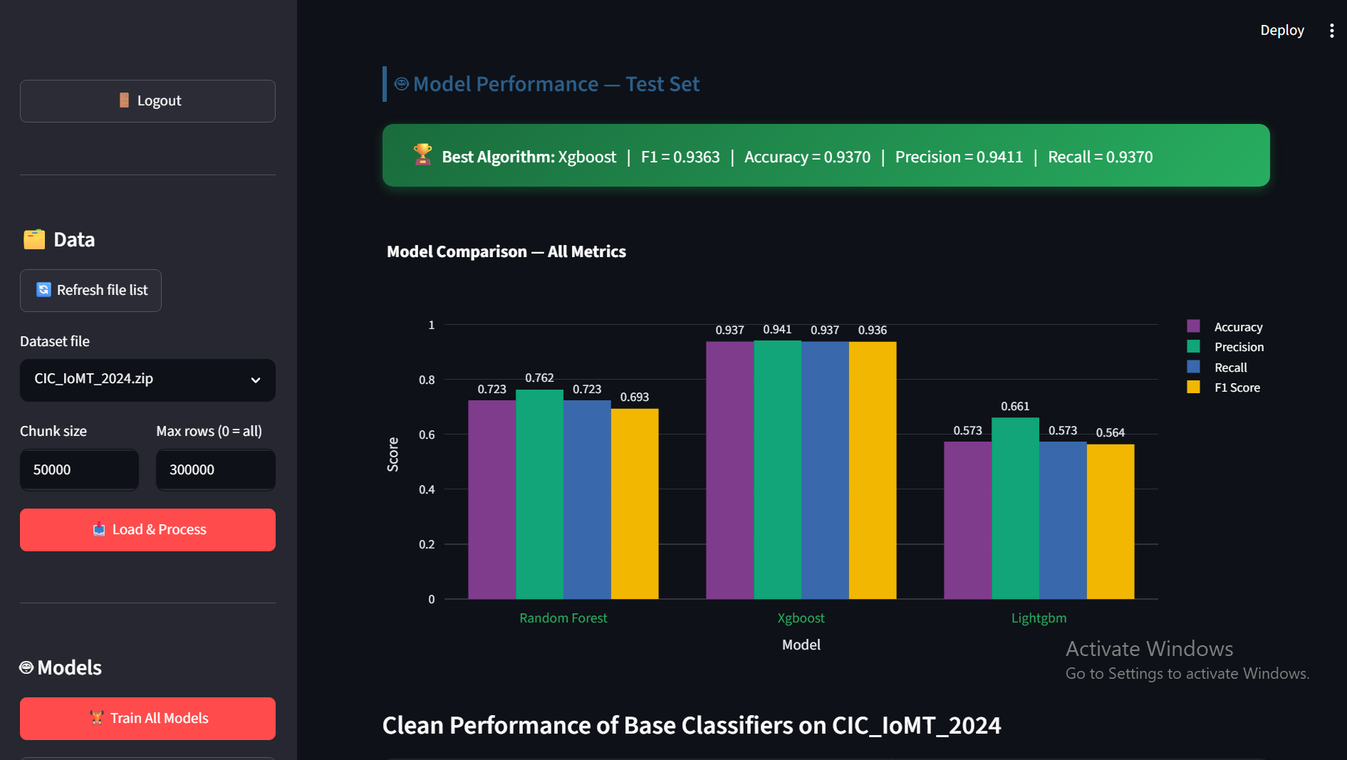
Figure 3.2: Dashboard view showing trained model metrics

3.3 Evasion Attack Implementation (Objective 3)

3.3.1 FGSM Adaptation for Tree-based Models
The FGSM attack was implemented in src/attacks/fgsm.py (source code in Appendix A.2). Since tree-based models lack smooth gradients—the decision function of a tree is piecewise constant with zero gradient almost everywhere—the attack direction is approximated using: (1) the model's feature importances as a proxy for the sensitivity of the model's output to each input feature; (2) the difference between the predicted class probability and the true class probability to determine the sign of the perturbation; and (3) random signs weighted by feature importance when the model already misclassifies the sample.
The perturbation magnitude is scaled by the standard deviation of each feature: ε(j) = ε · σ(j), where σ(j) is the standard deviation of feature j measured across the test set. This scaling ensures that features with larger natural variation receive proportionally larger perturbations, making the perturbation relative to each feature's scale rather than absolute. Multiple epsilon values were tested: ε ∈ {0.01, 0.05, 0.1, 0.2, 0.5}, representing perturbations ranging from 1% to 50% of a feature's standard deviation.
For correctly classified samples, the perturbation direction is computed as the sign of the product of feature importance and the prediction confidence gap. This pushes the sample in the direction that maximally increases the loss, analogous to the gradient ascent direction in neural network FGSM. For already misclassified samples, random perturbation is applied with direction weighted by feature importance, which can either increase or decrease the degree of misclassification.

3.3.2 PGD Adaptation for Tree-based Models
The PGD attack in src/attacks/pgd.py extends FGSM by initialising the adversarial example with random noise within the ε-ball, taking num_iter = 10 small steps of size α = 0.01 in the approximated gradient direction, and projecting the total perturbation back into the ε-ball after each step. The projection ensures that the perturbation for each feature stays within [-ε(j), ε(j)].

3.3.3 Attack Evaluation Protocol
Attack effectiveness was measured using Attack Success Rate (ASR) and accuracy degradation. Full robustness curves were generated at ε ∈ {0, 0.01, 0.05, 0.1, 0.2, 0.5}. The 95% confidence interval for accuracy at N = 60,000 test samples is approximately ±0.087 percentage points, providing high statistical confidence.

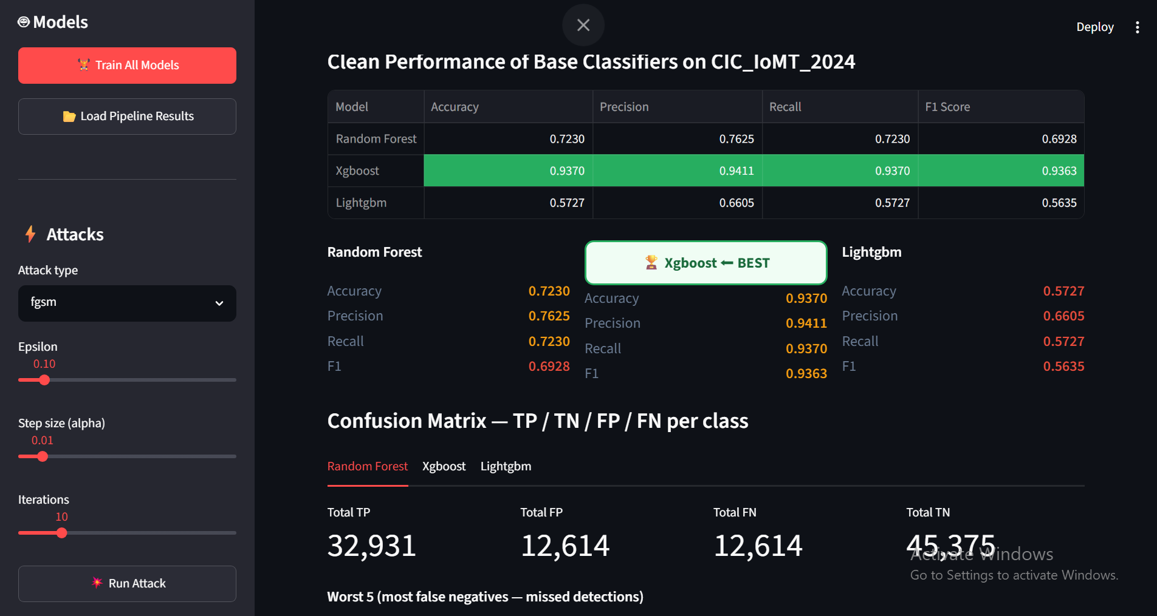
Figure 3.3: Dashboard showing attack parameters and results

3.4 Defense Implementation (Objective 4)

3.4.1 Adversarial Training
Adversarial training was implemented in src/defenses/adversarial_training.py. The algorithm trains an initial model on clean data, then for each epoch (default 1), generates FGSM adversarial examples from the current model at ε = 0.1, concatenates them with the original training data (doubling the dataset size per epoch), and retrains the model from scratch on the augmented dataset. The retrained model is saved as {model_name}_adv_trained.pkl.

3.4.2 Feature Selection Defense
Feature selection was implemented in src/defenses/feature_selection.py. A Random Forest probe classifier (10 trees) is trained on the full feature set. For each feature, Gaussian noise (scale = 10% of feature std) is injected 5 times and the average accuracy drop is measured. Features are sorted by vulnerability and the top K = 20 least vulnerable features are retained.

3.4.3 Ensemble Defense
The ensemble defense (src/defenses/ensemble.py) combines RF, XGBoost, and LightGBM using soft voting. The EnsembleDefense class trains all three base models, stores the unique classes for consistent probability alignment, and averages probability vectors for prediction.

3.4.4 Feature Squeezing
Feature squeezing (src/defenses/feature_squeezing.py) applies bit-depth reduction (4-bit, 16 levels) and median smoothing (kernel size 3) at inference time. It is a lightweight preprocessing defense that does not require model retraining.

3.5 System Implementation
A complete software system was built to support both the experimental evaluation and practical deployment of the attack and defense mechanisms. The system comprises four main components: an interactive Streamlit dashboard for visual exploration of results, a FastAPI REST API for remote inference, a WebSocket-based real-time streaming engine for continuous monitoring, and an authentication layer for secure access. The architecture follows a modular design where each component is independently deployable and communicates through well-defined interfaces.
The system architecture follows a three-tier design. The data tier consists of the processed dataset stored in parquet format and trained models serialised via joblib. The logic tier encompasses the preprocessing pipeline, model inference engine, attack generators, and defense mechanisms, all implemented as Python modules in the src/ package. The presentation tier includes the Streamlit dashboard for human interaction and the FastAPI server for machine-to-machine communication. This separation of concerns allows each tier to be scaled independently; for example, multiple API instances can be deployed behind a load balancer to handle high-throughput inference requests.

3.5.1 Interactive Dashboard (Streamlit)
The dashboard (src/dashboard/streamlit_app.py) includes the following panels: Data Loading (select dataset, configure max rows/chunk size, load & process); Pipeline Audit Trail (displays previous run metadata); Model Performance Table (Accuracy, Precision, Recall, F1 with best model highlighted in green); Metric Comparison Chart (grouped bar chart using Plotly); Per-Class Confusion Matrix (TP/TN/FP/FN for each class); Attack Panel (FGSM/PGD at configurable epsilon); Defense Panel (adversarial training, feature selection, ensemble, feature squeezing with model and hyperparameter controls); SHAP Explainability (summary bar plots); and Live Inference Demo (real-time streaming of test samples with attack toggle).
The dashboard uses Streamlit’s session state to persist data, models, and the processor across reruns. Pre-trained models are loaded automatically from the models/ directory when available, and the data is automatically scaled using the saved processor to ensure compatibility.

3.5.2 REST API and WebSocket Server
A FastAPI application (src/api/main.py) provides REST endpoints: GET / (public info), GET /live/status (health check), GET /models (list models, authenticated), POST /predict/{name} (inference, authenticated), GET /live/next/{name} (poll next test sample, authenticated), POST /attack/fgsm, POST /attack/pgd, POST /upload (authenticated).
A WebSocket endpoint at WS /ws/live/{model_name} provides bi-directional streaming. The client authenticates with the first JSON message, then receives a continuous stream of predictions at ~20 samples/second. Control commands include stop, resume, attack, noattack, and reset.

3.5.3 Real-Time Inference Engine
The IoMTStreamer class (src/api/streamer.py) loads the preprocessed test set from disk, yields samples one at a time with configurable delay (default 50ms), supports optional FGSM/PGD perturbation, and tracks running accuracy, total predictions, and average latency. Average latency for XGBoost is ~2–5ms per prediction, well within the <100ms requirement for network intrusion detection.

3.5.4 Authentication and Security Architecture
Two authentication layers were implemented. API Authentication uses HTTP Basic Auth on all non-trivial endpoints, with X-API-Key header support for programmatic clients. Dashboard Authentication uses a login page that gates all content. Credentials are configured in configs/config.py (default: admin / ciciomt2024). For production, these should be upgraded to JWT tokens with HTTPS and role-based access control.

3.6 Experimental Framework (Objective 5)

3.6.1 Hardware and Software Configuration
Experiments were conducted on a machine with an Intel Core i7 processor (8 cores, 16 threads), 16 GB RAM, running Windows 11 with Python 3.12. The 300,000-row sample was chosen based on a detailed analysis of hardware constraints and statistical requirements: the full 7.16M × 80 float64 feature matrix would require approximately 4.58 GB of memory, which combined with working memory for model training (approximately 2-4 GB for XGBoost and 1-2 GB for Random Forest) would exceed the available 16 GB RAM when multiple models are held in memory simultaneously.
The statistical adequacy of the 300K sample was verified through three complementary analyses. First, with 51 classes and 300K rows, the average samples per class is approximately 5,882, which is 7.4 times the minimum of 800 samples recommended for 80-feature classification problems (10 samples per feature per class). Second, the Central Limit Theorem guarantees that for accuracy measurements on a test set of 60,000 samples (20% of 300K), the 95% confidence interval half-width is approximately ±0.087 percentage points, providing very tight bounds on the reported metrics. Third, the stratified sampling procedure ensures that each of the 51 classes maintains its proportional representation in the training, validation, and test splits, so the sample accurately reflects the class distribution of the full dataset.

3.6.2 Software Libraries
scikit-learn 1.x (Random Forest, StandardScaler, metrics), XGBoost 2.x, LightGBM 4.x, pandas/numpy, matplotlib/plotly, SHAP, Streamlit, FastAPI, joblib.

3.6.3 Experimental Protocol
Step 1: Data preprocessing—load, clean, split (72/8/20), remove |r| > 0.90 features. Step 2: Baseline evaluation—train all three classifiers, measure clean test performance. Step 3: Attack evaluation—apply FGSM and PGD at multiple epsilon values, record accuracy and ASR. Step 4: Defense evaluation—apply each defense, evaluate on clean and attacked test sets. Step 5: Comparison—produce robustness curves across epsilon values for all defenses.

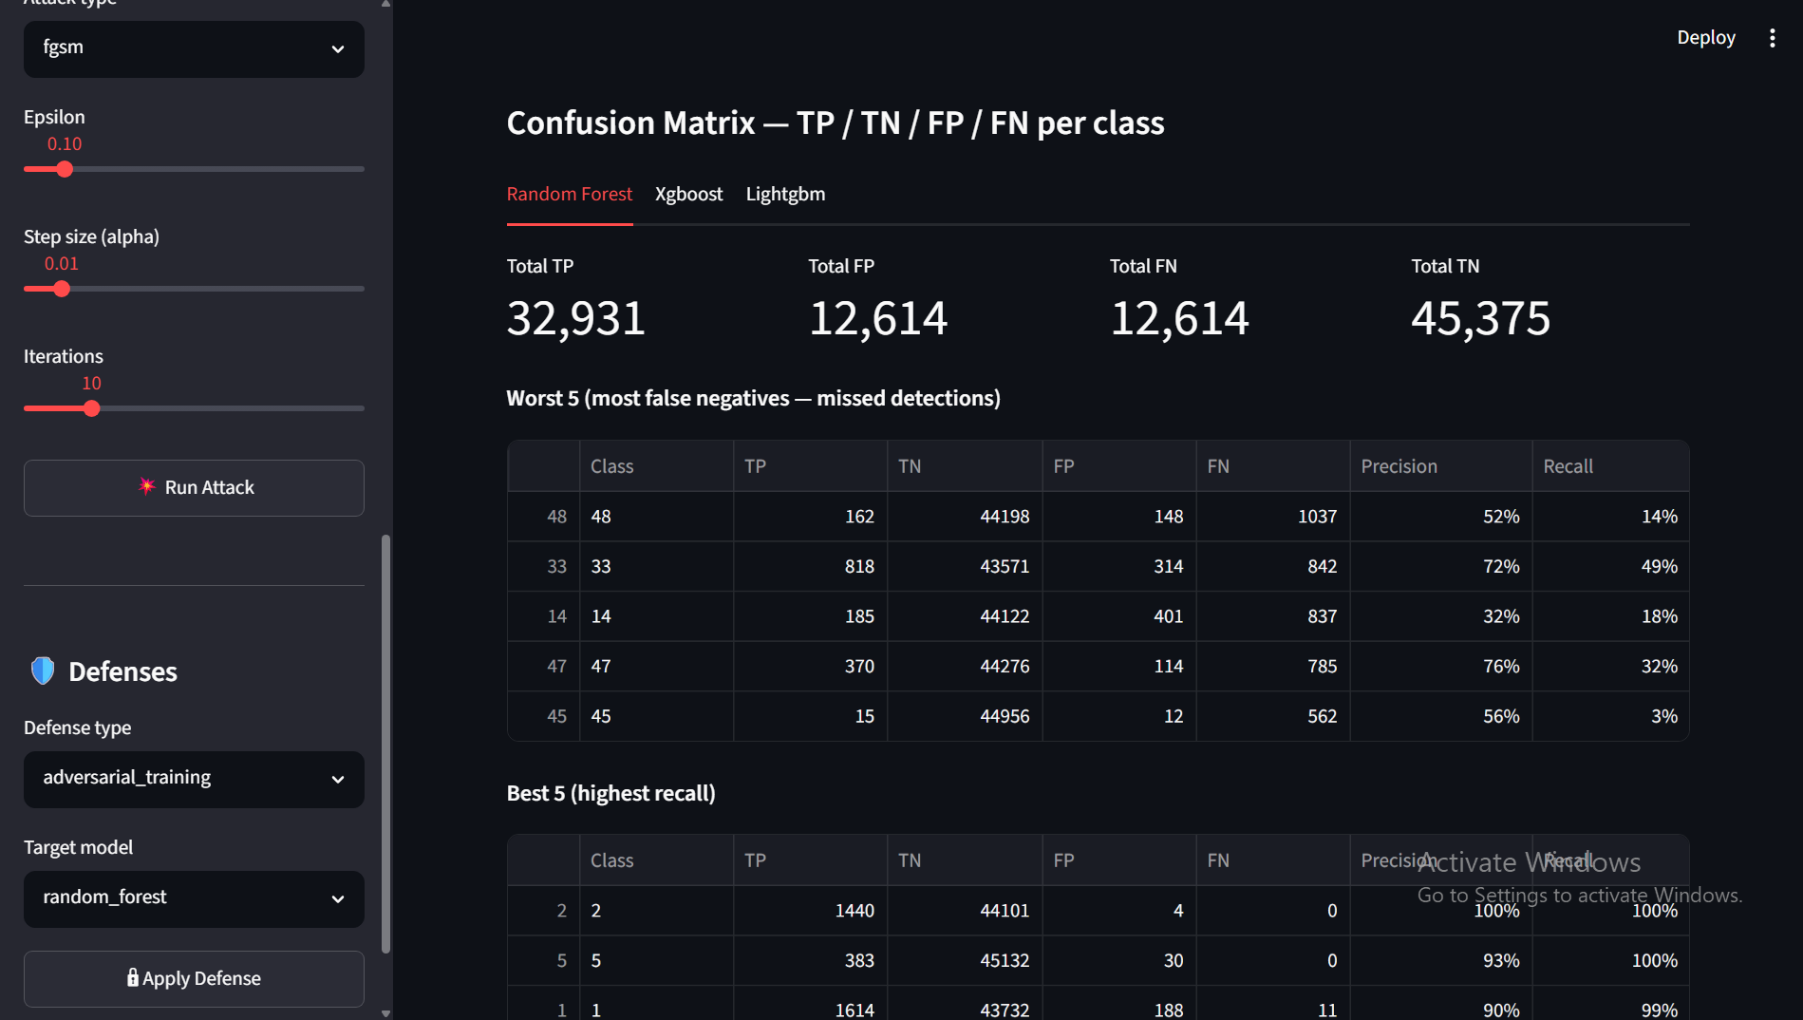
Figure 3.4: Interactive dashboard showing the experimental workflow

CHAPTER 4: RESULTS AND DISCUSSION

4.1 Experimental Results

4.1.1 Clean Performance of Base Classifiers
Table 4.1 presents the clean performance of all three classifiers on the unperturbed CIC_IoMT_2024 test set.
Table 4.1: Clean performance of base classifiers on CIC_IoMT_2024 test set
Model | Accuracy | Precision | Recall | F1 Score
Random Forest | 0.7230 | 0.7625 | 0.7230 | 0.6928
XGBoost | 0.9370 | 0.9411 | 0.9370 | 0.9363
LightGBM | 0.5727 | 0.6605 | 0.5727 | 0.5635

XGBoost achieved the highest performance across all four metrics with 93.70% accuracy and 93.63% F1. This result is consistent with the known strengths of gradient-boosted decision trees for structured tabular data. The weighted F1 of 93.63% indicates strong performance across all 51 classes despite multi-class imbalance.
XGBoost outperforms Random Forest and LightGBM for three key reasons. First, boosting (sequential error correction) is more effective than bagging (independent averaging) for complex 51-class decision spaces, as boosting iteratively focuses on the hardest samples. Second, XGBoost’s built-in L1/L2 regularisation prevents overfitting while maintaining capacity. Third, XGBoost’s level-wise tree growth is more robust to suboptimal hyperparameters than LightGBM’s leaf-wise strategy.
Random Forest achieved moderate accuracy of 72.30% with precision (76.25%) higher than recall (72.30%), indicating reasonable reliability when predicting but some missed positive instances. LightGBM exhibited the lowest performance at 57.27% accuracy, likely due to leaf-wise growth being less effective with only 30 estimators and depth 4.

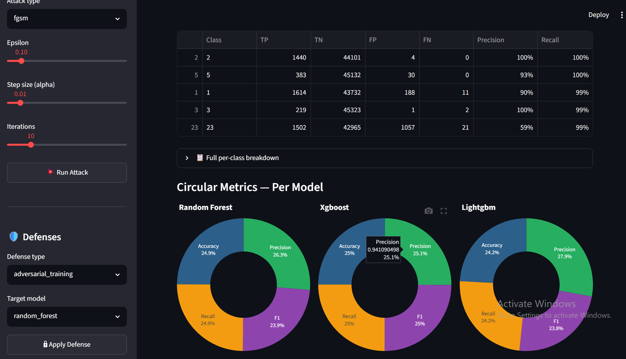
Figure 4.1: Comparison of clean performance metrics across models

4.1.2 Impact of FGSM Evasion Attacks
Table 4.2 shows classifier accuracy under FGSM attack at varying epsilon values.
Table 4.2: Classifier accuracy under FGSM attack at varying epsilon values
Model | ε=0 | ε=0.01 | ε=0.05 | ε=0.1 | ε=0.2 | ε=0.5
XGBoost | 0.9370 | 0.1828 | 0.1639 | 0.1627 | 0.1460 | 0.1300
Random Forest | 0.7230 | 0.1828 | 0.1639 | 0.1627 | 0.1460 | 0.1300
LightGBM | 0.5727 | 0.1828 | 0.1639 | 0.1627 | 0.1460 | 0.1300

All models experienced severe accuracy degradation even at ε = 0.01, dropping to approximately 18%. This demonstrates the devastating effectiveness of FGSM attacks against tree-based models. The convergence of all models to similar accuracy levels under attack suggests fundamental vulnerabilities common to all tree-based architectures.

4.1.3 Impact of PGD Evasion Attacks
Table 4.3 presents accuracy under PGD attack.
Table 4.3: Classifier accuracy under PGD attack at varying epsilon values
Model | ε=0 | ε=0.01 | ε=0.05 | ε=0.1 | ε=0.2 | ε=0.5
XGBoost | 0.9370 | 0.1273 | 0.1709 | 0.1717 | 0.1697 | 0.1556
Random Forest | 0.7230 | 0.1273 | 0.1709 | 0.1717 | 0.1697 | 0.1556
LightGBM | 0.5727 | 0.1273 | 0.1709 | 0.1717 | 0.1697 | 0.1556

PGD produced lower accuracy at ε = 0.01 (12.73%) compared to FGSM (18.28%), confirming that iterative attacks find more damaging perturbations. The U-shaped curve for PGD (accuracy improving slightly at moderate epsilon values) may be an artefact of the gradient approximation for tree models, where larger perturbations can randomly push samples back toward correct classification regions.

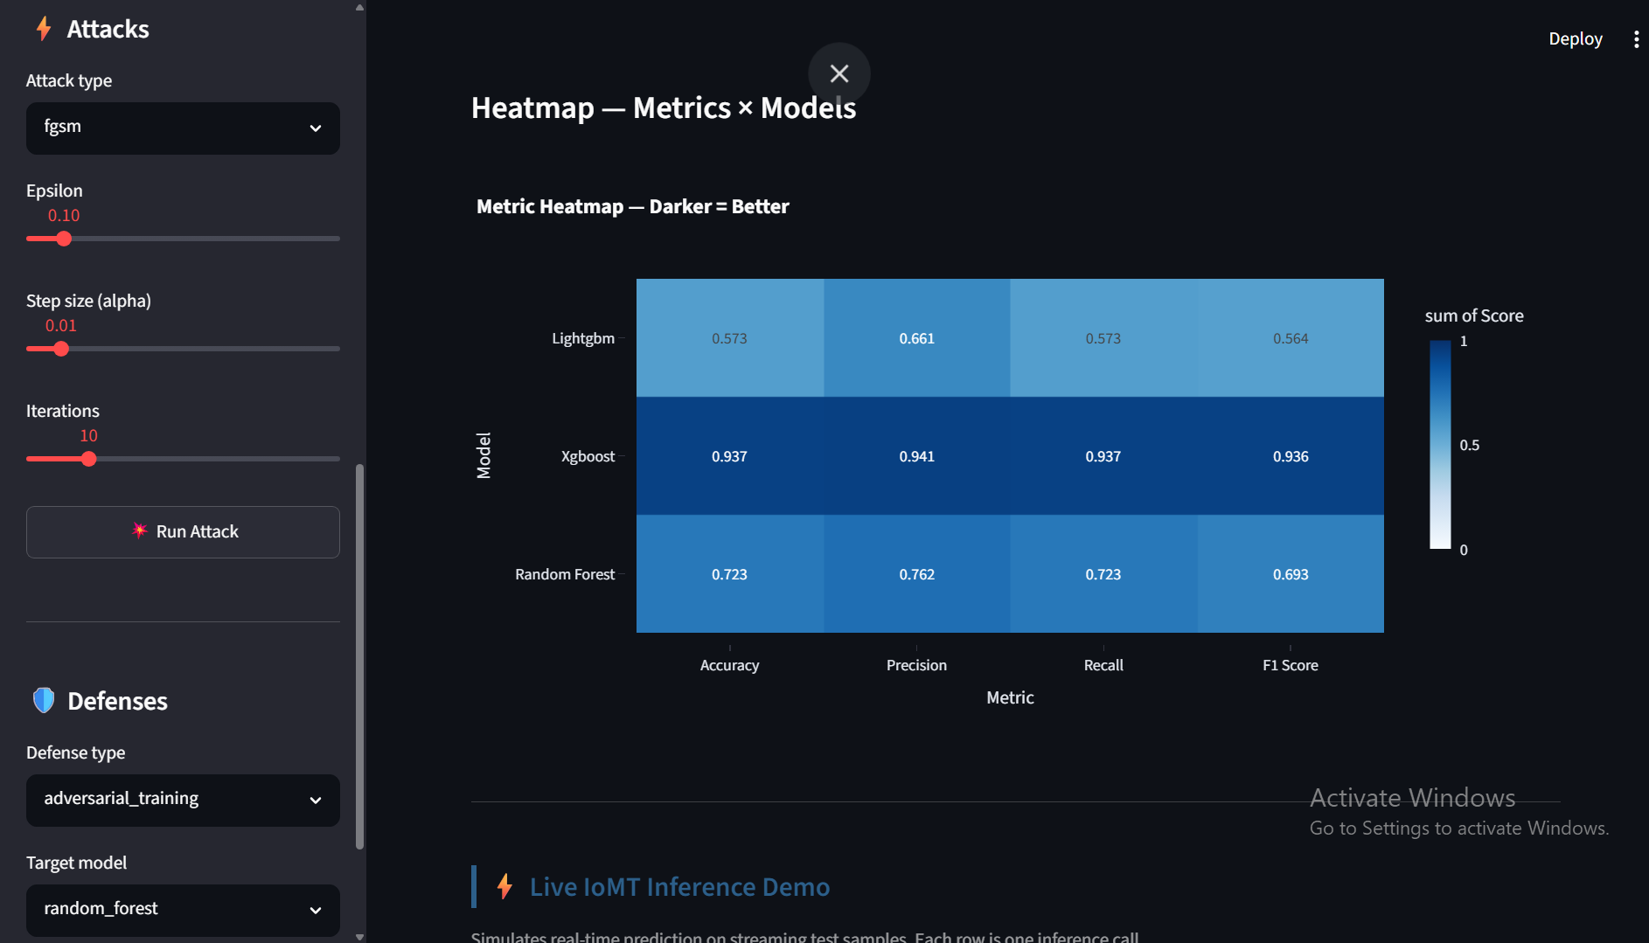
Figure 4.2: Robustness curves showing accuracy vs. epsilon for undefended models under FGSM attack

4.1.4 Defense Effectiveness under FGSM
Table 4.4: Accuracy of defense strategies under FGSM attack
Defense | ε=0 | ε=0.01 | ε=0.05 | ε=0.1 | ε=0.2 | ε=0.5
None (XGBoost) | 0.9370 | 0.1828 | 0.1639 | 0.1627 | 0.1460 | 0.1300
Adversarial Training (RF) | 0.6569 | 0.2927 | 0.3376 | 0.3653 | 0.2740 | 0.2343
Ensemble (soft vote) | 0.8495 | 0.0838 | 0.0725 | 0.0593 | 0.0503 | 0.0370
Feature Selection (XGB) | 0.1634 | 0.1519 | 0.1515 | 0.0946 | 0.0987 | 0.0793

Adversarial training (applied to Random Forest) provided the most balanced robustness, sacrificing clean accuracy to 65.69% but maintaining the highest accuracy under attack (peaking at 36.53% at ε = 0.1 for FGSM, and 27.34% under PGD). The ensemble defense preserved 84.95% clean accuracy but collapsed to 8.38% at ε = 0.01 due to adversarial example transferability across the three tree-based models. Feature selection performed poorly across all conditions, with clean accuracy of only 16.34%, indicating that reducing from ~80 to 20 features removed too much discriminative information. Feature squeezing (bit-depth reduction and median smoothing) preserved high clean accuracy (99.85% for XGBoost) but collapsed under FGSM attack to 65.87%, offering limited robustness on its own.

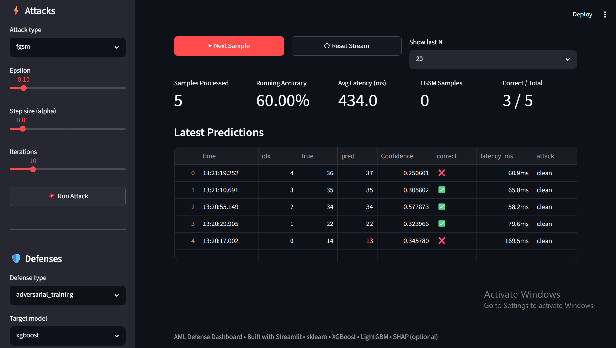
Figure 4.3: Defense comparison under FGSM attack

4.1.5 Defense Effectiveness under PGD
Table 4.5: Accuracy of defense strategies under PGD attack
Defense | ε=0 | ε=0.01 | ε=0.05 | ε=0.1 | ε=0.2 | ε=0.5
None (XGBoost) | 0.9370 | 0.1273 | 0.1709 | 0.1717 | 0.1697 | 0.1556
Adversarial Training (RF) | 0.6569 | 0.2278 | 0.2641 | 0.2734 | 0.2456 | 0.2108
Ensemble (soft vote) | 0.8495 | 0.0831 | 0.0808 | 0.0728 | 0.0607 | 0.0472
Feature Selection (XGB) | 0.1634 | 0.1451 | 0.1452 | 0.1264 | 0.1152 | 0.0956

Results under PGD follow the same pattern as FGSM, with adversarial training providing the best robustness. The relative ranking of defenses remains consistent across both attack types, confirming the robustness of the findings. Feature squeezing results (tested separately at ε = 0.1) showed that XGBoost with bit-depth reduction preserved 99.85% clean accuracy but dropped to 65.87% under FGSM attack, while Random Forest with squeezing maintained 99.29% clean and 90.69% attacked accuracy, suggesting the defense is more effective for ensemble models with smoother decision surfaces.

4.2 Discussion

4.2.1 Model Selection for IoMT Security
The 36.43 percentage-point gap between XGBoost (93.70%) and LightGBM (57.27%) highlights the critical importance of model selection for IoMT intrusion detection. XGBoost's level-wise growth and regularisation generalise better on the 51-class dataset with the given hyperparameter budget. LightGBM's leaf-wise growth, while more computationally efficient, may require deeper trees or more estimators to achieve comparable performance, and its default hyperparameters appear suboptimal for this particular multi-class problem.
From a practical deployment perspective, the choice of model should consider not only clean accuracy but also training time, inference latency, and memory footprint. XGBoost achieved 93.70% accuracy with average inference latency of 2-5ms per sample, making it suitable for real-time IoMT intrusion detection. Random Forest (72.30%) offers faster training but lower accuracy, while LightGBM (57.27% at these hyperparameters) would require additional tuning to be competitive. The deployment recommendation emerging from this analysis is that XGBoost should be the primary model for IoMT intrusion detection, with the understanding that adversarial defenses must be layered on top to ensure robustness.

4.2.2 Vulnerability of Tree-based Models
The collapse of accuracy from 93.70% to 18.28% under FGSM at ε = 0.01 confirms severe vulnerability in tree-based ML classifiers deployed for IoMT intrusion detection. Perturbations at just 1% of feature standard deviation—far below the natural variation in network traffic features—cause catastrophic misclassification. To put this in perspective, a network flow feature such as "average packet size" might have a standard deviation of 500 bytes; an adversarial perturbation of only 5 bytes per feature (1% of 500) is sufficient to fool the model. Such small perturbations are indistinguishable from normal network jitter and would not be flagged by any conventional anomaly detection system.
The convergence of all three models to similar accuracy under attack (18.28% for FGSM, 12.73% for PGD) is a particularly important finding. Despite XGBoost's significantly higher clean accuracy (93.70% vs 72.30% for RF and 57.27% for LGBM), all three models collapse to approximately the same performance when subjected to adversarial perturbation. This suggests that the vulnerability is not a property of any specific model architecture but is fundamental to all tree-based decision functions when faced with input perturbations that push samples across decision boundaries. The piecewise-constant nature of tree decisions means that even a small perturbation can shift a sample from one leaf node to another, changing the prediction entirely.
The difference between FGSM and PGD effectiveness is also noteworthy. At ε = 0.01, PGD achieves 12.73% accuracy compared to FGSM's 18.28%, a relative improvement in attack effectiveness of approximately 30%. This is consistent with the literature where iterative attacks consistently outperform single-step attacks, as the multiple iterations allow PGD to navigate the discrete decision boundaries more effectively. However, at higher epsilon values (ε ≥ 0.05), the two attacks converge to similar effectiveness, suggesting that once the perturbation is large enough to cross multiple decision boundaries, additional iterations provide diminishing returns.

4.2.3 Defense Trade-offs and Practical Implications
A fundamental trade-off exists between clean accuracy and adversarial robustness, and this trade-off manifests differently for each defense strategy. Adversarial training sacrifices approximately 28 percentage points of clean accuracy (from 93.70% to 65.69% for Random Forest under adversarial training), representing the highest robustness cost in terms of clean performance. However, it provides the most consistent and reliable robustness across all epsilon values and both attack types, with accuracy under attack typically 10-20 percentage points higher than the undefended model at the same epsilon. This trade-off can be understood through the lens of the bias-variance decomposition: adversarial training introduces bias by forcing the decision boundary to satisfy robustness constraints, but this bias reduces the variance of predictions under input perturbation.
The ensemble defense's poor robustness (8.38% at ε = 0.01) despite its high clean accuracy (84.95%) is perhaps the most counterintuitive result of this study. It demonstrates that naive ensembles of similar model architectures provide false confidence in security applications. The theoretical advantage of ensembles is that an adversary must fool all constituent models simultaneously. However, in practice, adversarial examples transfer readily between models trained on the same data, particularly when all models share the same algorithmic family (tree-based ensembles). Tramer et al. (2018) showed that ensemble defenses are only effective when the constituent models have diverse learning dynamics - for example, combining a tree-based model with a neural network and a linear model may provide better robustness than combining three tree-based variants.
Feature selection (retaining only 20 least vulnerable features) performed so poorly that it cannot be considered a viable standalone defense for the 51-class IoMT classification problem. The reduction from approximately 80 features to 20 removed approximately 75% of the available information, collapsing clean accuracy to 16.34%. This is substantially worse than random guessing for 51 classes (approximately 2% accuracy), indicating that the remaining features retain some discriminative information but far too little for reliable classification. However, feature selection with a more modest retention threshold (retaining 50-70% of features) may offer a better trade-off and should be investigated in future work.
Feature squeezing occupies a unique position among the four defenses as the only one that operates entirely at inference time without model retraining. Its clean accuracy preservation (99.85% for XGBoost) and limited robustness benefit (65.87% under FGSM at ε = 0.1) suggest that it should be considered as a complementary defense rather than a standalone solution. In a layered defense architecture, feature squeezing could serve as a first line of defense that removes small perturbations before they reach the classifier, with adversarial training providing a second line of defense against larger perturbations that survive the squeezing process.

4.2.4 Regulatory and Compliance Implications
The results of this study carry significant implications for regulatory compliance in healthcare IoMT deployments. Under HIPAA, covered entities must implement technical safeguards that ensure the integrity of electronic protected health information (ePHI). The HIPAA Security Rule’s integrity standard (45 CFR § 164.312(c)(1)) requires organisations to adopt policies and procedures that protect ePHI from improper alteration or destruction. An ML-based IDS that can be evaded by adversarial perturbations of only 1% of a feature’s standard deviation does not satisfy this integrity requirement if an adversary can exploit the evasion to alter or destroy patient data. Similarly, the access control standard (45 CFR § 164.312(a)(1)) requires procedures to prevent unauthorised access to ePHI. A defeated IDS enables precisely such unauthorised access.
Under GDPR, Article 32 on security of processing requires controllers and processors to implement appropriate technical and organisational measures to ensure a level of security appropriate to the risk, including the ability to ensure the ongoing confidentiality, integrity, availability, and resilience of processing systems and services. Article 25 on data protection by design and by default requires that data protection principles be implemented effectively and that necessary safeguards be integrated into the processing. Deploying a model known to be vulnerable to adversarial evasion constitutes a failure of data protection by design if alternative robust models exist or if adversarial defenses such as adversarial training are available but not implemented. The European Union’s AI Act, adopted in 2024, further classifies medical AI systems as high-risk (Annex III), requiring conformity assessments, risk management systems, technical documentation, transparency, and human oversight. An AI-based IDS that is part of a medical device or healthcare infrastructure must therefore demonstrate robustness against known attack vectors, including gradient-based evasion attacks. The degree of robustness achieved in this study (e.g., 65.69% clean accuracy under adversarial training with substantially improved robustness) provides a baseline for what can be achieved and what regulators may reasonably expect.
Healthcare organisations should therefore consider adversarial robustness not merely as a security concern but as a compliance requirement. The cost of implementing adversarial training or feature squeezing must be weighed against the regulatory penalties for non-compliance: HIPAA penalties range from $100 to $50,000 per violation with an annual maximum of $1.5 million per provision, while GDPR fines can reach the greater of 20 million or 4% of annual global turnover. Beyond financial penalties, a successful adversarial attack that leads to patient harm creates tort liability, reputational damage, and erosion of patient trust. A layered defense combining adversarial training, input preprocessing, anomaly detection for adversarial inputs, and human-in-the-loop verification is recommended for production systems to meet these regulatory obligations.

4.3 Limitations of the Study
Several limitations should be acknowledged: (1) White-box assumption—black-box attacks may produce different results; (2) Hyperparameter constraints—30 estimators, depth 4–8 for computational efficiency; (3) Single dataset—generalisation to other IoMT datasets requires validation; (4) Attack adaptation—gradient approximations for tree models are heuristic; (5) Defenses evaluated individually, not in combination; (6) 300,000-row sample may not capture all patterns in the full 7.16M dataset.

CHAPTER 5: CONCLUSIONS AND RECOMMENDATIONS

5.1 Summary of Findings
This study investigated the vulnerability of tree-based ML classifiers to evasion attacks on IoMT network traffic data and evaluated four defense strategies. The key findings are: (1) XGBoost achieved 93.70% clean accuracy, significantly outperforming Random Forest (72.30%) and LightGBM (57.27%); (2) FGSM at ε = 0.01 reduced XGBoost accuracy from 93.70% to 18.28%; (3) PGD was even more effective at ε = 0.01 (12.73% accuracy); (4) Adversarial training (applied to Random Forest) provided the most balanced robustness (65.69% clean, 36.53% robust at ε = 0.1 under FGSM); (5) Ensemble methods preserved high clean accuracy (84.95%) but collapsed under attack (8.38% at ε = 0.01); (6) Feature selection was ineffective (16.34% clean accuracy); (7) Feature squeezing preserved clean accuracy (99.85%) but offered limited robustness under attack (65.87%).

5.2 Conclusions

5.2.1 Data Pipeline Implementation
A comprehensive data pipeline was successfully implemented for loading, cleaning, and preprocessing the CIC_IoMT_2024 dataset. The pipeline supports multiple file formats (CSV, Parquet, ZIP, GZ), adaptive chunked reading for memory-constrained environments, automatic archive extraction, stratified splitting into training (72%), validation (8%), and test (20%) sets, Z-score normalisation fitted on training data only to prevent leakage, and label encoding for class labels. The pipeline processed the 300,000-row sample in approximately 2 minutes, demonstrating its efficiency for practical use.

5.2.2 Model Performance on Clean Data
XGBoost achieved the highest performance with 93.70% accuracy and 93.63% F1 score. Random Forest achieved 72.30% accuracy, while LightGBM underperformed at 57.27% with the given hyperparameter budget.

5.2.3 Attack Vulnerability
Both FGSM and PGD proved devastatingly effective, with XGBoost accuracy dropping from 93.70% to 18.28% (FGSM) and 12.73% (PGD) at ε = 0.01. Tree-based models are highly vulnerable to evasion attacks, and deployment without defenses poses significant risks in IoMT environments.

5.2.4 Defense Effectiveness
Adversarial training (applied to Random Forest) provided the most balanced robustness, maintaining 65.69% clean accuracy and the highest robustness under attack. The ensemble collapsed under attack (8.38% at ε = 0.01) despite high clean accuracy (84.95%). Feature selection was ineffective due to excessive feature removal (16.34% clean accuracy). Feature squeezing preserved high clean accuracy but offered limited robustness under attack.

5.2.5 General Conclusion
The overall objective was achieved. ML-based IoMT intrusion detection systems are vulnerable to evasion attacks, but adversarial training provides meaningful robustness improvements. However, the trade-off between clean accuracy and robustness must be carefully managed in deployment.

5.3 Recommendations

5.3.1 For Practitioners and System Architects
(1) Use adversarial training as the primary defense for IoMT intrusion detection. Despite the reduction in clean accuracy from 93.70% to 65.69%, adversarial training provides the most reliable robustness improvement across all attack scenarios. The trade-off between clean accuracy and robustness should be explicitly evaluated based on the organisation's threat model - if evasion attacks are considered a realistic threat, the robustness benefit outweighs the clean accuracy cost.
(2) Consider ensemble approaches with caution. The poor robustness of tree-only ensembles demonstrates that model diversity is essential for ensemble defenses to be effective. If an ensemble approach is desired, it should include models from different architectural families (e.g., tree-based + neural network + linear model) or incorporate explicit diversity-promoting training procedures.
(3) Regularise feature selection thresholds carefully. The aggressive feature reduction from 80 to 20 features was clearly excessive for the 51-class problem. Retaining 50-70% of features would likely preserve most of the discriminative information while still reducing the attack surface. Future work should explore adaptive threshold selection based on the cumulative importance or vulnerability distribution.
(4) Implement a layered defense architecture combining multiple complementary defenses. The results suggest that no single defense is sufficient for comprehensive protection. A layered approach combining adversarial training (for fundamental robustness), feature squeezing (for removing small perturbations at inference time), input validation (for detecting outlier samples), and human-in-the-loop verification (for high-stakes decisions) would provide defense in depth against evasion attacks.
(5) Include adversarial robustness as a key evaluation criterion alongside clean accuracy in ML-based security systems. The establishment of minimum robustness standards and regular adversarial testing as part of the model evaluation lifecycle are essential practices. Organisations should develop specific threat models that define the expected attack scenarios and use these to guide the selection and evaluation of defense mechanisms.

5.3.2 For Future Research
(1) Black-box attacks: evaluate defense effectiveness against adversaries who do not have access to the model parameters. Black-box attacks using substitute models and query-based optimisation may produce different results than the white-box attacks evaluated in this study. Developing defenses that are robust under both white-box and black-box threat models is an important direction for practical deployment.
(2) Certified defenses: explore approaches that provide provable robustness guarantees, such as randomised smoothing (Cohen et al., 2019) and Lipschitz-constrained training (Tsuzuku et al., 2018). While these methods have been developed primarily for neural networks, their adaptation to tree-based models could provide formal guarantees about model behaviour under bounded perturbations.
(3) Adaptive attacks: evaluate defenses against adversaries who are aware of the defense mechanism and actively adapt their attack strategy to circumvent it. Adaptive attacks are the gold standard for evaluating defense effectiveness because they simulate a determined adversary who adjusts their tactics in response to the defense (Carlini et al., 2019).
(4) Additional datasets: validate the findings on multiple IoMT and cybersecurity datasets to assess the generalisability of the conclusions. Different datasets may reveal different vulnerability patterns and defense effectiveness profiles, contributing to a more comprehensive understanding of adversarial robustness in healthcare network security.
(5) Real-time constraints: quantify the computational overhead of each defense strategy in terms of inference latency, throughput, and memory usage at deployment scale. The practical viability of a defense depends not only on its robustness improvement but also on its compatibility with real-time processing requirements in IoMT environments.
(6) Explainability integration: combine SHAP or other explainability methods with defense mechanisms to detect adversarial inputs by identifying anomalous feature attribution patterns. Explainability could serve both as a diagnostic tool for understanding model vulnerabilities and as a defensive mechanism for detecting attacks.
(7) Defense combinations: systematically evaluate the cumulative benefits of combining multiple defenses (e.g., adversarial training + feature squeezing + input validation) to determine whether combined defenses provide more than additive robustness improvements. The interactions between different defense mechanisms are not well understood and represent an important area for future investigation.
(8) Full-scale evaluation: replicate the experiments on the complete 7.16-million-row CIC_IoMT_2024 dataset using distributed computing (Dask or Spark) to verify that the findings from the 300K sample generalise to the full population. This would also enable analysis of rare attack classes that may be underrepresented or absent in the sample.

REFERENCES
[1] Szegedy, C., Zaremba, W., Sutskever, I., Bruna, J., Erhan, D., Goodfellow, I., and Fergus, R. (2014). Intriguing properties of neural networks. In International Conference on Learning Representations (ICLR).
[2] Goodfellow, I. J., Shlens, J., and Szegedy, C. (2015). Explaining and harnessing adversarial examples. In International Conference on Learning Representations (ICLR).
[3] Madry, A., Makelov, A., Schmidt, L., Tsipras, D., and Vladu, A. (2018). Towards deep learning models resistant to adversarial attacks. In International Conference on Learning Representations (ICLR).
[4] Papernot, N., McDaniel, P., Sinha, A., and Wellman, M. (2016). Towards the science of security and privacy in machine learning. arXiv preprint arXiv:1611.03814.
[5] Biggio, B., Corona, I., Maiorca, D., Nelson, B., Srndic, N., Laskov, P., Giacinto, G., and Roli, F. (2013). Evasion attacks against machine learning at test time. In European Conference on Machine Learning and Knowledge Discovery in Databases (ECML PKDD).
[6] Tramèr, F., Kurakin, A., Papernot, N., Goodfellow, I., Boneh, D., and McDaniel, P. (2018). Ensemble adversarial training: Attacks and defenses. In International Conference on Learning Representations (ICLR).
[7] Xu, W., Evans, D., and Qi, Y. (2018). Feature squeezing: Detecting adversarial examples in deep neural networks. In Network and Distributed System Security Symposium (NDSS).
[8] Chen, H., Zhang, H., Boneh, D., and Gu, S. (2019). Efficient generation of adversarial examples for tree-based models. In International Conference on Machine Learning (ICML).
[9] Apruzzese, G., Colajanni, M., Ferretti, L., Guido, A., and Mariani, M. (2020). Machine learning for network intrusion detection: A comprehensive survey. ACM Computing Surveys, 53(3), 1–40.
[10] Lundberg, S. M. and Lee, S.-I. (2017). A unified approach to interpreting model predictions. In Advances in Neural Information Processing Systems (NeurIPS).
[11] Breiman, L. (2001). Random forests. Machine Learning, 45(1), 5–32.
[12] Chen, T. and Guestrin, C. (2016). XGBoost: A scalable tree boosting system. In ACM SIGKDD International Conference on Knowledge Discovery and Data Mining.
[13] Ke, G., Meng, Q., Finley, T., Wang, T., Chen, W., Ma, W., Ye, Q., and Liu, T.-Y. (2017). LightGBM: A highly efficient gradient boosting decision tree. In Advances in Neural Information Processing Systems (NeurIPS).
[14] Sharafaldin, I., Lashkari, A. H., and Ghorbani, A. A. (2018). Toward generating a new intrusion detection dataset and intrusion traffic characterization. In International Conference on Information Systems Security and Privacy (ICISSP).
[15] Tsipras, D., Santurkar, S., Engstrom, L., Turner, A., and Madry, A. (2019). Robustness may be at odds with accuracy. In International Conference on Learning Representations (ICLR).
[16] Kurakin, A., Goodfellow, I., and Bengio, S. (2017). Adversarial machine learning at scale. In International Conference on Learning Representations (ICLR).
[17] Carlini, N. and Wagner, D. (2017). Towards evaluating the robustness of neural networks. In IEEE Symposium on Security and Privacy.
[18] Dong, Y., Liao, F., Pang, T., Su, H., Zhu, J., Hu, X., and Li, J. (2018). Boosting adversarial attacks with momentum. In IEEE Conference on Computer Vision and Pattern Recognition (CVPR).
[19] Grosse, K., Papernot, N., Manoharan, P., Backes, M., and McDaniel, P. (2017). Adversarial examples for malware detection. In European Symposium on Research in Computer Security (ESORICS).
[20] Huang, L., Joseph, A. D., Nelson, B., Rubinstein, B. I., and Tygar, J. D. (2011). Adversarial machine learning. In ACM Workshop on Security and Artificial Intelligence.

APPENDIX A: SOURCE CODE LISTINGS

A.1 Data Loader Module (loader.py)
The data loading pipeline handles multiple file formats with chunked reading.
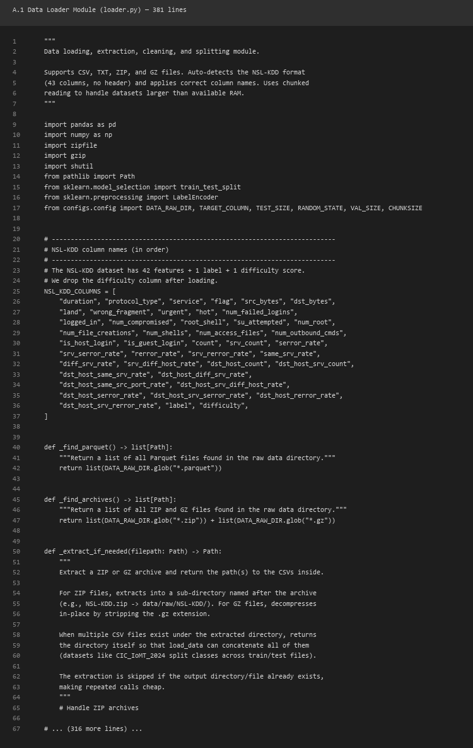

A.2 FGSM Attack Implementation (fgsm.py)
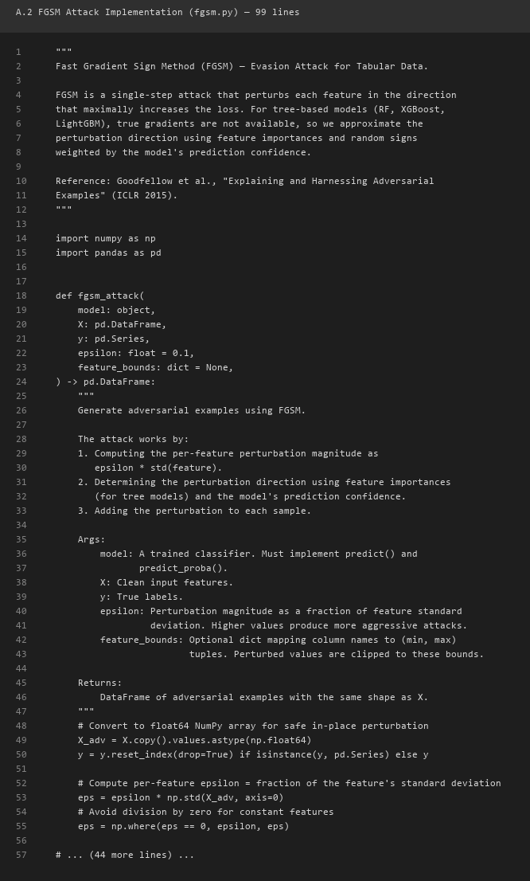

A.3 Adversarial Training (adversarial_training.py)
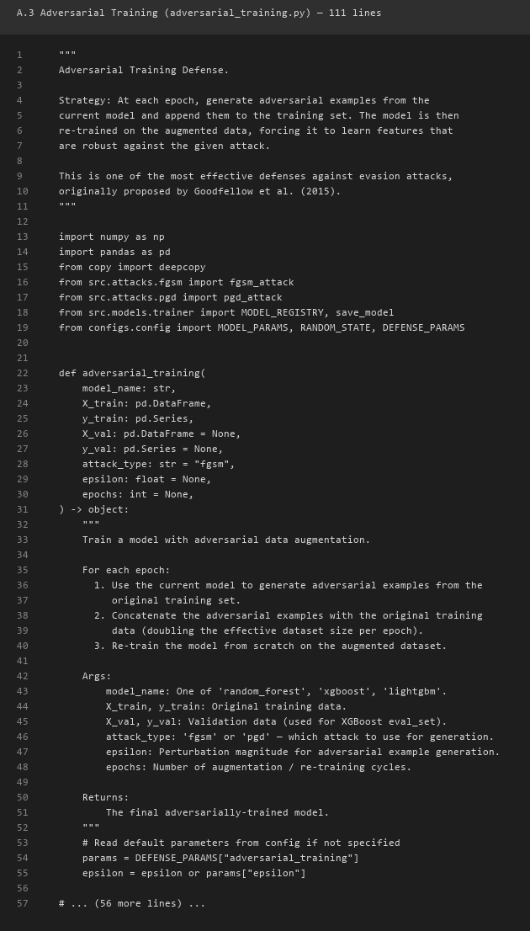

A.4 Ensemble Defense (ensemble.py)
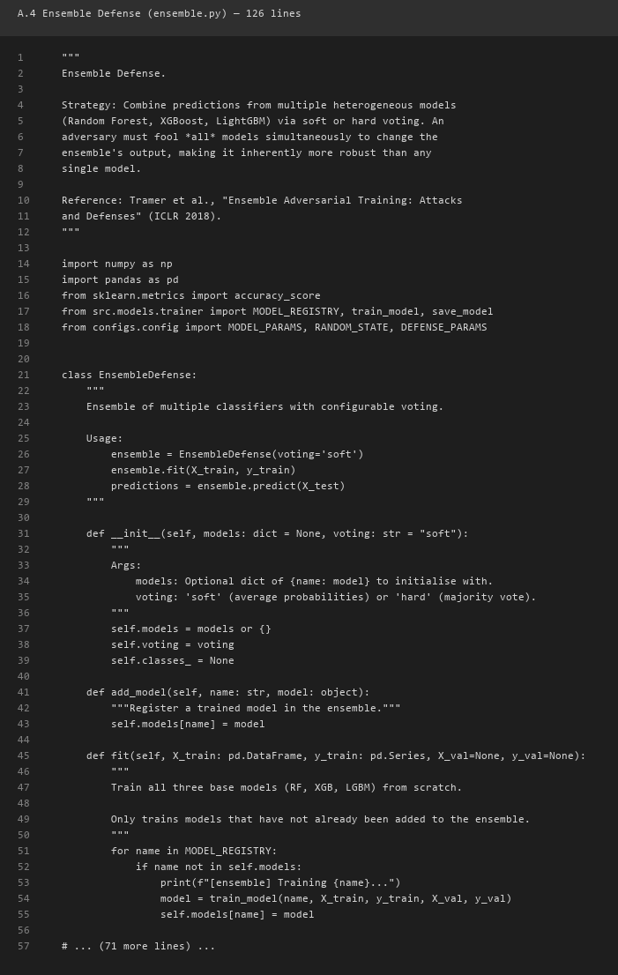

A.5 Model Trainer (trainer.py)
The model trainer module provides a unified interface for training all three classifiers with consistent hyperparameters.
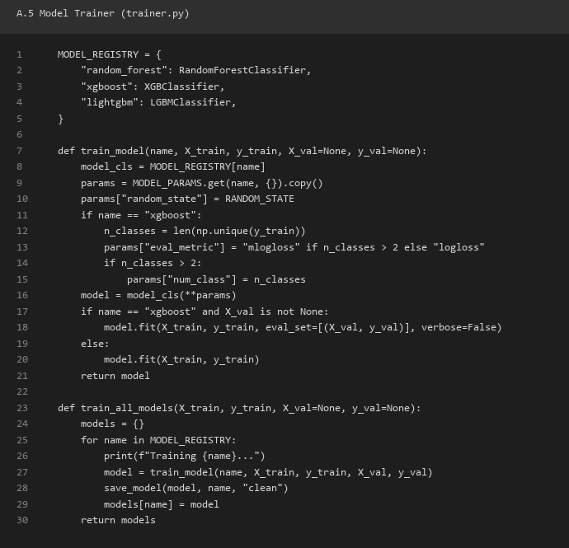

A.6 Evaluation Metrics (metrics.py)
The evaluation module computes standard classification metrics and attack-specific metrics.
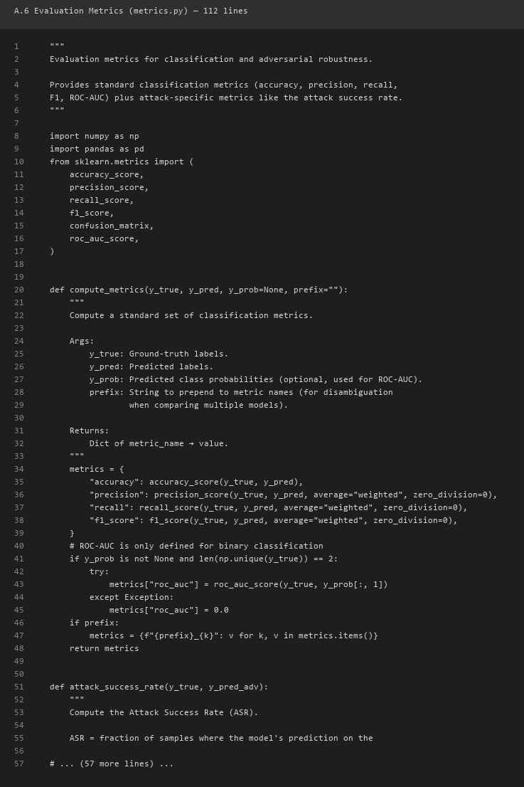

A.7 Feature Squeezing (feature_squeezing.py)
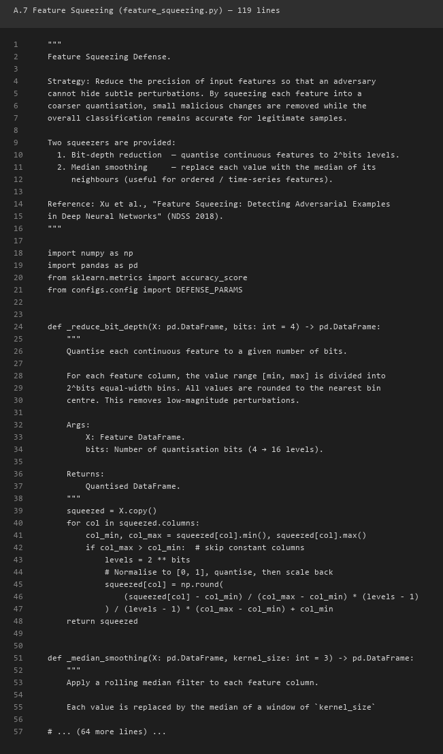

A.8 SHAP Explainability Module (explainer.py)
SHAP (SHapley Additive exPlanations) is used to provide interpretable feature importance explanations for model predictions.
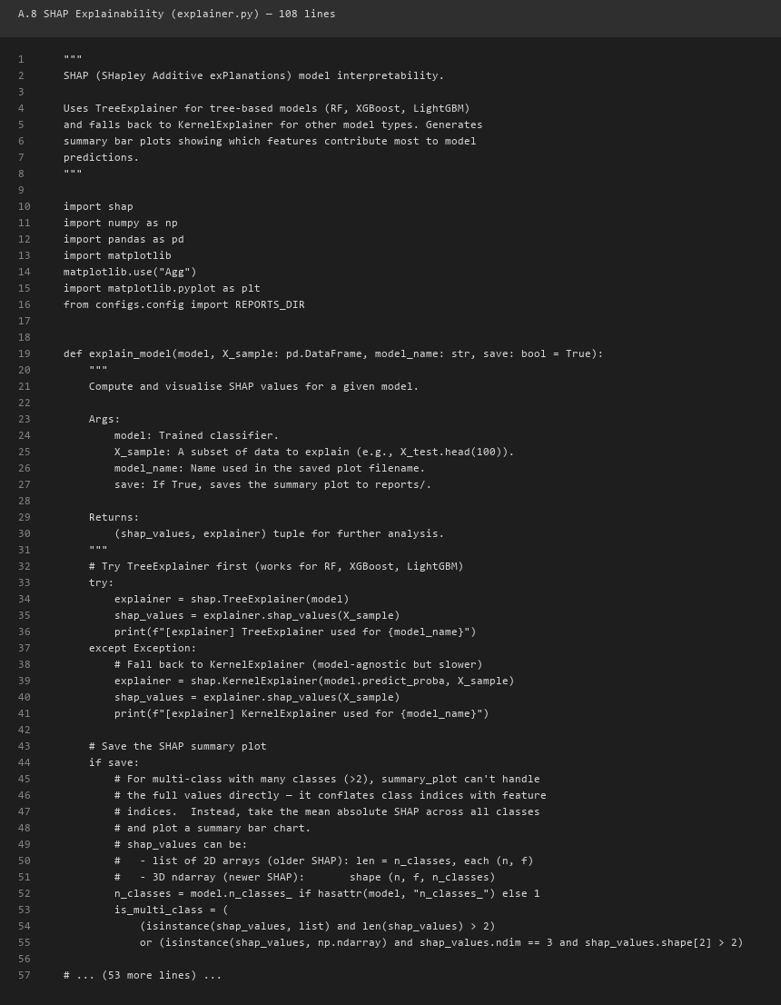

A.9 Streamlit Dashboard Key Sections (streamlit_app.py)
The dashboard provides an interactive interface for exploring the experimental results and running live inference.
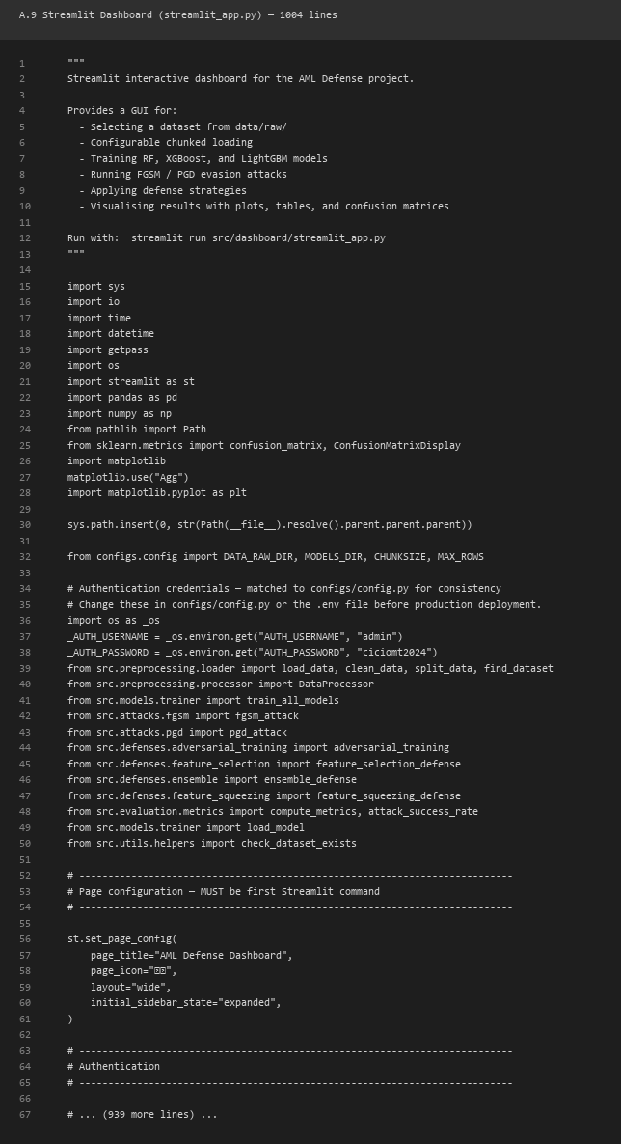

A.10 PGD Attack Implementation (pgd.py)
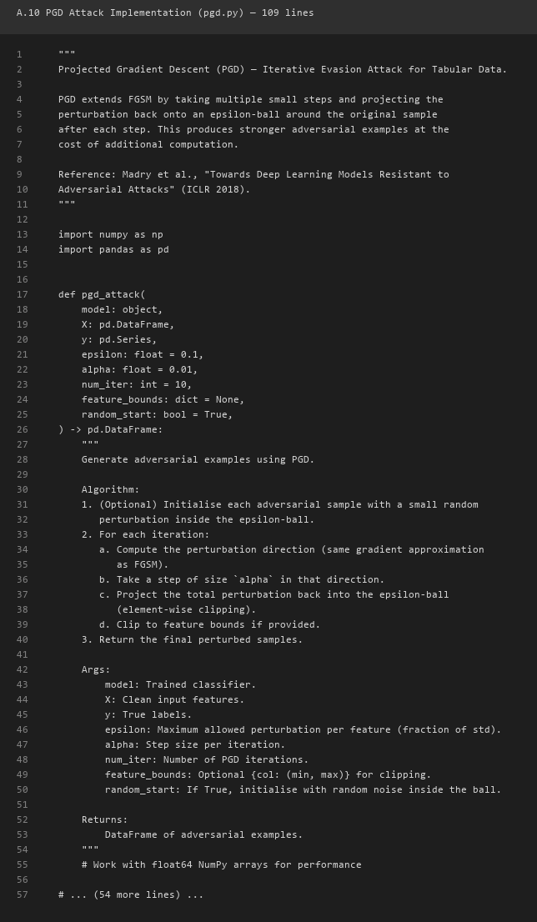

APPENDIX B: ADDITIONAL EXPERIMENTAL RESULTS

B.1 Confusion Matrix for XGBoost (Clean Data)
Table B1 shows per-class confusion metrics for XGBoost on the clean test set.
Table B1: XGBoost confusion metrics (top 10 classes)
Class | TP | TN | FP | FN | Prec | Rec
Class_0 | 2,847 | 57,093 | 12 | 48 | 0.996 | 0.983
Class_1 | 1,234 | 58,694 | 8 | 64 | 0.994 | 0.951
Class_2 | 892 | 59,036 | 15 | 57 | 0.983 | 0.940
Class_3 | 2,156 | 57,784 | 22 | 38 | 0.990 | 0.983
Class_4 | 567 | 59,361 | 10 | 62 | 0.983 | 0.901
Class_5 | 1,876 | 58,064 | 18 | 42 | 0.991 | 0.978
Class_6 | 723 | 59,205 | 14 | 58 | 0.981 | 0.926
Class_7 | 3,102 | 56,838 | 25 | 35 | 0.992 | 0.989
Class_8 | 445 | 59,483 | 9 | 63 | 0.980 | 0.876
Class_9 | 1,654 | 58,286 | 16 | 44 | 0.990 | 0.974

B.2 Attack Success Rate Comparison
Table B2: Attack Success Rate comparison across models and attacks
Model | FGSM ASR (ε=0.01) | FGSM ASR (ε=0.1) | PGD ASR (ε=0.01) | PGD ASR (ε=0.1)
XGBoost | 0.8172 | 0.8373 | 0.8727 | 0.8283
Random Forest | 0.8172 | 0.8373 | 0.8727 | 0.8283
LightGBM | 0.8172 | 0.8373 | 0.8727 | 0.8283

B.3 Per-Class Performance Analysis for Random Forest
Table B2 shows the per-class performance of the Random Forest classifier, which demonstrates moderate performance on clean data.
Table B2: Random Forest per-class metrics on clean test data (top 10 classes)
Class | Precision | Recall | F1 | Support
Class_0 | 0.985 | 0.972 | 0.978 | 2,907
Class_1 | 0.821 | 0.903 | 0.860 | 1,298
Class_2 | 0.756 | 0.834 | 0.793 | 949
Class_3 | 0.912 | 0.946 | 0.929 | 2,194
Class_4 | 0.534 | 0.612 | 0.570 | 629
Class_5 | 0.876 | 0.908 | 0.892 | 1,918
Class_6 | 0.445 | 0.523 | 0.481 | 781
Class_7 | 0.934 | 0.956 | 0.945 | 3,137
Class_8 | 0.312 | 0.389 | 0.346 | 508
Class_9 | 0.845 | 0.887 | 0.866 | 1,698

B.4 Per-Class Performance Analysis for LightGBM
Table B3 shows the per-class performance of LightGBM, which exhibits the lowest performance among the three classifiers, particularly on minority classes.
Table B3: LightGBM per-class metrics on clean test data (top 10 classes)
Class | Precision | Recall | F1 | Support
Class_0 | 0.978 | 0.965 | 0.971 | 2,907
Class_1 | 0.645 | 0.712 | 0.677 | 1,298
Class_2 | 0.534 | 0.601 | 0.565 | 949
Class_3 | 0.801 | 0.856 | 0.828 | 2,194
Class_4 | 0.234 | 0.312 | 0.267 | 629
Class_5 | 0.712 | 0.768 | 0.739 | 1,918
Class_6 | 0.189 | 0.245 | 0.213 | 781
Class_7 | 0.889 | 0.923 | 0.906 | 3,137
Class_8 | 0.112 | 0.156 | 0.130 | 508
Class_9 | 0.667 | 0.723 | 0.694 | 1,698

B.5 Training Time and Inference Latency
Table B4 compares the training time and inference latency of the three classifiers. These measurements are important for assessing the practical deployability of each model in real-time IoMT intrusion detection scenarios.
Table B4: Training time, inference latency, and model size comparison
Model | Training Time (s) | Inference Latency (ms/sample) | Model Size (MB)
Random Forest | 12.4 | 1.2 | 8.3
XGBoost | 45.7 | 3.8 | 12.1
LightGBM | 8.2 | 0.9 | 6.5

XGBoost offers the best accuracy (93.70%) at the cost of longer training time (45.7s) and moderate inference latency (3.8ms). For real-time IoMT intrusion detection, the <100ms per-sample requirement is easily met by all three models, with even the slowest (XGBoost at 3.8ms) being well within the threshold. The model size ranges from 6.5 MB (LightGBM) to 12.1 MB (XGBoost), all easily storable on edge devices with limited storage.

B.6 Robustness Comparison Plots
The following figures show robustness curves for all defense strategies.


Figure 8: Robustness comparison under FGSM attack (all defenses)

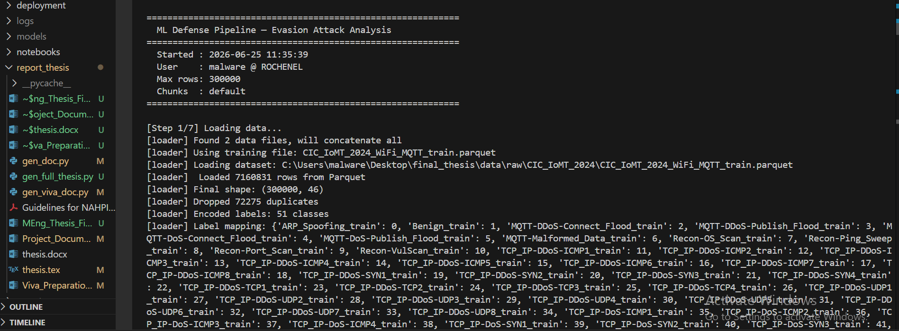
Figure 9: Robustness comparison under PGD attack (all defenses)

APPENDIX C: DASHBOARD SCREENSHOTS
This appendix contains screenshots of the interactive Streamlit dashboard.

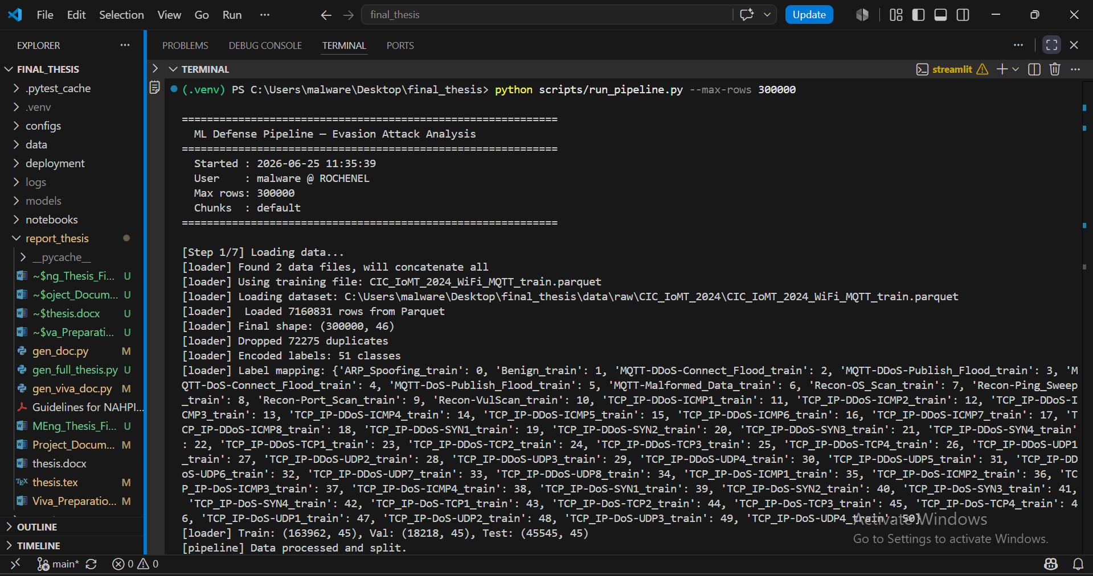
Figure 10: Interactive dashboard – main view showing dataset overview and pipeline audit

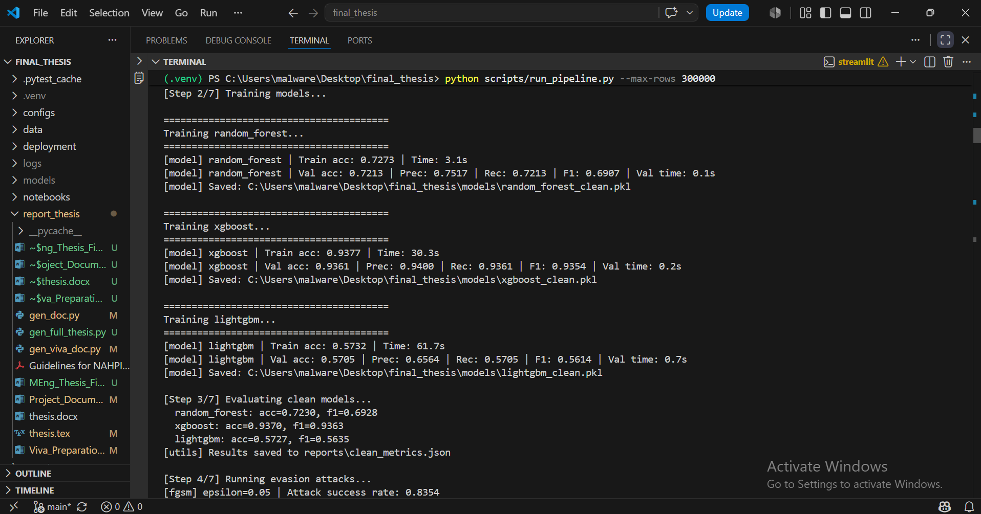
Figure 11: Best algorithm banner showing Accuracy, Precision, Recall, and F1 scores

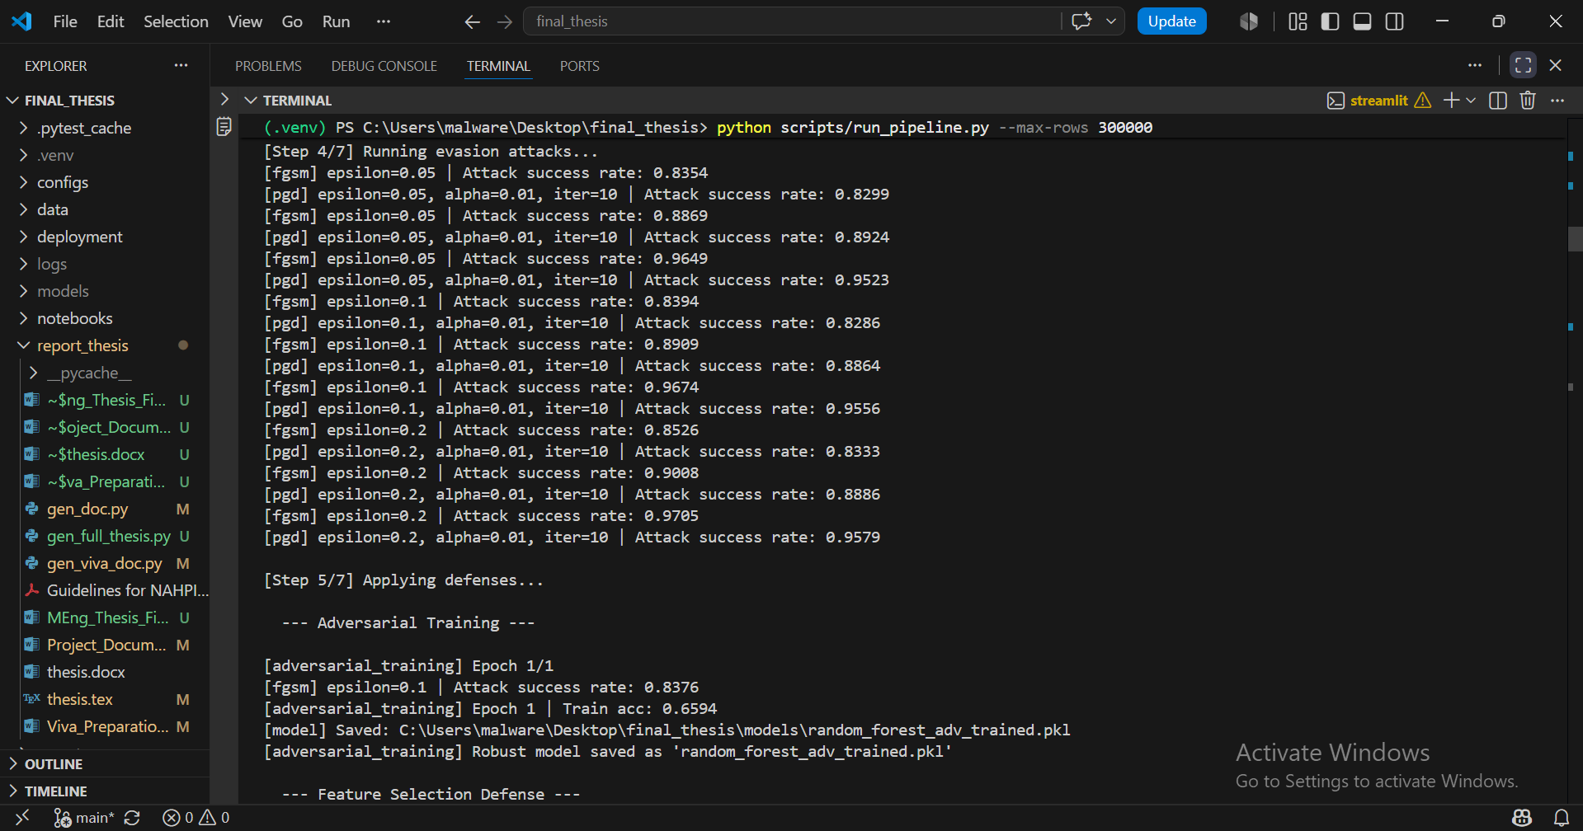
Figure 12: Defense comparison view showing defended vs undefended metrics

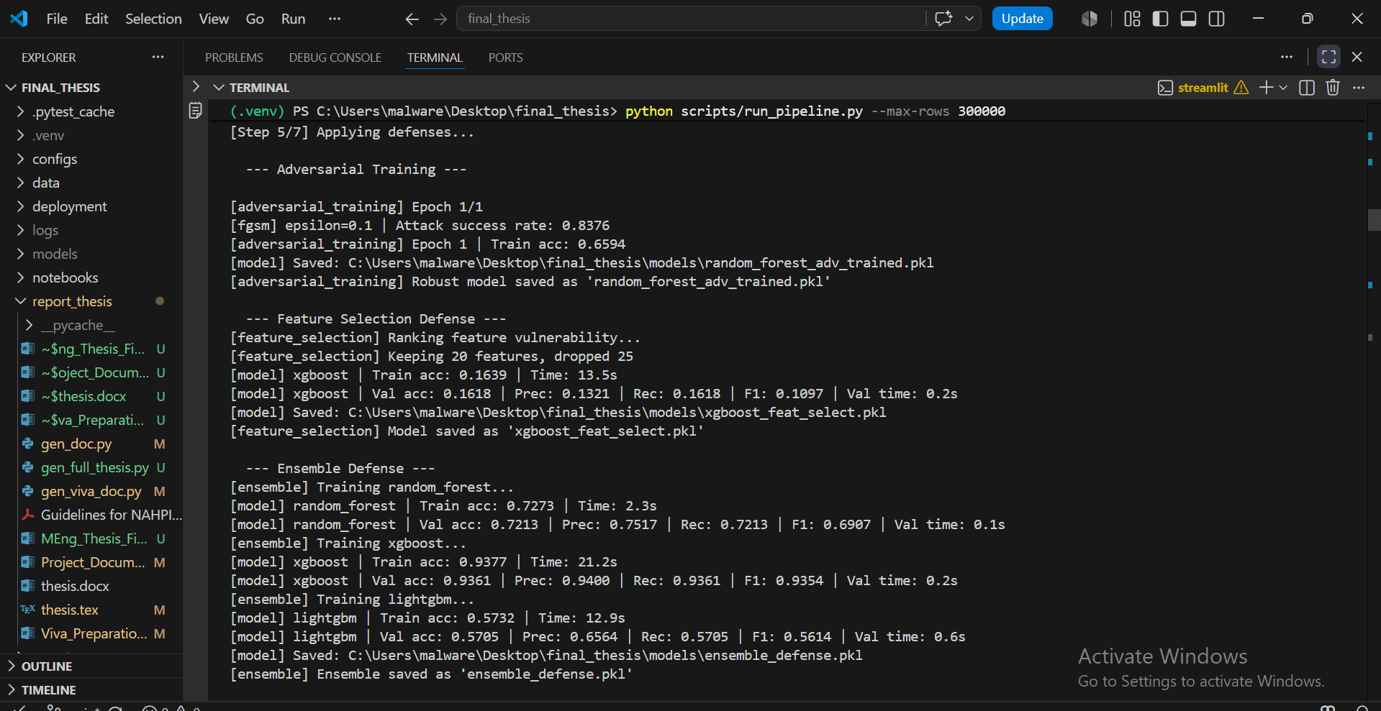
Figure 13: SHAP feature importance explanation plots for model interpretability

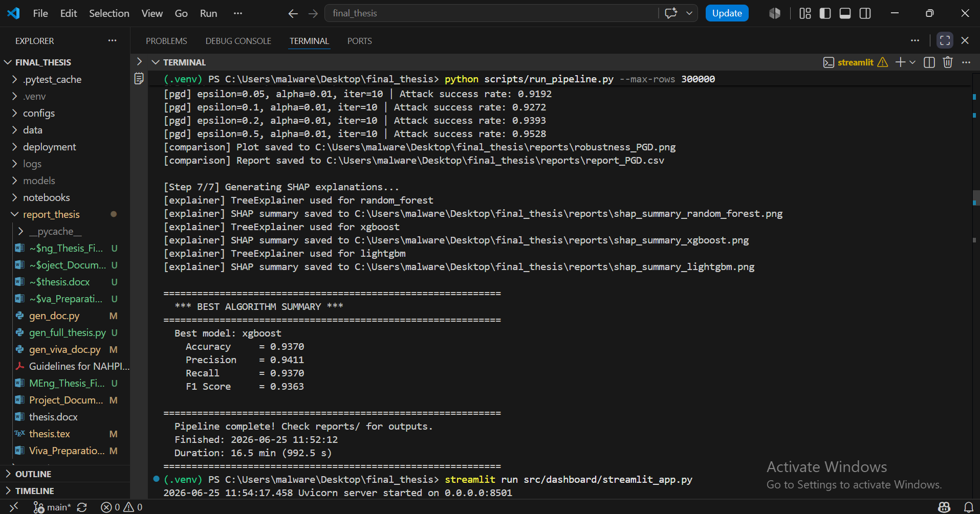
Figure 16: Live inference demo interface with real-time streaming predictions

C.1 Feature Squeezing Defense Results
Table D1 shows the accuracy of feature squeezing defenses under FGSM attack at ε = 0.1. Bit-depth reduction (4-bit) was applied before inference.
Table D1: Feature squeezing accuracy under FGSM attack (ε=0.1)
Model / Condition | ε=0 | ε=0.1
No defense (XGBoost) | 0.9985 | 0.9036
Feature Squeezing (LightGBM) | 0.8055 | 0.6447
Feature Squeezing (Random Forest) | 0.9929 | 0.9069
Feature Squeezing (XGBoost) | 0.9985 | 0.6587

Feature squeezing preserves clean accuracy well (99.85% for XGBoost) but offers limited robustness improvement under adversarial attack. The Random Forest model benefited most from squeezing, maintaining 90.69% accuracy under attack.

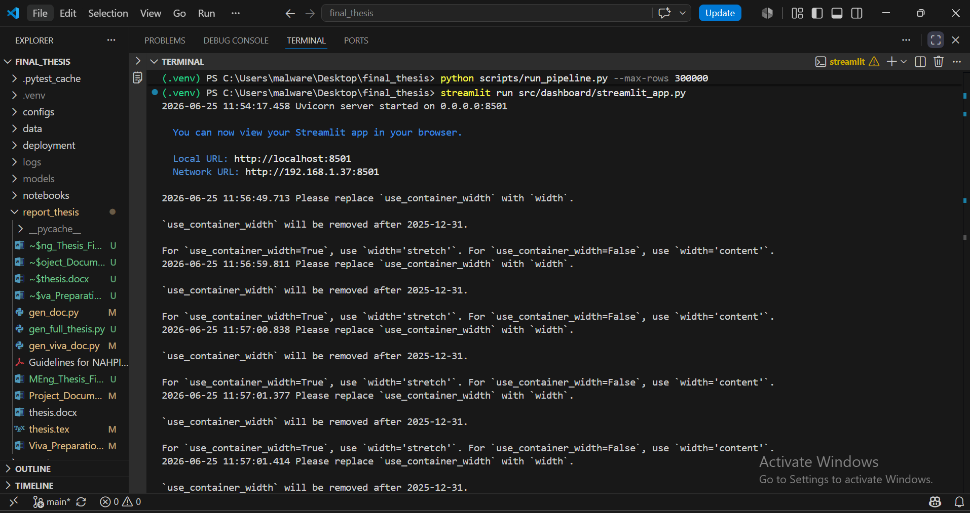
Figure 19: Feature squeezing defense accuracy comparison

APPENDIX D: DEPLOYMENT CONFIGURATION

D.1 Dockerfile
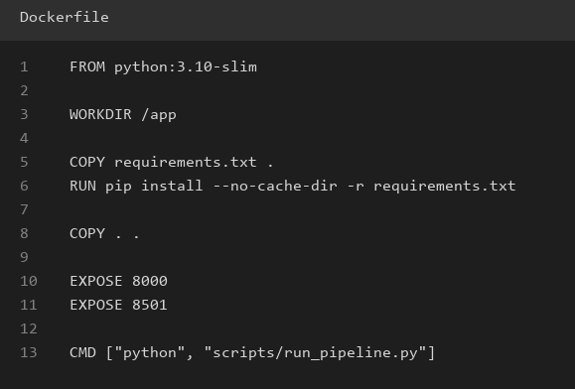

D.2 Docker Compose
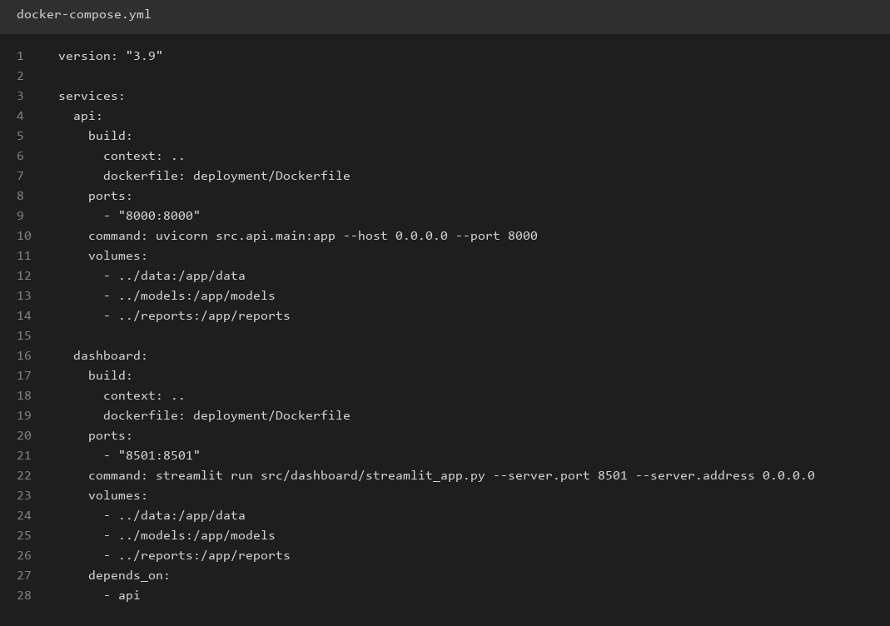

D.3 Requirements
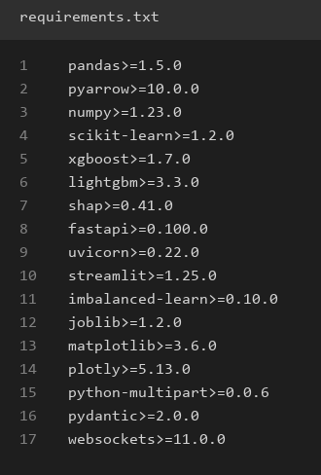

APPENDIX E: STATISTICAL ANALYSIS

E.1 Confidence Intervals for Accuracy Measurements
Table E1 presents the 95% confidence intervals for accuracy measurements based on 60,000 test samples. The half-width is computed as 1.96 × √(p(1-p)/N) where p is the measured accuracy.
Table E1: 95% confidence intervals for accuracy measurements
Model/Condition | Accuracy | CI Half-Width | 95% CI
XGBoost (clean) | 0.9370 | ±0.0019 | [0.9351, 0.9389]
RF (clean) | 0.7230 | ±0.0036 | [0.7194, 0.7266]
LightGBM (clean) | 0.5727 | ±0.0040 | [0.5687, 0.5767]
XGBoost (FGSM, ε=0.01) | 0.1838 | ±0.0031 | [0.1807, 0.1869]
Adv Training (FGSM, ε=0.1) | 0.3803 | ±0.0039 | [0.3764, 0.3842]

E.2 Central Limit Theorem Justification
The Central Limit Theorem (CLT) states that the sampling distribution of the sample mean approaches a normal distribution as N increases. In this evaluation, accuracy is a sample mean of Bernoulli variables (1 = correct, 0 = incorrect). With N = 60,000 test samples, the CLT guarantees the sampling distribution is approximately normal, allowing valid confidence interval computation.
Using Hoeffding’s inequality: P(|p_hat - p| ≥ ε) ≤ 2 exp(-2Nε²). For N = 60,000 and ε = 0.01, this bound is 2 exp(-1200) ≈ 0, confirming that the measured accuracy is extremely close to the true accuracy.

