# The Fire of Rome AD64: A Firefighter’s Perspective

This week, Hayden B. takes a look at one of the most infamous events in the history of the city of Rome: the fire of AD 64! How and why did this disaster strike? Let’s find out…

In July AD 64, Rome burned. It was one of the worst catastrophes in the city’s long history, and although Rome was no stranger to fire, no previous fire compared to the size and ferocity shown by this disaster. Tacitus tells us that of the fourteen regions of Rome, only four remained untouched by the conflagration, and three were completely destroyed [(Tac. . 15.40.1). How did this fire](http://penelope.uchicago.edu/Thayer/E/Roman/Texts/Tacitus/Annals/15B*.html) grow to such immense size and ferocity? What factors contributed to its destructiveness? How did the *vigiles*[1] attempt to combat such a merciless inferno?

## What is fire?

Before we can understand how this infamous fire came to be, the question which may seem completely obvious must first be answered; What, exactly, is fire? As a volatile oxidation of material that results in a combustion reaction, fire has shown to need four specific things for it to exist @Quintiere : 3. These are demonstrated in what we call the fire tetrahedron.

From the perspective of the *vigile*, everything is fuel. The flammability of that fuel is determined by its material composition (e.g. wood vs stone) and how fine or small it is (e.g. log vs stick). Finer fuel made of material with lower ignition temperatures burn more quickly @IcoveHaynes : 70. This would make structures like grain stores, bakeries, and mills much more explosive due to the flammable dust and powder within them. Heat is necessary as to induce the oxidation of nearby materials, which controls the chain reaction required for sustained combustion. As the word suggests, oxidation requires oxygen to function. As oxygen is needed in any combustion reaction, it is a crucial component of fire @IcoveHaynes : 61.

## How does fire spread?

Fire spreads through three main pathways - radiation, conduction, and convection @Quintiere : 77. All of them are controlled by the laws of physics governing heat transfer. Radiation is the ability for heat to travel outwards from the original source. Conduction occurs in solids where heat is able to pass through the object, quickly spreading heat down and through it. Convection in fires works the same as it does for magma under the mantle. In this case, the gas or liquid near the fire gets heated. As hot substances are more active and less dense than their colder counterparts, they begin to rise, before cooling and dropping again. This pushes very hot gas or liquid into new flammable material, causing fire to spread despite no physical connection between the two. These pathways through which fire can spread are limited by the material the heat passes through and its ability to absorb and transfer heat. The bigger the fire, the bigger and faster the spread. However, within confined spaces, another method of fire spreading becomes possible: pyrolysis @IcoveHaynes : 70-71. [Pyrolysis](https://www.youtube.com/watch?v=BtMmymOxdjc), as evident from its etymology (*pyro –* fire, and *lysis* – break down/apart), is the process whereby burning solids release gases. When these gases are trapped in confined spaces, they soon can become flammable themselves. As the gases catch alight (flashover), temperatures rise exponentially, causing fire to easily spread to areas previously unreachable.

The spread of fire is also dictated by the type and amount of fuel available, the weather, and topography of the land @IcoveHaynes : 500-504. Obviously, if there is a large quantity of flammable material nearby, a fire will grow and spread much more rapidly than if the fuel was less abundant or less flammable. Weather controls fire behaviour in many different ways. The most relevant of these are the temperature, relative humidity, wind speed, direction, and changes of direction. As temperature rises, materials and fuels begin to heat, depleting any moisture within them through evaporation, thus making the material more susceptible to ignition and fire spread. As relative humidity drops, the amount of water in the air, too, decreases, dissipating any protection those droplets may have had against fire @IcoveHaynes : 502. Wind works with fire in a number of ways. Firstly, strong winds can physically push a fire along its front at a much faster and ferocious manner than otherwise, as it feeds more oxygen into the combustion reaction. Secondly, any burning material, such as embers, can be taken up by the wind and land on a section which would have been previously been safe from the fire @IcoveHaynes : 503. Topography is especially important, too @IcoveHaynes : 500. As a consequence of convection, fire has a better ability to travel uphill then it does on flat ground or downhill. In exactly the same conditions, for every 10o angle uphill, a fire will travel twice the speed.

Setting: Rome AD64  
It’s mid-July, the peak of Mediterranean summer, and Rome is sweltering. As stated earlier, increased temperatures and reduced relative humidity removes moisture from any material, making it more likely to burn. Consequently, fighting a fire at this time would have been difficult at best, catastrophic at worst. Tacitus tells us that wind was present, most likely the [Scirocco wind](https://www.youtube.com/watch?v=iPOf1VBrF-g) from Africa @Byles : 78, which probably had a great effect in the spread of the fire [(Tac. *Ann*. 15.38.2)](http://penelope.uchicago.edu/Thayer/E/Roman/Texts/Tacitus/Annals/15B*.html). Even today, the hot, dry, and forceful winds of the Scirocco is heavily associated with heat waves and dangerous fire conditions.

The city of Rome is famed for its seven hills upon which it grew. The city has been moulded around this topography, and even writer’s such as Pliny cannot describe the city without mentioning them [(Plin. *NH.* 3.66-67)](https://sourcebooks.fordham.edu/ancient/pliny-natihist-rome.asp). As iconic as the hills may be, they make fire a much more real and dangerous prospect within Rome.

## Buildings and materials

Most of the buildings in Rome during the time of the fire were either destroyed in the blaze, or thereafter. This leaves us with minimal information on the way structures were built at the time. Luckily, the sites of Herculaneum and Pompeii can give clarity in this situation. Being ‘frozen’ in time from the eruption in AD79, buried under a pyroclastic flow and surge, respectively, these sites demonstrate the popular building materials and techniques used in the late republican and early imperial periods. The finding of preserved wood, such as in the House of the Relief of Relephus in 2009, prompted an investigation into the wooden ceiling panels @Macchionietal : 1024-1037. It also showed that Roman buildings had large amounts of wood within their structure, making them much more susceptible to the ignition and spread of fire.

## Origins of the fire

The recounts of Tacitus, Cassius Dio, and Suetonius all differ on the origins of the fire. The latter two believed Nero ordered the destruction and consequent plundering of the city through his soldiers [(Cass. Dio. 62.16.2-3)](http://penelope.uchicago.edu/Thayer/e/roman/texts/cassius_dio/62*.html). Tacitus, however, is far more specific. He states that it occurred in the “Circus which adjoins the Palatine and Caelian Hills… among shops” [(Tac. *Ann*. 15.38.2)](http://penelope.uchicago.edu/Thayer/E/Roman/Texts/Tacitus/Annals/15B*.html). His specificity and lack of blame on Nero, amongst other reasons, gives credibility to his assertion and, perhaps, can be considered a more reliable account. This will be discussed below.

Expansion of the fire  
The shops that Tacitus mentioned as the genesis of the fire are incredibly important. Due to the abundance of ‘merchandise’ within them, the fuel readily available to it from the start, combined with the strong wind allowed for the fire to quickly engulf the entire circus (region XI). Given its proximity to the origin point, and the inclination to the hill, it is reasonable to assume that the royal palace on the Palatine (region X) was also one of the first to go up.

Once the fire had passed the circus, the fire soon found the overburdened, narrow, and irregular streets of Rome [(Tac. *Ann*. 15.38.3)](http://penelope.uchicago.edu/Thayer/E/Roman/Texts/Tacitus/Annals/15B*.html). Being so close together, the buildings allowed easy transfer of fire between them, and even Tacitus remarks on how quickly the fire spread [(Tac. *Ann*. 15.38.5)](http://penelope.uchicago.edu/Thayer/E/Roman/Texts/Tacitus/Annals/15B*.html). Although Tacitus does not give us a direction of the fire, he sets up some important boundaries. He says that the fire was put out at the foot of the Esquiline Hill (Region V) and that Nero opened up the Campus Martius to the displaced populace [(Tac. *Ann*. 15.39-40)](http://penelope.uchicago.edu/Thayer/E/Roman/Texts/Tacitus/Annals/15B*.html). The structures that he mentions that burned can also be used to deduct the direction and behaviour of the fire [(Tac. *Ann*. 15.41.1)](http://penelope.uchicago.edu/Thayer/E/Roman/Texts/Tacitus/Annals/15B*.html). These can be traced to the Aventine Hill (Region XIII), *Forum Boarium* (Near *Porta Flumentana*), and *Forum Romanum* (Region VIII). As all of these are west of the ignition spot, an Easterly wind can be deduced as highly likely, at-least in the early stages of the fire. The fact that the fire eventually spread North East to the Esquiline Hill means that either a wind change occurred sometime during the fire, or regardless of the wind, the sheer amount of fuel allowed the fire to travel against the wind. Either way, it shows a characteristically dangerous fire which would have been near impossible to put out.

## Firefighting efforts

Given how quickly the fire spread, and the chaotic conditions created by panic, the conditions were set against the *vigiles* from the start. This leaves the firefighters little options in order to contain the fire. Even with our technology today, fires over 1.5 - 2 m in height are deemed too big for a direct attack. This leaves only defensive options. The biggest way to set up a defensive perimeter is by removing the fuel between the fire and that boundary. As structures were the fuel in this instance, that is what had to be removed through either demolishing them or by burning them down in a controlled manner. As recounts from all three authors include men, acting under authority, as purposefully destroying buildings by demolition or with fire. Although damning in their report of this activity, the removal of the structures would have been vital in the containment of the blaze. Considering that we know that the Esquiline and Campus Martius were spared from complete damage, it is logical to deduce that the back-burning and firefighting operations were centred on these areas. The use of firebreaks like the Servian wall would have acted like control lines for the firefighters, as they knew it would be their best chance at stopping the fire from spreading. Luckily enough, the plan seemed to have worked as the control lines held, protecting the Campus Martius, where Nero housed the displaced populace, and the where the original blaze was extinguished at the foot of the Esquiline Hill [(Tac. *Ann.* 15.40.1)](http://penelope.uchicago.edu/Thayer/E/Roman/Texts/Tacitus/Annals/15B*.html).

**Figures**

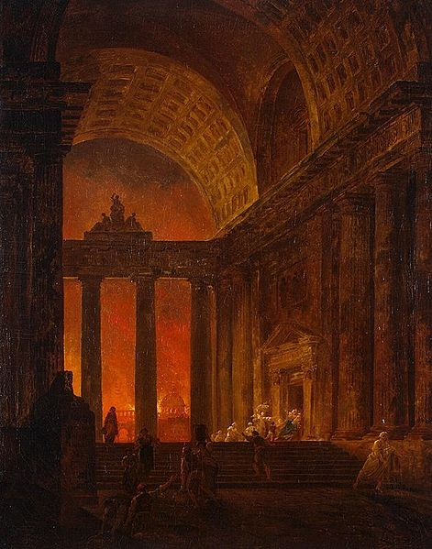

Figure 1: The Fire of Rome by Hubert Robert, 1787.

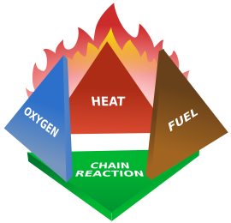

Figure 2: Fire Tetrahedron

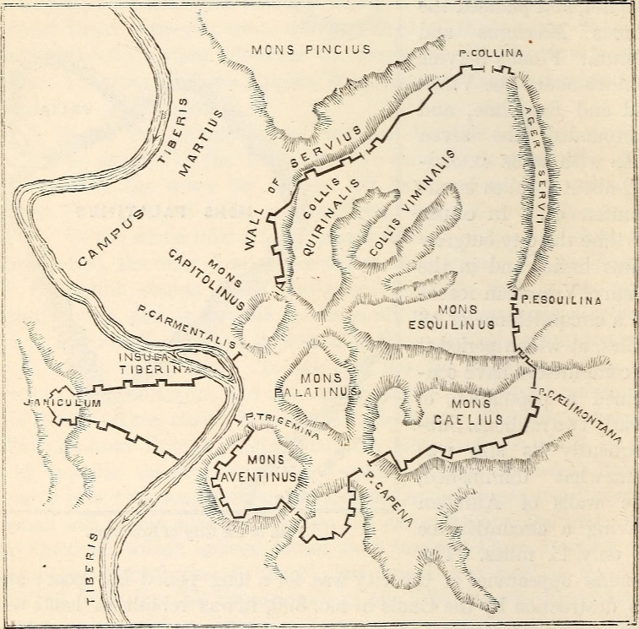

Figure 3: Map of Rome depicting the Hills and Servian Wall

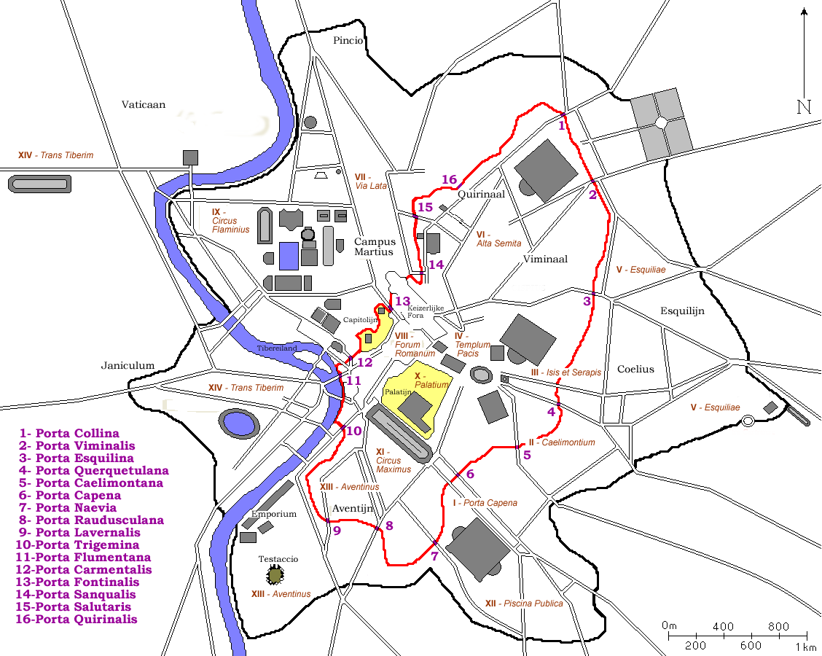

Figure 4: Map of Rome showing the Regions and walls of Rome.  
Originally made by fr:User:ColdEel & edited by nl:Gebruiker:Joris; modified by H. Bayne

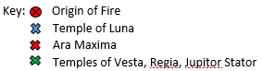

**Further Reading:**

* Fires of Rome:
  + Rubin, L. (2004), *De Indenddis Urbis Romae: The Fires of Rome in Their Urban Context,* PhD Thesis, State University of New York.
  + Closs, V. M. (2013), *While Rome Burned: Fire Leadership, and Urban Disaster in the Roman Cultural Imagination,* PhD Thesis, University of Pensylvania.
* Fire Behaviour and Principles:
  + Sundén, B. & Faghri, M. (2008), *Transport Phenomena in Fires,* WIT Press, Cambridge.
  + Bergman, T. L., Lavine, A. S., Incropera, F. P., Dewitt, D. P. (2011), *Fundamentals of Heat and Mass Transfer,* 7th ed.,John Wiley and Sons, United States of America.
* *Vigiles* 
  + Rainbird, J. S. (1986), “Fire Stations of Imperial Rome”, *Papers of the British School at Rome,* vol. 54, pp. 147-69.
  + Fuhrmann, C. (2005), *Keeping the imperial peace: Public Order, state control and policing in the Roman Empire during the first three centuries AD,* PhD Thesis, University of North Carolina.

**Bibliography:**

**Ancient Sources**

* Cassius Dio, *Roman History,* Translated by B. Thayer, From [http://penelope.uchicago.edu/Thayer/e/roman/texts/cassius_dio/62*.html](http://penelope.uchicago.edu/Thayer/e/roman/texts/cassius_dio/62*.html)
* Pliny the Elder, *Natural History*, Translated by W. S Davis, from <https://sourcebooks.fordham.edu/ancient/pliny-natihist-rome.asp>
* Suetonius, *Life of Nero,* 38. Translated by <http://www.perseus.tufts.edu/hopper/text?doc=urn:cts:latinLit:phi1348.abo016.perseus-eng1:38>

Tacitus, *Annals*, 15.40.2. Translated by A. J. Woodman. Hackett Publishing Company. Indianapolis, Chicago. 2004

**Modern Sources**

Quintiere, J. G., *Principles of Fire Behavior*, 2nd ed., 2017

Icove, D. J., Haynes, G. A., *Kirk’s Fire Investigation*, 8th ed., 2018

Byles, R., *Fire and its consequences in the city of Rome in antiquity, 390BC – AD410,* PhD thesis, University of Wales, 2013

Macchioni, N., Pizzo, B., Pecoraro, E., Sozzi, L., Lazzeri, S. ‘New Wooden Archaeological Finds from Herculaneum: The State of Preservation and Hypothesis of Consolidation of the Material from the House of the Relief of Telephus’ in *Archaeometry,* vol 58(6). 2015. pp. 1024-37

**Modern Sources in Bibtex:**

@book{Quintiere,  
title = {Principles of Fire Behavior, 2nd Edition},

author = {James G. Quintiere},

year = {2017},

month = {09},

isbn = {ISBN-10: 1498735649}

}

@book{IcoveHaynes,  
title = {Kirk's Fire Investigation, 8th Edition},

author = {David Icove and Gerald Haynes},

year = {2017},

month = {10},

isbn = {ISBN-13: 978-0134237923}

}

Cannot find Byles

@article{Macchionietal,

author = {Macchioni, N. and Pizzo, B. and Capretti, C. and Pecoraro, E. and Sozzi, L. and Lazzeri, S.},

title = {New Wooden Archaeological Finds from Herculaneum: The State of Preservation and Hypothesis of Consolidation of the Material from the House of the Relief of Telephus},

journal = {Archaeometry},

volume = {58},

number = {6},

pages = {1024-1037},

keywords = {waterlogged archaeological wood, chemical characterization, physical characterization, roman roof, ft–ir},

doi = {10.1111/arcm.12213},

url = {https://onlinelibrary.wiley.com/doi/abs/10.1111/arcm.12213},

eprint = {https://onlinelibrary.wiley.com/doi/pdf/10.1111/arcm.12213},

abstract = {This paper deals with the description of the analysis performed to characterize the state of preservation of the wooden artefacts recently discovered at the site of Herculaneum, Italy. During 2009, several wooden artefacts were brought to light during maintenance work at Herculaneum. They were attributed to both the roofing elements and the ceiling of the House of the Relief of Telephus. The roof was found mainly disassembled; nevertheless, it was an extraordinary archaeological find, because it represents a unique vestige of a Roman roof and, moreover, the aspect of both the structural and the decorative panels, where portions of the original polychrome decoration and traces of gilding were still preserved, appeared almost intact. Within the framework of the Herculaneum Conservation Project, a diagnostic study was undertaken to characterize the state of preservation of the wood constituting the roof, and also including the decorated panels of the ceiling, in order to determine a consolidation process able to structurally support the decayed wood without damaging the residual polychrome decoration. The results of the micromorphological, chemical and physical characterization of the wood, as a combined diagnostic process, are reported. A first proposal of a possible consolidation methodology based on the analytical results is also suggested.}

}

**Images**

Figure 1:

Hubert Robert, *The Fire of Rome,* Painting, 1787,  
Wikimedia Commons, (2015), accessed on 20 September 2018,

<<https://commons.wikimedia.org/wiki/File:Fire_in_Rome.jpg>>

Licence: Public Domain

Figure 2:   
Gustavb, *Fire Tetrahedron,* 2006,  
Wikimedia Commons, (2006), accessed on 20 September 2018,  
 <<https://commons.wikimedia.org/wiki/File:Fire_tetrahedron.svg>>

Licence: Public Domain

Figure 3:

William Smith,  *The Student’s manual of ancient geography, based upon the Dictionary of Greek and Roman Geography,* 1861,   
Wikimedia Commons, (2015), accessed on 20 September 2018, <<https://commons.wikimedia.org/wiki/File:The_student's_manual_of_ancient_geography,_based_upon_the_Dictionary_of_Greek_and_Roman_geography_(1861)_(14768984432).jpg>>

Licence: Flikr API, No known copywrite restrictions

Figure 4:

[fr:User:ColdEel](https://fr.wikipedia.org/wiki/User:ColdEel) & edited by [nl:Gebruiker:Joris](https://nl.wikipedia.org/wiki/Gebruiker:Joris), *Servian wall on a map of ancient Rome around 300AD,* edited by Hayden Bayne, 2018,  
Accessed on 20 September 2018,   
<<https://en.wikipedia.org/wiki/File:Plan_Rome-_Servische_Muur.png>>

Licence: Creative Commons Attribution-Share Alike 3.0 Unported

1. Firefighters