A *taurobolium* inscription mentioning *Magna Mater* (*CIL* XIII 1765). Image: Morburre, Wikimedia Commons, CC BY SA 3.0. <https://en.wikipedia.org/wiki/File:Lyon-Autel-CIL-XIII-1756.jpg>

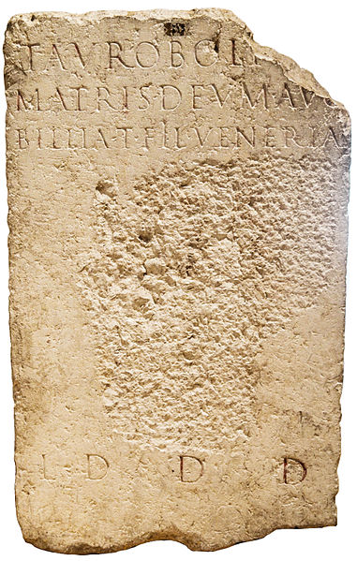

Three sides of a *taurobolium* altar to Magna Mater from Lyon. Wikimedia Commons, CIL XIII, 1751. Image: Morburre, WikiCommons, CC BY-SA 3.0. <https://en.wikipedia.org/wiki/Taurobolium#/media/File:Autel-Lyon-CIL-XIII-1751.jpg>

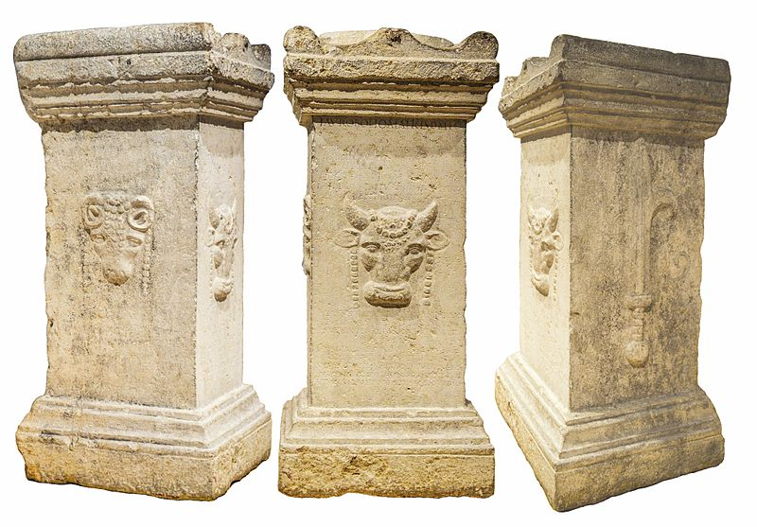

Engraving by Bernhard Rode. Image: WikiCommons, Public Domain. <https://simple.wikipedia.org/wiki/Taurobolium#/media/File:Taurobolium.jpg>