AI DESIGN LOG
Camply — Phiên bản v1 (UI ban đầu từ Google Stitch)
Môn học / Lab | PRM323 — Cross-Platform Application Development · Lab 2: Thiết kế UI/UX có hỗ trợ AI (Google Stitch → Figma)
Chủ đề | Camply — ứng dụng khám phá và đăng ký sự kiện trong trường cho sinh viên 18–24 tuổi (Android, 360 × 800 dp)
Sinh viên | [Họ tên] — MSSV: [điền]
Phiên bản log | v1 — giai đoạn Generate (UI ban đầu); chưa gồm vòng lặp và phản biện
Phạm vi bằng chứng | Prompt nguyên văn S01–S10 (camply.docx) và T01–T07 (bản soạn) · 16 ảnh chụp Stitch: S02–S10 và T01–T07 · DESIGN.md
Đường dẫn trong repo | ai/ai-design-log.md (nội dung tương ứng) · assets/stitch/ (ảnh chụp)

1. Khai báo công cụ AI
Công cụ | Dùng để làm gì | Giai đoạn
Google Stitch | Tạo UI ban đầu cho S01–S10 và các biến thể trạng thái T01–T07 từ prompt + DESIGN.md | Generate (v1)
Claude (Anthropic) | Tổng hợp tài liệu log này từ prompt và ảnh chụp có sẵn | Tài liệu
[Điền: trợ lý AI phản biện] | Đánh giá UI theo 10 heuristic của Nielsen, accessibility và persona | Critique (chưa thực hiện trong v1)

2. Bản mô tả thiết kế đưa cho Stitch (DESIGN.md)
Mọi prompt v1 đều tham chiếu file DESIGN.md (tên hệ thống: Campus Event Guide) và phong cách "Modern Campus Editorial". Các giá trị chính:
Nhóm | Giá trị trong DESIGN.md | Ghi chú sử dụng
Màu chính | primary-container / Electric Blue #2457F5; primary-pressed #1745D5; primary-soft #EAF0FF | Hành động chính
Màu nhấn | accent Lime #C9F46A | Dùng tiết chế (nhãn, điểm nhấn)
Nền & chữ | background #F8F9FC; text-primary #171923; text-secondary #525866; text-disabled #737987; border #DCE0E8 | Nền và văn bản
Trạng thái | success #18794E; warning #8A5700; error #B42336 (error-surface #FDECEF) | Phản hồi & lỗi
Typography | Inter — display 28/36 · headline 24/32 · subhead 20/28 · title 16/24 · body 14/20 · label 14/20 (500) · button 16/24 (600) | Chữ nội dung ≥ 14
Bo góc | sm 4 · DEFAULT 8 · md 12 · lg 16 · xl 24 · full 9999 (px) | Thẻ và control 8–16
Khoảng cách | margin/gutter 16 · xs 4 · sm 8 · md 12 · lg 16 · xl 24 (px) | Thang 4 dp, lề ngang 16

3. Danh mục kết quả v1
Mã | Màn hình | Prompt | Ảnh chụp
S01 | Discover / Home | Có (nguyên văn) | Thiếu — cần bổ sung
S02 | Explore Events | Có (nguyên văn) | Có
S03 | Event Detail | Có (nguyên văn) | Có
S04 | Event Registration | Có (nguyên văn) | Có
S05 | Registration Success | Có (nguyên văn) | Có
S06 | My Events | Có (nguyên văn) | Có
S07 | Digital Ticket | Có (nguyên văn) | Có
S08 | Saved Events | Có (nguyên văn) | Có
S09 | Notifications | Có (nguyên văn) | Có
S10 | Student Profile | Có (nguyên văn) | Có
T01 | Cancel Registration Dialog (biến thể của S06) | Có (nguyên văn, bản soạn) | Có
T02 | Registration Form Validation Error (biến thể của S04) | Có (nguyên văn, bản soạn) | Có
T03 | Registration Loading State (biến thể của S04) | Có (nguyên văn, bản soạn) | Có
T04 | Saved Events Empty State (biến thể của S08) | Có (nguyên văn, bản soạn) | Có
T05 | Notifications Empty State (biến thể của S09) | Có (nguyên văn, bản soạn) | Có
T06 | Explore – No Results (biến thể của S02) | Có (nguyên văn, bản soạn) | Có
T07 | My Events – Cancellation with Undo Snackbar (biến thể của S06) | Có (nguyên văn, bản soạn) | Có
Ghi chú: "Phạm vi" của v1 gồm 10 màn hình chính (S01–S10) và 7 biến thể trạng thái (T01–T07). Theo đề lab, dialog và biến thể trạng thái không tính là màn hình riêng.

4. Nhật ký prompt và kết quả v1

4.1 S01 — Discover / Home
Mục tiêu màn hình | Màn hình chính: khám phá sự kiện nổi bật, danh mục và sự kiện sắp diễn ra.
Công cụ | Google Stitch
Tham chiếu đưa vào prompt | design/DESIGN.md (Campus Event Guide) + các màn hình đã duyệt trước đó (S02, S03, S06, S08 được nêu trong prompt)
Prompt nguyên văn (không chỉnh sửa)
## ROLE
You are a senior mobile UI/UX designer specializing in clean, production-ready Android applications for university students.

## TASK
Create ONE polished, high-fidelity mobile screen for **Camply — S01 Discover / Home**, a campus event discovery and registration app for university students aged 18–24.

The screen should help students discover campus events quickly, understand what is happening, and access event details with minimal effort.

This is the main home screen, not a marketing landing page.

## DESIGN REFERENCES
- Use the attached `DESIGN.md` as the authoritative design system.
- Maintain visual consistency with the existing Camply screens, especially S02 Explore, S03 Event Detail, S06 My Events, and S08 Saved Events.
- Reuse the established typography, colors, icon style, spacing, buttons, card styling, and bottom navigation.
- Follow the Modern Campus Editorial visual style.
- Do not copy another screen's layout exactly; create a layout suitable for Discover / Home.

## FRAME AND DESIGN SYSTEM
- Platform: Android mobile.
- Frame: **360 × 800 dp**.
- Theme: Light.
- Font: Inter.
- Background: `#F8F9FC`.
- Primary color: Electric Blue `#2457F5`.
- Accent color: Lime `#C9F46A`, used sparingly.
- Primary text: `#171923`.
- Secondary text: `#525866`.
- Horizontal page margins: 16 dp.
- Use a consistent 4 dp spacing scale.
- Use 8–16 dp corner radii for cards and controls.
- Keep shadows subtle and visual hierarchy clear.

## EXACT SCREEN STRUCTURE

### 1. Header
- Display the Camply brand clearly.
- Include a short, friendly personalized greeting.
- Include a notification icon with a small unread indicator.
- Include a small student avatar.
- Keep the header compact and aligned.

### 2. Welcome Section
- Display the heading: **“What's happening on campus?”**
- Use a clear typographic hierarchy.
- Keep the supporting content minimal.
- Do not add a large promotional banner or excessive introductory text.

### 3. Featured Event
- Feature **“Campus Music Night”** as the main visual focus.
- Use an authentic-looking campus concert photograph.
- Show the event title, date, time, and venue.
- Place a compact date badge over the image.
- Include a clear **“Details”** action.
- Keep the image and its event information visually connected.
- Make the featured event prominent without allowing it to consume the entire screen.

### 4. Browse Categories
- Section title: **“Browse Categories”**.
- Include a **“See all”** action.
- Display four compact, recognizable icon-based category shortcuts:
- Music
- Workshop
- Sports
- Arts
- Keep the shortcuts evenly spaced and easy to tap.
- Avoid oversized illustrations or decorative category cards.

### 5. Upcoming Events
- Section title: **“Upcoming Events”**.
- Include a **“See all”** action that leads to S02 Explore Events.
- Show compact event previews with an image, event name, date, and venue.
- Use these example events:
- AI & Future Careers Workshop
- Football Tournament
- Photography Walk
- Prioritize readability and quick scanning.
- Use consistent event-card styling with the other Camply screens.

### 6. Bottom Navigation
Display exactly four tabs:
- Discover
- Explore
- My Events
- Profile

Requirements:
- Discover must be the selected tab.
- Use consistent icons, labels, spacing, and active-state styling with the other Camply screens.
- Keep the navigation fixed at the bottom.
- Ensure the content does not overlap the navigation.

## INTERACTION REQUIREMENTS
- Tapping the featured event or its “Details” action opens S03 Event Detail.
- Tapping a category opens S02 Explore Events with the relevant category selected.
- Tapping “See all” in Browse Categories opens S02 Explore Events.
- Tapping “See all” in Upcoming Events opens S02 Explore Events.
- Tapping the notification icon opens the existing notifications destination.
- Tapping the bottom navigation tabs opens their corresponding existing screens.
- Do not invent additional destinations or unsupported interactions.

## HARD CONSTRAINTS — MUST FOLLOW

1. Generate **S01 Discover / Home only**.
2. Generate exactly one mobile screen at 360 × 800 dp.
3. Do not generate additional screens, alternative versions, or a multi-screen flow.
4. Do not add login, registration, payment, admin, or onboarding features.
5. Do not add a full search field; search belongs to S02 Explore Events.
6. Do not replace the featured event with a generic promotional banner.
7. Do not remove the four required categories or the Upcoming Events section.
8. Do not add extra bottom navigation tabs.
9. Do not invent new features, sections, statistics, or promotional content.
10. Do not use excessive text, oversized headings, nested cards, heavy shadows, or excessive gradients.
11. Do not use lime as the dominant color. Electric Blue remains the primary action color.
12. Do not change the established Camply design system or create a visually unrelated style.
13. Maintain accessible text contrast and a minimum touch-target size of 48 × 48 dp.
14. Keep the layout compact, realistic, and feasible to implement in a production Android application.
15. Prioritize the event photograph, event information, category shortcuts, and upcoming events in a clear visual hierarchy.
16. Avoid unnecessary decorative elements that do not support event discovery.

## EXPECTED OUTPUT
Generate one polished, high-fidelity Android UI screen for **Camply S01 Discover / Home**, using the attached `DESIGN.md` and existing Camply screens as design references.

The final result must be visually consistent, compact, easy to scan, and ready for further UI/UX evaluation.
Kết quả và quyết định
[Chưa có ảnh S01 trong gói export — dán ảnh vào đây] | Ảnh: assets/stitch/s01_discover_home.png (cần bổ sung)  Quan sát kết quả  - Không có ảnh S01 trong gói export Stitch (thư mục chỉ có S02–S10 và T01–T07) → cần bổ sung ảnh chụp S01 để log truy vết được tới bằng chứng.  Quyết định (v1): Chưa thể đánh giá kết quả vì thiếu ảnh. Prompt đã được ghi nguyên văn.

4.2 S02 — Explore Events
Mục tiêu màn hình | Duyệt, tìm kiếm và lọc sự kiện.
Công cụ | Google Stitch
Tham chiếu đưa vào prompt | design/DESIGN.md (Campus Event Guide) + các màn hình đã duyệt trước đó
Prompt nguyên văn (không chỉnh sửa)
You are a senior mobile UI/UX designer specializing in clean, production-ready Android applications.

## TASK

Create ONE high-fidelity mobile screen for **Camply — S02 Explore Events**, a campus event discovery and registration application for university students aged 18–24.

This is a fresh generation. The target is a polished, compact, and highly usable interface that does not require major redesign.

Use the attached **DESIGN.md** and the approved S01 Discover screen as design references.

## SCREEN AND DESIGN SYSTEM

- Frame: 360 × 800 dp, Android-first.
- Style: Modern Campus Editorial, clean and professional.
- Background: #F8F9FC.
- Primary color: #2457F5.
- Accent: #C9F46A, used sparingly.
- Primary text: #171923.
- Secondary text: #525866.
- Font: Inter.
- Horizontal page margins: 16 dp.
- Spacing: consistent 4 dp scale.
- Corner radius: 8–16 dp for controls and cards.
- Use consistent icons, typography and bottom navigation from S01.

Do not create a tablet layout, marketing landing page, or oversized concept mockup.

## EXACT SCREEN STRUCTURE

Arrange the following elements vertically, in this order:

### 1. Page Header

- Title: "Explore Events".
- Clear, bold typography.
- No decorative subtitle, promotional banner or additional profile header.

### 2. Search Field

- Full-width search field.
- Search icon on the left.
- Placeholder: "Search events by name or keyword".
- Compact height and subtle border.
- Clear-search control only when a query is entered.

### 3. Category Filters

One horizontally scrollable row containing:

All | Music | Workshop | Sports | Arts

- "All" is selected by default.
- Selected state uses primary blue.
- Unselected chips use neutral backgrounds.
- Keep chips compact, readable and visually consistent.

### 4. Secondary Filters

One compact horizontal row containing:

Any time | On campus | Sort: Newest

- Use subtle outline controls.
- Avoid large filter panels or separate filter cards.
- Do not introduce additional filter categories.

### 5. Search Results

Display the text:

"24 events found"

Use a subtle, compact text style.

### 6. Event List

Create vertically stacked, **compact horizontal event cards**.

Each card must contain:

- One event thumbnail on the left.
- Category label.
- Event title in bold.
- Date and time.
- Venue.
- Bookmark icon aligned on the right.

Sample events, in this exact order:

1. Campus Music Night — Music
2. AI & Future Careers Workshop — Workshop
3. Football Tournament — Sports
4. Photography Walk — Arts

Use concise sample metadata. Do not invent extra descriptions, organizer biographies, ratings, ticket prices or promotional badges.

**Card layout requirements:**

- Use a thumbnail approximately 88 × 88 dp.
- Keep card height approximately 108–120 dp.
- Use balanced internal padding.
- Maintain clear alignment between image and text.
- Keep the event title visually dominant.
- Date/time and venue must remain legible.
- Avoid excessive nested containers, thick borders and heavy shadows.
- Avoid large vertical gaps between cards.
- Show approximately three cards within the initial viewport; remaining cards may continue below the fold through vertical scrolling.

### 7. Bottom Navigation

Use a fixed bottom navigation bar with exactly four destinations:

Discover | Explore | My Events | Profile

- Explore is active.
- Use the same visual treatment as S01.
- Keep navigation separate from scrollable content.
- Do not add additional tabs or floating action buttons.

## UX AND ACCESSIBILITY REQUIREMENTS

- Make the search field and filters easy to discover.
- Prioritize quick scanning of event titles and dates.
- Maintain a clear visual hierarchy.
- Body text must be at least 14 sp.
- Interactive targets must be at least 48 × 48 dp.
- Normal text must meet a minimum 4.5:1 contrast ratio.
- Avoid truncating important event titles or essential metadata.
- Use consistent icon sizes and spacing.
- Ensure the screen remains usable at 412 dp width.

## HARD CONSTRAINTS — MUST FOLLOW

1. Generate exactly ONE mobile screen.
2. Do not add marketing banners or hero sections.
3. Do not use oversized event images.
4. Do not use vertical poster-style event cards.
5. Do not create nested cards inside cards.
6. Do not add explanatory paragraphs or unnecessary copy.
7. Do not invent new functionality.
8. Do not change the four-item bottom navigation.
9. Do not use typography smaller than 14 sp for body metadata.
10. Do not squeeze all four events into the viewport at the expense of readability.
11. Preserve the established Camply design system.
12. Do not redesign any other Camply screen.

## EXPECTED RESULT

A polished, compact Explore Events screen with a clear search experience, readable category and filter controls, professional horizontal event cards, and consistent navigation.

The design should feel like a real production-ready campus application, not a decorative AI-generated concept.
Kết quả và quyết định
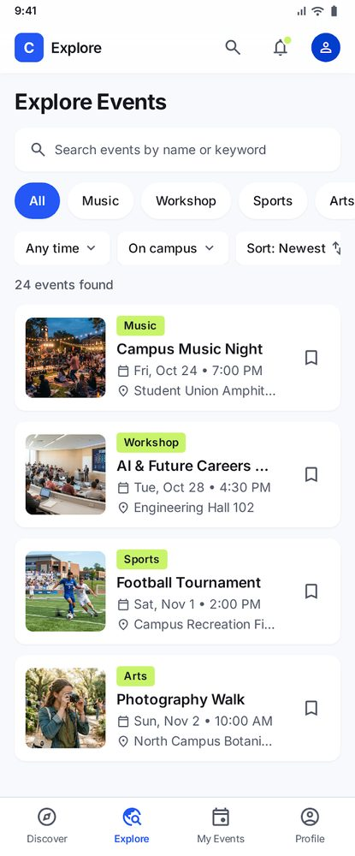 | Ảnh: assets/stitch/s02_explore_events.png  Quan sát kết quả  - Có tiêu đề "Explore Events", ô tìm kiếm, chip danh mục (All, Music, Workshop, Sports, Arts), 3 bộ lọc phụ, dòng "24 events found" và 4 thẻ sự kiện có nút bookmark.  - Chip "Arts" bị cắt ở mép phải (danh sách chip cuộn ngang).  - Thẻ Campus Music Night ghi "Fri, Oct 24 • 7:00 PM" tại "Student Union Amphit…".  Quyết định (v1): Chấp nhận làm baseline v1; các điểm cần xem xét được tập hợp ở mục 5.

4.3 S03 — Event Detail
Mục tiêu màn hình | Xem chi tiết một sự kiện và quyết định đăng ký.
Công cụ | Google Stitch
Tham chiếu đưa vào prompt | design/DESIGN.md (Campus Event Guide) + các màn hình đã duyệt trước đó
Prompt nguyên văn (không chỉnh sửa)
You are a senior mobile UI/UX designer. Create ONE production-ready high-fidelity Android screen for **Camply — S03 Event Detail**.

**Goal:** Help a student understand an event and confidently register.

**References:** Follow the attached Camply DESIGN.md and approved S01/S02 designs. Use a 360 × 800 dp mobile frame, Inter, background #F8F9FC, Electric Blue #2457F5, restrained Lime #C9F46A, text #171923 / #525866, 16 dp page margins, and consistent spacing.

**Exact content:**

- Event: Campus Music Night
- Category: Music
- Date: October 26, 2026
- Time: 18:00–22:00
- Venue: Main Stadium
- Organizer: Campus Student Union

**Required layout, top to bottom:**

1. Minimal app bar with Back button and a bookmark action.
2. Wide, high-quality photograph of a real-looking university music concert. Use a restrained image height so the hero does not dominate the viewport.
3. Prominent event title, compact Music badge, and clearly grouped date/time and venue metadata.
4. Three horizontal tabs: **About | Schedule | Location**. About is selected by default, with a visible blue active indicator.
5. About content: one short introductory paragraph about the campus music event and a compact organizer row. Keep the copy concise and readable.
6. Fixed bottom action area with one primary full-width button: **Register Now**.

**Interaction intent:**

- Back returns to S02 Explore.
- Bookmark saves the event.
- Schedule and Location switch content within the same screen.
- Register Now opens S04 Event Registration.

**Hard constraints:**

- Generate only the About-tab state of S03.
- Do not generate three separate screens.
- Do not add reviews, ratings, ticket prices, maps, verified badges, social sharing or related-event recommendations.
- Do not use multiple nested information cards.
- Do not repeat the date or venue in several sections.
- Keep the Register Now button visible and unobstructed.
- Use body text ≥14 sp and interactive targets ≥48 × 48 dp.
- Do not truncate essential information.
- Preserve a modern editorial look with clear hierarchy and restrained decoration.

**Expected output:** A compact, polished Event Detail screen with an attractive concert hero, readable information, clearly selected About tab and prominent registration action.
Kết quả và quyết định
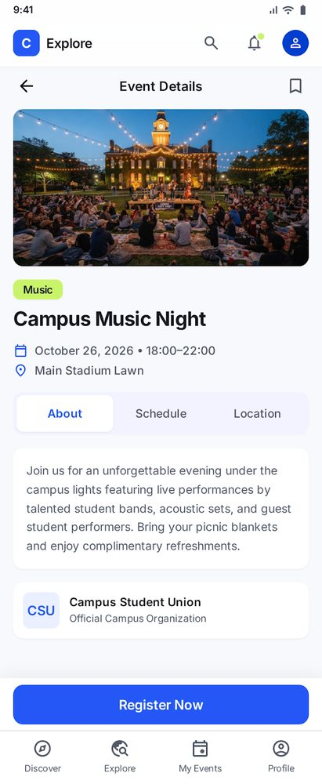 | Ảnh: assets/stitch/s03_event_detail.png  Quan sát kết quả  - Ảnh sự kiện, nhãn Music, tiêu đề, ngày giờ "October 26, 2026 • 18:00–22:00", địa điểm "Main Stadium Lawn".  - Tab About / Schedule / Location; mô tả; đơn vị tổ chức Campus Student Union.  - Nút "Register Now" cố định ở cuối màn hình; có nút back và bookmark ở app bar.  Quyết định (v1): Chấp nhận làm baseline v1.

4.4 S04 — Event Registration
Mục tiêu màn hình | Nhập thông tin để đăng ký tham gia sự kiện.
Công cụ | Google Stitch
Tham chiếu đưa vào prompt | design/DESIGN.md (Campus Event Guide) + các màn hình đã duyệt trước đó
Prompt nguyên văn (không chỉnh sửa)
You are a senior mobile UI/UX designer. Generate ONE high-fidelity Android mobile screen for **Camply — S04 Event Registration**.

**Goal:** Allow a university student to register for an event quickly, accurately and confidently.

Follow the attached DESIGN.md and the approved S03 Event Detail screen. Use a 360 × 800 dp frame, Inter, #2457F5 primary blue, #C9F46A restrained accent, #F8F9FC background, 16 dp horizontal margins, and the same component styling as the other Camply screens.

**Screen structure:**

1. Minimal top app bar with Back button and title **Event Registration**.
2. Compact event summary showing:
- Campus Music Night
- October 26, 2026
- 18:00–22:00
- Main Stadium
3. One concise section heading: **Your Information**.
4. Single-column registration form with four fields:
- Full Name — required
- Student ID — required
- University Email — required
- Phone Number — optional
5. Each field must have a persistent visible label, suitable placeholder and appropriate input affordance.
6. A clear primary button labeled **Confirm Registration** after the form.

**Form behavior to communicate visually:**

- Required fields are clearly identified.
- Optional Phone Number is explicitly marked.
- Inline validation should be possible without changing the overall layout.
- Confirm Registration leads to S05 Registration Success after successful submission.

**Hard constraints:**

- This is a SINGLE-SCREEN FORM, NOT A MULTI-STEP WIZARD.
- Do not add Step 1 of 1, Step 1 of 3, progress bars or numbered steps.
- Do not add payment, coupon, seat selection, account login or ticket pricing.
- Do not add privacy assurance cards, promotional messages, directions sections or long explanatory paragraphs.
- Do not use decorative illustrations that compete with the form.
- Do not duplicate event information.
- Do not generate validation, loading or success screens in this generation.
- All form labels and metadata must be readable at ≥14 sp.
- Tap targets must be ≥48 × 48 dp.
- Keep the layout compact enough for comfortable mobile form completion, allowing vertical scrolling when needed.

**Expected output:** A clean, practical event registration screen prioritizing the four form fields and the Confirm Registration action.
Kết quả và quyết định
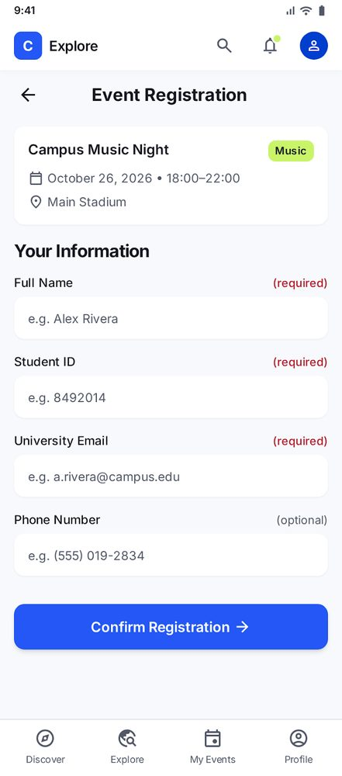 | Ảnh: assets/stitch/s04_event_registration.png  Quan sát kết quả  - Thẻ tóm tắt sự kiện + 4 trường: Full Name, Student ID, University Email (bắt buộc) và Phone Number (tuỳ chọn).  - Nút chính "Confirm Registration"; ví dụ placeholder dùng tên "Alex Rivera".  Quyết định (v1): Chấp nhận làm baseline v1.

4.5 S05 — Registration Success
Mục tiêu màn hình | Xác nhận đăng ký thành công và dẫn tới vé.
Công cụ | Google Stitch
Tham chiếu đưa vào prompt | design/DESIGN.md (Campus Event Guide) + các màn hình đã duyệt trước đó
Prompt nguyên văn (không chỉnh sửa)
You are a senior mobile UI/UX designer. Create ONE polished Android screen for **Camply — S05 Registration Success**.

**Goal:** Clearly confirm successful event registration and guide the student to their digital ticket.

Follow the attached Camply DESIGN.md and approved S04 design. Frame: 360 × 800 dp. Use Inter, background #F8F9FC, primary #2457F5, restrained lime #C9F46A, 16 dp page margins and consistent Camply buttons.

**Exact content:**

- Event: Campus Music Night
- Date: October 26, 2026
- Time: 18:00–22:00
- Venue: Main Stadium

**Layout:**

1. Minimal header consistent with Camply.
2. Centered success symbol: a clean checkmark inside a subtle circular treatment.
3. Large heading: **You're Registered!**
4. One short supporting sentence: **Your spot at Campus Music Night is confirmed.**
5. Compact event summary showing the event name, date/time and venue.
6. Primary full-width button: **View My Digital Ticket**.
7. Secondary text or outlined action: **Back to Discover**.

Use balanced vertical spacing. The success message should be the main focus, with the ticket button immediately recognizable as the next step.

**Hard constraints:**

- Generate only S05.
- Do not add Add to Calendar, Add to Schedule, Share Event, Download Ticket or promotional recommendations.
- Do not include registration form fields.
- Do not add a large decorative illustration or excessive confetti.
- Do not create oversized empty areas between the message, summary and actions.
- Do not use multiple overlapping or nested cards.
- Keep the event summary compact.
- Use accessible text contrast and ≥48 × 48 dp button targets.
- The primary action opens S07 Digital Ticket.
- Back to Discover opens S01.

**Expected output:** A simple, attractive confirmation screen that feels celebratory without clutter and provides one obvious next action.
Kết quả và quyết định
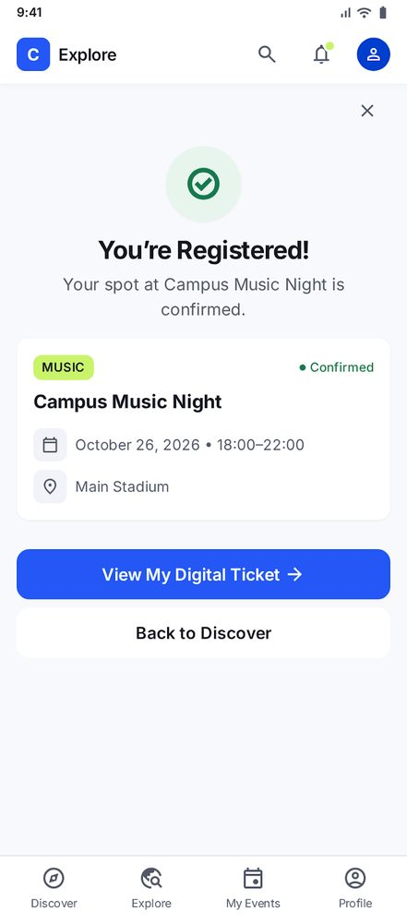 | Ảnh: assets/stitch/s05_registration_success.png  Quan sát kết quả  - Biểu tượng thành công, tiêu đề "You're Registered!", thẻ sự kiện trạng thái Confirmed.  - Hành động chính "View My Digital Ticket", hành động phụ "Back to Discover"; có nút đóng (X).  Quyết định (v1): Chấp nhận làm baseline v1.

4.6 S06 — My Events
Mục tiêu màn hình | Xem các sự kiện đã đăng ký (Upcoming / Past).
Công cụ | Google Stitch
Tham chiếu đưa vào prompt | design/DESIGN.md (Campus Event Guide) + các màn hình đã duyệt trước đó
Prompt nguyên văn (không chỉnh sửa)
You are a senior mobile UI/UX designer. Generate ONE production-ready Android screen for **Camply — S06 My Events**.

**Goal:** Let students review their registrations, open tickets and manage upcoming events.

Follow Camply DESIGN.md and the approved S02 horizontal card language. Use a 360 × 800 dp frame, Inter, #2457F5 primary, restrained #C9F46A accent, #F8F9FC background, 16 dp margins and consistent bottom navigation.

**Required structure:**

1. App header with title **My Events**.
2. Two tabs: **Upcoming** and **Past**, with Upcoming selected.
3. Display exactly two upcoming registered events:
- Campus Music Night — October 26, 2026 — 18:00–22:00 — Main Stadium.
- AI & Future Careers Workshop — a compact example workshop entry with date, time and venue.
4. Each event card includes a small thumbnail, event title, date/time, venue, a subtle **Registered** status indicator, and two actions:
- **View Ticket** — primary.
- **Cancel Registration** — secondary, visually less prominent.
5. Fixed four-item bottom navigation: Discover, Explore, My Events, Profile. My Events is selected.

**Interaction intent:**

- Upcoming/Past switches registered-event lists.
- View Ticket opens S07.
- Cancel Registration opens T01 confirmation dialog.
- A successful cancellation updates the list and supports Undo in T07.

**Hard constraints:**

- Generate only the default Upcoming state.
- Do not show the cancellation dialog, empty state or snackbar yet.
- Do not add ticket QR codes inside event cards.
- Do not add registration forms, promotional banners or recommendation sections.
- Do not invent an additional third registered event.
- Do not create huge poster cards.
- Keep the two event cards visually consistent.
- Avoid nested cards, duplicate status labels and redundant actions.
- Make the destructive action distinguishable from View Ticket.
- Use body text ≥14 sp and touch targets ≥48 × 48 dp.
- Keep bottom navigation fixed.

**Expected output:** A clean My Events screen with two manageable upcoming registrations and clearly differentiated ticket/cancellation actions.
Kết quả và quyết định
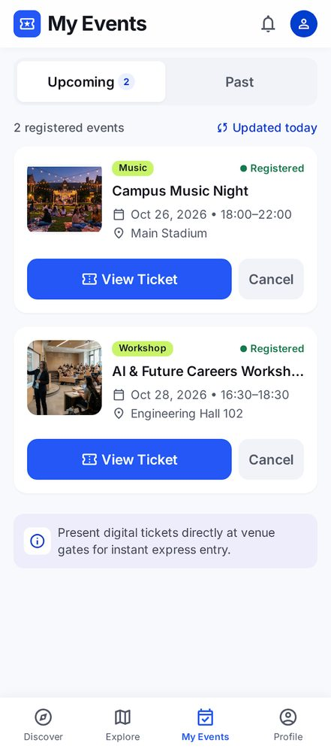 | Ảnh: assets/stitch/s06_my_events.png  Quan sát kết quả  - Tab Upcoming (2) / Past; 2 thẻ sự kiện, mỗi thẻ có "View Ticket" và "Cancel".  - Ghi chú cuối trang về việc xuất trình vé tại cổng.  Quyết định (v1): Chấp nhận làm baseline v1.

4.7 S07 — Digital Ticket
Mục tiêu màn hình | Hiển thị vé điện tử để check-in.
Công cụ | Google Stitch
Tham chiếu đưa vào prompt | design/DESIGN.md (Campus Event Guide) + các màn hình đã duyệt trước đó
Prompt nguyên văn (không chỉnh sửa)
You are a senior mobile UI/UX designer. Create ONE high-fidelity Android screen for **Camply — S07 Digital Ticket**.

**Goal:** Allow a registered student to display a clear digital admission ticket for event check-in.

Follow Camply DESIGN.md and approved S05/S06 designs. Frame 360 × 800 dp. Use Inter, primary blue #2457F5, restrained lime #C9F46A, light background #F8F9FC, 16 dp horizontal margins and readable typography.

**Exact ticket content:**

- Event: Campus Music Night
- Date: October 26, 2026
- Time: 18:00–22:00
- Venue: Main Stadium
- Attendee: Alex Morgan
- Student ID: STU-849201
- Pass type: General Admission
- Ticket number: CMN-2026-0849

**Required layout:**

1. Minimal app bar with Back button and title **My Ticket**.
2. One visually distinctive but restrained digital ticket card.
3. Ticket header containing the event name and a subtle blue/lime accent stripe.
4. Clearly grouped event details: date, time and venue.
5. Attendee details: name, student ID, pass type and ticket number.
6. A large centered black-and-white **simulated QR code**, with sufficient white quiet space around it.
7. Short instruction: **Show this ticket at the entrance for check-in.**

**Hard constraints:**

- Use exactly ONE primary ticket card.
- Do not add multiple tickets, extra event recommendations or large decorative illustrations.
- Do not add payment information, verified status, offline availability claims, wallet integration or share/download buttons.
- Do not duplicate the ticket number.
- Do not crop the QR code.
- Do not make the QR code too small to see.
- Clearly treat the QR as a visual prototype, not a claim of working ticket validation.
- Avoid excessive shadows, gradients and nested cards.
- Use readable metadata ≥14 sp and interactive targets ≥48 × 48 dp.
- Ensure the ticket is comfortably viewable on a 360 × 800 dp screen; scroll only if necessary.

**Expected output:** A realistic, organized digital event ticket with a prominent simulated QR and all essential admission details.
Kết quả và quyết định
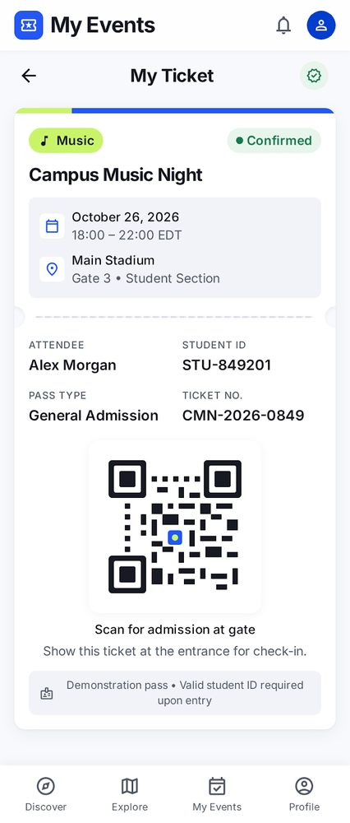 | Ảnh: assets/stitch/s07_digital_ticket.png  Quan sát kết quả  - Nhãn Music, trạng thái Confirmed, ngày giờ, "Main Stadium, Gate 3 • Student Section".  - Attendee Alex Morgan, Student ID STU-849201, Pass type, Ticket No. CMN-2026-0849; mã QR và ghi chú "Demonstration pass".  Quyết định (v1): Chấp nhận làm baseline v1.

4.8 S08 — Saved Events
Mục tiêu màn hình | Xem các sự kiện đã đánh dấu để xem sau.
Công cụ | Google Stitch
Tham chiếu đưa vào prompt | design/DESIGN.md (Campus Event Guide) + các màn hình đã duyệt trước đó
Prompt nguyên văn (không chỉnh sửa)
You are a senior mobile UI/UX designer. Generate ONE polished Android screen for **Camply — S08 Saved Events**.

**Goal:** Help students revisit bookmarked campus events and remove bookmarks easily.

Follow Camply DESIGN.md and the approved S02 Explore Events screen. Use the same compact horizontal event-card style. Frame 360 × 800 dp, Inter, #2457F5 primary, #C9F46A restrained accent, #F8F9FC background and 16 dp horizontal margins.

**Required layout:**

1. Minimal header with Back button and title **Saved Events**.
2. One concise supporting line indicating that this page contains bookmarked events.
3. A subtle saved-event count showing **3 saved events**.
4. Exactly three compact horizontal event cards:
- Campus Music Night — Music.
- AI & Future Careers Workshop — Workshop.
- Photography Walk — Arts.
5. Each card includes a thumbnail, category, event title, date/time, venue and an active bookmark icon.
6. A clear but secondary **Explore More Events** action after the list.

**Interactions:**

- Tapping a card opens its Event Detail screen.
- Tapping its active bookmark removes the saved event.
- Explore More Events opens S02 Explore.
- If all bookmarks are removed, the interface transitions to T04 Saved Empty.

**Hard constraints:**

- Generate only the populated saved-events state.
- Do not generate the empty state.
- Do not add folders, collections, social sharing, recommendations or promotional content.
- Do not add a large information banner or repeated explanations.
- Do not use oversized vertical event posters.
- Do not put a separate full-width Unsave button on every card.
- Keep the cards consistent with S02.
- Avoid truncated event titles and essential metadata where possible.
- Use body text ≥14 sp and touch targets ≥48 × 48 dp.

**Expected output:** A compact, consistent Saved Events screen with three readable cards and an unobtrusive path back to event discovery.
Kết quả và quyết định
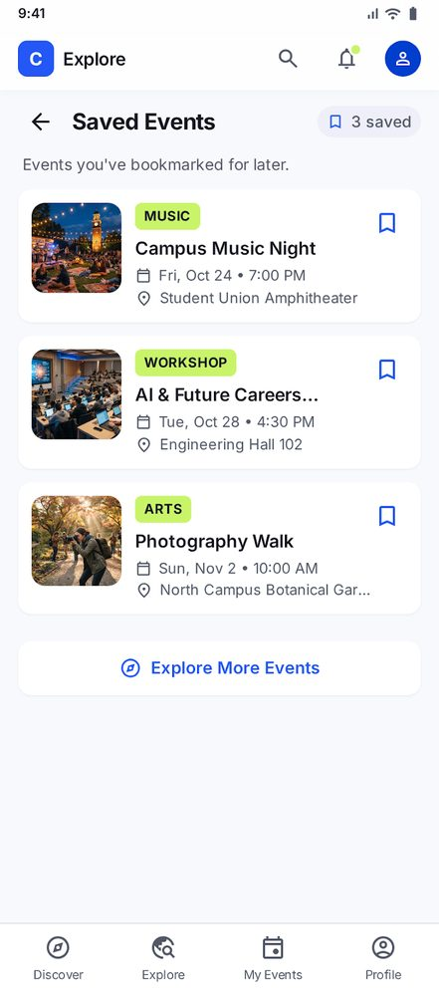 | Ảnh: assets/stitch/s08_saved_events.png  Quan sát kết quả  - Tiêu đề "Saved Events", nhãn "3 saved", 3 thẻ sự kiện có bookmark đã chọn.  - Nút "Explore More Events" ở cuối danh sách.  Quyết định (v1): Chấp nhận làm baseline v1.

4.9 S09 — Notifications
Mục tiêu màn hình | Xem thông báo liên quan đến sự kiện.
Công cụ | Google Stitch
Tham chiếu đưa vào prompt | design/DESIGN.md (Campus Event Guide) + các màn hình đã duyệt trước đó
Prompt nguyên văn (không chỉnh sửa)
You are a senior mobile UI/UX designer. Create ONE production-ready Android screen for **Camply — S09 Notifications**.

**Goal:** Help students quickly scan event-related updates and distinguish unread notifications.

Follow the attached Camply DESIGN.md and approved Camply screens. Use a 360 × 800 dp frame, Inter, #2457F5 primary, restrained #C9F46A accent, #F8F9FC background, 16 dp page margins and clean spacing.

**Required structure:**

1. Minimal app bar with Back button and title **Notifications**.
2. Right-aligned text action: **Mark all read**.
3. Group notifications under two compact section headings: **Today** and **This Week**.
4. Display four concise notification rows across the groups:
- Registration Confirmed — You're registered for Campus Music Night.
- Event Reminder — Campus Music Night is coming up soon.
- Event Update — Check the latest event details.
- New Workshop — AI & Future Careers Workshop is open for registration.
5. Each row includes a small contextual icon, bold short title, one-line supporting message where possible, timestamp and subtle unread indicator when applicable.
6. Use light separators or spacing between rows rather than large cards.

**Interaction intent:**

- Tapping a notification opens the related event or ticket.
- Mark all read removes unread indicators.
- T05 is the separate Notifications Empty state.

**Hard constraints:**

- Generate only the populated notifications state.
- Do not add embedded event cards, QR tickets, images, banners or action buttons inside each notification.
- Do not add multiple repeated section explanations.
- Do not invent chat, friend requests, system warnings or unrelated notification types.
- Do not create oversized notification cards.
- Use subtle blue unread indicators, not large colorful status badges.
- Maintain readable timestamps and body text ≥14 sp.
- Keep tap targets ≥48 × 48 dp.
- Do not generate the empty state in this request.

**Expected output:** A simple, professional notification inbox with compact chronological groups and clearly distinguishable unread updates.
Kết quả và quyết định
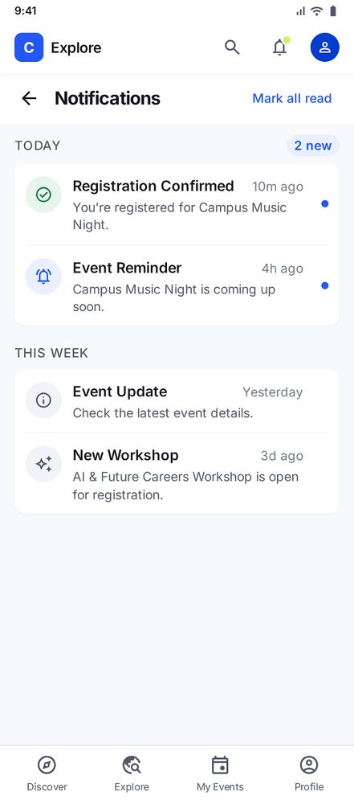 | Ảnh: assets/stitch/s09_notifications.png  Quan sát kết quả  - Nhóm "Today" (2 new) và "This week"; mỗi mục có biểu tượng, thời gian; mục chưa đọc có chấm xanh.  - Hành động "Mark all read" ở app bar.  Quyết định (v1): Chấp nhận làm baseline v1.

4.10 S10 — Student Profile
Mục tiêu màn hình | Xem thông tin sinh viên và đi nhanh tới hoạt động / hỗ trợ.
Công cụ | Google Stitch
Tham chiếu đưa vào prompt | design/DESIGN.md (Campus Event Guide) + các màn hình đã duyệt trước đó
Prompt nguyên văn (không chỉnh sửa)
You are a senior mobile UI/UX designer. Generate ONE high-fidelity Android screen for **Camply — S10 Student Profile**.

**Goal:** Let students view their identity and quickly navigate to event-related activities and account support.

Follow Camply DESIGN.md and the approved S01/S02 screens. Use 360 × 800 dp, Inter, background #F8F9FC, primary #2457F5, restrained lime #C9F46A, 16 dp horizontal margins, consistent iconography and the established four-item bottom navigation.

**Exact student identity:**

- Name: Alex Morgan
- Student ID: STU-849201
- University email: [alex.m@university.edu](mailto:alex.m@university.edu)

**Required layout:**

1. Compact header titled **Profile**.
2. One prominent but space-efficient student identity section containing:
- Circular avatar.
- Student name.
- Student ID.
- University email.
- One **Edit Profile** action.
3. Section heading: **Your Activity**.
4. Three simple navigation rows:
- My Events.
- Saved Events.
- Notifications.
5. Section heading: **Settings & Support**.
6. Two simple navigation rows:
- App Settings.
- Help & Support.
7. Fixed bottom navigation: Discover, Explore, My Events, Profile. Profile is selected.

**Interaction intent:**

- My Events opens S06.
- Saved Events opens S08.
- Notifications opens S09.
- Edit Profile, App Settings and Help & Support lead to their respective supporting prototype screens or states.

**Hard constraints:**

- Generate only S10 Profile.
- Do not add achievement badges, membership tiers, loyalty points, statistics dashboards or social profiles.
- Do not add unrelated settings, logout banners or promotional blocks.
- Do not create separate cards for every navigation row.
- Use a clean list-row structure with subtle dividers and right-facing chevrons.
- Keep the identity section compact.
- Avoid nested cards, large illustrations and excessive white space.
- Do not truncate the student's name, ID or email.
- Use body text ≥14 sp and touch targets ≥48 × 48 dp.
- Keep bottom navigation visually identical to S01/S02.

**Expected output:** A polished student profile with one clear identity area, two well-organized navigation groups and consistent Camply styling.
Kết quả và quyết định
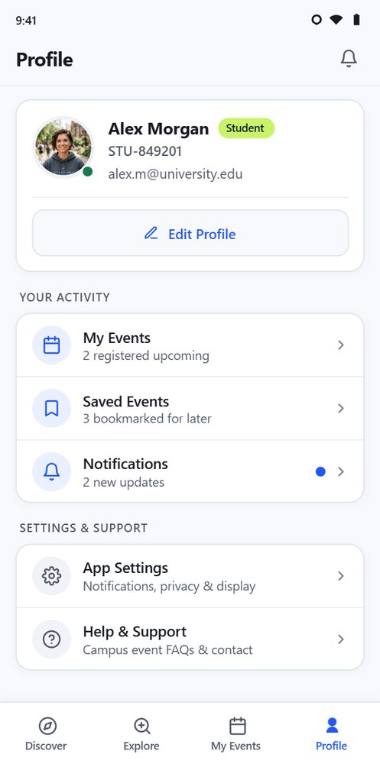 | Ảnh: assets/stitch/s10_student_profile.png  Quan sát kết quả  - Có đủ khối nhận dạng (Alex Morgan, STU-849201, alex.m@university.edu), nút Edit Profile, nhóm Your Activity (3 dòng) và Settings & Support (2 dòng); tab Profile được chọn.  - Có thêm nhãn "Student", chấm trạng thái xanh trên avatar và dòng phụ dưới mỗi mục (ví dụ "2 registered upcoming") — các chi tiết này không được nêu trong prompt.  Quyết định (v1): Chấp nhận làm baseline v1; chi tiết thêm ngoài prompt được ghi ở mục 5.

4.11 Biến thể trạng thái (T01–T07)
Các ảnh dưới đây là biến thể trạng thái của những màn hình ở trên. Prompt T01–T07 dưới đây là bản soạn nguyên văn (không có trong camply.docx). Trước khi nộp, cần đối chiếu với lịch sử thực tế trên Stitch; chỉ ghi là prompt đã gửi khi trùng khớp.
T01 — Cancel Registration Dialog
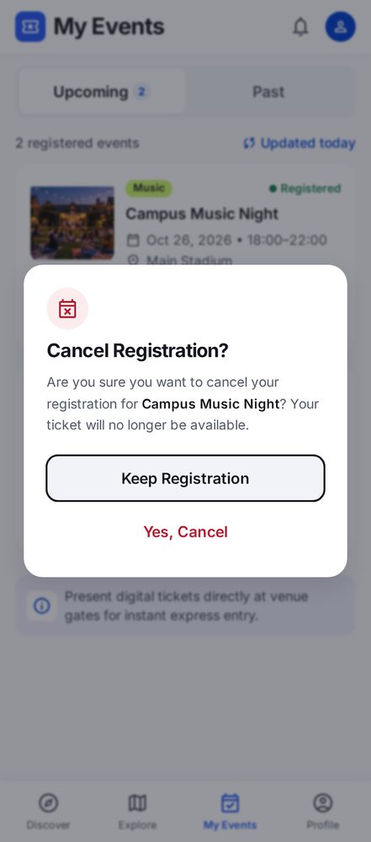 | Ảnh: assets/stitch/t01_cancel_registration_dialog.png  Biến thể của: S06  Prompt nguyên văn (bản soạn, không chỉnh sửa; cần đối chiếu lịch sử Stitch)  You are a senior mobile UI/UX designer. Generate ONE polished Android screen for Camply — T01 Cancel Registration Confirmation Dialog.  Goal: Help students confirm or safely cancel an event registration without accidental destructive actions.  References: Use the attached Camply DESIGN.md and the approved S06 My Events screen. Preserve the existing visual design, typography, spacing, event data, and navigation.  Frame: 360 × 800 dp, Android-first, Inter, #2457F5 primary, #C9F46A restrained accent, #F8F9FC background, #171923 primary text, #525866 secondary text, 16 dp horizontal margins.  Scenario: The student taps Cancel Registration for Campus Music Night.  Required layout:  1. Show the existing S06 My Events screen as the background.  2. Apply a subtle dark overlay to the background.  3. Display one centered confirmation dialog with a white surface and restrained corner radius.  4. Dialog title: Cancel Registration?  5. Message: Are you sure you want to cancel your registration for Campus Music Night? Your ticket will no longer be available.  6. Secondary action: Keep Registration.  7. Destructive action: Yes, Cancel.  Interactions:  - Keep Registration closes the dialog and returns to S06 without changes.  - Yes, Cancel confirms cancellation and leads to T07 My Events After Cancellation.  - Make the safe action easy to identify and distinguish the destructive action clearly.  Hard Constraints:  - Generate exactly ONE screen showing the confirmation dialog open.  - Do not remove the event before confirmation.  - Do not redesign the underlying S06 screen.  - Do not add payment, refund, calendar, sharing, or unrelated features.  - Do not add a second dialog or extra confirmation step.  - Use body text ≥14 sp and touch targets ≥48 × 48 dp.  - Maintain accessible contrast and keep the background recognizable.  Expected Output: A compact, accessible cancellation confirmation dialog consistent with Camply, with clear consequences and two unambiguous actions.  Quan sát kết quả  - Dialog overlay "Cancel Registration?" trên nền S06 làm mờ; hai lựa chọn "Keep Registration" (nút viền) và "Yes, Cancel" (chữ đỏ).  Quyết định (v1): Chấp nhận làm baseline v1.

T02 — Registration Form Validation Error
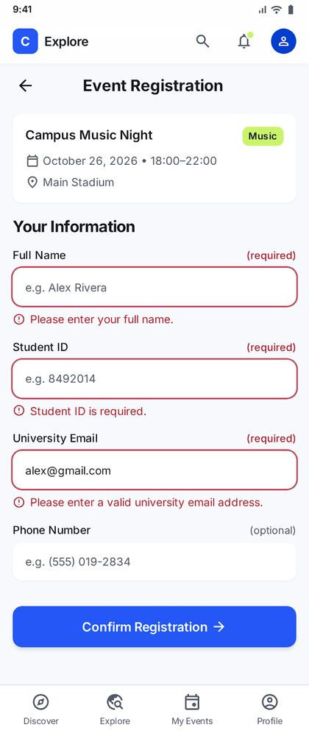 | Ảnh: assets/stitch/t02_registration_form_validation_error.png  Biến thể của: S04  Prompt nguyên văn (bản soạn, không chỉnh sửa; cần đối chiếu lịch sử Stitch)  You are a senior mobile UI/UX designer. Generate ONE polished Android screen for Camply — T02 Registration Form Validation Error.  Goal: Help students understand and correct registration form errors without losing their entered information.  References: Use the existing S04 Event Registration screen as the exact visual base. Follow the attached Camply DESIGN.md. Preserve the layout, event summary, form fields, typography, colors, spacing, and navigation.  Frame: 360 × 800 dp, Inter, #2457F5 primary, #C9F46A restrained accent, #F8F9FC background, 16 dp horizontal margins.  Scenario: The student taps Confirm Registration with missing required fields and an invalid university email.  Required layout:  1. Keep the existing Event Registration header and event summary.  2. Keep the original single-column form.  3. Full Name: empty, with inline error Please enter your full name.  4. Student ID Number: empty, with inline error Student ID is required.  5. University Email: show the entered value alex@gmail.com, with inline error Please enter a valid university email address.  6. Phone Number: optional, with no error.  7. Keep the Confirm Registration button visible.  Visual behavior:  - Highlight only invalid fields with subtle red borders.  - Place each error message directly below its corresponding field.  - Preserve the invalid email value so the student can correct it.  - Keep labels and error messages clearly distinguishable.  Hard Constraints:  - Generate only ONE validation-error screen.  - Do not redesign S04 or add new fields.  - Do not remove or rename existing form fields.  - Do not display a success message or navigate to S05.  - Do not add a large global error banner or unrelated explanatory content.  - Do not show an error for the optional phone field.  - Use body text ≥14 sp and touch targets ≥48 × 48 dp.  - Keep Confirm Registration visible and unobstructed.  Expected Output: A clear, compact form-validation state with field-specific feedback, preserved user input, and a visible retry action.  Quan sát kết quả  - Ba trường bắt buộc có viền đỏ và thông báo lỗi bên dưới; email "alex@gmail.com" bị báo không phải email trường.  Quyết định (v1): Chấp nhận làm baseline v1.

T03 — Registration Loading State
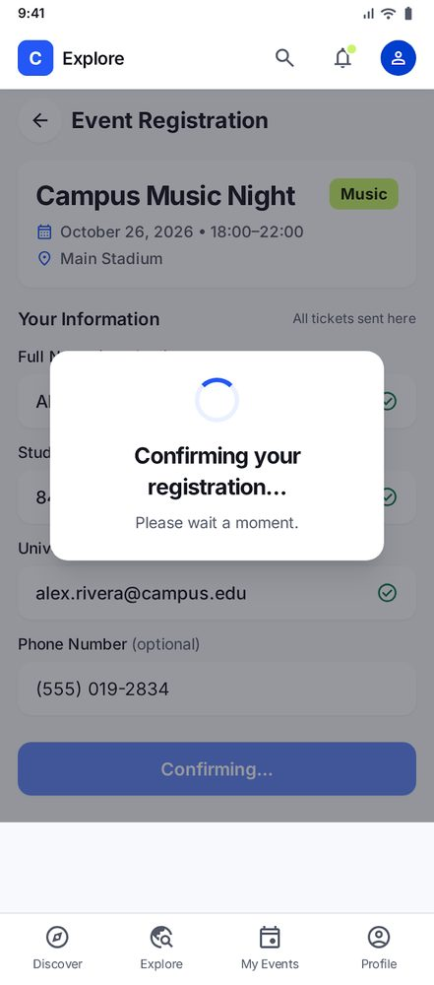 | Ảnh: assets/stitch/t03_registration_loading_state.png  Biến thể của: S04  Prompt nguyên văn (bản soạn, không chỉnh sửa; cần đối chiếu lịch sử Stitch)  You are a senior mobile UI/UX designer. Generate ONE polished Android screen for Camply — T03 Registration Loading State.  Goal: Communicate that a valid event registration is being processed and prevent repeated submission.  References: Use the existing S04 Event Registration screen as the visual base. Follow Camply DESIGN.md and preserve the original form, event information, colors, typography, spacing, and navigation.  Frame: 360 × 800 dp, Inter, #2457F5 primary, #C9F46A restrained accent, #F8F9FC background, 16 dp horizontal margins.  Scenario: The student completes all required fields correctly and taps Confirm Registration.  Required layout:  1. Keep the existing S04 Event Registration screen visible in the background.  2. Show a subtle dimmed overlay.  3. Place one compact white loading dialog near the center.  4. Display a blue circular progress indicator.  5. Main status: Confirming your registration...  6. Supporting message: Please wait a moment.  7. Show the Confirm Registration button as disabled while processing.  Interaction intent:  - Prevent repeated submissions while loading.  - When registration succeeds, transition to S05 Registration Success.  - Do not show success before processing finishes.  Hard Constraints:  - Generate only ONE loading-state screen.  - Do not redesign S04 or introduce new form fields.  - Do not show validation errors, ticket details, or success content.  - Do not add security verification claims or invented processing steps.  - Do not display progress percentages or additional actions.  - Use readable text and sufficient contrast.  - Keep the loading message concise and the original form recognizable.  Expected Output: A restrained loading overlay that communicates system status clearly and remains consistent with Camply's established mobile UI.  Quan sát kết quả  - Hộp thoại loading "Confirming your registration..." trên form bị làm mờ; nút chính đổi thành "Confirming..." (vô hiệu).  Quyết định (v1): Chấp nhận làm baseline v1.

T04 — Saved Events Empty State
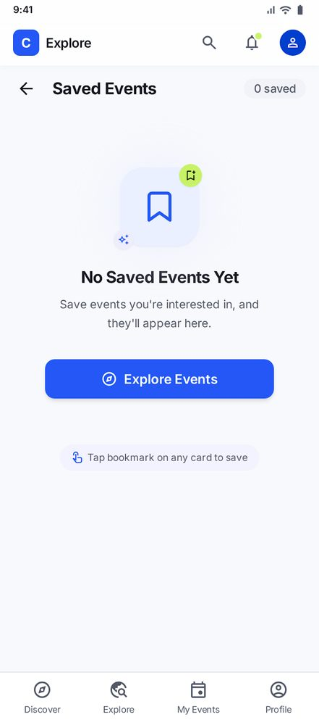 | Ảnh: assets/stitch/t04_saved_events_empty_state.png  Biến thể của: S08  Prompt nguyên văn (bản soạn, không chỉnh sửa; cần đối chiếu lịch sử Stitch)  You are a senior mobile UI/UX designer. Generate ONE polished Android screen for Camply — T04 Saved Events Empty State.  Goal: Help students understand that no events are bookmarked and return easily to event discovery.  References: Use the approved S08 Saved Events screen and attached Camply DESIGN.md. Preserve the established header, typography, colors, spacing, and overall visual language.  Frame: 360 × 800 dp, Inter, #2457F5 primary, #C9F46A restrained accent, #F8F9FC background, 16 dp horizontal margins.  Scenario: The student has not bookmarked any events or removes the last saved event from S08.  Required layout:  1. Minimal header with Back button and title Saved Events.  2. Remove all saved-event cards.  3. Display one simple bookmark illustration or bookmark icon.  4. Heading: No Saved Events Yet  5. Supporting message: Save events you're interested in, and they'll appear here.  6. Primary button: Explore Events.  Interactions:  - Back returns to the previous screen.  - Explore Events navigates to S02 Explore.  - This state appears when the saved-event list becomes empty.  Hard Constraints:  - Generate exactly ONE empty-state screen.  - Do not display any event cards or a saved-event count of three.  - Do not add folders, collections, recommendations, search fields, or social features.  - Do not add promotional banners or duplicate explanations.  - Keep the empty-state content visually balanced and easy to scan.  - Use body text ≥14 sp and touch targets ≥48 × 48 dp.  - Preserve Camply's established design system.  Expected Output: A simple, friendly Saved Events empty state with a clear explanation and one prominent path back to event discovery.  Quan sát kết quả  - "0 saved", icon bookmark, tiêu đề "No Saved Events Yet", một hành động "Explore Events" và gợi ý "Tap bookmark on any card to save".  Quyết định (v1): Chấp nhận làm baseline v1.

T05 — Notifications Empty State
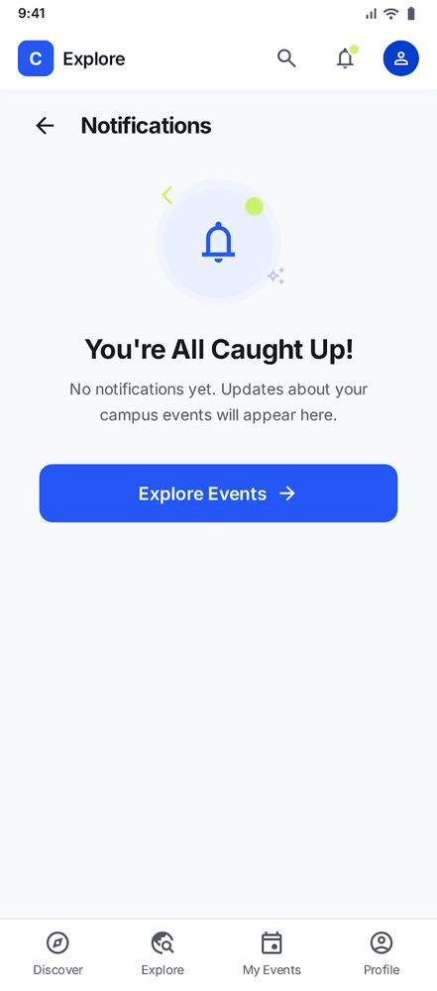 | Ảnh: assets/stitch/t05_notifications_empty_state.png  Biến thể của: S09  Prompt nguyên văn (bản soạn, không chỉnh sửa; cần đối chiếu lịch sử Stitch)  You are a senior mobile UI/UX designer. Generate ONE polished Android screen for Camply — T05 Notifications Empty State.  Goal: Tell students that they have no notifications yet and provide a straightforward way to discover campus events.  References: Use the approved S09 Notifications screen and T04 Saved Events Empty State as visual references. Follow the attached Camply DESIGN.md.  Frame: 360 × 800 dp, Inter, #2457F5 primary, #C9F46A restrained accent, #F8F9FC background, #171923 primary text, #525866 secondary text, 16 dp horizontal margins.  Required layout:  1. Minimal header with Back button and title Notifications.  2. Remove all notification rows, unread indicators, and New/Earlier sections.  3. Hide Mark all as read because there are no notifications.  4. Display a simple notification bell illustration.  5. Heading: You're All Caught Up!  6. Supporting message: No notifications yet. Updates about your campus events will appear here.  7. Primary button: Explore Events.  Interactions:  - Back returns to the previous screen.  - Explore Events navigates to S02 Explore.  Hard Constraints:  - Generate only ONE Notifications empty-state screen.  - Do not display the internal screen ID in the user-facing title.  - Do not add notification cards, settings, push-permission prompts, or unrelated features.  - Do not use a crossed-out bell that could imply notifications are disabled.  - Do not add redundant status chips or repeated empty-state messages.  - Use body text ≥14 sp and touch targets ≥48 × 48 dp.  - Keep the layout simple, centered, and consistent with T04.  Expected Output: A clean Notifications empty state that communicates the absence of notifications without suggesting an error or disabled feature.  Quan sát kết quả  - Icon chuông, tiêu đề "You're All Caught Up!", một hành động "Explore Events".  Quyết định (v1): Chấp nhận làm baseline v1.

T06 — Explore – No Results
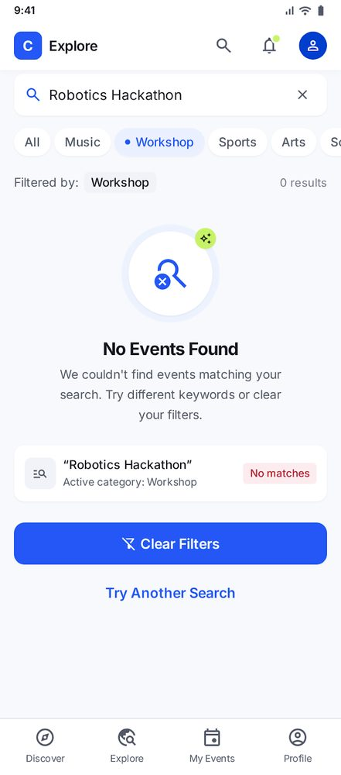 | Ảnh: assets/stitch/t06_explore_no_results.png  Biến thể của: S02  Prompt nguyên văn (bản soạn, không chỉnh sửa; cần đối chiếu lịch sử Stitch)  You are a senior mobile UI/UX designer. Generate ONE polished Android screen for Camply — T06 Explore No Results.  Goal: Help students recover from a search that returns no matching campus events without losing their search context.  References: Use the approved S02 Explore Events screen and attached Camply DESIGN.md. Preserve the existing search, filter, and bottom-navigation styles.  Frame: 360 × 800 dp, Inter, #2457F5 primary, #C9F46A restrained accent, #F8F9FC background, 16 dp horizontal margins.  Scenario: The student searches for campus events and applies filters, but no events match.  Required layout:  1. Keep the Explore Events header.  2. Keep the search field and show the query Robotics Hackathon.  3. Keep the existing category filters: All, Music, Workshop, Sports, Arts. Show Workshop as selected.  4. Preserve the selected filter state.  5. Remove all event result cards.  6. Display a simple search or magnifying-glass illustration.  7. Heading: No Events Found  8. Supporting message: We couldn't find events matching your search. Try different keywords or clear your filters.  9. Primary button: Clear Filters.  10. Secondary text action: Try Another Search.  11. Keep the four-tab bottom navigation: Discover, Explore, My Events, Profile. Explore is active.  Interactions:  - Clear Filters resets the query and selected filters and returns to the default S02 Explore results.  - Try Another Search focuses the search field so the student can edit the query.  - Neither action should navigate away from Explore.  Hard Constraints:  - Generate exactly ONE no-results screen.  - Do not redesign S02 or add new filters.  - Do not display event cards, recommendations, or promotional content.  - Do not show a system-error message or an unrelated empty state.  - Do not remove the existing search query or selected filter.  - Use body text ≥14 sp and touch targets ≥48 × 48 dp.  - Preserve the existing four-tab navigation and Camply design system.  Expected Output: A compact Explore no-results state that preserves search context and offers two clear recovery actions.  Quan sát kết quả  - Tìm "Robotics Hackathon" + chip Workshop → "0 results"; có "Clear Filters" và "Try Another Search".  Quyết định (v1): Chấp nhận làm baseline v1.

T07 — My Events – Cancellation with Undo Snackbar
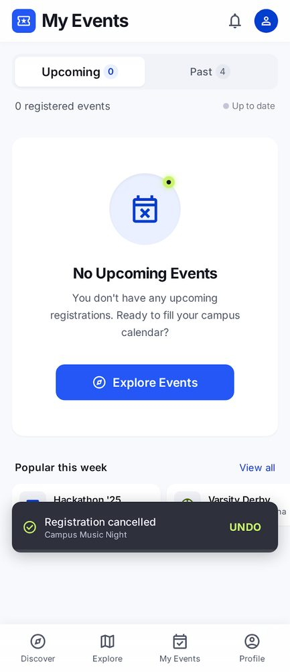 | Ảnh: assets/stitch/t07_my_events_cancellation_with_undo_snackbar.png  Biến thể của: S06  Prompt nguyên văn (bản soạn, không chỉnh sửa; cần đối chiếu lịch sử Stitch)  You are a senior mobile UI/UX designer. Generate ONE polished Android screen for Camply — T07 My Events After Cancellation with Undo Snackbar.  Goal: Confirm that an event registration was cancelled, update the student's Upcoming list, and provide a temporary way to undo the action.  References: Use the approved S06 My Events screen and T01 cancellation flow. Follow Camply DESIGN.md and preserve the established layout, colors, typography, spacing, and bottom navigation.  Frame: 360 × 800 dp, Inter, #2457F5 primary, #C9F46A restrained accent, #F8F9FC background, 16 dp horizontal margins.  Scenario: The student confirms cancellation of Campus Music Night through T01.  Required layout:  1. My Events  - Keep the My Events header.  - Keep the Upcoming and Past tabs, with Upcoming selected.  - Remove Campus Music Night from the Upcoming registered-event list.  - Update the Upcoming registration count to 0.  - Show a simple empty state in the Upcoming section.  - Heading: No Upcoming Events  - Supporting message: You don't have any upcoming registrations.  - Include an Explore Events action.  2. Cancellation Snackbar  - Display one compact snackbar above the bottom navigation.  - Message: Registration cancelled.  - Include a clearly visible Undo action.  - Use a neutral confirmation style, not a destructive error alert.  - Keep the snackbar from covering important navigation controls.  3. Bottom Navigation  - Keep exactly four destinations: Discover, Explore, My Events, Profile.  - My Events is selected.  Interactions:  - Undo restores the Campus Music Night registration and returns to the original S06 My Events state.  - Explore Events opens S02 Explore.  - The snackbar is temporary and dismisses after a short period.  - Make it clear that Undo is available temporarily, not indefinitely.  Hard Constraints:  - Generate only ONE screen showing the post-cancellation state with the snackbar visible.  - Do not show the T01 confirmation dialog.  - Do not keep Campus Music Night in the Upcoming list.  - Do not add payment, refund, calendar, sharing, or unrelated features.  - Do not add event recommendations or promotional sections.  - Do not redesign S06 or generate additional screens.  - Use body text ≥14 sp and touch targets ≥48 × 48 dp.  - Preserve the established Camply design system.  Expected Output: A compact My Events screen showing the updated empty Upcoming state and a clear, temporary Undo action without obstructing navigation.  Quan sát kết quả  - Trạng thái "0 registered events" với empty state "No Upcoming Events" và khối "Popular this week".  - Snackbar "Registration cancelled – Campus Music Night" có hành động UNDO, nằm đè lên các thẻ của "Popular this week".  Quyết định (v1): Chấp nhận làm baseline v1.

5. Quan sát sơ bộ trên v1
Đây là các điểm nhìn thấy trực tiếp trên ảnh chụp, ghi lại làm ứng viên cho các vòng lặp. Chúng chưa thay thế bản phản biện bằng AI theo 10 heuristic của Nielsen (mục 6.2).
# | Quan sát | Màn hình | Heuristic gần nhất
1 | Dữ liệu cùng một sự kiện không khớp: "Fri, Oct 24 • 7:00 PM", Student Union Amphitheater (S02, S08) so với "October 26, 2026 • 18:00–22:00", Main Stadium (S03–S07). | S02, S08 so với S03–S07 | Consistency and standards
2 | Biểu tượng tab Explore có ít nhất 3 kiểu khác nhau (kính lúp-quả địa cầu, bản đồ, kính lúp dấu cộng). | S02–S05, S06–S07, S10 | Consistency and standards
3 | Nhiều màn hình phụ hiện thanh thương hiệu "Explore" cố định phía trên thanh tiêu đề riêng (hai tầng header); S06–S07 dùng tiêu đề "My Events", S10 chỉ có "Profile". | S03, S04, S05, S08, S09 | Consistency; Aesthetic and minimalist design
4 | Tên mẫu trong form ("Alex Rivera") khác tên sinh viên trong vé và hồ sơ ("Alex Morgan"). | S04 so với S07, S10 | Consistency and standards
5 | Snackbar "UNDO" nằm đè lên thẻ trong khối "Popular this week". | T07 | Visibility of system status
6 | S10 có thêm nhãn "Student", chấm trạng thái và dòng phụ mà prompt không yêu cầu. | S10 | Aesthetic and minimalist design
7 | Chưa có ảnh S01 để đối chiếu với prompt. | S01 | —

6. Phần bổ sung cho các giai đoạn sau

6.1 Vòng lặp (cần ≥ 3, mỗi vòng một vấn đề có tên, khác nhau)
Vòng | Vấn đề có tên | Prompt nguyên văn | Ảnh trước / sau | Quyết định và lý do
1 | Thanh tiêu đề chồng nhau trên màn hình lồng bên trong; icon điều hướng dưới không nhất quán (Quan sát #2 và #3, mục 5). | Màn hình: S03 Event Detail (mã đề xuất; xác nhận lại nếu bạn chạy trên màn khác).  ## ROLE  You are a senior mobile UI/UX designer specializing in clean, production-ready Android applications for university students.  ## TASK  Revise the Camply screen S03 Event Detail to fix ONE specific problem only: the stacked top bars and inconsistent navigation.  Keep everything else as close to the current version as possible.  ## PROBLEM TO FIX  1. Some inner screens show a brand header (logo "C", app name, search, notification bell, avatar) stacked above a second header with a back button and title. Inner screens must have ONLY a back button, a centered or left-aligned title, and optionally one relevant action (e.g. bookmark). No brand logo, no avatar, no search icon on inner screens.  2. The bottom navigation icons change style between screens (for example Explore sometimes shows a magnifier with globe, sometimes a map). Use ONE consistent icon set for the four tabs: Discover, Explore, My Events, Profile, with the same outline style, size, and label on every screen. The selected tab uses the same icon in filled or accent color, not a different icon.  ## KEEP UNCHANGED  - DESIGN.md: Inter typography, Electric Blue #2457F5 primary, Lime #C9F46A accent used sparingly, background #F8F9FC, text #171923 and #525866, 16 dp margins, 4 dp spacing scale, 8–16 dp radii.  - Content, event data and layout of the screen, except the header area.  - Frame: Android mobile, 360 × 800 dp, light theme.  ## CONSTRAINTS  - Do not add any new features, sections, or screens.  - Do not add a search field to inner screens.  - All tap targets at least 48 × 48 dp.  - Body and content text at least 14 sp; secondary text must reach 4.5:1 contrast against its background.  - Do not use placeholder text colour (#737987) for any readable content text.  - Do not convey status by colour alone.  ## OUTPUT  One screen only at 360 × 800 dp. | Trước: S03 cũ (thanh Explore + Back chồng nhau, icon tab khác nhau).  Sau: S03 b Event Detail (Schedule) và các màn lồng bên trong chỉ còn Back, tiêu đề, bookmark.  TRƯỚC — S03 (log v1)  SAU — S03 b Schedule  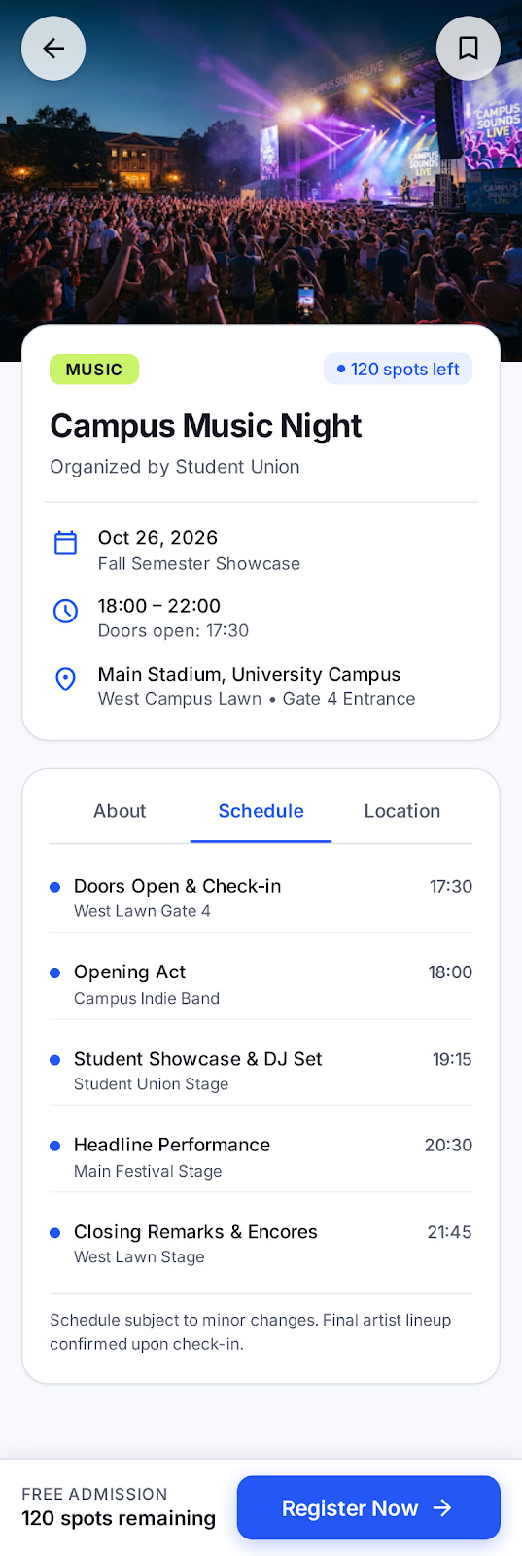 | [BẠN CHỌN: Chấp nhận / Chỉnh sửa / Từ chối]  Gợi ý lý do (chỉnh theo ý bạn): Persona Linh dùng một tay và phiên ngắn, nên màn lồng bên trong chỉ giữ Back, tiêu đề và một hành động để nút chính nằm trong tầm ngón cái. Heuristic 4 (Consistency) và 8 (Aesthetic and minimalist design).  Icon điều hướng: chấp nhận bộ icon thống nhất; còn lại Explore ở S02 vẫn có chữ đậm, cần kiểm tra thêm.
2 | Nhập liệu lặp lại khi đăng ký: các ô họ tên, MSSV, email để trống dù hồ sơ đã có (Quan sát #4, mục 5; phát hiện #3 của phản biện). | Màn hình: S04 Event Registration.  ## ROLE  You are a senior mobile UI/UX designer specializing in clean, production-ready Android applications for university students.  ## TASK  Revise the Camply screen S04 Event Registration to fix ONE specific problem only: repeated data entry. The student must not retype information the app already knows.  Keep everything else as close to the current version as possible.  ## PROBLEM TO FIX  1. Full Name, Student ID and University Email are empty placeholders ("e.g., ..."). They must be pre-filled with the student's saved profile: Alex Morgan, STU-849201, alex.m@university.edu. Show them as real entered values, not placeholder text.  2. Each pre-filled field must remain editable. Add a small "Edit" affordance or let the field be tapped directly. Do not lock the fields.  3. Keep the hint text under the fields only where it adds information (for example "Must match your student ID card"). Remove hints that only repeat the label.  4. Keep the Phone Number field empty and marked optional, because it is not in the saved profile.  5. The bottom navigation must stay hidden on this screen.  ## KEEP UNCHANGED  - DESIGN.md: Inter typography, Electric Blue #2457F5 primary, background #F8F9FC, text #171923 and #525866, 16 dp margins, 4 dp spacing scale, 8–16 dp radii.  - Event summary card at the top, the Confirm Registration button, and the back button in the header.  - Frame: Android mobile, 360 × 800 dp, light theme.  ## CONSTRAINTS  - Do not add any new features, sections, or screens.  - Do not use placeholder colour (#737987) for any readable content text, including pre-filled values.  - All tap targets at least 48 × 48 dp.  - Body and content text at least 14 sp.  - Do not convey error or status by colour alone.  ## OUTPUT  One screen only at 360 × 800 dp. | Trước: S04 cũ (ô placeholder, thanh điều hướng dưới, thương hiệu trên đầu).  TRƯỚC — S04 (log v1)  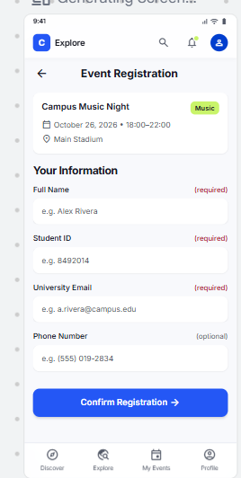  Sau: Full Name, Student ID, Email đã điền Alex Morgan, STU-849201, alex.m@university.edu. Phone để trống, ghi optional. Thanh điều hướng dưới đã ẩn. Hint có chọn lọc.  SAU — S04 vòng 2 (export mới nhất)  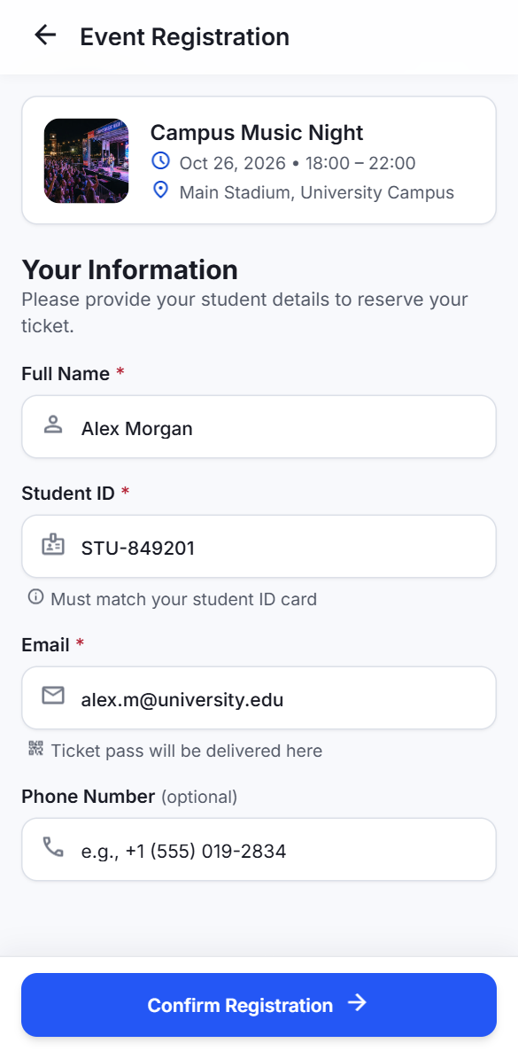  Kết quả: ĐẠT MỘT PHẦN. Chưa có affordance sửa cho các ô đã điền (không có nút hay biểu tượng Edit trong code). Nút Back vẫn 44 dp, chưa đạt 48 dp. | [BẠN CHỌN: Chấp nhận phần đã đạt / Làm vòng riêng để thêm nút sửa / Từ chối]  Gợi ý lý do (chỉnh theo ý bạn): Persona Linh cần đăng ký dưới 60 giây và không nhập lại thông tin (pain point 2), nên việc điền sẵn là đúng. Nhưng không có cách sửa rõ ràng vi phạm heuristic 3 (User control and freedom).
3 | Trạng thái chưa đọc chỉ bằng màu (chấm xanh) trên S09 Notifications (Quan sát/phát hiện #5 của phản biện). | Màn hình: S09 Notifications. Lần thử 1 bị từ chối: số "2 new" không khớp với 4 nhãn NEW, và hai thông báo This Week bị thay bằng nội dung của mục Today (sai ngữ cảnh mốc thời gian).  ## ROLE  You are a senior mobile UI/UX designer specializing in clean, production-ready Android applications for university students.  ## TASK  Revise the Camply screen S09 Notifications. Change ONE thing only: add a text label to each unread notification so unread status is not conveyed by colour alone.  ## EXACT CONTENT TO KEEP (do not change any text, time, or item)  Today:  - Registration Confirmed, 10m ago, "Your Campus Music Night ticket is ready." (unread)  - New Event Available, 2h ago, "AI & Future Careers Workshop is open for registration." (unread)  This Week:  - Event Reminder, Yesterday, "Campus Music Night starts in 3 days." (read)  - Schedule Update, Oct 8, "Photography Walk venue information has been updated." (read)  ## CHANGE  1. Only the two items in Today are unread. Give each one a visible "NEW" text label and keep the blue dot as a supporting cue.  2. The "2 new" count in the Today header must equal the number of NEW labels on the screen (2).  3. The two This Week items are read: no label, no dot.  4. Do not repeat any item in another section. Do not change timestamps.  ## KEEP UNCHANGED  - DESIGN.md: Inter typography, Electric Blue #2457F5 primary, background #F8F9FC, text #171923 and #525866, 16 dp margins, 4 dp spacing scale, 8–16 dp radii.  - Icons, section titles, "Mark all read" action, card layout.  - Frame: Android mobile, 360 × 800 dp, light theme.  ## CONSTRAINTS  - Do not add any new features, sections, or screens.  - Do not use placeholder colour (#737987) for any readable content text.  - All tap targets at least 48 × 48 dp.  - The NEW label is at least 14 sp, with contrast of at least 4.5:1.  - Do not convey status by colour alone.  ## OUTPUT  One screen only at 360 × 800 dp. | Trước: S09 cũ (chấm xanh là dấu hiệu duy nhất của chưa đọc).  TRƯỚC — S09 (log v1)  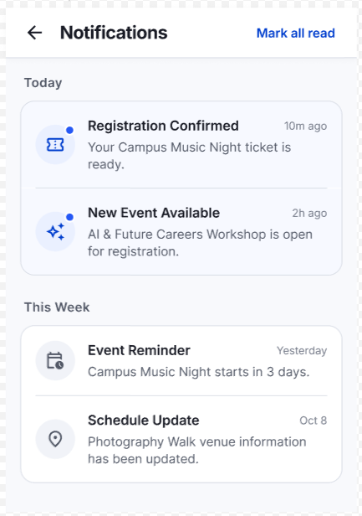  Sau: mỗi thông báo chưa đọc có nhãn NEW chữ; "2 new" khớp với 2 nhãn; This Week không có nhãn; nội dung và mốc thời gian giữ nguyên.  SAU — S09 vòng 3  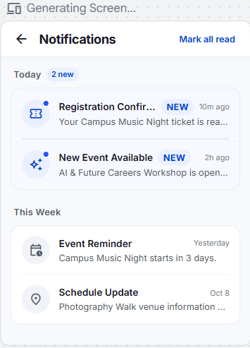  Còn tồn tại: tiêu đề và nội dung Today bị cắt bằng dấu "..." khi có nhãn NEW, cần kiểm tra ≥ 14 sp và độ đọc trong Figma.  Kiểm tra lại trong export mới nhất: đạt. Số "2 new" khớp với 2 nhãn NEW. Tiêu đề Today vẫn bị cắt ("..."), ghi là vấn đề còn tồn tại. | [BẠN CHỌN: Chấp nhận / Chỉnh sửa / Từ chối]  Gợi ý lý do (chỉnh theo ý bạn): Linh cần đọc nhanh thông báo chưa đọc ngoài nắng; nhãn chữ thỏa tiêu chí không dùng màu một mình (WCAG 1.4.1, Lab 2). Lần thử 1 bị từ chối vì sai số lượng và nội dung (heuristic 4 và 2).
4 | Chi tiết thừa và không thống nhất trên thẻ Trending của T08: chỉ báo "120 spots left" chỉ có ở một thẻ, và dữ liệu lịch sử tìm kiếm không khớp với bản đã chốt. Liên quan quyết định 2 và 4 của mục 6.3. | Màn hình: T08 Explore, idle search state. Prompt có hai thay đổi trong một lần chạy: bỏ chỉ báo "120 spots left" và thay mục lịch sử "Photography club" thành "Hackathon". Prompt vẫn ghi rõ các phần giữ nguyên. Trước vòng này, link "Details ›" đã được bỏ.  ## ROLE  You are a senior mobile UI/UX designer specializing in clean, production-ready Android applications for university students.  ## TASK  Revise the Camply Explore screen in its idle search state (T08). Make exactly two edits:  1. Remove the "120 spots left" indicator from the Campus Music Night card.  2. In the "Recent searches" list, replace the third item "Photography club" with "Hackathon". Keep its clock icon, its × remove icon, and its position.  Keep everything else exactly as the current version. Do not redesign, restyle, or add anything.  ## MUST STAY EXACTLY THE SAME (do not change, add, or remove)  - Header: the title "Explore Events" only. No subtitle, no bell, no other header icon.  - Search field: "Search events or keywords..." with a magnifier icon only. No microphone icon.  - Category chips: All, Music, Workshop, Sports, Arts, in the same order and style. Do not add the "Any time" or "On campus" filter row.  - Trending section: title "Trending on campus", no extra label, badge, or link on the right. No "Details" link on any card.  - Campus Music Night card: badge "Music", date "Mon, Oct 26 • 18:00", venue "Main Stadium". The card's other content and layout stay the same once the indicator is removed.  - Workshop card: unchanged, including its badge, title, date "Mon, Nov 2 • 09:00", and venue "Innovation Hub · Hall A".  - Recent searches: "campus music night", "football tournament", then "Hackathon". Section action reads "Clear".  - Bottom navigation: Discover, Explore, My Events, Profile. The Explore icon is the map icon with Explore selected.  - Layout, spacing, colours, typography, and corner radii: unchanged.  ## CONSTRAINTS  - Do not add any new text, label, link, counter, badge, or icon.  - Do not add a device frame, annotation text, or any label on the artboard.  - Do not use placeholder colour (#737987) for any readable content text.  - Do not convey status by colour alone.  - Use the design tokens from DESIGN.md. Do not hard-code colours or sizes.  ## OUTPUT  One screen only at 360 × 800 dp. | Trước: T08 có chỉ báo "120 spots left" trên thẻ Campus Music Night, không có link Details.  TRƯỚC  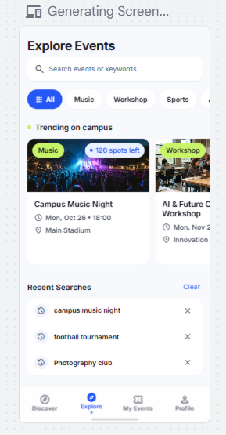  SAU  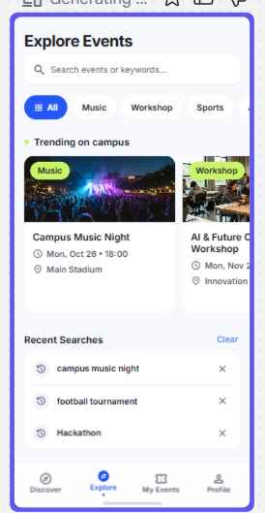  Đạt: không còn chỉ báo số chỗ và không còn link Details; mục lịch sử thứ ba là "Hackathon"; header, bộ lọc, nút Clear và thanh điều hướng giữ nguyên; không có chuông hay micro.  Lưu ý: vòng này chạy hai thay đổi trong một prompt. Đó là lỗi về nguyên tắc một vấn đề mỗi vòng. Ảnh có khung chọn màu tím và dòng "Generating Screen..." là giao diện của Stitch, không thuộc thiết kế. | [BẠN CHỌN: Chấp nhận / Chỉnh sửa / Từ chối]  Gợi ý lý do (chỉnh theo ý bạn): Chỉ báo số chỗ chỉ có ở một thẻ nên không nhất quán với hàng Trending, và không khớp với quyết định 4 trong mục 6.3. Lịch sử tìm kiếm đổi theo ý người thiết kế, cần ghi rõ đây là thay đổi dữ liệu mẫu, không phải thay đổi cấu trúc.

6.2 Phản biện UX bằng AI (cần ≥ 5 phát hiện gắn với màn hình)
Prompt phản biện:
# | Phát hiện | Màn hình | Heuristic / WCAG / persona | Chấp nhận · Chỉnh sửa · Từ chối | Lý do
1 | T07 không có nút Undo sau khi hủy đăng ký (AI #1) | T07 | H3 User control; H9 Error recovery | Từ chối | Hủy đã được commit, hệ thống không đảm bảo khôi phục được chỗ và vé. Ràng buộc nghiệp vụ, quyết định D07. Persona 1 cần biết trạng thái đăng ký rõ ràng (tiêu chí "Đã đăng ký").
2 | Tên và mã sinh viên trên vé không khớp hồ sơ (AI #3) | S07 (so với S04, S10) | H4 Consistency; H1 Visibility | Chấp nhận | Persona 1 cần tra lại đúng lịch và trạng thái khi đến sự kiện. Vé phải lấy từ cùng dữ liệu hồ sơ như S04 và S10.
3 | Ngày và địa điểm không nhất quán giữa các màn (AI #4) | S01, S02, S04–S08, T08 | H4 Consistency | Chấp nhận | Persona 1 cần đọc đúng thời gian và địa điểm trước khi đi. Ràng buộc: một bản ghi sự kiện chuẩn cho mọi màn.
4 | Màn loading không có thông báo chờ lâu hoặc lối thoát (AI #7) | T03 | H1 Visibility; H9 Error recovery | Chỉnh sửa | Persona 1 có kết nối không ổn định. Dùng lại trạng thái lỗi có nút thử lại, không thêm tính năng mới. Thời gian chờ cần kiểm tra trong Figma.
5 | QR ở S07 không được ghi rõ là bản demo (AI #11) | S07 | H1 Visibility; yêu cầu DESIGN.md | Chấp nhận | DESIGN.md yêu cầu QR giả lập phải được nhận diện là bản demo. Chỉ cần thêm một dòng chú thích.
You are a senior mobile UI/UX designer reviewing Camply, a campus event discovery and registration app for university students. The attached files are: screen images S01–S10 and T01, T03, T04, T06, T07, T08; DESIGN.md (design tokens); persona.md (persona Linh).
Note: screens T02 (registration validation error) and T05 (notifications empty state) are NOT attached. Do not review them and do not assume their content.
Review the attached screens against:

1. Nielsen's 10 usability heuristics. Name each heuristic you cite (for example "H4 Consistency and standards").
2. Basic mobile accessibility: text contrast at least 4.5:1 for normal text, touch targets at least 48 × 48 dp, body text at least 14 sp, and status must not rely on colour alone.
3. The persona: a second-year student who uses the app one-handed between classes, reads the screen outdoors, and often has an unstable network.

Output rules:

* List every finding you can support from the images. Do not invent findings to reach a number. If you find fewer than 5, say so.
* For each finding, use this format:
* Screen: (code, e.g. S04)
* Issue: what you see in the image
* Heuristic or criterion: (name it)
* Persona impact: how it affects Linh
* Priority: High / Medium / Low
* Recommendation: a concrete change, without adding new features
* Verification: "Observed in image" or "Needs Figma check" (for example exact sizes, sp values, hex colours, layout at 412 dp)
* Do not give numeric contrast ratios, sizes, or hex values unless they are printed in DESIGN.md or visible in the image. Mark anything else as "needs Figma check".
* Finish with a short list of what works well and should be kept.
* Do not redesign the product or propose new features.

Camply UX Review: Nielsen Heuristics, Accessibility and Persona Fit
Review of the Camply campus event app screens against Nielsen's 10 heuristics, basic mobile accessibility, and the persona Linh (second-year student, one-handed use between classes, outdoor reading, unstable network).
Scope and limits
• S03 (Event Detail) could not be reviewed. All three S03 image files in the zip are corrupt: each contains only the text "Image failed to fetch". Nothing was inferred from the HTML. This also means the "≤5 taps from Discover to registration" criterion can't be checked, because the step between S01's Details button and S04 is missing. Re-export S03 to complete the review.
• Screens reviewed: S01, S02, S04 to S10, T01, T03, T04, T06, T07 and T08. Where the zip has several versions, the latest was used (S09 v4, T04 v2, S05 v4, S06 v3, and so on).
• Excluded: T02, T05 (notifications empty state) and T09, as instructed or because they were not on the list.
• Numbers: DESIGN.md prints no contrast ratios, so none appear here. Exact sizes, sp values and hit areas are marked "Needs Figma check".
There are 22 findings that the images support, grouped by priority. The first four are trust issues that matter most for this persona.
High priority
1. Screen T07: no Undo on the cancellation snackbar
• Issue: After cancelling, the snackbar reads only "Registration cancelled." with no Undo action.
• Heuristic: H3 User control and freedom; H9 Help users recover from errors.
• Persona impact: Scenario 2 and DESIGN.md both promise Undo. A one-handed tap in a rush could cost Linh her spot with no way back.
• Priority: High
• Recommendation: Add an Undo action to the snackbar, per DESIGN.md ("offer Undo only when reversible"). It should stay up long enough to read and tap.
• Verification: Observed in image (the action is absent). Duration: needs Figma check.
2. Screen T07 (vs S06): registration count contradicts the earlier screen
• Issue: T07 shows "Upcoming 0" and an empty state. S06 showed two upcoming registrations, and the dialog in T01 cancels only one. The AI & Future Careers Workshop should still be registered.
• Heuristic: H4 Consistency and standards; H1 Visibility of system status.
• Persona impact: Linh would think she lost both registrations.
• Priority: High
• Recommendation: Make the count and list reflect the remaining registration (Upcoming 1, with the Workshop card). Keep the empty state for when none remain.
• Verification: Observed in image (assuming T07 follows S06 in one flow).
3. Screen S07 (vs S04, S10): ticket identity does not match the profile
• Issue: The ticket shows Attendee "Nguyen Van A" and Student ID "SE123456". The registration form and profile show "Alex Morgan" and "STU-849201".
• Heuristic: H4 Consistency and standards; H1 Visibility of system status.
• Persona impact: The ticket is what Linh shows at the gate. A name that doesn't match her ID undermines the peace-of-mind goal.
• Priority: High
• Recommendation: Populate the ticket from the same profile data as S04 and S10.
• Verification: Observed in image.
4. Screens S01, S02, S04 to S08, T08: the same events show different details
• Issue: Event details differ across screens.
• Campus Music Night: Fri Oct 26 (S01) and Fri Oct 28 (S02), versus Oct 26 18:00–22:00 (S04 to S08).
• Campus Music Night venue: Student Union Amphitheater (S01, S02) versus Main Stadium (S04 to S08).
• AI & Future Careers Workshop: Tue Nov 2, 4:00 PM, Science Hall 301 (S01, S02) versus Nov 2, 09:00–12:00, Innovation Hub · Hall A (S06, S08).
• The weekday for Nov 2 is Tue in S01/S02 but Mon in T08.
• Time format switches between 12-hour and 24-hour.
• Heuristic: H4 Consistency and standards.
• Persona impact: Linh commits from the list screens and could go to the wrong place or time. This is the most serious trust risk.
• Priority: High
• Recommendation: Use one data record per event and one date/time format throughout (for example "Mon, Oct 26 · 18:00"). Keep the venue name identical on every screen.
• Verification: Observed in image.
Medium priority
5. Screen S02: serif typeface
• Issue: Titles, labels and metadata render in a serif face, while the other screens use a sans-serif. DESIGN.md specifies Inter.
• Heuristic: H4 Consistency and standards.
• Persona impact: Serif text reads thinner outdoors, and the screen looks like a different app.
• Priority: Medium
• Recommendation: Apply the Inter text style to S02, as in T08.
• Verification: Observed in image. Exact weights: needs Figma check.
6. Screens T06, T07: broken logo placeholder
• Issue: The app bar shows a grey placeholder box labelled "img" where the logo should be.
• Heuristic: H8 Aesthetic and minimalist design; H4 Consistency and standards.
• Persona impact: The app looks unfinished and less trustworthy at the moment Linh needs reassurance.
• Priority: Medium
• Recommendation: Replace the placeholder with the logo or remove it. Use one app-bar pattern for each tab (S02 and T08 have no app bar, while T06 and T07 do).
• Verification: Observed in image.
7. Screen T03: loading state has no exit or slow-network message
• Issue: The loading modal says "Confirming your registration… Please wait a moment." It has a spinner plus separate dots, and shows no timeout message or way out.
• Heuristic: H1 Visibility of system status; H9 Help users recover from errors.
• Persona impact: The Wi-Fi in the persona's context is unstable. Linh could be stuck on a screen with no sign of whether to wait or retry.
• Priority: Medium
• Recommendation: Keep one progress indicator. After a delay, change the text to a slow-connection message with a Retry or Back option, so the screen is never a dead end. This reuses the error state and adds no feature.
• Verification: Observed in image. Delay length: needs Figma check.
8. Screen S01: essential text on a busy photo
• Issue: On the featured card, the title, date, venue, Details button and bookmark sit directly on a busy concert photo.
• Heuristic: Accessibility: text contrast ≥ 4.5:1; H8 Aesthetic and minimalist design. DESIGN.md says "Do not place essential text directly on busy photography."
• Persona impact: Linh reads outdoors in glare, and busy imagery lowers legibility.
• Priority: Medium
• Recommendation: Put the date and venue on a solid surface below the image (as in the list cards), or use a stronger solid scrim behind the text.
• Verification: Visible in image. Actual contrast ratio: needs Figma check.
9. Screens S01, S08: truncated date and venue lines
• Issue: The date and venue lines are cut off with an ellipsis ("Tue, Nov 2 • 4:00 …", "East Campus Athle…", "Oct 26, 2026 • 18:00 –…").
• Heuristic: H6 Recognition rather than recall.
• Persona impact: The end time and venue are what Linh decides on. Truncation hides them in the lists she scans.
• Priority: Medium
• Recommendation: Let metadata wrap to a second line, or shorten the format (for example "Tue, Nov 2 · 16:00"). DESIGN.md allows title truncation only. Check at larger system text sizes.
• Verification: Observed in image. Behaviour at 412 dp and with scaled text: needs Figma check.
10. Screens S02, S06, S10, T01, T06, T08: unstable bottom-nav icons
• Issue: The bottom-navigation icons are not stable.
• Explore uses a shapes icon in S02, S06, T01 and T06.
• Explore uses a map icon in S10.
• Explore uses a compass in T08, which is the same icon as Discover.
• Heuristic: H4 Consistency and standards; H6 Recognition rather than recall.
• Persona impact: Linh navigates one-handed and quickly. Changing or duplicate icons slow her down.
• Priority: Medium
• Recommendation: Pick one distinct icon per tab from the same outline family and use it on every screen.
• Verification: Observed in image.
11. Screen S07: no demo label on the QR
• Issue: No visible label says the QR is a UI demonstration.
• Heuristic: H1 Visibility of system status; DESIGN.md requirement ("A simulated ticket QR must be identified as a UI demonstration").
• Persona impact: Linh could think the ticket is real. This is also a spec gap.
• Priority: Medium
• Recommendation: Add a short "Demo QR" line near the code or in the info note.
• Verification: Observed in image (the label is absent from the image).
12. Screen S06: Cancel placed beside View Ticket
• Issue: Cancel (red outline) sits right next to View Ticket in the same row on both cards.
• Heuristic: H5 Error prevention.
• Persona impact: A one-handed thumb tap could hit Cancel by accident. The T01 dialog catches it, which helps.
• Priority: Medium
• Recommendation: Keep the confirmation dialog. Reduce Cancel's visual weight (tertiary text style) or separate it from View Ticket. Keep View Ticket as the single dominant action.
• Verification: Observed in image. Gap and hit sizes: needs Figma check.
13. Screens S01, S02, T06, T08: touch targets that look small
• Issue: Several controls look shorter than the bottom-nav items. These are the filter chips and dropdown buttons (Any time, On campus, Sort), the bookmark icons, the recent-search X icons and the small "Clear", "See all" and "Mark all read" links.
• Heuristic: Accessibility: touch targets ≥ 48 × 48 dp.
• Persona impact: Small targets are harder to hit one-handed while walking.
• Priority: Medium
• Recommendation: Confirm every target is at least 48 × 48 dp. Enlarge the hit area without changing the icon size.
• Verification: Needs Figma check (hit areas are not visible in a flat image).
14. Screens T06, T07: lime badges used for non-category labels
• Issue: Lime badges are used for "FALL '24" (T06) and "STUDENT ID" (T07). "FALL '24" is also a stale year next to 2026 dates. "STUDENT ID" has no clear meaning on My Events.
• Heuristic: H4 Consistency and standards; H2 Match between system and real world.
• Persona impact: Lime means "category" everywhere else, so these two badges mislead.
• Priority: Medium
• Recommendation: Remove both badges or give them a neutral style. If the term label stays, correct the year.
• Verification: Observed in image.
15. Screens S02, T08 (vs T06): selected chip shown by colour alone
• Issue: The selected "All" chip is marked by blue fill alone in S02 (a grid icon in T08). T06 adds a check mark to the selected chip, and other chips have none.
• Heuristic: Accessibility: status must not rely on colour alone; H4 Consistency and standards.
• Persona impact: In bright sun, fill colour alone is easy to miss.
• Priority: Medium
• Recommendation: Use the T06 pattern (check mark plus fill) for the selected chip on all Explore screens.
• Verification: Observed in image.
Low priority
16. Screen T01: dialog context
• Issue: The dialog has three problems.
• The backdrop does not dim the bottom navigation, so it looks tappable.
• The background behind the dialog is a different My Events layout from S06 (large-photo cards, a calendar icon at top right, a chevron on Past).
• The destructive button says "Yes, Cancel", while DESIGN.md names the pair "Keep Registration" and "Cancel Registration".
• Heuristic: H4 Consistency and standards; H5 Error prevention.
• Persona impact: Minor. The dialog does name the event and offers a safe choice.
• Priority: Low
• Recommendation: Dim the full screen, including the nav, and use the S06 layout as the background. Rename the button "Cancel Registration" and consider a clearer destructive style.
• Verification: Observed in image.
17. Screen S09: contradictory notification content
• Issue: "Registration Confirmed" was 10 minutes ago, yet "Event Reminder" yesterday says the Music Night starts in 3 days. "New Event Available" invites registration for the Workshop, which S06 shows as already registered.
• Heuristic: H4 Consistency and standards; H2 Match between system and real world.
• Persona impact: Contradictions make Linh doubt which registrations are real.
• Priority: Low
• Recommendation: Align the notification copy with the events data. The unread dots and tint are backed by the "2 unread" text, so per-item unread state is acceptable.
• Verification: Observed in image.
18. Screen S07: non-interactive text styled as a link
• Issue: Pass type "General" is blue text, the same style as links. It is not interactive.
• Heuristic: H4 Consistency and standards (blue is reserved for actions).
• Persona impact: Linh may tap it expecting something to happen.
• Priority: Low
• Recommendation: Use the same dark text as the other ticket values.
• Verification: Observed in image.
19. Screen S04: required fields marked by an asterisk only
• Issue: Required fields are marked only with a red asterisk, while optional is written in words. The phone placeholder uses a +1 format.
• Heuristic: Accessibility: status must not rely on colour alone; H2 Match between system and real world. DESIGN.md says to indicate required and optional fields in words.
• Persona impact: Minor. Linh's name, ID and email come prefilled, which is good.
• Priority: Low
• Recommendation: Add "(required)" or an equivalent word, and use a local phone example.
• Verification: Observed in image.
20. Screen S05: secondary button off-spec
• Issue: The secondary button "Back to Discover" has a dark label and a very faint outline. DESIGN.md calls for a blue label and a visible 1dp outline.
• Heuristic: H4 Consistency and standards; Accessibility: UI graphics contrast ≥ 3:1.
• Persona impact: Minor. The primary CTA is clear.
• Priority: Low
• Recommendation: Use the Secondary spec: blue label, visible outline.
• Verification: Outline contrast: needs Figma check.
21. Screen S01: logo and thumbnail crops
• Issue: The header has a very small logo image next to the "Camply" wordmark. The list thumbnails have different crops (the football image is noticeably shorter and wider than the others).
• Heuristic: H4 Consistency and standards; H8 Aesthetic and minimalist design. DESIGN.md asks for consistent crops in the same card type.
• Persona impact: Cosmetic only.
• Priority: Low
• Recommendation: Keep one logo treatment and one thumbnail ratio.
• Verification: Observed in image.
22. Screen T07: unlabeled "+" button and snackbar overlap
• Issue: In the "More Happening This Week" card, the "+" button has no label. The snackbar overlaps the card's bottom edge and its "42 spots left" line.
• Heuristic: H6 Recognition rather than recall; H2 Match between system and real world.
• Persona impact: Linh can't tell whether "+" registers or saves.
• Priority: Low
• Recommendation: Replace the "+" with the standard bookmark target or a labelled action used elsewhere, and give the snackbar its own space above the nav.
• Verification: Observed in image. Snackbar placement: needs Figma check.
What works well and should be kept
• S04: prefilled name, ID and email, a sticky "Confirm Registration" button at the thumb's reach, and persistent labels above the fields.
• S05 and S07: a clear loading → success → View Ticket path. The calm success screen follows the confetti rules, and the QR is large, high-contrast and printed on a white card.
• S06: the "Registered" status uses an icon plus text, not colour alone, and View Ticket is one tap from My Events.
• T01: the dialog names the event, explains the consequence and offers "Keep Registration" as the safe choice.
• T04 and T06: the empty and no-results screens each give a clear next step (Explore Events, Clear Filters).
• S10 and S09: simple, scannable structure, with Saved Events and Notifications reachable without adding bottom tabs.
• Bottom navigation overall: four tabs with labels and an active indicator, matching DESIGN.md.
• Lime badges with dark text: the category badges (S01, S02, S06) are consistent and legible.
Lý do phải gắn với persona, một heuristic hoặc một ràng buộc thực tế (phạm vi, thời gian, nền tảng). "Mình thích" và "AI nói vậy" không được tính.
6.3 Quyết định trên đề xuất T08 do Stitch tạo (vòng 4, lần 2)
So sánh đề xuất của Stitch với T08 do sinh viên thiết kế. Mỗi quyết định ghi lý do gắn với persona Linh, một heuristic, hoặc ràng buộc thực tế. Việc Stitch và sinh viên cùng chọn một cấu trúc không được tính là lý do.
# | Chi tiết trong đề xuất Stitch | Quyết định | Lý do | Phản ánh trong Figma
1 | Cấu trúc: thẻ Trending ảnh ngang + Recent searches | Chấp nhận | Persona Linh tìm sự kiện một tay và trong phiên ngắn (mục 8): thẻ ngang cho thấy nhiều sự kiện trong một lần cuộn. Heuristic 6 (Recognition rather than recall): lịch sử tìm kiếm giảm việc gõ lại. | T08 trong page 03 có cấu trúc này.
2 | Link "Details ›" trên mỗi thẻ | Từ chối | Heuristic 8 (Aesthetic and minimalist design): cả thẻ đã chạm được tới trang chi tiết, link thêm là thừa. Lab 2 yêu cầu vùng chạm ≥ 48 × 48 dp; link chữ nhỏ có vùng chạm khó đạt, và Linh dùng một tay nên dễ chạm lệch. | Thẻ trong T08 không có link Details; cả thẻ là vùng chạm.
3 | Subtitle "Find what's happening around campus" | Từ chối | Heuristic 8: subtitle lặp ý với tiêu đề "Explore Events", chiếm một dòng trong màn 800 dp, làm đẩy nội dung và nút xuống thấp hơn. Persona Linh cần thấy sự kiện ngay khi mở màn. | Header T08 chỉ có tiêu đề.
4 | Thẻ không có số người tham gia | Chỉnh sửa | Persona Linh quyết định đi vào phút chót và có động lực kết nối xã hội (mục 8): số người tham gia giúp quyết định nhanh. Nhưng vòng 4 đã bỏ bộ đếm để giữ dữ liệu khớp với S03 (S03 hiện là "120 spots left", không có "going"). Cần chọn một cách hiển thị duy nhất và dùng ở S02, S03, T08. | Chưa xác định. Phải thống nhất với S03 trước khi thêm lại.
5 | Thiếu hàng bộ lọc (Any time, On campus) | Từ chối | Heuristic 4 (Consistency and standards): T08 là trạng thái rỗng của S02, nên phải giữ cùng bộ lọc với S02. Ràng buộc phạm vi: một vấn đề mỗi vòng, không đổi cấu trúc S02 ngoài phần đang sửa. | T08 trong Figma có hàng bộ lọc giống S02.
Ghi chú về "mùi AI": hai chi tiết copy "Find what's happening around campus" và link "Details ›" là mẫu chung của giao diện do AI tạo. Ghi nhận ở đây để giảng viên thấy quá trình đánh giá, không phải lý do để thay đổi thêm.

