On Pitfalls of Test-Time Adaptation
Abstract
Test-Time Adaption or TTA, allows a pretrained model to adjust when it starts to see data that is different from what it originally trained on. This is useful in real-world situations because the data a model sees after deployment may not always stay the same. However, this paper shows that it is not enough to simply look at the final accuracy and decide that one adaptation method is better than another one. Things like hyperparameters, model quality, reset behavior, or distribution shift all can make one method look better or worse than it actually is. To make the comparisons more consistent, the authors introduce TTAB, a benchmark for testing different TTA methods under more consistent settings. One main thing I learned from this paper is that a good result does not always mean the adaptation method itself is good because the way we test it also makes a big difference.
Introduction
Machine learning models are usually trained under one set of conditions, but the data that they see after deployment may not always look the same. Let say, an image model trained on clear images may later receive blurry images, image from different camera, or data where some classes appear more often than others. This is called distribution shift. Test-Time Adaptation is one way to deal with this problem by allowing a pretrained model to adjust itself using unlabeled data during testing.
This paper focuses on how TTA methods are evaluated. Different studies often use different models, hyperparameters, reset rules, and distribution shifts, which make comparisons unfair. Therefore to address this, the authors introduce TTAB, a benchmark for evaluating TTA methods under more consistent conditions.
Hyperparameters and Batch Dependency
One of the main finding in the paper is that TTA performance can change a lot depending on the hyperparameters used. The authors tested different learning rates and numbers of adaptation steps and they found that poor setting could greatly reduce accuracy.
This becomes more important in online adaptation because the model keep its updates from previous batches. As the result, an update made early in the stream can affect how the model performs on later batches. The paper refers to this batch dependency.
The researchers also found that more adaptation is not always better. For example, SHOT improved from 69.2% accuracy with one adaptation step to 70.9% with three steps, but dropped to 68.4% with five steps. This shows that too much adaptation can cause the model to over-adapt to earlier batches.
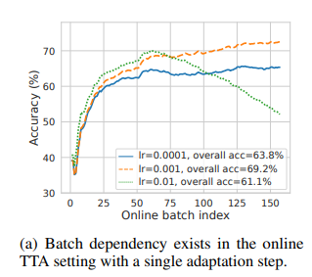
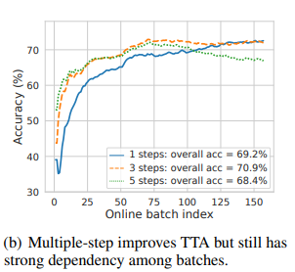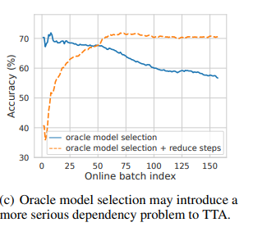
The first graph shows that different learning rates can lead to very different results over time. The second shows that increasing adaptation steps can help at first, but too many steps can lower accuracy. The third shows that even with oracle model selection, performance can still drop because earlier batches continue to affect later ones.
Episodic vs. Online Adaptation
There are two common ways of adapting a model. In episodic adaptation, the model resets to its original state after each batch, so previous updates do not affect future batches.
In online adaptation, the model keeps its updates and continues learning as new batches arrive. This can help the model use information from earlier data, but it can also cause mistakes to build up over time. Because of this, the paper shows that whether a model resets or keeps its updates can have a major effect on the final result.

When Adaptation Hurts Performance
One of the most surprising findings in the paper is that adaptation can actually make performance worse. The MEMO method performed slightly better than the baseline in the episodic setting, but its performance dropped dramatically when updates were carried online. This shows that adaptation is not always helpful, especially when errors from earlier batches continue to affect later ones.
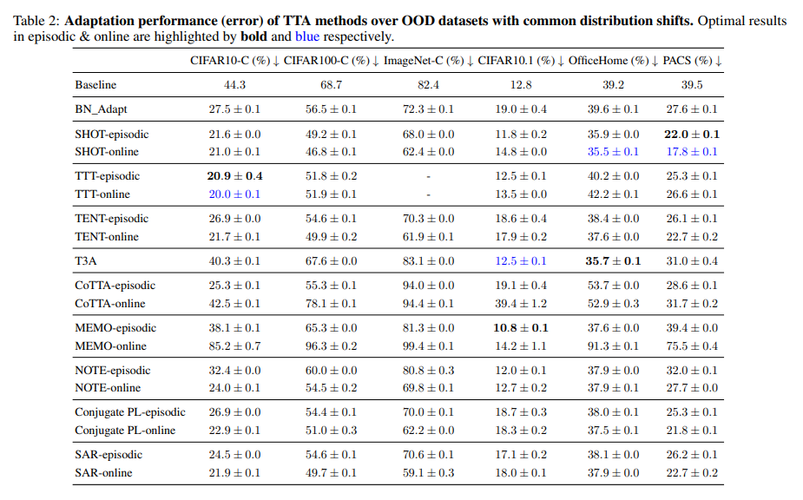
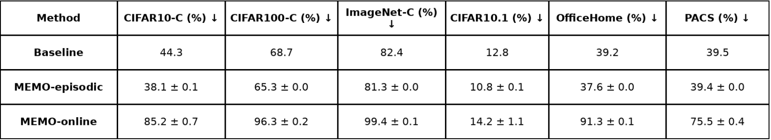

Why Stabilizing Online Adaptation Is Still Hard
The paper also looks at method designed to reduce the problems caused by online adaptation. Stochastic restoring randomly resets a small portion of the model back to its pretrained parameters, while the Fisher regularizer limits large changes to parameters that are considered important. These methods can reduce model drift, but Figure 9 shows that their performance is still very sensitive to the learning rate and the number of adaptation steps.
Main takeaway: Online adaptation has to balance learning new information with preserving what the model already knows.
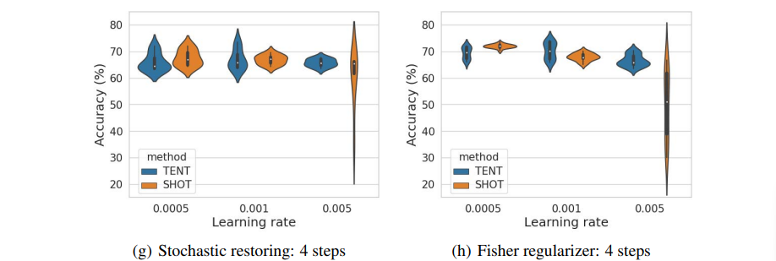

What This Means for Our Project
The main lesson I would want to bring into our project is that we should define the evaluation rules before comparing online-learning models. Instead of only looking at final accuracy, we should also track performance throughout the stream and compare the online model against a frozen baseline. This can help us see when updates are actually helping and when they start to hurt performance.
We should also keep settings such as the data split, random seed, batch size, stream order, and update rules consistent across experiments so that the comparison between models is more reliable.

Work Cited
Zhao, H., Liu, Y., Alahi, A., & Lin, T. (2023, June 6). On pitfalls of Test-Time adaptation. arXiv.org. https://arxiv.org/abs/2306.03536

