Jagiellonian University medical college
doctoral school of medical and health sciences

What is the optimal graft choice for primary anterior cruciate ligament reconstruction surgery?


A systematic review and network meta-analysis
A dissertation submitted in partial fulfillment of the requirements for the award of the degree of:
Doctor of Philosophy (Ph.D.)

submitted by:
Dong Woon Kim, M.D.^{1,2,3}
dr n. med. Dong Woon Kim

supervised by:
_{Konrad Malinowski, M.D., Ph.D.} ^{1,4}

Kraków, 2026

Table of Contents
What is the optimal graft choice for primary anterior cruciate ligament reconstruction surgery? 1
A systematic review and network meta-analysis 1
What is the optimal graft choice for primary anterior cruciate ligament reconstruction surgery? 4
Abstract 4
Introduction 5
Rationale 5
Objectives 5
Methods 6
Protocol and registration 6
Eligbility criteria 6
Information sources 7
Search strategy 7
Study selection process 8
Data collection process 8
Data items 8
Study risk of bias assessment 8
Effect measures 8
Synthesis methods Error! Bookmark not defined.
Risk of bias within individual studies Error! Bookmark not defined.
Certainty assessment Error! Bookmark not defined.
Results 10
Study selection 10
Presentation of the network structure Error! Bookmark not defined.
Summary of network geometry Error! Bookmark not defined.
Study characteristics 10
Risk of bias in studies 10
Patient-reported outcome measures 10
Objective measures of knee stability 11
Graft failure 12
Reporting biases 10
Certainty of evidence 10
Geometry of the network 10
Study characteristics Error! Bookmark not defined.
Risk of bias within studies Error! Bookmark not defined.
Results of individual studies 10
Synthesis of results 10
Exploration for inconsistency Error! Bookmark not defined.
Risk of bias across studies Error! Bookmark not defined.
Results of additional analyses Error! Bookmark not defined.
Discussion 13
Summary of evidence 13
Limitations 13
Conclusions 13
Funding 13
References 14
Data availability statement 18
Tables and Figures 19
Tables 19
Supplementary Tables 20
Supplementary Table 1 Eligibility crtieria for inclusion and exclusion of studies. 24
Supplementary Table 2 Database search strategies 25
Table 1 Characteristics of included studies 20
Table 2 International Knee Documentation Committee (IKDC) Subjective Knee Form Error! Bookmark not defined.
Table 3 Lysholm Knee Scoring Scale 29
Table 4 Tegner Activity Scale 31
Table 5 Side-to-side difference in instrumented laxity 33
Table 6 Pivot-shift Test 35
Table 7 Lachman Test 36
Table 8 Graft failure including re-rupture, clinical failure and revision surgery Error! Bookmark not defined.
Figures 39
Fig 1. Central Figure 40
Fig 2. PRISMA flowchart depicting the study identification and selection process 41
Fig 3. Network graph 42

Network meta-analysis of autografts and allografts
Pairwise meta-analyses:
Bone-patellar tendon-bone autograft vs. Hamstring tendon autograft
Bone-patellar tendon-bone autograft vs. Quadriceps tendon autograft
Hamstring tendon autograft vs. Quadriceps tendon autograft

What is the optimal graft choice for primary anterior cruciate ligament reconstruction surgery?
A systematic review and network meta-analysis of randomised controlled trials.

Dong Woon Kim, M.D.^{1,2,3,4}, Wiktoria Westen MS⁵, Konrad Malinowski, M.D., Ph.D.^{1, 2}
¹ International Evidence-Based Anatomy Working Group (iEBA-WG)
Department of Anatomy, Jagiellonian University Medical College, Kraków, Poland
² Artromedical
³ Johns Hopkins University School of Medicine, Baltimore, Maryland, United States
⁴ Harvard University, Cambridge, Massachusetts, United States
⁵ University of Porto, Porto, Portugal

duAbstract
Objective: The objective of the review was to synthesise the results between the most common graft types for primary anterior cruciate ligament reconstruction surgery. In this review, four autologous grafts (bone-patellar tendon-bone, hamstring, quadriceps, and peroneus longus tendon) and two allogenic grafts (Achilles tendon and tibialis anterior tendon) were included and compared in terms of patient-reported outcome measures, antero-posterior translation and posterolateral knee stability, and graft failure.
Design: Systematic review of randomised controlled trials
Methods: Data sources: The literature search was initially performed on July 29, 2026 for all six graft types from database sources: PubMed/MEDLINE, Embase, Web of Science Core Collection, and Cochrane Library. Study eligibility criteria: Sixty-nine randomised controlled trials that compared the results of at least one of the specified outcome measures between at least two of the specified graft types were included in the qualitative review. Forty-five studies reported sufficient data on outcome measures to be included in the quantitative review. Synthesis methods: Two-arm and multi-arm study results underwent network meta-analysis of standardized mean differences (SMDs) and odds ratios (ORs) for continuous and dichotomous variables. Direct and indirect comparisons between the four autologus grafts and the two allogenic grafts were summarised with a regression analysis of covariates as predictors: follow-up duration (months) and short, medium, and long-term follow-up duration, mean age and male to female gender ratios.

Results:

Conclusion:
Protocol registration: PROSPERO (CRD42024592549) and Cochrane Reviews (COCHRANEEMD-2026-00379)

Introduction

Rationale
The anterior cruciate ligament (ACL) is responsible for approximately 70% of antero-posterior and postero-lateral stability of the knee joint [citation]. A complete rupture of the ACL requires surgical reconstruction of the ligament in order to restore the native biomechanical properties of the joint. Although extra-articular procedures gained initial popularity for performing ACLR, they have since been phased out as an auxiliary procedure, called lateral extra-articular tenodesis (LET) and thus, intra-articular procedures currently dominate the ACLR scene. Currently, the most common grafts utilized for such intra-articular ACLR include autologous tendons and allogenic tendons, and less commonly, synthetic sources (1). Despite the comprehensive scope by which ACLR has been studied, with numerous systematic reviews and meta-analysis papers on the topic, a consensus has not been made regarding the optimal graft choice (1).
Autologous grafts—harvested from the tendons of the patients’ own muscles, include the patellar tendon, the hamstring tendon, the quadriceps tendon, and the peroneus longus tendon. The patellar tendon—otherwise known as the bone-patellar tendon-bone (BPTB) graft—is currently the gold-standard and most common choice for ACL reconstruction surgery. The hamstring tendon (HT), includes single, double, triple and quadruple-bundled semitendinosus with or without gracilis tendon, and has been associated with outcomes that closely resemble those of the BPTB. The quadriceps tendon (QT), whether harvested with or without the patellar bony attachment has been shown to be a non-inferior choice for ACLR (2). The peroneus longus tendon (PLT) can be harvested with or without peroneus brevis tenodesis.
Allogenic grafts—harvested from exogenous sources—include the allogenic BPTB, Achilles tendon (AT), and the tibialis anterior tendon (TA). Currently, the only utilized synthetic or artificial sources of ACL is the Leeds-Keido graft.

Objectives
Although there are many graft harvesting choices from which the surgeon must preferentially decide from, there are no comprehensive studies that compare the outcomes of all of these aforementioned grafts. Many randomized controlled trials (RCTs) exist that compare the most common choices, such as BPTB, HT, and QT; however, only a few studies compare autografts with allografts. Thus, a network meta-analysis was conducted in order to produce a comprehensive set of outcome data that summarizes the comparative results between all of the grafts inclusive of all contemporary surgical graft harvesting options.

Methods

Protocol and registration
The current review adhered strictly to the guidelines outlined in the Preferred Reporting Items for Systematic Reviews and Meta-Analyses (PRISMA) and the extension for Network Meta-Analyses (PRISMA-NMA) (3). The review protocol was developed and registered on the International Prospective Registry of Systematic Reviews (PROSPERO) under the registration number: CRD42024592549. The review protocol was submitted and accepted on Cochrane Database of Interventional Reviews under registration number: COCHRANEEMD-2026-00379.

Eligibility criteria
The inclusion and exclusion criteria for selecting studies are shown in Supplementary Table 1.

Population: Studies conducted on skeletally-mature, adult patients after complete rupture (grade III sprain) of the anterior cruciate ligament were included. Skeletal maturity was determined to be a study in which the mean age of all participants was greater than or equal to 18 years old. Studies which were conducted on pediatric or adolescent patients, or in which the mean age of all participants was less than 18 years were excluded.

Intervention: Studies in which the patients underwent primary anterior cruciate ligament reconstruction were included. Studies in which the patients underwent revision or repair of the anterior cruciate ligament were excluded.

Comparator(s): Studies in which the primary anterior cruciate ligament was reconstructed using the bone-patellar tendon-bone autograft, hamstring tendon autograft, quadriceps tendon autograft, peroneus longus tendon autograft, Achilles tendon allograft or tibialis anterior tendon allograft were included in the study. Autografts must have been harvested from the ipsilateral limb of the patients, and the allografts were included regardless of their prior γ-irradiation status prior to transplantation. Studies that performed the reconstruction using any other graft were excluded from the study.

Outcome(s): Studies that reported on the IKDC subjective knee form (IKDC-SKF) score, Lysholm knee scoring scale, Tegner activity scale score, instrumented laxity measured as the side-to-side difference in anteroposterior tibial translation by KT-1000/2000 or Rolimeter, pivot-shift test, Lachman test, and graft failure (including graft re-rupture, clinical failure, or revision surgery) were included in the study. Studies that did not report on at least one of the specified outcomes were excluded from the quantitative review.

Study design: Studies that were randomised controlled trials (RCTs) were included. All other study designs, including but not limited to non-randomised controlled trials, prospective and retrospective cohort studies (comparative and non-comparative), case-control studies, and case series and/or reports were excluded.
There were no restrictions placed on length of follow-up or year of publication. No restrictions were placed on language for retrieval of full-text reports; however, only studies written in English were considered for inclusion. Only studies published in peer-reviewed journals were included in the review.
The studies were grouped by the graft harvested for reconstructing the anterior cruciate ligament. There was a total of 12 different graft types, which were grouped into six subgroups for the purposes of the network meta-analysis. The groups were formed according to the muscle of which the tendon was harvested from.
- Graft types included in study
 | No. | Subgroup | Intervention | Full name and description
 | 1 | BPTB | BPTB | Bone-patellar tendon-bone autograft.
 | 2 | HT | 2-ST | Double-stranded semitendinosus hamstring autograft.
 | 3 | HT | 4-ST | Quadruple-stranded semitendinosus hamstring autograft.
 | 4 | HT | 4-STG | Quadruple-looped semitendinosus and gracilis autograft.
 | 5 | HT | 6-STG | Six-stranded semitendinosus and gracilis autograft.
 | 6 | QT | B-QT | Quadriceps tendon with bone autograft.
 | 7 | QT | S-QT | All soft-tissue quadriceps tendon autograft.
 | 8 | PLT | PLT | Peroneus longus tendon autograft.
 | 9 | PLT | PLT + PBT | Peroneus longus tendon autograft with peroneus longus brevis tenodesis.
 | 10 |  | AT | Achilles tendon allograft.
 | 11 | TA | TA | Tibialis anterior tendon allograft.
 | 12 | TA | TP | Tibialis posterior tendon allograft.

Information sources
The literature search was conducted using the following three databases: PubMed/MEDLINE, Embase, and Web of Science Core Collection. The Cochrane Central Register of Controlled Trials (CENTRAL) and reference lists of systematic reviews and network meta-analysis review articles on the topic were used as a source for citation search. The database and register searches were performed up to and including July 29, 2026. Reference/citation search was performed on August 21, 2026.

Search strategy
The inclusion criteria for intervention, comparators and study design were used to construct the search strategy for each database. The inclusion criteria for intervention included the following search terms, "anterior cruciate ligament", "anterior cruciate ligament reconstruction", "ACL", and "ACLR", which were combined by the Boolean operator, "OR". For comparators, "bone-patellar tendon-bone", "patellar tendon", "BPTB", "hamstring tendon", "semitendinosus", "gracilis", "quadriceps tendon", "QT", "peroneus longus", "PLT", "Achilles tendon", and "tibialis anterior" were used. Study design was used to filter out "randomised controlled trials" and "clinical trials" using publication type field tag and filters. The full search strategy for each of the three database/registry searches is shown in Supplementary Table 2. The full search strategy for PubMed/MEDLINE (shown below) was translated into Embase, Web of Science Core Collection and Cochrane Central Register of Controlled Trials (CENTRAL) search syntax.

PubMed/MEDLINE
- "anterior cruciate ligament"[MeSH Term]
- "anterior cruciate ligament reconstruction"[Title/Abstract]
- "anterior cruciate ligament reconstruction"[Title/Abstract]
- "ACL"[Title/Abstract]
- "ACLR"[Title/Abstract]
- #1 OR #2 OR #3 OR #4 OR #5
- "bone-patellar tendon-bone"[Title/Abstract]
- "patellar tendon"[Title/Abstract]
- "BPTB"[Title/Abstract]
- #7 OR #8 OR #9
- "hamstring"[Title/Abstract]
- "hamstring tendon"[Title/Abstract]
- "semitendinosus"[Title/Abstract]
- "gracilis"[Title/Abstract]
- #11 OR #12 OR #13 OR #14
- "quadriceps"[Title/Abstract]
- "quadriceps tendon"[Title/Abstract]
- "QT"[Title/Abstract]
- #16 OR #17 OR #18
- "peroneus"[Title/Abstract]
- "peroneus longus"[Title/Abstract]
- "fibularis longus"[Title/Abstract]
- #20 OR #21 OR #22
- "achilles"[Title/Abstract]
- "achilles tendon"[Title/Abstract]
- #24 OR #25
- "tibialis"[Title/Abstract]
- "tibialis anterior"[Title/Abstract]
- "tibialis posterior"[Title/Abstract]
- #27 OR #28 OR #29
- #10 OR #15 OR #19 OR #23 OR #26 OR #30
- "randomized controlled trials"[Publication Type]
- "randomized controlled trials"[Title/Abstract]
- "randomised controlled trials"[Title/Abstract]
- #32 OR #33 OR #34
- "review"[Publication Type]
- "systematic review"[Publication Type]
- "meta-analysis"[Publication Type]
- "review"[Title/Abstract]
- "systematic review"[Title/Abstract]
- "meta-analysis"[Title/Abstract]
- #36 OR #37 OR #38 OR #39 OR #40 OR #41
- #35 NOT #42
- #6 AND #31 AND #43

There were no limitations on date of publication, language, or any other filters other than publication type in the database and registry searches.

Study selection process
One reviewer (D.W.K.) performed the literature search on July 29th 2026. Database search resulted in 622, 317, 531 and 234 records for PubMed/MEDLINE, Embase, Web of Science Core Collection, and Cochrane Central Register of Controlled Trials (CENTRAL), respectively, for a total of 1,704 records. Nine hundred and ninety-seven duplicate records were removed. The titles and abstracts of 707 records were screened, and 103 full-text reports were sought for retrieval. All 103 reports were retrieved and underwent full-text screening. Thirty-four reports were excluded from the review during full-text screening for the following reasons for exclusion: two reports were not randomised controlled trials, 17 studies did not report on at least one of the specified outcomes, two did not compare at least two of the specified graft types, nine were duplicates of the same study, and four reports were written in a language other than English. Sixty-nine studies were included in the qualitative review and 45 studies were included in the quantitative review. The study selection process is depicted in Figure 2.

Data collection process
Data extraction was performed using spreadsheets created on Microsoft Excel®. Data extraction was performed by one independent reviewer. Although data collection forms were created and piloted, the extraction was performed directly on Microsoft Excel® spreadsheets for consistency in methods between the reviewers. Data extraction for study results included the subgroups, data type (continuous and dichotomous), sample size, effect size (mean or event), median, range (minimum and maximum), interquartile range (first and third quartiles), and standard deviations. Furthermore, for pivot-shift and Lachman outcomes, the sample size and event (0, 1+, 2+, and 3+) were extracted. For graft failure, the sample size and event (re-rupture, clinical failures, and revision) were extracted.

Data items
Data collection involved extracting (1) study characteristics (total participants, including total number of male and female participants), the sample size at last follow-up, (including sample size of male and female participants), number lost due to follow-up, study design, and the level of evidence), (2) recruitment details (country, department, institution, period of enrollment (start and end dates of the recruitment period), (3) covariates (mean age and standard deviation, follow-up duration in months (minimum, mean and standard deviation) and the male to female ratio taken from the sample size for each gender), and (4) outcomes (IKDC subjective knee form scores, Lysholm knee scoring scale, Tegner activity scale, instrumented laxity, pivot-shift, lachman, graft failure (including graft re-rupture, clinical failure, and revision ACLR).

Study risk of bias assessment
The risk of bias assessment was performed using the Cochrane Revised Risk of Bias Assessment Tool (R.o.B.2) for randomised controlled trials. Each randomised controlled trial was assessed for risk of bias in five domains: bias in randomisation, bias from deviation from treatment intention, bias in measurement of the outcome, reporting or selection bias, and bias in missing outcomes. An overall risk of bias was given according to the R.o.B 2 tool with a designation for each study derived from the algorithm for determining whether a study has ‘High risk’, ‘Low risk’ or ‘Some concerns’ regarding bias.

Effect measures
The effect measures extracted for continuous outcomes were the mean and standard deviation. If a study did not report the mean, but reported the median and range (minimum and maximum) or interquartile range, the mean was estimated using transformation methods for estimating the sample mean from the sample size, median, and range or from the sample size, median, range, and interquartile ranges. For continuous outcomes, the standardised mean difference (SMD) and standard error of the SMD were calculated between the two treatment groups (i.e., graft types) of two-arm and multi-arm studies. For dichotomous outcomes, the odds ratio (OR) and the standard error of the OR was calculated.

Network meta-analysis (synthesis methods)
The effect sizes of individual studies were grouped by graft type and synthesised into summary estimates of standardised mean difference (SMD) and the 95% confidence interval., or odds ratio (OR) and the 95% confidence interval for continuous and dichotomous outcomes respectively, using network meta-analysis of random effects. The outcome measures were categorised into three separate dimensions: (1) subjective patient satisfaction, (2) objective knee stability and (3) graft failure. Subjective patient satisfaction following primary ACLR involved patient-reported outcome measures (PROMs), such as IKDC subjective, Lysholm and Tegner scores. Objective measures of knee stability included instrumental laxity, pivot-shift and Lachman tests. Graft failure included graft re-rupture, clinical failure, and revision surgery.

Results

Study selection
Identification of studies included search of databases PubMed/MEDLINE, Embase, Web of Science Core Collection, and the Cochrane Central Register of Controlled Trials (CENTRAL) registry, which resulted in 622, 317, 531 and 234 records respectively, for a total of 1,704 records. Nine hundred and ninety-seven duplicate records were removed, leaving titles and abstracts of 707 records to be screened. Six hundred and four records were excluded during title and abstract screening. One hundred and three full-text reports were sought and retrieved and screened. Thirty-four reports were excluded from the review for the following reasons: two reports were not randomised controlled trials, 17 studies did not report on at least one of the specified outcomes, two did not compare at least two of the specified graft types, nine were duplicates of the same study, and four reports were written in a language other than English. Fifty-nine studies were included in the qualitative review and 45 studies were included in the quantitative review. The study selection process is depicted in Figure 2.

Study characteristics
The study characteristics recorded were the total number of participants (including total number of male and female), sample size at last follow-up, number of participants lost during follow-up, study design, and level of evidence. Covariates for regression analysis included follow-up duration in months (minimum, mean and standard deviation), age (mean and standard deviation), and gender (male to female ratio).

Risk of bias in studies
Risk of bias assessment was performed using Cochrane’s Risk of Bias Assessment Tool (Ro.B. 2).

Reporting biases

Certainty of evidence

Geometry of the network

Results of individual studies
The results of individual studies are shown in Supplementary Tables 3-9.

Synthesis of results

Patient-reported outcome measures
Twenty-six studies reported on IKDC Subjective Knee Form scores (4–29), 35 studies reported on Lysholm Knee Scoring Scale scores (4,6,8–14,16,17,19,21,22,25–28,30–44), and 27 studies reported on Tegner activity scale scores (4,6,7,14–16,19,25,28,30–33,37–42,44–47).
- Network graphs of patient-reported outcome measures (A-C)
 | A. IKDC Subjective | B. Lysholm | C. Tegner
 | 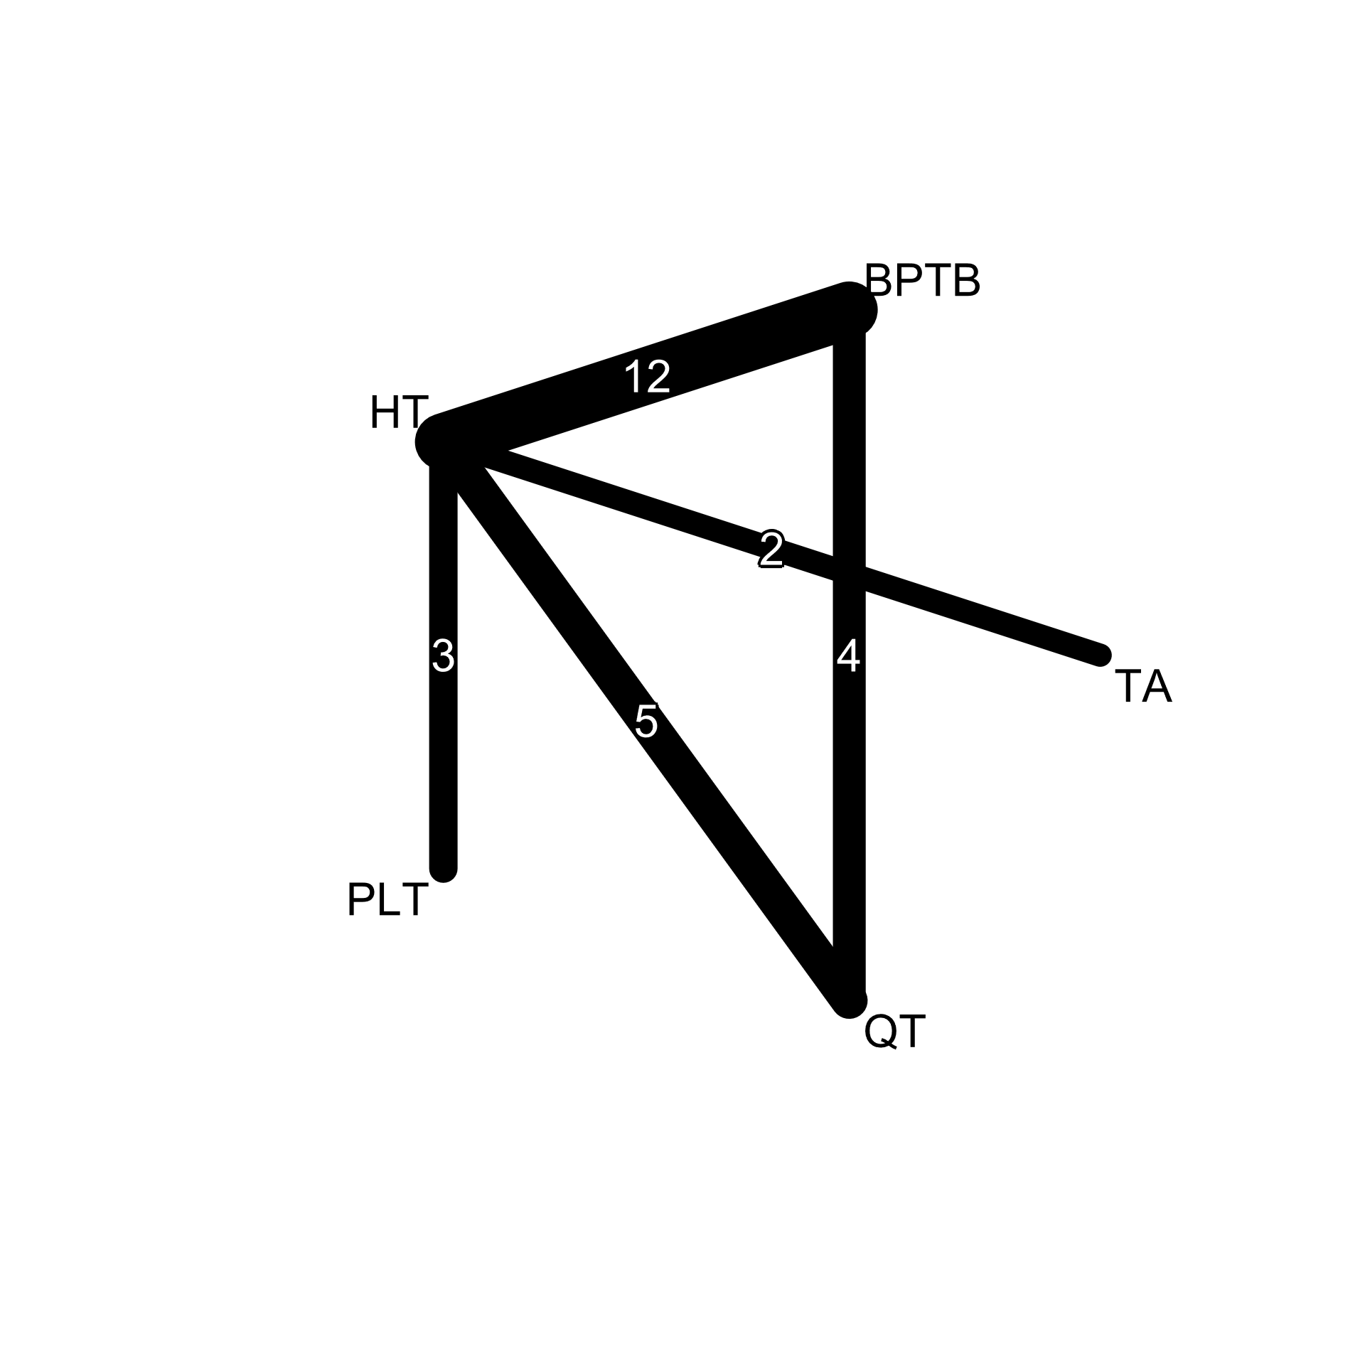 | 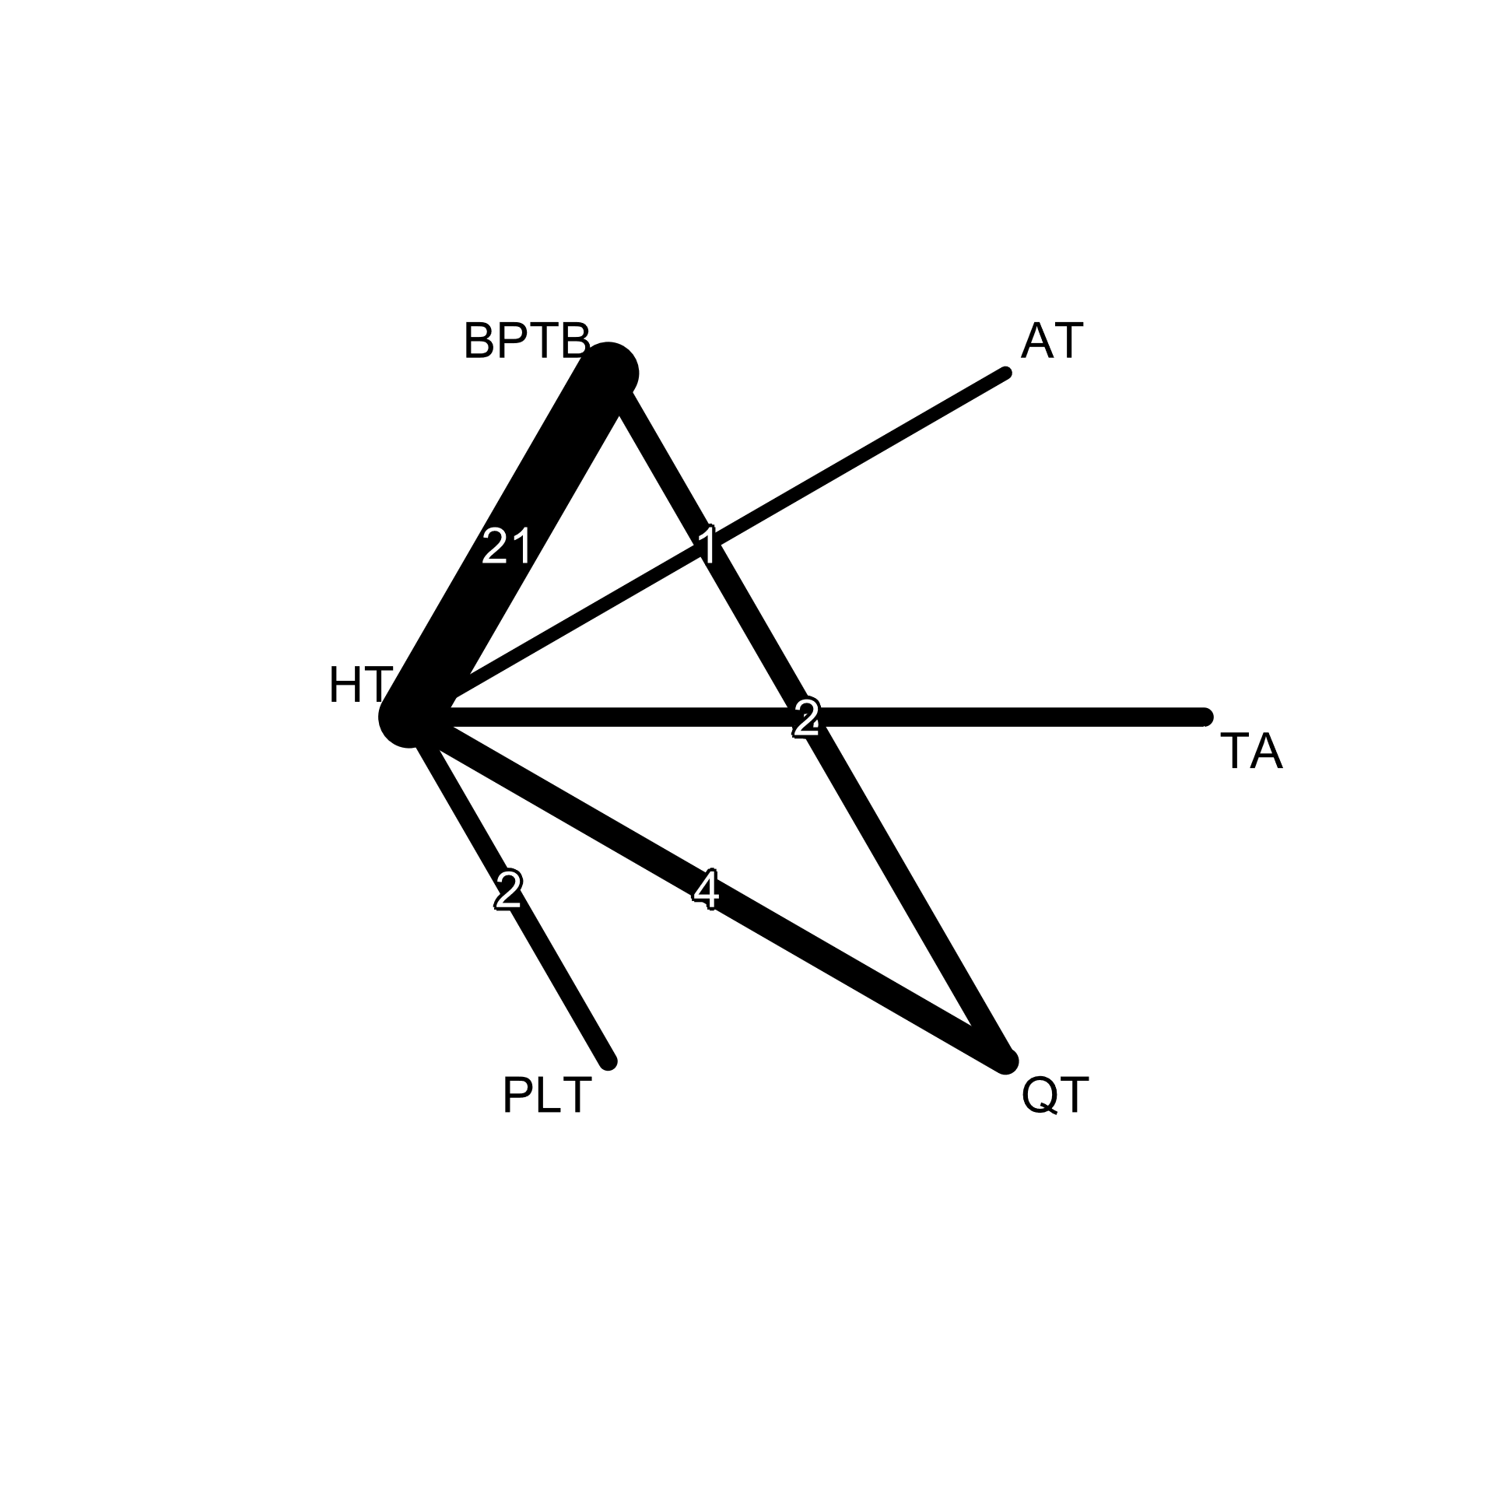 | 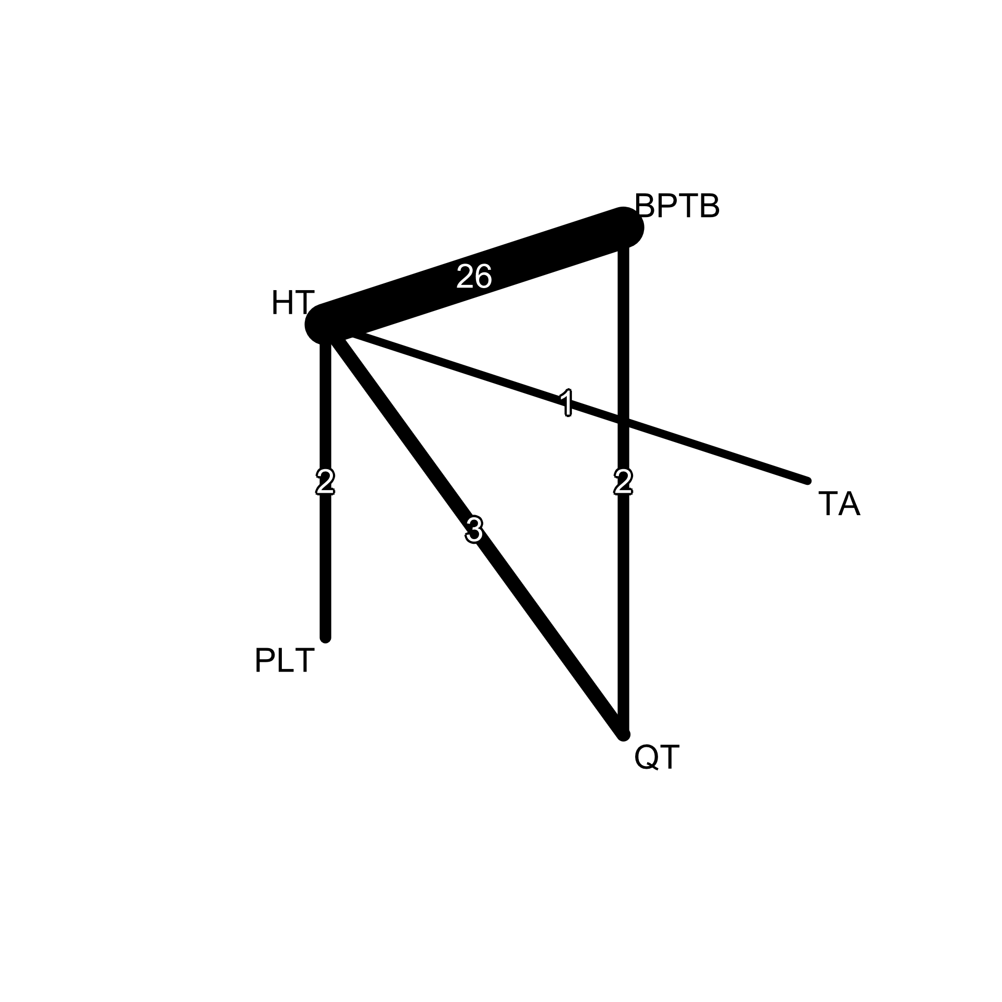

Objective measures of knee stability
Forty-eight studies reported on instrumented laxity (1,4,5,11,14–20,24,25,28–30,32–34,36–39,41,43,47–55), 30 studies reported on pivot-shift test (1,5,6,10,11,14–16,18,19,33,35,40,41,43,44,46–48,50,51,53,54,56–58), and 26 studies reported on Lachman test (6,10,14,17,19,32,33,35,37,39–41,44,47,48,51,52,54,56,58).

- Objective measures of knee stability
A. Instrumented laxity | B. Lachman test (≥ 1+) | C. Pivot-shift test (≥ 1+)
 | 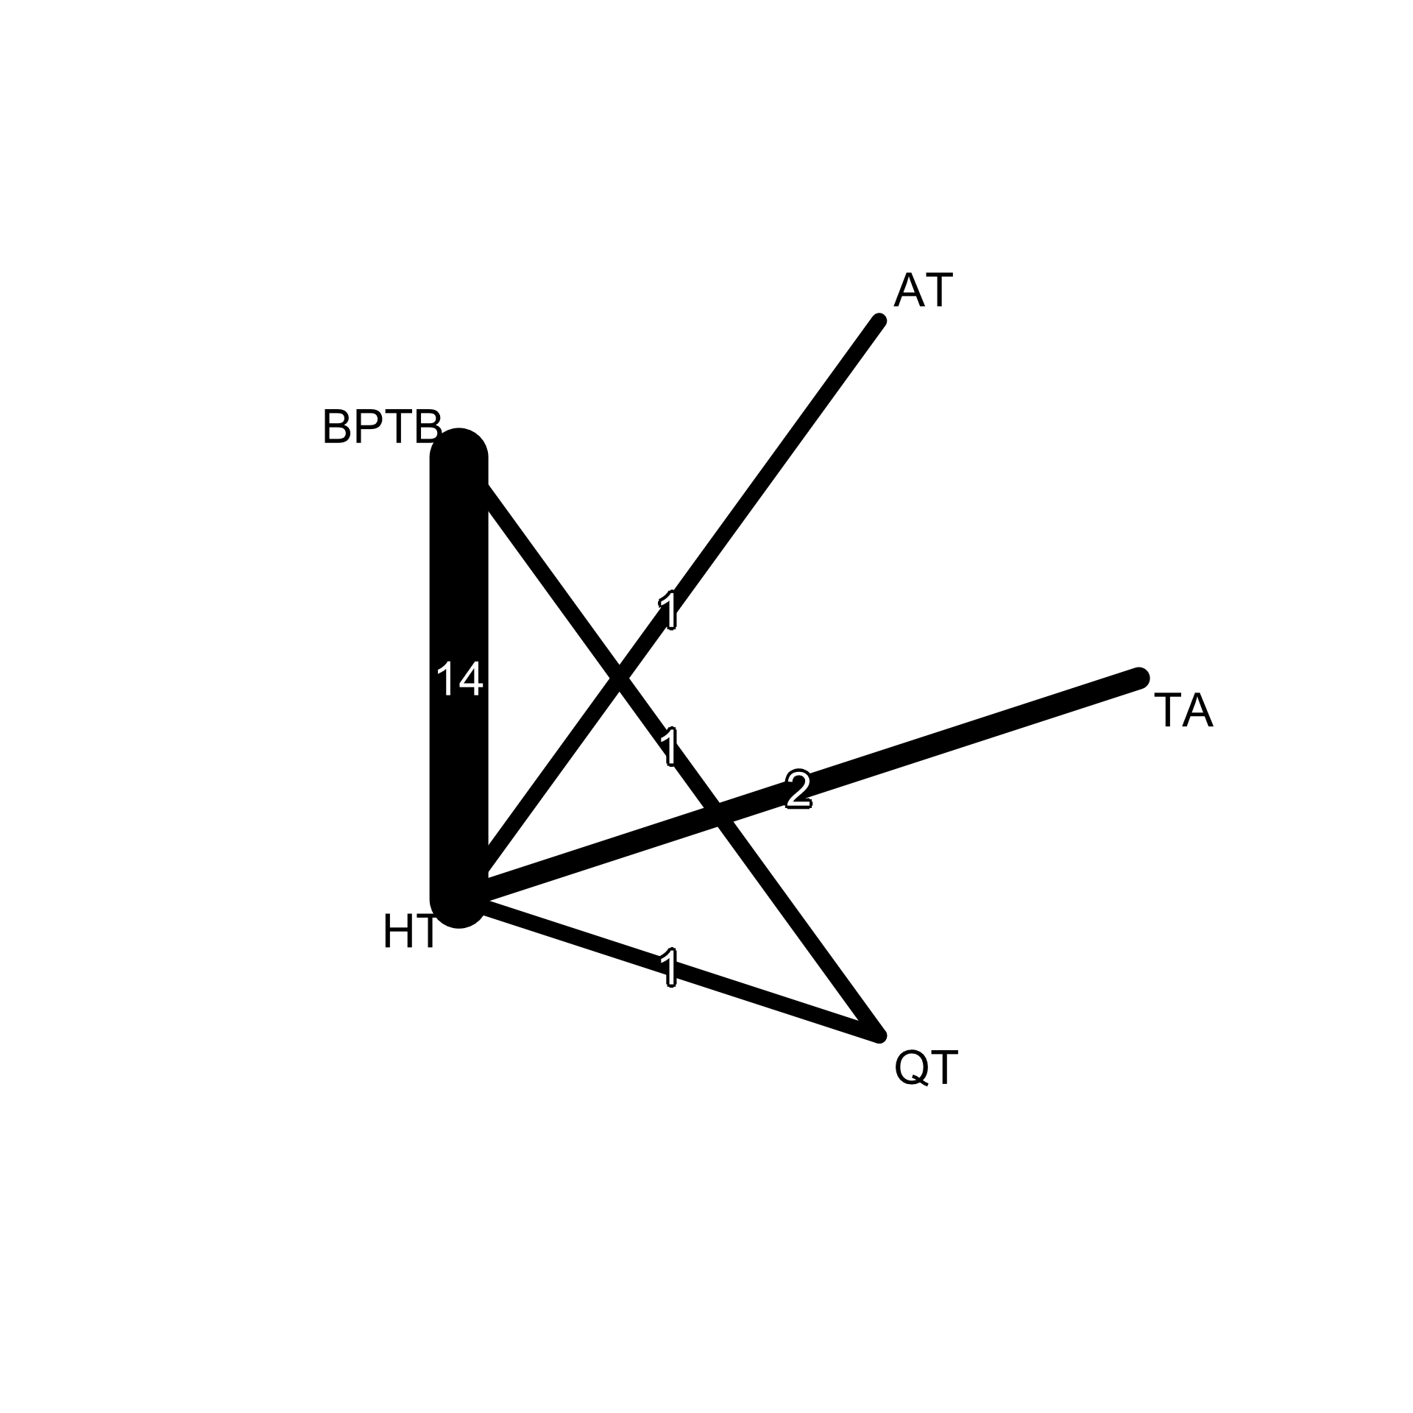

Graft failure
Graft failure was defined as either (1) graft re-rupture confirmed by MRI or arthroscopy, (2) clinical failure defined as ≥ grade 2+ or 3+ on Lachman and/or pivot-shift tests, or (3) revision ACLR surgery. The sum of the three nominal data was recorded as the number of events in a dichotomous dataset.

A. Graft failure | Clinical failure
A. Graft failure | B. Pivot-shift test | C. Lachman test
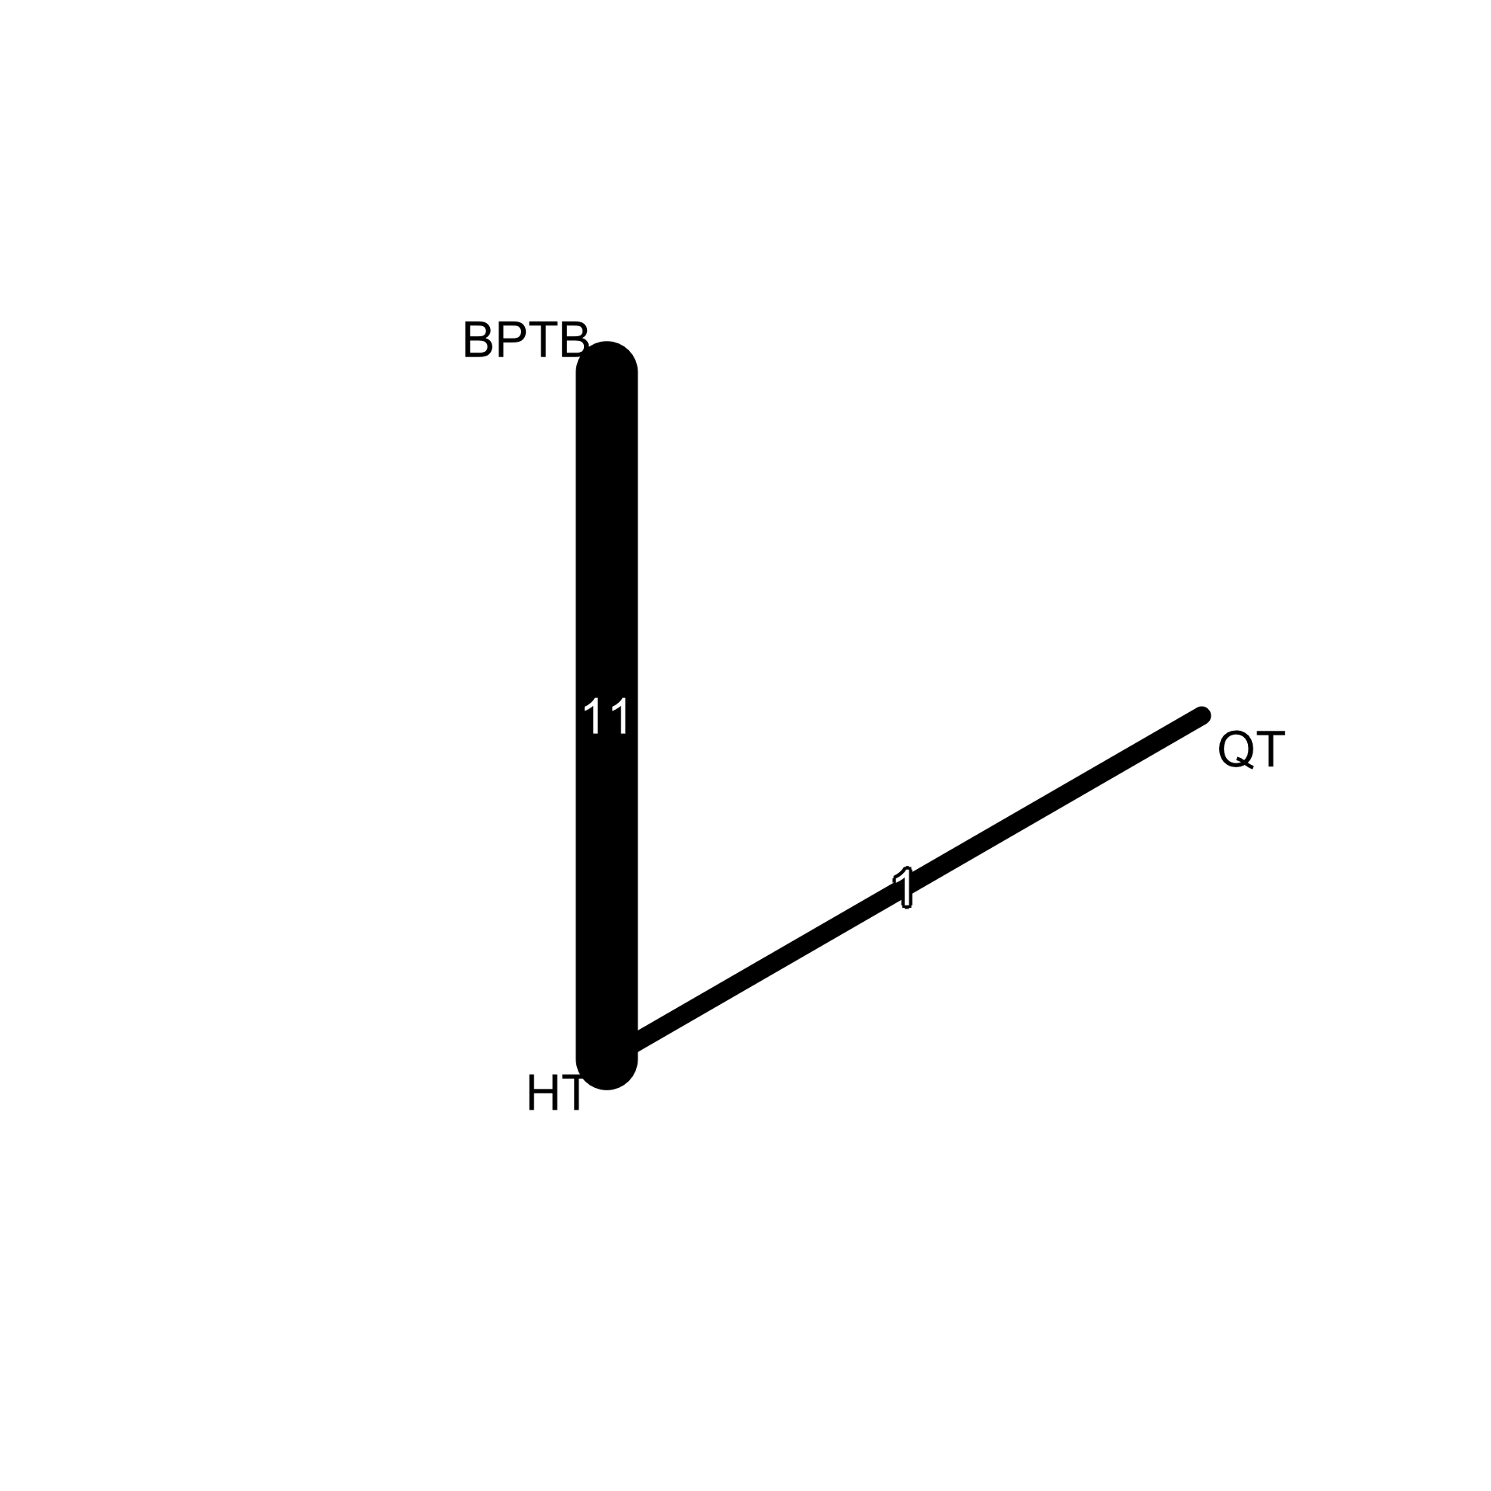 | 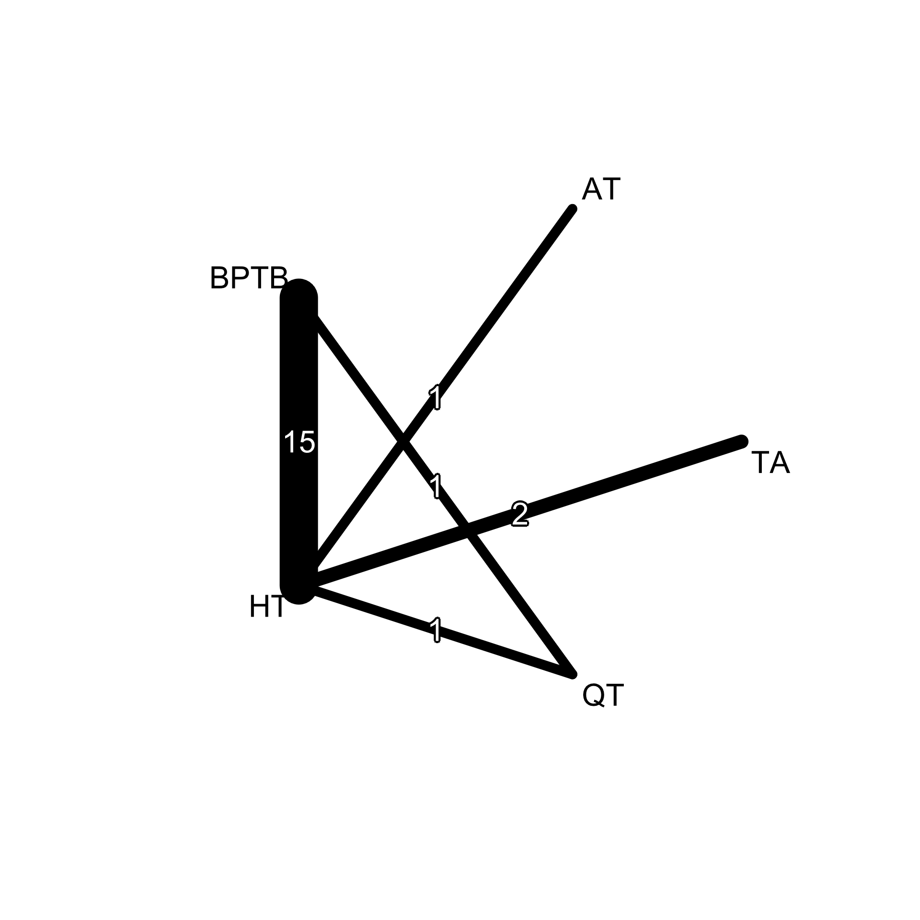

Discussion

Summary of evidence

Limitations

Conclusions

Funding

References
1. Anderson AF, Snyder RB, Lipscomb AB Jr. Anterior cruciate ligament reconstruction. A prospective randomized study of three surgical methods. Am J Sports Med. 2001;29(3):272–9. doi:10.1177/03635465010290030201
2. Quadriceps tendon-bone vs all soft-tissue autografts for primary anterior cruciate ligament reconstruction: a systematic review and meta-analysis of 7,748 patients | EFORT Open Reviews | Bioscientifica Journals [Internet]. [cited 2026 Jul 31]. Available from: https://journals.bioscientifica.com/eor/article/10/12/865/75877/Quadriceps-tendon-bone-vs-all-soft-tissue
3. The PRISMA Extension Statement for Reporting of Systematic Reviews Incorporating Network Meta-analyses of Health Care Interventions: Checklist and Explanations | Annals of Internal Medicine [Internet]. [cited 2026 Aug 19]. Available from: https://www.acpjournals.org/doi/10.7326/M14-2385
4. Barié A, Sprinckstub T, Huber J, Jaber A. Quadriceps tendon vs. patellar tendon autograft for ACL reconstruction using a hardware-free press-fit fixation technique: comparable stability, function and return-to-sport level but less donor site morbidity in athletes after 10 years. Arch Orthop Trauma Surg. 2020;140(10):1465–74. doi:10.1007/s00402-020-03508-1
5. Bi M, Zhao C, Zhang S, Yao B, Hong Z, Bi Q. All-Inside Single-Bundle Reconstruction of the Anterior Cruciate Ligament with the Anterior Half of the Peroneus Longus Tendon Compared to the Semitendinosus Tendon: A Two-Year Follow-Up Study. J Knee Surg. 2018;31(10):1022–30. doi:10.1055/s-0038-1627466
6. Björnsson H, Samuelsson K, Sundemo D, Desai N, Sernert N, Rostgård-Christensen L, et al. A Randomized Controlled Trial With Mean 16-Year Follow-up Comparing Hamstring and Patellar Tendon Autografts in Anterior Cruciate Ligament Reconstruction. Am J Sports Med. 2016;44(9):2304–13. doi:10.1177/0363546516646378
7. Bottoni CR, Smith EL, Shaha J, Shaha SS, Raybin SG, Tokish JM, et al. Autograft Versus Allograft Anterior Cruciate Ligament Reconstruction: A Prospective, Randomized Clinical Study With a Minimum 10-Year Follow-up. Am J Sports Med. 2015;43(10):2501–9. doi:10.1177/0363546515596406
8. Butt U, Vuletic F, Shaikh MAA, Amanullah, Rehman GU, Shah IA, et al. 5-years outcomes following arthroscopic anterior cruciate ligament reconstruction comparing quadruple hamstring and peroneus longus tendon autografts: a randomized control trial. Arch Orthop Trauma Surg. 2024;145(1):85. doi:10.1007/s00402-024-05639-1
9. Calvert ND, Ebert JR, Radic R. Kneeling tolerance when using quadriceps tendon autograft for anterior cruciate ligament reconstruction is superior to hamstring tendon autograft. Knee Surg Sports Traumatol Arthrosc. 2025;33(7):2390–6. doi:10.1002/ksa.12583
10. Guglielmetti LGB, Salas VER, Jorge PB, Severino FR, Duarte A, de Oliveira VM, et al. Prospective and Randomized Clinical Evaluation of Hamstring Versus Patellar Tendon Autograft for Anterior Cruciate Ligament Reconstruction in Soccer Players. Orthop J Sports Med. 2021;9(9):23259671211028168. Located at: ClinicalTrials.gov/NCT02642692. doi:10.1177/23259671211028168
11. Horstmann H, Petri M, Tegtbur U, Felmet G, Krettek C, Jagodzinski M. Quadriceps and hamstring tendon autografts in ACL reconstruction yield comparably good results in a prospective, randomized controlled trial. Arch Orthop Trauma Surg. 2022;142(2):281–9. doi:10.1007/s00402-021-03862-8
12. Iliopoulos E, Galanis N, Zafeiridis A, Iosifidis M, Papadopoulos P, Potoupnis M, et al. Anatomic single-bundle anterior cruciate ligament reconstruction improves walking economy: hamstrings tendon versus patellar tendon grafts. Knee Surg Sports Traumatol Arthrosc. 2017;25(10):3155–62. doi:10.1007/s00167-016-4229-4
13. Komzák M, Hart R, Náhlík D, Vysoký R. In vivo knee rotational stability 2 years after the ACL reconstruction using a quadriceps tendon graft with bone block and bone-patellar tendon-bone graft. Arch Orthop Trauma Surg. 2022;142(8):1995–9. doi:10.1007/s00402-021-04195-2
14. Li J, Wang J, Li Y, Shao D, You X, Shen Y. A Prospective Randomized Study of Anterior Cruciate Ligament Reconstruction With Autograft, γ-Irradiated Allograft, and Hybrid Graft. Arthroscopy. 2015;31(7):1296–302. doi:10.1016/j.arthro.2015.02.033
15. Lind M, Nielsen TG, Soerensen OG, Mygind-Klavsen B, Faunø P. Quadriceps tendon grafts does not cause patients to have inferior subjective outcome after anterior cruciate ligament (ACL) reconstruction than do hamstring grafts: a 2-year prospective randomised controlled trial. Br J Sports Med. 2020;54(3):183–7. Located at: ClinicalTrials.gov/NCT02173483. doi:10.1136/bjsports-2019-101000
16. Lucidi GA, Agostinone P, Di Paolo S, Dal Fabbro G, Serra M, Viotto M, et al. Long-term Outcomes After Anterior Cruciate Ligament Reconstruction With 3 Different Surgical Techniques: A Prospective Randomized Clinical and Radiographic Evaluation at a Minimum of 20 Years’ Follow-up. Orthop J Sports Med. 2025;13(1):23259671241302348. doi:10.1177/23259671241302348
17. Lui PP, Cheng YY, Yung SH, Hung AS, Chan KM. A randomized controlled trial comparing bone mineral density changes of three different ACL reconstruction techniques. Knee. 2012;19(6):779–85. doi:10.1016/j.knee.2012.02.005
18. Lund B, Nielsen T, Faunø P, Christiansen SE, Lind M. Is quadriceps tendon a better graft choice than patellar tendon? a prospective randomized study. Arthroscopy. 2014;30(5):593–8. doi:10.1016/j.arthro.2014.01.012
19. Malik S, Biswas G, Singh SK, Sundaresan N, Bera AP, Kyada M. Comparative Evaluation of Peroneus Longus Tendon and Hamstring Tendon Autografts in Primary Anterior Cruciate Ligament Reconstruction: A Randomized Controlled Trial. J Orthop Case Rep. 2026;16(5):320–8. doi:10.13107/jocr.2026.v16.i05.7294
20. Matsumoto A, Yoshiya S, Muratsu H, Yagi M, Iwasaki Y, Kurosaka M, et al. A comparison of bone-patellar tendon-bone and bone-hamstring tendon-bone autografts for anterior cruciate ligament reconstruction. Am J Sports Med. 2006;34(2):213–9. doi:10.1177/0363546505279919
21. Moraiti CO, Stergiou N, Vasiliadis HS, Motsis E, Georgoulis A. Anterior cruciate ligament reconstruction results in alterations in gait variability. Gait Posture. 2010;32(2):169–75. doi:10.1016/j.gaitpost.2010.04.008
22. Papalia R, Franceschi F, Tecame A, D’Adamio S, Maffulli N, Denaro V. Anterior cruciate ligament reconstruction and return to sport activity: postural control as the key to success. Int Orthop. 2015;39(3):527–34. doi:10.1007/s00264-014-2513-9
23. Sinding KS, Nielsen TG, Hvid LG, Lind M, Dalgas U. Effects of Autograft Types on Muscle Strength and Functional Capacity in Patients Having Anterior Cruciate Ligament Reconstruction: A Randomized Controlled Trial. Sports Med. 2020;50(7):1393–403. Located at: ClinicalTrials.gov/NCT02173483. doi:10.1007/s40279-020-01276-x
24. Smith PA, Cook CS, Bley JA. All-Inside Quadrupled Semitendinosus Autograft Shows Stability Equivalent to Patellar Tendon Autograft Anterior Cruciate Ligament Reconstruction: Randomized Controlled Trial in Athletes 24 Years or Younger. Arthroscopy. 2020;36(6):1629–46. doi:10.1016/j.arthro.2020.01.048
25. Sonnery-Cottet B, Carrozzo A, Poilvache H, Fayard JM, Freychet B, Thaunat M, et al. Anterior cruciate ligament reconstruction combined with anterolateral ligament reconstruction using hamstring autograft versus anterior cruciate ligament reconstruction using bone-patellar tendon-bone autograft: a randomised controlled trial with 5-year f. Lancet Reg Health Eur. 2026;62:101561. Located at: ClinicalTrials.gov/NCT03740022. doi:10.1016/j.lanepe.2025.101561
26. Tang N, Eren M, Gurpinar T, Ozturkmen Y. A prospective randomized controlled study of hamstring and bone-free quadriceps tendons autografts in arthroscopic ACL reconstruction. Eur J Orthop Surg Traumatol. 2024;34(1):293–301. doi:10.1007/s00590-023-03636-5
27. Vilchez-Cavazos F, Dávila-Martínez A, Garza-Castro S, Simental-Mendía M, Garay-Mendoza D, Tamez-Mata Y, et al. Anterior cruciate ligament injuries treated with quadriceps tendon autograft versus hamstring autograft: A randomized controlled trial. Cir Cir. 2020;88(1):76–81. doi:10.24875/CIRU.19001001
28. Wipfler B, Donner S, Zechmann CM, Springer J, Siebold R, Paessler HH. Anterior cruciate ligament reconstruction using patellar tendon versus hamstring tendon: a prospective comparative study with 9-year follow-up. Arthroscopy. 2011;27(5):653–65. doi:10.1016/j.arthro.2011.01.015
29. Zaffagnini S, Bruni D, Marcheggiani Muccioli GM, Bonanzinga T, Lopomo N, Bignozzi S, et al. Single-bundle patellar tendon versus non-anatomical double-bundle hamstrings ACL reconstruction: a prospective randomized study at 8-year minimum follow-up. Knee Surg Sports Traumatol Arthrosc. 2011;19(3):390–7. doi:10.1007/s00167-010-1225-y
30. Ahldén M, Kartus J, Ejerhed L, Karlsson J, Sernert N. Knee laxity measurements after anterior cruciate ligament reconstruction, using either bone-patellar-tendon-bone or hamstring tendon autografts, with special emphasis on comparison over time. Knee Surg Sports Traumatol Arthrosc. 2009;17(9):1117–24. doi:10.1007/s00167-009-0846-5
31. Barenius B, Nordlander M, Ponzer S, Tidermark J, Eriksson K. Quality of life and clinical outcome after anterior cruciate ligament reconstruction using patellar tendon graft or quadrupled semitendinosus graft: an 8-year follow-up of a randomized controlled trial. Am J Sports Med. 2010;38(8):1533–41. doi:10.1177/0363546510369549
32. Ejerhed L, Kartus J, Sernert N, Köhler K, Karlsson J. Patellar tendon or semitendinosus tendon autografts for anterior cruciate ligament reconstruction? A prospective randomized study with a two-year follow-up. Am J Sports Med. 2003;31(1):19–25. doi:10.1177/03635465030310011401
33. Harilainen A, Linko E, Sandelin J. Randomized prospective study of ACL reconstruction with interference screw fixation in patellar tendon autografts versus femoral metal plate suspension and tibial post fixation in hamstring tendon autografts: 5-year clinical and radiological follow-up res. Knee Surg Sports Traumatol Arthrosc. 2006;14(6):517–28. doi:10.1007/s00167-006-0059-0
34. Holm I, Oiestad BE, Risberg MA, Aune AK. No difference in knee function or prevalence of osteoarthritis after reconstruction of the anterior cruciate ligament with 4-strand hamstring autograft versus patellar tendon-bone autograft: a randomized study with 10-year follow-up. Am J Sports Med. 2010;38(3):448–54. doi:10.1177/0363546509350301
35. Ibrahim SA, Al-Kussary IM, Al-Misfer AR, Al-Mutairi HQ, Ghafar SA, El Noor TA. Clinical evaluation of arthroscopically assisted anterior cruciate ligament reconstruction: patellar tendon versus gracilis and semitendinosus autograft. Arthroscopy. 2005;21(4):412–7. doi:10.1016/j.arthro.2004.12.002
36. Kautzner J, Kos P, Hanus M, Trc T, Havlas V. A comparison of ACL reconstruction using patellar tendon versus hamstring autograft in female patients: a prospective randomised study. Int Orthop. 2015;39(1):125–30. doi:10.1007/s00264-014-2495-7
37. Konrads C, Reppenhagen S, Plumhoff P, Hoberg M, Rudert M, Barthel T. No significant difference in clinical outcome and knee stability between patellar tendon and semitendinosus tendon in anterior cruciate ligament reconstruction. Arch Orthop Trauma Surg. 2016;136(4):521–5. doi:10.1007/s00402-015-2386-4
38. Laxdal G, Kartus J, Hansson L, Heidvall M, Ejerhed L, Karlsson J. A prospective randomized comparison of bone-patellar tendon-bone and hamstring grafts for anterior cruciate ligament reconstruction. Arthroscopy. 2005;21(1):34–42. doi:10.1016/j.arthro.2004.09.014
39. Lidén M, Ejerhed L, Sernert N, Laxdal G, Kartus J. Patellar tendon or semitendinosus tendon autografts for anterior cruciate ligament reconstruction: a prospective, randomized study with a 7-Year follow-up. Am J Sports Med. 2007;35(5):740–8. doi:10.1177/0363546506298275
40. Noh JH, Yi SR, Song SJ, Kim SW, Kim W. Comparison between hamstring autograft and free tendon Achilles allograft: minimum 2-year follow-up after anterior cruciate ligament reconstruction using EndoButton and Intrafix. Knee Surg Sports Traumatol Arthrosc. 2011;19(5):816–22. doi:10.1007/s00167-010-1388-6
41. Popovic M, Myhre JR, Holen JIH, Gifstad T, Strand IL, Strand T, et al. Reduced Knee Flexion Strength 18 Years After ACL Reconstruction With Hamstring Tendon Versus Patellar Tendon. Am J Sports Med. 2024;52(11):2750–7. Located at: ClinicalTrials.gov/NCT05876013. doi:10.1177/03635465241271524
42. Taylor DC, DeBerardino TM, Nelson BJ, Duffey M, Tenuta J, Stoneman PD, et al. Patellar tendon versus hamstring tendon autografts for anterior cruciate ligament reconstruction: a randomized controlled trial using similar femoral and tibial fixation methods. Am J Sports Med. 2009;37(10):1946–57. doi:10.1177/0363546509339577
43. Yadav AK, Sharma A, Paul N, Bhakhar A, Sarkar B, Azam MQ. Quadriceps versus hamstrings autograft in anterior cruciate ligament reconstruction: a randomized control trial. Eur J Orthop Surg Traumatol. 2025;35(1):395. doi:10.1007/s00590-025-04510-2
44. Yoo SH, Song EK, Shin YR, Kim SK, Seon JK. Comparison of clinical outcomes and second-look arthroscopic findings after ACL reconstruction using a hamstring autograft or a tibialis allograft. Knee Surg Sports Traumatol Arthrosc. 2017;25(4):1290–7. doi:10.1007/s00167-015-3955-3
45. Ageberg E, Roos HP, Silbernagel KG, Thomeé R, Roos EM. Knee extension and flexion muscle power after anterior cruciate ligament reconstruction with patellar tendon graft or hamstring tendons graft: a cross-sectional comparison 3 years post surgery. Knee Surg Sports Traumatol Arthrosc. 2009;17(2):162–9. doi:10.1007/s00167-008-0645-4
46. Heijne A, Werner S. A 2-year follow-up of rehabilitation after ACL reconstruction using patellar tendon or hamstring tendon grafts: a prospective randomised outcome study. Knee Surg Sports Traumatol Arthrosc. 2010;18(6):805–13. doi:10.1007/s00167-009-0961-3
47. Jansson KA, Linko E, Sandelin J, Harilainen A. A prospective randomized study of patellar versus hamstring tendon autografts for anterior cruciate ligament reconstruction. Am J Sports Med. 2003;31(1):12–8. doi:10.1177/03635465030310010501
48. Aglietti P, Giron F, Buzzi R, Biddau F, Sasso F. Anterior cruciate ligament reconstruction: bone-patellar tendon-bone compared with double semitendinosus and gracilis tendon grafts. A prospective, randomized clinical trial. J Bone Jt Surg Am. 2004;86(10):2143–55.
49. Aune AK, Holm I, Risberg MA, Jensen HK, Steen H. Four-strand hamstring tendon autograft compared with patellar tendon-bone autograft for anterior cruciate ligament reconstruction. A randomized study with two-year follow-up. Am J Sports Med. 2001;29(6):722–8. doi:10.1177/03635465010290060901
50. Eriksson K, Anderberg P, Hamberg P, Olerud P, Wredmark T. There are differences in early morbidity after ACL reconstruction when comparing patellar tendon and semitendinosus tendon graft. A prospective randomized study of 107 patients. Scand J Med Sci Sports. 2001;11(3):170–7.
51. Feller JA, Webster KE. A randomized comparison of patellar tendon and hamstring tendon anterior cruciate ligament reconstruction. Am J Sports Med. 2003;31(4):564–73. doi:10.1177/03635465030310041501
52. Gifstad T, Sole A, Strand T, Uppheim G, Grøntvedt T, Drogset JO. Long-term follow-up of patellar tendon grafts or hamstring tendon grafts in endoscopic ACL reconstructions. Knee Surg Sports Traumatol Arthrosc. 2013;21(3):576–83. doi:10.1007/s00167-012-1947-0
53. Laoruengthana A, Pattayakorn S, Chotanaputhi T, Kosiyatrakul A. Clinical comparison between six-strand hamstring tendon and patellar tendon autograft in arthroscopic anterior cruciate ligament reconstruction: a prospective, randomized clinical trial. J Med Assoc Thai. 2009;92(4):491–7.
54. Pinczewski LA, Lyman J, Salmon LJ, Russell VJ, Roe J, Linklater J. A 10-year comparison of anterior cruciate ligament reconstructions with hamstring tendon and patellar tendon autograft: a controlled, prospective trial. Am J Sports Med. 2007;35(4):564–74. doi:10.1177/0363546506296042
55. Webster KE, Feller JA, Hameister KA. Bone tunnel enlargement following anterior cruciate ligament reconstruction: a randomised comparison of hamstring and patellar tendon grafts with 2-year follow-up. Knee Surg Sports Traumatol Arthrosc. 2001;9(2):86–91. doi:10.1007/s001670100191
56. Beynnon BD, Johnson RJ, Fleming BC, Kannus P, Kaplan M, Samani J, et al. Anterior cruciate ligament replacement: comparison of bone-patellar tendon-bone grafts with two-strand hamstring grafts. A prospective, randomized study. J Bone Jt Surg Am. 2002;84(9):1503–13. doi:10.2106/00004623-200209000-00001
57. Lawhorn KW, Howell SM, Traina SM, Gottlieb JE, Meade TD, Freedberg HI. The effect of graft tissue on anterior cruciate ligament outcomes: a multicenter, prospective, randomized controlled trial comparing autograft hamstrings with fresh-frozen anterior tibialis allograft. Arthroscopy. 2012;28(8):1079–86. doi:10.1016/j.arthro.2012.05.010
58. Sajovic M, Stropnik D, Skaza K. Long-term Comparison of Semitendinosus and Gracilis Tendon Versus Patellar Tendon Autografts for Anterior Cruciate Ligament Reconstruction: A 17-Year Follow-up of a Randomized Controlled Trial. Am J Sports Med. 2018;46(8):1800–8. doi:10.1177/0363546518768768
59. Ageberg E, Roos HP, Silbernagel KG, Thomeé R, Roos EM. Knee extension and flexion muscle power after anterior cruciate ligament reconstruction with patellar tendon graft or hamstring tendons graft: a cross‐sectional comparison 3 years post surgery. Knee Surg Sports Traumatol Arthrosc. 2009 Feb;17(2):162–9. doi:10.1007/s00167-008-0645-4
- Quadriceps tendon-bone vs all soft-tissue autografts for primary anterior cruciate ligament reconstruction: a systematic review and meta-analysis of 7,748 patients | EFORT Open Reviews | Bioscientifica Journals [Internet]. [cited 2026 Jul 31]. Available from: https://journals.bioscientifica.com/eor/article/10/12/865/75877/Quadriceps-tendon-bone-vs-all-soft-tissue
- Barié A, Sprinckstub T, Huber J, Jaber A. Quadriceps tendon vs. patellar tendon autograft for ACL reconstruction using a hardware-free press-fit fixation technique: comparable stability, function and return-to-sport level but less donor site morbidity in athletes after 10 years. Arch Orthop Trauma Surg. 2020;140(10):1465–doi:10.1007/s00402-020-03508-1
- Bi M, Zhao C, Zhang S, Yao B, Hong Z, Bi Q. All-Inside Single-Bundle Reconstruction of the Anterior Cruciate Ligament with the Anterior Half of the Peroneus Longus Tendon Compared to the Semitendinosus Tendon: A Two-Year Follow-Up Study. J Knee Surg. 2018;31(10):1022–doi:10.1055/s-0038-1627466
- Björnsson H, Samuelsson K, Sundemo D, Desai N, Sernert N, Rostgård-Christensen L, et al. A Randomized Controlled Trial With Mean 16-Year Follow-up Comparing Hamstring and Patellar Tendon Autografts in Anterior Cruciate Ligament Reconstruction. Am J Sports Med. 2016;44(9):2304–doi:10.1177/0363546516646378
- Bottoni CR, Smith EL, Shaha J, Shaha SS, Raybin SG, Tokish JM, et al. Autograft Versus Allograft Anterior Cruciate Ligament Reconstruction: A Prospective, Randomized Clinical Study With a Minimum 10-Year Follow-up. Am J Sports Med. 2015;43(10):2501–doi:10.1177/0363546515596406
- Butt U, Vuletic F, Shaikh MAA, Amanullah, Rehman GU, Shah IA, et al. 5-years outcomes following arthroscopic anterior cruciate ligament reconstruction comparing quadruple hamstring and peroneus longus tendon autografts: a randomized control trial. Arch Orthop Trauma Surg. 2024;145(1):doi:10.1007/s00402-024-05639-1
- Calvert ND, Ebert JR, Radic R. Kneeling tolerance when using quadriceps tendon autograft for anterior cruciate ligament reconstruction is superior to hamstring tendon autograft. Knee Surg Sports Traumatol Arthrosc. 2025;33(7):2390–doi:10.1002/ksa.12583
- Guglielmetti LGB, Salas VER, Jorge PB, Severino FR, Duarte A, de Oliveira VM, et al. Prospective and Randomized Clinical Evaluation of Hamstring Versus Patellar Tendon Autograft for Anterior Cruciate Ligament Reconstruction in Soccer Players. Orthop J Sports Med. 2021;9(9):232596712110281Located at: ClinicalTrials.gov/NCT026426doi:10.1177/23259671211028168
- Horstmann H, Petri M, Tegtbur U, Felmet G, Krettek C, Jagodzinski M. Quadriceps and hamstring tendon autografts in ACL reconstruction yield comparably good results in a prospective, randomized controlled trial. Arch Orthop Trauma Surg. 2022;142(2):281–doi:10.1007/s00402-021-03862-8Iliopoulos E, Galanis N, Zafeiridis A, Iosifidis M, Papadopoulos P, Potoupnis M, et al. Anatomic single-bundle anterior cruciate ligament reconstruction improves walking economy: hamstrings tendon versus patellar tendon grafts. Knee Surg Sports Traumatol Arthrosc. 2017;25(10):3155–doi:10.1007/s00167-016-4229-4
- Komzák M, Hart R, Náhlík D, Vysoký R. In vivo knee rotational stability 2 years after the ACL reconstruction using a quadriceps tendon graft with bone block and bone-patellar tendon-bone graft. Arch Orthop Trauma Surg. 2022;142(8):1995–9. doi:10.1007/s00402-021-04195-2
- Li J, Wang J, Li Y, Shao D, You X, Shen Y. A Prospective Randomized Study of Anterior Cruciate Ligament Reconstruction With Autograft, γ-Irradiated Allograft, and Hybrid Graft. Arthroscopy. 2015;31(7):1296–3doi:10.1016/j.arthro.2015.02.033
- Lind M, Nielsen TG, Soerensen OG, Mygind-Klavsen B, Faunø P. Quadriceps tendon grafts does not cause patients to have inferior subjective outcome after anterior cruciate ligament (ACL) reconstruction than do hamstring grafts: a 2-year prospective randomised controlled trial. Br J Sports Med. 2020;54(3):183–7. Located at: ClinicalTrials.gov/NCT021734doi:10.1136/bjsports-2019-101000
- Lucidi GA, Agostinone P, Di Paolo S, Dal Fabbro G, Serra M, Viotto M, et al. Long-term Outcomes After Anterior Cruciate Ligament Reconstruction With 3 Different Surgical Techniques: A Prospective Randomized Clinical and Radiographic Evaluation at a Minimum of 20 Years’ Follow-up. Orthop J Sports Med. 2025;13(1):232596712413023doi:10.1177/23259671241302348
- Lui PP, Cheng YY, Yung SH, Hung AS, Chan KM. A randomized controlled trial comparing bone mineral density changes of three different ACL reconstruction techniques. Knee. 2012;19(6):779–doi:10.1016/j.knee.2012.02.005
- Lund B, Nielsen T, Faunø P, Christiansen SE, Lind M. Is quadriceps tendon a better graft choice than patellar tendon? a prospective randomized study. Arthroscopy. 2014;30(5):593–8. doi:10.1016/j.arthro.2014.01.012
- Malik S, Biswas G, Singh SK, Sundaresan N, Bera AP, Kyada M. Comparative Evaluation of Peroneus Longus Tendon and Hamstring Tendon Autografts in Primary Anterior Cruciate Ligament Reconstruction: A Randomized Controlled Trial. J Orthop Case Rep. 2026;16(5):320–8. doi:10.13107/jocr.2026.v16.i05.7294
- Matsumoto A, Yoshiya S, Muratsu H, Yagi M, Iwasaki Y, Kurosaka M, et al. A comparison of bone-patellar tendon-bone and bone-hamstring tendon-bone autografts for anterior cruciate ligament reconstruction. Am J Sports Med. 2006;34(2):213–9. doi:10.1177/0363546505279919
- Moraiti CO, Stergiou N, Vasiliadis HS, Motsis E, Georgoulis A. Anterior cruciate ligament reconstruction results in alterations in gait variability. Gait Posture. 2010;32(2):169–doi:10.1016/j.gaitpost.2010.04.008
- Papalia R, Franceschi F, Tecame A, D’Adamio S, Maffulli N, Denaro V. Anterior cruciate ligament reconstruction and return to sport activity: postural control as the key to success. Int Orthop. 2015;39(3):527–doi:10.1007/s00264-014-2513-9
- Sinding KS, Nielsen TG, Hvid LG, Lind M, Dalgas U. Effects of Autograft Types on Muscle Strength and Functional Capacity in Patients Having Anterior Cruciate Ligament Reconstruction: A Randomized Controlled Trial. Sports Med. 2020;50(7):1393–4Located at: ClinicalTrials.gov/NCT021734doi:10.1007/s40279-020-01276-x
- Smith PA, Cook CS, Bley JA. All-Inside Quadrupled Semitendinosus Autograft Shows Stability Equivalent to Patellar Tendon Autograft Anterior Cruciate Ligament Reconstruction: Randomized Controlled Trial in Athletes 24 Years or Younger. Arthroscopy. 2020;36(6):1629–doi:10.1016/j.arthro.2020.01.048
- Sonnery-Cottet B, Carrozzo A, Poilvache H, Fayard JM, Freychet B, Thaunat M, et al. Anterior cruciate ligament reconstruction combined with anterolateral ligament reconstruction using hamstring autograft versus anterior cruciate ligament reconstruction using bone-patellar tendon-bone autograft: a randomised controlled trial with 5-year f. Lancet Reg Health Eur. 2026;62:1015Located at: ClinicalTrials.gov/NCT037400doi:10.1016/j.lanepe.2025.101561
- Tang N, Eren M, Gurpinar T, Ozturkmen Y. A prospective randomized controlled study of hamstring and bone-free quadriceps tendons autografts in arthroscopic ACL reconstruction. Eur J Orthop Surg Traumatol. 2024;34(1):293–3doi:10.1007/s00590-023-03636-5
- Vilchez-Cavazos F, Dávila-Martínez A, Garza-Castro S, Simental-Mendía M, Garay-Mendoza D, Tamez-Mata Y, et al. Anterior cruciate ligament injuries treated with quadriceps tendon autograft versus hamstring autograft: A randomized controlled trial. Cir Cir. 2020;88(1):76–doi:10.24875/CIRU.19001001
- Wipfler B, Donner S, Zechmann CM, Springer J, Siebold R, Paessler HH. Anterior cruciate ligament reconstruction using patellar tendon versus hamstring tendon: a prospective comparative study with 9-year follow-up. Arthroscopy. 2011;27(5):653–doi:10.1016/j.arthro.2011.01.015
- Zaffagnini S, Bruni D, Marcheggiani Muccioli GM, Bonanzinga T, Lopomo N, Bignozzi S, et al. Single-bundle patellar tendon versus non-anatomical double-bundle hamstrings ACL reconstruction: a prospective randomized study at 8-year minimum follow-up. Knee Surg Sports Traumatol Arthrosc. 2011;19(3):390–7. doi:10.1007/s00167-010-1225-y
- Ahldén M, Kartus J, Ejerhed L, Karlsson J, Sernert N. Knee laxity measurements after anterior cruciate ligament reconstruction, using either bone-patellar-tendon-bone or hamstring tendon autografts, with special emphasis on comparison over time. Knee Surg Sports Traumatol Arthrosc. 2009;17(9):1117–doi:10.1007/s00167-009-0846-5
- Barenius B, Nordlander M, Ponzer S, Tidermark J, Eriksson K. Quality of life and clinical outcome after anterior cruciate ligament reconstruction using patellar tendon graft or quadrupled semitendinosus graft: an 8-year follow-up of a randomized controlled trial. Am J Sports Med. 2010;38(8):1533–doi:10.1177/0363546510369549
- Ejerhed L, Kartus J, Sernert N, Köhler K, Karlsson J. Patellar tendon or semitendinosus tendon autografts for anterior cruciate ligament reconstruction? A prospective randomized study with a two-year follow-up. Am J Sports Med. 2003;31(1):19–doi:10.1177/03635465030310011401
- Harilainen A, Linko E, Sandelin J. Randomized prospective study of ACL reconstruction with interference screw fixation in patellar tendon autografts versus femoral metal plate suspension and tibial post fixation in hamstring tendon autografts: 5-year clinical and radiological follow-up res. Knee Surg Sports Traumatol Arthrosc. 2006;14(6):517–doi:10.1007/s00167-006-0059-0
- Holm I, Oiestad BE, Risberg MA, Aune AK. No difference in knee function or prevalence of osteoarthritis after reconstruction of the anterior cruciate ligament with 4-strand hamstring autograft versus patellar tendon-bone autograft: a randomized study with 10-year follow-up. Am J Sports Med. 2010;38(3):448–doi:10.1177/0363546509350301
- Ibrahim SA, Al-Kussary IM, Al-Misfer AR, Al-Mutairi HQ, Ghafar SA, El Noor TA. Clinical evaluation of arthroscopically assisted anterior cruciate ligament reconstruction: patellar tendon versus gracilis and semitendinosus autograft. Arthroscopy. 2005;21(4):412–7. doi:10.1016/j.arthro.2004.12.002
- Kautzner J, Kos P, Hanus M, Trc T, Havlas V. A comparison of ACL reconstruction using patellar tendon versus hamstring autograft in female patients: a prospective randomised study. Int Orthop. 2015;39(1):125–doi:10.1007/s00264-014-2495-7
- Konrads C, Reppenhagen S, Plumhoff P, Hoberg M, Rudert M, Barthel T. No significant difference in clinical outcome and knee stability between patellar tendon and semitendinosus tendon in anterior cruciate ligament reconstruction. Arch Orthop Trauma Surg. 2016;136(4):521–5. doi:10.1007/s00402-015-2386-4
- Laxdal G, Kartus J, Hansson L, Heidvall M, Ejerhed L, Karlsson J. A prospective randomized comparison of bone-patellar tendon-bone and hamstring grafts for anterior cruciate ligament reconstruction. Arthroscopy. 2005;21(1):34–doi:10.1016/j.arthro.2004.09.014
- Lidén M, Ejerhed L, Sernert N, Laxdal G, Kartus J. Patellar tendon or semitendinosus tendon autografts for anterior cruciate ligament reconstruction: a prospective, randomized study with a 7-Year follow-up. Am J Sports Med. 2007;35(5):740–8. doi:10.1177/0363546506298275
- Noh JH, Yi SR, Song SJ, Kim SW, Kim W. Comparison between hamstring autograft and free tendon Achilles allograft: minimum 2-year follow-up after anterior cruciate ligament reconstruction using EndoButton and Intrafix. Knee Surg Sports Traumatol Arthrosc. 2011;19(5):816–doi:10.1007/s00167-010-1388-6
- Popovic M, Myhre JR, Holen JIH, Gifstad T, Strand IL, Strand T, et al. Reduced Knee Flexion Strength 18 Years After ACL Reconstruction With Hamstring Tendon Versus Patellar Tendon. Am J Sports Med. 2024;52(11):2750–7. Located at: ClinicalTrials.gov/NCT058760doi:10.1177/03635465241271524
- Taylor DC, DeBerardino TM, Nelson BJ, Duffey M, Tenuta J, Stoneman PD, et al. Patellar tendon versus hamstring tendon autografts for anterior cruciate ligament reconstruction: a randomized controlled trial using similar femoral and tibial fixation methods. Am J Sports Med. 2009;37(10):1946–doi:10.1177/0363546509339577
- Yadav AK, Sharma A, Paul N, Bhakhar A, Sarkar B, Azam MQ. Quadriceps versus hamstrings autograft in anterior cruciate ligament reconstruction: a randomized control trial. Eur J Orthop Surg Traumatol. 2025;35(1):3doi:10.1007/s00590-025-04510-2
- Yoo SH, Song EK, Shin YR, Kim SK, Seon JK. Comparison of clinical outcomes and second-look arthroscopic findings after ACL reconstruction using a hamstring autograft or a tibialis allograft. Knee Surg Sports Traumatol Arthrosc. 2017;25(4):1290–7. doi:10.1007/s00167-015-3955-3
- Ageberg E, Roos HP, Silbernagel KG, Thomeé R, Roos EM. Knee extension and flexion muscle power after anterior cruciate ligament reconstruction with patellar tendon graft or hamstring tendons graft: a cross-sectional comparison 3 years post surgery. Knee Surg Sports Traumatol Arthrosc. 2009;17(2):162–9. doi:10.1007/s00167-008-0645-4
- Heijne A, Werner S. A 2-year follow-up of rehabilitation after ACL reconstruction using patellar tendon or hamstring tendon grafts: a prospective randomised outcome study. Knee Surg Sports Traumatol Arthrosc. 2010;18(6):805–doi:10.1007/s00167-009-0961-3
- Jansson KA, Linko E, Sandelin J, Harilainen A. A prospective randomized study of patellar versus hamstring tendon autografts for anterior cruciate ligament reconstruction. Am J Sports Med. 2003;31(1):12–8. doi:10.1177/03635465030310010501
- Aglietti P, Giron F, Buzzi R, Biddau F, Sasso F. Anterior cruciate ligament reconstruction: bone-patellar tendon-bone compared with double semitendinosus and gracilis tendon grafts. A prospective, randomized clinical trial. J Bone Joint Surg Am. 2004;86(10):2143–Anderson AF, Snyder RB, Lipscomb AB Jr. Anterior cruciate ligament reconstruction. A prospective randomized study of three surgical methods. Am J Sports Med. 2001;29(3):272–9. doi:10.1177/03635465010290030201
- Aune AK, Holm I, Risberg MA, Jensen HK, Steen H. Four-strand hamstring tendon autograft compared with patellar tendon-bone autograft for anterior cruciate ligament reconstruction. A randomized study with two-year follow-up. Am J Sports Med. 2001;29(6):722–8. doi:10.1177/03635465010290060901
- Eriksson K, Anderberg P, Hamberg P, Olerud P, Wredmark T. There are differences in early morbidity after ACL reconstruction when comparing patellar tendon and semitendinosus tendon graft. A prospective randomized study of 107 patients. Scand J Med Sci Sports. 2001;11(3):170–7.
- Feller JA, Webster KE. A randomized comparison of patellar tendon and hamstring tendon anterior cruciate ligament reconstruction. Am J Sports Med. 2003;31(4):564–doi:10.1177/03635465030310041501
- Gifstad T, Sole A, Strand T, Uppheim G, Grøntvedt T, Drogset JO. Long-term follow-up of patellar tendon grafts or hamstring tendon grafts in endoscopic ACL reconstructions. Knee Surg Sports Traumatol Arthrosc. 2013;21(3):576–doi:10.1007/s00167-012-1947-0
- Laoruengthana A, Pattayakorn S, Chotanaputhi T, Kosiyatrakul A. Clinical comparison between six-strand hamstring tendon and patellar tendon autograft in arthroscopic anterior cruciate ligament reconstruction: a prospective, randomized clinical trial. J Med Assoc Thai. 2009;92(4):491–7.
- Pinczewski LA, Lyman J, Salmon LJ, Russell VJ, Roe J, Linklater J. A 10-year comparison of anterior cruciate ligament reconstructions with hamstring tendon and patellar tendon autograft: a controlled, prospective trial. Am J Sports Med. 2007;35(4):564–doi:10.1177/0363546506296042
- Webster KE, Feller JA, Hameister KA. Bone tunnel enlargement following anterior cruciate ligament reconstruction: a randomised comparison of hamstring and patellar tendon grafts with 2-year follow-up. Knee Surg Sports Traumatol Arthrosc. 2001;9(2):86–doi:10.1007/s001670100191
- Beynnon BD, Johnson RJ, Fleming BC, Kannus P, Kaplan M, Samani J, et al. Anterior cruciate ligament replacement: comparison of bone-patellar tendon-bone grafts with two-strand hamstring grafts. A prospective, randomized study. J Bone Joint Surg Am. 2002;84(9):1503–doi:10.2106/00004623-200209000-00001
- Lawhorn KW, Howell SM, Traina SM, Gottlieb JE, Meade TD, Freedberg HI. The effect of graft tissue on anterior cruciate ligament outcomes: a multicenter, prospective, randomized controlled trial comparing autograft hamstrings with fresh-frozen anterior tibialis allograft. Arthroscopy. 2012;28(8):1079–doi:10.1016/j.arthro.2012.05.010
- Sajovic M, Stropnik D, Skaza K. Long-term Comparison of Semitendinosus and Gracilis Tendon Versus Patellar Tendon Autografts for Anterior Cruciate Ligament Reconstruction: A 17-Year Follow-up of a Randomized Controlled Trial. Am J Sports Med. 2018;46(8):1800–8. doi:10.1177/0363546518768768

Data availability statement
The datasets used for analyses in this review were made publicly accessible on Open Science Framework (DOI: 10.17605/osf.io/ssnda) and Harvard Dataverse (10.7910/DVN/NGIW6E).

Tables and Figures

Tables
Table 1 Eligibility criteria for inclusion and exclusion of studies
- Database search strategies
- Graft types included in study
 | No. | Subgroup | Intervention | Full name and description
 | 1 | BPTB | BPTB | Bone-patellar tendon-bone autograft.
 | 2 | HT | 2-ST | Double-stranded semitendinosus hamstring autograft.
 | 3 | HT | 4-ST | Quadruple-stranded semitendinosus hamstring autograft.
 | 4 | HT | 4-STG | Quadruple-looped semitendinosus and gracilis autograft.
 | 5 | HT | 6-STG | Six-stranded semitendinosus and gracilis autograft.
 | 6 | QT | B-QT | Quadriceps tendon with bone autograft.
 | 7 | QT | S-QT | All soft-tissue quadriceps tendon autograft.
 | 8 | PLT | PLT | Peroneus longus tendon autograft.
 | 9 | PLT | PLT + PBT | Peroneus longus tendon autograft with peroneus longus brevis tenodesis.
 | 10 |  | AT | Achilles tendon allograft.
 | 11 | TA | TA | Tibialis anterior tendon allograft.
 | 12 | TA | TP | Tibialis posterior tendon allograft.

Table 4 Characteristics of included studies
Table 4 IKDC Subjective Knee Form
Table 5 Lysholm Knee Scoring Scale
Table 6 Tegner Activity Scale
Table 7 Instrumented Laxity
Table 8 Pivot-Shift Test
Table 9 Lachman Test
Table 10 Graft failure

- Characteristics of included studies.
ID | Study, Author et al., year |  | Arms |  |  | Covariates |  |  |  |  |  |  |  |  |  | Outcomes
ID | Study, Author et al., year |  | Intervention 1 | Intervention 2 |  | Age,  Mean ± SD |  | Sample size, n |  |  |  | Follow-up duration |  |  |  | Continuous |  |  |  |  | Dichotomous
 |  |  |  |  |  |  |  | Total, n | Male, n | Female, n |  | Months | Years | Category |  | IKDC subjective | Lysholm | Tegner | Instrumented Laxity |  | Pivot-shift | Lachman | Graft failure
1 | Ageberg et al., 2009 |  | BPTB | HT |  | 30.0 ± 5.1 |  | 36 | 27 | 9 |  | 36 | 3 | Medium |  | ✗ | ✗ | ✓ | ✗ |  | ✗ | ✗ | ✗
2 | Aglietti et al., 2004 |  | BPTB | HT |  | 25.0 ± 5.1 |  | 120 | 92 | 28 |  | 24 | 2 | Medium |  | ✗ | ✗ | ✗ | ✓ |  | ✓ | ✓ | ✗
3 | Ahldén et al., 2009 |  | BPTB | HT |  | 28.0 ± 5.1 |  | 47 | 32 | 15 |  | 88.5 | 7.4 | Long |  | ✗ | ✓ | ✓ | ✓ |  | ✗ | ✓ | ✗
5 | Anderson et al., 2001 |  | BPTB | HT |  | 20.6 ± 5.9 |  | 103 | 68 | 35 |  | 35.9 | 3 | Medium |  | ✓ | ✗ | ✗ | ✓ |  | ✓ | ✗ | ✗
6 | Anz et al., 2023 |  | BPTB | HT |  | 28.5 ± 6.4 |  | 20 | 7 | 13 |  | 12 | 1 | Short |  | ✗ | ✗ | ✗ | ✗ |  | ✗ | ✗ | ✓
7 | Aune et al., 2001 |  | BPTB | HT |  | 26.0 ± 5.8 |  | 72 | 40 | 32 |  | 24 | 2 | Medium |  | ✗ | ✗ | ✗ | ✓ |  | ✗ | ✗ | ✗
9 | Barenius et al., 2010 |  | BPTB | HT |  | 34.0 ± 7.9 |  | 153 | 89 | 64 |  | 96 | 8 | Long |  | ✓ | ✓ | ✗ | ✓ |  | ✓ | ✓ | ✗
10 | Barié et al., 2020 |  | BPTB | QT |  | 30.6 ± 8.1 |  | 60 | 34 | 26 |  | 123 | 10.3 | Long |  | ✓ | ✓ | ✓ | ✓ |  | ✗ | ✗ | ✓
11 | Beynnon et al., 2002 |  | BPTB | HT |  | 29.2 ± 7.0 |  | 56 | 31 | 25 |  | 36 | 3 | Medium |  | ✓ | ✗ | ✓ | ✓ |  | ✓ | ✓ | ✗
12 | Bi et al., 2018 |  | HT | PLT |  | 28.5 ± 7.6 |  | 124 | 65 | 59 |  | 30 | 2.5 | Medium |  | ✓ | ✗ | ✗ | ✓ |  | ✓ | ✗ | ✓
13 | Björnsson et al., 2016 |  | BPTB | HT |  | 27.5 ± 6.3 |  | 147 | 95 | 52 |  | 197.3 | 16.5 | Long |  | ✓ | ✓ | ✓ | ✓ |  | ✗ | ✗ | ✗
14 | Bottoni et al., 2015 |  | HT | TA |  | 29.1 ± 6.6 |  | 97 | 84 | 13 |  | 120 | 10 | Long |  | ✓ | ✗ | ✓ | ✗ |  | ✗ | ✗ | ✗
18 | Butt et al., 2024 |  | HT | PLT |  | 28.5 ± 8.3 |  | 60 | 59 | 1 |  | 60 | 5 | Long |  | ✓ | ✓ | ✗ | ✗ |  | ✓ | ✓ | ✗
19 | Calvert et al., 2025 |  | HT | QT |  | 28.8 ± 5.6 |  | 112 | 56 | 56 |  | 24 | 2 | Medium |  | ✓ | ✗ | ✗ | ✓ |  | ✗ | ✗ | ✗
23 | Ejerhed et al., 2003 |  | BPTB | HT |  | 29.0 ± 4.6 |  | 66 | 46 | 20 |  | 24 | 2 | Medium |  | ✗ | ✓ | ✓ | ✓ |  | ✗ | ✓ | ✗
25 | Eriksson et al., 2001 |  | BPTB | HT |  | 27.0 ± 7.9 |  | 116 | 0 | 0 |  | 6.7 | 0.6 | Short |  | ✗ | ✗ | ✗ | ✓ |  | ✓ | ✗ | ✗
26 | Feller & Webster, 2003 |  | BPTB | HT |  | 26.1 ± 9.7 |  | 65 | 47 | 18 |  | 36 | 3 | Medium |  | ✓ | ✗ | ✗ | ✓ |  | ✓ | ✓ | ✗
30 | Gifstad et al., 2013 |  | BPTB | HT |  | 27.0 ± 6.0 |  | 77 | 0 | 0 |  | 84 | 7 | Long |  | ✗ | ✓ | ✓ | ✓ |  | ✗ | ✓ | ✗
32 | Guglielmetti et al., 2021 |  | BPTB | HT |  | 24.9 ± 6.0 |  | 62 | 42 | 20 |  | 24 | 2 | Medium |  | ✓ | ✓ | ✗ | ✗ |  | ✓ | ✓ | ✗
33 | Harilainen et al., 2006 |  | BPTB | HT |  | .0 ± 6.7 |  | 79 | 0 | 0 |  | 60.6 | 5.1 | Long |  | ✓ | ✓ | ✓ | ✓ |  | ✓ | ✗ | ✗
34 | Heijne & Werner, 2010 |  | BPTB | HT |  | 29.5 ± 5.4 |  | 68 | 36 | 32 |  | 24.7 | 2.1 | Medium |  | ✗ | ✗ | ✓ | ✓ |  | ✓ | ✗ | ✗
35 | Holm et al., 2010 |  | BPTB | HT |  | 35.9 ± .0 |  | 57 | 33 | 24 |  | 10.5 | 0.9 | Short |  | ✗ | ✗ | ✓ | ✓ |  | ✗ | ✗ | ✗
36 | Horstmann et al., 2022 |  | HT | QT |  | 28.4 ± 8.0 |  | 51 | 33 | 18 |  | 24 | 2 | Medium |  | ✓ | ✓ | ✗ | ✓ |  | ✗ | ✗ | ✗
37 | Ibrahim et al., 2005 |  | BPTB | HT |  | 22.3 ± 8.0 |  | 86 | 86 | 0 |  | 81 | 6.8 | Long |  | ✗ | ✓ | ✗ | ✓ |  | ✓ | ✓ | ✗
38 | Iliopoulos et al., 2017 |  | BPTB | HT |  | 25.8 ± 9.6 |  | 20 | 20 | 0 |  | 9 | 0.8 | Short |  | ✓ | ✓ | ✗ | ✗ |  | ✓ | ✓ | ✗
41 | Jansson et al., 2003 |  | BPTB | HT |  | .0 ± 3.9 |  | 89 | 0 | 0 |  | 24 | 2 | Medium |  | ✗ | ✓ | ✓ | ✓ |  | ✓ | ✓ | ✗
43 | Kautzner et al., 2015 |  | BPTB | HT |  | 26.0 ± 6.1 |  | 147 | 0 | 147 |  | 24 | 2 | Medium |  | ✗ | ✓ | ✗ | ✓ |  | ✗ | ✗ | ✗
44 | Komzak et al., 2022 |  | BPTB | QT |  | 30.4 ± .0 |  | 72 | 44 | 36 |  | 28 | 2.3 | Medium |  | ✓ | ✓ | ✗ | ✗ |  | ✗ | ✗ | ✗
45 | Konrads et al., 2016 |  | BPTB | HT |  | 29.8 ± 6.3 |  | 62 | 45 | 17 |  | 120 | 10 | Long |  | ✓ | ✓ | ✓ | ✓ |  | ✓ | ✓ | ✗
46 | Laoruengthana et al., 2009 |  | BPTB | HT |  | 29.3 ± 9.4 |  | 28 | 0 | 0 |  | 19 | 1.6 | Medium |  | ✓ | ✓ | ✗ | ✓ |  | ✓ | ✗ | ✗
47 | Lawhorn et al., 2012 |  | HT | TA |  | 32.5 ± 6.3 |  | 92 | 70 | 32 |  | 24 | 2 | Medium |  | ✓ | ✗ | ✗ | ✓ |  | ✓ | ✗ | ✗
49 | Laxdal et al., 2005 |  | BPTB | HT |  | 26.5 ± 8.9 |  | 118 | 0 | 0 |  | 26 | 2.2 | Medium |  | ✓ | ✓ | ✓ | ✓ |  | ✗ | ✗ | ✗
51 | Li et al., 2015 |  | HT | TA |  | 30.2 ± 8.3 |  | 64 | 32 | 32 |  | 71.4 | 6 | Long |  | ✓ | ✓ | ✓ | ✓ |  | ✓ | ✓ | ✗
52 | Lidén et al., 2007 |  | BPTB | HT |  | 28.5 ± 6.8 |  | 71 | 49 | 22 |  | 87.1 | 7.3 | Long |  | ✓ | ✓ | ✓ | ✓ |  | ✗ | ✓ | ✗
53 | Lind et al., 2020 |  | HT | QT |  | 27.2 ± 7.0 |  | 96 | 54 | 45 |  | 24 | 2 | Medium |  | ✓ | ✗ | ✓ | ✓ |  | ✓ | ✗ | ✗
54 | Lucidi et al., 2025 |  | BPTB | HT |  | 53.7 ± 9.4 |  | 39 | 0 | 0 |  | 240 | 20 | Long |  | ✓ | ✓ | ✓ | ✓ |  | ✓ | ✗ | ✓
55 | Lui et al., 2012 |  | BPTB | HT |  | 25.5 ± 11.9 |  | 55 | 55 | 0 |  | 12 | 1 | Short |  | ✓ | ✓ | ✗ | ✓ |  | ✗ | ✓ | ✗
56 | Lund et al., 2014 |  | BPTB | QT |  | 30.5 ± 14.7 |  | 39 | 32 | 7 |  | 24 | 2 | Medium |  | ✓ | ✗ | ✗ | ✓ |  | ✗ | ✗ | ✗
58 | Malik et al., 2026 |  | HT | PLT |  | 28.0 ± 4.7 |  | 50 | 35 | 15 |  | 6 | 0.5 | Short |  | ✓ | ✓ | ✓ | ✓ |  | ✓ | ✓ | ✗
62 | Matsumoto et al., 2006 |  | BPTB | HT |  | 24.1 ± 8.5 |  | 72 | 41 | 31 |  | 83.9 | 7 | Long |  | ✓ | ✗ | ✗ | ✓ |  | ✗ | ✗ | ✗
66 | Mohtadi et al., 2016 |  | BPTB | HT |  | 28.5 ± 6.5 |  | 330 | 179 | 151 |  | 24 | 2 | Medium |  | ✗ | ✗ | ✗ | ✓ |  | ✗ | ✓ | ✓
68 | Moraiti et al., 2010 |  | BPTB | HT |  | 23.5 ± 9.6 |  | 12 | 12 | 0 |  | 23 | 2 | Medium |  | ✓ | ✓ | ✓ | ✓ |  | ✗ | ✓ | ✓
70 | Noh et al., 2011 |  | HT | AT |  | 25.7 ± 9.8 |  | 65 | 56 | 9 |  | 29.9 | 2.5 | Medium |  | ✓ | ✓ | ✓ | ✓ |  | ✓ | ✓ | ✓
73 | Papalia et al., 2015 |  | BPTB | HT |  | 25.1 ± 2.5 |  | 40 | 0 | 40 |  | 6 | 0.5 | Short |  | ✓ | ✓ | ✗ | ✗ |  | ✗ | ✗ | ✗
76 | Pinczewski et al., 2007 |  | BPTB | HT |  | 24.5 ± 7.9 |  | 180 | 95 | 85 |  | 120 | 10 | Long |  | ✓ | ✓ | ✗ | ✓ |  | ✓ | ✓ | ✗
77 | Popovic et al., 2024 |  | BPTB | HT |  | 27.0 ± .4 |  | 144 | 0 | 0 |  | 228 | 19 | Long |  | ✗ | ✓ | ✓ | ✓ |  | ✓ | ✓ | ✗
82 | Sajovic et al., 2018 |  | BPTB | HT |  | 44.0 ± 6.8 |  | 48 | 28 | 20 |  | 204 | 17 | Long |  | ✓ | ✓ | ✗ | ✓ |  | ✓ | ✓ | ✗
84 | Sinding et al., 2020 |  | HT | QT |  | 28.5 ± 6.5 |  | 85 | 48 | 37 |  | 12.5 | 1 | Medium |  | ✓ | ✗ | ✗ | ✗ |  | ✗ | ✗ | ✗
85 | Smith et al., 2020 |  | BPTB | HT |  | 17.7 ± 8.2 |  | 64 | 28 | 36 |  | 24 | 2 | Medium |  | ✓ | ✗ | ✗ | ✓ |  | ✗ | ✗ | ✓
87 | Sonnery-Cottet et al., 2026 |  | BPTB | HT |  | 25.0 ± 6.3 |  | 556 | 447 | 109 |  | 62.7 | 5.2 | Long |  | ✓ | ✓ | ✓ | ✓ |  | ✓ | ✗ | ✓
89 | Tang et al., 2023 |  | HT | QT |  | 28.2 ± 2.4 |  | 33 | 30 | 3 |  | 24 | 2 | Medium |  | ✓ | ✗ | ✗ | ✗ |  | ✗ | ✗ | ✗
90 | Taylor et al., 2009 |  | BPTB | HT |  | 21.9 ± 4.5 |  | 64 | 53 | 11 |  | 35.4 | 3 | Medium |  | ✓ | ✓ | ✓ | ✓ |  | ✓ | ✗ | ✗
93 | Vilchez-Cavazos et al., 2020 |  | HT | QT |  | 24.5 ± 7.3 |  | 28 | 23 | 6 |  | 12 | 1 | Short |  | ✓ | ✓ | ✓ | ✓ |  | ✗ | ✗ | ✗
95 | Webster et al., 2001 |  | BPTB | HT |  | 26.5 ± 5.6 |  | 61 | 43 | 18 |  | 24 | 2 | Medium |  | ✓ | ✗ | ✗ | ✓ |  | ✗ | ✗ | ✗
96 | Wipfler et al., 2011 |  | BPTB | HT |  | 32.1 ± 8.5 |  | 62 | 37 | 25 |  | 108 | 9 | Long |  | ✓ | ✓ | ✓ | ✓ |  | ✓ | ✓ | ✓
97 | Yadav et al., 2025 |  | HT | QT |  | 29.4 ± 6.2 |  | 69 | 62 | 7 |  | 12 | 1 | Short |  | ✗ | ✓ | ✗ | ✓ |  | ✓ | ✓ | ✗
98 | Yoo et al., 2017 |  | HT | TA |  | 27.0 ± 8.6 |  | 132 | 120 | 12 |  | 33.7 | 2.8 | Medium |  | ✗ | ✓ | ✓ | ✓ |  | ✓ | ✓ | ✗
100 | Zaffagnini et al., 2011 |  | BPTB | HT |  | 26.5 ± 8.8 |  | 79 | 42 | 37 |  | 103.2 | 8.6 | Long |  | ✓ | ✗ | ✗ | ✓ |  | ✗ | ✗ | ✗

ID | Study | Arms |  |  | Covariates
ID | Study | Intervention 1 | Intervention 2 |  | Age,  Mean ± SD |  | Sample size, n |  |  |  | Follow-up duration
 |  |  |  |  |  |  | Total, n | Male, n | Female, n |  | Months | Years
1 | Ageberg et al., 2009 | BPTB | HT |  | 30 ± 5.1 |  | 36 | 27 | 9 |  | 36 | 3
2 | Aglietti et al., 2004 | BPTB | HT |  | 25 ± 5.1 |  | 120 | 92 | 28 |  | 24 | 2
3 | Ahldén et al., 2009 | BPTB | HT |  | 28 ± 5.1 |  | 47 | 32 | 15 |  | 88.5 | 7.4
5 | Anderson et al., 2001 | BPTB | HT |  | 20.6 ± 5.9 |  | 103 | 68 | 35 |  | 35.9 | 3
6 | Anz et al., 2023 | BPTB | HT |  | 28.5 ± 6.4 |  | 20 | 7 | 13 |  | 12 | 1
7 | Aune et al., 2001 | BPTB | HT |  | 26 ± 5.8 |  | 72 | 40 | 32 |  | 24 | 2
9 | Barenius et al., 2010 | BPTB | HT |  | 34 ± 7.9 |  | 153 | 89 | 64 |  | 96 | 8
10 | Barié et al., 2020 | BPTB | QT |  | 30.6 ± 8.1 |  | 60 | 34 | 26 |  | 123 | 10.3
11 | Beynnon et al., 2002 | BPTB | HT |  | 29.2 ± 7 |  | 56 | 31 | 25 |  | 36 | 3
12 | Bi et al., 2018 | HT | PLT |  | 28.5 ± 7.6 |  | 124 | 65 | 59 |  | 30 | 2.5
13 | Björnsson et al., 2016 | BPTB | HT |  | 27.5 ± 6.3 |  | 147 | 95 | 52 |  | 197.3 | 16.5
14 | Bottoni et al., 2015 | HT | TA |  | 29.1 ± 6.6 |  | 97 | 84 | 13 |  | 120 | 10
18 | Butt et al., 2024 | HT | PLT |  | 28.5 ± 8.3 |  | 60 | 59 | 1 |  | 60 | 5
19 | Calvert et al., 2025 | HT | QT |  | 28.8 ± 5.6 |  | 112 | 56 | 56 |  | 24 | 2
23 | Ejerhed et al., 2003 | BPTB | HT |  | 29 ± 4.6 |  | 66 | 46 | 20 |  | 24 | 2
25 | Eriksson et al., 2001 | BPTB | HT |  | 27 ± 7.9 |  | 0 | 0 | 0 |  | 6.7 | 0.6
26 | Feller & Webster, 2003 | BPTB | HT |  | 26.1 ± 9.7 |  | 65 | 47 | 18 |  | 36 | 3
30 | Gifstad et al., 2013 | BPTB | HT |  | 27 ± 6 |  | 0 | 0 | 0 |  | 84 | 7
32 | Guglielmetti et al., 2021 | BPTB | HT |  | 24.9 ± 6 |  | 62 | 42 | 20 |  | 24 | 2
33 | Harilainen et al., 2006 | BPTB | HT |  |  |  |  |  |  |  | 60.6 | 5.1
34 | Heijne & Werner, 2010 | BPTB | HT |  | 29.5 ± 5.4 |  | 68 | 36 | 32 |  | 24.7 | 2.1
35 | Holm et al., 2010 | BPTB | HT |  | 35.9 ± 0 |  | 57 | 33 | 24 |  | 10.5 | 0.9
36 | Horstmann et al., 2022 | HT | QT |  | 28.4 ± 8 |  | 51 | 33 | 18 |  | 24 | 2
37 | Ibrahim et al., 2005 | BPTB | HT |  | 22.3 ± 8 |  | 86 | 86 | 0 |  | 81 | 6.8
38 | Iliopoulos et al., 2017 | BPTB | HT |  | 25.8 ± 9.6 |  | 20 | 20 | 0 |  | 9 | 0.8
41 | Jansson et al., 2003 | BPTB | HT |  |  |  |  |  |  |  | 24 | 2
43 | Kautzner et al., 2015 | BPTB | HT |  | 26 ± 6.1 |  | 147 | 0 | 147 |  | 24 | 2
44 | Komzak et al., 2022 | BPTB | QT |  | 30.4 ± 0 |  | 80 | 44 | 36 |  | 28 | 2.3
45 | Konrads et al., 2016 | BPTB | HT |  | 29.8 ± 6.3 |  | 62 | 45 | 17 |  | 120 | 10
46 | Laoruengthana et al., 2009 | BPTB | HT |  | 29.3 ± 9.4 |  | 0 | 0 | 0 |  | 19 | 1.6
47 | Lawhorn et al., 2012 | HT | TA |  | 32.5 ± 6.3 |  | 102 | 70 | 32 |  | 24 | 2
49 | Laxdal et al., 2005 | BPTB | HT |  | 26.5 ± 8.9 |  | 0 | 0 | 0 |  | 26 | 2.2
51 | Li et al., 2015 | HT | TA |  | 30.2 ± 8.3 |  | 64 | 32 | 32 |  | 71.4 | 6
52 | Lidén et al., 2007 | BPTB | HT |  | 28.5 ± 6.8 |  | 71 | 49 | 22 |  | 87.1 | 7.3
53 | Lind et al., 2020 | HT | QT |  | 27.2 ± 7 |  | 99 | 54 | 45 |  | 24 | 2
54 | Lucidi et al., 2025 | BPTB | HT |  | 53.7 ± 9.4 |  |  |  |  |  | 240 | 20
55 | Lui et al., 2012 | BPTB | HT |  | 25.5 ± 11.9 |  | 55 | 55 | 0 |  | 12 | 1
56 | Lund et al., 2014 | BPTB | QT |  | 30.5 ± 14.7 |  | 39 | 32 | 7 |  | 24 | 2
58 | Malik et al., 2026 | HT | PLT |  | 28 ± 4.7 |  | 50 | 35 | 15 |  | 6 | 0.5
62 | Matsumoto et al., 2006 | BPTB | HT |  | 24.1 ± 8.5 |  | 72 | 41 | 31 |  | 83.9 | 7
66 | Mohtadi et al., 2016 | BPTB | HT |  | 28.5 ± 6.5 |  | 330 | 179 | 151 |  | 24 | 2
68 | Moraiti et al., 2010 | BPTB | HT |  | 23.5 ± 9.6 |  | 12 | 12 | 0 |  | 23 | 2
70 | Noh et al., 2011 | HT | AT |  | 25.7 ± 9.8 |  | 65 | 56 | 9 |  | 29.9 | 2.5
73 | Papalia et al., 2015 | BPTB | HT |  | 25.1 ± 2.5 |  | 40 | 0 | 40 |  | 6 | 0.5
76 | Pinczewski et al., 2007 | BPTB | HT |  | 24.5 ± 7.9 |  | 180 | 95 | 85 |  | 120 | 10
77 | Popovic et al., 2024 | BPTB | HT |  | 27 ± 0.4 |  | 0 | 0 | 0 |  | 228 | 19
82 | Sajovic et al., 2018 | BPTB | HT |  | 44 ± 6.8 |  | 48 | 28 | 20 |  | 204 | 17
84 | Sinding et al., 2020 | HT | QT |  | 28.5 ± 6.5 |  | 85 | 48 | 37 |  | 12.5 | 1
85 | Smith et al., 2020 | BPTB | HT |  | 17.7 ± 8.2 |  | 64 | 28 | 36 |  | 24 | 2
87 | Sonnery-Cottet et al., 2026 | BPTB | HT |  | 25 ± 6.3 |  | 556 | 447 | 109 |  | 62.7 | 5.2
89 | Tang et al., 2023 | HT | QT |  | 28.2 ± 2.4 |  | 33 | 30 | 3 |  | 24 | 2
90 | Taylor et al., 2009 | BPTB | HT |  | 21.9 ± 4.5 |  | 64 | 53 | 11 |  | 35.4 | 3
93 | Vilchez-Cavazos et al., 2020 | HT | QT |  | 24.5 ± 7.3 |  | 29 | 23 | 6 |  | 12 | 1
95 | Webster et al., 2001 | BPTB | HT |  | 26.5 ± 5.6 |  | 61 | 43 | 18 |  | 24 | 2
96 | Wipfler et al., 2011 | BPTB | HT |  | 32.1 ± 8.5 |  | 62 | 37 | 25 |  | 108 | 9
97 | Yadav et al., 2025 | HT | QT |  | 29.4 ± 6.2 |  | 69 | 62 | 7 |  | 12 | 1
98 | Yoo et al., 2017 | HT | TA |  | 27 ± 8.6 |  | 132 | 120 | 12 |  | 33.7 | 2.8
100 | Zaffagnini et al., 2011 | BPTB | HT |  | 26.5 ± 8.8 |  | 79 | 42 | 37 |  | 103.2 | 8.6

- Eligibility crtieria for inclusion and exclusion of studies.
 | Inclusion criteria | Exclusion criteria
Population/participants | Adult patients (mean age of all patients ≥ 18 years). | Studies pediatric and adolescent population.
Interventions | Primary anterior cruciate ligament reconstruction surgery | Revision, repair and lateral extra-articular tenodesis (LET) anterior cruciate ligament surgeries.
Comparators | Bone-patellar tendon-bone, hamstring tendon, quadriceps tendon, and peroneus longus tendon autologous grafts. Achilles tendon and tibialis anterior tendon allogenic grafts. | All other autologous and allogenic grafts.
Outcomes | IKDC subjective knee form, Lysholm knee scoring scale, and Tegner activity scale, Instrumented laxity, Pivot-shift, and Lachman test, graft re-rupture, clinical failure (pivot-shift and Lachman ≥ grade 2+ and 3+), and revision surgery. | All other outcome measures (e.g., Marx activity scale, KOOS (subscales: QoL, ADL, Sports & Recreation, Symptoms, and Pain), Anterior drawer test, muscle strength recovery (Q-LSI and H-LSI).
Study designs | Randomised controlled trials (RCTs) | Observational studies, case series and reports.

- Database search strategies
 | Data source | Full search strategy
 | PubMed/MEDLINE | (("anterior cruciate ligament"[mh] OR "anterior cruciate ligament"[tiab] OR "anterior cruciate ligament reconstruction"[tiab] OR "acl"[tiab])) AND (("bone-patellar tendon-bone"[tiab] OR "bone patellar tendon bone"[tiab] OR "patellar tendon"[tiab] OR "bptb"[tiab]) OR ("hamstring"[tiab] OR "hamstring tendon"[tiab] OR "semitendinosus"[tiab] OR "gracilis"[tiab]) OR ("quadriceps"[tiab] OR "quadriceps tendon"[tiab] OR "qt"[tiab]) OR ("peroneus"[tiab] OR "peroneus longus"[tiab] OR "fibularis longus"[tiab]) OR ("achilles"[tiab] OR "achilles tendon"[tiab]) OR ("tibialis"[tiab] OR "tibialis anterior"[tiab] OR "tibialis posterior"[tiab])) AND (("randomized controlled trial"[pt] OR "randomized controlled trial"[tiab] OR "randomised controlled trial"[tiab]) NOT ("review"[pt] OR "review"[tiab] OR "systematic review"[pt] OR "systematic review"[tiab] OR "meta-analysis"[pt] OR "meta-analysis"[tiab]))
 | Embase | (('anterior cruciate ligament'/exp OR 'anterior cruciate ligament':ti,ab OR 'anterior cruciate ligament reconstruction':ti,ab OR 'acl':ti,ab)) AND (('bone-patellar tendon-bone':ti,ab OR 'bone patellar tendon bone':ti,ab OR 'patellar tendon':ti,ab OR 'bptb':ti,ab) OR ('hamstring':ti,ab OR 'hamstring tendon':ti,ab OR 'semitendinosus':ti,ab OR 'gracilis':ti,ab) OR ('quadriceps':ti,ab OR 'quadriceps tendon':ti,ab OR 'qt':ti,ab) OR ('peroneus':ti,ab OR 'peroneus longus':ti,ab OR 'fibularis longus':ti,ab) OR ('achilles':ti,ab OR 'achilles tendon':ti,ab) OR ('tibialis':ti,ab OR 'tibialis anterior':ti,ab OR 'tibialis posterior':ti,ab)) AND (('randomized controlled trial':it,ti,ab OR 'randomized controlled trial':ti,ab OR 'randomised controlled trial':ti,ab) NOT ('review':it,ti,ab OR 'review':ti,ab OR 'systematic review':it,ti,ab OR 'systematic review':ti,ab OR 'meta-analysis':it,ti,ab OR 'meta-analysis':ti,ab))
 | Web of Science  Core Collection | (((TMIC=(anterior cruciate ligament)) OR (TI=(anterior cruciate ligament) OR AB=(anterior cruciate ligament)) OR (TI=(anterior cruciate ligament reconstruction) OR AB=(anterior cruciate ligament reconstruction)) OR (TI=(acl) OR AB=(acl)))) AND (((TI=(bone-patellar tendon-bone) OR AB=(bone-patellar tendon-bone)) OR (TI=(bone patellar tendon bone) OR AB=(bone patellar tendon bone)) OR (TI=(patellar tendon) OR AB=(patellar tendon)) OR (TI=(bptb) OR AB=(bptb))) OR ((TI=(hamstring) OR AB=(hamstring)) OR (TI=(hamstring tendon) OR AB=(hamstring tendon)) OR (TI=(semitendinosus) OR AB=(semitendinosus)) OR (TI=(gracilis) OR AB=(gracilis))) OR ((TI=(quadriceps) OR AB=(quadriceps)) OR (TI=(quadriceps tendon) OR AB=(quadriceps tendon)) OR (TI=(qt) OR AB=(qt))) OR ((TI=(peroneus) OR AB=(peroneus)) OR (TI=(peroneus longus) OR AB=(peroneus longus)) OR (TI=(fibularis longus) OR AB=(fibularis longus))) OR ((TI=(achilles) OR AB=(achilles)) OR (TI=(achilles tendon) OR AB=(achilles tendon))) OR ((TI=(tibialis) OR AB=(tibialis)) OR (TI=(tibialis anterior) OR AB=(tibialis anterior)) OR (TI=(tibialis posterior) OR AB=(tibialis posterior)))) AND (((TS=(randomized controlled trial)) OR (TI=(randomized controlled trial) OR AB=(randomized controlled trial)) OR (TI=(randomised controlled trial) OR AB=(randomised controlled trial))) NOT ((TS=(review)) OR (TI=(review) OR AB=(review)) OR (TS=(systematic review)) OR (TI=(systematic review) OR AB=(systematic review)) OR (TS=(meta-analysis)) OR (TI=(meta-analysis) OR AB=(meta-analysis))))
 | Cochrane Central Register of Controlled Trials (CENTRAL) | ([mh ("anterior cruciate ligament"] OR "anterior cruciate ligament":ti,ab OR "anterior cruciate ligament reconstruction":ti,ab OR "acl":ti,ab)) AND (("bone-patellar tendon-bone":ti,ab OR "bone patellar tendon bone":ti,ab OR "patellar tendon":ti,ab OR "bptb":ti,ab) OR ("hamstring":ti,ab OR "hamstring tendon":ti,ab OR "semitendinosus":ti,ab OR "gracilis":ti,ab) OR ("quadriceps":ti,ab OR "quadriceps tendon":ti,ab OR "qt":ti,ab) OR ("peroneus":ti,ab OR "peroneus longus":ti,ab OR "fibularis longus":ti,ab) OR ("achilles":ti,ab OR "achilles tendon":ti,ab) OR ("tibialis":ti,ab OR "tibialis anterior":ti,ab OR "tibialis posterior":ti,ab)) AND (("randomized controlled trial":pt OR "randomized controlled trial":ti,ab OR "randomised controlled trial":ti,ab) NOT ("review":pt OR "review":ti,ab OR "systematic review":pt OR "systematic review":ti,ab OR "meta-analysis":pt OR "meta-analysis":ti,ab))

- IKDC subjective knee form (IKDC-SKF) score
 | ID | Study | Subgroup | Sample size | Mean ± SD
 | 10 | Barié et al., 2020 | BPTB | 43 | 91.00 ± 7.30
 | 10 | Barié et al., 2020 | QT | 43 | 92.00 ± 11.50
 | 12 | Bi et al., 2018 | HT | 62 | 90.40 ± 7.10
 | 12 | Bi et al., 2018 | PLT | 62 | 89.30 ± 8.40
 | 13 | Björnsson et al., 2016 | BPTB | 61 | 67.30 ± 20.80
 | 13 | Björnsson et al., 2016 | HT | 86 | 74.00 ± 18.80
 | 14 | Bottoni et al., 2015 | HT | 44 | 79.50 ± 24.70
 | 14 | Bottoni et al., 2015 | TA | 36 | 81.10 ± 23.10
 | 18 | Butt et al., 2024 | HT | 30 | 89.70 ± 5.70
 | 18 | Butt et al., 2024 | PLT | 30 | 89.90 ± 9.80
 | 19 | Calvert et al., 2025 | HT | 92 | 92.00 ± 8.00
 | 19 | Calvert et al., 2025 | QT | 89 | 89.00 ± 10.00
 | 32 | Guglielmetti et al., 2021 | BPTB | 31 | 88.75 ± 9.27
 | 32 | Guglielmetti et al., 2021 | HT | 31 | 91.00 ± 9.07
 | 36 | Horstmann et al., 2022 | HT | 26 | 83.70 ± 12.70
 | 36 | Horstmann et al., 2022 | QT | 23 | 89.30 ± 12.20
 | 38 | Iliopoulos et al., 2017 | BPTB | 45 | 83.20 ± 2.80
 | 38 | Iliopoulos et al., 2017 | HT | 45 | 82.78 ± 2.80
 | 44 | Komzak et al., 2022 | BPTB | 36 | 74.20 ± 10.20
 | 44 | Komzak et al., 2022 | QT | 36 | 78.30 ± 10.50
 | 51 | Li et al., 2015 | HT | 32 | 87.50 ± 3.20
 | 51 | Li et al., 2015 | TA | 32 | 83.80 ± 6.90
 | 53 | Lind et al., 2020 | HT | 49 | 78.00 ± 18.00
 | 53 | Lind et al., 2020 | QT | 47 | 82.00 ± 14.00
 | 54 | Lucidi et al., 2025 | BPTB | 19 | 78.40 ± 13.70
 | 54 | Lucidi et al., 2025 | HT | 20 | 81.60 ± 11.90
 | 55 | Lui et al., 2012 | BPTB | 14 | 71.90 ± 15.20
 | 55 | Lui et al., 2012 | HT | 17 | 73.10 ± 12.30
 | 56 | Lund et al., 2014 | BPTB | 18 | 75.00 ± 13.00
 | 56 | Lund et al., 2014 | QT | 21 | 76.00 ± 16.00
 | 58 | Malik et al., 2026 | HT | 25 | 78.90 ± 7.40
 | 58 | Malik et al., 2026 | PLT | 25 | 82.60 ± 6.30
 | 62 | Matsumoto et al., 2006 | BPTB | 37 | 84.30 ± 11.00
 | 62 | Matsumoto et al., 2006 | HT | 35 | 86.80 ± 8.30
 | 68 | Moraiti et al., 2010 | BPTB | 6 | 92.00 ± 7.00
 | 68 | Moraiti et al., 2010 | HT | 6 | 90.00 ± 10.00
 | 73 | Papalia et al., 2015 | BPTB | 20 | 86.90 ± 11.70
 | 73 | Papalia et al., 2015 | HT | 20 | 90.97 ± 5.10
 | 84 | Sinding et al., 2020 | HT | 43 | 76.00 ± 15.00
 | 84 | Sinding et al., 2020 | QT | 42 | 76.00 ± 17.00
 | 85 | Smith et al., 2020 | BPTB | 32 | 89.40 ± 9.20
 | 85 | Smith et al., 2020 | HT | 32 | 94.80 ± 6.40
 | 87 | Sonnery-cottet et al., 2026 | BPTB | 296 | 89.40 ± 10.90
 | 87 | Sonnery-cottet et al., 2026 | HT | 297 | 91.00 ± 10.30
 | 89 | Tang et al., 2023 | HT | 16 | 90.13 ± 6.99
 | 89 | Tang et al., 2023 | QT | 17 | 87.12 ± 6.61
 | 93 | Vilchez-Cavazos et al., 2020 | BPTB | 14 | 90.00 ± 1.76
 | 93 | Vilchez-Cavazos et al., 2020 | QT | 14 | 88.17 ± 2.49
 | 96 | Wipfler et al., 2011 | BPTB | 29 | 86.72 ± 2.27
 | 96 | Wipfler et al., 2011 | HT | 25 | 92.95 ± 1.99
 | 100 | Zaffagnini et al., 2011 | BPTB | 40 | 82.00 ± 20.00
 | 100 | Zaffagnini et al., 2011 | HT | 39 | 88.00 ± 9.00

- Lysholm
 | ID | Study | Subgroup | Sample size | Mean ± SD
 | 3 | Ahldén et al., 2009 | BPTB | 25 | 80.70 ± 21.64
 | 3 | Ahldén et al., 2009 | HT | 22 | 79.16 ± 13.35
 | 9 | Barenius et al., 2010 | BPTB | 78 | 85.82 ± 11.83
 | 9 | Barenius et al., 2010 | HT | 75 | 86.42 ± 12.53
 | 10 | Barié et al., 2020 | BPTB | 43 | 95.20 ± 6.60
 | 10 | Barié et al., 2020 | QT | 43 | 95.60 ± 7.80
 | 13 | Björnsson et al., 2016 | BPTB | 61 | 79.40 ± 16.90
 | 13 | Björnsson et al., 2016 | HT | 86 | 80.70 ± 15.30
 | 18 | Butt et al., 2024 | HT | 30 | 95.10 ± 5.20
 | 18 | Butt et al., 2024 | PLT | 30 | 94.50 ± 6.40
 | 19 | Calvert et al., 2025 | HT | 92 | 94.00 ± 7.00
 | 19 | Calvert et al., 2025 | QT | 89 | 93.00 ± 8.00
 | 23 | Ejerhed et al., 2003 | BPTB | 32 | 89.96 ± 13.06
 | 23 | Ejerhed et al., 2003 | HT | 34 | 86.79 ± 11.71
 | 32 | Guglielmetti et al., 2021 | BPTB | 31 | 89.87 ± 9.17
 | 32 | Guglielmetti et al., 2021 | HT | 31 | 91.26 ± 9.36
 | 33 | Harilainen et al., 2006 | BPTB | 37 | 89.11 ± 15.53
 | 33 | Harilainen et al., 2006 | HT | 37 | 95.00 ± 15.53
 | 35 | Holm et al., 2010 | BPTB | 28 | 84.20 ± 15.40
 | 35 | Holm et al., 2010 | HT | 29 | 86.10 ± 15.10
 | 36 | Horstmann et al., 2022 | HT | 26 | 83.50 ± 17.40
 | 36 | Horstmann et al., 2022 | QT | 23 | 90.40 ± 11.90
 | 37 | Ibrahim et al., 2005 | BPTB | 40 | 91.60 ± 3.94
 | 37 | Ibrahim et al., 2005 | HT | 46 | 92.70 ± 3.62
 | 38 | Iliopoulos et al., 2017 | BPTB | 45 | 95.80 ± 2.40
 | 38 | Iliopoulos et al., 2017 | HT | 45 | 94.00 ± 3.60
 | 43 | Kautzner et al., 2015 | BPTB | 74 | 88.00 ± 7.50
 | 43 | Kautzner et al., 2015 | HT | 73 | 90.00 ± 7.60
 | 44 | Komzak et al., 2022 | BPTB | 36 | 93.40 ± 9.60
 | 44 | Komzak et al., 2022 | QT | 36 | 90.10 ± 6.70
 | 45 | Konrads et al., 2016 | BPTB | 24 | 92.00 ± 8.99
 | 45 | Konrads et al., 2016 | HT | 23 | 91.80 ± 9.33
 | 49 | Laxdal et al., 2005 | BPTB | 40 | 94.00 ± 18.09
 | 49 | Laxdal et al., 2005 | HT | 78 | 92.00 ± 13.40
 | 51 | Li et al., 2015 | HT | 32 | 91.30 ± 11.50
 | 51 | Li et al., 2015 | TA | 32 | 88.70 ± 8.60
 | 52 | Lidén et al., 2007 | BPTB | 30 | 81.00 ± 18.38
 | 52 | Lidén et al., 2007 | HT | 32 | 90.00 ± 12.10
 | 54 | Lucidi et al., 2025 | BPTB | 19 | 84.80 ± 10.30
 | 54 | Lucidi et al., 2025 | HT | 20 | 88.60 ± 8.30
 | 55 | Lui et al., 2012 | BPTB | 14 | 84.00 ± 13.47
 | 55 | Lui et al., 2012 | HT | 17 | 80.00 ± 15.59
 | 58 | Malik et al., 2026 | HT | 25 | 85.10 ± 6.40
 | 58 | Malik et al., 2026 | PLT | 25 | 89.40 ± 5.80
 | 68 | Moraiti et al., 2010 | BPTB | 6 | 96.00 ± 3.00
 | 68 | Moraiti et al., 2010 | HT | 6 | 95.00 ± 5.00
 | 70 | Noh et al., 2011 | HT | 33 | 98.00 ± 3.61
 | 70 | Noh et al., 2011 | AT | 32 | 99.00 ± 3.63
 | 73 | Papalia et al., 2015 | BPTB | 20 | 87.40 ± 13.80
 | 73 | Papalia et al., 2015 | HT | 20 | 93.17 ± 10.30
 | 77 | Popovic et al., 2024 | BPTB | 38 | 82.00 ± 15.45
 | 77 | Popovic et al., 2024 | HT | 33 | 85.00 ± 14.67
 | 87 | Sonnery-Cottet et al., 2026 | BPTB | 296 | 89.00 ± 12.40
 | 87 | Sonnery-Cottet et al., 2026 | HT | 297 | 91.10 ± 11.90
 | 89 | Tang et al., 2023 | HT | 16 | 90.06 ± 7.33
 | 89 | Tang et al., 2023 | QT | 17 | 90.00 ± 4.26
 | 90 | Taylor et al., 2009 | BPTB | 21 | 90.30 ± 12.19
 | 90 | Taylor et al., 2009 | HT | 23 | 90.40 ± 12.75
 | 93 | Vilchez-Cavazos et al., 2020 | BPTB | 14 | 96.00 ± 2.93
 | 93 | Vilchez-Cavazos et al., 2020 | QT | 14 | 95.33 ± 2.64
 | 96 | Wipfler et al., 2011 | BPTB | 29 | 87.28 ± 1.76
 | 96 | Wipfler et al., 2011 | HT | 25 | 91.82 ± 1.71
 | 97 | Yadav et al., 2025 | HT | 36 | 92.40 ± .00
 | 97 | Yadav et al., 2025 | QT | 33 | 88.20 ± .00
 | 98 | Yoo et al., 2017 | HT | 68 | 96.00 ± 6.99
 | 98 | Yoo et al., 2017 | TA | 64 | 93.00 ± 5.78

- Tegner Activity Scale
 | ID | Study | Subgroup | Sample size | Mean ± SD
 | 1 | Ageberg et al., 2009 | BPTB | 16 | 4.17 ± 1.41
 | 1 | Ageberg et al., 2009 | HT | 20 | 3.15 ± 1.34
 | 3 | Ahldén et al., 2009 | BPTB | 25 | 4.87 ± 2.29
 | 3 | Ahldén et al., 2009 | HT | 22 | 4.86 ± 1.31
 | 9 | Barenius et al., 2010 | BPTB | 78 | 5.80 ± 1.87
 | 9 | Barenius et al., 2010 | HT | 75 | 4.07 ± 1.88
 | 10 | Barié et al., 2020 | BPTB | 43 | 6.10 ± 1.14
 | 10 | Barié et al., 2020 | QT | 43 | 6.10 ± 1.14
 | 13 | Björnsson et al., 2016 | BPTB | 61 | 4.10 ± 1.70
 | 13 | Björnsson et al., 2016 | HT | 86 | 4.00 ± 1.70
 | 14 | Bottoni et al., 2015 | HT | 44 | 5.10 ± 2.20
 | 14 | Bottoni et al., 2015 | TA | 36 | 5.10 ± 2.00
 | 23 | Ejerhed et al., 2003 | BPTB | 32 | 5.77 ± 1.94
 | 23 | Ejerhed et al., 2003 | HT | 34 | 6.39 ± 1.43
 | 33 | Harilainen et al., 2006 | BPTB | 37 | 5.89 ± 2.12
 | 33 | Harilainen et al., 2006 | HT | 37 | 6.00 ± 1.41
 | 34 | Heijne & Werner, 2010 | BPTB | 30 | 6.64 ± 2.21
 | 34 | Heijne & Werner, 2010 | HT | 29 | 5.00 ± 1.48
 | 41 | Jansson et al., 2003 | BPTB | 43 | 5.98 ± 1.60
 | 41 | Jansson et al., 2003 | HT | 46 | 5.82 ± 2.26
 | 45 | Konrads et al., 2016 | BPTB | 24 | 5.90 ± 1.28
 | 45 | Konrads et al., 2016 | HT | 23 | 5.10 ± 1.04
 | 49 | Laxdal et al., 2005 | BPTB | 40 | 6.00 ± 1.85
 | 49 | Laxdal et al., 2005 | HT | 78 | 4.00 ± 1.64
 | 51 | Li et al., 2015 | HT | 32 | 7.30 ± 1.30
 | 51 | Li et al., 2015 | TA | 32 | 7.00 ± 2.10
 | 52 | Lidén et al., 2007 | BPTB | 30 | 5.00 ± 1.72
 | 52 | Lidén et al., 2007 | HT | 32 | 6.00 ± 1.69
 | 53 | Lind et al., 2020 | HT | 49 | 5.90 ± 1.30
 | 53 | Lind et al., 2020 | QT | 47 | 6.00 ± 1.50
 | 54 | Lucidi et al., 2025 | BPTB | 19 | 3.00 ± 1.08
 | 54 | Lucidi et al., 2025 | HT | 20 | 4.00 ± .80
 | 58 | Malik et al., 2026 | HT | 25 | 5.10 ± 1.00
 | 58 | Malik et al., 2026 | PLT | 25 | 5.60 ± .90
 | 70 | Noh et al., 2011 | HT | 33 | 6.00 ± .96
 | 70 | Noh et al., 2011 | AT | 32 | 6.00 ± 1.21
 | 77 | Popovic et al., 2024 | BPTB | 38 | 4.00 ± 1.64
 | 77 | Popovic et al., 2024 | HT | 33 | 5.00 ± 2.16
 | 87 | Sonnery-Cottet et al., 2026 | BPTB | 296 | 6.60 ± 1.60
 | 87 | Sonnery-Cottet et al., 2026 | HT | 297 | 6.70 ± 1.70
 | 90 | Taylor et al., 2009 | BPTB | 20 | 6.80 ± 3.27
 | 90 | Taylor et al., 2009 | HT | 24 | 5.30 ± 3.58
 | 96 | Wipfler et al., 2011 | BPTB | 29 | 6.20 ± .35
 | 96 | Wipfler et al., 2011 | HT | 25 | 6.14 ± .37
 | 98 | Yoo et al., 2017 | HT | 68 | 5.00 ± 1.48
 | 98 | Yoo et al., 2017 | TA | 64 | 5.00 ± 1.07

- Side-to-side difference in instrumented laxity
ID | Study | Subgroup | Sample size | Mean ± SD
2 | Aglietti et al., 2004 | BPTB | 60 | 2.20 ± 1.08
2 | Aglietti et al., 2004 | HT | 60 | 1.95 ± 1.30
3 | Ahldén et al., 2009 | BPTB | 25 | 2.60 ± 3.30
3 | Ahldén et al., 2009 | HT | 22 | 1.40 ± 2.60
5 | Anderson et al., 2001 | BPTB | 35 | 2.10 ± 2.00
5 | Anderson et al., 2001 | HT | 33 | 3.10 ± 2.30
7 | Aune et al., 2001 | BPTB | 32 | 3.30 ± 2.60
7 | Aune et al., 2001 | HT | 29 | 2.90 ± 2.40
10 | Barié et al., 2020 | BPTB | 43 | 1.05 ± 1.36
10 | Barié et al., 2020 | QT | 43 | 1.00 ± 1.10
12 | Bi et al., 2018 | HT | 62 | 1.71 ± .57
12 | Bi et al., 2018 | PLT | 62 | 1.85 ± .77
23 | Ejerhed et al., 2003 | BPTB | 32 | 2.29 ± 3.99
23 | Ejerhed et al., 2003 | HT | 34 | 2.47 ± 3.47
25 | Eriksson et al., 2001 | BPTB | 42 | 0.95 ± .91
25 | Eriksson et al., 2001 | HT | 47 | 1.10 ± .95
26 | Feller & Webster, 2003 | BPTB | 27 | 0.50 ± 1.00
26 | Feller & Webster, 2003 | HT | 21 | 1.10 ± 1.20
30 | Gifstad et al., 2013 | BPTB | 41 | 1.40 ± 1.80
30 | Gifstad et al., 2013 | HT | 36 | 1.40 ± 1.40
33 | Harilainen et al., 2006 | BPTB | 37 | 1.50 ± 3.00
33 | Harilainen et al., 2006 | HT | 37 | 1.20 ± 3.90
35 | Holm et al., 2010 | BPTB | 28 | 3.00 ± 3.20
35 | Holm et al., 2010 | HT | 29 | 2.00 ± 3.50
36 | Horstmann et al., 2022 | HT | 26 | 0.20 ± 2.20
36 | Horstmann et al., 2022 | QT | 23 | 0.70 ± 1.10
41 | Jansson et al., 2003 | BPTB | 43 | 1.70 ± 2.63
41 | Jansson et al., 2003 | HT | 46 | 1.20 ± 2.65
43 | Kautzner et al., 2015 | BPTB | 74 | 0.60 ± .21
43 | Kautzner et al., 2015 | HT | 73 | 0.50 ± .42
45 | Konrads et al., 2016 | BPTB | 24 | 1.80 ± .51
45 | Konrads et al., 2016 | HT | 23 | 2.20 ± .78
46 | Laoruengthana et al., 2009 | BPTB | 15 | 1.22 ± .69
46 | Laoruengthana et al., 2009 | HT | 13 | 0.96 ± .42
49 | Laxdal et al., 2005 | BPTB | 40 | 1.00 ± 3.01
49 | Laxdal et al., 2005 | HT | 78 | 1.50 ± 3.12
51 | Li et al., 2015 | HT | 32 | 2.10 ± 1.60
51 | Li et al., 2015 | TA | 32 | 3.50 ± 1.20
52 | Lidén et al., 2007 | BPTB | 30 | 2.30 ± 3.06
52 | Lidén et al., 2007 | HT | 32 | 2.70 ± 3.39
53 | Lind et al., 2020 | HT | 49 | 1.90 ± 1.70
53 | Lind et al., 2020 | QT | 47 | 1.80 ± 1.00
54 | Lucidi et al., 2025 | BPTB | 19 | -0.10 ± 1.60
54 | Lucidi et al., 2025 | HT | 20 | 1.50 ± 1.20
55 | Lui et al., 2012 | BPTB | 14 | 3.70 ± 1.40
55 | Lui et al., 2012 | HT | 17 | 3.10 ± 1.60
56 | Lund et al., 2014 | BPTB | 18 | 1.10 ± 1.40
56 | Lund et al., 2014 | QT | 21 | 0.80 ± 1.70
58 | Malik et al., 2026 | HT | 25 | 2.10 ± 1.00
58 | Malik et al., 2026 | PLT | 25 | 1.80 ± .90
62 | Matsumoto et al., 2006 | BPTB | 37 | 1.20 ± 2.10
62 | Matsumoto et al., 2006 | HT | 35 | 1.70 ± 1.40
76 | Pinczewski et al., 2007 | BPTB | 54 | 1.20 ± 1.69
76 | Pinczewski et al., 2007 | HT | 58 | 1.60 ± 1.55
77 | Popovic et al., 2024 | BPTB | 38 | 1.30 ± 2.20
77 | Popovic et al., 2024 | HT | 33 | 1.50 ± 3.30
85 | Smith et al., 2020 | BPTB | 32 | 0.00 ± .80
85 | Smith et al., 2020 | HT | 32 | 0.30 ± .70
87 | Sonnery-cottet et al., 2026 | BPTB | 296 | 1.20 ± 1.40
87 | Sonnery-cottet et al., 2026 | HT | 297 | 0.90 ± 1.00
95 | Webster et al., 2001 | BPTB | 23 | 1.10 ± .65
95 | Webster et al., 2001 | HT | 31 | 1.70 ± .97
96 | Wipfler et al., 2011 | BPTB | 29 | 0.90 ± .27
96 | Wipfler et al., 2011 | HT | 25 | 0.64 ± .36
97 | Yadav et al., 2025 | HT | 36 | 3.77 ± 2.01
97 | Yadav et al., 2025 | QT | 33 | 2.73 ± 1.64
100 | Zaffagnini et al., 2011 | BPTB | 40 | 0.40 ± .60
100 | Zaffagnini et al., 2011 | HT | 39 | 1.10 ± 1.90

- Pivot-shift test
ID | Study | Subgroup | Sample size | 0  (Normal) | 1+  (Glide) | 2+  (Clunk) | 3+  (Gross) | ≥ 1+ |  |  | ≥ 2+
 |  |  |  |  |  |  |  | Event | Proportion |  | Event | Proportion
2 | Aglietti et al., 2004 | BPTB | 60 | 50 (83%) | 10 (17%) | 0 (0%) | 0 (0%) | 10 (17%) | 0.174 |  | 0 (0%) | 0.008
2 | Aglietti et al., 2004 | HT | 60 | 49 (82%) | 11 (18%) | 0 (0%) | 0 (0%) | 11 (18%) | 0.19 |  | 0 (0%) | 0.008
5 | Anderson et al., 2001 | BPTB | 35 | 17 (49%) | 3 (9%) | 8 (23%) | 7 (20%) | 3 (9%) | 0.521 |  | 15 (43%) | 0.437
5 | Anderson et al., 2001 | HT | 70 | 34 (49%) | 9 (13%) | 16 (23%) | 11 (16%) | 9 (13%) | 0.518 |  | 27 (39%) | 0.390
11 | Beynnon et al., 2002 | BPTB | 22 | 19 (86%) | 3 (14%) | 0 (0%) | 0 (0%) | 3 (14%) | 0.156 |  | 0 (0%) | 0.022
11 | Beynnon et al., 2002 | HT | 22 | 13 (59%) | 3 (14%) | 6 (27%) | 0 (0%) | 3 (14%) | 0.422 |  | 6 (27%) | 0.289
12 | Bi et al., 2018 | HT | 62 | 58 (94%) | 3 (5%) | 1 (2%) | 0 (0%) | 3 (5%) | 0.072 |  | 1 (2%) | 0.024
12 | Bi et al., 2018 | PLT | 62 | 57 (92%) | 5 (8%) | 0 (0%) | 0 (0%) | 5 (8%) | 0.088 |  | 0 (0%) | 0.008
13 | Björnsson et al., 2016 | BPTB | 60 | 34 (57%) | 14 (23%) | 12 (20%) | 0 (0%) | 14 (23%) | 0.438 |  | 12 (20%) | 0.207
13 | Björnsson et al., 2016 | HT | 86 | 58 (67%) | 15 (17%) | 12 (14%) | 1 (1%) | 15 (17%) | 0.329 |  | 13 (15%) | 0.156
25 | Eriksson et al., 2001 | BPTB | 42 | 36 (86%) | 6 (14%) | 0 (0%) | 0 (0%) | 6 (14%) | 0.153 |  | 0 (0%) | 0.012
25 | Eriksson et al., 2001 | HT | 47 | 28 (60%) | 19 (40%) | 0 (0%) | 0 (0%) | 19 (40%) | 0.411 |  | 0 (0%) | 0.011
26 | Feller & Webster, 2003 | BPTB | 42 | 40 (95%) | 2 (5%) | 0 (0%) | 0 (0%) | 2 (5%) | 0.059 |  | 0 (0%) | 0.012
26 | Feller & Webster, 2003 | HT | 47 | 38 (81%) | 9 (19%) | 0 (0%) | 0 (0%) | 9 (19%) | 0.2 |  | 0 (0%) | 0.011
32 | Guglielmetti et al., 2021 | BPTB | 31 | 24 (77%) | 5 (16%) | 0 (0%) | 2 (6%) | 5 (16%) | 0.238 |  | 2 (6%) | 0.079
32 | Guglielmetti et al., 2021 | HT | 31 | 20 (65%) | 8 (26%) | 2 (6%) | 1 (3%) | 8 (26%) | 0.365 |  | 3 (10%) | 0.111
33 | Harilainen et al., 2006 | BPTB | 37 | 33 (89%) | 4 (11%) | 0 (0%) | 0 (0%) | 4 (11%) | 0.12 |  | 0 (0%) | 0.013
33 | Harilainen et al., 2006 | HT | 37 | 33 (89%) | 3 (8%) | 1 (3%) | 0 (0%) | 3 (8%) | 0.12 |  | 1 (3%) | 0.040
34 | Heijne & Werner, 2010 | BPTB | 30 | 17 (57%) | 10 (33%) | 3 (10%) | 0 (0%) | 10 (33%) | 0.443 |  | 3 (10%) | 0.115
34 | Heijne & Werner, 2010 | HT | 29 | 8 (28%) | 13 (45%) | 7 (24%) | 1 (3%) | 13 (45%) | 0.729 |  | 8 (28%) | 0.288
36 | Horstmann et al., 2022 | HT | 26 | 26 (100%) | 0 (0%) | 0 (0%) | 0 (0%) | 0 (0%) | 0.019 |  | 0 (0%) | 0.019
36 | Horstmann et al., 2022 | QT | 23 | 23 (100%) | 0 (0%) | 0 (0%) | 0 (0%) | 0 (0%) | 0.021 |  | 0 (0%) | 0.021
37 | Ibrahim et al., 2005 | BPTB | 40 | 35 (88%) | 5 (13%) | 0 (0%) | 0 (0%) | 5 (13%) | 0.136 |  | 0 (0%) | 0.012
37 | Ibrahim et al., 2005 | HT | 45 | 37 (82%) | 8 (18%) | 0 (0%) | 0 (0%) | 8 (18%) | 0.187 |  | 0 (0%) | 0.011
41 | Jansson et al., 2003 | BPTB | 43 | 40 (93%) | 3 (7%) | 0 (0%) | 0 (0%) | 3 (7%) | 0.08 |  | 0 (0%) | 0.011
41 | Jansson et al., 2003 | HT | 46 | 43 (93%) | 3 (7%) | 0 (0%) | 0 (0%) | 3 (7%) | 0.075 |  | 0 (0%) | 0.011
46 | Laoruengthana et al., 2009 | BPTB | 15 | 13 (87%) | 2 (13%) | 0 (0%) | 0 (0%) | 2 (13%) | 0.161 |  | 0 (0%) | 0.032
46 | Laoruengthana et al., 2009 | HT | 13 | 11 (85%) | 2 (15%) | 0 (0%) | 0 (0%) | 2 (15%) | 0.185 |  | 0 (0%) | 0.037
47 | Lawhorn et al., 2012 | HT | 54 | 48 (89%) | 5 (9%) | 0 (0%) | 1 (2%) | 5 (9%) | 0.119 |  | 1 (2%) | 0.028
47 | Lawhorn et al., 2012 | TA | 48 | 44 (92%) | 4 (8%) | 0% | 0% | 4 (8%) | 0.093 |  | 0 (0%) | 0.010
51 | Li et al., 2015 | HT | 32 | 28 (88%) | 4 (13%) | 0 (0%) | 0 (0%) | 4 (13%) | 0.138 |  | 0 (0%) | 0.015
51 | Li et al., 2015 | TA | 32 | 23 (72%) | 8 (25%) | 1 (3%) | 0 (0%) | 8 (25%) | 0.292 |  | 1 (3%) | 0.046
53 | Lind et al., 2020 | HT | 49 | 38 (78%) | 11 (22%) | 0 (0%) | 0 (0%) | 11 (22%) | 0.232 |  | 0 (0%) | 0.010
53 | Lind et al., 2020 | QT | 47 | 39 (83%) | 8 (17%) | 0 (0%) | 0 (0%) | 8 (17%) | 0.179 |  | 0 (0%) | 0.011
70 | Noh et al., 2011 | HT | 33 | 27 (82%) | 5 (15%) | 1 (3%) | 0 (0%) | 5 (15%) | 0.194 |  | 1 (3%) | 0.045
70 | Noh et al., 2011 | AT | 32 | 21 (66%) | 8 (25%) | 3 (9%) | 0 (0%) | 8 (25%) | 0.354 |  | 3 (9%) | 0.108
76 | Pinczewski et al., 2007 | BPTB | 53 | 48 (91%) | 5 (9%) | 0 (0%) | 0 (0%) | 5 (9%) | 0.103 |  | 0 (0%) | 0.009
76 | Pinczewski et al., 2007 | HT | 58 | 50 (86%) | 8 (14%) | 0 (0%) | 0 (0%) | 8 (14%) | 0.145 |  | 0 (0%) | 0.009
82 | Sajovic et al., 2018 | BPTB | 24 | 19 (79%) | 5 (21%) | 0 (0%) | 0 (0%) | 5 (21%) | 0.224 |  | 0 (0%) | 0.020
82 | Sajovic et al., 2018 | HT | 24 | 18 (75%) | 6 (25%) | 0 (0%) | 0 (0%) | 6 (25%) | 0.265 |  | 0 (0%) | 0.020
97 | Yadav et al., 2025 | HT | 36 | 31 (86%) | 4 (11%) | 1 (3%) | 0 (0%) | 4 (11%) | 0.151 |  | 1 (3%) | 0.041
97 | Yadav et al., 2025 | QT | 33 | 33 (100%) | 0 (0%) | 0 (0%) | 0 (0%) | 0 (0%) | 0.015 |  | 0 (0%) | 0.015
98 | Yoo et al., 2017 | HT | 68 | 42 (62%) | 24 (35%) | 2 (3%) | 0 (0%) | 24 (35%) | 0.387 |  | 2 (3%) | 0.036
98 | Yoo et al., 2017 | TA | 64 | 31 (48%) | 30 (47%) | 1 (2%) | 2 (3%) | 30 (47%) | 0.519 |  | 3 (5%) | 0.054

- Lachman test
ID | Study | Subgroup | Sample size | 0  (≥ 2.5 mm) | 1+  (3-5 mm) | 2+  (5-10 mm) | 3+  (> 10 mm) | ≥ 1+ |  |  | ≥ 2+
 |  |  |  |  |  |  |  | Event | Proportion |  | Event | Proportion
11 | Beynnon et al., 2002 | BPTB | 22 | 10 (45%) | 10 (45%) | 2 (9%) | 0 (0%) | 12 (55%) | 0.556 |  | 2 (9%) | 0.111
11 | Beynnon et al., 2002 | HT | 22 | 3 (14%) | 6 (27%) | 8 (36%) | 5 (23%) | 19 (86%) | 0.867 |  | 13 (59%) | 0.600
13 | Björnsson et al., 2016 | BPTB | 61 | 30 (49%) | 24 (39%) | 6 (10%) | 1 (2%) | 31 (51%) | 0.512 |  | 7 (11%) | 0.122
13 | Björnsson et al., 2016 | HT | 86 | 19 (22%) | 46 (53%) | 12 (14%) | 9 (10%) | 67 (78%) | 0.780 |  | 21 (24%) | 0.249
23 | Ejerhed et al., 2003 | BPTB | 32 | 18 (56%) | 12 (38%) | 2 (6%) | 0 (0%) | 14 (44%) | 0.446 |  | 2 (6%) | 0.077
23 | Ejerhed et al., 2003 | HT | 33 | 16 (48%) | 17 (52%) | 0 (0%) | 0 (0%) | 17 (52%) | 0.522 |  | 0 (0%) | 0.015
26 | Feller & Webster, 2003 | BPTB | 42 | 36 (86%) | 6 (14%) | 0 (0%) | 0 (0%) | 6 (14%) | 0.153 |  | 0 (0%) | 0.012
26 | Feller & Webster, 2003 | HT | 47 | 28 (60%) | 19 (40%) | 0 (0%) | 0 (0%) | 19 (40%) | 0.411 |  | 0 (0%) | 0.011
30 | Gifstad et al., 2013 | BPTB | 45 | 29 (64%) | 15 (33%) | 1 (2%) | 0 (0%) | 16 (36%) | 0.363 |  | 1 (2%) | 0.033
30 | Gifstad et al., 2013 | HT | 32 | 19 (59%) | 12 (38%) | 1 (3%) | 0 (0%) | 13 (41%) | 0.415 |  | 1 (3%) | 0.046
32 | Guglielmetti et al., 2021 | BPTB | 31 | 22 (71%) | 7 (23%) | 1 (3%) | 1 (3%) | 9 (29%) | 0.302 |  | 2 (6%) | 0.079
32 | Guglielmetti et al., 2021 | HT | 31 | 22 (71%) | 6 (19%) | 2 (6%) | 1 (3%) | 9 (29%) | 0.302 |  | 3 (10%) | 0.111
33 | Harilainen et al., 2006 | BPTB | 37 | 29 (78%) | 8 (22%) | 0 (0%) | 0 (0%) | 8 (22%) | 0.227 |  | 0 (0%) | 0.013
33 | Harilainen et al., 2006 | HT | 37 | 31 (84%) | 5 (14%) | 1 (3%) | 0 (0%) | 6 (16%) | 0.173 |  | 1 (3%) | 0.040
37 | Ibrahim et al., 2005 | BPTB | 40 | 35 (88%) | 5 (13%) | 0 (0%) | 0 (0%) | 5 (13%) | 0.136 |  | 0 (0%) | 0.012
37 | Ibrahim et al., 2005 | HT | 46 | 39 (85%) | 7 (15%) | 0 (0%) | 0 (0%) | 7 (15%) | 0.161 |  | 0 (0%) | 0.011
41 | Jansson et al., 2003 | BPTB | 43 | 35 (81%) | 8 (19%) | 0 (0%) | 0 (0%) | 8 (19%) | 0.195 |  | 0 (0%) | 0.011
41 | Jansson et al., 2003 | HT | 46 | 38 (83%) | 8 (17%) | 0 (0%) | 0 (0%) | 8 (17%) | 0.183 |  | 0 (0%) | 0.011
45 | Konrads et al., 2016 | BPTB | 24 | 16 (67%) | 8 (33%) | 0 (0%) | 0 (0%) | 8 (33%) | 0.347 |  | 0 (0%) | 0.020
45 | Konrads et al., 2016 | HT | 23 | 12 (52%) | 9 (39%) | 1 (4%) | 1 (4%) | 11 (48%) | 0.489 |  | 2 (9%) | 0.106
51 | Li et al., 2015 | HT | 32 | 26 (81%) | 4 (13%) | 2 (6%) | 0 (0%) | 6 (19%) | 0.200 |  | 2 (6%) | 0.077
51 | Li et al., 2015 | TA | 32 | 19 (59%) | 9 (28%) | 3 (9%) | 1 (3%) | 13 (41%) | 0.415 |  | 4 (13%) | 0.138
52 | Lidén et al., 2007 | BPTB | 30 | 8 (27%) | 21 (70%) | 1 (3%) | 0 (0%) | 22 (73%) | 0.738 |  | 1 (3%) | 0.049
52 | Lidén et al., 2007 | HT | 32 | 7 (22%) | 23 (72%) | 1 (3%) | 1 (3%) | 25 (78%) | 0.785 |  | 2 (6%) | 0.077
55 | Lui et al., 2012 | BPTB | 14 | 10 (71%) | 4 (29%) | 0 (0%) | 0 (0%) | 4 (29%) | 0.310 |  | 0 (0%) | 0.034
55 | Lui et al., 2012 | HT | 38 | 32 (84%) | 6 (16%) | 0 (0%) | 0 (0%) | 6 (16%) | 0.169 |  | 0 (0%) | 0.013
58 | Lund et al., 2014 | BPTB | 18 | 14 (76%) | 3 (16%) | 1 (8%) | 0 (0%) | 4 (22%) | 0.243 |  | 1 (6%) | 0.081
58 | Lund et al., 2014 | QT | 21 | 16 (77%) | 4 (19%) | 1 (4%) | 0 (0%) | 5 (24%) | 0.256 |  | 1 (5%) | 0.070
70 | Noh et al., 2011 | HT | 33 | 27 (82%) | 5 (15%) | 1 (3%) | 0 (0%) | 6 (18%) | 0.194 |  | 1 (3%) | 0.045
70 | Noh et al., 2011 | AT | 32 | 26 (81%) | 3 (9%) | 3 (9%) | 0 (0%) | 6 (19%) | 0.200 |  | 3 (9%) | 0.108
76 | Pinczewski et al., 2007 | BPTB | 53 | 43 (81%) | 10 (19%) | 0 (0%) | 0 (0%) | 10 (19%) | 0.196 |  | 0 (0%) | 0.009
76 | Pinczewski et al., 2007 | HT | 58 | 46 (79%) | 11 (19%) | 1 (2%) | 0 (0%) | 12 (21%) | 0.214 |  | 1 (2%) | 0.026
82 | Sajovic et al., 2018 | BPTB | 24 | 19 (79%) | 5 (21%) | 0 (0%) | 0 (0%) | 5 (21%) | 0.224 |  | 0 (0%) | 0.020
82 | Sajovic et al., 2018 | HT | 24 | 19 (79%) | 5 (21%) | 0 (0%) | 0 (0%) | 5 (21%) | 0.224 |  | 0 (0%) | 0.020
97 | Yadav et al., 2025 | HT | 36 | 15 (42%) | 12 (33%) | 8 (22%) | 1 (3%) | 21 (58%) | 0.589 |  | 9 (25%) | 0.260
97 | Yadav et al., 2025 | QT | 33 | 24 (73%) | 6 (18%) | 3 (9%) | 0 (0%) | 9 (27%) | 0.284 |  | 3 (9%) | 0.104
98 | Yoo et al., 2017 | HT | 68 | 33 (49%) | 31 (46%) | 3 (4%) | 1 (1%) | 35 (51%) | 0.518 |  | 4 (6%) | 0.066
98 | Yoo et al., 2017 | TA | 64 | 30 (47%) | 28 (44%) | 4 (6%) | 2 (3%) | 34 (53%) | 0.535 |  | 6 (9%) | 0.101

- Graft failure
ID | Study | Subgroup | Sample size | Re-rupture | Clinical failure |  | Revision | Event | Proportion
 |  |  |  |  | Pivot-shift | Lachman | Revision | Event | Proportion
2 | Aglietti et al., 2004 | BPTB | 60 | – | 0 | – | – | 0 | 0.008
2 | Aglietti et al., 2004 | HT | 60 | – | 0 | – | – | 0 | 0.008
5 | Anderson et al., 2001 | BPTB | 35 | – | 15 | – | – | 15 | 0.437
5 | Anderson et al., 2001 | HT | 70 | – | 27 | – | – | 27 | 0.390
6 | Anz et al., 2023 | BPTB | 16 | 0 | – | – | – | 0 | 0.030
6 | Anz et al., 2023 | HT | 16 | 0 | – | – | – | 0 | 0.030
11 | Beynnon et al., 2002 | BPTB | 22 | – | 0 | 2 | – | 2 | 0.111
11 | Beynnon et al., 2002 | HT | 22 | – | 6 | 13 | – | 19 | 0.867
12 | Bi et al., 2018 | HT | 62 | – | 1 | – | – | 1 | 0.024
12 | Bi et al., 2018 | PLT | 62 | – | 0 | – | – | 0 | 0.008
13 | Björnsson et al., 2016 | BPTB | 60 | – | 12 | 7 | – | 19 | 0.322
13 | Björnsson et al., 2016 | HT | 86 | – | 13 | 21 | – | 34 | 0.399
23 | Ejerhed et al., 2003 | BPTB | 32 | – | – | 2 | – | 2 | 0.077
23 | Ejerhed et al., 2003 | HT | 33 | – | – | 0 | – | 0 | 0.015
25 | Eriksson et al., 2001 | BPTB | 42 | – | 0 | – | – | 0 | 0.012
25 | Eriksson et al., 2001 | HT | 47 | – | 0 | – | – | 0 | 0.011
26 | Feller & Webster, 2003 | BPTB | 42 | – | 0 | 0 | – | 0 | 0.012
26 | Feller & Webster, 2003 | HT | 47 | – | 0 | 0 | – | 0 | 0.011
32 | Guglielmetti et al., 2021 | BPTB | 31 | – | 2 | 2 | – | 4 | 0.143
32 | Guglielmetti et al., 2021 | HT | 31 | – | 1 | 3 | – | 4 | 0.143
33 | Harilainen et al., 2006 | BPTB | 37 | – | 0 | 1 | – | 1 | 0.040
33 | Harilainen et al., 2006 | HT | 37 | – | 1 | 0 | – | 1 | 0.040
34 | Heijne & Werner, 2010 | BPTB | 30 | – | 3 | – | – | 3 | 0.115
34 | Heijne & Werner, 2010 | HT | 29 | – | 8 | – | – | 8 | 0.288
36 | Horstmann et al., 2022 | HT | 26 | – | 0 | – | – | 0 | 0.019
36 | Horstmann et al., 2022 | QT | 23 | – | 0 | – | – | 0 | 0.021
37 | Ibrahim et al., 2005 | BPTB | 40 | – | 0 | 0 | – | 0 | 0.012
37 | Ibrahim et al., 2005 | HT | 45 | – | 0 | 0 | – | 0 | 0.011
41 | Jansson et al., 2003 | BPTB | 43 | – | 0 | 0 | – | 0 | 0.011
41 | Jansson et al., 2003 | HT | 46 | – | 0 | 0 | – | 0 | 0.011
43 | Kautzner et al., 2015 | BPTB | 74 | 0 | – | – | – | 0 | 0.007
43 | Kautzner et al., 2015 | HT | 73 | 2 | – | – | – | 2 | 0.034
45 | Konrads et al., 2016 | BPTB | 24 | – | – | 0 | – | 0 | 0.020
45 | Konrads et al., 2016 | HT | 23 | – | – | 2 | – | 2 | 0.106
46 | Laoruengthana et al., 2009 | BPTB | 15 | – | 0 | – | – | 0 | 0.032
46 | Laoruengthana et al., 2009 | HT | 13 | – | 0 | – | – | 0 | 0.037
47 | Lawhorn et al., 2012 | HT | 54 | – | 1 | – | – | 1 | 0.028
47 | Lawhorn et al., 2012 | TA | 48 | – | 0 | – | – | 0 | 0.010
49 | Laxdal et al., 2005 | BPTB | 40 | 1 | – | – | – | 1 | 0.037
49 | Laxdal et al., 2005 | HT | 78 | 2 | – | – | – | 2 | 0.032
51 | Li et al., 2015 | HT | 32 | – | 0 | 2 | – | 2 | 0.077
51 | Li et al., 2015 | TA | 32 | – | 1 | 4 | – | 5 | 0.169
53 | Lind et al., 2020 | HT | 49 | – | 0 | 1 | – | 1 | 0.030
53 | Lind et al., 2020 | QT | 47 | – | 0 | 2 | – | 2 | 0.053
58 | Lund et al., 2014 | BPTB | 18 | – | – | 1 | – | 1 | 0.081
58 | Lund et al., 2014 | QT | 21 | – | – | 1 | – | 1 | 0.070
54 | Lucidi et al., 2025 | BPTB | 19 | 7 | – | – | – | 7 | 0.385
54 | Lucidi et al., 2025 | HT | 20 | 3 | – | – | – | 3 | 0.171
66 | Mohtadi et al., 2016 | BPTB | 110 | 19 |  |  |  | 19 | 0.176
66 | Mohtadi et al., 2016 | HT | 110 | 24 |  |  |  | 24 | 0.222
70 | Noh et al., 2011 | HT | 33 |  | 1 | 1 |  | 2 | 0.075
70 | Noh et al., 2011 | AT | 32 |  | 3 | 3 |  | 6 | 0.200
76 | Pinczewski et al., 2007 | BPTB | 58 | 7 | 0 | 0 |  | 7 | 0.128
76 | Pinczewski et al., 2007 | HT | 53 | 12 | 0 | 1 |  | 13 | 0.252
77 | Popovic et al., 2024 | BPTB | 38 | 3 |  | 9 |  | 12 | 0.325
77 | Popovic et al., 2024 | HT | 33 | 4 |  | 5 |  | 9 | 0.284
82 | Sajovic et al., 2018 | BPTB | 24 |  | 0 | 0 |  | 0 | 0.020
82 | Sajovic et al., 2018 | HT | 24 |  | 0 | 0 |  | 0 | 0.020
85 | Smith et al., 2020 | BPTB | 32 | 0 |  |  |  | 0 | 0.015
85 | Smith et al., 2020 | HT | 32 | 2 |  |  |  | 2 | 0.077
87 | Sonnery-Cottet et al., 2026 | BPTB | 273 | 12 |  |  |  | 12 | 0.046
87 | Sonnery-Cottet et al., 2026 | HT | 283 | 12 |  |  |  | 12 | 0.044
90 | Taylor et al., 2009 | BPTB | 32 | 3 |  |  |  | 3 | 0.108
90 | Taylor et al., 2009 | HT | 32 | 4 |  |  |  | 4 | 0.138
96 | Wipfler et al., 2011 | BPTB | 29 | 3 |  |  |  | 3 | 0.119
96 | Wipfler et al., 2011 | HT | 25 | 3 |  |  |  | 3 | 0.137
97 | Yadav et al., 2025 | HT | 36 | 1 | 1 | 9 |  | 11 | 0.315
97 | Yadav et al., 2025 | QT | 33 | 0 | 0 | 3 |  | 3 | 0.104
98 | Yoo et al., 2017 | HT | 68 |  | 2 | 4 |  | 6 | 0.095
98 | Yoo et al., 2017 | TA | 64 |  | 3 | 6 |  | 9 | 0.147

Figures
Figure 1 PRISMA flowchart depicting the study identification and selection process

- Central Figure

- PRISMA flowchart depicting the study identification and selection process
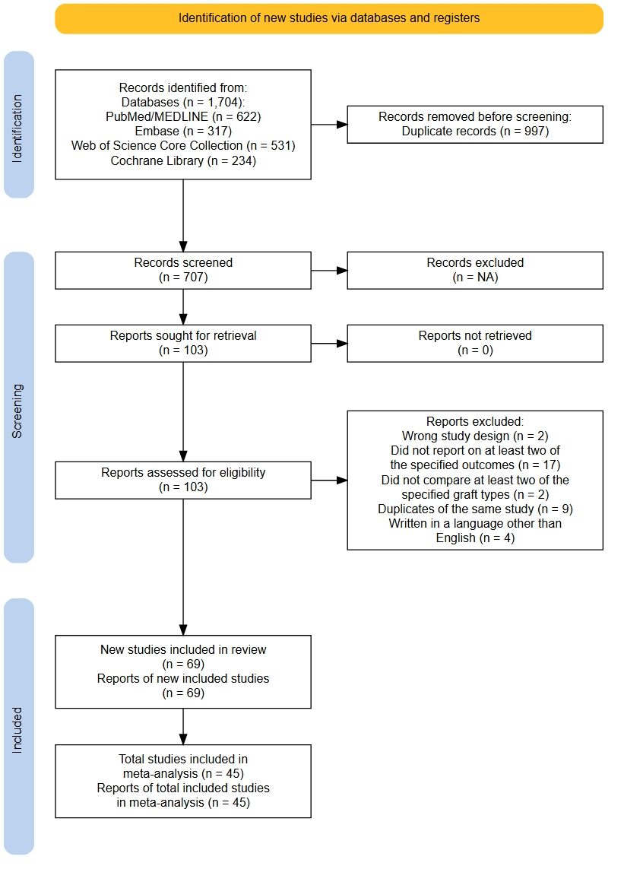

- Network graph

Lachman test ≥ 1+ (3-5 mm) grade was considered an event.
Pivot-shift test ≥ 2+ (clunk) was considered a clinical graft failure.
Lachman test ≥ 2+ (5-10 mm) grade was considered an event.
Revision surgery was defined as subsequent ACLR on the ipsilateral limb after clinical failure or graft re-rupture.
Clinical failure was defined by grade 2 (clunk) or 3 (gross) on pivot-shift test
Clinical failure was defined by grade 2 (5-10 mm) or 3 (> 10 mm) on Lachman test

