theme_agile

This is an outline of the core functionality of theme_agile.

## Some core theme_agile functionality

theme_agile is a ggplot2 theme designed to make journal ready figures easier, but also to make nice figures for a general audience.

I will use the mtcars data set to show the core functionality of theme_agile.

First, a plot with the defaults

## Including Plots

You can also embed plots, for example:

require(ggplot2)  
  
  
ggplot(mtcars, aes(mpg, disp))+  
 geom_point()+  
 theme_agile()

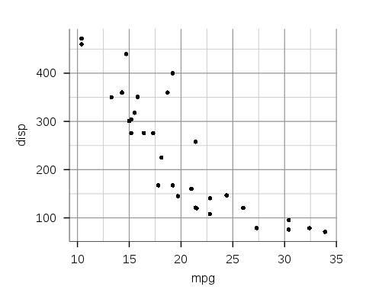

We may not want to have a minor grid, so let's remove that. This is done by simply setting minor.grid = FALSE.

ggplot(mtcars, aes(mpg, disp))+  
 geom_point()+  
 theme_agile(minor.grid = FALSE)

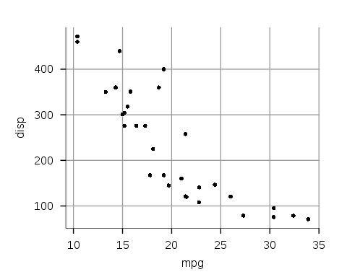

If we want to get rid off the vertical grid we can simply set vert.grid = FALSE.

ggplot(mtcars, aes(mpg, disp))+  
 geom_point()+  
 theme_agile(vert.grid = FALSE)

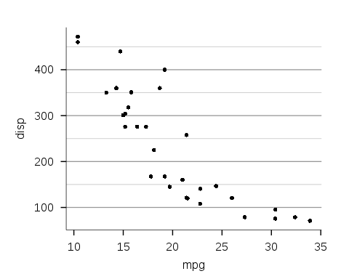

Now, let's consider the problem of creating plots that are acceptable for scientific journals.

Imagine we have a journal that does not allow grids and also requires inner axis ticks. We can do this quite easily.

ggplot(mtcars, aes(mpg, disp))+  
 geom_point()+  
 theme_agile(plot.grid = FALSE, ticks.type = "inner")

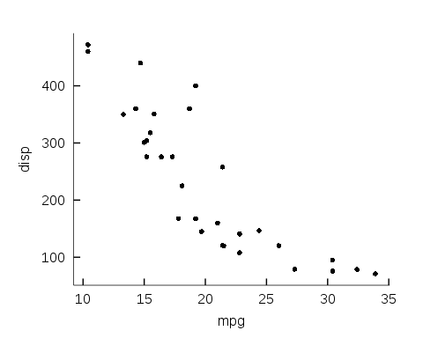

Alternatively, we might want to create a plot that is for a more informal venue. Here are a couple of options. In both cases I will use plot.type = "informal".

First, we have a simple plot with a horizontal grid. I will remove the axis

ggplot(mtcars, aes(mpg, disp))+  
 geom_point()+  
 theme_agile(plot.type = "informal", vert.grid = FALSE, minor.grid = FALSE, ticks.length = 0)

