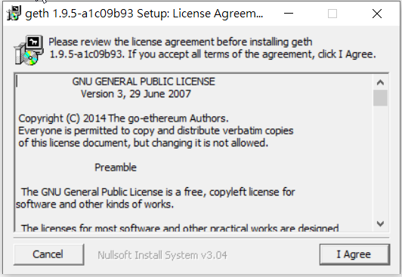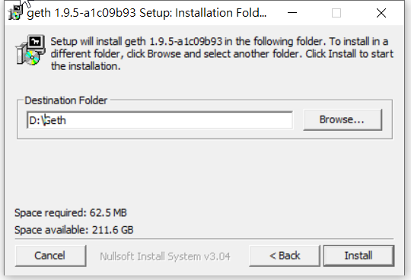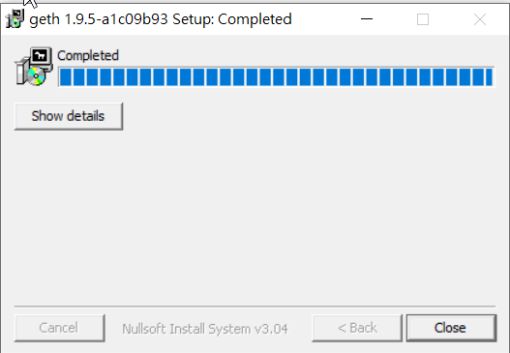

genesis.json

{

"config":{

"chainId":15,

"homesteadBlock":0,

"eip155Block":0,

"eip158Block":0

},

"nonce":"0x0000000000000042",

"mixhash":"0x0000000000000000000000000000000000000000000000000000000000000000",

"difficulty":"0x00",

"alloc":{},

"coinbase":"0x0000000000000000000000000000000000000000",

"timestamp":"0x00",

"parentHash":"0x0000000000000000000000000000000000000000000000000000000000000000",

"gasLimit":"0xffffffff"

}

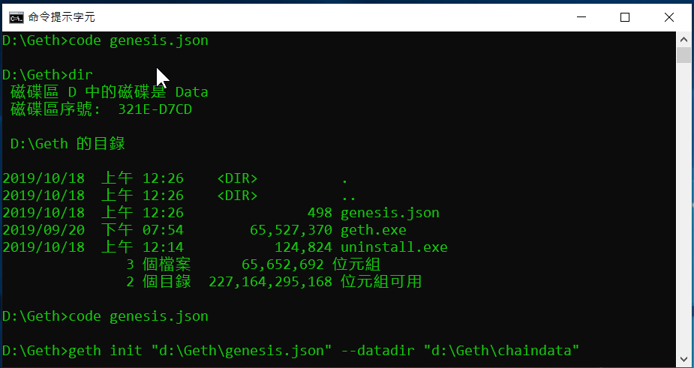

>geth init "d:\Geth\genesis.json" --datadir "d:\Geth\chaindata"

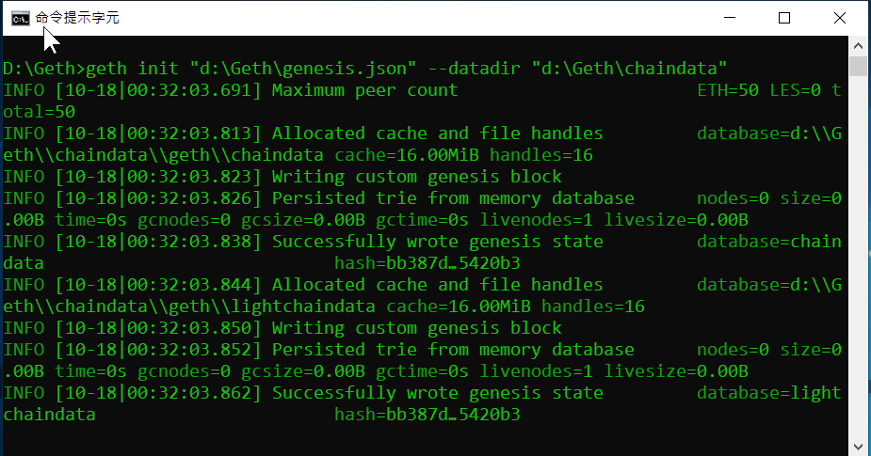

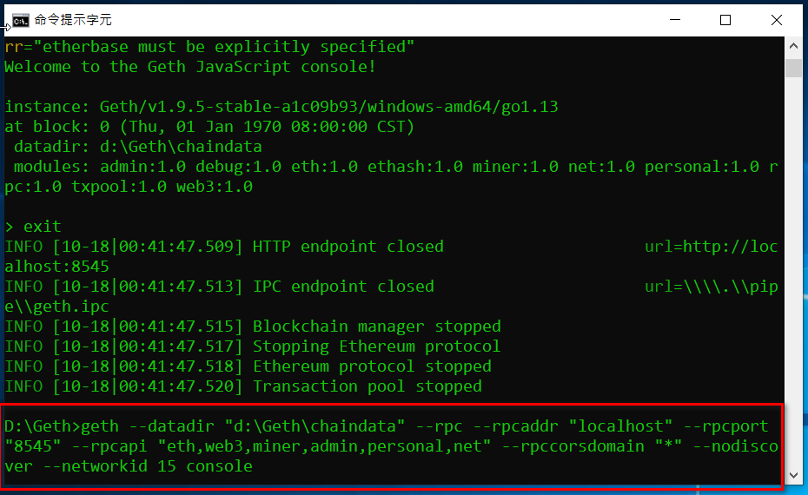

>geth --datadir "d:\Geth\chaindata" --rpc --rpcaddr "localhost" --rpcport "8545" --rpcapi "eth,web3,miner,admin,personal,net" --rpccorsdomain "\*" --nodiscover --networkid 15 console

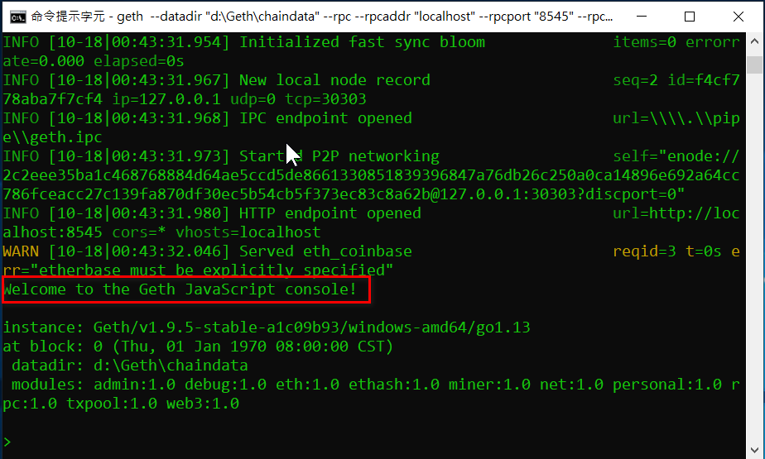

>geth attach ipc:\\.\pipe\geth.ipc

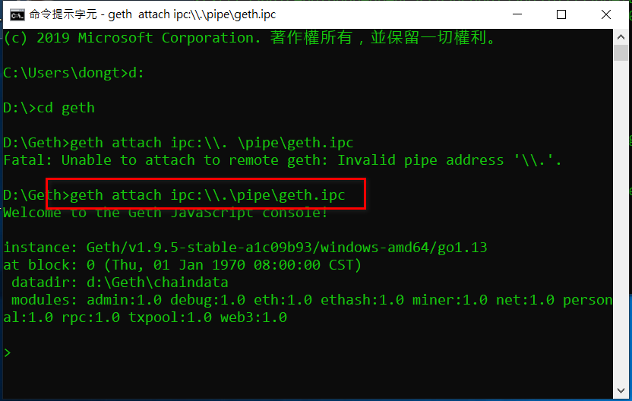

>geth attach rpc:http://localhost:8545

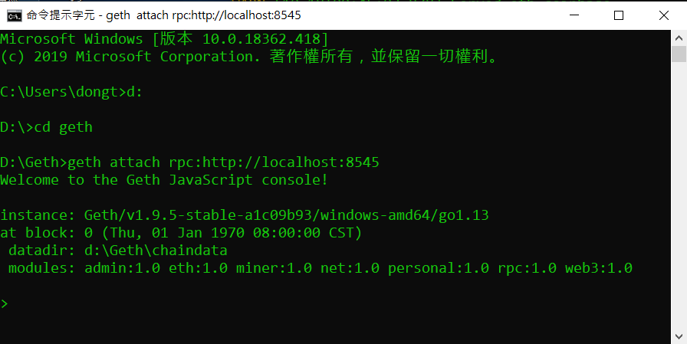

建新帳號

>personal.newAccount()

指定coinbase帳戶

>miner.setEtherbase(“…..”)

查看coinbase帳戶

>eth.coinbase

確認帳戶

>eth.accounts

挖礦

>miner.start()

停止挖礦

>miner.stop()

解鎖

>personal.unlockAccount(eth.accounts[0])