Hungry Shark’s User Guide

Team Shake Shark

December 1, 2019

Team Members
Qingyang Dong
Jialei Zhou
Ziwen Wang
Feishian Tzeng

Contents

Contents 2
1 Introduction 3
2 Quick Start Guide 3
3 System Requirements 5
4 Main Scenarios of Use 5
5 Troubleshooting 6

Introduction
Hungry Shark is a 2D casual game which is written in Python 3. During the game process, user can freely move the shark to dodge marine debris. In order to get into next game level, user also need to control shark to eat enough food. This document will provide instructions for playing the game.

Quick Start Guide
- Download Python 3.6.1 or greater on your computer.
For Windows Users: https://www.python.org/ftp/python/3.8.0/python-3.8.0.exe
For Linux/ UNIX Users: https://www.python.org/downloads/release/python-380/
For Mac OS X Users: https://www.python.org/downloads/release/python-380/
For Other Platforms Users: https://www.python.org/download/other/
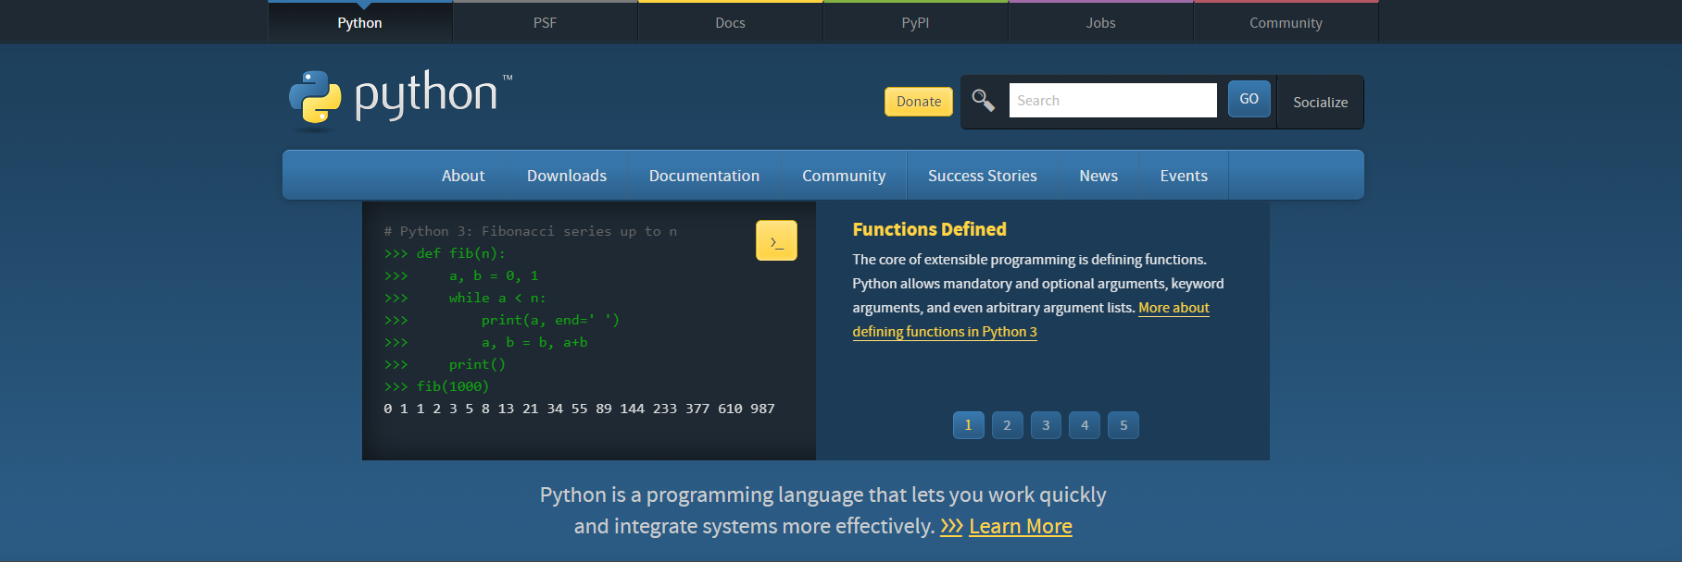

- Install Pygame on your computer. The best way to install Pygame is with the pip tool.
python3 -m pip install -U pygame --user

- Run the main.py file to start game
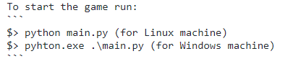

System Requirements
Hungry Shark should be run using pygame and python 3.6.1 or greater on Windows, Linux and MacOS X. For downloading python 3 and pygame, refer to the Quick Start Guide (2.1 & 2.2) for more instructions on installation.

Main Scenarios of Use

Gameplay
- After getting into main interface, there are three buttons list on menu, which are Start button, Quit button and Leaderboard button. The next few instructions will show each button’s functionality.
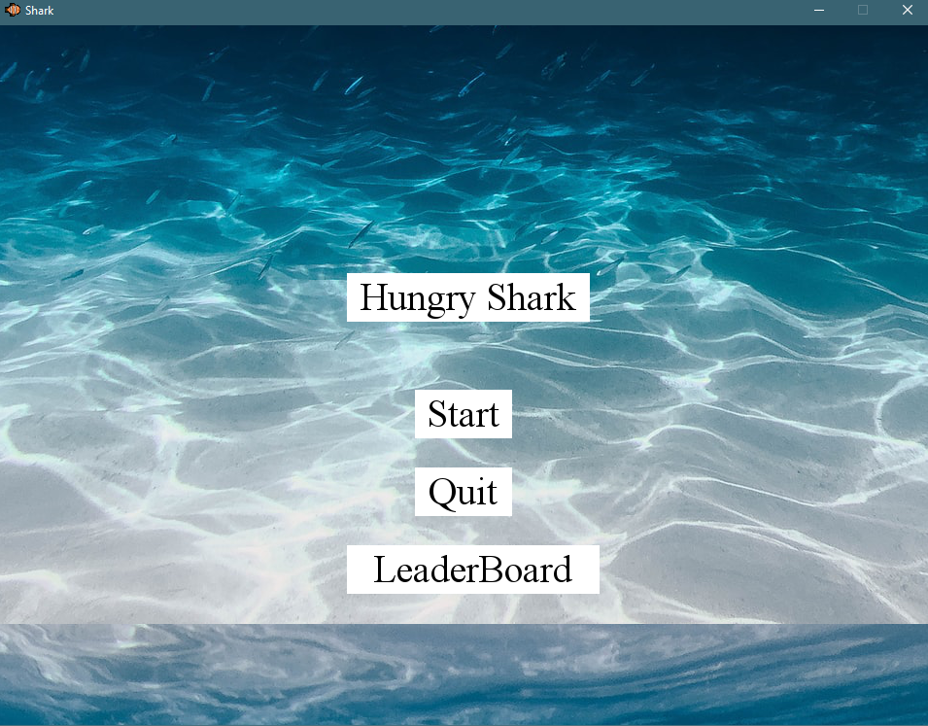

- Start Button& Gameplay
Tap the Start button, the game will begin. The movement of shark is controlled by keyboard. By clicking ‘A’ to move left, clicking ‘D’ to move right, click ‘W’ to move upward, clicking ‘S’ to move downward. After scoring enough points, game will get into next level. There is random special mode show up as game progressing.
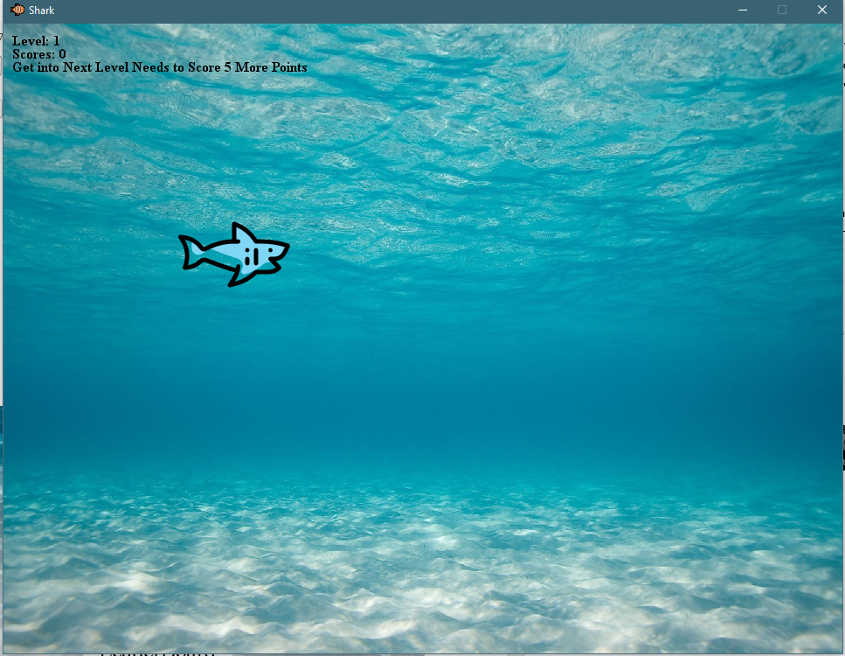
Use following imgs to find out which can score points which will lead shark to death:
Food:
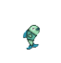

Obstacle:
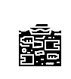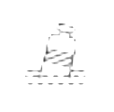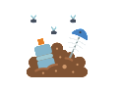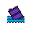
- Quit button
Click Quit button, the game will end, which is same as the X close button at the top right corner.
- Leaderboard button
Highest scores will be saved. Leaderboard will be shown after clicking the leaderboard button.

During game process

Troubleshooting

