



Rayat Shikshan Sanstha's
Karmaveer Bhaurao Patil Mahavidyalaya, Pandharpur
(Autonomous)
Affiliated To Punyashlok Ahilyadevi Holkar Solapur University, Solapur

Dept. - Bachelor of Computer Application
A
OJT Report On

Training Management system

Submitted by –
Mrs. Dongare Maruti Astik
Class –
BCA-III (Sem-VI)
Course-
Bachelor of Computer Application
Subject-
Training Management System

Guided by –

Mr. Gaikwad M.K

For the Academic Year 2025-26

Karmaveer Bhaurao Patil Mahavidyalaya, Pandharpur (Autonomous)
Affiliated To
Punyashlok Ahilyadevi Holkar Solapur University ,Solapur

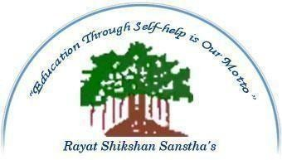

CERTIFICATE

DEPARTMENT OF BACHELOR OF COMPUTER APPLICATION

Date: / /

This is to certify that Miss Sayali Shivaji Patil From BCA-III has successfully completed

the Projects on, “Training Management System ”.

Under OJT in partial fulfilment of “Bachelor of Computer Application” at Karmaveer Bhaurao Patil Mahavidyalaya, Pandharpur.
This OJT presents their sincere work carried out under my guidance in the year 2025-26.

Mentor External Examiner (HOD of BCA)

Completion Certificate

Declaration by Student

I hereby declare that the On-the-Job Training (OJT) report submitted by me is a genuine and original record of the work carried out during my training period. This report has been prepared by me based on the knowledge, practical experience, and understanding gained throughout the course of my training. I confirm that this work has not been copied from any other source, either fully or partially, and all the information provided in this report is true and authentic to the best of my knowledge. I further declare that I have completed my training sincerely and have actively participated in all the assigned tasks, activities, and responsibilities given to me during the training period.

The report reflects my personal learning, observations, and contributions made during the training. Wherever any external references, materials, or guidance have been used, proper acknowledgment has been given in the report. I understand the importance of academic integrity and assure that this report is free from any form of plagiarism. I take full responsibility for the content presented in this report.

In case any discrepancy or false information is found, I shall be solely responsible for the same. This report is submitted as a part of my academic requirement for the successful completion of my course. I hope that this report clearly demonstrates my learning outcomes, skills acquired, and overall experience gained during the training period.

Student Name: Dongare Maruti
Course / Class: BCA-III
College Name: K.B.P College, Pandharpur
Date: / /2026

Acknowledgement

I am sincerely express my deepfelt gratitude to a number of persons who have helped me throughout My project works.
I would like to convey feeling of gratitude to my guide Mr. Gaikwad.M.K. who have guided me and my team members throughout my project work.
Knowledge me and my team members and encourage I also wish to express independences and thankfulness to Mr. Gaikwad.M.K. and other staff members of BCA department for their encouragement.
Lastly, I would also thank my all team members of creative bazaar and friends who have helped me and my team member directly and indirectly.

Place: PANDHARPUR Thank You
Date: / / 2026

Table of Content

Sr.no | Content | Page no.
1 | Cover Page | 1
2 | Completion Certificate | 2
3 | Declaration by Student | 3
4 | Acknowledgement | 4
5 | Table of Contents | 5
6 | Introduction | 6
7 | Profile of the Organization | 7
8 | Objectives of the Training | 8
9 | Duration and Schedule | 9
10 | Work Done / Training Details | 10-11
11 | Skills Acquired | 12
12 | Learning Outcomes | 12
13 | Skills Acquired | 14
14 | Safety Practices (Important for Science Students) | 15
15 | Evaluation of Training8 | 16
16 | Conclusion | 17
17 | References | 18
18 | Appendices | 19

Introduction

Meaning and Importance of OJT

  - On-the-Job Training (OJT) is a practical training method where students learn by working in a real professional environment.
  - It helps in applying theoretical knowledge to real-world IT tasks such as coding, testing, and system management.
  - OJT bridges the gap between academic learning and industry requirements.
  - It improves technical skills, problem-solving ability, and confidence.
  - It provides exposure to workplace culture, teamwork, and professional ethics.
  - It prepares students to become industry-ready and increases employability.

Objectives of Training

  - To gain practical experience in the IT industry.
  - To develop technical skills such as programming, web development, database handling, or networking.
  - To understand real-time project development and workflow.
  - To enhance problem-solving and analytical thinking abilities.
  - To improve communication, teamwork, and professional behavior.
  - To learn time management and work discipline.
  - To understand the use of modern tools, technologies, and software used in the IT field.

Brief about IT Field

  - Information Technology (IT) involves the use of computers, software, and networks to manage and process information.
  - It includes areas such as software development, web development, database management, networking, cyber security, and IT support.
  - IT professionals design, develop, test, and maintain software applications and systems.
  - The IT field plays a major role in business operations, communication, data management, and automation.
  - It is a rapidly growing field with continuous advancements in technology and innovation.
  - IT is widely used in various sectors like education, healthcare, banking, and e- commerce.

Profile of the Organization

Greentin Solutions Pvt Ltd

Greentin Solutions Pvt Ltd is a software development company focused on delivering innovative and scalable technology solutions. The company operates from Pandharpur, Maharashtra, and offers a broad portfolio of IT services spanning application development, cloud platforms, SaaS products, and IoT solutions. It works with clients across multiple sectors, providing both technical execution and consulting capabilities.

Key Brands
myeNovation — Innovation and digital transformation platform
Excelleta — Technology excellence and service delivery brand
Venda4s — Sales-oriented SaaS and business solutions

Service Portfolio
Custom Software Development
Web and Mobile Application Development
Cloud Application Development
SaaS Product Development
Salesforce Services (RFQ and Costing Solutions)

Objectives of the Training

Learning Goals

  - To understand the practical working environment of the IT industry.
  - To apply theoretical knowledge gained during academic studies to real-world situations.
  - To learn about software development processes, tools, and technologies used in the industry.
  - To gain knowledge of project development life cycle and workflow in an organization.

Skills Intended to Develop

  - To develop technical skills such as programming, web development, and database management.
  - To improve problem-solving and analytical thinking abilities.
  - To enhance communication and interpersonal skills.
  - To build teamwork and collaboration skills while working on projects.
  - To improve time management and the ability to meet deadlines.
  - To develop professional behavior and work ethics.

Exposure Expected from the Training

  - To gain hands-on experience in real-time IT projects.
  - To get familiar with industry tools, software, and technologies.
  - To understand organizational structure and workplace culture.
  - To interact with professionals and learn from their experience.
  - To observe and participate in actual project development and implementation.
  - To understand client requirements and how solutions are designed accordingly.

Duration and Schedule

The On-the-Job Training (OJT) was carried out for a total duration of 7 weeks, which provided sufficient time to gain practical exposure and understand the working environment of the organization. During this period, the student was actively involved in various tasks and activities that contributed to the development of technical knowledge and professional skills. The duration of seven weeks proved to be effective in learning new concepts, understanding real-time work processes, and applying theoretical knowledge in practical situations.
The daily working schedule consisted of 4 hours per day, as per the guidelines of the organization. The student followed the assigned timing regularly and maintained discipline, punctuality, and consistency throughout the training period. These working hours were efficiently utilized to perform assigned tasks, learn new tools and technologies, and interact with team members. The training was systematically planned to provide step-by-step learning. In the initial phase, the student was introduced to the organization, its work culture, and basic operations. This helped in building a foundation and understanding the overall workflow. In the subsequent weeks, the student was gradually assigned tasks related to software development, database handling, and system operations.
The work was distributed in a way that allowed the student to gain exposure to different areas and improve both technical and problem-solving skills. The department-wise schedule ensured that the student could observe and understand how different sections of the organization function and coordinate with each other. Each phase of training focused on specific objectives, allowing gradual improvement and better understanding of the work environment. Overall, the duration and schedule of the training were well-structured and beneficial. It helped the student to utilize time effectively, gain hands-on experience, and build confidence, making the OJT a valuable learning experience.

Work Done / Training Details
This is the core section. Include:

Week 1: Introduction & Setup
  - Introduction to the company/project and team members
  - Understanding project requirements
  - Installation of required software (Python, Mysql)
  - Assigned roles within the group

Week 2: Development Phase
  - Started coding modules as per project requirement
  - Worked on frontend (UI design) and backend logic
  - Created database tables and connections
  - Regular group discussions for progress tracking

Week 3: Testing & Debugging
  - Performed unit testing and debugging
  - Fixed errors and improved code efficiency
  - Integrated different modules developed by team members
  - Tested application functionality

Week 4: Final Project & Deployment
  - Completed final project implementation
  - Prepared project documentation
  - Group presentation and demonstration
  - Deployment of the project (local/server)

Week 5: Description of Tasks Performed
  - Divided project work among group members
  - Designed and developed application modules
  - Created and managed database
  - Wrote and tested code
  - Debugged errors and optimized performance

  - Maintained documentation and reports Tools, Technologies, and Methods Used Programming Languages:
  - Python /Mysql / Django
  - HTML, CSS

Tools & Software:
  - PyCharm
  - MySQL

Technologies:
  - Web Development (Frontend & Backend)
  - Database Management Systems (DBMS)
  - API Integration

Methods:
- Modular Programming
  - Version Control System (Git)

Safety & Best Practices Followed
  - Proper use of licensed software
  - Data security and password protection
  - Regular backup of project files
  - Writing clean and readable code
  - Following coding standards and team coordination

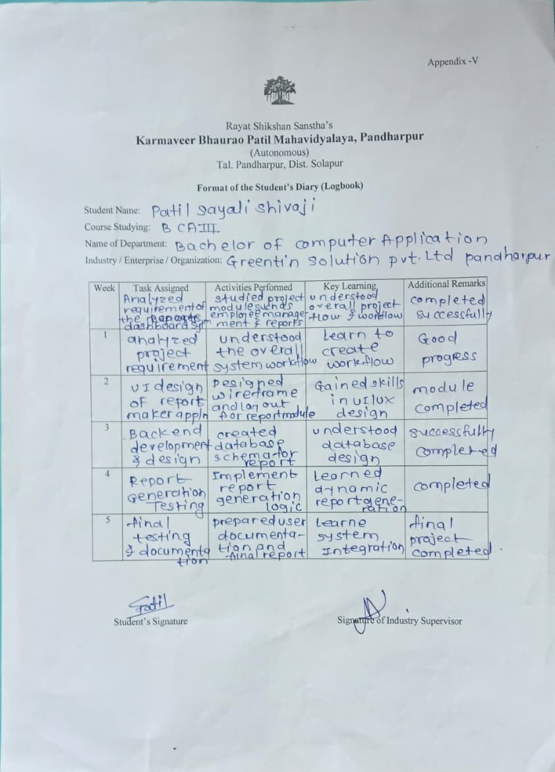

Skills Acquired

During the On-the-Job Training (OJT), the student acquired a combination of technical and soft skills that are essential for professional growth in the field of Information Technology. The training provided hands-on experience and practical exposure, which helped in enhancing overall capabilities.

Technical Skills: The student developed strong technical skills in areas such as software development, web application development, and database management. Knowledge of technologies like Spring Boot, MySQL, React, and JavaScript was gained and applied in real-time project development. The student learned how to design and develop APIs, handle database operations (CRUD), and integrate frontend with backend systems. Understanding of concepts such as authentication (JWT), role-based access control, and system architecture was also improved.

Soft Skills: The training helped in improving essential soft skills required in a professional environment. The student developed effective communication skills through interaction with team members and supervisors. Teamwork and collaboration were enhanced by working on group tasks and projects. Additionally, qualities such as discipline, punctuality, time management, and adaptability were strengthened during the training period. Problem-Solving Ability: The student improved problem-solving skills by working on real-time challenges during

Learning Outcomes

What Was Learned
During the training period, we gained practical knowledge of software development and IT industry practices. We learned how to design, develop, and test applications using programming languages and modern tools. We also understood how different components like frontend, backend, and databases work together in a real project.

Difference Between Theory and Practical Exposure
The training helped us understand the gap between theoretical knowledge and practical implementation. While theory provided the basic concepts of programming and system design, practical exposure showed us:
  - How to apply concepts in real-time projects
  - How to handle errors and unexpected issues
  - The importance of teamwork and coordination
  - Working with real tools, environments, and deadlines
This experience made learning more effective and application-oriented.

Real-World Understanding Gained
  - Understanding of real software development processes (planning, coding, testing, deployment)
  - Experience of working in a team environment similar to an IT company
  - Exposure to real-world challenges like debugging, integration issues, and time constraints
  - Importance of writing efficient, clean, and maintainable code
  - Awareness of professional work culture, communication, and responsibility

Challenges Faced

Problems Encountered During Training
During the training period, we faced several challenges while working on the project:
  - Difficulty in understanding complex programming concepts and logic
  - Errors and bugs in code during development
  - Issues in database connectivity and integration
  - Managing time effectively while completing assigned tasks
  - Coordination challenges while working in a group
  - Lack of initial familiarity with some tools and technologies

How They Were Resolved
We used the following approaches to overcome these challenges:
  - Referred to online resources, documentation, and tutorials
  - Took guidance from mentors and trainers
  - Conducted group discussions to solve problems collaboratively
  - Practiced coding regularly to improve understanding
Debugged code step-by-step to identify

Lessons Learned from Difficulties
  - Importance of patience and consistency in problem-solving
  - Value of teamwork and effective communication
  - Gaining confidence in handling technical issues independently
  - Learning to adapt to new tools and technologies quickly
  - Understanding the importance of planning and time management
  - Developing a positive approach toward challenges and continuous learning

Safety Practices

Safety Rules Followed
  - Followed proper system usage guidelines in the lab/workplace
  - Avoided unauthorized access to systems and data
  - Logged out of systems after use to maintain security
  - Maintained discipline while handling computer equipment
  - Followed instructions given by mentors and lab in-charge

Use of Protective Measures (IT Environment)
  - Used strong passwords and secure login practices
  - Enabled antivirus and firewall protection
  - Avoided downloading unsafe or unknown files
  - Took regular backups of project data
  - Ensured safe handling of hardware components

Data Handling & Disposal Methods
  - Properly managed and stored project files
  - Avoided sharing sensitive data without permission
  - Deleted unnecessary or temporary files safely
  - Followed ethical practices for data usage
  - Ensured proper shutdown of systems after work

Additional Good Practices
  - Maintained clean and organized workspace
  - Avoided food or liquids near computer systems
  - Handled devices carefully to prevent damage
  - Followed basic cybersecurity awareness practices

Evaluation of Training

The On-the-Job Training (OJT) was a valuable learning experience that helped in assessing both technical and professional growth during the training period.

Self-Evaluation of Performance: During the training, the student actively participated in all assigned tasks and projects with dedication and responsibility. The student was able to understand and implement various concepts related to software development, database management, and web technologies. Regular practice and continuous learning helped in improving coding skills, problem-solving ability, and confidence.

The student maintained punctuality, discipline, and a positive attitude throughout the training. Although some difficulties were faced initially, consistent efforts led to noticeable improvement in performance. The supervisor appreciated the student’s willingness to learn, sincerity, and commitment towards work.

The student was recognized for completing tasks on time and showing interest in understanding new technologies. Suggestions were given to further improve technical knowledge, write more efficient code, and continue practicing real-time problem-solving. Overall, the feedback received was positive and encouraging, highlighting the student’s good performance and potential for future growth. In conclusion, the training performance was satisfactory, and the experience contributed significantly to the development of both technical and professional skills.

Conclusion

Overall Experience Summary
The training period provided valuable practical exposure to real-world IT environments. It helped us understand how software projects are planned, developed, tested, and implemented in a professional setting. Working in a group improved our coordination, communication, and technical skills. Overall, the experience was very informative and beneficial for our academic and technical growth.

Importance of OJT in Career Development
On-the-Job Training (OJT) plays an important role in bridging the gap between theoretical knowledge and practical application. It helps students gain industry experience, understand workplace culture, and develop professional skills required in the IT industry. OJT also enhances confidence and prepares students for future job opportunities.

Final Reflection
This training experience has helped us gain a better understanding of the IT field and improved our technical as well as soft skills. It has encouraged us to learn new technologies and work more efficiently in teams. We feel more confident and better prepared for future challenges in our career.

References

During the On-the-Job Training (OJT), various learning resources were referred to for gaining technical knowledge, understanding concepts, and successfully completing the project work. These references played an important role in enhancing both theoretical understanding and practical implementation skills.

Several official documentation sources were used as primary references. The documentation of Spring Boot Framework (spring.io) was referred to for backend development, API creation, and understanding concepts such as dependency injection, REST APIs, and security features like JWT authentication. The MySQL official documentation (dev.mysql.com) was used for learning database design, table creation, relationships, and performing CRUD operations effectively.

For frontend development, the student referred to React documentation

Html and JavaScript documentation to understand user interface development, component-based architecture, and client-side scripting. The Bootstrap documentation was used for designing responsive and user-friendly interfaces. In addition to official documentation, various online resources such as tutorials, technical blogs, and developer forums were used to solve practical problems and understand real-time implementation challenges.

These platforms provided examples, best practices, and solutions for debugging errors encountered during development. The student also referred to project-related manuals, system design documents, and Product Requirements Document (PRD) provided by the organization. These documents helped in understanding the system architecture, workflow, and functional requirements of the project. Furthermore, Standard Operating Procedures (SOPs) followed within the organization were studied to understand professional practices, coding standards, and workflow management.


Appendices

Attendance

Photographs




