**COMP 473 / COMP 6731**

**Assignment 2:**

Due date: as indicated on Moodle

**You may work individually or in pairs**

Given that:



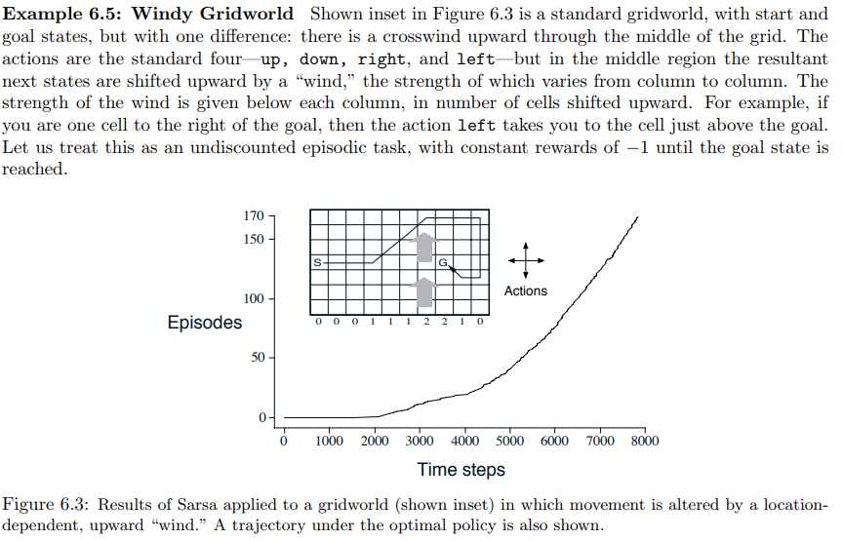

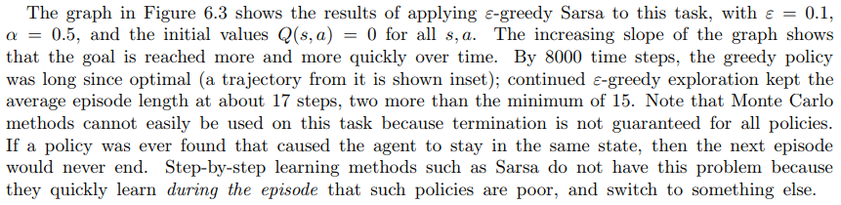

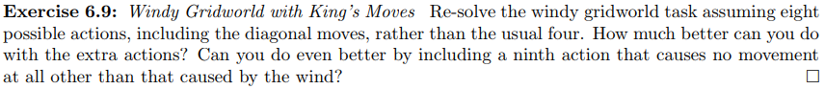

This exercise is from: <http://incompleteideas.net/book/the-book.html>

* You need to indicate your discount rate and learning rate
* You need to show a few examples of the values of Q’s as they change
* You need to show the final optimum solution

**No late submissions are accepted.**

**Have fun ☺**