Concordia University

Department of Software Engineer and Computer Science

# COMP 6231, Summer 2016

# Assignment 1

# Dong Chen : 40013109 & Peilin Jiang: 40015338

## About this assignment 1:

To complete this assignment, we use Eclipse 4.5.1 with JDK&JRE 1.8.0_65. The core techniques of this DSMS system is using JAVA RMI and UDP programming.

## Design of DSMS:

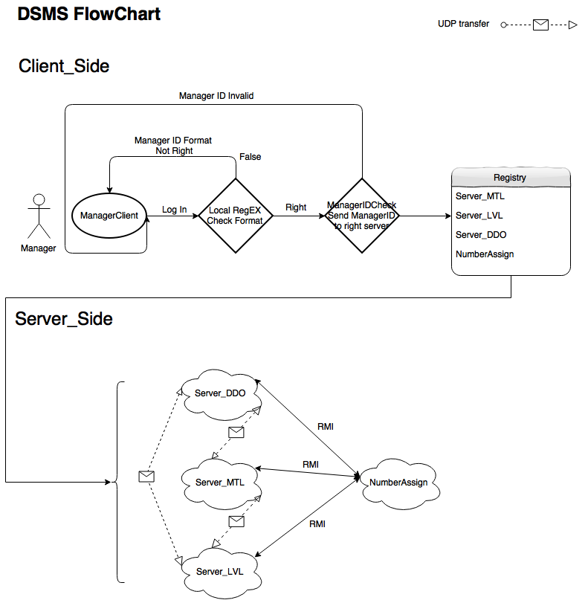

## Architecture and Data structures:

Architecture:

About the design of this DSMS, we have multiple packages like below:



## Test Scenarios:

## Most Important part: