To use just run the Dummy Process Monitor application. This can then be left running while you run your own application any number of times. When you run your application you will see it appear in the list of processes and the entity listed will be the --entity-name given on the command line.

This is built mainly for GUI’s but can be used for other applications that register with a Process Monitor.

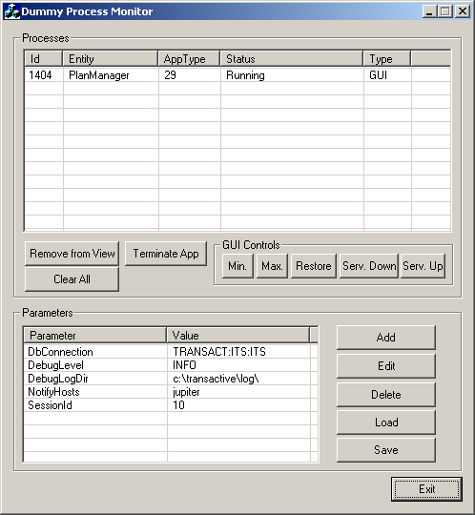
List of running processes and processes that have run
Remove a terminated process from the view
Terminate the selected process.
List of RunParams that will be received by an application registering with the process monitor.
Buttons to change the RunParams that will be received by the applications.

BG 29/4/04: The currently selected process will automatically receive a parameter update. When a parameter is deleted the update will contain an empty value string.
Operations that can be called on GUI’s:
Minimise
Maximise
Restore / Get Focus
Server Down
Server Up
Buttons to load/save RunParams from/to a disk file.

BG 29/4/04: To have parameters load automatically on startup, use the –param-file=<file path> command line argument.

