2018-04-28
Bree-张慧(3043821679) 10:44:29
h455081173
Bree-张慧(3043821679) 10:44:31
你加我
Bree-张慧(3043821679) 11:55:38
你先看
Bree-张慧(3043821679) 11:56:03
没问题的话付款了 我吃饭回来发你代码
旅途(1772655586) 12:12:04
@晕下单了
晕(1104872420) 12:22:06
好了
Bree-张慧(3043821679) 12:23:11
@ 你怎么转我
晕(1104872420) 12:24:17
@Bree-张慧 你先发他，没问题了，就转账
晕(1104872420) 12:24:26
支付宝
Bree-张慧(3043821679) 12:24:44
zhbabara@163.com
旅途(1772655586) 12:24:53
我付款了
Bree-张慧(3043821679) 12:24:55
我视频已经发了啊
Bree-张慧(3043821679) 12:25:03
对方都付款了
旅途(1772655586) 12:25:33
旅途(1772655586) 12:25:54
@晕
Bree-张慧(3043821679) 12:26:06
怎么是650
旅途(1772655586) 12:26:17
两次啊
旅途(1772655586) 12:26:26
上次650
Bree-张慧(3043821679) 12:26:26
哦哦
Bree-张慧(3043821679) 12:26:46
原来已经交了一部分定金了
晕(1104872420) 12:27:09
发吧
晕(1104872420) 12:27:17
@Bree-张慧
Bree-张慧(3043821679) 12:27:43
你已经转账了？
晕(1104872420) 12:27:56
你先发
晕(1104872420) 12:28:05
等他确认没问题
晕(1104872420) 12:28:09
就转你
Bree-张慧(3043821679) 12:28:53
我之前都是发了视频 对方赚钱给中间 中间转给我 我再发代码的
晕(1104872420) 12:30:05
@Bree-张慧 我要确保没有问题
Bree-张慧(3043821679) 12:30:32
ok
晕(1104872420) 12:30:45
这就是我的作用
Bree-张慧(3043821679) 12:31:11
但是我的权益怎么保障？
Bree-张慧(3043821679) 12:31:21
不过我相信旅途
Bree-张慧(3043821679) 12:31:28
只不过觉得这样不合理
晕(1104872420) 12:31:34
晕(1104872420) 12:31:56
放心，我是搞技术，大部分自己做
Bree-张慧(3043821679) 12:31:56
你是转我1000把？
晕(1104872420) 12:32:00
找人很麻烦
晕(1104872420) 12:33:35
晕(1104872420) 12:33:53
@Bree-张慧 发吧
Bree-张慧(3043821679) 12:34:37
我问下，你给我的是1000嘛
Bree-张慧(3043821679) 12:34:55
/托腮
Bree-张慧(3043821679) 12:41:25
测试的时候，运行predict_cnn和predict_rnn,改下面path中的图片名称可以切换图片进行测试
Bree-张慧(3043821679) 12:41:27
Bree-张慧(3043821679) 12:50:49
@旅途 测试好了你说下
旅途(1772655586) 12:52:30
嗯
Bree-张慧(3043821679) 12:54:31
先不要运行model文件
旅途(1772655586) 13:02:07
那运行哪个？
旅途(1772655586) 13:06:18
运行顺序给我说下
Bree-张慧(3043821679) 13:06:40
测试的时候，运行predict_cnn和predict_rnn,改下面path中的图片名称可以切换图片进行测试
旅途(1772655586) 13:15:23
不行啊报错呀
Bree-张慧(3043821679) 13:15:33
截图
Bree-张慧(3043821679) 13:15:34
我看下
Bree-张慧(3043821679) 13:15:44
是不环境没装好
旅途(1772655586) 13:17:07
Bree-张慧(3043821679) 13:17:19
哦哦
旅途(1772655586) 13:17:19
手写板
Bree-张慧(3043821679) 13:17:22
装一下
Bree-张慧(3043821679) 13:17:22
嗯
Bree-张慧(3043821679) 13:18:58
按住windows和R
Bree-张慧(3043821679) 13:19:13

2018-04-28
Bree-张慧(3043821679) 10:44:29
h455081173
Bree-张慧(3043821679) 10:44:31
你加我
Bree-张慧(3043821679) 11:55:38
你先看
Bree-张慧(3043821679) 11:56:03
没问题的话付款了 我吃饭回来发你代码
旅途(1772655586) 12:12:04
@晕下单了
晕(1104872420) 12:22:06
好了
Bree-张慧(3043821679) 12:23:11
@ 你怎么转我
晕(1104872420) 12:24:17
@Bree-张慧 你先发他，没问题了，就转账
晕(1104872420) 12:24:26
支付宝
Bree-张慧(3043821679) 12:24:44
zhbabara@163.com
旅途(1772655586) 12:24:53
我付款了
Bree-张慧(3043821679) 12:24:55
我视频已经发了啊
Bree-张慧(3043821679) 12:25:03
对方都付款了
旅途(1772655586) 12:25:33
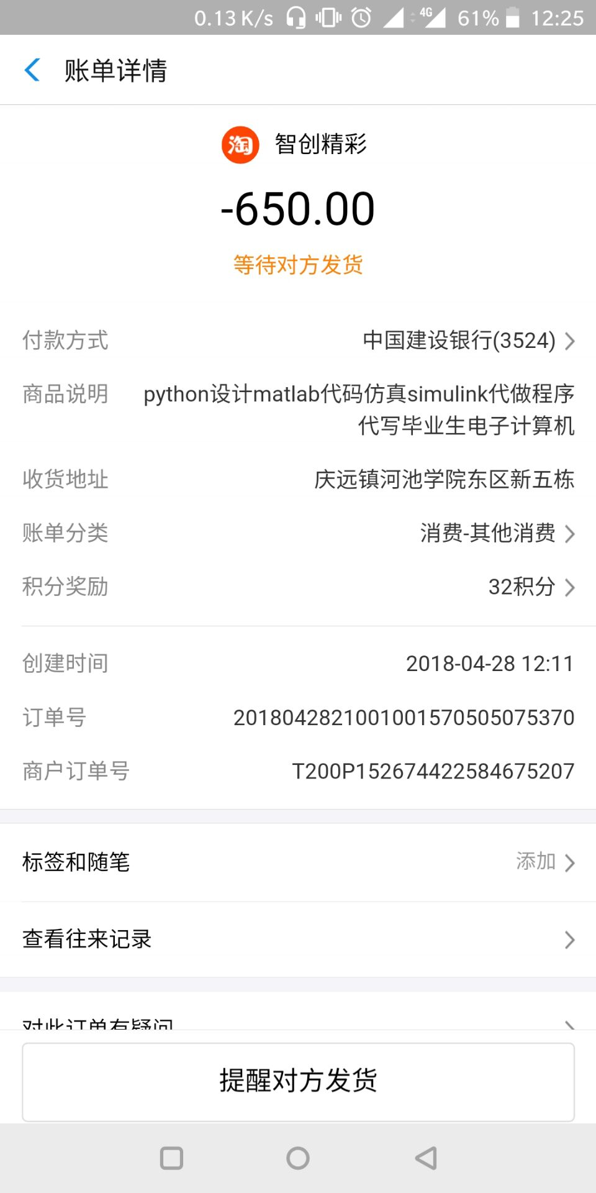
旅途(1772655586) 12:25:54
@晕
Bree-张慧(3043821679) 12:26:06
怎么是650
旅途(1772655586) 12:26:17
两次啊
旅途(1772655586) 12:26:26
上次650
Bree-张慧(3043821679) 12:26:26
哦哦
Bree-张慧(3043821679) 12:26:46
原来已经交了一部分定金了
晕(1104872420) 12:27:09
发吧
晕(1104872420) 12:27:17
@Bree-张慧
Bree-张慧(3043821679) 12:27:43
你已经转账了？
晕(1104872420) 12:27:56
你先发
晕(1104872420) 12:28:05
等他确认没问题
晕(1104872420) 12:28:09
就转你
Bree-张慧(3043821679) 12:28:53
我之前都是发了视频 对方赚钱给中间 中间转给我 我再发代码的
晕(1104872420) 12:30:05
@Bree-张慧 我要确保没有问题
Bree-张慧(3043821679) 12:30:32
ok
晕(1104872420) 12:30:45
这就是我的作用
Bree-张慧(3043821679) 12:31:11
但是我的权益怎么保障？
Bree-张慧(3043821679) 12:31:21
不过我相信旅途
Bree-张慧(3043821679) 12:31:28
只不过觉得这样不合理
晕(1104872420) 12:31:34
晕(1104872420) 12:31:56
放心，我是搞技术，大部分自己做
Bree-张慧(3043821679) 12:31:56
你是转我1000把？
晕(1104872420) 12:32:00
找人很麻烦
晕(1104872420) 12:33:35
晕(1104872420) 12:33:53
@Bree-张慧 发吧
Bree-张慧(3043821679) 12:34:37
我问下，你给我的是1000嘛
Bree-张慧(3043821679) 12:34:55
/托腮
Bree-张慧(3043821679) 12:41:25
测试的时候，运行predict_cnn和predict_rnn,改下面path中的图片名称可以切换图片进行测试
Bree-张慧(3043821679) 12:41:27
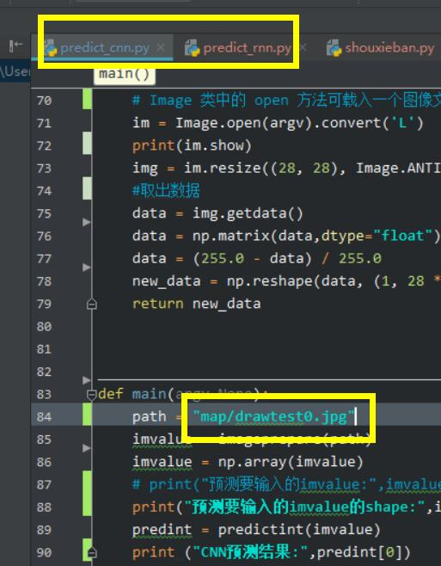
Bree-张慧(3043821679) 12:50:49
@旅途 测试好了你说下
旅途(1772655586) 12:52:30
嗯
Bree-张慧(3043821679) 12:54:31
先不要运行model文件
旅途(1772655586) 13:02:07
那运行哪个？
旅途(1772655586) 13:06:18
运行顺序给我说下
Bree-张慧(3043821679) 13:06:40
测试的时候，运行predict_cnn和predict_rnn,改下面path中的图片名称可以切换图片进行测试
旅途(1772655586) 13:15:23
不行啊报错呀
Bree-张慧(3043821679) 13:15:33
截图
Bree-张慧(3043821679) 13:15:34
我看下
Bree-张慧(3043821679) 13:15:44
是不环境没装好
旅途(1772655586) 13:17:07
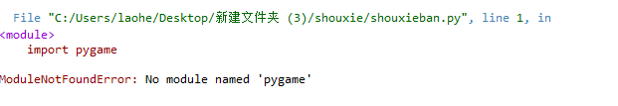
Bree-张慧(3043821679) 13:17:19
哦哦
旅途(1772655586) 13:17:19
手写板
Bree-张慧(3043821679) 13:17:22
装一下
Bree-张慧(3043821679) 13:17:22
嗯
Bree-张慧(3043821679) 13:18:58
按住windows和R
Bree-张慧(3043821679) 13:19:13
2018-04-28
Bree-张慧(3043821679) 13:19:21
输入cmd
Bree-张慧(3043821679) 13:19:51
再输入pip install pygame
旅途(1772655586) 13:22:17
你都没进去python呢
旅途(1772655586) 13:22:42
我用anconda下载了
旅途(1772655586) 13:24:31
在手写版上输入数字怎么保存
Bree-张慧(3043821679) 13:24:39
自动保存
Bree-张慧(3043821679) 13:24:56
在map里的drawtest
旅途(1772655586) 13:30:26
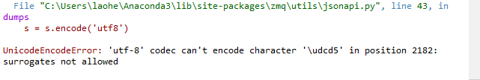ptedict_rnn,py运行报错
Bree-张慧(3043821679) 13:31:02
保错都截个图
Bree-张慧(3043821679) 13:31:07
我看哪一行
Bree-张慧(3043821679) 13:31:54
解压后用英文路径
旅途(1772655586) 13:38:19
cnn那个还是两层卷积，第三层是全链接层，第四层输出层，跟官方的一样呀/泪奔
旅途(1772655586) 14:06:43
Traceback (most recent call last):
File "C:\Users\laohe\Anaconda3\lib\site-packages\IPython\core\interactiveshell.py", line 2927, in run_code
self.showtraceback(running_compiled_code=True)
File "C:\Users\laohe\Anaconda3\lib\site-packages\IPython\core\interactiveshell.py", line 1833, in showtraceback
self._showtraceback(etype, value, stb)
File "C:\Users\laohe\Anaconda3\lib\site-packages\ipykernel\zmqshell.py", line 558, in _showtraceback
dh.parent_header, ident=topic)
File "C:\Users\laohe\Anaconda3\lib\site-packages\jupyter_client\session.py", line 737, in send
to_send = self.serialize(msg, ident)
File "C:\Users\laohe\Anaconda3\lib\site-packages\jupyter_client\session.py", line 625, in serialize
content = self.pack(content)
File "C:\Users\laohe\Anaconda3\lib\site-packages\jupyter_client\session.py", line 103, in <lambda>
ensure_ascii=False, allow_nan=False,
File "C:\Users\laohe\Anaconda3\lib\site-packages\zmq\utils\jsonapi.py", line 43, in dumps
s = s.encode('utf8')
UnicodeEncodeError: 'utf-8' codec can't encode character '\udcd5' in position 2174: surrogates not allowed
Bree-张慧(3043821679) 14:07:05
你的意思要三层卷积层
旅途(1772655586) 14:07:15
en
Bree-张慧(3043821679) 14:07:31
你这个报错是哪个文件啊
Bree-张慧(3043821679) 14:07:50
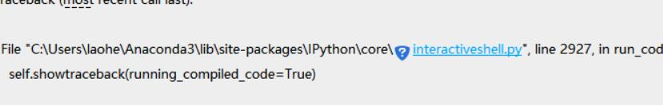
Bree-张慧(3043821679) 14:07:59
感觉是你包的问题
旅途(1772655586) 14:08:30
preddict_rnn
旅途(1772655586) 14:10:38
File "<ipython-input-1-09c8b893997e>", line 1, in <module>
runfile('C:/Users/laohe/Desktop/shouxie/shouxie/predict_cnn.py', wdir='C:/Users/laohe/Desktop/shouxie/shouxie')
File "C:\Users\laohe\Anaconda3\lib\site-packages\spyder\utils\site\sitecustomize.py", line 705, in runfile
execfile(filename, namespace)
File "C:\Users\laohe\Anaconda3\lib\site-packages\spyder\utils\site\sitecustomize.py", line 102, in execfile
exec(compile(f.read(), filename, 'exec'), namespace)
File "C:/Users/laohe/Desktop/shouxie/shouxie/predict_cnn.py", line 93, in <module>
main()
File "C:/Users/laohe/Desktop/shouxie/shouxie/predict_cnn.py", line 85, in main
imvalue = imageprepare(path)
File "C:/Users/laohe/Desktop/shouxie/shouxie/predict_cnn.py", line 71, in imageprepare
im = Image.open(argv).convert('L')
File "C:\Users\laohe\Anaconda3\lib\site-packages\PIL\Image.py", line 2543, in open
fp = builtins.open(filename, "rb")
FileNotFoundError: [Errno 2] No such file or directory: 'map/drawtes4.jpg'
旅途(1772655586) 14:11:16
这是predict_cnn的
Bree-张慧(3043821679) 14:11:17
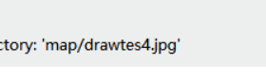
Bree-张慧(3043821679) 14:11:23
名字没输对啊
Bree-张慧(3043821679) 14:11:30
你看清名字
旅途(1772655586) 14:16:50
runfile('C:/Users/laohe/Desktop/shouxie/shouxie/predict_cnn.py', wdir='C:/Users/laohe/Desktop/shouxie/shouxie')
<bound method Image.show of <PIL.Image.Image image mode=L size=800x600 at 0x1AB3908D128>>
预测要输入的imvalue的shape: (1, 784)
INFO:tensorflow:Restoring parameters from tmp_mnist_cnn/model.ckpt
Traceback (most recent call last):
File "<ipython-input-2-09c8b893997e>", line 1, in <module>
runfile('C:/Users/laohe/Desktop/shouxie/shouxie/predict_cnn.py', wdir='C:/Users/laohe/Desktop/shouxie/shouxie')
File "C:\Users\laohe\Anaconda3\lib\site-packages\spyder\utils\site\sitecustomize.py", line 705, in runfile
execfile(filename, namespace)
File "C:\Users\laohe\Anaconda3\lib\site-packages\spyder\utils\site\sitecustomize.py", line 102, in execfile
exec(compile(f.read(), filename, 'exec'), namespace)
File "C:/Users/laohe/Desktop/shouxie/shouxie/predict_cnn.py", line 93, in <module>
main()
File "C:/Users/laohe/Desktop/shouxie/shouxie/predict_cnn.py", line 89, in main
predint = predictint(imvalue)
File "C:/Users/laohe/Desktop/shouxie/shouxie/predict_cnn.py", line 61, in predictint
saver.restore(sess, "tmp_mnist_cnn/model.ckpt")
File "C:\Users\laohe\Anaconda3\lib\site-packages\tensorflow\python\training\saver.py", line 1775, in restore
{self.saver_def.filename_tensor_name: save_path})
File "C:\Users\laohe\Anaconda3\lib\site-packages\tensorflow\python\client\session.py", line 905, in run
run_metadata_ptr)
File "C:\Users\laohe\Anaconda3\lib\site-packages\tensorflow\python\client\session.py", line 1140, in _run
feed_dict_tensor, options, run_metadata)
File "C:\Users\laohe\Anaconda3\lib\site-packages\tensorflow\python\client\session.py", line 1321, in _do_run
run_metadata)
File "C:\Users\laohe\Anaconda3\lib\site-packages\tensorflow\python\client\session.py", line 1340, in _do_call
raise type(e)(node_def, op, message)
旅途(1772655586) 14:17:55
NotFoundError: Key Variable_10 not found in checkpoint
[[Node: save_1/RestoreV2 = RestoreV2[dtypes=[DT_FLOAT, DT_FLOAT, DT_FLOAT, DT_FLOAT, DT_FLOAT, ..., DT_FLOAT, DT_FLOAT, DT_FLOAT, DT_FLOAT, DT_FLOAT], _device="/job:localhost/replica:0/task:0/device:CPU:0"](_arg_save_1/Const_0_0, save_1/RestoreV2/tensor_names, save_1/RestoreV2/shape_and_slices)]]
Caused by op 'save_1/RestoreV2', defined at:
File "C:\Users\laohe\Anaconda3\lib\site-packages\spyder\utils\ipython\start_kernel.py", line 268, in <module>
main()
File "C:\Users\laohe\Anaconda3\lib\site-packages\spyder\utils\ipython\start_kernel.py", line 264, in main
kernel.start()
File "C:\Users\laohe\Anaconda3\lib\site-packages\ipykernel\kernelapp.py", line 478, in start
self.io_loop.start()
File "C:\Users\laohe\Anaconda3\lib\site-packages\zmq\eventloop\ioloop.py", line 177, in start
super(ZMQIOLoop, self).start()
File "C:\Users\laohe\Anaconda3\lib\site-packages\tornado\ioloop.py", line 888, in start
handler_func(fd_obj, events)
File "C:\Users\laohe\Anaconda3\lib\site-packages\tornado\stack_context.py", line 277, in null_wrapper
return fn(*args, **kwargs)
File "C:\Users\laohe\Anaconda3\lib\site-packages\zmq\eventloop\zmqstream.py", line 440, in _handle_events
self._handle_recv()
File "C:\Users\laohe\Anaconda3\lib\site-packages\zmq\eventloop\zmqstream.py", line 472, in _handle_recv
self._run_callback(callback, msg)
File "C:\Users\laohe\Anaconda3\lib\site-packages\zmq\eventloop\zmqstream.py", line 414, in _run_callback
callback(*args, **kwargs)
File "C:\Users\laohe\Anaconda3\lib\site-packages\tornado\stack_context.py", line 277, in null_wrapper
return fn(*args, **kwargs)
File "C:\Users\laohe\Anaconda3\lib\site-packages\ipykernel\kernelbase.py", line 283, in dispatcher
return self.dispatch_shell(stream, msg)
File "C:\Users\laohe\Anaconda3\lib\site-packages\ipykernel\kernelbase.py", line 233, in dispatch_shell
handler(stream, idents, msg)
Bree-张慧(3043821679) 14:18:01
# -*- coding: utf-8 -*-
Bree-张慧(3043821679) 14:18:30
你在predict_cnn最上面 加上这句
Bree-张慧(3043821679) 14:19:06
我都不知道你咋运行的
Bree-张慧(3043821679) 14:19:09
我本地都好好的
Bree-张慧(3043821679) 14:19:17
你咋能出来那么多错
Bree-张慧(3043821679) 14:19:34
你先别乱运行其他文件
Bree-张慧(3043821679) 14:19:36
先测试啊
旅途(1772655586) 14:19:39
我第二次改了cnn的手写时有错
Bree-张慧(3043821679) 14:19:49
你重新解压
Bree-张慧(3043821679) 14:19:53
别乱改
旅途(1772655586) 14:20:09
行
旅途(1772655586) 14:38:08
看下呗报错了
Bree-张慧(3043821679) 14:38:17
我这没错啊
Bree-张慧(3043821679) 14:38:27
你给我分享屏幕
Bree-张慧(3043821679) 14:38:29
我调
旅途(1772655586) 14:38:59
好
Bree-张慧(3043821679) 15:22:48
这个是？
旅途(1772655586) 15:23:16
就是报错的视频
旅途(1772655586) 16:24:07
差不多都达成要求了
旅途(1772655586) 16:24:30
@晕
晕(1104872420) 16:25:29
搞定了？
晕(1104872420) 16:25:40
没问题了吗
旅途(1772655586) 16:26:36
嗯基本达到要求了
晕(1104872420) 16:27:34
那你确认下收货
旅途(1772655586) 16:30:34
确认了
晕(1104872420) 16:31:40
还有一个啊
旅途(1772655586) 16:33:11
那个运输途中怎么确认
旅途(1772655586) 16:33:52
都确认了
晕(1104872420) 16:33:55
好的
晕(1104872420) 16:34:41
@Bree-张慧 查收
晕(1104872420) 16:34:59
Bree-张慧(3043821679) 16:41:23
收到
晕(1104872420) 16:42:55
旅途(1772655586) 19:48:01
@Bree-张慧 rnn那个测试多少轮

