x<-1

x<-c(1,3)

x<- vector("numeric",length=10)

x<-9:29

as.numeric(x)

as.character(x)

as.complex(x)

m<-matrix(nrow=2,ncol=3)

dim(m)?

m<-1:10

dim(m)<-c(2,5)

cbind

rbind

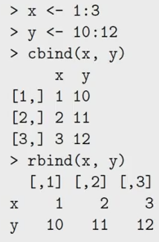

X<-list(1,”a”,TRUE,1+4i)

Is.na

Is.nan

Data.frame

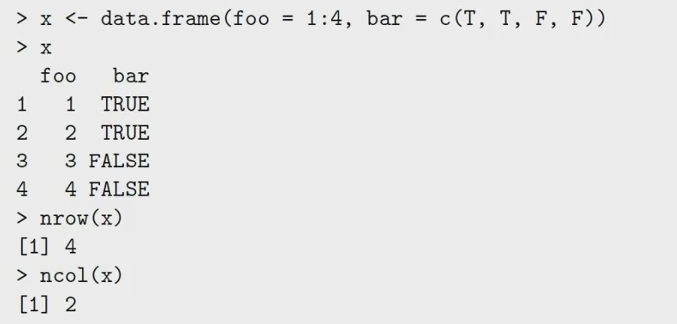

Names(x)<-c(“c1”,”c2”)

Dimnames(x)

Subset

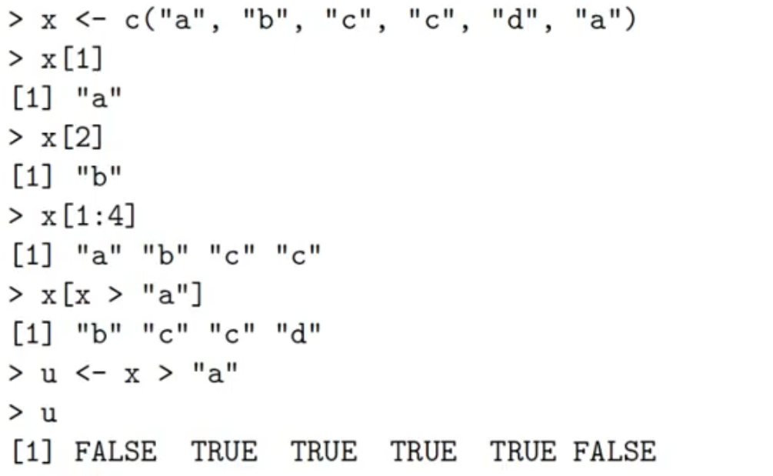

M是矩阵w<-m[which(m[,1] > 31 & m[, 2] > 90), ]

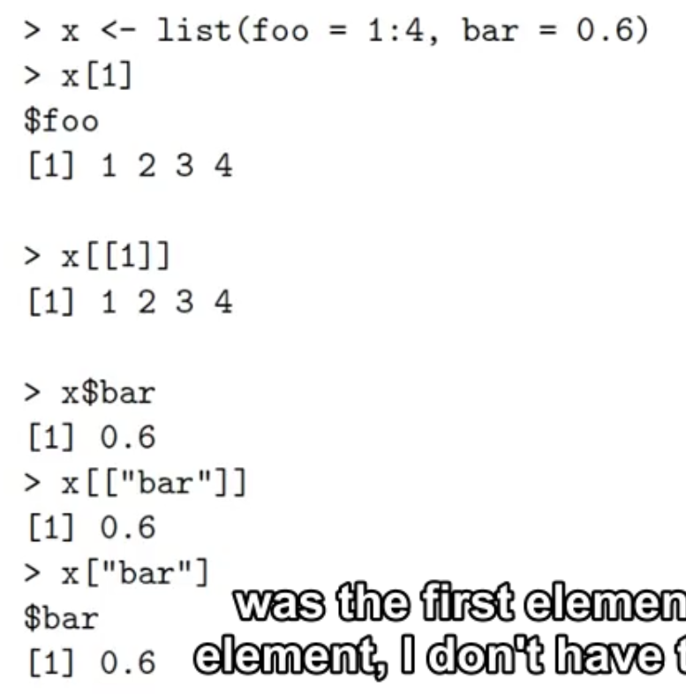

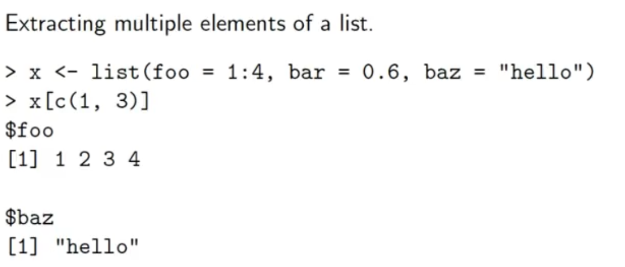

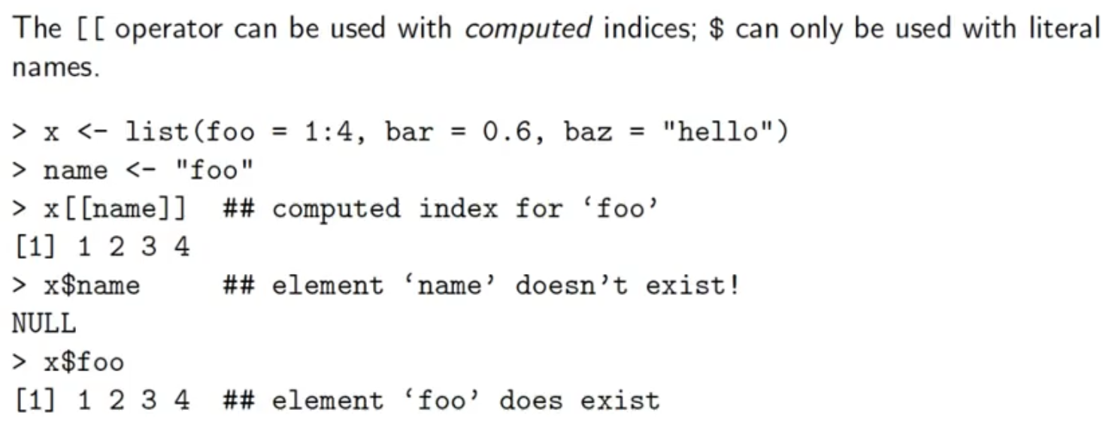

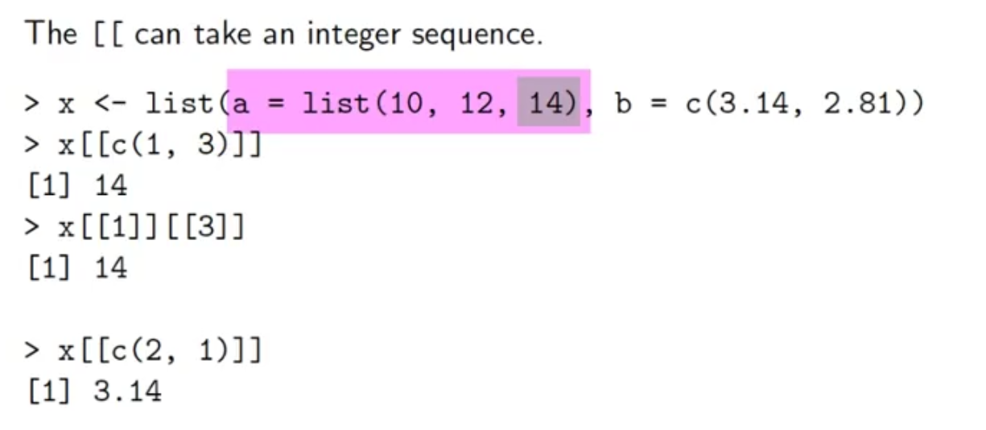

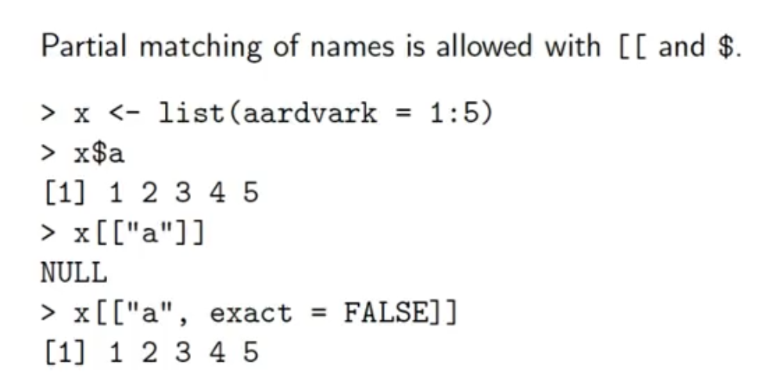

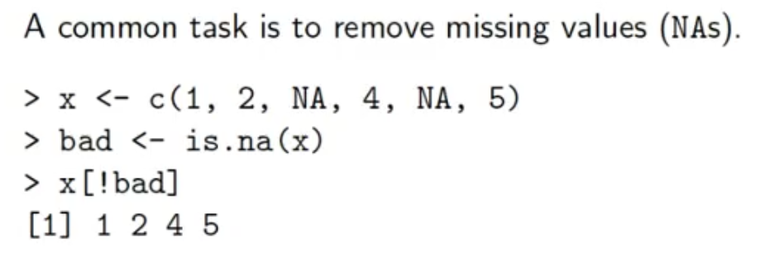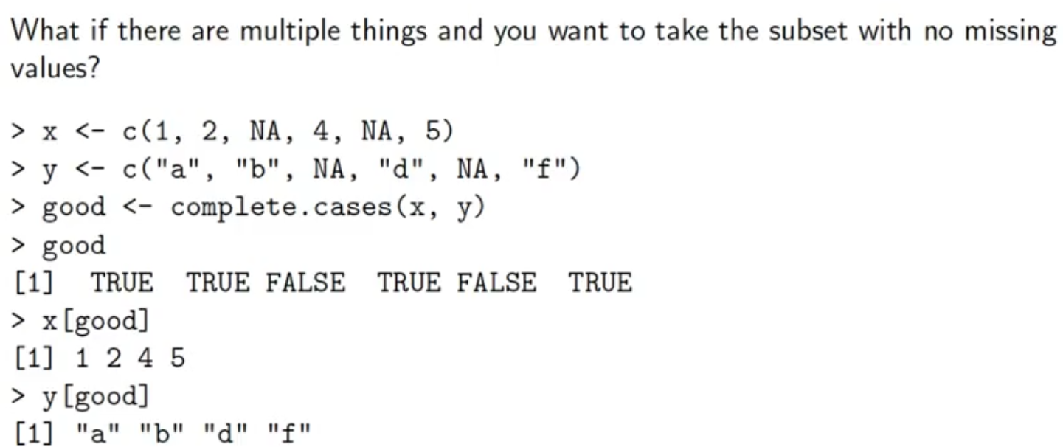

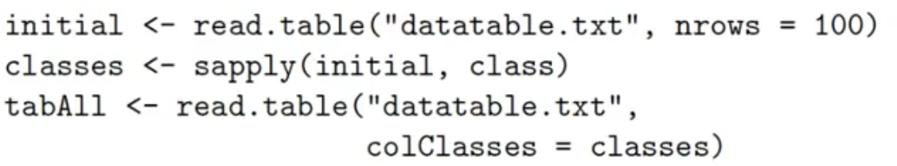

Data<-read.csv()

Getwd()

Nrow()查看矩阵rowlength

