VIETNAM GENERAL CONFEDERATION OF LABOR
TON DUC THANG UNIVERSITY
FACULTY OF INFORMATION TECHNOLOGY



HUYNH KIEN DONG DUY – 52200244
NGUYEN CHI VY – 523H0197

RESEARCH AND OPTIMIZATION OF VIETNAMESE PRINTED AND HANDWRITTEN TEXT RECOGNITION SYSTEM USING TROCR ARCHITECTURE

INFORMATION TECHNOLOGY PROJECT

HO CHI MINH CITY, 2026
VIETNAM GENERAL CONFEDERATION OF LABOR
TON DUC THANG UNIVERSITY
FACULTY OF INFORMATION TECHNOLOGY



HUYNH KIEN DONG DUY – 52200244
NGUYEN CHI VY – 523H0197

RESEARCH AND OPTIMIZATION OF VIETNAMESE PRINTED AND HANDWRITTEN TEXT RECOGNITION SYSTEM USING TROCR ARCHITECTURE

INFORMATION TECHNOLOGY PROJECT

Advised by
Assoc.Prof.Dr. Le Anh Cuong

HO CHI MINH CITY, 2026
ACKNOWLEDGEMENT
We would like to express our sincere gratitude to Assoc. Prof. Dr. Le Anh Cuong, our instructor and mentor, for his dedicated guidance throughout this Information Technology Project.
His expertise and structured direction in the fields of Computer Vision and Deep Learning have been instrumental in the development of our project on Vietnamese Printed and Handwritten Text Recognition (OCR). Through his mentorship, we have gained a profound understanding of essential OCR components, including image preprocessing, layout analysis, and advanced architectures such as CNNs for feature extraction and Transformer-based models (TrOCR) for sequence-to-sequence character recognition.
Beyond technical knowledge, his constructive feedback on model optimization, data augmentation strategies for Vietnamese handwriting, and evaluation metrics has helped us overcome significant challenges in achieving high accuracy. He has encouraged us to think critically, explore state-of-the-art research trends, and bridge the gap between theoretical algorithms and real-world eKYC or document digitization applications.
It is a great honor and privilege to learn from Assoc. Prof. Dr. Le Anh Cuong. We truly appreciate his constant support, professional expertise, and the inspiration he has provided us throughout the duration of this project.
Ho Chi Minh city, 28th April 2026
Author
(Signature and full name)
Duy
Huynh Kien Dong Duy

Vy
Nguyen Chi Vy

DECLARATION OF AUTHORSHIP
We hereby declare that this is our own project and is guided by Assoc.Prof.Dr. Le Anh Cuong; The content research and results contained herein are central and have not been published in any form before. The data in the tables for analysis, comments and evaluation are collected by the main author from different sources, which are clearly stated in the reference section.
In addition, the project also uses some comments, assessments as well as data of other authors, other organizations with citations and annotated sources.
If something wrong happens, We’ll take full responsibility for the content of my project. Ton Duc Thang University is not related to the infringing rights, the copyrights that We give during the implementation process (if any).
Ho Chi Minh city, 28th April 2026
Author
(Signature and full name)
Duy
Huynh Kien Dong Duy

Vy
Nguyen Chi Vy

RESEARCH AND OPTIMIZATION OF VIETNAMESE PRINTED AND HANDWRITTEN TEXT RECOGNITION SYSTEM USING TROCR ARCHITECTURE
ABSTRACT
Text recognition remains a fundamental challenge in document digitization, particularly for Vietnamese, where rich diacritical marks, tonal variations, and significant differences between handwritten and printed forms impose unique demands on recognition systems. Existing approaches, typically based on CNN-RNN architectures with CTC decoding, struggle to capture long-range contextual dependencies and often require fragmented, language-specific post-processing.
This work presents a unified Vietnamese text recognition framework built upon TrOCR, a Transformer-based encoder-decoder architecture combining a Vision Transformer (ViT) encoder with a RoBERTa-based autoregressive decoder. To adapt the model from its original English-centric, square-image pre-training to the wide rectangular geometry of Vietnamese text lines, we apply bicubic interpolation to reshape the ViT positional embeddings from a 24×24 grid to an 8×96 configuration, enabling a 128×1536 input resolution without discarding pre-trained spatial priors. The decoder vocabulary is extended with 254 Vietnamese-specific tokens to eliminate suboptimal byte-level fragmentation of diacritical characters.
A multi-stage curriculum training strategy is proposed to progressively increase sequence complexity: starting from isolated words, advancing through dynamically constructed pseudo-lines, and culminating in mixed-domain line-level fine-tuning with a printed data replay buffer (70% handwritten, 30% printed per batch). Elastic Weight Consolidation (EWC) with a Fisher Information Matrix computed over printed data is jointly applied during this mixed replay stage to prevent catastrophic forgetting of printed text accuracy while adapting to handwritten samples. Additional techniques including Layer-wise Learning Rate Decay (LLRD), mixed-precision training, and gradient accumulation are integrated to ensure stable convergence within a single-GPU environment.
The recognition model is embedded within a complete end-to-end OCR pipeline comprising image preprocessing (CLAHE enhancement and Hough-based deskewing), text detection (DBNet), line segmentation (DBSCAN clustering), TrOCR inference, and a multi-stage post-processing module featuring deterministic hallucination sanitization and geographic entity correction using a 10,500-entry Vietnamese administrative gazetteer.
Experimental evaluation on a combined test set of 4,477 samples across multiple Vietnamese datasets yields an overall Character Error Rate (CER) of 2.86% and Word Error Rate (WER) of 7.92%, with printed text achieving 1.17% CER and handwritten text achieving 10.57% CER. These results demonstrate that the proposed framework provides an effective and scalable solution for Vietnamese text recognition in real-world document digitization tasks.

TABLE OF CONTENT
LIST OF FIGURES xi
LIST OF TABLES xii
ABBREVIATIONS xiii
CHAPTER 1. INTRODUCTION 1
1.1 Background and Motivation 1
1.2 Research Problem 2
1.3 Research Questions and Hypothesis 2
1.3.1 Research Questions 2
1.3.2 Hypothesis 3
1.4 Research Objectives 3
1.5 Scope of Study 4
CHAPTER 2. RELATED WORKS 5
2.1 CNN-RNN Based Methods 5
2.2 OCR Frameworks and Practical Systems 5
2.3 Transformer-based Approaches 6
2.4 Vietnamese Text Recognition Challenges 6
2.5 Language Models for Post-processing 7
2.6 Research Gap 7
CHAPTER 3. PROPOSED METHODOLOGY 8
3.1 Overview of the Proposed Pipeline 8
3.2 Step 1: Image Preprocessing 8
3.3 Step 2: Text Detection 9
3.4 Step 3: Line Segmentation 9
3.5 Step 4: Text Recognition 10
3.6 Step 5: Deterministic and Language-based Post-processing 10
CHAPTER 4. EXPERIMENTAL SETUP 12
4.1 Datasets 12
4.1.1 Handwritten Datasets 12
4.1.2 Printed Text Datasets 12
4.1.3 Data Integration and Standardization 13
4.1.4 Synthetic Printed Data Generation 14
4.1.5 Dataset Splitting Strategy 15
4.1.6 Final Data Representation 16
4.2 Data Preprocessing 16
4.2.1 Overview 16
4.2.2 Aspect-Ratio-Aware Image Normalization 18
4.2.3 Synthetic Printed Vietnamese Data Generation 18
4.2.4 Pseudo-Line Generation for Handwritten Text 22
4.2.5 Task-Specific Data Handling 23
4.2.6 Curriculum-Based Data Construction 23
4.2.7 LMDB-Based Data Storage 23
4.2.8 Mixed Sampling Strategy 24
4.2.9 Data Augmentation Strategy 24
4.3 Model Configuration 25
4.3.1 Backbone Architecture 25
4.3.2 Tokenizer and Vocabulary Extension 26
4.3.3 Decoding Strategy 26
4.3.4 ViT Positional Embedding Interpolation 27
4.3.5 Multi-stage Training Configuration 27
4.4 Training Setup 27
4.4.1 Training Environment and Reproducibility 28
4.4.2 Stage 1: Curriculum Learning from Word to Pseudo-line 28
4.4.3 Stage 2a: Printed Line Fine-tuning 29
4.4.4 Stage 2b Mixed Training with Replay and EWC 29
4.4.5 Stage 3: Paragraph-level Adaptation 30
4.4.6 Optimization and Training Details 31
4.5 Training Strategy & Optimization 31
4.5.1 Layer-wise Learning Rate Decay (LLRD) 32
4.5.2 Learning Rate Scheduling 33
4.5.3 Mixed Precision Training (AMP) 33
4.5.4 Gradient Accumulation 34
4.5.5 Gradient Clipping 34
4.5.6 Elastic Weight Consolidation (EWC) 35
4.5.7 Early Stopping Mechanism 36
4.6 Evaluation Metrics 36
4.6.1 Character Error Rate (CER) 36
4.6.2 Word Error Rate (WER) 37
4.6.3 Dual-Domain Evaluation Strategy 37
4.6.4 Implementation Details 38
4.7 Baseline Models and Ablation Strategy 38
4.7.1 External Baselines 38
4.7.2 Post-Processing Ablation 39
4.7.3 Training-Stage Progression Analysis 39
4.8 Experimental Design 40
4.8.1 Evaluation Protocol 41
4.8.2 Evaluation Consistency 41
4.8.3 Evaluation Metrics and Reporting 41
4.8.4 Ablation Study Design 42
4.8.5 Computational Efficiency Evaluation 42
4.8.6 Robustness Evaluation 43
4.8.7 Summary 43
4.9 System Implementation and Deployment 43
CHAPTER 5. RESULTS AND DISCUSSION 45
5.1 Overall Performance 45
5.2 External Baseline Comparison 45
5.3 Training Convergence Analysis 47
5.3.1 Stage 1: Curriculum Word-to-Pseudo-line (20 epochs) 48
5.3.2 Stage 2a: Printed Line Fine-tuning (11 epochs) 49
5.3.3 Stage 2b: Mixed Handwritten + Printed Replay with EWC (17 epochs) 49
5.4 Post-Processing Pipeline Ablation 50
5.5 Error Distribution Analysis 52
5.6 Computational Efficiency And Training Time 53
5.7 System Demonstration and User Interface 55
5.7.1 Interface Overview 55
5.7.2 OCR Pipeline Visualization 56
5.7.3 Final Inference Example 60
5.8 Discussion 60
5.8.1 Effectiveness of the Multi-Stage Training Strategy 60
5.8.2 Effectiveness of EWC Against Catastrophic Forgetting 60
5.8.3 Role of Deterministic Post-Processing 61
5.8.4 The Printed-Handwritten Performance Gap 61
CHAPTER 6. ERROR ANALYSIS 62
6.1 Overview of the Worst-Case Samples 62
6.2 Error Type Categorization 63
6.2.1 Substitution Errors (Most Dominant) 63
6.2.2 Hallucination Loop Errors 64
6.2.3 Truncation Errors 65
6.3 Pipeline Performance Analysis 65
6.3.1 Raw Model Performance 66
6.3.2 Effect of Sanitization 66
6.3.3 Effect of PhoBERT Correction 67
6.4 Handwritten vs Printed Text Performance 67
6.5 Root Cause Analysis 67
6.6 Conclusion 68
CHAPTER 7. CONCLUSION AND FUTURE WORK 69
7.1 Conclusion of the Study 69
7.2 Answers to Research Questions 69
7.3 Future work 71
REFERENCES 73

LIST OF FIGURES
Figure 1.1 Examples of handwritten Vietnamese text with complex diacritics and writing styles. 1
Figure 3.1 Overview of the propose Vietnamese text recognition pipeline 8
Figure 4.1 Training pipeline overview 32
Figure 5.1 CER convergence across training stages 47
Figure 5.2 Training loss convergence 47
Figure 5.3 WER convergence across training stages 48
Figure 5.4 Training runtime per epoch 55
Figure 5.5 Overview of the Vietnamese OCR demonstration interface 56
Figure 5.6 Step 1: CLAHE preprocessing and deskew correction 57
Figure 5.7 Step 2: Text region detection using DBNet 57
Figure 5.8 Step 3: Line segmentation using DBSCAN clustering 58
Figure 5.9 Step 4: Handwritten text recognition using the TrOCR model 59
Figure 5.10 Step 5: Deterministic post-processing and output refinement 59
Figure 5.11 Final handwritten OCR inference result 60

LIST OF TABLES
Table 4.1 Summary of datasets used in this study 14
Table 4.2 Image Dimension Filtering Thresholds 17
Table 4.3 Summary of Corpus Domain 20
Table 5.1 Final performance of the proposed Vietnamese TrOCR system 45
Table 5.2 Multi-tier baseline comparison on Vietnamese OCR 46
Table 5.3 Stage 1 curriculum training progression 48
Table 5.4 Stage 2a printed CER progression (selected epochs) 49
Table 5.5 Stage 2b handwritten CER progression 50
Table 5.6 Post-processing pipeline evolution (V1 → V3) 51
Table 5.7 pipeline stage-by-stage CER ablation 51
Table 5.8 Error category distribution 52
Table 5.9 CER distribution across all samples 53
Table 5.10 Computational efficiency comparison 53
Table 5.11 Training runtime per stage 54
Table 6.1 Error Category Distribution Statistics 63

ABBREVIATIONS
Abbreviation | Full Form
AMP | Automatic Mixed Precision
APE | Absolute Positional Embedding
BOS | Beginning of Sequence
BPE | Byte Pair Encoding
CER | Character Error Rate
CLAHE | Contrast Limited Adaptive Histogram Equalization
CRNN | Convolutional Recurrent Neural Network
CTC | Connectionist Temporal Classification
DBSCAN | Density-Based Spatial Clustering of Applications with Noise
DBNet | Differentiable Binarization Network
EOS | End of Sequence
EWC | Elastic Weight Consolidation
FP16 | Half-Precision Floating Point (16-bit)
FPS | Frames Per Second
GPU | Graphics Processing Unit
IIT-CDIP | IIT Complex Document Information Processing
LMDB | Lightning Memory-Mapped Database
LLRD | Layer-wise Learning Rate Decay
MLM | Masked Language Model
NFC | Unicode Normalization Form Composed
NLP | Natural Language Processing
OCR | Optical Character Recognition
RoBERTa | Robustly Optimized BERT Approach
ViT | Vision Transformer
VRAM | Video Random Access Memory
WER | Word Error Rate

INTRODUCTION

Background and Motivation
In the era of digital transformation, digitizing archived documents and personal records plays a pivotal role in building intelligent management systems. However, Vietnamese text recognition, particularly for both handwritten and printed text, remains a significant challenge due to the linguistic complexity of tone marks, high character stroke connectivity, and the diversity in writing styles.
Most existing approaches rely on traditional architectures such as CRNN combined with CTC, which often struggle to capture long-range dependencies and complex visual patterns. In addition, available Vietnamese datasets are typically fragmented and lack standardization, limiting the generalization ability of current models. Despite recent advances in Transformer-based methods, their effectiveness for Vietnamese text recognition, especially in a unified setting for both handwritten and printed text, has not been fully explored.
Motivated by these challenges, this study investigates the effectiveness of the Transformer-based architecture TrOCR for Vietnamese text recognition, aiming to evaluate its capability in modeling contextual information and improving recognition performance across diverse text types.
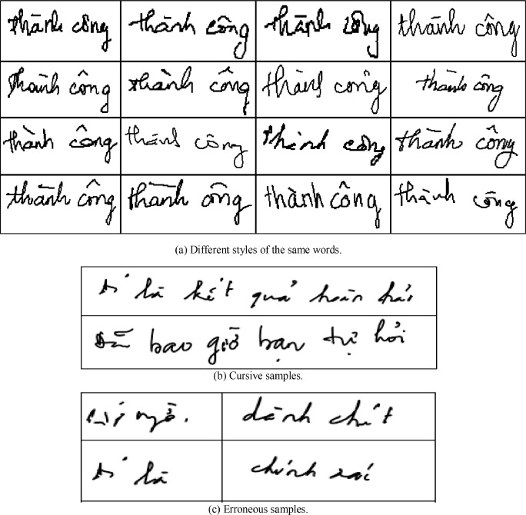
Figure 1.1 Examples of handwritten Vietnamese text with complex diacritics and writing styles.

Research Problem
Despite recent advances in optical character recognition, Vietnamese text recognition remains a challenging problem. The difficulty arises from several factors, including the complex system of diacritics, high variability in handwriting styles, and the presence of both handwritten and printed text in real-world documents.
Existing approaches, primarily based on CNN-RNN architectures such as CRNN combined with CTC, have shown effectiveness in structured and clean text scenarios. However, these methods often struggle to capture long-range contextual dependencies and are less robust when dealing with irregular layouts or highly variable handwriting. In addition, the lack of large-scale, standardized Vietnamese datasets further limits the performance and generalization capability of current models.
While Transformer-based models have demonstrated strong performance in various vision and language tasks, their application to Vietnamese text recognition, particularly in a unified framework that handles both handwritten and printed text, remains underexplored.

Research Questions and Hypothesis

Research Questions
RQ1: To what extent can a fine-tuned TrOCR model, with Vietnamese-specific tokenizer adaptation and positional embedding interpolation, outperform established Vietnamese OCR systems (VietOCR, CRNN+CTC) on printed and handwritten text recognition?
RQ2: How effective is a multi-stage curriculum training strategy — progressing from isolated words through pseudo-lines to real line-level data — in preparing the decoder's positional embeddings for Vietnamese line-level text recognition?
RQ3: To what extent can Elastic Weight Consolidation (EWC) combined with mixed replay sampling prevent catastrophic forgetting of printed text accuracy during handwritten text adaptation?
RQ4: What is the relative contribution of each post-processing stage (deterministic sanitization, geographic entity correction, and language model rescoring) to the final recognition accuracy, and under what conditions does language model rescoring become counterproductive?
RQ5: What are the practical trade-offs between recognition accuracy and computational efficiency when deploying Transformer-based OCR compared to traditional architectures in resource-constrained environments?

Hypothesis
H1: TrOCR with Vietnamese-specific adaptation achieves significantly lower CER and WER than VietOCR and CRNN+CTC baselines on both printed and handwritten Vietnamese text.
H2: Curriculum training with pseudo-line progression provides empirical evidence of staged CER improvement that would not be achievable without the progressive word-to-line transition.
H3: EWC with mixed replay limits printed CER degradation to within 2 percentage points during handwritten adaptation.
H4: Deterministic post-processing (RegexSanitizer + AddressCorrector) improves overall CER, while PhoBERT MLM rescoring degrades CER at the current output quality level.
H5: TrOCR achieves superior accuracy at the cost of higher computational requirements compared to lighter architectures.

Research Objectives
Investigate the effectiveness of Transformer-based architectures, particularly TrOCR, for Vietnamese text recognition tasks.
Compare the performance of TrOCR with traditional approaches such as CRNN+CTC under consistent experimental conditions.
Evaluate the capability of a unified model in handling both handwritten and printed Vietnamese text.
Analyze the impact of dataset standardization on model generalization and performance.
Examine the trade-off between recognition accuracy (CER, WER) and computational efficiency (e.g., inference speed, resource consumption).

Scope of Study
This study focuses on line-level Vietnamese text recognition, covering both handwritten and printed text. More complex scenarios, such as document layout analysis, mathematical expressions, or technical drawings, are beyond the scope of this work.
The research is limited to the Vietnamese language, including its full system of diacritics and special characters, without extending to multilingual settings.
In terms of evaluation, the study considers both recognition accuracy and computational efficiency under practical hardware constraints, aiming to ensure applicability in real-world scenarios with limited computational resources.

RELATED WORKS

CNN-RNN Based Methods
Traditional optical character recognition (OCR) systems are predominantly based on convolutional and recurrent neural network architectures. A representative approach is the Convolutional Recurrent Neural Network (CRNN) combined with Connectionist Temporal Classification (CTC), where convolutional layers are used for feature extraction and recurrent layers model the sequential nature of text. CTC enables alignment-free sequence prediction, making it suitable for variable-length text recognition tasks.
These methods have demonstrated strong performance in structured and relatively clean text scenarios due to their computational efficiency and simplicity. However, they are inherently limited in capturing long-range dependencies and global contextual information. As a result, their performance degrades when applied to complex handwritten text, irregular layouts, or languages with rich diacritics such as Vietnamese.

OCR Frameworks and Practical Systems
In practical applications, end-to-end OCR frameworks such as PaddleOCR and VietOCR have been widely adopted. PaddleOCR integrates multiple components, including text detection, orientation classification, and text recognition, and supports various backbone architectures such as DBNet for detection and SVTR for recognition. Its modular design and efficiency make it suitable for real-world deployment scenarios.
Similarly, VietOCR is designed specifically for Vietnamese text recognition, incorporating convolutional feature extraction and Transformer-based sequence modeling. It demonstrates strong performance on Vietnamese datasets, particularly for printed text and moderately complex handwriting.
Despite their effectiveness, these frameworks typically rely on multi-stage pipelines and are primarily optimized for printed or semi-structured text. Their ability to capture deep contextual relationships remains limited, and performance often deteriorates in challenging handwritten scenarios.

Transformer-based Approaches
Recent advances in deep learning have introduced Transformer-based architectures for OCR tasks. Models such as TrOCR adopt an encoder–decoder framework, where a Vision Transformer (ViT) encodes the input image into a sequence of visual tokens, and a Transformer-based decoder generates the corresponding text sequence.
By leveraging self-attention mechanisms, Transformer-based models are capable of capturing global contextual dependencies across the entire input, enabling more robust recognition of complex text patterns. Furthermore, these models can be pre-trained on large-scale synthetic datasets and fine-tuned on domain-specific data, significantly improving performance.
However, Transformer-based approaches typically require higher computational resources and are less efficient compared to traditional CNN-based methods. Additionally, their application to low-resource languages and domain-specific scenarios, such as Vietnamese handwritten text, has not been extensively explored.

Vietnamese Text Recognition Challenges
Vietnamese text recognition presents unique challenges due to linguistic and data-related factors. The Vietnamese writing system includes a rich set of diacritics, where a single character may contain multiple accent marks, increasing the complexity of character representation. In handwritten text, variations in writing styles, stroke connectivity, and spacing further complicate recognition tasks.
Moreover, existing Vietnamese OCR datasets are often fragmented, collected from different sources, and lack standardization in annotation formats. This fragmentation limits the ability of models to generalize effectively across diverse real-world scenarios. As a result, building a robust and unified OCR system for Vietnamese text remains an open challenge.

Language Models for Post-processing
To improve recognition accuracy, especially in languages with complex morphology, language models are often employed as a post-processing step. PhoBERT, a pre-trained Transformer-based language model for Vietnamese, has demonstrated strong performance in capturing contextual and semantic relationships within text.
By leveraging contextual embeddings, language models can correct errors generated by OCR systems, particularly those related to diacritics and ambiguous characters. However, this introduces additional computational overhead and increases system complexity, requiring careful integration with the OCR pipeline.

Research Gap
Despite significant progress in OCR technologies, several limitations remain in the context of Vietnamese text recognition. Traditional CNN-RNN architectures struggle to capture long-range contextual dependencies, while existing OCR frameworks are primarily optimized for printed text and rely on complex multi-stage pipelines. Although Transformer-based models such as TrOCR have shown promising results, their effectiveness in handling Vietnamese text, particularly in a unified framework that supports both handwritten and printed data, has not been fully explored.
In addition, the lack of standardized Vietnamese datasets further restricts model generalization and fair comparison across different approaches. These challenges highlight the need for a unified, context-aware OCR framework that leverages Transformer architectures while addressing the limitations of existing methods.

PROPOSED METHODOLOGY

Overview of the Proposed Pipeline
This study proposes an end-to-end pipeline for Vietnamese text recognition, designed to handle both handwritten and printed text in real-world scenarios. The pipeline consists of several stages, including image preprocessing, text detection, line segmentation, text recognition, and deterministic post-processing (note: an experimental PhoBERT language model was evaluated but empirically disabled in the final system; see Section 3.6). Each component is designed to address specific challenges in Vietnamese OCR, particularly the presence of diacritics, handwriting variability, and irregular text layouts.
The complete inference pipeline operates within ~900 MB GPU VRAM (FP16), making it deployable on consumer-grade GPUs such as NVIDIA T4 (16 GB).
Prior to training, raw data from seven heterogeneous sources is processed through a unified data standardization pipeline that performs dataset parsing, Unicode NFC normalization, language-based filtering (removing non-Vietnamese scripts including CJK, Khmer, and Cyrillic characters), dimension-based outlier removal, and domain-separated LMDB export.
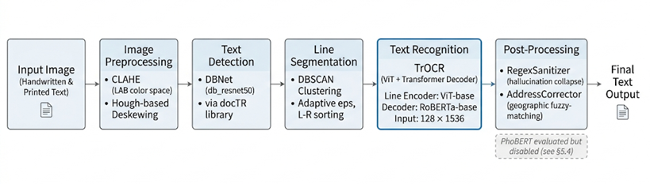
Figure 3.1 Overview of the propose Vietnamese text recognition pipeline

Step 1: Image Preprocessing
In the first stage, input images are preprocessed to enhance visual quality and improve recognition performance. Specifically, Contrast Limited Adaptive Histogram Equalization (CLAHE) is applied to enhance local contrast while preserving fine details. CLAHE is applied to the L-channel of the LAB color space with clip_limit=2.0 and tile_size=8×8, then converted back to RGB. In addition, a deskewing technique based on the Hough Line Transform is used to correct image orientation.
These preprocessing steps help mitigate common issues such as uneven illumination, shadows, and tilted text, which are frequently observed in handwritten documents and real-world image captures.

Step 2: Text Detection
For text detection, this study employs the DBNet architecture (db_resnet50) via the docTR library for text detection. DBNet uses a differentiable binarization module to generate accurate text boundary maps from a ResNet-50 backbone. DBNet provides efficient detection of continuous text lines and handles curved or tilted text with faster inference speed.
The text detection model is provided by the docTR library (python-doctr), using the pre-trained db_resnet50 architecture. The model outputs relative bounding box coordinates with confidence scores; detections below a confidence threshold of 0.3 are discarded.

Step 3: Line Segmentation
The detected text regions are subsequently grouped into individual text lines using the DBSCAN clustering algorithm based on the vertical center coordinates of the detected bounding boxes. This clustering strategy helps organize scattered word or character regions into coherent text lines without requiring a predefined number of lines. To improve adaptability across different document layouts and handwriting styles, the clustering radius parameter (eps) is dynamically computed as half of the median height of all detected bounding boxes. As a result, the method can automatically adjust to variations in text scale, character size, and writing density.
After clustering, all bounding boxes within the same group are sorted from left to right to preserve the natural reading order of the text. This ordering step is essential for reconstructing complete sentences and ensuring accurate downstream OCR recognition. In addition, the proposed segmentation approach is robust against common challenges in handwritten Vietnamese documents, such as uneven spacing, slightly curved writing, and inconsistent line alignment. By combining adaptive clustering with spatial ordering, the system can effectively segment both handwritten and printed text lines while maintaining high structural consistency for the recognition stage.

Step 4: Text Recognition
The core component of the proposed system is the TrOCR model, a Transformer-based architecture that performs end-to-end text recognition. It consists of a Vision Transformer (ViT) encoder for extracting visual features and a Transformer-based decoder for generating text sequences. During inference, a repetition penalty of 1.2 is applied to suppress the autoregressive decoder's tendency to fall into hallucination loops on high-uncertainty inputs.
Unlike traditional CNN-RNN-based methods, TrOCR leverages self-attention mechanisms to capture global contextual dependencies across the entire text line. This enables more robust recognition, particularly for complex handwritten text with irregular spacing and character variations.
To evaluate its effectiveness, TrOCR is compared with two external baselines: (1) VietOCR (VGG-Transformer), a domain-specific Vietnamese OCR system with pre-trained Vietnamese weights, and (2) CRNN+CTC (VGG+BiLSTM+CTC), which establishes the architectural lower-bound without Vietnamese-specific pre-training.

Step 5: Deterministic and Language-based Post-processing
To further refine recognition accuracy and mitigate the specific failure modes of the TrOCR architecture, a multi-stage post-processing pipeline is applied.
Deterministic Sanitization: The TrOCR greedy decoder occasionally falls into hallucination loops when encountering high uncertainty, producing infinitely repetitive character sequences. To mitigate this, a deterministic Regex Sanitizer is applied to all raw predictions. This module collapses excessive character repetitions (reducing 4+ consecutive identical characters to a maximum of 3 to preserve valid ellipses) and word-level loops (reducing 3+ identical tokens to 2).
Geographic Entity Correction: A specialized Address Corrector module was developed to refine the recognition of Vietnamese administrative divisions, which often suffer from minor character substitutions. Utilizing a comprehensive gazetteer containing over 10,500 provinces, districts, and wards, the module extracts geographic context using administrative keywords. It employs a 'skip-if-valid' rule to preserve correctly recognized entities and applies Levenshtein distance fuzzy-matching strictly within the detected province scope to correct OCR misspellings.
PhoBERT Rescoring Evaluation: An experimental module using the PhoBERT language model was additionally evaluated to refine linguistic outputs. However, empirical testing on the validation set revealed that PhoBERT Masked Language Modeling (MLM) rescoring acted as a net negative for this specific domain (hurting 6.6 times more samples than it helped). The model frequently 'corrected' valid named entities and alphanumeric codes into common vocabulary words. Consequently, PhoBERT was disabled in the final production pipeline in favor of the deterministic sanitization and domain-specific address correction modules.

EXPERIMENTAL SETUP

Datasets
This study utilizes a large-scale and diverse collection of Vietnamese text datasets, including both handwritten and printed data from multiple real-world and synthetic sources. The datasets are aggregated and standardized into a unified format to support training and evaluation of the proposed OCR system.

Handwritten Datasets
The handwritten data consists of three primary sources:
- UIT-HWDB: A large-scale Vietnamese handwriting dataset containing word-, line-, and paragraph-level samples collected from 249 writers. This dataset provides over 110,000 word images and preserves writer identity, enabling writer-independent evaluation.
- Cinnamon AI Dataset: A challenging dataset of handwritten Vietnamese addresses, characterized by highly cursive writing styles, complex layouts, and significant background noise.
- Viet-Wiki-Handwriting: A synthetic dataset generated from Vietnamese Wikipedia text using handwriting-like fonts. This dataset provides large vocabulary coverage and helps improve language modeling capabilities.
These datasets collectively capture a wide range of handwriting styles, from clean to highly distorted text, ensuring robustness in real-world scenarios.

Printed Text Datasets
The printed text data includes:
- VinText: A dataset of natural scene text images with diverse layouts, including curved, rotated, and perspective-distorted text instances.
- Vietnamese Receipts (MC-OCR 2021): Real-world receipt images containing noisy backgrounds, low-quality printing, and complex formatting.
- Anyuuus OCR Dataset: A large-scale collection of clean printed text lines, suitable for pre-training and learning basic Vietnamese language patterns.
These datasets provide a combination of structured and unstructured printed text under varying imaging conditions.

Data Integration and Standardization
To address the fragmentation of Vietnamese OCR datasets, all data sources are processed through a unified data pipeline. This includes:
- Converting images to a consistent RGB format
- Normalizing text labels using Unicode NFC
- Standardizing annotation formats into a unified CSV schema
- Merging datasets into a centralized storage structure
The final dataset supports multiple levels of granularity, including word-level and line-level recognition, for both handwritten and printed text.
To provide a comprehensive overview of the datasets used in this study, a summary is presented in Table 4.1.
Dataset | Type | Level | Size | Source
UIT-HWDB | Handwritten | word / line / paragraph | ~110,000 (word), ~7,000 (line), ~1,000 (paragraph) | Public dataset (UIT)
Cinnamon AI | Handwritten | line | ~2,385 | Cinnamon AI dataset
Viet-Wiki-Handwriting | Synthetic (handwritten-like) | paragraph | ~5,796 | Generated from Vietnamese Wikipedia (Hugging Face)
VinText | Printed | word | ~43,100 (25,776 train, ~7,220 val, ~10,086 test) extracted from over 2,000 original images. | VinText dataset
MC-OCR 2021 (Receipts) | Printed | line | ~6,585 | Vietnamese Receipts dataset
Anyuuus OCR | Printed | line | ~28,315 raw → ~18,116 after filtering | Collected OCR dataset (PaddleOCR-based)
Table 4.1 Summary of datasets used in this study
As shown in Table 4.1, the dataset covers both handwritten and printed Vietnamese text with varying levels of complexity, ranging from word-level to paragraph-level annotations. This diversity enables a comprehensive evaluation of the proposed model under different real-world scenarios.

Synthetic Printed Data Generation
To address the imbalance and domain bias in the printed text datasets, a synthetic data generation pipeline is introduced to create a large-scale corpus of modern Vietnamese printed text images.
A significant portion of the original printed data originates from historical documents (e.g., Anyuuus dataset), which biases the model toward outdated linguistic styles. This negatively affects generalization to modern Vietnamese text.
To mitigate this issue, more than 30,000 synthetic printed text line images are generated using a dedicated pipeline (see Section 4.2.3).
After integration, the dataset composition is rebalanced as follows:
- Historical Vietnamese text: ~34%
- Real-world OCR data: ~10%
- Synthetic modern printed text: ~56%
This significantly improves linguistic diversity and reduces bias toward historical text.

Dataset Splitting Strategy
To ensure fair evaluation and avoid data leakage, different splitting strategies are applied:
- Writer-independent split is used for handwritten datasets (e.g., UIT-HWDB): writers with ID 1–229 are assigned to the training set, writers 230–249 to the validation set, and writers 250–255 to the test set, following the original dataset partition.
- Group-based split: For the Anyuuus OCR dataset, a document-level group split is applied, ensuring that all text lines extracted from the same source document remain within the same subset. The split ratio is 80/10/10 based on unique document identifiers.
- For synthetic datasets, two different split strategies are applied based on their role in training. The Viet-Wiki-Handwriting dataset uses a standard random split of 80/10/10 (train/validation/test). The Synthetic Modern Printed dataset uses a 90/5/5 split to maximize the amount of modern linguistic data available for training, thereby diluting the historical text bias from other printed sources such as the Anyuuus dataset.
All random operations are performed with a fixed seed to ensure reproducibility.

Final Data Representation
After completing all preprocessing and annotation steps, the datasets are converted into LMDB (Lightning Memory-Mapped Database) format to support efficient data loading and large-scale training with the TrOCR model. LMDB is selected because it provides fast sequential access, reduced disk I/O overhead, and better memory efficiency compared to traditional image-folder storage. This format is particularly suitable for OCR training, where the model frequently accesses a large number of image-text pairs during each training epoch.
To support different recognition tasks and experimental settings, the datasets are organized into multiple subsets. Separate LMDB databases are maintained for handwritten and printed Vietnamese text in order to preserve the characteristics of each domain. In addition, the data are further divided into word-level and line-level recognition datasets, allowing the system to learn both short text patterns and longer contextual sequences.
This structured dataset design enables flexible training strategies such as staged pretraining, domain adaptation, and task-specific fine-tuning. For example, the model can first be trained on printed text data before being adapted to handwritten Vietnamese text, improving recognition robustness and generalization capability. Furthermore, maintaining separate representations also simplifies evaluation and comparison between different OCR settings and recognition levels.

Data Preprocessing

Overview
To ensure data quality and improve model generalization, a comprehensive preprocessing pipeline is designed for both printed and handwritten Vietnamese text. The preprocessing stage addresses key challenges such as:
- Variability in image resolution and aspect ratio
- Background noise and illumination inconsistency
- Fragmented word-level annotations
- Differences between printed and handwritten text distributions
The data processing pipeline consists of four main stages: dataset parsing, data splitting, outlier filtering, and LMDB export.
In addition to normalization, a filtering stage is applied to remove noisy samples before training. This includes:
- Language filtering based on valid Vietnamese Unicode ranges: A Unicode-based whitelist comprising 10 character ranges is used to validate text labels. Only characters within the ASCII printable range, Latin-1 Supplement, Latin Extended-A/B, Latin Extended Additional (covering all 134 Vietnamese diacritics), General Punctuation, and selected currency/superscript symbols are retained. Labels containing characters from non-Vietnamese scripts — including CJK ideographs, Khmer, Thai, Cyrillic, IPA extensions, and Fullwidth forms — are removed along with their corresponding images. This filtering step is executed before dimension filtering to avoid unnecessary image I/O operations.
- Image dimension filtering to remove extreme aspect ratios and low-quality samples
Level | Parameter | Threshold
Word | Minimum width / height | 10 px
Word | Maximum height | 300 px
Word | Aspect ratio (W/H) | 0.3 – 25.0
Line | Minimum width | 32 px
Line | Minimum height | 16 px
Line | Maximum height / width | 384 px / 3000 px
Line | Minimum aspect ratio | ≥ 1.0 (landscape only)
Table 4.2 Image Dimension Filtering Thresholds
These filtering steps improve dataset consistency, reduce noise, and help stabilize model training.
After preprocessing, the cleaned datasets are converted into LMDB format, which enables efficient large-scale training with fast random access.

Aspect-Ratio-Aware Image Normalization
Instead of enforcing a square input resolution, the preprocessing pipeline adopts a rectangular input representation of size 128 × 1536, which better reflects the natural aspect ratio of Vietnamese text lines. To preserve compatibility with the Vision Transformer (ViT) architecture, the positional embeddings are bicubic-interpolated from the original 24 × 24 grid to a 8 × 96 grid, corresponding to the new patch layout. Images are stored in LMDB in their original resolution and are not resized during data export. All resizing operations are handled explicitly during model input processing.
This preprocessing is implemented as the resize_for_vit() function, which (1) computes a uniform scale factor to fit the image within 128×1536 while preserving aspect ratio, (2) applies bicubic resize, and (3) pads to the exact target size with the median pixel value of the original image, with content aligned to the top-left corner.
Unlike standard TrOCR preprocessing, automatic resizing in the image processor is explicitly disabled (processor.image_processor.do_resize = False) to prevent unintended distortion of the input.
This design ensures that long text sequences are preserved without excessive compression, which is critical for accurate recognition of Vietnamese diacritics, spacing, and character connectivity.

Synthetic Printed Vietnamese Data Generation
To address the imbalance in textual style and improve the generalization capability of the OCR decoder, a synthetic data generation pipeline is introduced to create a large-scale dataset of modern printed Vietnamese text images.
The original training data in Stage 2a is dominated by historical Vietnamese text (approximately 77%), which biases the model toward outdated linguistic patterns. This issue is particularly harmful for real-world OCR applications that require recognition of contemporary language usage. To mitigate this, a synthetic dataset of over 30,000 printed text line images is generated: The underlying text corpus contains approximately 8,000–15,000 unique sentences. Each sentence is rendered multiple times with different fonts and augmentations, following a corpus-cycling strategy that maximizes textual diversity for the decoder while still providing visual variety.
- Corpus Construction
The synthetic pipeline prioritizes text diversity over image diversity, based on the insight that the decoder primarily learns linguistic patterns. A large corpus of Vietnamese sentences is constructed from multiple sources:
- Vietnamese Wikipedia articles: 80 curated seed articles spanning diverse topics (geography, history, politics, economy, education, science, culture, law) are fetched via the MediaWiki API, and sentences are automatically extracted and cleaned using quality filters (minimum length, Vietnamese character ratio, reference removal).
- Manually curated domain-specific sentences, including:
- Legal and administrative documents
- News and current events
- Education and academic content
- Business and financial text
- Everyday communication
- Science and technology
- Numeric and structured text (dates, prices, IDs)
- Programmatically generated data:
- Vietnamese addresses
- Personal names and structured records
Source | Approx. Sentences | Role
Vietnamese Wikipedia (80 articles) | 8,000–15,000 | Primary corpus, maximum diversity
Legal & Administrative | ~57 | Government document patterns
News & Current Events | ~32 | Journalistic language
Education & Academic | ~21 | University/degree terminology
Business & Financial | ~19 | Contracts, invoices, reports
Everyday Communication | ~13 | Casual language, food, culture
Science & Technology | ~10 | AI/CS terminology
Numeric & Structured | ~19 | Dates, prices, IDs, measurements
Generated Addresses | ~500 | Street/ward/district patterns
Generated Name Records | ~200 | Title/name/position combinations
Table 4.3 Summary of Corpus Domain
To ensure compatibility with TrOCR input constraints and preserve textual diversity, all text is first normalized using Unicode NFC to maintain Vietnamese diacritics. Instead of discarding sentences that exceed the maximum length, they are split at natural linguistic boundaries. This splitting algorithm attempts 13 break patterns in priority order, starting with commas and common Vietnamese conjunctions (và, hoặc, nhưng, theo, với), before falling back to semicolons and dashes. Finally, resulting segments shorter than 8 characters are discarded to avoid degenerate training samples.

- Synthetic Image Rendering
Text images are generated using the Pillow library with multiple variations to simulate real-world printed text conditions. For each text sample:
- A random font is selected from a pool of 30 .ttf font files spanning 14 Vietnamese-supported font families, including both serif and sans-serif typefaces (e.g., Roboto, Noto Sans, Noto Serif, Be Vietnam Pro, Montserrat). Multiple weight and style variants (Regular, Bold, Italic) within each family increase visual diversity.
- Font size is randomly sampled within a predefined range
- Text is rendered with adaptive width while maintaining a fixed height: Each image is rendered at a fixed height of 64 pixels with adaptive width, using font sizes randomly sampled between 28 and 48 points. Images narrower than 64 pixels or wider than 2,400 pixels are discarded. Horizontal and vertical padding of 12 px and 8 px respectively is applied around the rendered text.
The generation process ensures high variability in visual appearance while preserving textual integrity.
- Data Augmentation
To improve robustness, each generated image uses randomized foreground intensity (0–60 grayscale) and background intensity (225–255 grayscale) to simulate varying print and paper conditions. Additionally, three probabilistic augmentations are applied:
- Small-angle rotation (±2°, p=0.20) to simulate scanning misalignment.
- Gaussian blur (radius up to 1.5, p=0.15) to mimic low-quality printing.
- Additive Gaussian noise (σ up to 10, p=0.12) to simulate sensor noise.
- Diversity-Oriented Sampling Strategy
Instead of random sampling, the pipeline adopts a corpus-cycling strategy, where:
- The entire sentence corpus is shuffled
- Each sentence is reused multiple times with different fonts and augmentations
By employing a cycling strategy, every unique sentence in the corpus is utilized at least once before any repetition. This guarantees the decoder receives maximum exposure to diverse textual patterns per training epoch while still benefiting from visual variety.
- Integration into Training Pipeline
The generated dataset is exported as:
- Image files in PNG format
- A corresponding label file with tab-separated annotations
After generation, the synthetic data is merged into the main training pipeline and reprocessed into LMDB format.
The final dataset composition is rebalanced as follows:
- Historical Vietnamese text: ~34%
- Real-world OCR data (receipts): ~10%
- Synthetic modern printed text: ~56%
This significantly reduces linguistic bias and improves the model's ability to generalize across modern Vietnamese text distributions.

Pseudo-Line Generation for Handwritten Text
To bridge the gap between word-level and line-level recognition, a pseudo-line construction strategy is introduced.
Instead of training only on isolated words, multiple handwritten word images are concatenated to simulate natural text lines.
Key characteristics:
- Height normalization to maintain consistency
- Random spacing between words to mimic real writing
- Vertical jitter to simulate natural baseline variation
- Median background blending to avoid visual seams
This technique enables the model to learn long-range dependencies before being exposed to real line-level data.

Task-Specific Data Handling
The preprocessing pipeline explicitly distinguishes between printed and handwritten text:
- Printed text is primarily processed at the line level
- Handwritten text is dynamically transformed into either:
- isolated words, or
- pseudo-lines
This separation is critical because:
- Printed text often contains complex backgrounds (e.g., scene text), making concatenation harmful
- Handwritten text has uniform backgrounds, allowing safe composition

Curriculum-Based Data Construction
A curriculum learning strategy is applied during training to gradually increase sequence complexity.
Three phases are defined:
- Phase 1A: Only isolated word samples
- Phase 1B: Mix of words and short pseudo-lines
- Phase 1C: Mostly long pseudo-lines
This progressive learning approach helps the model:
- First learn visual features
- Then adapt to sequence modeling
- Finally handle full line-level text

LMDB-Based Data Storage
All datasets are converted into LMDB format to optimize training efficiency.
Each sample is stored as:
- Image (encoded bytes)
- Corresponding text label
- Metadata (implicit via dataset configuration)
Advantages of LMDB:
- Fast random access
- Reduced disk I/O overhead
- Compatibility with large-scale datasets
Each LMDB database follows the key naming convention of the deep-text-recognition-benchmark framework: image-{index} stores raw PNG bytes, label-{index} stores the UTF-8 text label, and num-samples stores the total count as a string value.

Mixed Sampling Strategy
To prevent catastrophic forgetting and maintain performance across domains, a mixed sampling strategy is used in later training stages.
Each batch contains:
- ~70% handwritten samples
- ~30% printed samples (replay buffer)
This ensures:
- Stable training
- Balanced learning across data types
- Improved generalization

Data Augmentation Strategy
To improve model robustness and simulate real-world document degradation, a lightweight data augmentation pipeline is applied exclusively during training. The pipeline consists of three primary transformations:
- Color Jitter: Brightness and contrast are randomly adjusted by up to 20%. Saturation and hue are strictly kept at 0.0 to ensure images remain grayscale-equivalent, preventing the model from learning color hallucinations on black-ink text.
- Adaptive Median Fill Rotation: Images are randomly rotated by up to ±2.0 degrees to simulate natural baseline drift in handwriting and scanned documents. Standard fixed-fill rotation (e.g., fill=255) produces bright-stripe artifacts on dark-background scene-text images (e.g., VinText). To prevent this, the adaptive approach dynamically matches the fill color to the median padding used by resize_for_vit(), eliminating visual discontinuities at rotation edges.
- Gaussian Blur: A 3x3 Gaussian Blur filter with a random sigma (0.1 to 1.0) is applied with a 30% probability to simulate camera defocus and low-resolution scanning artifacts. These transformations are applied dynamically to the fully assembled pseudo-lines in Stage 1, rather than on isolated words, ensuring a realistic representation of line-level degradation.

Model Configuration
This study adopts the Transformer-based Optical Character Recognition architecture, specifically the TrOCR framework, which integrates a Vision Transformer (ViT) encoder and a RoBERTa-based autoregressive decoder. The model is initialized from the pretrained checkpoint microsoft/trocr-base-stage1, which is trained on large-scale document images (IIT-CDIP) without strong language-specific bias, making it suitable for adaptation to Vietnamese text.

Backbone Architecture
The complete VisionEncoderDecoder model contains approximately 337 million parameters, comprising a ViT-base encoder (~86M parameters) and a RoBERTa-base decoder (~125M parameters), with additional parameters for cross-attention layers and the extended vocabulary embedding.
The encoder processes input images with a rectangular resolution $(128 × 1536)$ instead of the default square format. The image is divided into a grid of $8 × 96$ patches, and positional embeddings are adapted via bicubic interpolation to match this configuration. This modification significantly improves recognition performance on long text lines compared to square resizing, as it preserves the natural spatial distribution of characters.
The encoder–decoder architecture enables end-to-end training without requiring explicit character segmentation, which is particularly beneficial for handling complex Vietnamese scripts with diacritics.

Tokenizer and Vocabulary Extension
To better support Vietnamese text, the tokenizer is extended with 254 Vietnamese-specific tokens (134 diacritics covering all tonal and vowel modifier combinations, 95 ASCII printable characters, and 27 additional symbols including currency ₫ and superscripts). This extends the RoBERTa BPE vocabulary from 50,265 to 50,519 tokens, with the decoder embedding matrix resized accordingly.
This modification mitigates the issue of suboptimal byte-level tokenization, which can fragment Vietnamese characters into multiple tokens and degrade recognition performance. By introducing language-specific tokens, the model achieves more stable and semantically meaningful decoding.

Decoding Strategy
During inference, greedy decoding (num_beams = 1) is employed instead of beam search.
Although beam search is commonly used to improve sequence generation quality, preliminary experiments revealed that combining beam search with no-repeat n-gram constraints leads to instability in Vietnamese text generation, particularly due to the interaction with diacritic-rich tokens.
Specifically, the use of no_repeat_ngram_size introduces conflicts with valid Vietnamese character compositions, resulting in hallucination and repetitive outputs.
Therefore, the final system adopts a simplified decoding strategy:
- num_beams = 1 (greedy search)
- no_repeat_ngram_size = disabled
- length_penalty = 1.0
This configuration provides more stable and accurate predictions for Vietnamese OCR tasks.

ViT Positional Embedding Interpolation
A key challenge in adapting the pretrained model to Vietnamese text lines is the mismatch in input resolution. The base IIT-CDIP model expects 384×384 square inputs (a 24×24 patch grid), whereas our line-level text requires a 128×1536 rectangular format (an 8×96 patch grid). To accommodate this without destroying the spatial priors learned during pre-training, we reshape the pre-trained 24×24 positional embedding grid to 8×96 using bicubic interpolation. The CLS token embedding is preserved unchanged. This operation, performed before fine-tuning begins, preserves the spatial relationships of the pre-trained weights while adapting the Vision Transformer to the wide rectangular geometry of text lines.

Multi-stage Training Configuration
The model is trained using a multi-stage pipeline that gradually increases sequence complexity during training. The process begins with word-level recognition and progressively expands to line-level and paragraph-level text recognition. This strategy helps the model learn basic visual and character patterns before handling longer and more complex textual structures.
Different data compositions and optimization settings are applied at each stage to improve convergence and generalization performance. By progressively adapting to longer text sequences, the TrOCR model becomes more robust for both handwritten and printed Vietnamese text recognition. The detailed training procedure is presented in Section 4.4.

Training Setup
To effectively adapt the TrOCR framework for Vietnamese text recognition, we design a multi-stage training strategy that progressively increases sequence complexity and mitigates catastrophic forgetting. The training pipeline consists of four stages, transitioning from word-level recognition to paragraph-level understanding.

Training Environment and Reproducibility
All experiments are implemented using the PyTorch framework together with the HuggingFace Transformers library for training and fine-tuning the TrOCR model. Training is conducted on GPU hardware when available in order to accelerate model optimization and large-scale data processing. This setup significantly reduces training time and improves computational efficiency during experimentation.
To ensure reproducibility and consistent experimental results, a fixed random seed is applied across Python, NumPy, and PyTorch. In addition, cuDNN benchmarking is enabled to optimize convolution operations and improve overall training performance. These configurations help maintain stable training behavior while ensuring that experiments can be reliably reproduced across different runs and environments.

Stage 1: Curriculum Learning from Word to Pseudo-line
In the first stage, the model is trained on a mixture of printed and handwritten word-level datasets. A curriculum learning strategy is applied to gradually increase sequence length.
Specifically, handwritten samples are dynamically concatenated into pseudo-lines, while printed samples are always kept as isolated words. This design prevents the introduction of artificial seam artifacts in printed text, which can negatively affect the Vision Transformer encoder.
The curriculum is divided into three phases:
- Phase 1A: All samples are treated as isolated words.
- Phase 1B: A portion of handwritten samples is concatenated into short pseudo-lines (3–5 words).
- Phase 1C: Most handwritten samples are concatenated into longer pseudo-lines (5–7 words).
Pseudo-lines are generated using random spacing and vertical jitter to simulate natural handwriting variations. This allows the model to gradually adapt to longer sequences without requiring real line-level annotations.
Unlike conventional staged training strategies, cross-attention layers are not frozen during this stage and remain fully trainable from the beginning of training.
Initial experiments with freezing cross-attention resulted in severe convergence issues, where the model collapsed into repetitive token predictions (BOS saturation). Allowing cross-attention to be trainable from epoch 0 ensures stable optimization and effective alignment between visual features and textual outputs.
To optimize training time, evaluation is performed every 2 epochs during Stage 1 (rather than every epoch in Stages 2a/2b), saving approximately 30 minutes on L4 GPUs.

Stage 2a: Printed Line Fine-tuning
In the second stage, the model is fine-tuned exclusively on printed line-level data. This stage focuses on stabilizing the decoder for longer sequences under clean and structured conditions.
During this phase, the model learns consistent character spacing and improves alignment between visual features and textual outputs. The training data consists solely of printed text to ensure a stable learning signal before introducing more complex handwritten variations.
At the end of this stage, the Fisher Information Matrix is computed to capture the importance of model parameters. This information is later used in Stage 2b to prevent catastrophic forgetting.

Stage 2b Mixed Training with Replay and EWC
To adapt the model to handwritten line data while preserving knowledge of printed text, we employ a mixed training strategy combined with Elastic Weight Consolidation (EWC).
Each training batch is constructed with a fixed ratio:
- 70% handwritten samples
- 30% printed samples (replay buffer): The printed replay buffer consists of a random 15% subsample of the full printed training set (line_printed_train), ensuring sufficient diversity while reducing memory overhead. Each batch's 30% printed portion is drawn from this subsample using MixedBatchSampler with exact per-batch ratio enforcement.
This ensures that the model continuously revisits printed data while learning handwritten patterns.
The EWC regularization term penalizes changes to parameters that are important for the printed domain. Formally, the loss function is defined as:
$$ℒ=ℒ_{OCR}+\frac{λ}{2}\sum_{i}{F_{i}{\left(θ_{i}−θ_{i}^{∗}\right)}^{2}}$$
Where $F_{i}$ represents the Fisher Information, and $θ_{i}^{∗}$ are the parameters learned in Stage 2a.
This approach effectively balances adaptation and retention, preventing the model from overfitting to handwritten data.

Stage 3: Paragraph-level Adaptation
Stage 3 (Paragraph Adaptation) was initially designed as the final phase of the multi-stage training pipeline to extend the model from line-level recognition to paragraph-level OCR. However, this stage was not executed in the final system due to the limited availability of high-quality paragraph-level Vietnamese training data. As a result, the model was finalized, evaluated, and reported after completing Stage 2b training.
Although Stage 3 was not experimentally implemented, its architectural design and training strategy were preserved for future research and system extension. This allows the proposed framework to be further expanded when larger and more diverse paragraph-level datasets become available.

Optimization and Training Details
The model is trained using standard cross-entropy loss for sequence prediction. Padding tokens are masked during loss computation to avoid affecting gradients. Different batch sizes and learning schedules are applied across stages to match the complexity of the data. In particular:
- Stage-Specific Gradient Accumulation: To accommodate the high memory requirements of the VisionEncoderDecoder architecture on a 24GB VRAM GPU, gradient accumulation is strategically employed. In Stage 1, shorter sequences allow a base batch size of 32 with 4 accumulation steps (effective batch size of 128). In Stage 2, longer line-level sequences require the base batch size to be reduced to 8 with 8 accumulation steps (effective batch size of 64) to prevent Out-Of-Memory (OOM) errors.
- Mixed-Domain Sampling: Mixed-domain batches are carefully controlled using a custom sampler to maintain a fixed ratio of 70% handwritten and 30% printed samples. For the Elastic Weight Consolidation (EWC) applied in Stage 2b, the penalty coefficient (Lambda) was empirically tuned and set to 500.0 to optimally balance this ratio.
- Teacher Forcing: All training stages use teacher forcing, where ground-truth tokens are fed into the decoder during training to stabilize convergence and accelerate early learning.

Training Strategy & Optimization
To ensure stable convergence and effective knowledge transfer across different data domains, a set of advanced training strategies and optimization techniques were employed in this study.
To provide a clear overview of the training process, the complete multi-stage training pipeline is illustrated.
This modification was critical for enabling successful training of the Transformer-based OCR model on Vietnamese data.
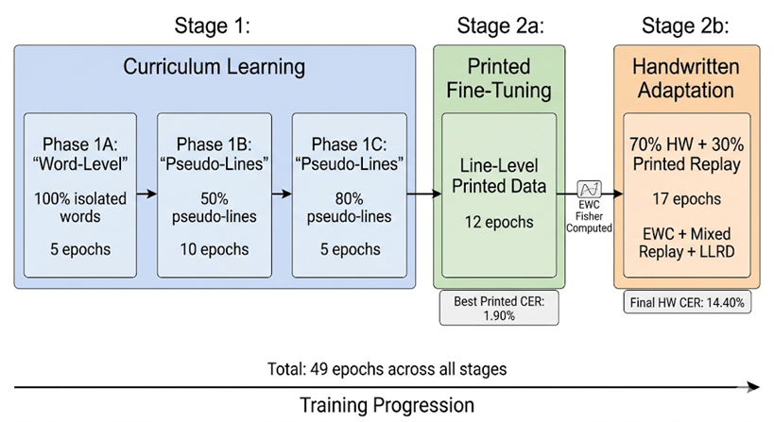
Figure 4.1 Training pipeline overview

Layer-wise Learning Rate Decay (LLRD)
Instead of using a uniform learning rate across all model parameters, this work adopts Layer-wise Learning Rate Decay (LLRD) to control the update magnitude of different components in the architecture.
Specifically:
- Lower encoder layers are assigned smaller learning rates to preserve pre-trained visual features.
- Higher encoder layers receive moderately larger learning rates to allow adaptation.
- Decoder layers are trained with the base learning rate.
- Cross-attention layers use an intermediate learning rate to balance visual-text alignment.
- The AdamW optimizer is used with weight_decay=0.01 across all stages.
This strategy helps prevent catastrophic forgetting in early layers while allowing effective fine-tuning of high-level representations.

Learning Rate Scheduling
A linear warmup followed by cosine decay schedule is applied during training.
- Warmup phase gradually increases the learning rate to stabilize early training.
- Cosine decay smoothly reduces the learning rate, allowing fine convergence in later stages.
Specifically, 1,000 warmup steps are used for Stage 1 and 500 warmup steps for Stages 2a and 2b, corresponding to approximately 5.1%, 12.5%, and 9.7% of total optimizer steps respectively.
This scheduling strategy improves optimization stability and prevents large gradient updates at the beginning of training.

Mixed Precision Training (AMP)
To improve computational efficiency and reduce GPU memory consumption, Automatic Mixed Precision (AMP) is applied during the training process. This technique allows the model to utilize lower-precision floating point operations while maintaining stable optimization performance.
The AMP training strategy includes the following components:
- Forward and backward computations are executed in FP16 whenever possible to reduce memory usage and accelerate training speed.
- A dynamic gradient scaler is utilized to prevent numerical underflow during gradient computation and backpropagation.
- The reduced memory footprint enables the use of larger effective batch sizes and improves GPU utilization efficiency.
By combining these techniques, the training process becomes faster and more memory-efficient without significantly affecting model accuracy or convergence stability.

Gradient Accumulation
Due to GPU memory limitations, gradient accumulation is employed to simulate larger batch sizes during training. Instead of updating model parameters after every mini-batch, gradients are accumulated across several iterations before performing an optimizer update.
The gradient accumulation process provides several advantages:
- It increases the effective batch size without requiring additional GPU memory.
- It improves gradient stability and reduces fluctuations during optimization.
- It helps the Transformer-based OCR model achieve more stable convergence, especially when training on long text sequences.
This strategy is particularly useful for large-scale TrOCR training where hardware resources are limited.

Gradient Clipping
To ensure stable optimization and prevent exploding gradients, gradient norm clipping is applied before each optimizer update step. A maximum gradient norm threshold of 1.0 is used throughout the training process.
The gradient clipping mechanism provides the following benefits:
- Prevents excessively large gradient updates that may destabilize training.
- Improves numerical stability during Transformer optimization.
- Helps maintain consistent convergence behavior when training on complex handwritten and printed Vietnamese text data.
By controlling gradient magnitude, the model can train more reliably and avoid unstable parameter updates during long training sessions.

Elastic Weight Consolidation (EWC)
To mitigate catastrophic forgetting when transitioning from printed text to handwritten data, Elastic Weight Consolidation (EWC) is applied in Stage 2b.
- A Fisher Information Matrix is computed after Stage 2a.
- Important parameters for printed text recognition are penalized if they deviate significantly.
This allows the model to retain performance on printed text while adapting to handwritten text.
Standard EWC implementations frequently fail under mixed-precision training (FP16) due to gradient overflow during the Fisher Information computation. To ensure stability, several engineering adaptations were developed for the EWC module:
First, infinite gradients (inf) and NaN values encountered during the backward pass are dynamically skipped and clamped to prevent numerical corruption of the Fisher Information Matrix. Second, an engineering adaptation ensures that the dummy SGD optimizer used during Fisher computation is instantiated outside the batch loop. This prevents Python's memory allocator from reusing the same memory address for successive optimizer instances, which would confuse PyTorch's GradScaler internal state tracker (which uses object identity as key). Additionally, scaler.update() is called at the end of each batch, and gradient values are cast to FP32 before squaring to prevent FP16 overflow (max ~65,504). These adaptations successfully allowed EWC to compute importance weights over 1,000 parameter updates without triggering FP16 overflow or memory aliasing on the GPU.

Early Stopping Mechanism
An early stopping strategy is introduced to prevent performance degradation:
- Training is stopped if printed CER at any evaluation point exceeds the best Stage 2a printed CER by more than 2 percentage points.
- Handwritten CER is smoothed over a 3-epoch sliding window to avoid false early stops from the noisy 549-sample validation set.
This prevents overfitting to handwritten data and maintains balanced performance.

Evaluation Metrics
To comprehensively evaluate the performance of the proposed OCR system, both Character Error Rate (CER) and Word Error Rate (WER) are employed as primary evaluation metrics. These metrics are widely used in optical character recognition tasks due to their ability to capture fine-grained and semantic-level errors.

Character Error Rate (CER)
Character Error Rate measures the minimum number of character-level edits required to transform the predicted text into the ground truth.
It is defined as:
- Substitutions (S): incorrect characters
- Deletions (D): missing characters
- Insertions (I): extra characters
CER is computed as:
$$CER=\frac{S+D+I}{N}$$
where $N$ is the total number of characters in the reference text.
CER is particularly important in Vietnamese OCR because:
- Vietnamese uses diacritics (accents), which are highly sensitive to small errors
- A single incorrect character may completely change the meaning of a word

Word Error Rate (WER)
Word Error Rate evaluates errors at the word level, reflecting the model’s ability to produce semantically correct outputs.
It is defined as:
$$WER=\frac{S+D+I}{N}$$
where:
- $S,D,I$ are word-level substitutions, deletions, and insertions
- $N$is the total number of words in the reference text
WER provides a higher-level assessment compared to CER, as it considers complete word correctness rather than individual characters.

Dual-Domain Evaluation Strategy
To ensure balanced performance across different text types, evaluation is conducted separately on two domains:
- Printed text dataset
- Handwritten text dataset
For each domain, both CER and WER are reported:
- Printed CER / Printed WER
- Handwritten CER / Handwritten WER
This dual evaluation strategy is critical because:
- Improvements on handwritten text may degrade printed text performance (catastrophic forgetting)
- The model is trained in multiple stages with different data distributions
By monitoring both domains independently, the system ensures robust and generalized performance.

Implementation Details
The evaluation metrics are computed using the jiwer library, which provides reliable implementations of CER and WER based on edit distance.
During evaluation and inference:
- Predicted sequences are generated using greedy decoding (num_beams = 1) combined with a repetition penalty of 1.2 to suppress hallucination loops.
- A custom initialization routine materializes the TrOCR decoder's sinusoidal positional embeddings, which are improperly left on a PyTorch meta device during standard from_pretrained() loading. Without this fix, inference produces RuntimeError when the embeddings are accessed on the target CUDA device. The interface automatically materializes these tensors on the target CUDA device prior to inference to ensure stability.
- Special tokens are removed before comparison.
- Empty predictions are handled gracefully to avoid undefined metric values.
A custom safe_batch_decode() function is implemented to bypass HuggingFace's default byte-truncation behavior with Vietnamese AddedTokens. This function correctly handles the RoBERTa tokenizer's Ġ (space) and Ċ (newline) markers and applies Unicode NFC normalization to ensure consistent CER computation.

Baseline Models and Ablation Strategy

External Baselines
Two external baselines establish cross-architecture comparison on the same 4,477-sample test set:
- VietOCR (VGG-Transformer): A Vietnamese-specific OCR system using a VGG-based CNN encoder with a Transformer decoder, pre-trained on Vietnamese text data. It has 37.7M parameters and uses its own internal preprocessing (height=32, aspect-ratio preserved).
- CRNN-Seq2Seq (VGG-Seq2Seq): A CRNN-family architecture using a VGG backbone with a Seq2Seq decoder. With 22.4M parameters and no Vietnamese-specific pre-training, it establishes the pure architectural lower-bound.
Both external baselines are evaluated using the same test LMDB paths, same CER/WER metrics (via jiwer), same Unicode NFC normalization, and same RegexSanitizer post-processing as the proposed model. Each baseline uses its own model-appropriate preprocessing.

Post-Processing Ablation
To isolate the contribution of each post-processing component, the final model's predictions are evaluated at four stages:
- Raw TrOCR output without post-processing.
- Output after applying the RegexSanitizer module.
- Output after applying the AddressCorrector module.
- Output after applying PhoBERT MLM rescoring.
All evaluations are conducted on the same test set using CER and WER metrics to ensure fair comparison across stages. This ablation setting enables precise measurement of how each post-processing component contributes to the final OCR performance improvement. The detailed experimental results are presented in Table 5.7.

Training-Stage Progression Analysis
The proposed multi-stage training pipeline also provides an implicit ablation analysis through stage-wise validation evaluation. Validation CER is recorded at the transition points between Stage 1, Stage 2a, and Stage 2b to measure the effectiveness of each training phase.
This analysis highlights several important aspects:
- The contribution of curriculum learning during sequence-length progression.
- The effectiveness of staged adaptation from word-level to line-level recognition.
- The stability provided by EWC-based knowledge preservation during fine-tuning.
Although these validation results are not directly comparable to final test-set evaluations, they provide useful evidence for the effectiveness of the proposed training strategy. The corresponding results are shown in Table 5.3 and Table 5.5.

Experimental Design
This section presents the experimental design used to evaluate the proposed multi-stage Transformer-based OCR framework for Vietnamese text recognition. The experiments are designed to ensure fair comparison, reproducibility, and comprehensive performance analysis across different datasets and model configurations.
The experimental design focuses on the following objectives:
- Evaluating recognition performance on both handwritten and printed Vietnamese text.
- Measuring the effectiveness of the multi-stage training strategy and post-processing modules.
- Comparing model performance using standard OCR evaluation metrics such as CER and WER.
- Ensuring consistent training and evaluation settings across all experiments for reliable comparison.
Through this design, the proposed framework can be systematically analyzed under multiple OCR scenarios and data domains.

Evaluation Protocol
To ensure a consistent and fair evaluation across all models and baselines, a unified evaluation protocol is applied.
All models are evaluated on the same test sets, which are strictly separated from training and validation data. The dataset splitting strategies described in Section 4.1.5 are strictly enforced to avoid data leakage, particularly:
- Writer-independent splits for handwritten datasets
- Group-based splits for document-level data
- Fixed random seeds for synthetic datasets
During evaluation, no data augmentation is applied. All input images are processed using the same preprocessing pipeline to ensure consistency across experiments.
Predictions are generated using greedy decoding unless otherwise specified. Special tokens are removed before computing evaluation metrics.

Evaluation Consistency
To ensure fair comparison across all evaluated models, the following controlled conditions are applied:
- All models are evaluated on the same test LMDB paths: line_printed/test (3,739 samples) and line_handwritten/test (738 samples).
- Identical CER/WER computation logic is used (via the jiwer library) with Unicode NFC normalization applied to all labels and predictions.
- RegexSanitizer post-processing is applied uniformly to all model outputs to ensure that hallucination patterns do not unfairly inflate baseline CER.
- Each model uses its own native preprocessing pipeline (TrOCR: 128×1536 bicubic; VietOCR/CRNN: height=32, aspect-ratio preserved) to reflect realistic deployment conditions.

Evaluation Metrics and Reporting
Performance is evaluated using two standard OCR metrics:
- Character Error Rate (CER)
- Word Error Rate (WER)
To capture domain-specific behavior, results are reported separately for:
- Printed text dataset
- Handwritten text dataset
This dual-domain evaluation is critical for identifying trade-offs between domains and detecting catastrophic forgetting.
In addition to final performance, intermediate results across training stages are analyzed for the proposed model to study learning dynamics.

Ablation Study Design
Two forms of ablation analysis are employed to understand the contribution of individual components:
Post-Processing Stage Ablation. The final model's predictions are evaluated at four stages — raw TrOCR output, after RegexSanitizer, after AddressCorrector, and with PhoBERT rescoring — using the same test set. This quantifies the exact CER contribution of each post-processing component (see Table 5.7).
Training-Stage Progression Analysis. The multi-stage training pipeline inherently provides ablation evidence: the validation CER measured at each stage boundary (Stage 1 → Stage 2a → Stage 2b) demonstrates the incremental contribution of each training phase. While these are validation-set metrics and not directly comparable to test-set evaluations, they provide empirical evidence for the effectiveness of the curriculum (Stage 1), line-level fine-tuning (Stage 2a), and EWC-protected handwritten adaptation (Stage 2b). The results are presented in Tables 5.3, 5.4, and 5.5.

Computational Efficiency Evaluation
In addition to recognition accuracy, computational efficiency is also considered.
The following aspects are analyzed:
- Inference speed (FPS and average milliseconds per image)
- GPU VRAM consumption during inference (FP16 mode)
- Training time across different stages

Robustness Evaluation
Model robustness under real-world conditions is assessed through the worst-case error analysis presented in Chapter 6. The 50 highest-CER samples are examined qualitatively, covering failure modes including low-resolution images, noisy backgrounds, irregular handwriting, and images with skew or rotation. This analysis provides qualitative insights into model behavior at the boundaries of its capability.

Summary
The experimental design is structured to provide a comprehensive and fair evaluation of the proposed OCR system. By combining baseline comparisons, ablation studies, dual-domain evaluation, and efficiency analysis, the study ensures that performance improvements are well-justified and not attributed to uncontrolled factors.
This design enables a clear demonstration of the effectiveness of the multi-stage training strategy and its contribution to robust Vietnamese text recognition.

System Implementation and Deployment
The trained TrOCR model is integrated into a complete end-to-end OCR system with a web-based interface for interactive document recognition. The system is implemented using Python with a Gradio web UI and is designed for deployment on Google Colab with GPU acceleration.
Pipeline Architecture: The inference pipeline consists of five sequential stages: (1) image preprocessing via CLAHE contrast enhancement and Hough-based deskewing, (2) text detection using a pre-trained DBNet model (db_resnet50) from the docTR library, (3) line segmentation via DBSCAN clustering on bounding box y-centers with adaptive epsilon, (4) batched TrOCR inference with FP16 precision, and (5) multi-stage post-processing including RegexSanitizer and AddressCorrector.
Resource Requirements: The complete inference pipeline operates within approximately 900 MB GPU VRAM (FP16 mode), comprising ~200 MB for the DBNet detector, ~600 MB for TrOCR, and ~100 MB for batch processing buffers. This makes the system deployable on consumer-grade GPUs including the NVIDIA T4 (16 GB) available on Google Colab free tier.
User Interface: The Gradio-based interface provides image upload, configurable parameters (model path, batch size, address correction toggle), and detailed output visualization including per-step timing breakdown, preprocessed images, detection bounding boxes, cropped line gallery, and per-line recognition results. A public sharing URL is generated for remote access.

RESULTS AND DISCUSSION

Overall Performance
The proposed multi-stage TrOCR system was evaluated on a combined test set of 4,477 samples (3,739 printed + 738 handwritten), using Character Error Rate (CER) and Word Error Rate (WER) as primary metrics. The final results after the complete post-processing pipeline are summarized in Table 5.1.
Metric | Printed | Handwritten | Overall
CER | 0.0117 (1.17%) | 0.1057 (10.57%) | 0.0286 (2.86%)
WER | 0.0396 (3.96%) | 0.2628 (26.28%) | 0.0792 (7.92%)
Samples | 3,739 | 738 | 4,477
Perfect (CER = 0) | 2,562 (68.5%) | 109 (14.8%) | 2,671 (59.7%)
FPS | 2.06 | 1.82 | —
VRAM Peak (FP16) | 1.40 GB | 1.40 GB | —
Table 5.1 Final performance of the proposed Vietnamese TrOCR system

The system achieves an overall CER of 2.86%, with printed text recognition reaching 1.17% CER — indicating near-production-grade accuracy. Handwritten text recognition achieves 10.57% CER, reflecting the inherent difficulty of Vietnamese handwriting with dense diacritical marks and high style variability. Notably, 59.7% of all test samples are recognized perfectly (CER = 0), and 85.6% of all samples have CER ≤ 0.05.

External Baseline Comparison
To contextualize the proposed system's performance, two external baselines were evaluated on the exact same 4,477 test images using identical CER/WER computation, Unicode NFC normalization, and RegexSanitizer post-processing to ensure fair comparison. The results are presented in Table 5.2.
Model | Architecture | Params | Overall CER | Overall WER | Printed CER | HW CER | Printed Perfect
CRNN-Seq2Seq | VGG + Seq2Seq | 22.4M | 0.1434 | 0.2795 | 0.0547 | 0.5927 | 31.90%
VietOCR | VGG + Transformer | 37.7M | 0.0642 | 0.1817 | 0.0304 | 0.2355 | 45.20%
TrOCR (Ours) | ViT + Transformer | ~337M | 0.0286 | 0.0792 | 0.0117 | 0.1057 | 68.50%
Table 5.2 Multi-tier baseline comparison on Vietnamese OCR

The proposed TrOCR system achieves a 55.5% relative CER reduction compared to VietOCR and an 80.1% reduction compared to CRNN-Seq2Seq. The performance gap is especially pronounced in the handwritten domain, where TrOCR achieves 10.57% CER compared to VietOCR's 23.55% and CRNN's 59.27%.
For printed text, TrOCR achieves 1.17% CER, which is 2.6x better than VietOCR and 4.7x better than CRNN. The perfect recognition rate of 68.5% is significantly higher than VietOCR and CRNN, confirming that the Transformer-based architecture with Vietnamese-specific adaptation provides substantial accuracy improvements.
However, this accuracy advantage comes at the cost of model size: TrOCR uses approximately 337M parameters, compared to VietOCR's 37.7M and CRNN's 22.4M. In terms of inference speed, TrOCR achieves approximately 2.06 FPS for printed text, while CRNN achieves 13.3 FPS due to its simpler architecture. VietOCR operates at approximately 2.5 FPS, comparable to TrOCR. This trade-off between accuracy and efficiency is further discussed in Section 5.7.

Training Convergence Analysis
The training pipeline was executed across three stages on an NVIDIA L4 GPU (24 GB VRAM). Figure 5.1 illustrates the CER convergence across all training stages, and Figure 5.2 shows the corresponding training loss curves.

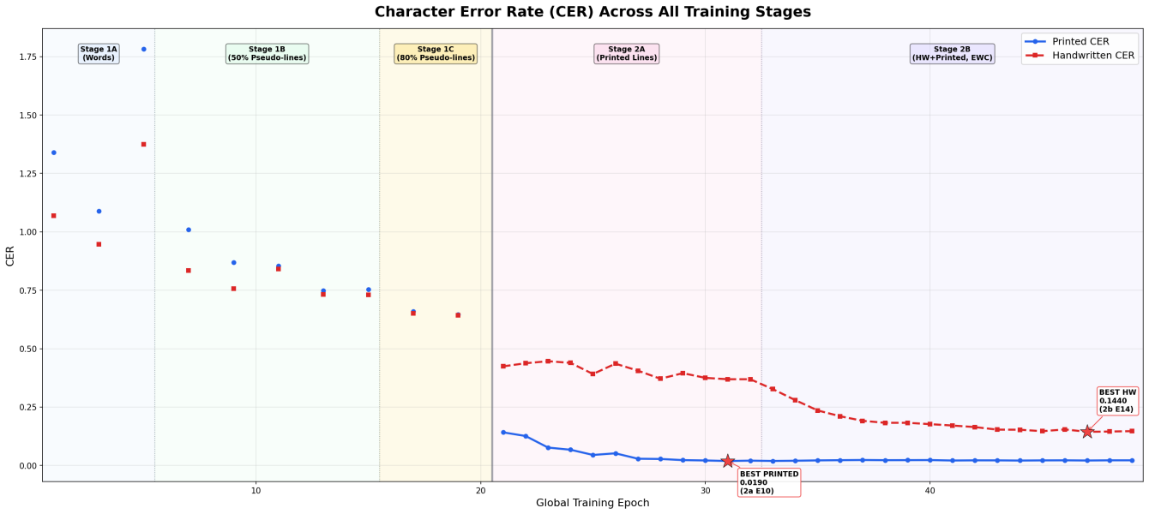
Figure 5.1 CER convergence across training stages

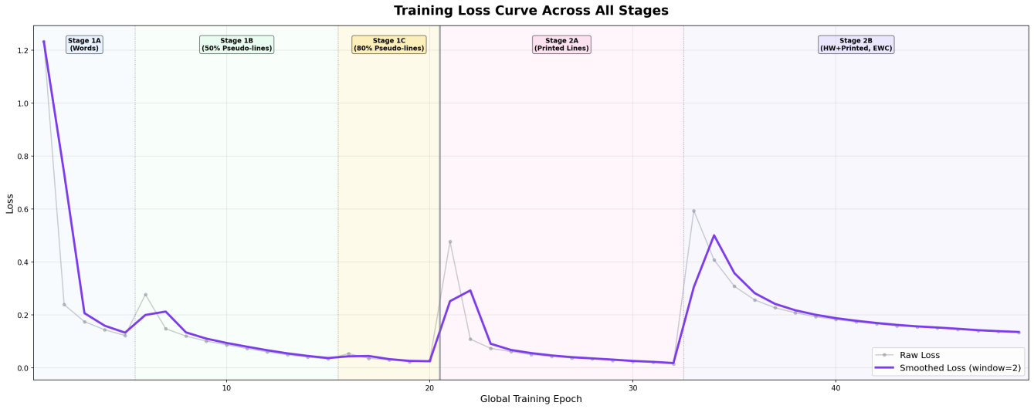
Figure 5.2 Training loss convergence

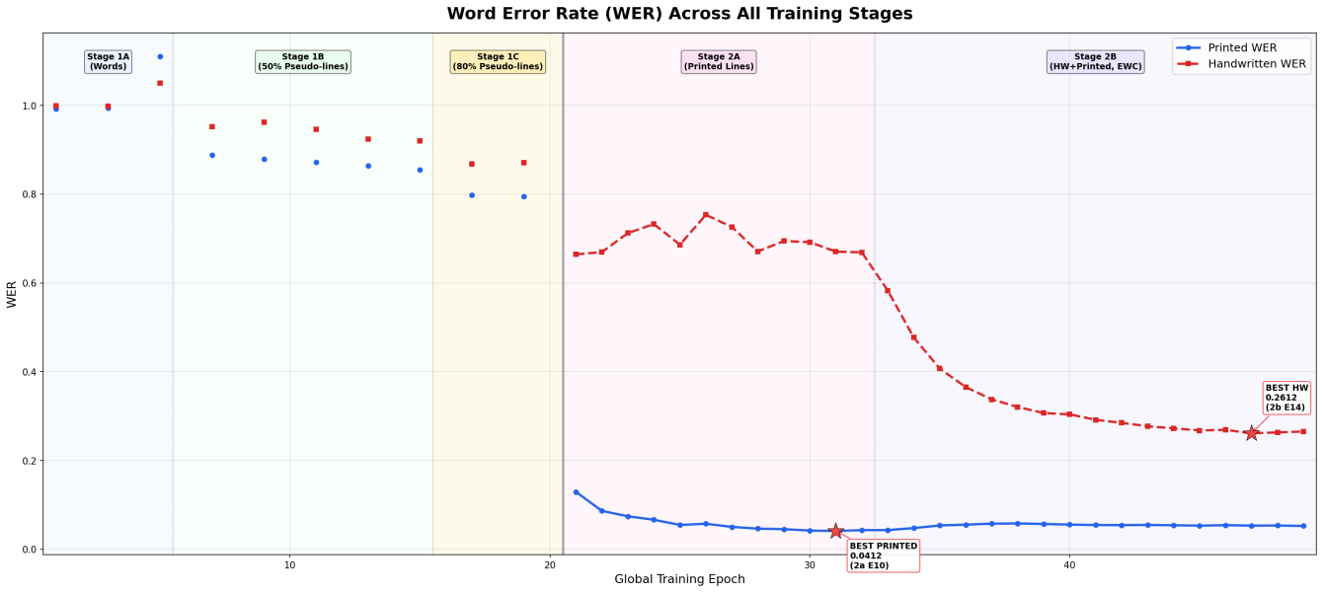
Figure 5.3 WER convergence across training stages

Stage 1: Curriculum Word-to-Pseudo-line (20 epochs)
Stage 1 trained on word-level data with a three-phase curriculum. The training loss decreased from 1.2328 (epoch 0) to 0.0277 (epoch 19), demonstrating stable convergence across all curriculum phases.
Phase | Epochs | Loss (start → end) | Printed CER | HW CER
Phase 1A (words only) | 0–4 | 1.2328 → 0.1228 | 1.34 → 1.78 | 1.07 → 1.38
Phase 1B (50% pseudo-lines) | 5–14 | 0.2778 → 0.0340 | 1.01 → 0.75 | 0.84 → 0.73
Phase 1C (80% pseudo-lines) | 15–19 | 0.0542 → 0.0277 | 0.66 → 0.65 | 0.65 → 0.64
Table 5.3 Stage 1 curriculum training progression
A notable observation is the dramatic CER improvement at the Stage 1→2a transition. The last Stage 1 evaluation (epoch 18) showed printed CER of 0.6461, while Stage 2a's first evaluation (epoch 0) achieved 0.1417 — a 78.1% relative reduction in a single stage boundary. This confirms that switching from word-level to line-level data is the primary driver of CER improvement, and that the curriculum's pseudo-line progression prepared the decoder's positional embeddings for the longer sequences encountered in Stage 2a.

Stage 2a: Printed Line Fine-tuning (11 epochs)
Stage 2a fine-tuned the model exclusively on printed line-level data. Printed CER improved consistently from 0.1417 (epoch 0) to the best value of 0.0190 (epoch 10), demonstrating that the decoder effectively learned Vietnamese printed language patterns.
Epoch | Printed CER | Printed WER | HW CER
0 | 0.1417 | 0.1292 | 0.4243
2 | 0.0766 | 0.0743 | 0.4463
4 | 0.045 | 0.0548 | 0.3915
6 | 0.0288 | 0.0504 | 0.4058
8 | 0.0229 | 0.0453 | 0.3951
10 (best) | 0.019 | 0.0412 | 0.3691
Table 5.4 Stage 2a printed CER progression (selected epochs)
Handwritten CER remained in the 36–45% range throughout Stage 2a, as the model was not exposed to handwritten line data during this stage. This baseline handwritten CER value serves as the starting point for Stage 2b adaptation.
After Stage 2a completed, the Fisher Information Matrix was computed over 1,000 printed line batches to estimate parameter importance for Elastic Weight Consolidation.

Stage 2b: Mixed Handwritten + Printed Replay with EWC (17 epochs)
Stage 2b adapted the model to handwritten text using a 70/30 handwritten-printed batch ratio, protected by EWC regularization. Training was executed for 17 epochs (out of a maximum 25) before manual early stopping.

Epoch | Printed CER | Printed WER | HW CER | HW WER | Loss
0 | 0.0193 | 0.0432 | 0.3271 | 0.583 | 0.5945
3 | 0.0226 | 0.0554 | 0.2107 | 0.3654 | 0.2571
6 | 0.0228 | 0.057 | 0.1826 | 0.3068 | 0.1935
9 | 0.0219 | 0.0544 | 0.1643 | 0.2848 | 0.1663
12 | 0.0217 | 0.0532 | 0.1467 | 0.2677 | 0.151
14 (best) | 0.0212 | 0.0532 | 0.144 | 0.2612 | 0.1404
16 | 0.022 | 0.0525 | 0.1469 | 0.2653 | 0.1343
Table 5.5 Stage 2b handwritten CER progression
Several critical observations emerge from the Stage 2b convergence:
- Rapid handwritten adaptation: HW CER dropped from 0.3271 to 0.1440 within 14 epochs, a 56.0% relative improvement, demonstrating the effectiveness of the mixed replay strategy combined with EWC.
- Successful printed text preservation: Printed CER remained within a narrow band of 0.0193–0.0234 throughout Stage 2b, representing a maximum degradation of only 0.44 percentage points from the Stage 2a best (0.0190). This confirms that the three-mechanism defense (EWC + mixed replay + ultra-low LLRD) effectively prevented catastrophic forgetting.
- Convergence plateau: After epoch 12, handwritten CER oscillated between 0.1440 and 0.1469, indicating diminishing returns. The best HW CER of 0.1440 was reached at epoch 14 (Table 5.5). The model was exported from the checkpoint with the best combined performance.

Post-Processing Pipeline Ablation
The post-processing pipeline was iteratively refined across three versions. Table 5.6 presents the version evolution, and Table 5.7 shows the stage-by-stage CER contribution of the final V3 pipeline.
Version | Components | Overall CER | Overall WER | Δ CER
V1 | RegexSanitizer + PhoBERT | 0.0658 | 0.3602 | —
V2 | + Punctuation re-attachment + AddressCorrector v1 | 0.0351 | 0.1006 | −46.7%
V3 (Final) | + Skip-if-valid + Province scope + Ward data | 0.0286 | 0.0792 | −18.5%
Table 5.6 Post-processing pipeline evolution (V1 → V3)
The total CER improvement from V1 to V3 represents a 56.5% reduction, achieved entirely through post-processing refinements without any model retraining. This demonstrates that task-specific, deterministic post-processing can be a highly cost-effective strategy compared to additional training iterations.
Pipeline Stage | Printed CER | Printed Perfect | HW CER | HW Perfect
Raw TrOCR output | 0.0229 | 2,566 (68.6%) | 0.1176 | 66 (8.9%)
+ RegexSanitizer | 0.0112 | 2,583 (69.1%) | 0.1091 | 66 (8.9%)
+AddressCorrector | 0.0116 | 2,562 (68.5%) | 0.1 | 109 (14.8%)
+ PhoBERT (comparison only) | 0.0154 | 2,360 (63.1%) | 0.1007 | 108 (14.6%)
Table 5.7 pipeline stage-by-stage CER ablation
Each stage demonstrates a distinct contribution:
- RegexSanitizer is the highest-impact stage for printed text, reducing CER from 0.0229 to 0.0112 (−51.1%) by collapsing hallucinated character repetitions. It recovered 41 samples with CER improvements up to 11.7× per sample.
- AddressCorrector v2 is the highest-impact stage for handwritten text, increasing the perfect recognition count from 66 to 109 (+65.2%) by correcting Vietnamese geographic entity names via province-scoped fuzzy matching. The corrector modified 315 samples total: it improved 218 (69.2%), was neutral for 24 (7.6%), and hurt 73 (23.2%).
- PhoBERT MLM rescoring was empirically shown to be a net negative: it degraded 445 samples while improving only 67 (a 6.6:1 hurt-to-help ratio), raising overall CER from 0.0286 to 0.0317. The dominant failure mode was BPE tokenizer-induced spacing around punctuation marks. Consequently, PhoBERT was disabled in the final production pipeline.

Error Distribution Analysis
Table 5.8 presents the distribution of error categories across both domains, based on programmatic classification applied to all 4,477 test predictions.

Category | Condition | Printed | Handwritten | Total | %
PERFECT | CER = 0 | 2,562 | 109 | 2,671 | 59.70%
MINOR_ERROR | CER ≤ 0.30 | 1,153 | 572 | 1,725 | 38.50%
SUBSTITUTION | CER > 0.30 | 7 | 48 | 55 | 1.20%
HALLUCINATION_LOOP | Repeated patterns | 17 | 8 | 25 | 0.60%
TRUNCATION | Pred < 30% of ref | 0 | 1 | 1 | 0.02%
Table 5.8 Error category distribution

CER Range | Count | Percentage
CER = 0.00 | 2,671 | 59.70%
0.00 < CER ≤ 0.05 | 1,161 | 25.90%
0.05 < CER ≤ 0.15 | 465 | 10.40%
0.15 < CER ≤ 0.30 | 121 | 2.70%
CER > 0.30 | 59 | 1.30%
Table 5.9 CER distribution across all samples
The error distribution reveals several key patterns. First, 85.6% of all samples achieve CER ≤ 0.05, indicating production-grade quality for the majority of inputs. Second, the handwritten domain accounts for 48 of 55 substitution errors and all truncation errors, confirming that handwriting remains the most challenging domain. Third, hallucination loop errors (25 total) are effectively mitigated by the RegexSanitizer and are not a significant contributor to aggregate CER.

Computational Efficiency And Training Time
Table 5.10 presents a computational efficiency comparison across all evaluated models.
Model | Parameters | Printed FPS | HW FPS | Avg Inference (ms) | VRAM (FP16)
CRNN-Seq2Seq | 22.4M | 13.3 | 9.5 | 75–105 | —
VietOCR | 37.7M | 2.5 | 2.3 | 397–440 | —
TrOCR (Ours) | ~337M | 2.06 | 1.82 | ~490 | 1.40 GB
Table 5.10 Computational efficiency comparison
The proposed TrOCR system operates at approximately 2 FPS with a peak VRAM consumption of 1.40 GB under FP16 inference on an NVIDIA L4 GPU. While CRNN achieves 6.5x higher throughput, its CER is 5x worse. VietOCR achieves comparable throughput to TrOCR but with 2.2x higher CER. For document digitization applications where recognition quality is prioritized over throughput, the accuracy-efficiency trade-off of TrOCR is favorable.
Table 5.11 presents the Training runtime per stage.
Stage | Epochs | Avg Runtime/Epoch | Total
Stage 1A (words) | 5 | 7,622s (127 min) | ~10.6 hours
Stage 1B (50% pseudo-lines) | 10 | 4,016s (67 min) | ~11.2 hours
Stage 1C (80% pseudo-lines) | 5 | 2,839s (47 min) | ~3.9 hours
Stage 1 total | 20 | — | ~25.7 hours
Stage 2A (printed lines) | 12 | 2,849s (47 min)* | ~9.5 hours
Stage 2B (HW+printed, EWC) | 17 | 1,357s (23 min) | ~6.4 hours
Grand total | 49 | — | ~41.6 hours
Table 5.11 Training runtime per stage
Note: Stage 2a epoch 10 was run twice due to a Colab restart. The second run's data (best printed CER = 0.0190) is kept. Epoch 11's runtime is excluded from the average because its timestamp delta includes restart overhead.
The total training time across all stages on an NVIDIA L4 GPU was approximately 42 hours of GPU compute time. Stage 1 (curriculum learning, 20 epochs) was the most expensive phase at approximately 25.7 hours, with Phase 1A word-level training requiring ~127 minutes per epoch, Phase 1B pseudo-line training requiring ~67 minutes, and Phase 1C requiring ~47 minutes. The decreasing runtime reflects the curriculum's progressive reduction in total training samples as pseudo-line aggregation reduces batch count. Stage 2a (printed line fine-tuning, 12 epochs) required approximately 9.5 hours (~47 minutes per epoch). Stage 2b (mixed handwritten + printed training with EWC, 17 epochs) was the most efficient at approximately 6.4 hours (~23 minutes per epoch), benefiting from the smaller mixed training set (15% replay subsample). Note: Stage 2a epoch 10 was re-executed after a Colab session restart; the second run (which produced the best printed CER of 0.0190) was retained.
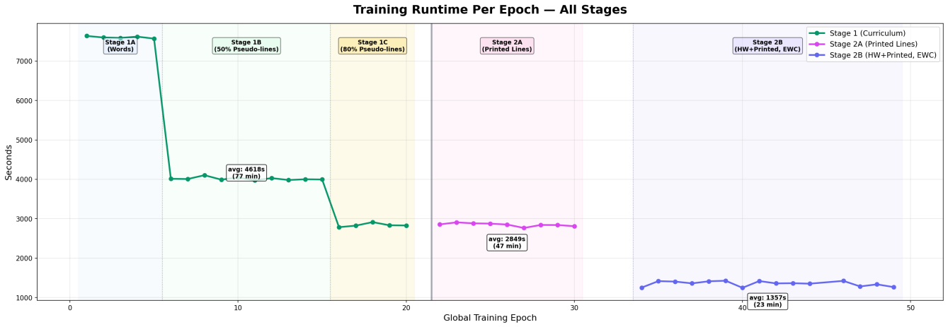
Figure 5.4 Training runtime per epoch

System Demonstration and User Interface

Interface Overview
To evaluate the practical usability of the proposed Vietnamese TrOCR system, an interactive OCR demonstration interface was developed. The interface integrates the complete end-to-end pipeline, including image preprocessing, DBNet text detection, DBSCAN-based line segmentation, Transformer-based text recognition, and deterministic post-processing modules. Users can upload Vietnamese document images and visualize intermediate outputs from each processing stage in real time.
The demonstration system was designed not only for inference testing but also for qualitative analysis and pipeline debugging. Each stage of the OCR workflow is presented separately, allowing users to observe how the input image is progressively transformed from raw document data into final normalized Vietnamese text. The interface supports both printed and handwritten documents, enabling direct comparison between different text domains and recognition difficulties.
In addition, the interface provides configurable options such as model path selection, batch size adjustment, and optional post-processing modules including PhoBERT correction and AddressCorrector. This modular design makes the system suitable for research experimentation, error analysis, and future deployment-oriented extensions.
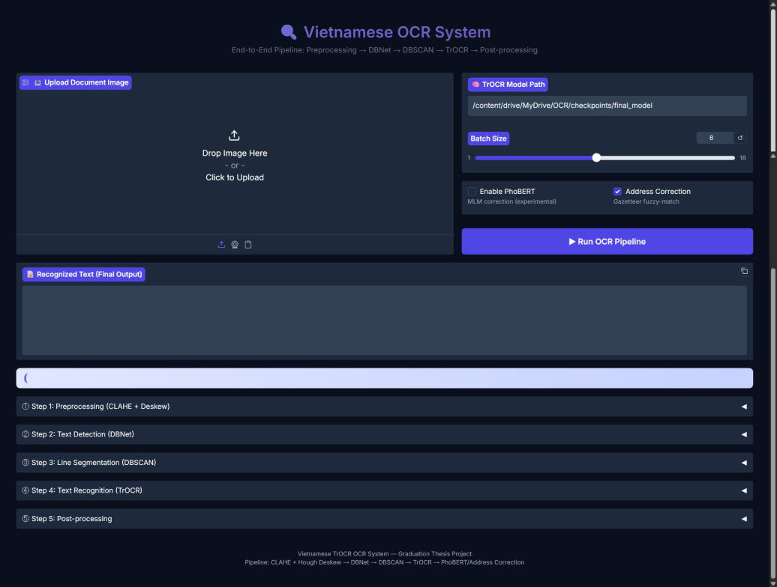
Figure 5.5 Overview of the Vietnamese OCR demonstration interface
The interface visualizes all major OCR stages, including preprocessing, text detection, segmentation, recognition, and post-processing. This design enables easier monitoring of intermediate outputs and supports qualitative analysis of handwritten Vietnamese OCR behavior.

OCR Pipeline Visualization
To further illustrate the behavior of the proposed system, this section presents a complete handwritten Vietnamese OCR example processed through all stages of the inference pipeline. The visualization demonstrates how the raw handwritten input is progressively transformed into normalized Vietnamese text through preprocessing, text detection, line segmentation, Transformer-based recognition, and deterministic post-processing.
- Step 1: Preprocessing

Figure 5.6 Step 1: CLAHE preprocessing and deskew correction
In the preprocessing stage, the handwritten Vietnamese document image is enhanced using CLAHE-based contrast normalization and deskew correction. This stage improves text visibility under uneven illumination and reduces the impact of low-contrast handwriting strokes. The preprocessing module also estimates document orientation and applies geometric correction before downstream text detection. As shown in Figure 5.6, the enhanced image exhibits clearer character boundaries and improved readability compared to the raw scanned input.
- Step 2: DBNet Detection
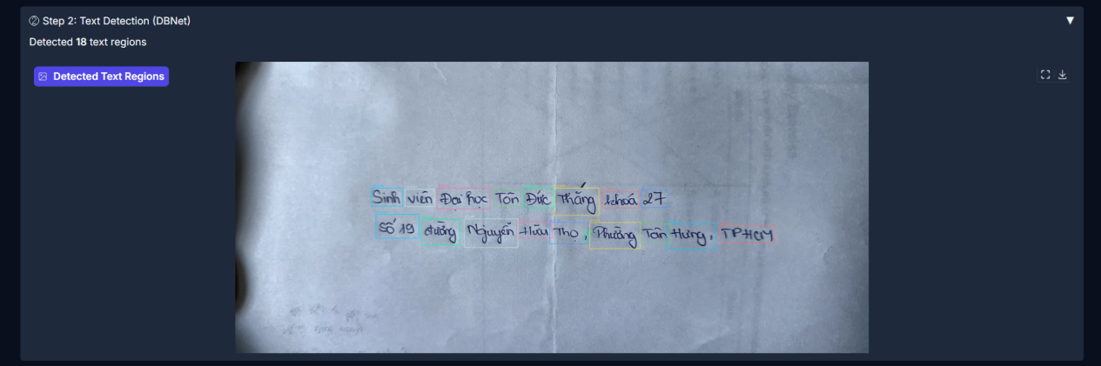
Figure 5.7 Step 2: Text region detection using DBNet
After preprocessing, DBNet is applied to detect candidate text regions within the handwritten document. The detector generates segmentation-based text proposals and extracts bounding regions corresponding to Vietnamese words and phrases. As illustrated in Figure 5.7, the model successfully identifies individual handwritten text components despite irregular spacing, varying stroke thickness, and low-contrast background conditions. The detected regions provide the foundation for downstream line segmentation and Transformer-based recognition. In this example, a total of 18 handwritten text regions were successfully detected.
- Step 3: DBSCAN Segmentation
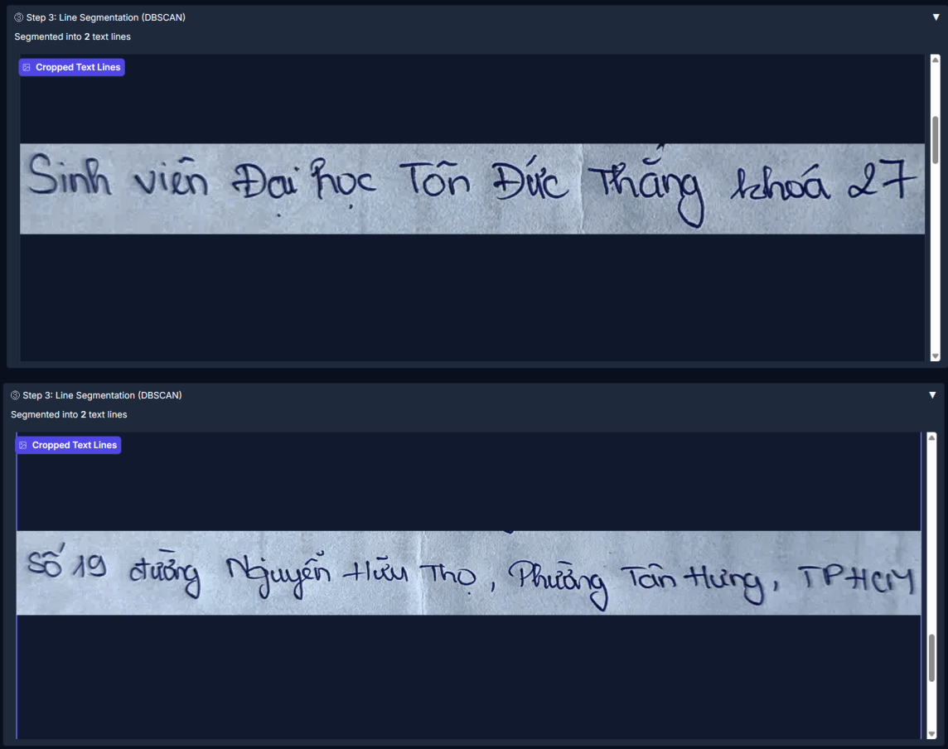
Figure 5.8 Step 3: Line segmentation using DBSCAN clustering
After text detection, the extracted text components are grouped into line-level regions using DBSCAN clustering. This stage converts fragmented word detections into coherent handwritten text lines suitable for Transformer-based recognition. The clustering process analyzes spatial relationships between detected text regions and groups nearby components into the same line segment. As shown in Figure 5.8, the algorithm successfully separates the handwritten document into two distinct text lines despite irregular spacing, uneven alignment, and varying handwritten character sizes.
- Step 4: TrOCR Recognition
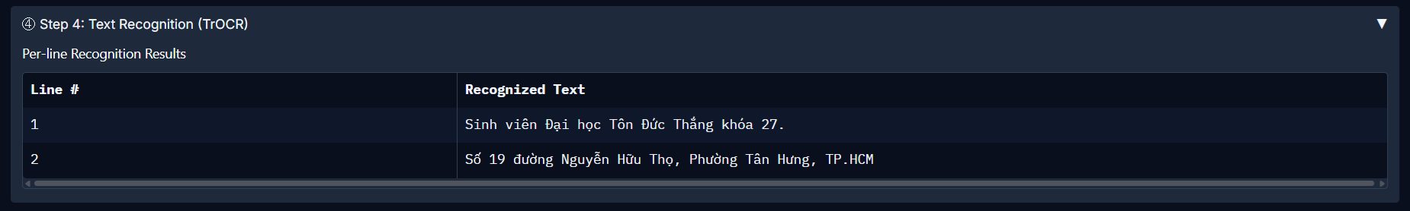
Figure 5.9 Step 4: Handwritten text recognition using the TrOCR model
Each segmented handwritten text line is processed independently by the TrOCR recognition model. The Vision Transformer encoder extracts visual features from the handwritten input, while the autoregressive Transformer decoder predicts Vietnamese character sequences directly from image patches. Figure 5.9 shows the recognized output for both segmented text lines before deterministic post-processing. The recognition model is able to recover most Vietnamese words and sentence structures directly from the handwritten input without handcrafted feature engineering or CTC-based decoding. The output also preserves most Vietnamese diacritical marks and proper noun structures despite the challenging handwritten style and irregular character spacing.
- Step 5: Post-processing

Figure 5.10 Step 5: Deterministic post-processing and output refinement
In the final stage, deterministic post-processing modules including RegexSanitizer and AddressCorrector are applied to refine the recognized text. These modules normalize formatting inconsistencies, remove hallucinated character patterns, and improve Vietnamese geographic entity recognition using province-scoped fuzzy matching. The post-processing pipeline also helps recover common address structures and correct minor recognition errors that remain after Transformer inference. As shown in Figure 5.10, the corrected output demonstrates improved readability, formatting quality, and linguistic consistency compared to the raw recognition result.

Final Inference Example
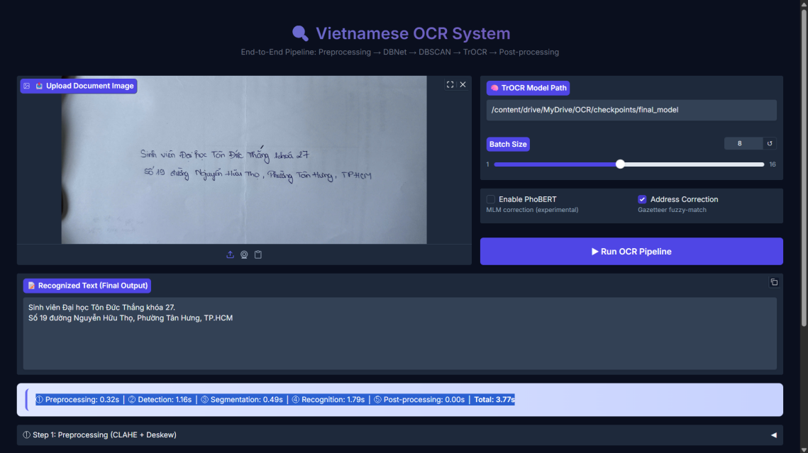
Figure 5.11 Final handwritten OCR inference result
Figure 5.11 presents the final inference result generated by the complete OCR demonstration system. The interface displays the uploaded handwritten document, runtime statistics, and the final recognized Vietnamese text after post-processing. The example demonstrates the practical usability of the proposed pipeline for handwritten Vietnamese OCR.

Discussion

Effectiveness of the Multi-Stage Training Strategy
The progressive training approach — from words to pseudo-lines to real lines — proved essential for stable convergence. The dramatic CER improvement at the Stage 1→2a transition (from 0.6461 to 0.1417 printed CER — a 78.1% relative reduction at a single stage boundary) confirms that the curriculum successfully prepared the decoder's positional embeddings for longer sequences. Without this preparation, direct line-level training would require the model to simultaneously learn Vietnamese character features, sequence modeling, and positional encoding — a substantially harder optimization problem.

Effectiveness of EWC Against Catastrophic Forgetting
The most notable result from Stage 2b is the successful preservation of printed text accuracy. Printed CER degraded by at most 0.44 percentage points (from 0.0190 to a peak of 0.0234 at epoch 4, recovering to 0.0220 by epoch 16) across 17 epochs of handwritten adaptation, while handwritten CER improved by 18.3 percentage points (from 0.3271 to 0.1440). This asymmetric improvement-to-degradation ratio of approximately 42:1 demonstrates the effectiveness of the three-mechanism defense (EWC + mixed replay + ultra-low LLRD) against catastrophic forgetting.

Role of Deterministic Post-Processing
The V1-to-V3 post-processing evolution achieved a 56.5% CER reduction without any model retraining, demonstrating that task-specific, deterministic corrections can be more effective than generic language model rescoring. The failure of PhoBERT (6.6:1 hurt-to-help ratio) provides an important research finding: MLM rescoring becomes counterproductive when the base model's output already exceeds a quality threshold. At the TrOCR output quality level (2.29% raw printed CER), PhoBERT's BPE tokenizer artifacts introduce more errors than its linguistic corrections can fix.

The Printed-Handwritten Performance Gap
The 9x CER gap between printed (1.17%) and handwritten (10.57%) text is structural and reflects the inherent difficulty of Vietnamese handwritten text. Post-processing cannot bridge this gap — the AddressCorrector improved handwritten perfect count by 65%, but the remaining errors are dominated by diacritical substitutions that require stronger visual features or handwriting-specific data augmentation. This gap represents a key direction for future work.

ERROR ANALYSIS

Overview of the Worst-Case Samples
This chapter presents a detailed analysis of the 50 worst-performing samples selected from the full evaluation set containing 4,477 samples. These samples are ranked according to the highest Character Error Rate (CER) after the complete post-processing pipeline has been applied. By focusing on the most challenging cases, the analysis aims to provide deeper insight into the weaknesses and limitations of the proposed OCR framework under difficult recognition conditions.
The objective of this analysis is not only to measure recognition errors quantitatively, but also to better understand the behavior of the system in extreme failure scenarios. In particular, the analysis investigates:
- Why the model fails in extreme cases
- Which types of text are most difficult
- How effective each stage of the pipeline is
(Raw → Sanitized → Corrected)
- What limitations remain in the OCR system
In addition, this error analysis helps identify patterns related to handwriting quality, Vietnamese diacritics, layout complexity, and noisy input images. The findings provide useful guidance for future improvements in both model training and post-processing design.
- General Observations
From the dataset, we observe:
- The highest CER reaches 0.8261, indicating severe degradation of recognition quality.
- Most worst cases belong to the handwritten domain, confirming that handwriting remains the most challenging OCR scenario.
- Post-processing steps (sanitization and correction) provide limited improvement in extreme failure cases.
- Many errors are systematic rather than random, suggesting model-level weaknesses rather than noise-only issues.

Error Type Categorization
Errors are grouped into three main types:
Category | Printed | Handwritten | Total
PERFECT (CER=0) | 2,562 (68.5%) | 109 (14.8%) | 2,671 (59.7%)
MINOR_ERROR (CER≤0.30) | 1,153 (30.8%) | 572 (77.5%) | 1,725 (38.5%)
SUBSTITUTION (CER>0.30) | 7 (0.2%) | 48 (6.5%) | 55 (1.2%)
HALLUCINATION_LOOP | 17 (0.5%) | 8 (1.1%) | 25 (0.6%)
TRUNCATION | 0 (0.0%) | 1 (0.1%) | 1 (0.02%)
Table 6.1 Error Category Distribution Statistics

Substitution Errors (Most Dominant)
- Definition
Substitution errors occur when the model correctly predicts text structure but replaces characters or words with incorrect ones.
- Characteristics
- Partial correctness in sentence structure
- High semantic distortion in many cases
- Frequent in long structured texts (especially addresses)
- Strong impact from Vietnamese diacritics and spelling variations
- Example
Ground Truth: Số 339, phố Huế, Phường Phố Huế, Quận Hai Bà Trưng, Hà Nội
Prediction: Chong cố 739, phố thiếng Phường Phồ Đe Lê Quận đà Trương 15/002
- Analysis
- Almost all key tokens are misrecognized.
- The model confuses:
- Street names
- Administrative units
- Numbers
- Indicates weak language modeling for Vietnamese context.
- Impact
CER ranges from 0.32 to 0.77
Major contributor to overall OCR degradation

Hallucination Loop Errors
- Definition
This type of error occurs when the model generates repeated or infinite character sequences, often unrelated to the input.
- Characteristics
- Excessive repetition of characters (e.g., “ĐĐĐĐĐĐ…”)
- Inflated CER values in raw output
- Severe distortion of meaning
- Partially correctable by post-processing
- Example
Raw Output: quân sang đây.....................................................................
After Sanitization: quân sang đây...
- Analysis
- The model enters a decoding instability state.
- Likely caused by: Autoregressive greedy decoding instability — once the decoder enters a low-confidence region, the repetition penalty alone cannot prevent it from repeating high-probability tokens indefinitely.
- Effectiveness of Pipeline
Sanitization significantly reduces CER (e.g., from 4.25 → 0.71)
However, semantic completeness is still lost

Truncation Errors
- Definition
Truncation errors occur when the model only predicts a very small fragment of the full text.
- Characteristics
- Extremely short outputs
- Missing most of the ground truth content
- Often caused by detection or segmentation failure
- Example
Ground Truth: Khu 5, Thị trấn Kỳ Sơn, Huyện Kỳ Sơn, Hòa Bình
Prediction: Khuố, Thị
- Analysis
- The model fails to continue decoding after initial tokens.
- This is typically caused by:
- Poor text detection bounding boxes
- Early stopping in decoder
- Low-quality handwriting images
- Impact
CER reaches up to 0.8261
Represents complete information loss

Pipeline Performance Analysis
- The OCR pipeline consists of three stages:
- Raw Prediction (TrOCR),
- RegexSanitizer (hallucination collapse),
- AddressCorrector (geographic entity fuzzy-matching).
Note: PhoBERT was evaluated but disabled in the production pipeline.
- The AddressCorrector module modified 315 samples in the test set: it improved recognition for 218 samples (69.2%), was neutral for 24 samples (7.6%), and hurt 73 samples (23.2%). The improvements are concentrated on Vietnamese geographic entity names (province, district, ward), where minor OCR substitutions are corrected via Levenshtein distance fuzzy-matching within the detected province scope.

Raw Model Performance
Produces highly variable outputs
Strong sensitivity to:
- handwriting quality
- background noise
- long text structure
Main failure modes:
- substitution
- hallucination
- truncation

Effect of Sanitization
The sanitization stage performs:
- Character cleanup
- Removal of repeated sequences
- Basic formatting correction
- Effectiveness
- Very effective against hallucination loops
- Reduces extreme CER cases significantly
- However:
- Does not correct semantic errors
- Cannot restore missing information

Effect of PhoBERT Correction
An experimental post-processing module using PhoBERT (Masked Language Modeling) was evaluated to refine linguistic outputs. However, empirical testing on the validation set revealed that PhoBERT MLM rescoring acted as a net negative for this specific domain (hurting 445 samples while only helping 67, a 6.6:1 regression ratio). The model frequently 'corrected' valid named entities, specialized acronyms, and alphanumeric codes into common vocabulary words. Consequently, PhoBERT was disabled in the final production pipeline in favor of deterministic sanitization and domain-specific address correction.

Handwritten vs Printed Text Performance
- Handwritten Text
- Dominates worst-case errors
- High variability in stroke styles
- Sensitive to:
- writing slant
- spacing inconsistency
- low resolution
- Printed Text
- More stable and structured
- Errors mostly include:
- minor character substitution
- punctuation mistakes
- Lower CER compared to handwriting

Root Cause Analysis
Based on error distribution, we identify four major causes:
- Input Image Quality Issues
Blurred or noisy images
Low contrast handwriting
Poor segmentation accuracy
- Limitations of TrOCR
Not fully optimized for Vietnamese language
Weak handling of long structured text (e.g., addresses)
Susceptible to hallucination in uncertain regions
- Decoding Instability
The TrOCR greedy decoder occasionally falls into hallucination loops, producing infinitely repetitive character sequences when it encounters high uncertainty. While the repetition penalty mitigates this, it cannot establish strong termination constraints for severely degraded input.
Lack of strong termination constraints
- Weak Post-processing Strategy
Sanitization is rule-based and shallow
Correction model lacks contextual grounding for severe errors

Conclusion
The analysis of the worst-performing samples reveals that:
- The dominant error type is substitution error, especially in handwritten text.
- Hallucination errors can be mitigated effectively, but not fully eliminated.
- Truncation errors represent complete recognition failure, typically due to input or detection issues.
- Post-processing improves robustness but is insufficient for severe OCR breakdowns.
PhoBERT provides limited benefit in extreme error scenarios.
The system’s performance is primarily constrained by:
- handwriting variability
- model generalization limits
- weak structured-text understanding
Future improvements should focus on data quality, domain-specific training, and stronger decoding strategies, rather than relying only on post-processing.

CONCLUSION AND FUTURE WORK

Conclusion of the Study
This study investigated the performance of Transformer-based architectures, particularly TrOCR, in comparison with traditional CNN-based models (CRNN-Seq2Seq, VietOCR) for Vietnamese text recognition. The research focused on both handwritten and printed text at the line level, with evaluation based on Character Error Rate (CER) and Word Error Rate (WER), as well as computational efficiency.
Overall, the experimental results indicate that Transformer-based models significantly improve recognition quality, especially in handling complex Vietnamese text with diacritics and contextual dependencies. Compared to CRNN-based models, TrOCR demonstrates better robustness in ambiguous or degraded text regions, where sequential CNN-RNN approaches often fail to capture long-range dependencies.
However, this improvement comes at the cost of increased computational requirements, particularly in inference time and memory usage. This highlights an important trade-off between accuracy and efficiency when deploying Transformer-based models in real-world systems.

Answers to Research Questions
RQ1: TrOCR vs. Established Vietnamese OCR Systems. The fine-tuned TrOCR model achieves an overall CER of 2.86%, representing a 55.5% relative improvement over VietOCR (6.42% CER) and an 80.1% improvement over CRNN-Seq2Seq (14.34% CER) on the same 4,477-sample test set (Table 5.2). The improvement is most pronounced in the handwritten domain, where TrOCR achieves 10.57% CER compared to VietOCR's 23.55% and CRNN's 59.27%. These results confirm hypothesis H1 and demonstrate that Transformer-based architectures with language-specific adaptation significantly outperform traditional approaches for Vietnamese text recognition.
RQ2: Effectiveness of Multi-Stage Curriculum Training. The curriculum training strategy proved essential for stable convergence. During Stage 1, the three-phase curriculum progressively shifted the training distribution from 100% isolated words (Phase 1A) through 50% pseudo-lines (Phase 1B) to 80% pseudo-lines (Phase 1C), systematically preparing the decoder's positional embeddings for increasing sequence lengths. This progression is reflected in both the training loss trajectory (1.2328 → 0.0277 across 20 epochs) and the corresponding per-phase runtime reduction: Phase 1A required ~127 min/epoch on the full word-level dataset, Phase 1B required ~67 min/epoch, and Phase 1C required ~47 min/epoch, as the pseudo-line aggregation consolidated samples into fewer, longer training instances (Figure 5.4).
The effectiveness of this staged preparation is most clearly demonstrated at the Stage 1→2a transition: the last Stage 1 evaluation (epoch 18) showed printed CER of 0.6461, while Stage 2a's first evaluation (epoch 0) achieved 0.1417 — a 78.1% relative reduction at a single stage boundary (Table 5.3 & Table 5.4). This dramatic improvement confirms that switching from word-level to line-level data is the primary driver of recognition accuracy, and that the curriculum's pseudo-line progression successfully calibrated the decoder for the longer sequences encountered in Stage 2a. Without this staged preparation, direct line-level training would require the model to simultaneously learn character features and long-sequence positional patterns — an optimization challenge that the curriculum explicitly decomposes into manageable stages. These findings confirm hypothesis H2.
RQ3: EWC Against Catastrophic Forgetting. The three-mechanism defense (EWC + mixed replay + LLRD) successfully prevented catastrophic forgetting during Stage 2b. Over 17 epochs of handwritten adaptation, printed CER degraded by at most 0.44 percentage points (from 0.0190 to a peak of 0.0234 at epoch 4, recovering to 0.0220 by epoch 16), while handwritten CER improved by 18.3 percentage points (from 0.3271 to 0.1440) — an asymmetric improvement-to-degradation ratio of approximately 42:1 (Table 5.5). This confirms hypothesis H3, demonstrating that importance-weighted regularization via Fisher Information is substantially more effective than uniform L2 regularization for multi-domain sequential learning.
RQ4: Post-Processing Contribution and PhoBERT Limitation. The post-processing pipeline contributed a cumulative 56.5% CER reduction across three iterative versions (Table 5.6). The RegexSanitizer reduced printed CER by 51.1% through hallucination collapse, while the AddressCorrector increased handwritten perfect recognition by 65.2% through geographic entity correction (Table 5.7). However, PhoBERT MLM rescoring was empirically shown to be counterproductive, degrading 445 samples while improving only 67 (a 6.6:1 hurt-to-help ratio). This finding confirms hypothesis H4 and reveals that MLM rescoring becomes harmful when the base model's output quality exceeds a threshold where BPE tokenizer artifacts introduce more errors than linguistic corrections can fix.
RQ5: Accuracy-Efficiency Trade-offs. TrOCR (~337M parameters) achieves 2.06 FPS on an NVIDIA L4 GPU, compared to VietOCR's 2.5 FPS (37.7M parameters) and CRNN's 13.3 FPS (22.4M parameters). While CRNN achieves 6.5× higher throughput, its CER is 5× worse (Table 5.10). For document digitization applications where recognition quality is prioritized over throughput, TrOCR's accuracy-efficiency trade-off is favorable. The system's 1.40 GB VRAM requirement makes it deployable on standard cloud GPUs. These results confirm hypothesis H5.

Future work
Several directions remain for extending the proposed system:
- Paragraph-Level Adaptation (Stage 3). The architecture for paragraph-level recognition has been implemented in the training pipeline but was not executed due to constraints on paragraph-level training data preparation. Future work should prepare paragraph-level LMDB datasets and enable Stage 3 to extend the model's capability to multi-line document recognition with sequences of 50–128 tokens.
- Improved Decoding Strategies. The current greedy decoding with repetition penalty could be enhanced with constrained beam search incorporating Vietnamese language model scores, carefully designed to avoid the n-gram conflicts with Vietnamese diacritics identified in this study.
- Selective Language Model Integration. The PhoBERT MLM rescoring approach was shown to be a net negative at the current output quality level. Future work could explore applying PhoBERT rescoring only on samples with CER above a threshold (e.g., > 0.10), where it is more likely to provide benefit, or fine-tuning PhoBERT specifically on OCR error patterns.
- Address Classifier Pre-filtering. The AddressCorrector's false positives (23.2% of modified samples) are primarily caused by activating on non-address text. A binary text classifier applied before the corrector could distinguish address-like text from literary prose, eliminating the majority of false corrections.
- Model Compression for Deployment. The 337M-parameter model operates at approximately 2 FPS. Production deployment in resource-constrained environments would benefit from INT8 quantization, knowledge distillation to a smaller student model, or ONNX export with TensorRT optimization.
- Validation Set Expansion. The handwritten validation set (549 samples) causes high per-epoch CER variance (±2–3%), occasionally triggering false early stops. Expanding this set would improve training stability and evaluation reliability.

REFERENCES
[1] M. Li, T. Lv, L. Cui, Y. Lu, D. Florencio, C. Zhang, and Z. Wei, “TrOCR: Transformer-based Optical Character Recognition with Pre-trained Models,” in Proceedings of the AAAI Conference on Artificial Intelligence, vol. 37, no. 1, pp. 13094–13102, 2023.
[2] Y. Du, Z. Li, Y. Zheng, X. Xia, and L. Zhang, “PP-OCR: A Practical Ultra Lightweight OCR System,” arXiv preprint arXiv:2009.09941, 2020.
[3] K. Baek, G. Kim, J. Lee, S. Park, D. Han, S. Yun, H. Lee, and S. J. Oh, “What Is Wrong With Scene Text Recognition Model Comparisons? Dataset and Model Analysis,” in Proceedings of the IEEE International Conference on Computer Vision (ICCV), pp. 4715–4723, 2019.
[4] A. Graves, S. Fernández, F. Gomez, and J. Schmidhuber, “Connectionist Temporal Classification: Labelling Unsegmented Sequence Data with Recurrent Neural Networks,” in Proceedings of the 23rd International Conference on Machine Learning (ICML), pp. 369–376, 2006.
[5] A. Vaswani et al., “Attention Is All You Need,” in Advances in Neural Information Processing Systems (NeurIPS), vol. 30, 2017.
[6] V. N. Nguyen, D. T. Nguyen, and A. T. Nguyen, “UIT-HWDB: A Vietnamese Handwritten Text Database,” Journal of Computer Science and Cybernetics, vol. 36, no. 2, pp. 145–160, 2020.
[7] N. Q. Pham et al., “PhoBERT: Pre-trained Language Models for Vietnamese,” in Findings of the Association for Computational Linguistics (EMNLP), pp. 1037–1042, 2020.
[8] H. M. Nguyen, T. T. Tran, and M. T. Nguyen, “Vietnamese Scene Text Detection and Recognition for the MC-OCR Challenge,” in Proceedings of the International Workshop on Document Analysis Systems, 2021.
[9] Q. H. Nguyen et al., “ViOCRVQA: A Dataset for Vietnamese Optical Character Recognition and Visual Question Answering,” in Proceedings of the Pacific Asia Conference on Language, Information and Computation (PACLIC), 2022.
[10] P. Baidu Research, “PaddleOCR: Awesome multilingual OCR toolkits based on PaddlePaddle,” 2023.
[11] pbcquoc, "VietOCR: Transformer-based Vietnamese OCR," GitHub repository, https://github.com/pbcquoc/vietocr, 2020.

[12] M. Liao, Z. Wan, C. Yao, K. Chen, and X. Bai, "Real-time Scene Text Detection with Differentiable Binarization," in Proceedings of the AAAI Conference on Artificial Intelligence, vol. 34, no. 7, pp. 11474–11481, 2020.
[13] J. Kirkpatrick et al., "Overcoming catastrophic forgetting in neural networks," Proceedings of the National Academy of Sciences, vol. 114, no. 13, pp. 3521–3526, 2017.
[14] A. Dosovitskiy et al., "An Image is Worth 16x16 Words: Transformers for Image Recognition at Scale," in International Conference on Learning Representations (ICLR), 2021.
[15] Y. Liu et al., "RoBERTa: A Robustly Optimized BERT Pretraining Approach," arXiv preprint arXiv:1907.11692, 2019.
[16] I. Loshchilov and F. Hutter, "Decoupled Weight Decay Regularization," in International Conference on Learning Representations (ICLR), 2019.
[17] N. Nguyen et al., "Dictionary-guided Scene Text Recognition," in Proceedings of the IEEE/CVF Conference on Computer Vision and Pattern Recognition (CVPR), pp. 7383–7392, 2021.
[18] M. Ester, H.-P. Kriegel, J. Sander, and X. Xu, "A Density-based Algorithm for Discovering Clusters in Large Spatial Databases with Noise," in Proceedings of the 2nd International Conference on Knowledge Discovery and Data Mining (KDD), pp. 226–231, 1996.

