*This file contains step by step instructions on how to use this admissions data visualization tool in Tableau.*

**TABLE OF CONTENTS**

1. Overview
2. Getting Started
3. Updating Data
4. Altering Graphs
5. Creating Graphs

**OVERVIEW**

Tableau is a data visualization tool that readily creates easy to read graphs. Tableau files are saved as “.twbx” files. A Tableau dashboard is always paired with a data source, which in this case will be the Excel spreadsheet, “Tableau_Input.xlsx”. Each dashboard here visualizes past admissions information and predicts certain key metrics. As a quick overview,

1. “Admission Statistics.twbx” displays various general SEAS graduate admissions information, including applicants and enrollments among Masters and PhD students.
2. “Admission Statistics Submat Pred.twbx” is similar to “Admission Statistics.twbx” but focuses more on submatriculants and their admissions.
3. “Admission Statistics - 2DDLv1DDL.twbx” compares the effects of various deadlines on admissions. The two main comparisons are the outcomes of the early and late deadlines under the two deadline format and the outcomes of switching from two deadlines to one deadline.
4. As mentioned, “Tableau_Input.xlsx” serves as the input data source for the three Tableau files. Altering the data here will alter the graphs in the Tableau files.

**GETTING STARTED**

To begin, download the following files:

1. Tableau_Input.xlsx
2. Admission Statistics.twbx
3. Admission Statistics - 2DDLv1DDL.twbx
4. Admission Statistics Submat Pred.twbx

Open any Tableau file and you will start on the “Data Source” tab. This gives you an overview of the data you are using in this dashboard.

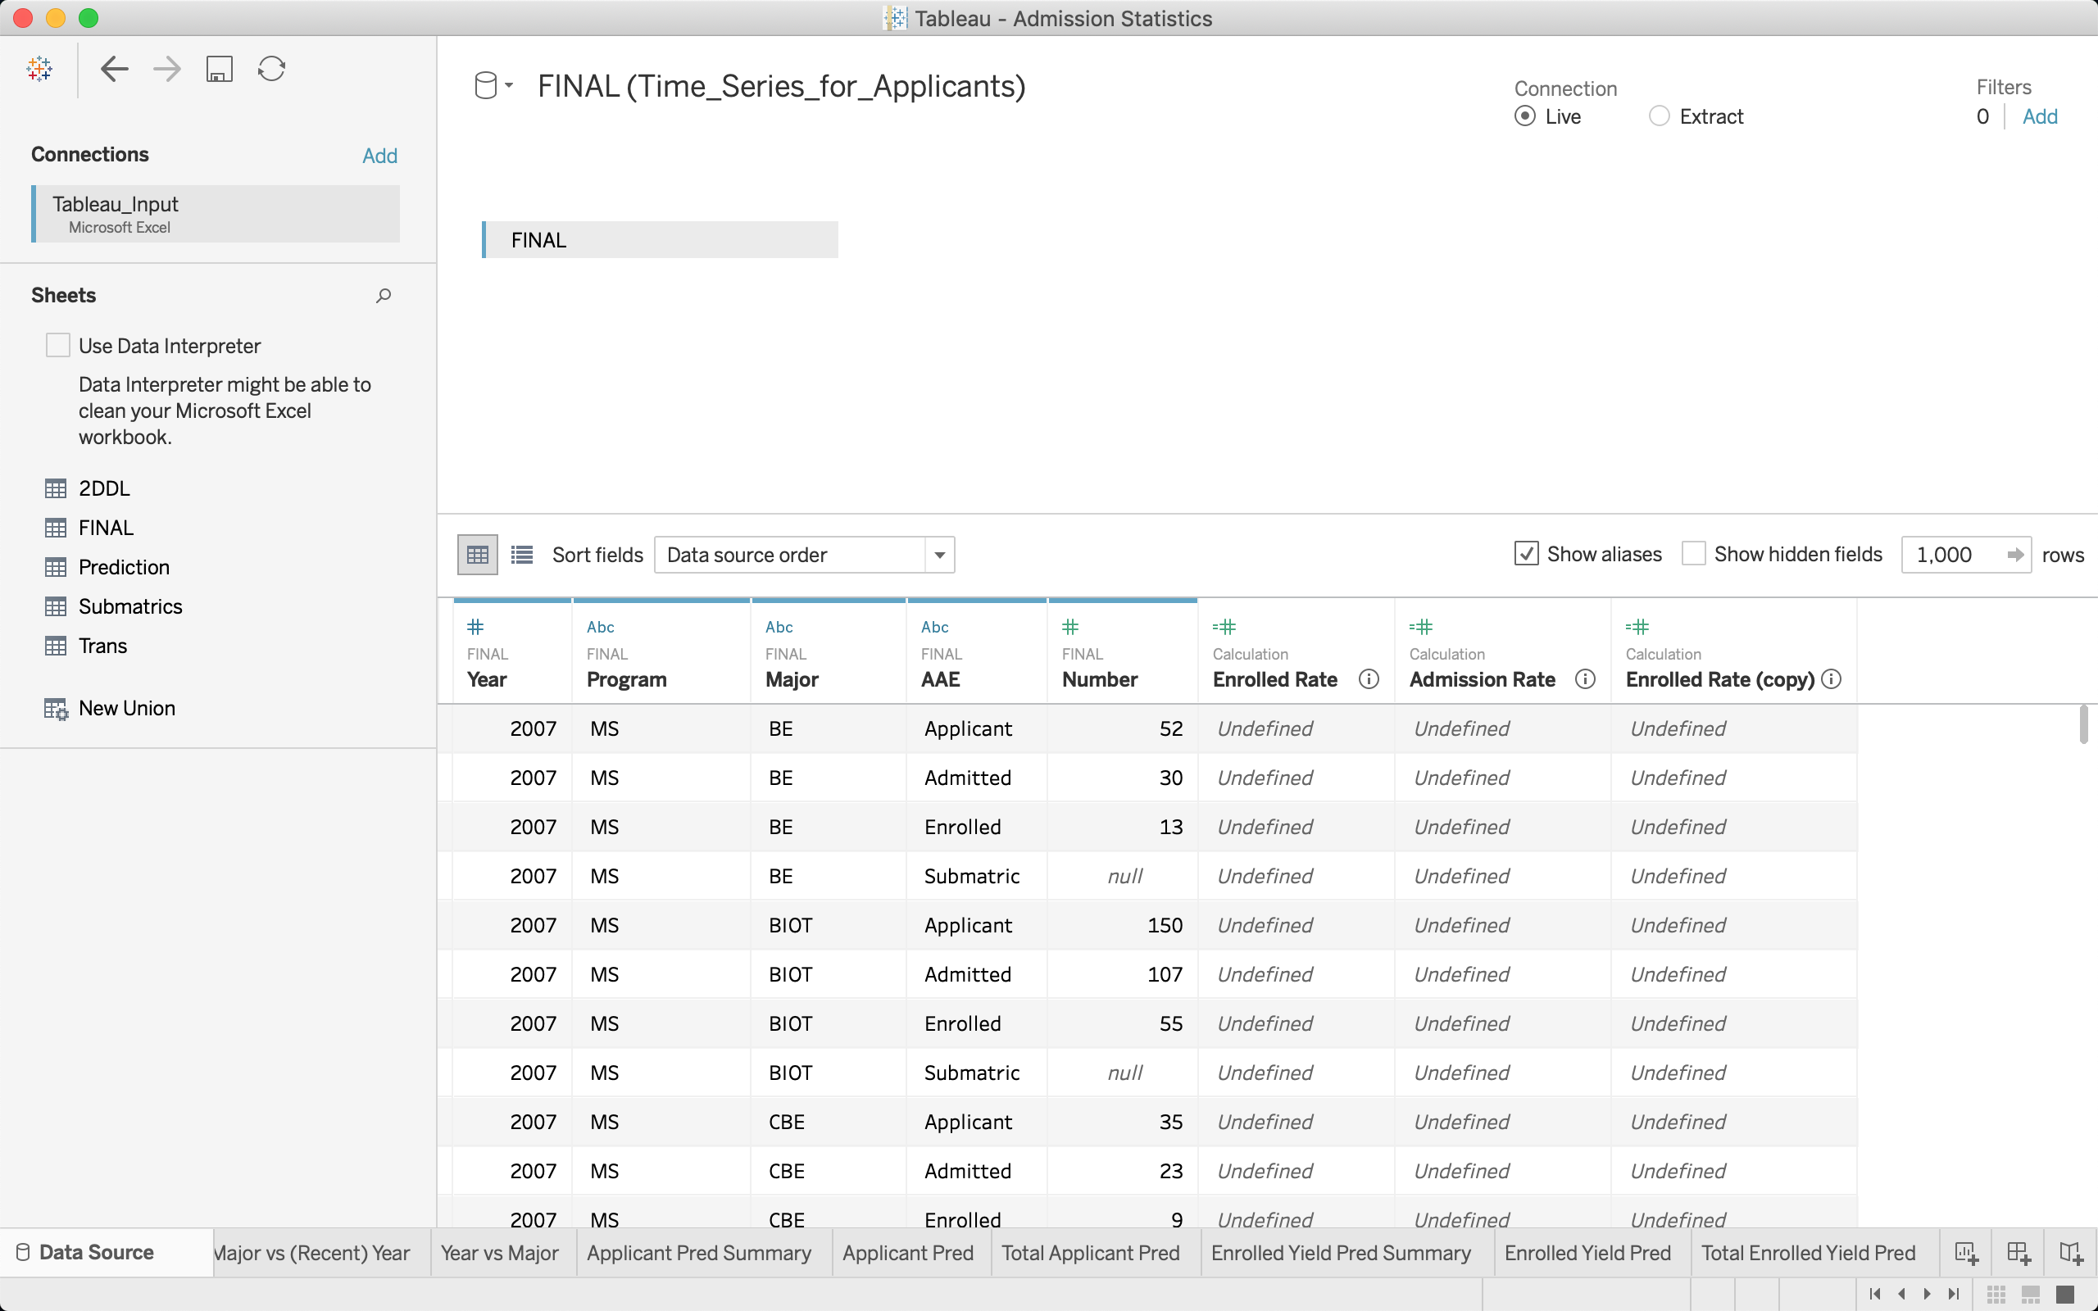

Click on any of the tabs to the right of the “Data Source” tab at the bottom and this will bring you to the various graphs hosted on this dashboard. Each visualization page consists of a graph (center), data to use (on the left), graph editing options (immediately above and to the left of the graph), and filtering options (right of the graph).

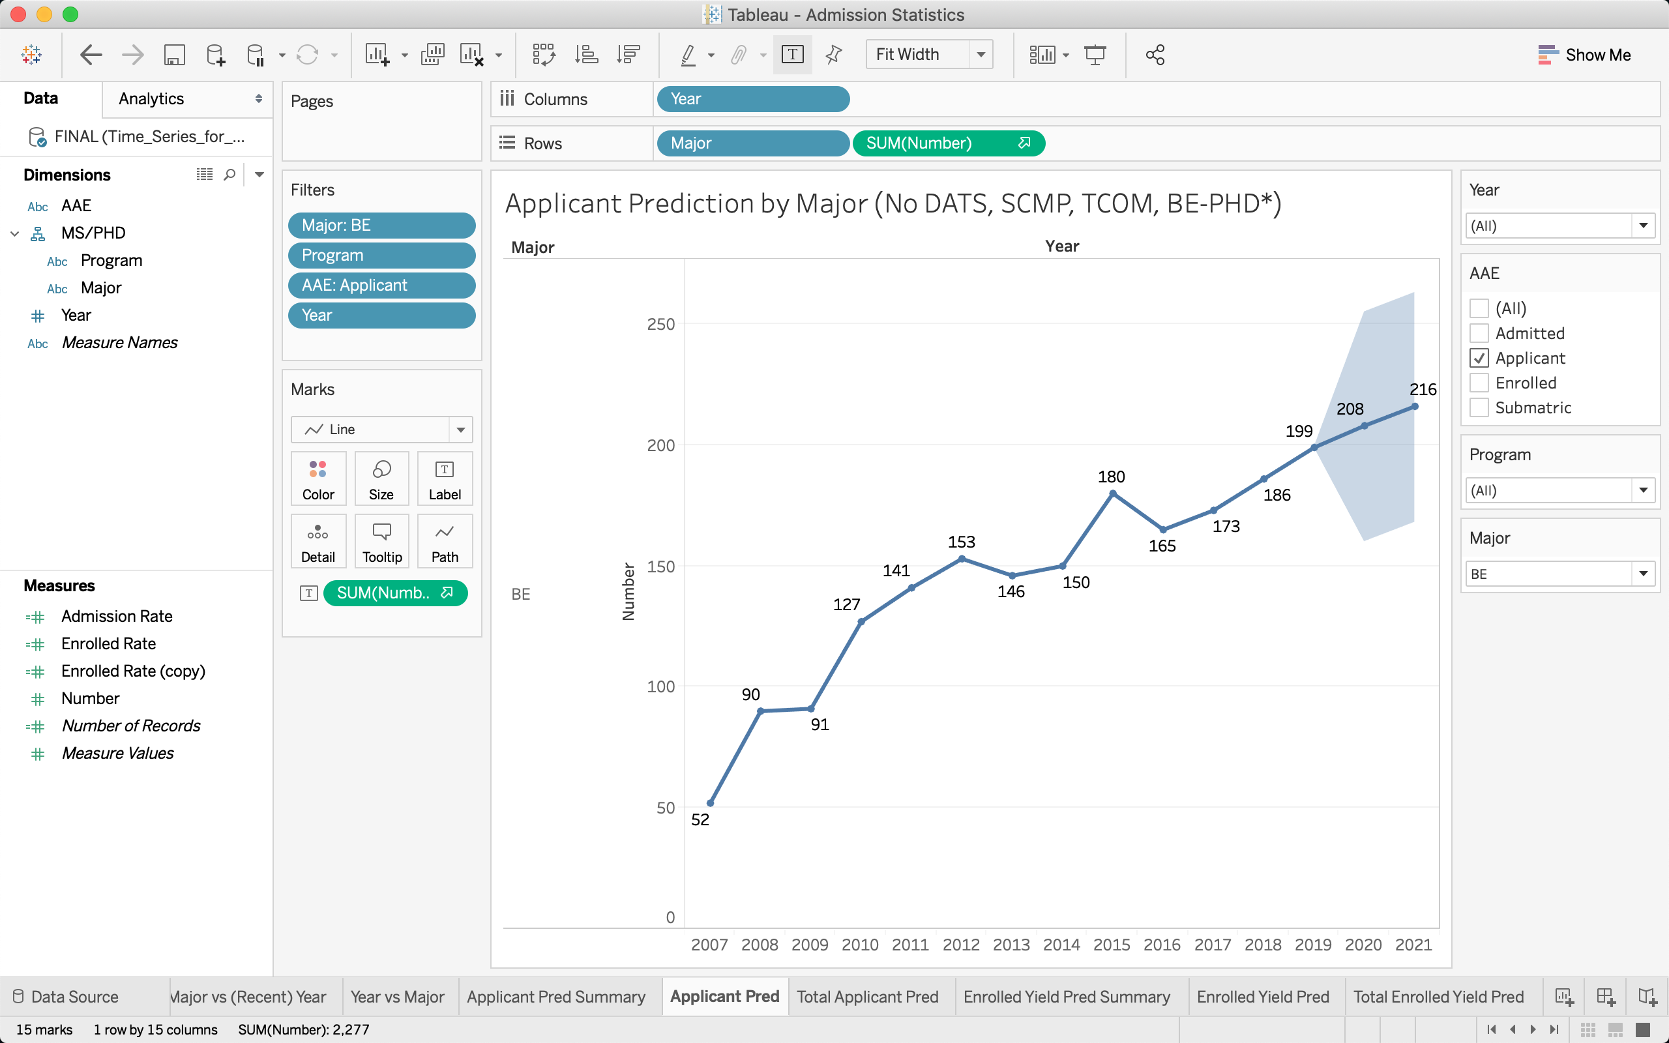

The graphs are interactive: you can hover over items to get more detail. You can also adjust the filtering options and the graphs will update accordingly (i.e. adjust the program you want the graph to show.

**UPDATING DATA**

Whenever the data needs to be updated (i.e. adding a new year of admissions statistics), you should use “Tableau_Input.xlsx”. The spreadsheet is split between multiple pages, with each Tableau file pulling from a specific page in the spreadsheet:

1. “FINAL” contains the main admissions data. It contains the number of students applied/admitted/enrolled/submatriculated sorted by year, program (MS or PhD), and major. “Admission Statistics.twbx” and “Admission Statistics Submat Pred.twbx” pull from this page.
2. “2DDL” is a more granular view of a subset of “FINAL”. In particular, “2DDL” considers only external applicants (so not submats) and sorts the number of students applied/admitted/enrolled by year, program, major, AND the relevant deadline. For example, if systems engineering (SE) had two deadlines, then there are enrollment numbers for both deadlines (the sum of these two numbers would be the SE enrollment number for the corresponding row in “FINAL”). The deadline associated with the number is under the column “DDL” where 1 denotes the first deadline, 2 denotes the second, and 0 denotes when a one deadline format is being followed. Also note that the enrolled status is split between “Enrolled1” and “Enrolled2”, which represent initial enrollment and final enrollment respectively. “Admission Statistics - 2DDLv1DDL.twbx” pulls from this page.
3. “Submatrics” is a subset of “FINAL” that only contains the submatriculant data.
4. “Trans” contains the transfer student data.
5. “Prediction” summarizes some recent prediction results and evaluates the performance of these predictions.

You will primarily be editing the “FINAL” and “2DDL” pages when updating the data. When updating, it is important that you maintain the provided format. Once you finish updating, save the file and navigate back to your Tableau file of interest. To refresh Tableau so that these changes are reflected in the graphs,

* Go to the “Data Source” tab,
* Under “Connections” in the upper left, click the drop down arrow by “Tableau_Input”,
* Click “Edit Connection…”,
* Select the “Tableau_Input.xlsx” spreadsheet you just saved (note this should be in the directory you saved the spreadsheet to and may not be the one that Tableau automatically navigated to when you clicked “Edit Connection…”),
* Click “Open”.

Now you should see all your plots and charts reflect the changes you’ve made. If not, click “Refresh Data Source” at the top left (next to the save icon, it looks like circular arrows) under the “Data Source” tab.

**ALTERING GRAPHS**

You have the option to change a graph beyond the filtering options using the data selection and graph editing options. You can change the following,

* “Dimensions” are categorical features of your data such as the name of each major. You can select which “Dimensions” you want to include or remove. You can also modify the dimensions by clicking the drop down arrow next to each dimension. For example, you can rename certain categories within the feature using the “Aliases…” option.
* “Measures” are numerical features of your data such as the enrollment numbers. Other than their different interpretation, “Measures” have many similar features to “Dimensions” and behave somewhat similarly. You can perform custom calculations on “Measures” to obtain other features, such as using application and admission numbers to generate admissions rates.
* “Columns” and “Rows” specify what each column and row will represent respectively. You can drag “Dimensions” and “Measures” (or any sort of derivative of them) here to populate the axes of your graph.
* “Filters” allows you to selectively display the data. For example, dragging “Year” to “Filters” will allow you to choose which years to view. These filters can also be displayed interactively to the immediate right of the graph.
* “Marks” provides other detailing options for your graph as follows.
  + The first drop down (labeled “Line” in this case) allows you to select the type of graph you want to have such as a scatterplot, bar chart, heat map, etc.
  + “Color” allows you to customize the color options of your graph. Dragging a feature to “Color” allows you to segment/split your graph based on that feature by color (i.e. you can have CIS students show up in a different color).
  + “Size” allows you to modify the sizes of parts of your graph. Dragging a feature to “Size” allows you to segment/split your graph based on that feature by size (i.e. you can have majors with larger numbers appear larger).
  + “Label” allows you to adjust the text in your graph. Dragging a feature to “Label” allows you to mark data points on your graph by that feature with text.

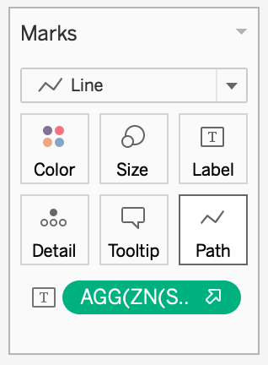

**CREATING GRAPHS**

The process of creating graphs is very similar to the process detailed in “Altering Graphs” above except you start with a blank slate. The “Show Me” tab at the top right of the window can be very helpful when generating new graphs as it provides templates.