**Homework 2**

1 a. Write AVR instructions that store your full name (all CAP ASCII characters, no spaces) into internal SRAM starting at address 0x0100.

b. Add a loop that takes each character, converts it to lower case and stores it into internal SRAM starting at address 0x0130. Note: adding 0x20 to an upper case ASCII character results in a lower case ASCII character.

2. The DAC output shown is observed when a 4-bit binary ramp is applied to the inputs.

Complete the table with the output code observed in the diagram & identify the type of error(s).

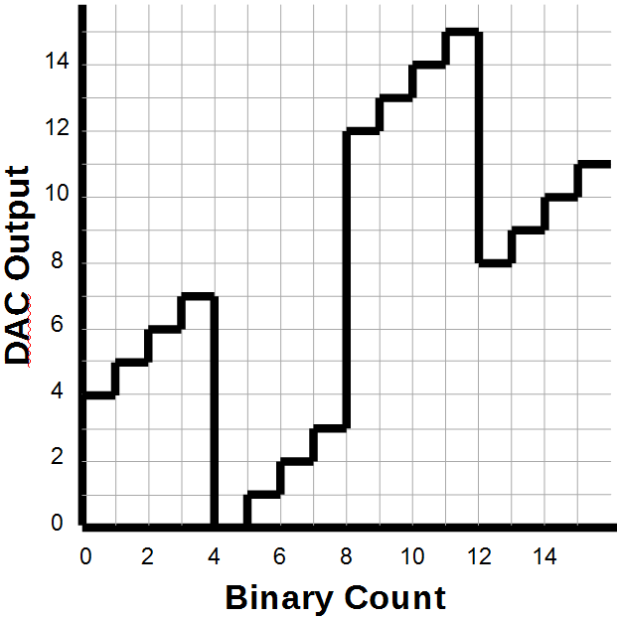

|  |  |  |
| --- | --- | --- |
|  | **Input Code** | **Output Code** |
| 0 | 0000 |  |
| 1 | 0001 |  |
| 2 | 0010 |  |
| 3 | 0011 |  |
| 4 | 0100 |  |
| 5 | 0101 |  |
| 6 | 0110 |  |
| 7 | 0111 |  |
| 8 | 1000 |  |
| 9 | 1001 |  |
| 10 | 1010 |  |
| 11 | 1011 |  |
| 12 | 1100 |  |
| 13 | 1101 |  |
| 14 | 1110 |  |
| 15 | 1111 |  |

3. Draw the schematic for a binary-weighted DAC that allows 52 different digital values.

Use generic resistor values, R, 2R, etc. Set the MSB circuit gain to AV = ½ .

4. For a certain 8-bit SAR, the conversion time for Vin=1V is 80us.

What will be the conversion time for Vin=1.5V? Vin=2.0V?

5. Consider a dual-slope ADC with Vref = -1.0V, R = 20KΩ, C = 10nF and integration time of 280μs. Calculate the total conversion time when Vin = +2.3 V.