LAB01 – DAC vs DAC
Zach D'Agostino

The intention of this lab is to simulate two types of DAC types using LTSpice and draw comparisons between the two. The two types of DACs under test are the R-2R DAC and the Binary-Weighted DAC.
To test the simulation, I took a measurement of our ideal binary count based upon the sum of binary outputs and compared them to each DAC type's ouput.

In Figure 1, we have our ideal binary count in red, the R-2R DEC in green and the Binary-Weighted DAC in blue.

Figure 1:
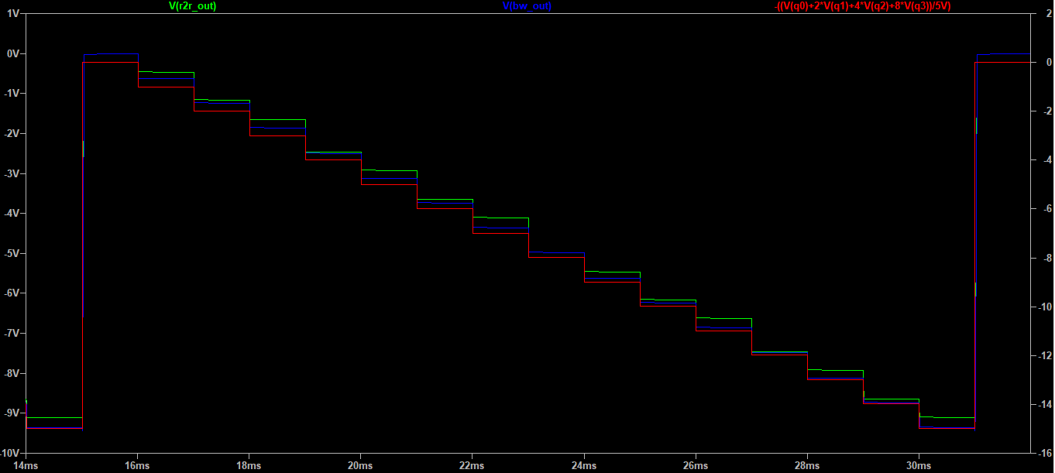
In this simulation we see that both DAC match the our ideal output in red. The BW DAC appears more effective in producing our desired count. At the LSB, the BW DAC (in blue) is offset by 100-200mV. But as we reach the MSB, we see the BW DAC output is spot on with out ideal output. The R-2R output appears less consistent. Sometimes it is off by 100mV and other times by 300mV.

Through this simulation, we found that the Binary-Weighed DAC performs more closely to our target output and functions with more consistency.

Questions/Deliverables:

1. What variables determine the step size?
There are a few variables that determine the step size. Rf on the Inverting Configuration will dictate the scale. Increasing the resistance of Rf increases expands the scale/increases the output amplitude while decreasing Rf will scale the amplitude down.
The other variables that determine the step size are the other resistors. For example, on the R2R DAC, changing all the 1k resistors to a different value will the scale the voltage like adjusting Rf, however, making them larger will decrease the scale of the output amplitude while decreasing the resistor values will increase the scale of the output amplitude.
The same logic can also be applied to the BW DAC, but the would depend more on the total parellel resistance of the 4 resistors.

2. How difficult would it be to expand the number of bits for each of these DAC types? Explain.
To expand the number of bits for the BW DAC type, one would need to add a resistor for each bit that is added. To keep with the same ratio/scaling to match the 1k reference resistor on the op amp, the resistor values would need to be adjusted to accomidate the extra bits. For example adding a 5th bit (or Q4), the resistor tied to Q0 would need to be increased to 16k, Q1 to 8k, Q2 to 4k, Q3 to 2k, and Q4 would be 1k.

To expand the number of bits for an R-2R, you wouldn't need to adjust any values, but you will have to add 2 resistors for each added bit in order to create the approptiate voltage divider. The resistors added would be R and 2*R to match the other resistors in the configuration.

