
BNO055-Bit module

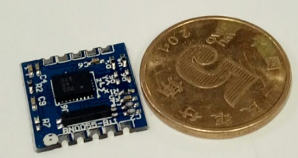

- Introduction
A high precision, low power, low cost AHRS module BNO055-Bit is using Bosch high-precision 9-axis sensor BNO055, which contain 3D 12-bit digital accelerometer, 3D 16-bit digital gyroscope and 3D digital magnetometer, with an Atmel 32-bit Cortex-M0+ MCU inside. Through the fusion algorithm to calculate the quaternion, Euler angle, linear acceleration, gravity, etc., directly available for the user, so that users can directly use the relevant parameters. Shorten the user's development cycle and reduce the difficulty of development.
The BNO055 can also provide single data for three types of sensors (accelerometer / gyroscope / magnetometer) alone, as well as providing combined data, to provide more application support for products such as smartphones and wearing devices through built-in MCU calculations.

- features
Model | BNO055-Bit module
Size | 15*15MM
Power | 2.4V~3.6V
Working mode | Normal mode, low power mode, pause mode
Working temperature | -40°C ~+85°C
Communication interface | I2C
Combined data output | Output acceleration, geomagnetism, gyro sensor fusion data, including quaternion data and Euler data
- pin define
Pin1 | SDA | BNO055 I2C Communication data line
Pin2 | SCL | BNO055 I2C Communication clock line
Pin3 | INT | BNO055 INT1 Interrupt line 1
Pin4 | RESET | BNO055 Reset pin
Pin5 | GND | Power ground
Pin6 | GND | Power ground
Pin7 | BOOT | Bootloader Mode selection (default high)
Pin8 | I2C_Addr | BNO055 I2C Address selection line
Pin9 | GND | Power ground
Pin10 | VCC | Power anode（range in 2.4V~3.6V）

- package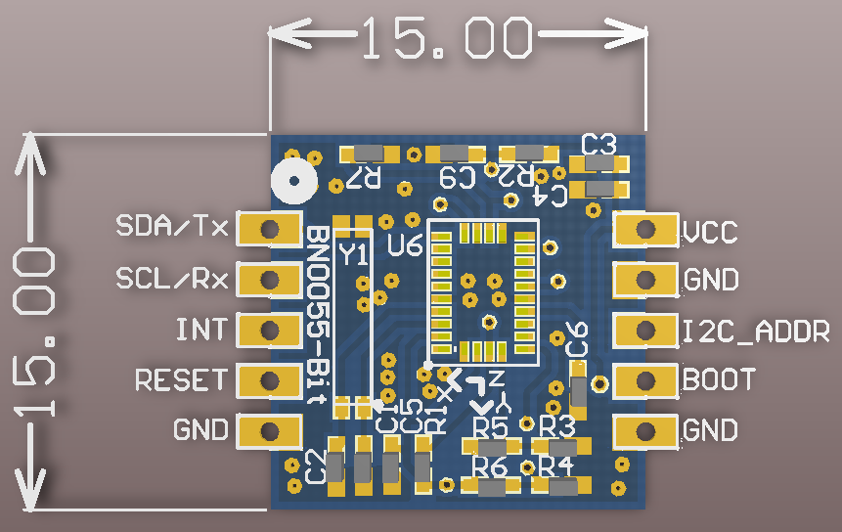
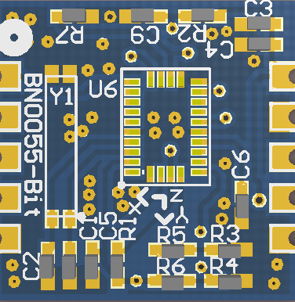
OWL-BNO055-Bit
- BNO055 block diagram
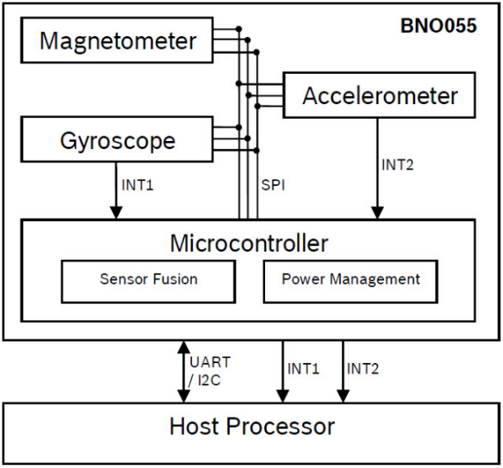
- Application
Module OWL-BNO055-Bit can be used directly for unmanned aerial vehicles, balance cars, wearable devices, hand-held instrumentation, robot navigation and other products.
