**[37. Sudoku Solver](https://leetcode-cn.com/problems/sudoku-solver/)**

Write a program to solve a Sudoku puzzle by filling the empty cells.

A sudoku solution must satisfy all of the following rules:

Each of the digits 1-9 must occur exactly once in each row.

Each of the digits 1-9 must occur exactly once in each column.

Each of the the digits 1-9 must occur exactly once in each of the 9 3x3 sub-boxes of the grid.

Empty cells are indicated by the character '.'.

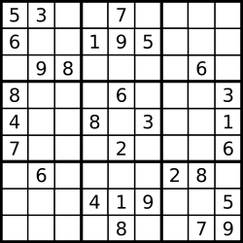

A sudoku puzzle...

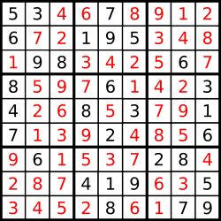

...and its solution numbers marked in red.

Note:

The given board contain only digits 1-9 and the character '.'.

You may assume that the given Sudoku puzzle will have a single unique solution.

The given board size is always 9x9.

来源：力扣（LeetCode）

链接：https://leetcode-cn.com/problems/sudoku-solver

著作权归领扣网络所有。商业转载请联系官方授权，非商业转载请注明出处。

[37. 解数独](https://leetcode-cn.com/problems/sudoku-solver/)

编写一个程序，通过已填充的空格来解决数独问题。

一个数独的解法需遵循如下规则：

数字 1-9 在每一行只能出现一次。

数字 1-9 在每一列只能出现一次。

数字 1-9 在每一个以粗实线分隔的 3x3 宫内只能出现一次。

空白格用 '.' 表示。



一个数独。



答案被标成红色。

Note:

给定的数独序列只包含数字 1-9 和字符 '.' 。

你可以假设给定的数独只有唯一解。

给定数独永远是 9x9 形式的。

来源：力扣（LeetCode）

链接：https://leetcode-cn.com/problems/sudoku-solver

著作权归领扣网络所有。商业转载请联系官方授权，非商业转载请注明出处。

class Solution {

public void solveSudoku(char[][] board) {

}

}

[["5","3",".",".","7",".",".",".","."],["6",".",".","1","9","5",".",".","."],[".","9","8",".",".",".",".","6","."],["8",".",".",".","6",".",".",".","3"],["4",".",".","8",".","3",".",".","1"],["7",".",".",".","2",".",".",".","6"],[".","6",".",".",".",".","2","8","."],[".",".",".","4","1","9",".",".","5"],[".",".",".",".","8",".",".","7","9"]]