Centos7.0安装及配置步骤
- 保证先联网.
nat配置
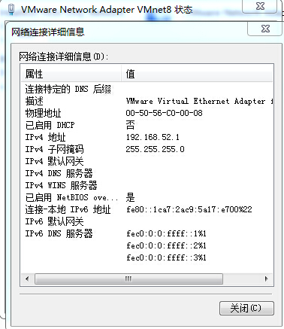
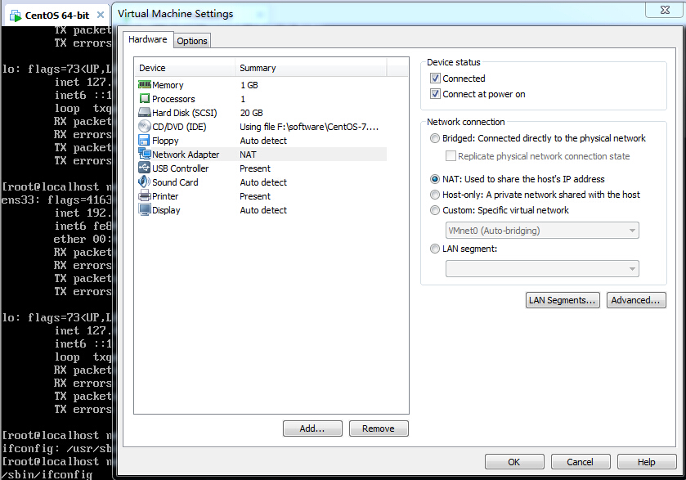

：vi /etc/sysconfig/network-scripts/ifcfg-xxx(xxx表示网络接口名)，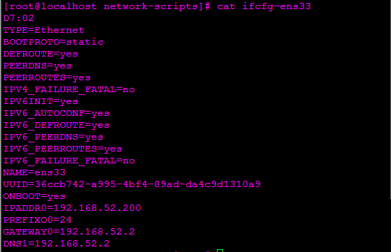关键设置对BOOTPROTO,ONBOOT,IPADDR0,PREFIXO0,GATEWAY0,DNS1,(DNS2)

- net-tools安装(为了得到ifconfig命名)
yum install net-tools

/sbin/iptables -I INPUT -p tcp --dport 80 -j ACCEPT

- django1.4.15（python web框架）
tar zxvf Django-1.4.15.tar.gz
cd Django-1.4.15
python setup.py install
- dojango-0.5.5（python第三方库）
tar zxvf dojango-0.5.5.tar.gz
cd dojango-0.5.5
python setup.py install
- South-1.0（python第三方库）
- ipaddr-2.1.11（python第三方库）
- flup-1.0.2(python第三方库)
- httplib2-0.9.tar(python第三方库)
- oauth2-1.5.211(python第三方库)
- libxml2-2.7.5.tar.gz
- libxml2-python-2.6.9.tar.gz(python第三方库)
yum install libxml2-python
- simplejson-3.6.4(python第三方库)
- eventlet-0.15.2(python第三方库)
- greenlet-0.3.4(python第三方库)
- python-ldap2.4.18(python第三方库
yum install python-ldap()
- dnspython-1.12.0(python第三方库)
- django-json-rpc-0.6.1(python第三方库)
- python-daemon-1.5.5.tar.gz(python第三方库)
- python-dateutil-2.2.tar.gz(ptyhon第三方库)
- psutil-2.1.3(python第三方库)
- pyzmq-14.3.1(杨杰所需)
- tornado-4.0(杨杰所需)
- sockjs-tornado-1.0.1(杨杰所需)
- Berkeley DB-4.7.25(oracle db)
tar –zxvf db-4.7.25.tar.gz
cd build_unix
../dist/configure
Make & make install
- bsddb3-6.10(python第三方库)
- python-devel()
centos7.0 安装greenlet时报错：fatal error: Python.h: No such file or directory
系统中没有Python.h的原因，是因为没有安装python的开发版，即Python-devel这个包，命令提示符下执行
yum install python-devel
即可。
http://rpmfind.net/linux/rpm2html/search.php?query=python-devel
- gcc安装
yum install gcc
yum group install "Development Tools"

- pcre-8.36
- zlib-1.2.8
- openssl
- nginx-1.6.2
tar –zxvf nginx-1.6.2.tar.gz
cd nginx-1.6.2
./configure
Make
Make install
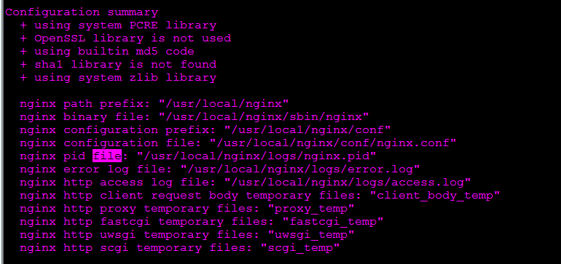

备注：
/etc/rc.freenas，/etc/rc.subr，/etc/version
/usr/local/www（特别是data/django.fcgi，chmod 755 django.fcgi）
Nginx配置
/data/freenas-v1.db

1.Cd /usr/local/www/freenasUI python manage.pyc runfcgi method=threaded host=127.0.0.1 port=9042

2.Cd /usr/local/nginx/sbin ./nginx

3. /sbin/iptables -I INPUT -p tcp --dport 80 -j ACCEPT

python /DTS/DTSManage/mange.py runfcgi method=threaded host=127.0.0.1 port=8100
/usr/local/nginx/sbin/nginx -c /usr/local/nginx/conf/nginx.conf

nginx配置php老是出错，最后才发现是$document_root的设置问题。
location ~ \.php$ {
root html;
fastcgi_pass 127.0.0.1:9000;
fastcgi_index index.php;
fastcgi_param SCRIPT_FILENAME $document_root$fastcgi_script_name;
include fastcgi_params;
}
这个用出现找不到php的错误。因为$document_root 的参数是由root html那一行定义的，默认是在/etc/nginx/html/ 所以把 html换成站点根目录就正常了。
location ~ \.php$ {
root /usr/share/nginx/html;
fastcgi_pass 127.0.0.1:9000;
fastcgi_index index.php;
fastcgi_param SCRIPT_FILENAME $document_root$fastcgi_script_name;
include fastcgi_params;
}

