**Code Implementation**[1]

- Assumption

1. The collision point is the center of the ball

2. After first collision, the ball rolls(not slides).

3. If the ball’s velocity becomes 5% of initial velocity then regard it as stopped

- Code

1. detect_collision

for θ:0~2π

if (Table[(center)+(Rcosθ,Rsinθ)]==obstacle)

isDetected = True

angle.append(θ)

angle = mean(angle)

if (isDetected)

collision_count++

collide(-angle)

2. collide($θ$)

$v_{T}=v_{x}sinθ+v_{y}cosθ$

$v_{N}={-v}_{x}cosθ+v_{y}sinθ$

$v_{N}^{'}=-ev_{N} (e=0.95)$

$v_{x}^{'}=v_{T}sinθ-v_{N}cosθ$

$v_{y}^{'}=v_{T}cosθ+v_{N}sinθ$

$\vec{ω}=follows rolling$

There are some computational issue. First, because the computation is discrete, the ball overlaps with the obstacle. Not exactly meet at one point**(Fig#####).** Second, if the ball is slow, it cannot escape the overlap region after the collision. So then the collision is detected continuously**(Fig#####).**

To manage the first issue, we found the range of angle that overlaps with the obstacle and assumed the collision point angle as middle point of these range. For the second issue, we set the flag variable to prevent contiguous collision.

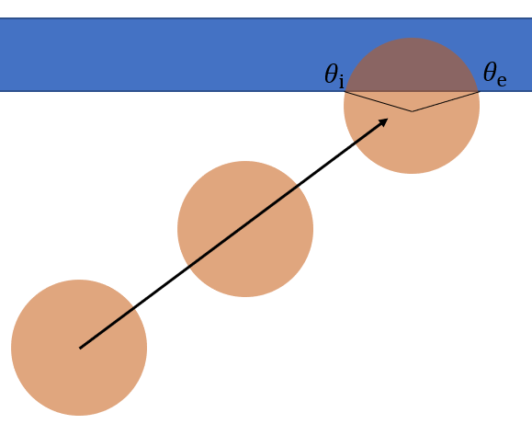 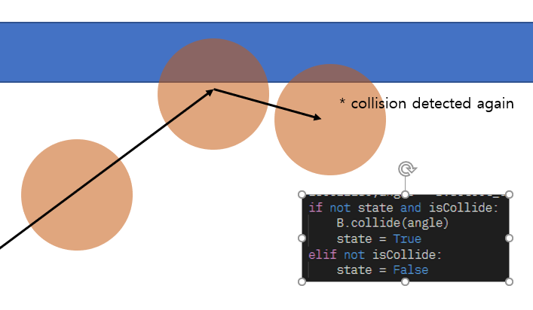

**Result**

We want to know the relation between the cue stick velocity and the number of collision. So we constructed the simulation code which runs below testcase set.



As results, we found that the number of collision linearly increases as the cue stick velocity increases. To make trend lines softer, we must diversify the testcase set. But the time cost per each testcase is too large, we cannot run the simulataion more precisely.

|  |  |
| --- | --- |
|  |  |
|  |  |
|  |  |
|  |  |

**Conclusion**

We would like to understand in more detail the collision we had learned only from theory through billiard ball trajectory simulation. Our simulation has two steps: the first is the initialization process, which creates a billiard table, positions the initial billiard ball, and sets the hitting point and speed of the cue stick. The second is a record of trajectory motion. The ball's exercise is divided into sliding and rolling exercises, and each has different coefficient of friction, so we have to consider it separately.

Through this theoretical background, we will express the trajectory of the billiard ball movement in a two-dimensional plane, analyze the distance moved, and analyze the number of collisions.

**Reference**

* Mathavan, Senthan & Jackson, M & Parkin, Robert. (2010). A theoretical analysis of billiard ball dynamics under cushion impacts. Proceedings of The Institution of Mechanical Engineers Part C-journal of Mechanical Engineering Science - PROC INST MECH ENG C-J MECH E. 1. 1-10. 10.1243/09544062JMES1964.
* Leckie, Will & Greenspan, Michael. (2006). An Event-Based Pool Physics Simulator. 247-262. 10.1007/11922155_19.

1. <https://github.com/dongha-yoon/Computational_Physics/>