**TreeBuilder**

**“Builder 패턴”**

**Author : Ganghee-Lee**

**Date : 2019-11-27**

# Overview

**Director : Parser**

**Builder : TreeBuildeer**

**Concrete Builder : HtmlTreeBuilder / XmlTreeBuilder**

**Product : Document**

Parser에서 parseInput()을 통해 treebuilder의 parse()를 호출한다.

treebuilder의 parse()에서는 각각 Concrete Builder의 initialiseParse 메소드를 호출하여 Product인 Document에 part들을 생성하고 추가한다.

# Class Diagrams

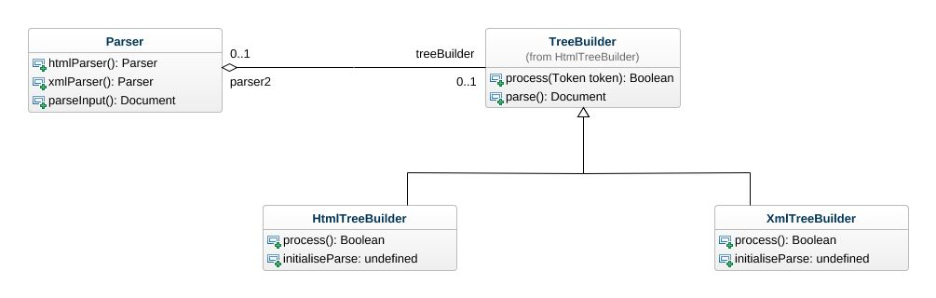



### Class Parser

Attributes

* htmlParser() : Parser
* attribute : Undefined
* xmlParser() : Parser
* parseInput() : Document

Implemented interfaces

* Request

Associations

* treeBuilder : TreeBuilder

### Class HtmlTreeBuilder*.*

Attributes

* process() : Boolean
* attribute : Undefined
* initialiseParse : Undefined

Implemented interfaces

* Request

Super classes

* TreeBuilder

Nested classifiers

* Class TreeBuilder

### Class HtmlTreeBuilder::TreeBuilder

Attributes

* process(Token token) : Boolean
* attribute : Undefined
* parse() : Document

Implemented interfaces

* Request

Direct sub-classes

* HtmlTreeBuilder
* XmlTreeBuilder

Associations

* parser : Parser

### Class XmlTreeBuilder

Attributes

* process() : Boolean
* attribute : Undefined
* initialiseParse : Undefined

Implemented interfaces

* Request

Super classes

* TreeBuilder