**HtmlTreeBuilderState**

**“State 패턴”**

**Author : Ganghee-Lee**

**Date : 2019-11-27**

# Overview

HtmlTreeBuilder는 두개의 state (Original, Current state)를 가지고 있다. HtmlTreeBuilder가 process 메소드 호출하면 state.process가 호출된다.

HtmlTreeBuilderState에는 Initial, BeforeHtml …​가 enum으로 존재하고 있고 각각 enum마다 process 메소드가 다르게 정의되어 있으며state에 따라 각기 process 메소드의 behavior가 다르고 behavior의 마지막에서는 transition을 통해 매번 state를 바꿔준다.

# Class Diagrams

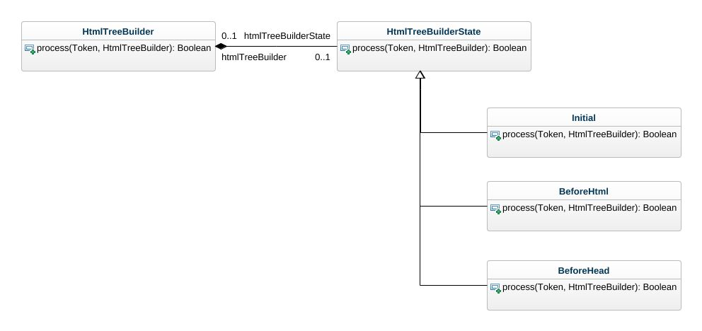

### Class HtmlTreeBuilder*.*

Attributes

* process(Token, HtmlTreeBuilder) : Boolean

Implemented interfaces

* Request

Super classes

* TreeBuilder

Nested classifiers

* Class TreeBuilder

### Class HtmlTreeBuilderState

Attributes

* process(Token, HtmlTreeBuilder) : Boolean

Implemented interfaces

* Request

Super classes

* TreeBuilder

Direct sub-classes

* BeforeHtml
* BeforeHead
* Initial

Associations

* htmlTreeBuilder : HtmlTreeBuilder

Nested classifiers

* Class TreeBuilder

### Class BeforeHtml

Attributes

* process(Token, HtmlTreeBuilder) : Boolean

Implemented interfaces

* Request

Super classes

* HtmlTreeBuilderState
* TreeBuilder

Nested classifiers

* Class TreeBuilder

### Class BeforeHtml

Attributes

* process(Token, HtmlTreeBuilder) : Boolean

Implemented interfaces

* Request

Super classes

* HtmlTreeBuilderState
* TreeBuilder

Nested classifiers

* Class TreeBuilder

### Class BeforeHead

Attributes

* process(Token, HtmlTreeBuilder) : Boolean

Implemented interfaces

* Request

Super classes

* HtmlTreeBuilderState
* TreeBuilder

Nested classifiers

* Class TreeBuilder