**Jsoup_Flow**

**“Jsoup의 전체적인 흐름”**

**Author : Ganghee-Lee**

**Date : 2019-11-24**

**Overview**

Jsoup에서 HttpConnection에게 Uri을 주면서 connect 요청

HttpConnection에서 Request와 Response를 보유하고있음

HttpConnection에서 connect받으면 전달받은 Uri에 사용할 proxy를 설정하고 자신을 return

이 과정에서 HttpConnectin의 이너클래스 request에서 Parser의 htmlparser메소드를 호출한다.

htmlparser는 Parse(treebuilder를 보유) 에서 HtmlTreeBuilder넣은 Parser를 return 한다.

HtmlTreeBuilder는 Tag를 search하기 위해 String 배열들을 갖고있다.

# Class Diagrams

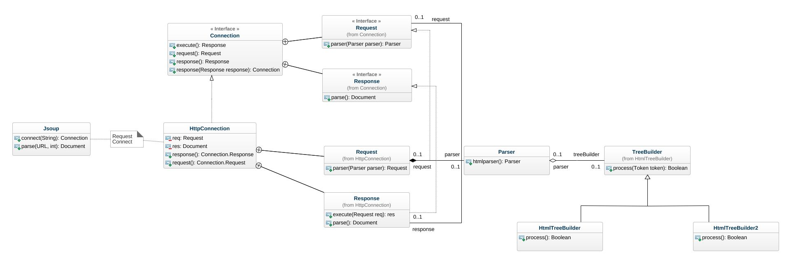

### 

### Class Jsoup

### Attributes

* connect(String) : Connection
* parse(URL, int) : Document

### Class HttpConnection

Attributes

* req : Request
* res : Document
* parser(Parser parser) : HttpConnection
* response() : Connection.Response
* request() : Connection.Request

Implemented interfaces

* Connection

Nested classifiers

* Class Request
* Class Response

### Class HttpConnection::Request

Attributes

* parser(Parser parser) : Request

Implemented interfaces

* Request

Associations

* parser : Parser

### Class HttpConnection::Response

Attributes

* execute(Request req) : res
* parse() : Document

Implemented interfaces

* Response

Associations

* request : Request

### Interface Connection

Attributes

* execute() : Response
* request() : Request
* response() : Response
* response(Response response) : Connection

Nested classifiers

* Interface Request
* Interface Response

### Interface Connection::Request

Attributes

* parser(Parser parser) : Parser

Associations

* response: Class Response

### Interface Connection::Response

Attributes

* execute(Request req) : Undefined
* parse() : Document

### Class Parser

Attributes

* htmlparser() : Parser
* attribute : Undefined

Implemented interfaces

* Request

Associations

* request : Request
* treeBuilder : TreeBuilder

### Class HtmlTreeBuilder*.*

Attributes

* process() : Boolean
* attribute : Undefined

Implemented interfaces

* Request

Super classes

* TreeBuilder

Nested classifiers

* Class TreeBuilder

### Class HtmlTreeBuilder::TreeBuilder

*No description.*

Attributes

* process(Token token) : Boolean[1]

Implemented interfaces

* Request

Associations

* parser : Parser

### Class XmlTreeBuilder::TreeBuilder

*No description.*

Attributes

* process(Token token) : Boolean[1]

Implemented interfaces

* Request

Associations

* parser : Parser