目录

1. 背景 1

2. 纹理理论和方法 2

2.1 扩展纹理集 2

2.2.1 均值和协方差矩阵 2

2.2.2特征值和特征向量 3

2.2.3 中心化 3

2.2.4 随机生成 4

2.2 选择纹理 4

# 背景

大草场 长密狗尾巴草 照片：DSC00975

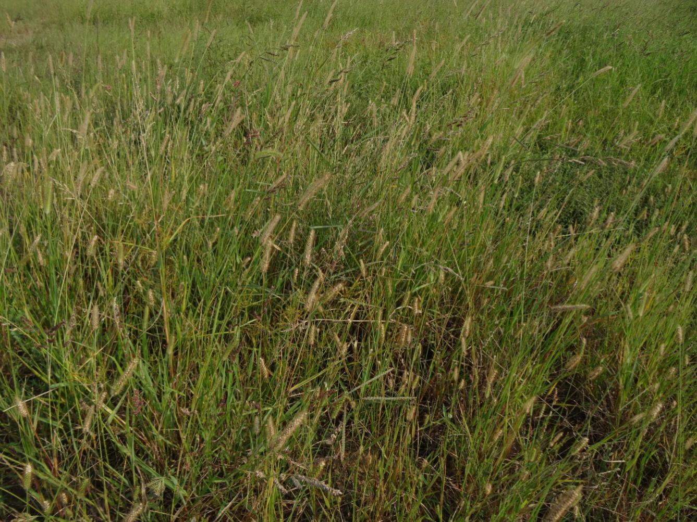

光谱：0039~0040

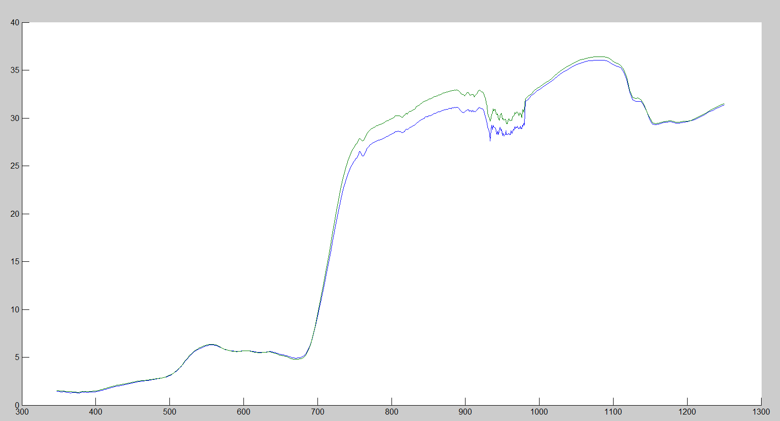

随机生成10条光谱曲线：

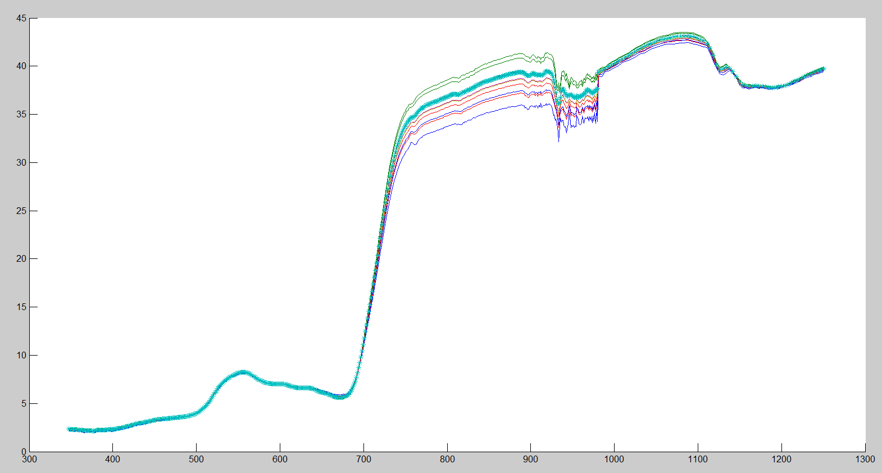

# 2. 纹理理论和方法

## 2.1 扩展纹理集

### 2.2.1 均值和协方差矩阵

从一个实际地表类型所对应的光谱（假设它服从正态分布 ，进行次采样需要条原始曲线）对应的均值向量和协方差矩阵（注意：不同维度之间的协方差）分别为





这里， 和 是每一类的均值向量和协方差矩阵， 是光谱上第个点的均值， 是这个类中第个光谱均值和第个光谱均值之间的协方差。

### 2.2.2特征值和特征向量

计算这个协方差矩阵的特征值值和特征向量，分别为





这里满足： 并且 的每一列都是特征值相对应的归一化特征向量。

### 2.2.3 中心化

通过特征向量 将原始的光谱数据转化为以零为中心的光谱非相关的数据



这个非相关的数据服从，且其协方差矩阵 满足



### 2.2.4 随机生成

用非相关的协方差矩阵生成多变量随机变量分布 。首先产生一组满足 的高斯随机数 组成的向量

对方程进行逆变换得到



为了服从多变量随机变量的分布，需要用到许多多变量统计数据来代表反射率曲线（注意：任何非零的值都要截断成零）。

为了获得更快的计算机运行速度，先优先用某种材料（这里使用草地）的特定像素进行一致抽样来产生一组曲线（比如100条曲线）。

## 2.2 选择纹理

对于某种特定材质类型的光谱数据库的每一条曲线，都可以得到每条曲线在这一组曲线中的评定，先计算曲线反射率的均值



这里，是第条曲线在波长为时的光谱反射率，是第条曲线在光谱条带上的采样数目，时曲线数据库中第条曲线从到之间反射率的均值。所有曲线的均值和标准差分别为





一旦确定光谱数据，这组光谱数据中每条曲线的-值的计算为



这个-值将会用来选择纹理图像中与特定亮度相匹配的曲线。

Matlab程序：

clear

load HR.090715.0000_moc.txt

load HR.090715.0001_moc.txt

load HR.090715.0002_moc.txt

load HR.090715.0003_moc.txt

load HR.090715.0004_moc.txt

load HR.090715.0005_moc.txt

load HR.090715.0006_moc.txt

load HR.090715.0007_moc.txt

load HR.090715.0008_moc.txt

load HR.090715.0009_moc.txt

load HR.090715.0010_moc.txt

load HR.090715.0011_moc.txt

load HR.090715.0012_moc.txt

load HR.090715.0013_moc.txt

load HR.090715.0014_moc.txt

load HR.090715.0015_moc.txt

load HR.090715.0016_moc.txt

load HR.090715.0017_moc.txt

load HR.090715.0018_moc.txt

load HR.090715.0019_moc.txt

load HR.090715.0020_moc.txt

load HR.090715.0021_moc.txt

load HR.090715.0022_moc.txt

load HR.090715.0023_moc.txt

load HR.090715.0024_moc.txt

load HR.090715.0025_moc.txt

load HR.090715.0026_moc.txt

load HR.090715.0027_moc.txt

load HR.090715.0028_moc.txt

load HR.090715.0029_moc.txt

load HR.090715.0030_moc.txt

load HR.090715.0031_moc.txt

load HR.090715.0032_moc.txt

load HR.090715.0033_moc.txt

load HR.090715.0034_moc.txt

load HR.090715.0035_moc.txt

load HR.090715.0036_moc.txt

load HR.090715.0037_moc.txt

load HR.090715.0038_moc.txt

load HR.090715.0039_moc.txt

load HR.090715.0040_moc.txt

load HR.090715.0041_moc.txt

load HR.090715.0042_moc.txt

load HR.090715.0043_moc.txt

load HR.090715.0044_moc.txt

load HR.090715.0045_moc.txt

load HR.090715.0046_moc.txt

load HR.090715.0047_moc.txt

load HR.090715.0048_moc.txt

load HR.090715.0049_moc.txt

load HR.090715.0050_moc.txt

load HR.090715.0051_moc.txt

load HR.090715.0052_moc.txt

load HR.090715.0053_moc.txt

load HR.090715.0054_moc.txt

load HR.090715.0055_moc.txt

load HR.090715.0056_moc.txt

load HR.090715.0057_moc.txt

load HR.090715.0058_moc.txt

load HR.090715.0059_moc.txt

load HR.090715.0060_moc.txt

load HR.090715.0061_moc.txt

load HR.090715.0062_moc.txt

load HR.090715.0063_moc.txt

load HR.090715.0064_moc.txt

load HR.090715.0065_moc.txt

x = HR_090715_0000_moc(:, 1);

y0 = HR_090715_0000_moc(:, 2);

y1 = HR_090715_0001_moc(:, 2);

y2 = HR_090715_0002_moc(:, 2);

y3 = HR_090715_0003_moc(:, 2);

y4 = HR_090715_0004_moc(:, 2);

y5 = HR_090715_0005_moc(:, 2);

y6 = HR_090715_0006_moc(:, 2);

y7 = HR_090715_0007_moc(:, 2);

y8 = HR_090715_0008_moc(:, 2);

y9 = HR_090715_0009_moc(:, 2);

y10 = HR_090715_0010_moc(:, 2);

y11 = HR_090715_0011_moc(:, 2);

y12 = HR_090715_0012_moc(:, 2);

y13 = HR_090715_0013_moc(:, 2);

y14 = HR_090715_0014_moc(:, 2);

y15 = HR_090715_0015_moc(:, 2);

y16 = HR_090715_0016_moc(:, 2);

y17 = HR_090715_0017_moc(:, 2);

y18 = HR_090715_0018_moc(:, 2);

y19 = HR_090715_0019_moc(:, 2);

y20 = HR_090715_0020_moc(:, 2);

y21 = HR_090715_0021_moc(:, 2);

y22 = HR_090715_0022_moc(:, 2);

y23 = HR_090715_0023_moc(:, 2);

y24 = HR_090715_0024_moc(:, 2);

y25 = HR_090715_0025_moc(:, 2);

y26 = HR_090715_0026_moc(:, 2);

y27 = HR_090715_0027_moc(:, 2);

y28 = HR_090715_0028_moc(:, 2);

y29 = HR_090715_0029_moc(:, 2);

y30 = HR_090715_0030_moc(:, 2);

y31 = HR_090715_0031_moc(:, 2);

y32 = HR_090715_0032_moc(:, 2);

y33 = HR_090715_0033_moc(:, 2);

y34 = HR_090715_0034_moc(:, 2);

y35 = HR_090715_0035_moc(:, 2);

y36 = HR_090715_0036_moc(:, 2);

y37 = HR_090715_0037_moc(:, 2);

y38 = HR_090715_0038_moc(:, 2);

y39 = HR_090715_0039_moc(:, 2);

y40 = HR_090715_0040_moc(:, 2);

y41 = HR_090715_0041_moc(:, 2);

y42 = HR_090715_0042_moc(:, 2);

y43 = HR_090715_0043_moc(:, 2);

y44 = HR_090715_0044_moc(:, 2);

y45 = HR_090715_0045_moc(:, 2);

y46 = HR_090715_0046_moc(:, 2);

y47 = HR_090715_0047_moc(:, 2);

y48 = HR_090715_0048_moc(:, 2);

y49 = HR_090715_0049_moc(:, 2);

y50 = HR_090715_0050_moc(:, 2);

y51 = HR_090715_0051_moc(:, 2);

y52 = HR_090715_0052_moc(:, 2);

y53 = HR_090715_0053_moc(:, 2);

y54 = HR_090715_0054_moc(:, 2);

y55 = HR_090715_0055_moc(:, 2);

y56 = HR_090715_0056_moc(:, 2);

y57 = HR_090715_0057_moc(:, 2);

y58 = HR_090715_0058_moc(:, 2);

y59 = HR_090715_0059_moc(:, 2);

y60 = HR_090715_0060_moc(:, 2);

y61 = HR_090715_0061_moc(:, 2);

y62 = HR_090715_0062_moc(:, 2);

y63 = HR_090715_0063_moc(:, 2);

y64 = HR_090715_0064_moc(:, 2);

y65 = HR_090715_0065_moc(:, 2);

%%

sum0 = y0 + y1 + y2 + y3 + y4 + y5 + y6 + y7 + y8 + y9;

sum1 = y10 + y11 + y12 + y13 + y14 + y15 + y16 + y17 + y18 + y19;

sum2 = y20 + y21 + y22 + y23 + y24 + y25 + y26 + y27 + y28 + y29;

sum3 = y30 + y31 + y32 + y33 + y34 + y35 + y36 + y37 + y38 + y39;

sum4 = y40 + y41 + y42 + y43 + y44 + y45 + y46 + y47 + y48 + y49;

sum5 = y50 + y51 + y52 + y53 + y54 + y55 + y56 + y57 + y58 + y59;

sum6 = y60 + y61 + y62 + y63 + y64 + y65;

mean = (sum0 + sum1 + sum2 + sum3 + sum4 + sum5 + sum6) / 66;

A0 = [y0'; y1'; y2'; y3'; y4'; y5'; y6'; y7'; y8'; y9'];

A1 = [y10'; y11'; y12'; y13'; y14'; y15'; y16'; y17'; y18'; y19'];

A2 = [y20'; y21'; y22'; y23'; y24'; y25'; y26'; y27'; y28'; y29'];

A3 = [y30'; y31'; y32'; y33'; y34'; y35'; y36'; y37'; y38'; y39'];

% A3 = [y30'; y31'; y32'; y33'; y34'; y36'; y37'; y38'; y39'];

A4 = [y40'; y41'; y42'; y43'; y44'; y45'; y46'; y47'; y48'; y49'];

A5 = [y50'; y51'; y52'; y53'; y54'; y55'; y56'; y57'; y58'; y59'];

A6 = [y60'; y61'; y62'; y63'; y64'; y65'];

% A6 = [y63'; y64'; y65'];

% A = [A0; A1; A2; A3; A4; A5; A6];

A = [y39'; y40'];

%%

% A = [A; A; A; A; A; A; A; A; A; A; A; A; A; A];

covarianceMatrix = cov(A);

% [D, p] = chol(covarianceMatrix);

d = eig(covarianceMatrix);

[eigenVector, eigenValue] = eig(covarianceMatrix);

% sort eigenValue(with eigenVector)

n = length(d);

i = 1; j = 1;

min = 1e-10;

for i = 1 : n

if d(i) < min

d(i) = 0;

end

end

% for j = 1 : n

% for i = 2 : n

% if d(i-1) < d(i)

% temp = d(i);

% d(i) = d(i-1);

% d(i-1) = temp;

% for k = 1 : n % exchange eigenVector according eigenValue

% t = eigenVector(k, i);

% eigenVector(k, i) = eigenVector(k, i-1);

% eigenVector(k, i-1) = t;

% end

% end

% end

% n = n-1;

% end

% normalize eigenVector

[rowNum colNum] = size(A);

for i = 1 : colNum

eigenVector(:, i) = eigenVector(:, i) / norm(A(:, i));

end

% d = sort(d, 'descend');

% for i = 1 : 548

% if d(i) < 0

% d(i) = 0;

% end

% end

% d = (d - min(d))/(max(d)-min(d));

% for i = 0 : 100

% yi = normrnd(0, d');

% resulti = inv(eigenVector) * yi' + mean;

% plot(x, resulti, '-');

% end

% Y1= normrnd(0,d');

% result1 = inv(eigenVector) * Y1' + mean;

hold all;

rouSum = 0;

N = 100; % the sum of line

for i = 1 : N

yi = normrnd(0, d');

yi = yi / 300;

resulti = inv(eigenVector') * yi' + mean;

plot(x, resulti, '-');

% compute the z-score

rouAvgI(1, i) = sum(resulti) / 61;

rouSum = rouSum + rouAvgI(1, i);

end

rouAvg = rouSum / N;

deltaRou = std(rouAvgI);

zi = (rouAvgI - rouAvg) / deltaRou;

%%

plot(x, mean, '*');