**Supplemental Materials**

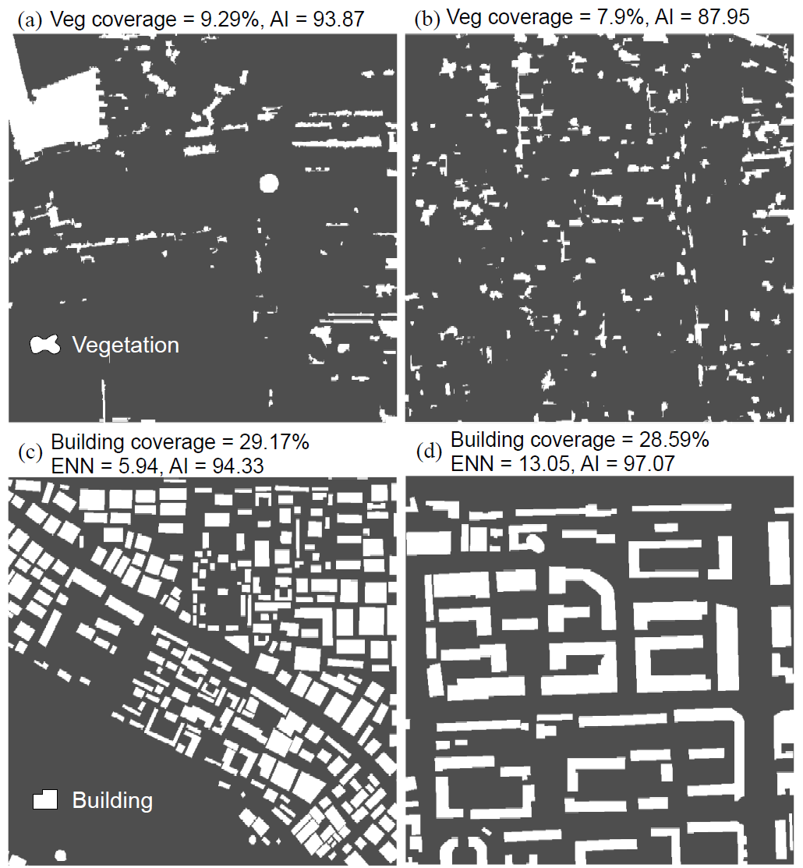

**Fig. S1.** Illustration of spatial aggregation measurements using the aggregation index (AI) and mean of Euclidean nearest-neighbor distance (ENN) for (a) aggregated vegetation, (b) fragmented vegetation, (c) aggregated buildings and (d) isolated buildings.

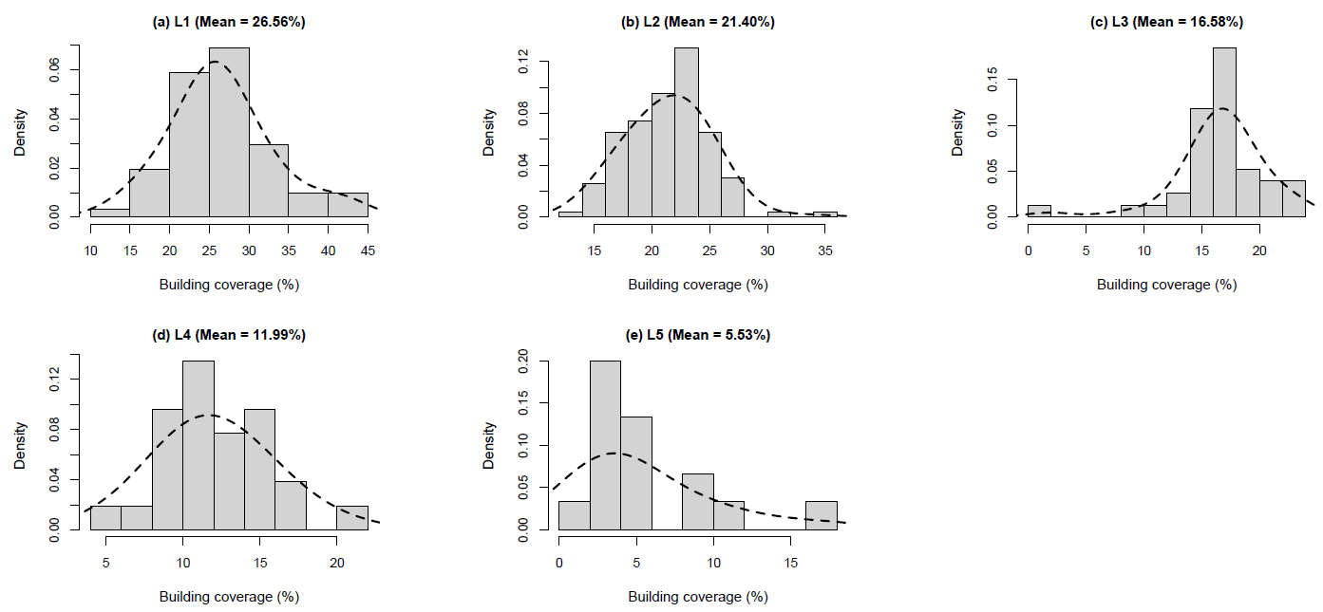

**Fig. S2.** The distributions of building coverage (%) at each fractional vegetation cover (FVC) level. The mean values indicate the mean building coverage at each FVC level.

**Table S1**

Confusion matrix for the land cover map of the Beijing metropolitan region derived from GF-2 images in 2017. a)

|  |  |  |  |  |  |  |  |  |
| --- | --- | --- | --- | --- | --- | --- | --- | --- |
| Classification | WB | UT | GL | BL | IS | BD | Total | UA (%) |
| WB | 16 | 0 | 0 | 0 | 1 | 0 | 17 | 94.12 |
| UT | 1 | 30 | 6 | 1 | 2 | 1 | 41 | 73.17 |
| GL | 0 | 3 | 18 | 1 | 0 | 0 | 22 | 81.82 |
| BL | 0 | 0 | 0 | 19 | 2 | 1 | 22 | 86.36 |
| IS | 0 | 1 | 0 | 2 | 39 | 6 | 48 | 81.25 |
| BD | 0 | 1 | 0 | 0 | 0 | 49 | 50 | 98.00 |
| Total | 17 | 35 | 24 | 23 | 44 | 57 | 200 |  |
| PA (%) | 94.12 | 85.71 | 75.00 | 82.61 | 88.64 | 85.96 |  | 85.50 |

a) Overall accuracy = 85.50%, WB = water body, UT = urban tree, GL = grassland, BL = bare land, IS = impervious surface, BD = building, UA = user accuracy and PA = producer accuracy. Kappa coefficient = 0.82.

**Table S2**

The relative contribution (*RC*) of spatial autocorrelation to model coefficients at multiple moving window size.

|  |  |  |  |  |  |  |  |  |
| --- | --- | --- | --- | --- | --- | --- | --- | --- |
| Window size | Moran's *I* | *RC*water body | *RC*urban tree | *RC*grassland | *RC*bare land | *RC*building | *RC*averagea) | *R*2 |
| 240 | 0.7779*** | 13.1752 | 14.9870 | 21.1401 | 38.1969 | 17.3724 | 16.6687 | 0.88 |
| 480 | 0.7183*** | 10.9101 | 14.5087 | 16.2652 | 28.6157 | 10.0876 | 12.9429 | 0.81 |
| 720 | 0.6984*** | 7.2366 | 9.3080 | 10.8562 | 19.8776 | 7.3971 | 8.6995 | 0.83 |
| 960 | 0.6967*** | 8.2958 | 11.2527 | 12.8424 | 129.1418 | 7.0248 | 9.8539 | 0.82 |
| 1200 | 0.6729*** | 5.8216 | 9.7594 | 12.0507 | 14.4561 | 5.4738 | 8.2764 | 0.83 |
| **1440** | **0.6485**\*\*\* | **4.1946** | **6.2902** | **7.0186** | **38.2545** | **4.3804** | **5.4709** | **0.86** |
| 1680 | 0.6302*** | 4.6654 | 8.4306 | 7.7357 | 9.4929 | 5.3601 | 6.5479 | 0.79 |
| 1920 | 0.6558*** | 8.0157 | 15.6371 | 12.4805 | 49.2968 | 7.2717 | 10.8512 | 0.75 |
| 2160 | 0.7036*** | 6.5593 | 10.0336 | 19.2837 | 1268.1970 | 7.7010 | 10.8944 | 0.82 |
| 2400 | 0.6719*** | 4.9370 | 8.6959 | 11.9343 | 3189.0070 | 5.6223 | 7.7974 | 0.90 |

a) The average *RC* of the water body, urban tree, grassland, and building (bare land is excluded due to too large standard deviation).

*** Significant at the 0.001 level.

**Table S3**

Comparison of standardized coefficients and fitting accuracy between the simple regression, multiple regression, and elastic net regression.

|  |  |  |  |  |  |  |  |
| --- | --- | --- | --- | --- | --- | --- | --- |
| Land cover type | Simple regression | | |  | Multiple regression (*R*2 = 0.81, RMSE = 0.438 ℃) |  | Elastic net regression (*R*2 = 0.81, RMSE = 0.438 ℃) |
|
| Standardized coefficient ± S.D. | *R*2 | RMSE (℃) |  | Standardized coefficient ± S.D. |  | Standardized coefficient ± S.D. |
| Water body | -0.469 ± 0.0555*** | 0.22 | 0.883 |  | 39283.24 ± 79718.28 |  | -0.166 ± 0.00378** |
| Urban tree | -0.751 ± 0.0415*** | 0.56 | 0.661 |  | 81261.32 ± 164905.1 |  | -0.268 ± 0.00125*** |
| Grassland | -0.514 ± 0.0539*** | 0.26 | 0.858 |  | 40515.29 ± 82218.43 |  | -0.142 ± 0.00130* |
| Bare land | 0.00916 ± 0.0629 | 0.000084 | 1.000 |  | 27527.74 ± 55862.29 |  | 0.0226 ± 0.00290 |
| Impervious surface | 0.658 ± 0.0474*** | 0.43 | 0.753 |  | 78219.71 ± 158731.9 |  | 0.103 ± 0.00127* |
| Building | 0.830 ± 0.0350*** | 0.69 | 0.557 |  | 58441.54 ± 118595.2 |  | 0.431 ± 0.000982*** |

*** Significant at the 0.001 level.

** Significant at the 0.01 level.

* Significant at the 0.05 level.