**1.diagram**

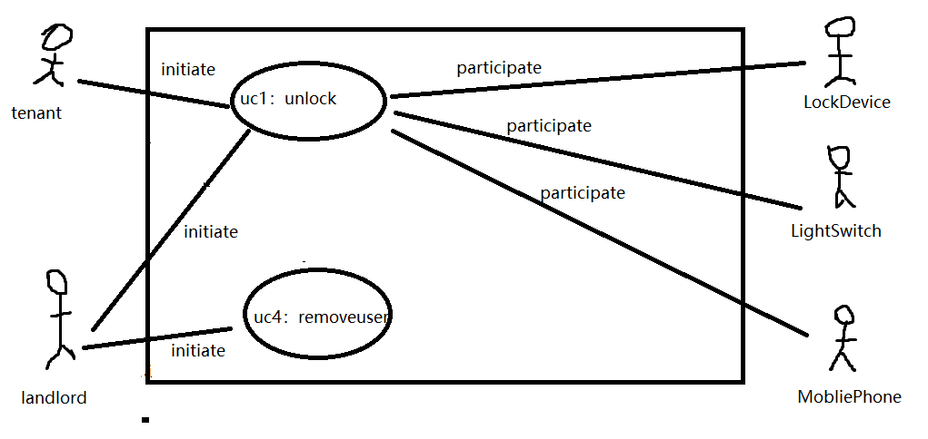

**2.schema**

**Use Case UC-1: Unlock**

**Related**

**Requirem’ts:** REQ1, REQ3, REQ4, and REQ5 stated in Table 2-1

**Initiating Actor:** Any of: Tenant, Landlord

**Actor’s Goal:** To disarm the lock and enter, and get space lighted up automatically.

**Participating**

**Actors:**

LockDevice, LightSwitch, Timer，mobile phones

**Preconditions:**

• The set of valid keys stored in the system database is non-empty.

• The system displays the menu of available functions; at the door keypad the menu

choices are “Lock” and “Unlock.”

**Postconditions:** The auto-lock timer has started countdown from autoLockInterval.

**Flow of Events for Main Success Scenario:**

® 1. Tenant/Landlord arrives at the door and selects the menu item “Unlock”

2. include::AuthenticateUser (UC-7)

¬ 3. System (a) signals to the Tenant/Landlord the lock status, e.g., “disarmed,” (b) signals to

LockDevice to disarm the lock, and (c) signals to LightSwitch to turn the light on

¬ 4. System signals to the Timer to start the auto-lock timer countdown

® 5. Tenant/Landlord opens the door, enters the home [and shuts the door and locks]

**Use Case UC-4: Remove User**

**Related**

**Requirem’ts:** REQ6 stated in Error! Reference source not found

**Initiating Actor:** Landlord

**Actor’s Goal:** To remove departed residents at runtime.

**Participating**

**Actors:**

Database

**Preconditions:**

• None worth mentioning.

**Postconditions:** The modified data is stored into the database.

**Flow of Events for Main Success Scenario:**

® 1. Landlord selects the menu item “ManageUsers”

2. Landlord identification: Include Login (UC-8)

¬ 3. System (a) displays the options of activities available to the Landlord (including “Add

User” and “Remove User”), and (b) prompts the Landlord to make selection

® 4. Landlord selects the activity, such as “Add User,” and enters the new data

¬ 5. System (a) stores the new data on a persistent storage, and (b) signals completion

**3. acceptance tests**

**Use Case UC-1: Unlock**

**Test-case Identifier:** TC-1

**Use Case Tested:** UC-1

**Pass/fail Criteria:**

The test passes If matching Bluetooth signals are detected and the number of failures is smaller than the maximum number allowed, the test passes

**Input Data**: Mobile Phone Bluetooth signal

**Test Procedure:**  Step 1. Give an unrelated Bluetooth signal

Step 2. Give a correct Bluetooth signal

**Expected Result:** System beeps to indicate failure； records unsuccessful attempt in the database； prompts the user to try again System flashes a green light to indicate success; records successful access in the database; disarms the lock device

**Use Case UC-4: Remove User**

**Test-case Identifier:** TC-2

**Use Case Tested:** UC-4

**Pass/fail Criteria:**

The test passes If matching Bluetooth signals are undetected and the number of failures is smaller than the maximum number allowed, the test passes

**Input Data**: Mobile Phone Bluetooth signal

**Test Procedure:**  Step 1. Give an related Bluetooth signal

Step 2. Give a undetected Bluetooth signal

**Expected Result:** System beeps to indicate failure； records unsuccessful attempt in the database； prompts the user to try again System flashes a green light to indicate success; records successful access in the database; disarms the lock device