**5.Bootstrap表格**

一.基本表格

1. 为任意 <table> 标签添加 .table 类可以为其赋予基本的样式 — 少量的内补（padding）和水平方向的分隔线。

<div class=**"container"**>  
 <table class=**"table"**>  
 <thead>  
 <tr>  
 <th>**#**</th>  
 <th>**First Name**</th>  
 <th>**Last Name**</th>  
 <th>**Username**</th>  
 </tr>  
 </thead>  
 <tbody>  
 <tr>  
 <td>**1**</td>  
 <td>**Mark**</td>  
 <td>**Otto**</td>  
 <td>**@mdo**</td>  
 </tr>  
 <tr>  
 <td>**2**</td>  
 <td>**Jacob**</td>  
 <td>**Thornton**</td>  
 <td>**@fat**</td>  
 </tr>  
 <tr>  
 <td>**3**</td>  
 <td>**Larry**</td>  
 <td>**the Bird**</td>  
 <td>**@twitter**</td>  
 </tr>  
 </tbody>  
 </table>  
</div>

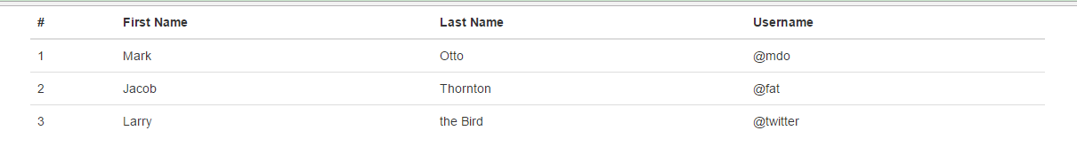

二.条纹状表格

1. 通过 .table-striped 类 可以给 <tbody> 之内的每一行增加斑马条纹样式。

<div class=**"container"**>  
 <table class=**"table table-striped"**>  
 <thead>  
 <tr>  
 <th>**#**</th>  
 <th>**First Name**</th>  
 <th>**Last Name**</th>  
 <th>**Username**</th>  
 </tr>  
 </thead>  
 <tbody>  
 <tr>  
 <td>**1**</td>  
 <td>**Mark**</td>  
 <td>**Otto**</td>  
 <td>**@mdo**</td>  
 </tr>  
 <tr>  
 <td>**2**</td>  
 <td>**Jacob**</td>  
 <td>**Thornton**</td>  
 <td>**@fat**</td>  
 </tr>  
 <tr>  
 <td>**3**</td>  
 <td>**Larry**</td>  
 <td>**the Bird**</td>  
 <td>**@twitter**</td>  
 </tr>  
 </tbody>  
 </table>  
</div>

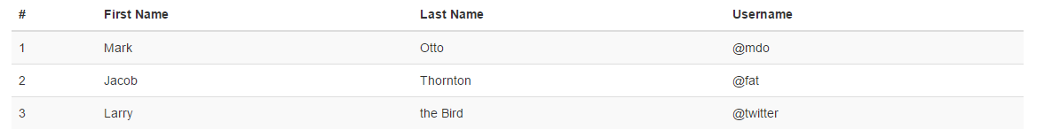

三.带边框的表格

1. 添加 .table-bordered 类为表格和其中的每个单元格增加边框

<div class=**"container"**>  
 <table class=**"table table-bordered"**>  
 <thead>  
 <tr>  
 <th>**#**</th>  
 <th>**First Name**</th>  
 <th>**Last Name**</th>  
 <th>**Username**</th>  
 </tr>  
 </thead>  
 <tbody>  
 <tr>  
 <td>**1**</td>  
 <td>**Mark**</td>  
 <td>**Otto**</td>  
 <td>**@mdo**</td>  
 </tr>  
 <tr>  
 <td>**2**</td>  
 <td>**Jacob**</td>  
 <td>**Thornton**</td>  
 <td>**@fat**</td>  
 </tr>  
 <tr>  
 <td>**3**</td>  
 <td>**Larry**</td>  
 <td>**the Bird**</td>  
 <td>**@twitter**</td>  
 </tr>  
 </tbody>  
 </table>  
</div>

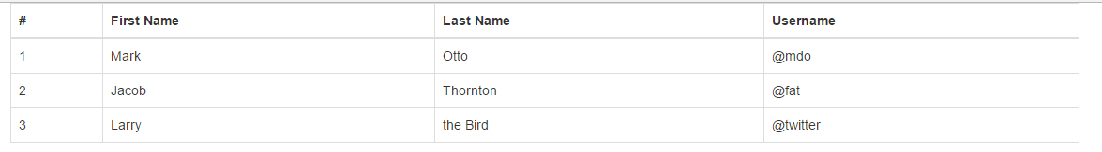

四.鼠标悬停

1. 通过添加 .table-hover 类可以让 <tbody> 中的每一行对鼠标悬停状态作出响应。

<div class=**"container"**>  
 <table class=**"table table-hover"**>  
 <thead>  
 <tr>  
 <th>**#**</th>  
 <th>**First Name**</th>  
 <th>**Last Name**</th>  
 <th>**Username**</th>  
 </tr>  
 </thead>  
 <tbody>  
 <tr>  
 <td>**1**</td>  
 <td>**Mark**</td>  
 <td>**Otto**</td>  
 <td>**@mdo**</td>  
 </tr>  
 <tr>  
 <td>**2**</td>  
 <td>**Jacob**</td>  
 <td>**Thornton**</td>  
 <td>**@fat**</td>  
 </tr>  
 <tr>  
 <td>**3**</td>  
 <td>**Larry**</td>  
 <td>**the Bird**</td>  
 <td>**@twitter**</td>  
 </tr>  
 </tbody>  
 </table>  
</div>

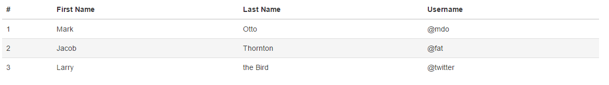

五.紧缩表格

1. 通过添加 .table-condensed 类可以让表格更加紧凑，单元格中的内补（padding）均会减半。

<div class=**"container"**>  
 <table class=**"table table-condensed"**>  
 <thead>  
 <tr>  
 <th>**#**</th>  
 <th>**First Name**</th>  
 <th>**Last Name**</th>  
 <th>**Username**</th>  
 </tr>  
 </thead>  
 <tbody>  
 <tr>  
 <td>**1**</td>  
 <td>**Mark**</td>  
 <td>**Otto**</td>  
 <td>**@mdo**</td>  
 </tr>  
 <tr>  
 <td>**2**</td>  
 <td>**Jacob**</td>  
 <td>**Thornton**</td>  
 <td>**@fat**</td>  
 </tr>  
 <tr>  
 <td>**3**</td>  
 <td>**Larry**</td>  
 <td>**the Bird**</td>  
 <td>**@twitter**</td>  
 </tr>  
 </tbody>  
 </table>  
</div>

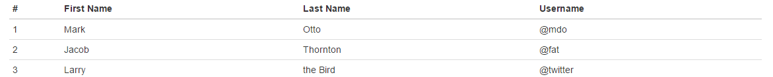

六. 状态类

1. 通过这些状态类可以为行或单元格设置颜色。

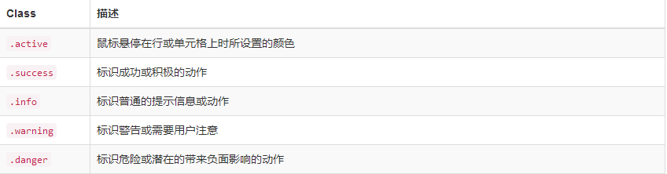

这些class属性既可以添加在行tr上，也可以添加在单元格td上。

<div class=**"container"**>  
 <table class=**"table"**>  
 <thead>  
 <tr>  
 <th>**#**</th>  
 <th>**First Name**</th>  
 <th>**Last Name**</th>  
 <th>**Username**</th>  
 </tr>  
 </thead>  
 <tbody>  
 <tr class=**"active"**>  
 <td>**1**</td>  
 <td>**Mark**</td>  
 <td>**Otto**</td>  
 <td>**@mdo**</td>  
 </tr>  
 <tr class=**"success"**>  
 <td>**2**</td>  
 <td>**Jacob**</td>  
 <td>**Thornton**</td>  
 <td>**@fat**</td>  
 </tr>  
 <tr class=**"info"**>  
 <td>**3**</td>  
 <td>**Larry**</td>  
 <td>**the Bird**</td>  
 <td>**@twitter**</td>  
 </tr>  
 <tr class=**"warning"**>  
 <td>**4**</td>  
 <td>**Larry**</td>  
 <td>**the Bird**</td>  
 <td>**@twitter**</td>  
 </tr>  
 <tr class=**"danger"**>  
 <td>**5**</td>  
 <td>**Larry**</td>  
 <td>**the Bird**</td>  
 <td>**@twitter**</td>  
 </tr>  
 </tbody>  
 </table>  
</div>

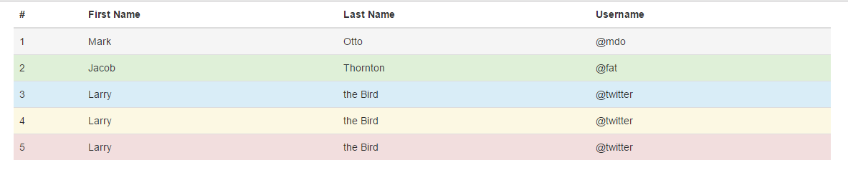

七. 响应式表格

1. 将任何 .table 元素包裹在div元素类名为： .table-responsive 内，即可创建响应式表格，其会在小屏幕设备上（小于768px）水平滚动。当屏幕大于 768px 宽度时，水平滚动条消失。

<div class=**"container"**>  
 <div class=**"table-responsive"**>  
 <table class=**"table"**>  
 <thead>  
 <tr>  
 <th>**#**</th>  
 <th>**First Name**</th>  
 <th>**Last Name**</th>  
 <th>**Username**</th>  
 <th>**Username**</th>  
 <th>**Username**</th>  
 <th>**Username**</th>  
 <th>**Username**</th>  
 </tr>  
 </thead>  
 <tbody>  
 <tr>  
 <td>**1**</td>  
 <td>**Mark**</td>  
 <td>**Otto**</td>  
 <td>**@mdo**</td>  
 <td>**@mdo**</td>  
 <td>**@mdo**</td>  
 <td>**@mdo**</td>  
 <td>**@mdo**</td>  
 </tr>  
 <tr>  
 <td>**1**</td>  
 <td>**Mark**</td>  
 <td>**Otto**</td>  
 <td>**@mdo**</td>  
 <td>**@mdo**</td>  
 <td>**@mdo**</td>  
 <td>**@mdo**</td>  
 <td>**@mdo**</td>  
 </tr>  
 <tr>  
 <td>**1**</td>  
 <td>**Mark**</td>  
 <td>**Otto**</td>  
 <td>**@mdo**</td>  
 <td>**@mdo**</td>  
 <td>**@mdo**</td>  
 <td>**@mdo**</td>  
 <td>**@mdo**</td>  
 </tr>  
 <tr>  
 <td>**1**</td>  
 <td>**Mark**</td>  
 <td>**Otto**</td>  
 <td>**@mdo**</td>  
 <td>**@mdo**</td>  
 <td>**@mdo**</td>  
 <td>**@mdo**</td>  
 <td>**@mdo**</td>  
 </tr>  
 </tbody>  
 </table>  
 </div><!--/.table-responsive-->  
</div>

