**12.Bootstrap缩略图**

一.缩略图

通过缩略图组件扩展Bootstrap 的栅格系统，可展示栅格样式的图像、视频、文本等内容。

<div class=**"container"**>  
 <div class=**"row"**>  
 <div class=**"col-xs-6 col-md-3"**>  
 <a href=**"#"** class=**"thumbnail"**>  
 <img src=**"../img/3.png"**>  
 </a>  
 </div>  
 <div class=**"col-xs-6 col-md-3"**>  
 <a href=**"#"** class=**"thumbnail"**>  
 <img src=**"../img/4.png"**>  
 </a>  
 </div>  
 <div class=**"col-xs-6 col-md-3"**>  
 <a href=**"#"** class=**"thumbnail"**>  
 <img src=**"../img/5.png"**>  
 </a>  
 </div>  
 <div class=**"col-xs-6 col-md-3"**>  
 <a href=**"#"** class=**"thumbnail"**>  
 <img src=**"../img/6.png"**>  
 </a>  
 </div>  
 <div class=**"col-xs-6 col-md-3"**>  
 <a href=**"#"** class=**"thumbnail"**>  
 <img src=**"../img/7.png"**>  
 </a>  
 </div>  
 <div class=**"col-xs-6 col-md-3"**>  
 <a href=**"#"** class=**"thumbnail"**>  
 <img src=**"../img/8.png"**>  
 </a>  
 </div>  
 <div class=**"col-xs-6 col-md-3"**>  
 <a href=**"#"** class=**"thumbnail"**>  
 <img src=**"../img/9.png"**>  
 </a>  
 </div>  
 </div>   
</div>

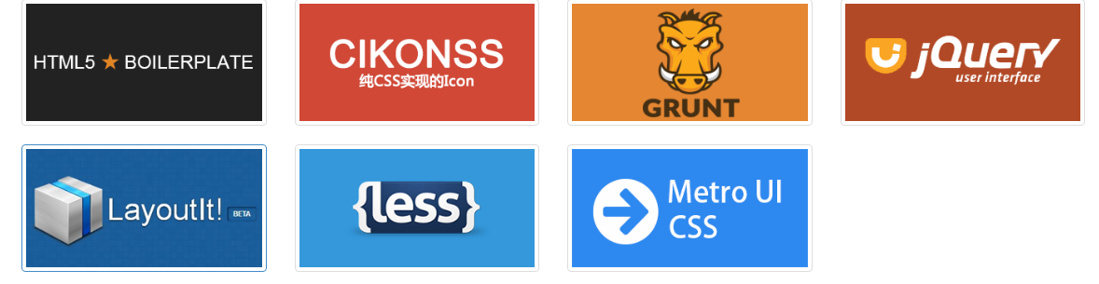

二.自定义内容

添加一点点额外的标签，就可以把任何类型的 HTML 内容，例如标题、段落或按钮，加入缩略图组件内。

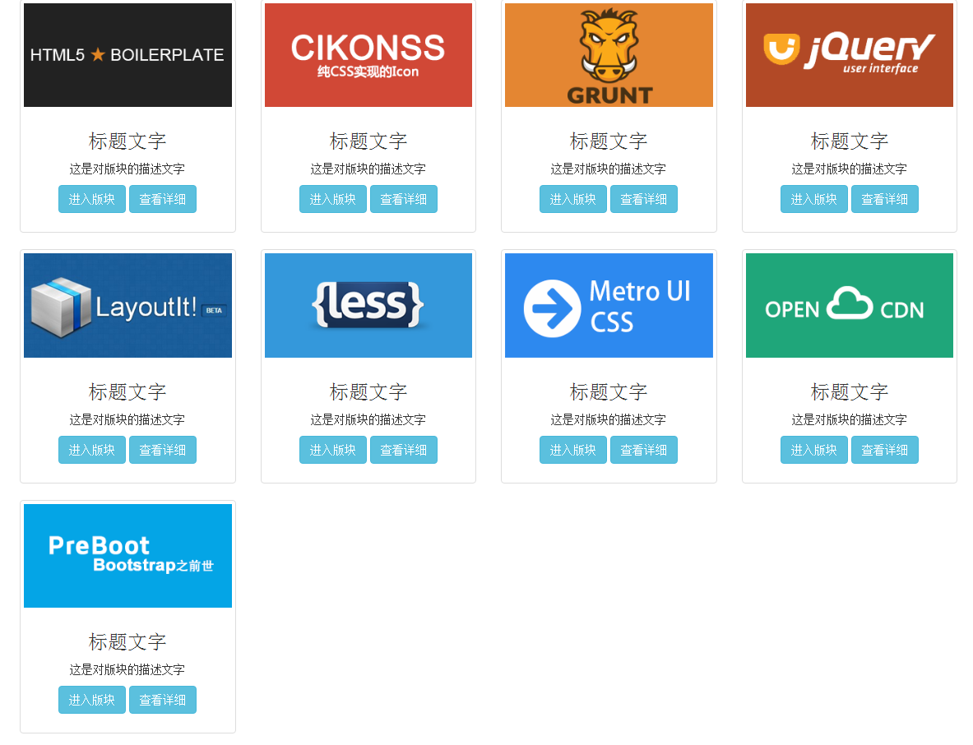

<!-- 自定义缩略图 -->  
<div class=**"container"**>

<div class=**"row"**>  
 <div class=**"col-xs-6 col-md-3"**>  
 <div class=**"thumbnail text-center"**>  
 <img src=**"../img/3.png"**/>  
 <div class=**"caption"**>  
 <h3>**标题文字**</h3>  
 <p>**这是对版块的描述文字**</p>  
 <p>  
 <button type=**"button"** class=**"btn btn-info"**>**进入版块**</button>  
 <button type=**"button"** class=**"btn btn-info"**>**查看详细**</button>  
 </p>  
 </div>  
 </div>  
 </div>  
  
 <div class=**"col-xs-6 col-md-3"**>  
 <div class=**"thumbnail text-center"**>  
 <img src=**"../img/4.png"**/>  
 <div class=**"caption"**>  
 <h3>**标题文字**</h3>  
 <p>**这是对版块的描述文字**</p>  
 <p>  
 <button type=**"button"** class=**"btn btn-info"**>**进入版块**</button>  
 <button type=**"button"** class=**"btn btn-info"**>**查看详细**</button>  
 </p>  
 </div>  
 </div>  
 </div>  
  
 <div class=**"col-xs-6 col-md-3"**>  
 <div class=**"thumbnail text-center"**>  
 <img src=**"../img/5.png"**/>  
 <div class=**"caption"**>  
 <h3>**标题文字**</h3>  
 <p>**这是对版块的描述文字**</p>  
 <p>  
 <button type=**"button"** class=**"btn btn-info"**>**进入版块**</button>  
 <button type=**"button"** class=**"btn btn-info"**>**查看详细**</button>  
 </p>  
 </div>  
 </div>  
 </div>  
  
 <div class=**"col-xs-6 col-md-3"**>  
 <div class=**"thumbnail text-center"**>  
 <img src=**"../img/6.png"**/>  
 <div class=**"caption"**>  
 <h3>**标题文字**</h3>  
 <p>**这是对版块的描述文字**</p>  
 <p>  
 <button type=**"button"** class=**"btn btn-info"**>**进入版块**</button>  
 <button type=**"button"** class=**"btn btn-info"**>**查看详细**</button>  
 </p>  
 </div>  
 </div>  
 </div>  
  
 <div class=**"col-xs-6 col-md-3"**>  
 <div class=**"thumbnail text-center"**>  
 <img src=**"../img/7.png"**/>  
 <div class=**"caption"**>  
 <h3>**标题文字**</h3>  
 <p>**这是对版块的描述文字**</p>  
 <p>  
 <button type=**"button"** class=**"btn btn-info"**>**进入版块**</button>  
 <button type=**"button"** class=**"btn btn-info"**>**查看详细**</button>  
 </p>  
 </div>  
 </div>  
 </div>  
  
 <div class=**"col-xs-6 col-md-3"**>  
 <div class=**"thumbnail text-center"**>  
 <img src=**"../img/8.png"**/>  
 <div class=**"caption"**>  
 <h3>**标题文字**</h3>  
 <p>**这是对版块的描述文字**</p>  
 <p>  
 <button type=**"button"** class=**"btn btn-info"**>**进入版块**</button>  
 <button type=**"button"** class=**"btn btn-info"**>**查看详细**</button>  
 </p>  
 </div>  
 </div>  
 </div>  
  
 <div class=**"col-xs-6 col-md-3"**>  
 <div class=**"thumbnail text-center"**>  
 <img src=**"../img/9.png"**/>  
 <div class=**"caption"**>  
 <h3>**标题文字**</h3>  
 <p>**这是对版块的描述文字**</p>  
 <p>  
 <button type=**"button"** class=**"btn btn-info"**>**进入版块**</button>  
 <button type=**"button"** class=**"btn btn-info"**>**查看详细**</button>  
 </p>  
 </div>  
 </div>  
 </div>  
  
 <div class=**"col-xs-6 col-md-3"**>  
 <div class=**"thumbnail text-center"**>  
 <img src=**"../img/10.png"**/>  
 <div class=**"caption"**>  
 <h3>**标题文字**</h3>  
 <p>**这是对版块的描述文字**</p>  
 <p>  
 <button type=**"button"** class=**"btn btn-info"**>**进入版块**</button>  
 <button type=**"button"** class=**"btn btn-info"**>**查看详细**</button>  
 </p>  
 </div>  
 </div>  
 </div>  
  
 <div class=**"col-xs-6 col-md-3"**>  
 <div class=**"thumbnail text-center"**>  
 <img src=**"../img/11.png"**/>  
 <div class=**"caption"**>  
 <h3>**标题文字**</h3>  
 <p>**这是对版块的描述文字**</p>  
 <p>  
 <button type=**"button"** class=**"btn btn-info"**>**进入版块**</button>  
 <button type=**"button"** class=**"btn btn-info"**>**查看详细**</button>  
 </p>  
 </div>  
 </div>  
 </div>  
 </div>  
  
</div>