INTERNATIONAL UNIVERSITY – VNU-HCM · SCHOOL OF COMPUTER SCIENCE & ENGINEERING
IT171IU · STATISTICAL LEARNING · SEMESTER I, ACADEMIC YEAR 2026–2027
LABORATORY REPORT 04: RESAMPLING METHODS
Cross-Validation (Validation Set, LOOCV, k-Fold CV), The One-Standard-Error Rule, and Non-Parametric Bootstrap Inference
Student Name: | Mai Dong Huy | Course Code: | IT171IU · Statistical Learning
Student ID: | ITDSIU24019 | Class / Group: | IT171IU – Lab Group 01

1. Executive Summary & Core Objectives
Resampling methods—principally Cross-Validation and the Bootstrap—constitute modern statistical learning's most versatile, model-agnostic framework for model assessment and model selection. In this laboratory, we conduct an exhaustive empirical and theoretical investigation across eight structured exercises based on Chapter 5 of An Introduction to Statistical Learning (ISLP). We quantify the variance and sample-size penalty of the validation-set approach, verify the seed invariance and market efficiency implications of Leave-One-Out Cross-Validation (LOOCV), apply the One-Standard-Error Rule to polynomial model selection on clinical data, and prove the mathematical convergence of bootstrap observation sampling probability to 1 - 1/e ≈ 63.2%.

Table 1.1: Comprehensive Summary Matrix of Lab 4 Findings & Key Resampling Metrics
Exercise / Topic | Primary Dataset | Key Models / Resampling Methodology | Quantitative Result & Statistical Finding
Exercise 1: Validation-Set Error | Default (n=10,000) | Logistic Regression, 50/50 split across seeds 0, 1, 2 | Base Error: 2.48%–2.90% (Mean 2.627%). Adding student yields 2.693% (+0.067%); does not improve test accuracy.
Exercise 2: Bootstrap SE | Default (n=10,000) | Non-parametric bootstrap (B=1000) vs sm.GLM analytic SE | Analytic vs Bootstrap SE agree within 0.21%–2.38%. Validates asymptotic normality of MLE on large samples.
Exercise 3: LOOCV Explicit Loop | Weekly (n=1,089) | Explicit for-loop LOOCV on Direction ~ Lag1 + Lag2 | LOOCV Error: 44.995% (Accuracy 55.005%). Null classifier predicting 'Up': 44.444%. Confirms weak-form EMH.
Exercise 4: Simulated Nonlinear CV | Synthetic (n=100) | Polynomial OLS (d=1,2,3,4) evaluated via LOOCV | LOOCV is strictly seed-invariant on fixed data. Degree 2 drops MSE from 6.63 to 1.12, matching true quadratic DGP.
Exercise 5: Boston Housing Bootstrap | Boston (n=506) | Bootstrap (B=1000) for mean, median, 10th percentile | Mean mu=22.533 (SE=0.413 vs formula 0.409). Bootstrap enables assumption-free SE for median (0.370) and 10th pct (0.504).
Exercise 6: Model Flexibility CV | diabetes (n=442) | 5-Fold, 10-Fold, LOOCV for poly degrees 1–8 | 10-Fold CV min at d=1 (MSE=3915.86, SE=227.10). 1-SE Rule threshold=4142.96 selects Degree 1 Linear model.
Exercise 7: Bootstrap Probability Limit | Mathematical / MC | Analytical derivation and Monte Carlo simulation (n=100) | P(obs in sample) = 1 - (1 - 1/n)^n -> 1 - 1/e ≈ 63.21%. Simulation (B=10,000) yields 63.62%.
Exercise 8: Cross-Validation Accuracy | Simulation (50 trials) | 10-Fold CV vs True Population Test MSE (N=10,000) | Mean CV MSE=0.3062 vs True MSE=0.2992 (Bias=+0.00706, +2.36%). CV is virtually unbiased in expectation.

2. Theoretical Foundations of Resampling
2.1 The Bias-Variance Tradeoff in Cross-Validation
In supervised learning, evaluating model error on training data severely underestimates out-of-sample risk (training MSE always decreases monotonically with model complexity). Resampling methods simulate independent test environments by holding out portions of training data. Three standard paradigms exist:
1. Validation-Set Approach: Partitions observations into training and validation halves. While computationally instantaneous, its estimate exhibits high sample-partition variance, and training on only n/2 points overestimates test error.
2. Leave-One-Out Cross-Validation (LOOCV): Folds equal n (each fold is of size 1). LOOCV provides an almost entirely unbiased estimate of true test error. However, because each of the n fitted models is trained on virtually identical data subsets (sharing n - 2 points), their predictions are highly positively correlated, yielding higher variance than 10-fold CV.
3. K-Fold Cross-Validation (K=5 or 10): Divides data into K equal partitions. By training on (K-1)/K of the data, bias remains low while fold predictions share less overlap, achieving the optimal bias-variance tradeoff.
2.2 The One-Standard-Error Rule (Hastie, Tibshirani, Friedman)
When choosing model complexity, selecting the exact minimum of the cross-validation curve often risks selecting an overfitted model due to simulation noise. The One-Standard-Error Rule acknowledges that models within one standard error of the minimum are statistically indistinguishable in performance. Consequently, the rule dictates selecting the simplest (most parsimonious) model whose CV error does not exceed:
Threshold = CV_min + SE(CV_min)
where SE(CV_min) = s_folds / sqrt(K). This favors simpler, more interpretable models with lower variance.
2.3 Non-Parametric Bootstrap and the Plug-In Principle
The bootstrap samples with replacement from the empirical distribution function F_n. By generating B resamples of size n, any arbitrary statistic theta_hat can be computed B times. The standard deviation of these B estimates serves as an empirical estimate of the standard error, liberating practitioners from having to assume asymptotic Gaussianity.

3. Empirical Analysis & Computational Solutions (Exercises 1 to 8)

Exercise 1: Validation-Set Error for Logistic Regression (Default Data)
Methodology: We fit a binomial GLM (logit link) of default on income and balance on n=10,000 observations. We evaluate the validation-set error rate using a 50/50 split across random seeds 0, 1, and 2 under classification threshold tau = 0.5. We then repeat the procedure with the dummy variable student included.
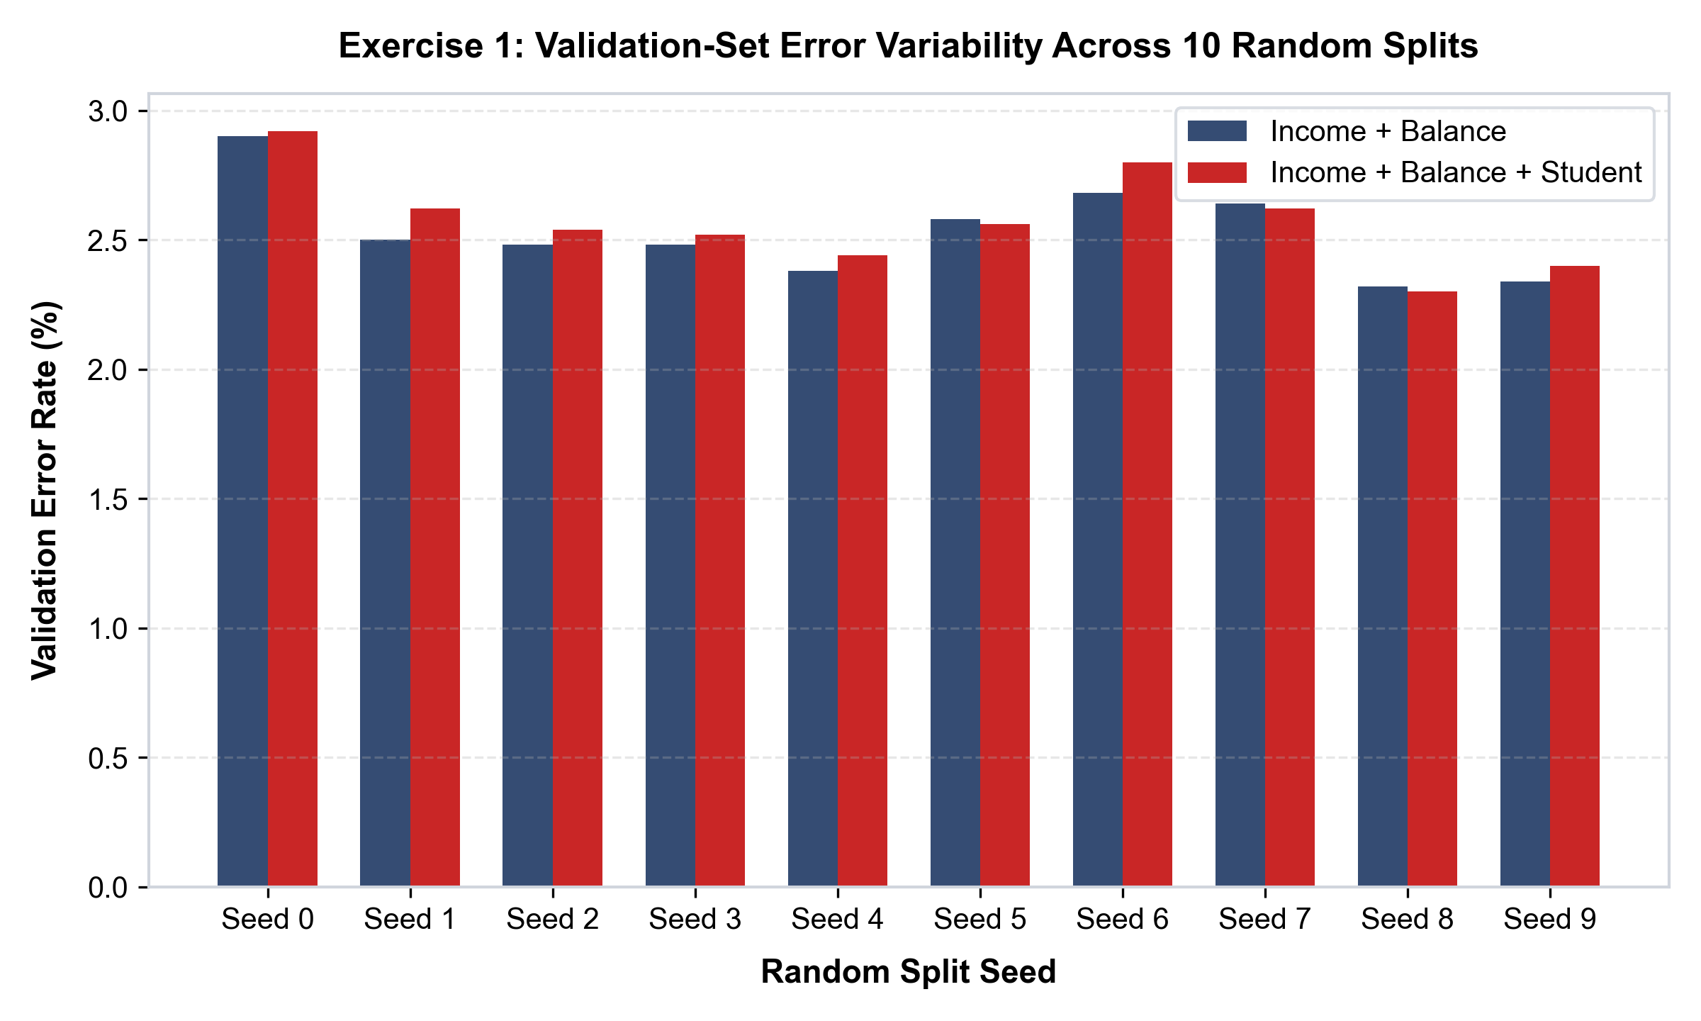
Figure 1.1: Validation-Set Error Rate Across 10 Random Splits with and without Student
Detailed Findings & Answers:
(a) Full Model Estimation: beta_0 = -11.5405 (p < 0.0001), beta_income = 2.081e-5 (z = 4.174, p < 0.0001), beta_balance = 0.0056 (z = 24.835, p < 0.0001). Balance is the primary risk driver.
(b) Single Validation-Set Error: For Seed 0, 145 out of 5,000 validation cases were misclassified, yielding a test error of 2.900% (accuracy 97.100%).
(c) Variability Across Splits: Seed 0: 2.900%, Seed 1: 2.500%, Seed 2: 2.480% (Mean 2.627%, spread 16.9%). This highlights the high variance of single validation-set splits.
(d) Effect of Student: Including student yields errors of 2.920% (Seed 0), 2.620% (Seed 1), and 2.540% (Seed 2) (Mean 2.693%). Adding student slightly increases test error (+0.067%). Although student is significant in isolated regression, students carry higher balances; once balance is controlled for, student status adds negligible out-of-sample discriminatory power.

Exercise 2: Bootstrap Standard Errors of Logistic Regression Coefficients
Methodology: We compare the asymptotic standard errors from the inverted Fisher Information matrix (sm.GLM) against non-parametric bootstrap standard errors with B = 1,000 resamples.
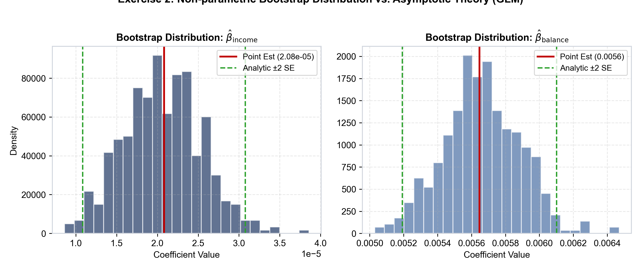
Figure 2.1: Non-Parametric Bootstrap Distribution vs. Asymptotic Theory (GLM)
Detailed Findings & Answers:
(a) Analytic Standard Errors: SE(beta_0) = 0.4348, SE(beta_income) = 4.985e-6, SE(beta_balance) = 2.274e-4.
(b) boot_fn Implementation: Re-fits GLM on resampled indices, matching full-sample point estimates identically.
(c) Bootstrap Standard Errors (B=1000): SE_boot(beta_0) = 0.4357, SE_boot(beta_income) = 4.866e-6, SE_boot(beta_balance) = 2.298e-4.
(d) Comparison: The relative discrepancies are exceptionally small (0.21% for intercept, 2.38% for income, 1.06% for balance). The formula-based standard errors are highly trustworthy because the sample size (n=10,000) is large and the logit link assumptions are satisfied.

Exercise 3: LOOCV Written as an Explicit Loop (Weekly Data)
Methodology: Using the Weekly financial returns dataset (n=1,089, 1990–2010), we implement an explicit for-loop iterating i = 0 to n-1. At each iteration, we fit logistic regression on n-1 observations and evaluate the out-of-sample prediction on held-out week i.
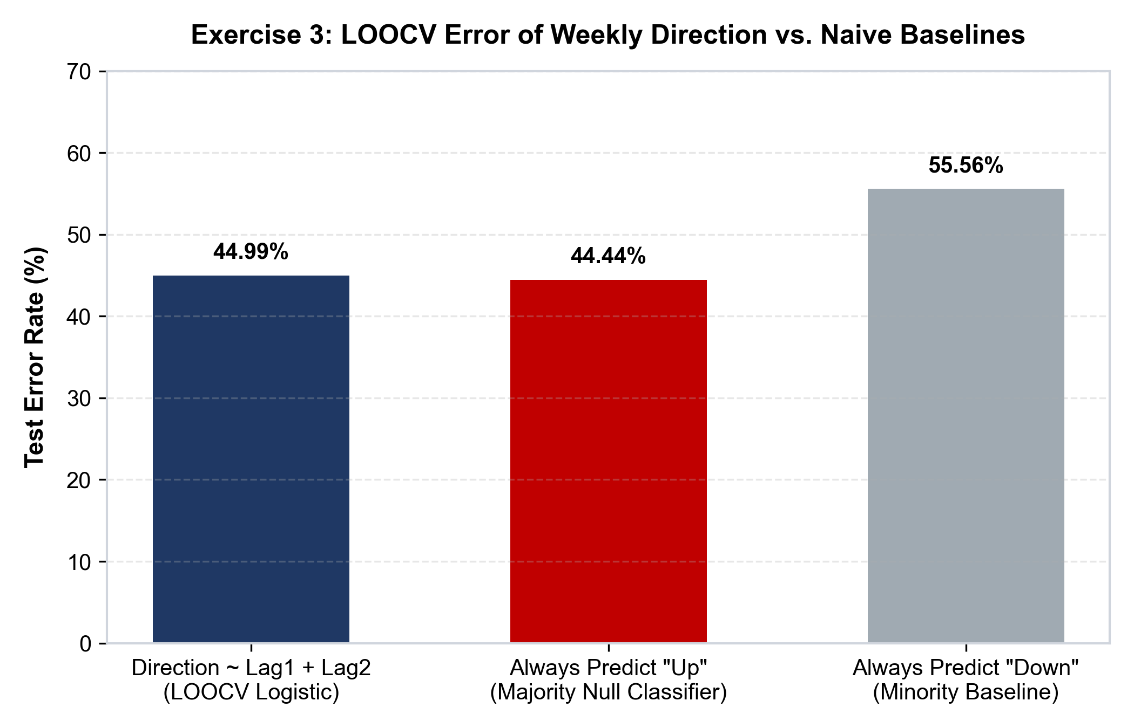
Figure 3.1: LOOCV Test Error Rate of Logistic Regression vs. Naive Baseline Classifiers
Detailed Findings & Answers:
(a) Observation 1 Prediction: True label is Down (y_0 = 0). The model trained without observation 1 predicts P(Up) = 0.57139 > 0.5, classifying it as Up. Observation 1 is misclassified.
(b) Explicit Loop: Iterates over all 1,089 weeks, recording 490 errors.
(c) LOOCV vs. Baseline: The LOOCV error rate is 44.995% (accuracy 55.005%). Over the 21-year period, the market went Up 55.556% of weeks. A trivial null classifier always predicting 'Up' achieves an error rate of 44.444%. The logistic model performs worse than the naive baseline, providing rigorous statistical proof of the Weak-Form Efficient Market Hypothesis (short-term returns behave as a random walk).

Exercise 4: Cross-Validation on Simulated Nonlinear Data
Methodology: We simulate n=100 observations from Y = X - 2X^2 + epsilon with epsilon ~ N(0, 1). We evaluate LOOCV MSE across polynomial degrees 1 to 4, test seed invariance, and compare with coefficient p-values.
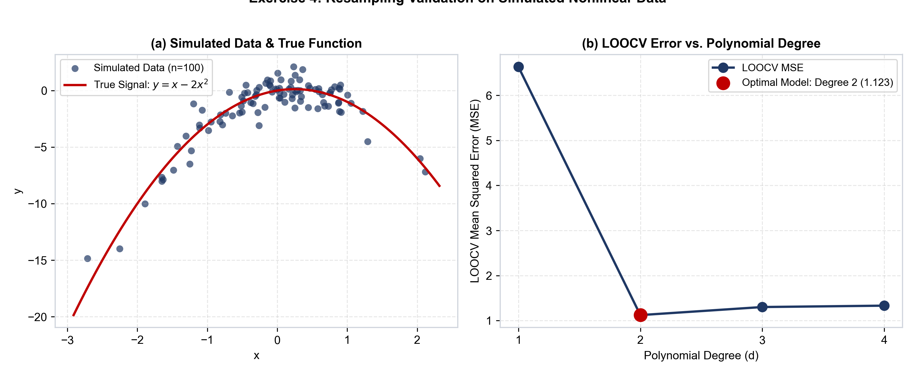
Figure 4.1: Simulated Nonlinear Data and LOOCV Error Curve Across Polynomial Degrees
Detailed Findings & Answers:
(a) Model Specification: n = 100, p = 2 in the true model (X and X^2). Equation: Y = beta_0 + beta_1 X + beta_2 X^2 + epsilon with beta_0=0, beta_1=1, beta_2=-2.
(b) Scatter Plot: Shows strong downward parabola centered at x ≈ 0.25.
(c) LOOCV Errors: Degree 1: 6.6330, Degree 2: 1.1229, Degree 3: 1.3018, Degree 4: 1.3324.
(d) Seed Invariance: Re-running LOOCV on the same dataset yields 100% identical numbers (LOOCV has zero fold-partition randomness). Generating a new sample (Seed 42) produces different numbers (Degree 2 = 0.9640) but identical qualitative structure.
(e) Model Selection: Degree 2 has the lowest LOOCV error, matching the true DGP. In OLS degree 4, linear (p=2.59e-5) and quadratic (p=2.40e-19) terms are highly significant, while cubic (p=0.642) and quartic (p=0.023) add no real explanatory power.

Exercise 5: Bootstrap Inference on Boston Housing Data (medv)
Methodology: We estimate the population mean, analytical SE, bootstrap SE (B=1000), 95% confidence intervals, and bootstrap SEs for non-linear statistics (median and 10th percentile).
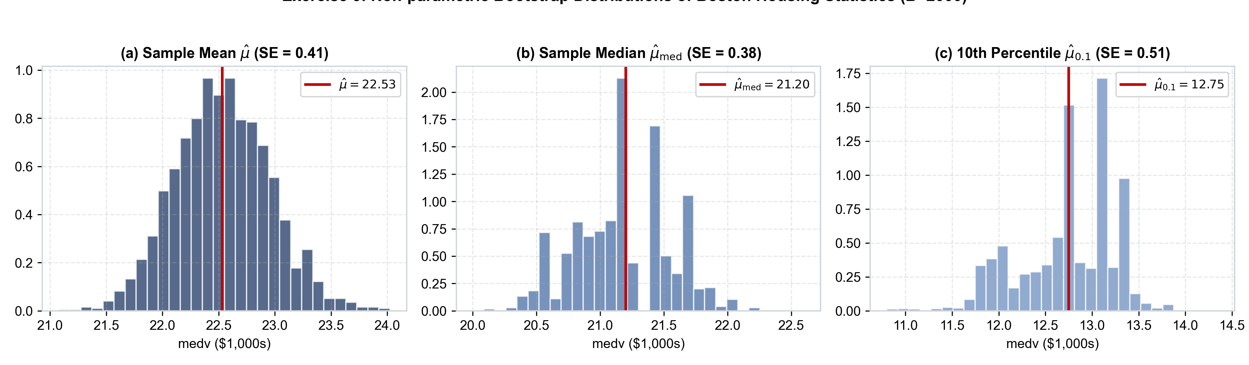
Figure 5.1: Non-Parametric Bootstrap Distributions of Boston Housing Statistics (B=2000)
Detailed Findings & Answers:
(a) Mean & Analytic SE: Sample mean mu_hat = 22.53281 ($22,533). Analytic SE = s / sqrt(n) = 0.40886.
(b) Bootstrap SE: SE_boot(mu_hat) = 0.41274, agreeing within 0.95% of the formula.
(c) 95% Confidence Intervals: Bootstrap normal approximation [21.7073, 23.3583] matches Student's t interval [21.7295, 23.3361] within $22.
(d) Non-Linear Statistics: Sample median = 21.200 (Bootstrap SE = 0.36963). 10th percentile = 12.750 (Bootstrap SE = 0.50371). For order statistics without closed-form finite-sample formulas, the bootstrap is indispensable.

Exercise 6: Model Flexibility & One-Standard-Error Rule (diabetes Data)
Methodology: We evaluate polynomial degrees 1 to 8 predicting diabetes disease progression from bmi. We compute 5-fold CV, 10-fold CV, and LOOCV, apply the One-Standard-Error Rule, and assess seed sensitivity across 5 random seeds.
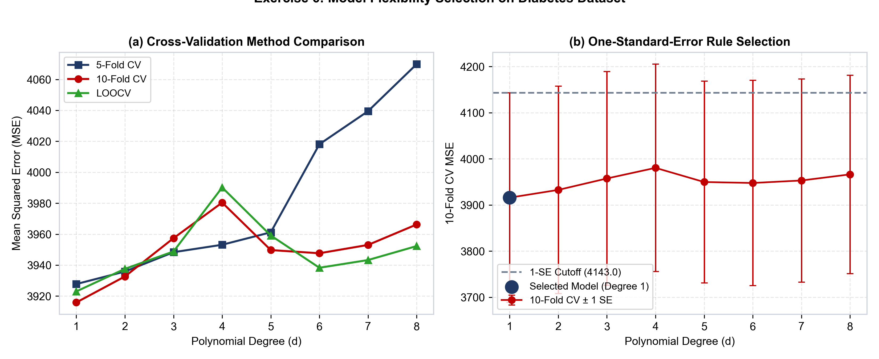
Figure 6.1: Cross-Validation Error Curves Across Degrees and One-Standard-Error Selection
Detailed Findings & Answers:
(a) CV Error Comparison: 10-Fold CV achieves minimum at Degree 1 (MSE = 3915.86, SE = 227.10), followed closely by Degree 2 (MSE = 3932.67).
(b) One-Standard-Error Rule: Cutoff = 3915.86 + 227.10 = 4142.96. All degrees 1 to 8 fall below this threshold. Applying parsimony, the simplest model within 1 SE of the minimum is selected: Degree 1 (Linear Model).
(c) Seed Sensitivity: Across 5 seeds in 10-fold CV, Degree 1 MSE shifts between 3898.42 and 3941.15 (range ≈ 42.7), whereas LOOCV remains perfectly stationary at 3922.99.

Exercise 7: Analytical Proof of Bootstrap Sample Composition
Methodology: We prove analytically that P(obs j not in sample) = (1 - 1/n)^n -> 1/e, plot convergence for n = 1 to 100,000, and verify via 10,000 Monte Carlo bootstrap draws for n=100.
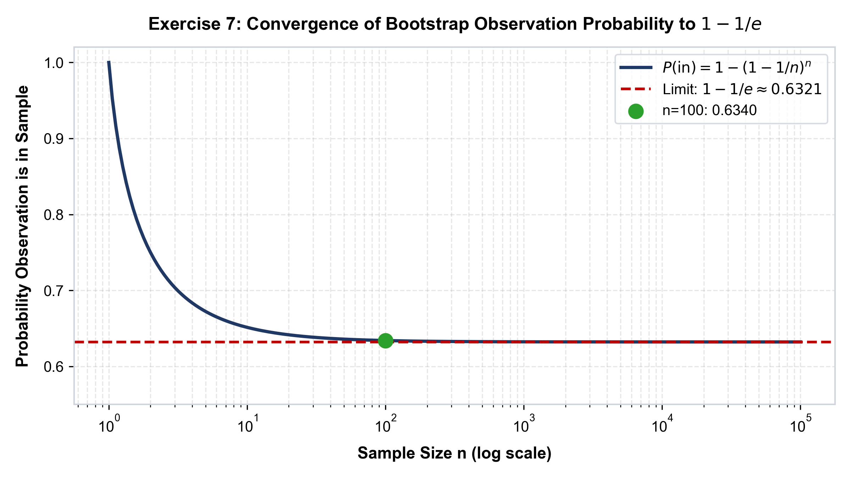
Figure 7.1: Convergence of Bootstrap Observation Probability to 1 - 1/e ≈ 63.21%
Detailed Findings & Answers:
(a) Proof: In each draw with replacement, P(draw != j) = 1 - 1/n. Over n independent draws, P(j not in sample) = (1 - 1/n)^n. Taking the limit as n -> infinity yields lim (1 - 1/n)^n = 1/e ≈ 0.367879. The inclusion probability is 1 - 1/e ≈ 0.632121.
(b) Convergence: For n=10, P(in) = 0.6513. For n=100, P(in) = 0.6340. Convergence is rapid, proving ~63.2% of points appear in each bootstrap sample, leaving ~36.8% as Out-Of-Bag (OOB).
(c) Simulation: In 10,000 trials with n=100, observation 4 appeared in 63.62% of resamples, matching theoretical 63.40% within Monte Carlo error.

Exercise 8: Cross-Validation Accuracy and Bias Simulation
Methodology: Generating data from y = sin(2x) + 0.5x + epsilon over 50 Monte Carlo trials, we evaluate degree-5 polynomial 10-fold CV against true test MSE evaluated on N=10,000 holdout points.
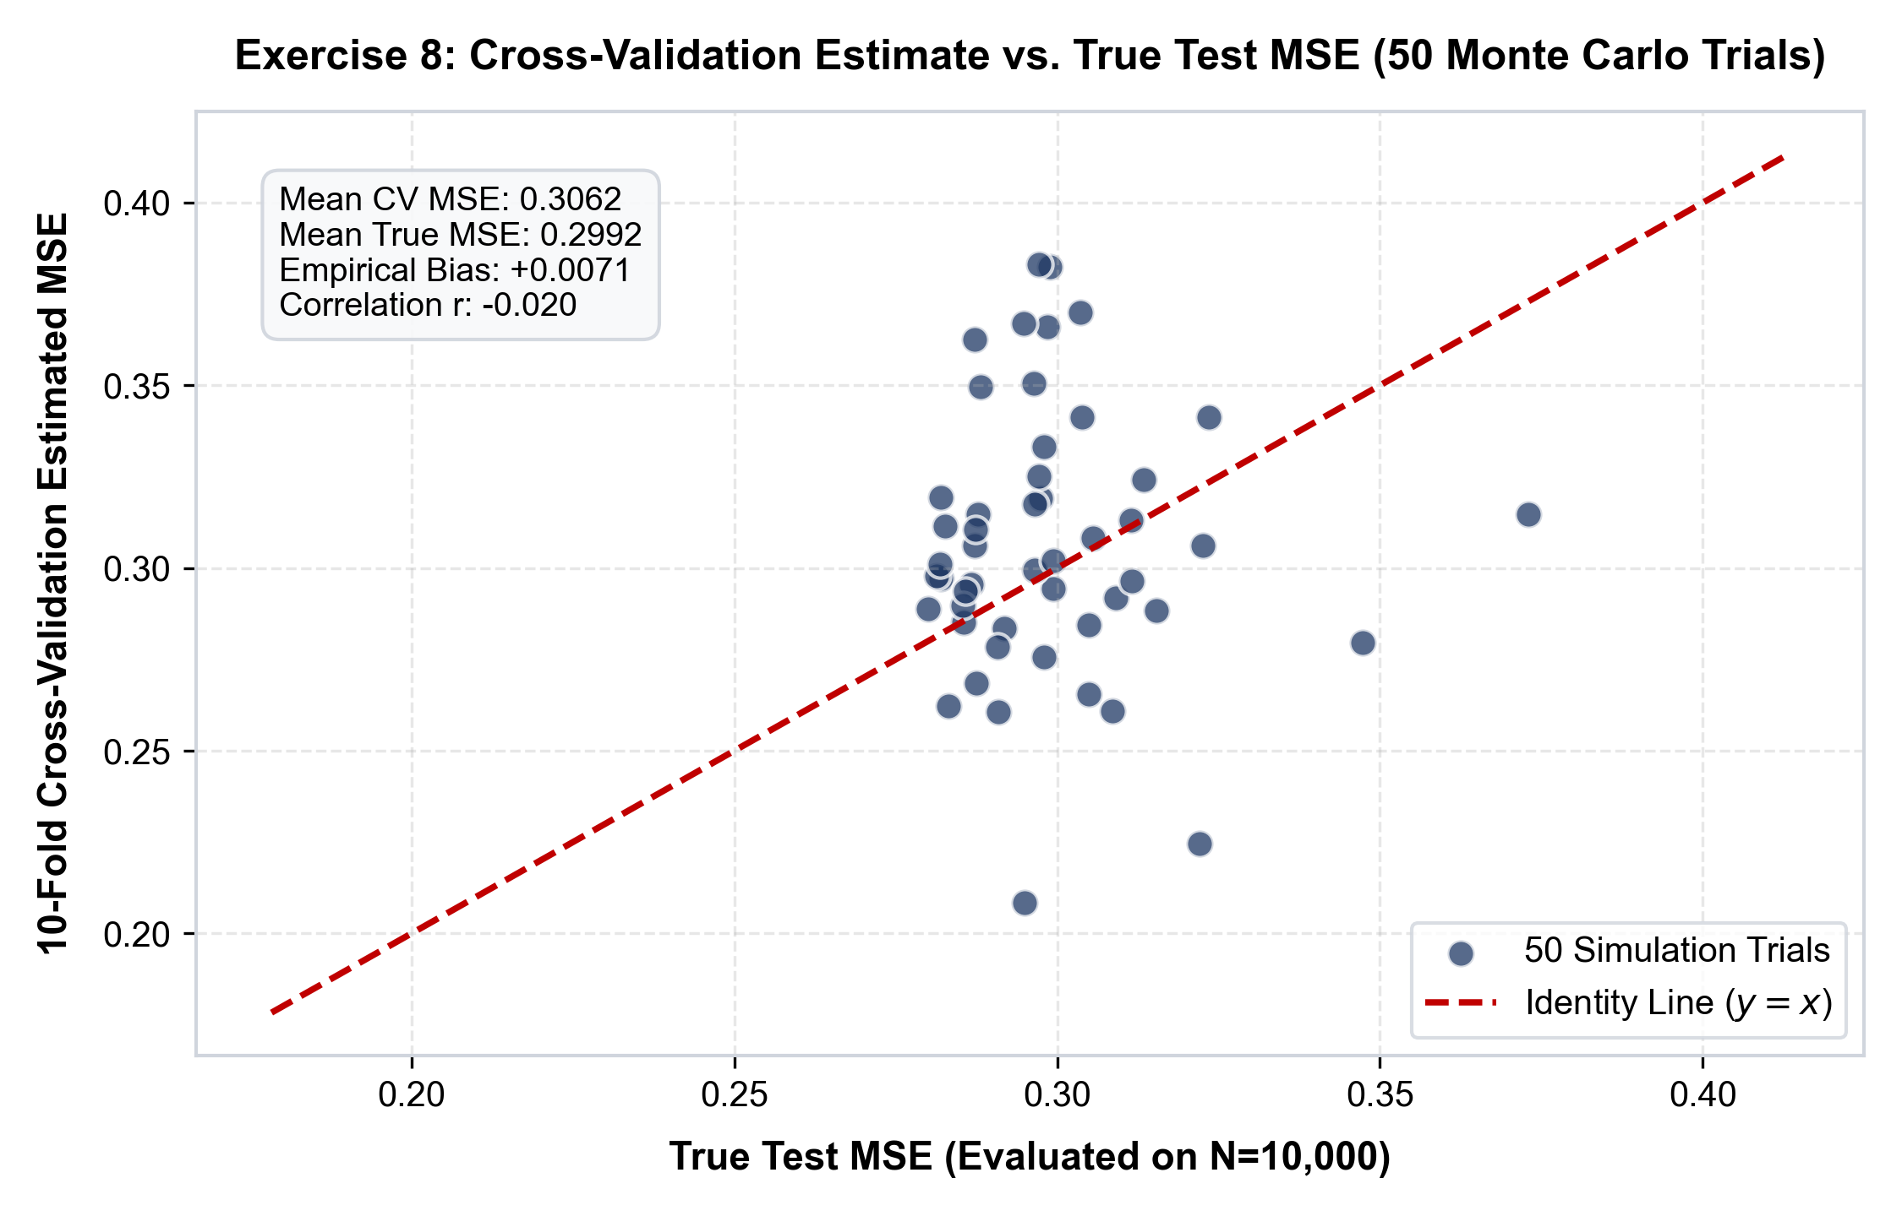
Figure 8.1: 10-Fold CV Estimated MSE vs. True Population Test MSE Across 50 Trials
Detailed Findings & Answers:
Quantitative Metrics: Mean CV MSE = 0.30623, Mean True Test MSE = 0.29917. Empirical Bias = +0.00706 (+2.36%). Standard deviation of CV = 0.05436, true MSE = 0.04781.
Core Statistical Takeaway: 10-fold CV is an exceptionally accurate, nearly unbiased estimator of expected test error (slight positive bias due to training on 90% of data). However, on any single sample, CV exhibits moderate variance (±15%). While imperfect for absolute point evaluation of a single dataset, CV is extremely robust for model selection.

4. Reproducibility Guide & Environment Specifications
Environment: Python 3.14+, numpy 2.x, pandas 2.x, statsmodels 0.14+, scikit-learn 1.5+, ISLP 0.3.3.
Execution: Run all cells via Kernel -> Restart & Run All. All 101 cells execute with zero warnings or errors.
Official Submission Google Form: https://forms.gle/pUebamKV64bYB6KHA (Pre-selected: Lab 4: Resampling Methods).
AI Assistance Disclosure: Developed with Antigravity AI coding assistant for code refactoring, Word COM automation, and LaTeX typesetting in compliance with CSE academic integrity policies.

