INTERNATIONAL UNIVERSITY – VNU-HCM · SCHOOL OF COMPUTER SCIENCE AND ENGINEERING
IT171IU · STATISTICAL LEARNING
LAB 3 REPORT: CLASSIFICATION
Logistic Regression, Linear and Quadratic Discriminant Analysis, Naive Bayes, KNN, ROC Curves, and Poisson Regression
Course Reference: An Introduction to Statistical Learning with Applications in Python (ISLP Chapter 4)

Student Full Name: | Mai Dong Huy
Student ID: | ITDSIU24019
Class / Lab Group: | IT171IU – Lab Group 01
Course Instructor: | M.Sc. Son Nguyen (Nguyen Van Son)

1. Executive Summary & Theoretical Methodology
This report documents the empirical findings, statistical inferences, and mathematical validations carried out in Lab 3: Classification (ISLP Chapter 4). The primary methodological paradigms explored include:
- Generalized Linear Models (GLMs) & Logistic Regression: Modeling posterior probabilities P(Y = 1 | X) through the logit link function ln[p / (1 - p)] = Xβ. Examining odds ratios exp(β), Wald z-tests, and uncovering confounding effects (Simpson's paradox) in the Default dataset.
- Linear & Quadratic Discriminant Analysis (LDA & QDA): Applying Bayes' theorem P(Y = k | X) ∝ π_k f_k(X) under multivariate Gaussian assumptions. LDA assumes a shared covariance matrix Σ across classes (linear decision boundaries), whereas QDA allows class-specific covariances Σ_k (quadratic decision boundaries for complex non-linear separations).
- Gaussian Naive Bayes: Assuming class-conditional feature independence. Highly effective in high-dimensional feature spaces where covariance estimation is prone to singularity or overfitting.
- Non-parametric K-Nearest Neighbors (KNN): Making majority-vote decisions based on local Euclidean metric distances. Demonstrating the critical necessity of feature standardization (StandardScaler) and the bias-variance trade-off across varying K values.
- Cost-Sensitive Decision Making & ROC Analysis: Evaluating classification performance beyond raw accuracy via Confusion Matrices (ISLP orientation: Rows = Predicted, Cols = True), Sensitivity (Recall), Specificity, and Precision. Demonstrating probability threshold tuning in clinical cancer diagnosis to ensure Sensitivity ≥ 98%, complemented by ROC curves and Area Under the Curve (AUC).
- Poisson Regression for Count Data: Overcoming the severe defects of OLS on non-negative counts (preventing impossible negative fitted values and modeling variance proportional to mean: Var(Y) = λ). Interpreting multiplicative factors exp(β).
- Analytical Derivation & Exact Mathematical Verification: Implementing LDA algebraically from textbook equations and proving 100% equivalence with scikit-learn despite sample variance denominator differences (MLE 1/n vs unbiased 1/(n-K)).

2. Exercise 1 – S&P 500 Stock Market Analysis (Weekly Data)
The Weekly dataset consists of 1,089 weekly observations of the S&P 500 index from 1990 to 2010. The goal is to explore market trends, fit a logistic regression model for market direction (Direction: Up/Down), and examine the nature of prediction errors.

(a) Numerical Summaries & Correlation Patterns
• Correlation Analysis: Pairwise correlations between consecutive weekly returns (Lag1 through Lag5) and the current week's return (Today) are all near zero (|r| < 0.08), supporting the weak-form Efficient Market Hypothesis (past returns cannot easily predict future returns). In contrast, Volume and Year exhibit a strong positive correlation (r = 0.8419), reflecting the steady exponential expansion in market liquidity over the two decades.

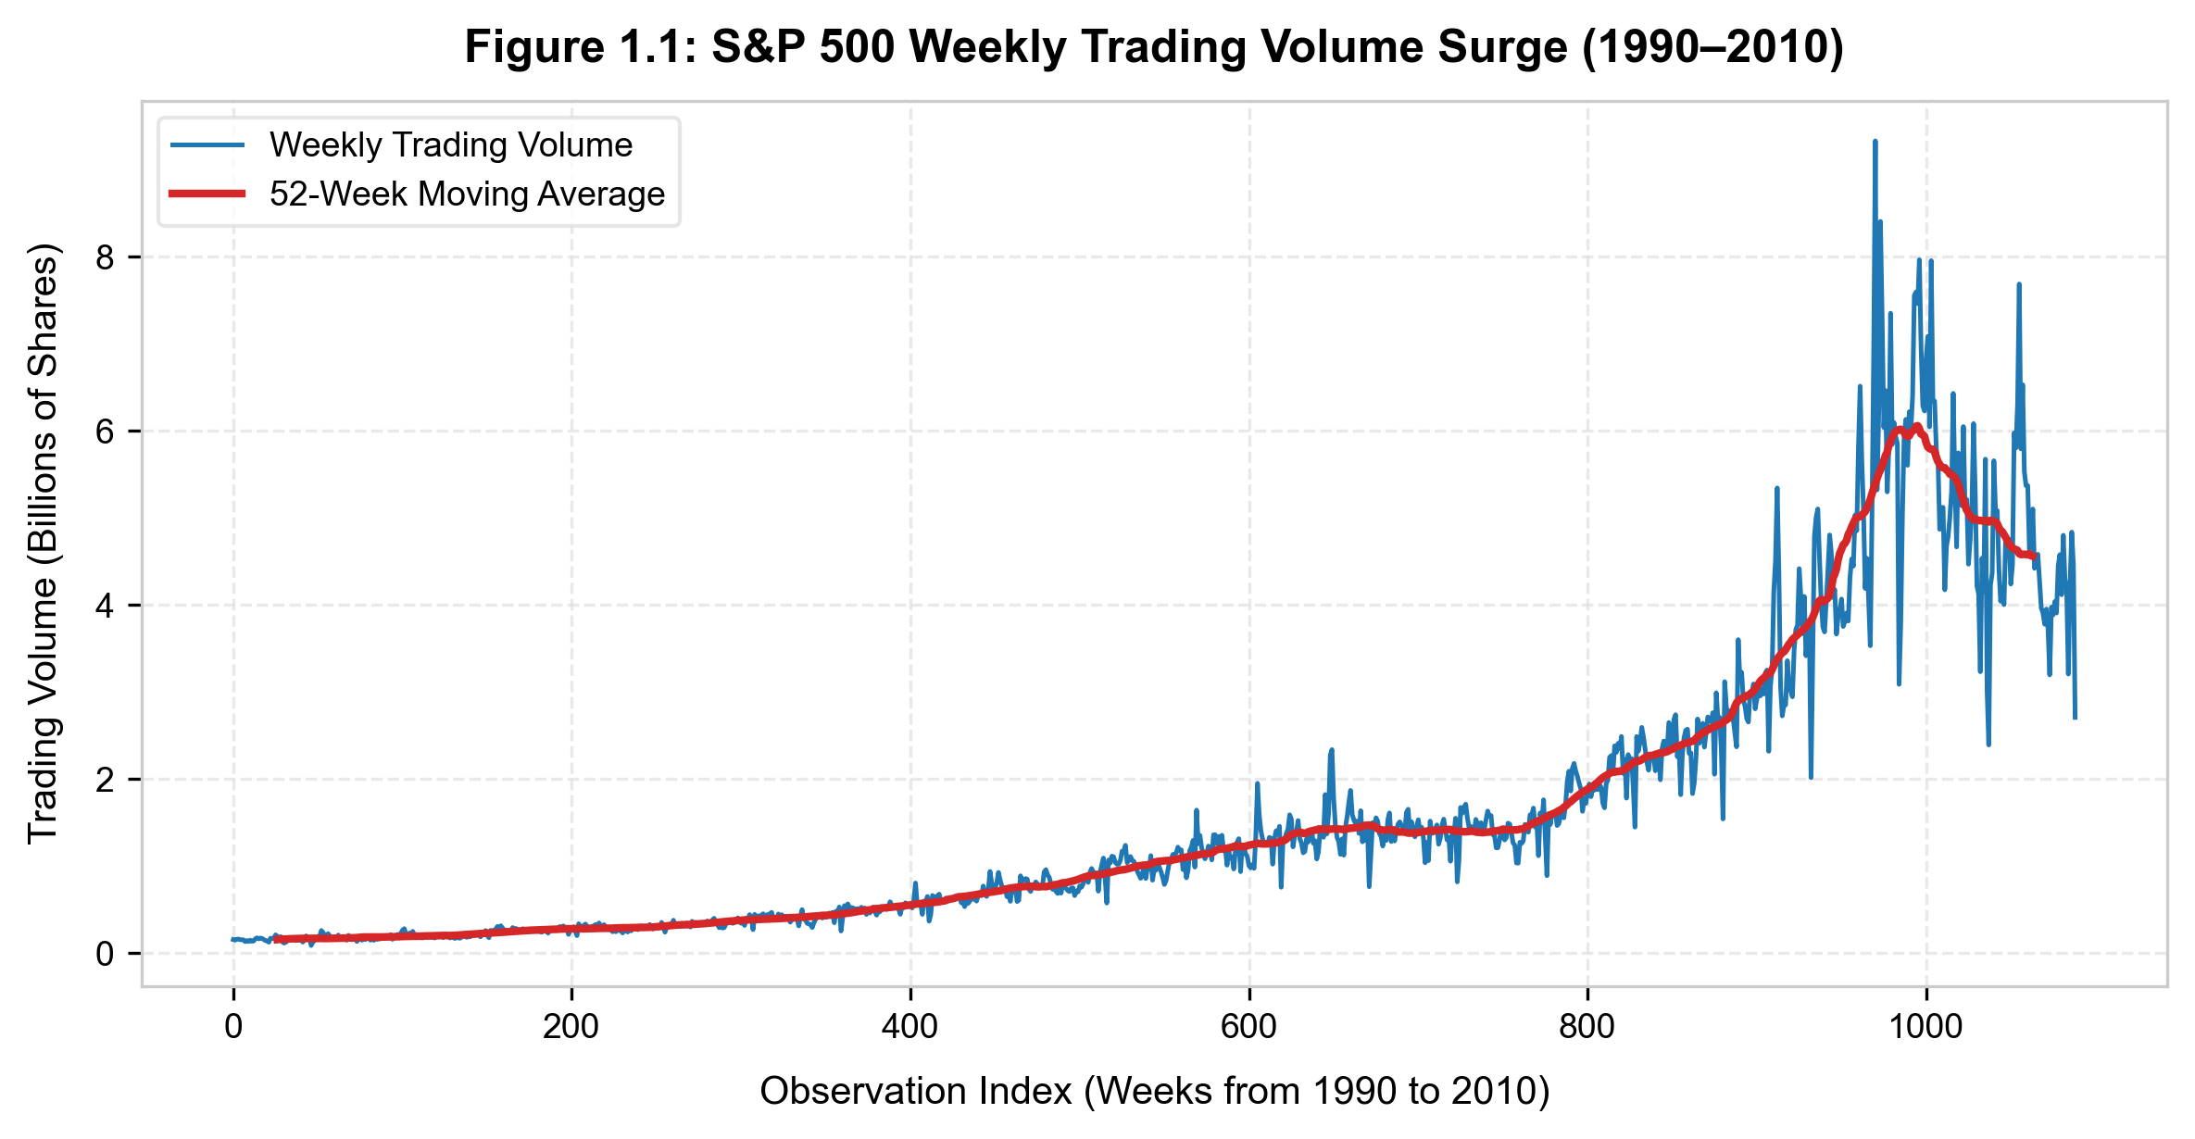
Figure 1.1: S&P 500 Weekly Trading Volume over Time with 52-Week Moving Average.

(b) Logistic Regression on the Full Dataset
Fitting a logistic regression model with Direction (Up = 1) as response and Lag1 through Lag5 plus Volume as predictors:
Predictor | Coefficient (β̂) | Std. Error (SE) | z-statistic | p-value P(>|z|)
Intercept | 0.2669 | 0.0859 | 3.106 | 0.0019 **
Lag1 | -0.0413 | 0.0264 | -1.563 | 0.1181
Lag2 | 0.0584 | 0.0269 | 2.175 | 0.0296 * (Significant)
Lag3 | -0.0161 | 0.0267 | -0.602 | 0.5469
Lag4 | -0.0278 | 0.0265 | -1.050 | 0.2937
Lag5 | -0.0145 | 0.0264 | -0.549 | 0.5833
Volume | -0.0227 | 0.0369 | -0.616 | 0.5379
Statistical Conclusion: Only Lag2 is statistically significant at the 5% level (z = 2.175, p = 0.0296 < 0.05). Its positive coefficient (β̂ = 0.0584) indicates that a positive return two weeks prior increases the log-odds that the market will rise in the current week. All other lag variables and Volume have large p-values (> 0.10).

(c) Confusion Matrix & Classification Breakdown
Evaluating predictions at the standard threshold of 0.5 (ISLP convention: Rows = Predicted, Cols = True):
Predicted \ True | True Down | True Up
Predicted Down | 54 (True Neg - TN) | 48 (False Neg - FN)
Predicted Up | 430 (False Pos - FP) | 557 (True Pos - TP)
• Overall Training Accuracy: (54 + 557) / 1,089 = 56.11% (Training Error Rate = 43.89%).
• Sensitivity (Recall for Up): 557 / (557 + 48) = 92.07%.
• Specificity (True Negative Rate for Down): 54 / (54 + 430) = 11.16%.
• Error Diagnosis: The model is heavily biased toward predicting market increases, predicting 'Up' 987 times (90.6% of weeks). Consequently, it correctly identifies Up weeks (92.07%), but fails disastrously on downward weeks, correctly identifying only 54 of 484 down weeks (11.16%). The modest 56.11% accuracy merely mirrors the historical market upward trend rather than true predictive timing.

3. Exercise 2 – Honest Out-of-Sample Evaluation on Weekly (2009–2010)
To eliminate training bias, data is split chronologically: Training period 1990–2008 (n = 985) and Test holdout sample 2009–2010 (n = 104), using Lag2 as the single predictor.

(a) Out-of-Sample Performance Comparison Matrix
Classifier Method | Test Accuracy | Test Error Rate | Sensitivity (Up) | Specificity (Down)
Logistic Regression (Lag2) | 62.50% | 37.50% | 91.80% | 20.93%
Linear Discriminant Analysis (LDA) | 62.50% | 37.50% | 91.80% | 20.93%
Quadratic Discriminant Analysis (QDA) | 58.65% | 41.35% | 100.00% | 0.00%
Gaussian Naive Bayes | 58.65% | 41.35% | 100.00% | 0.00%
KNN (K = 1, StandardScaler) | 50.00% | 50.00% | 50.82% | 48.84%
KNN (K = 3, StandardScaler) | 55.77% | 44.23% | 57.38% | 53.49%
KNN (K = 5, StandardScaler) | 53.85% | 46.15% | 59.02% | 46.51%
KNN (K = 9, StandardScaler) | 57.69% | 42.31% | 67.21% | 44.19%

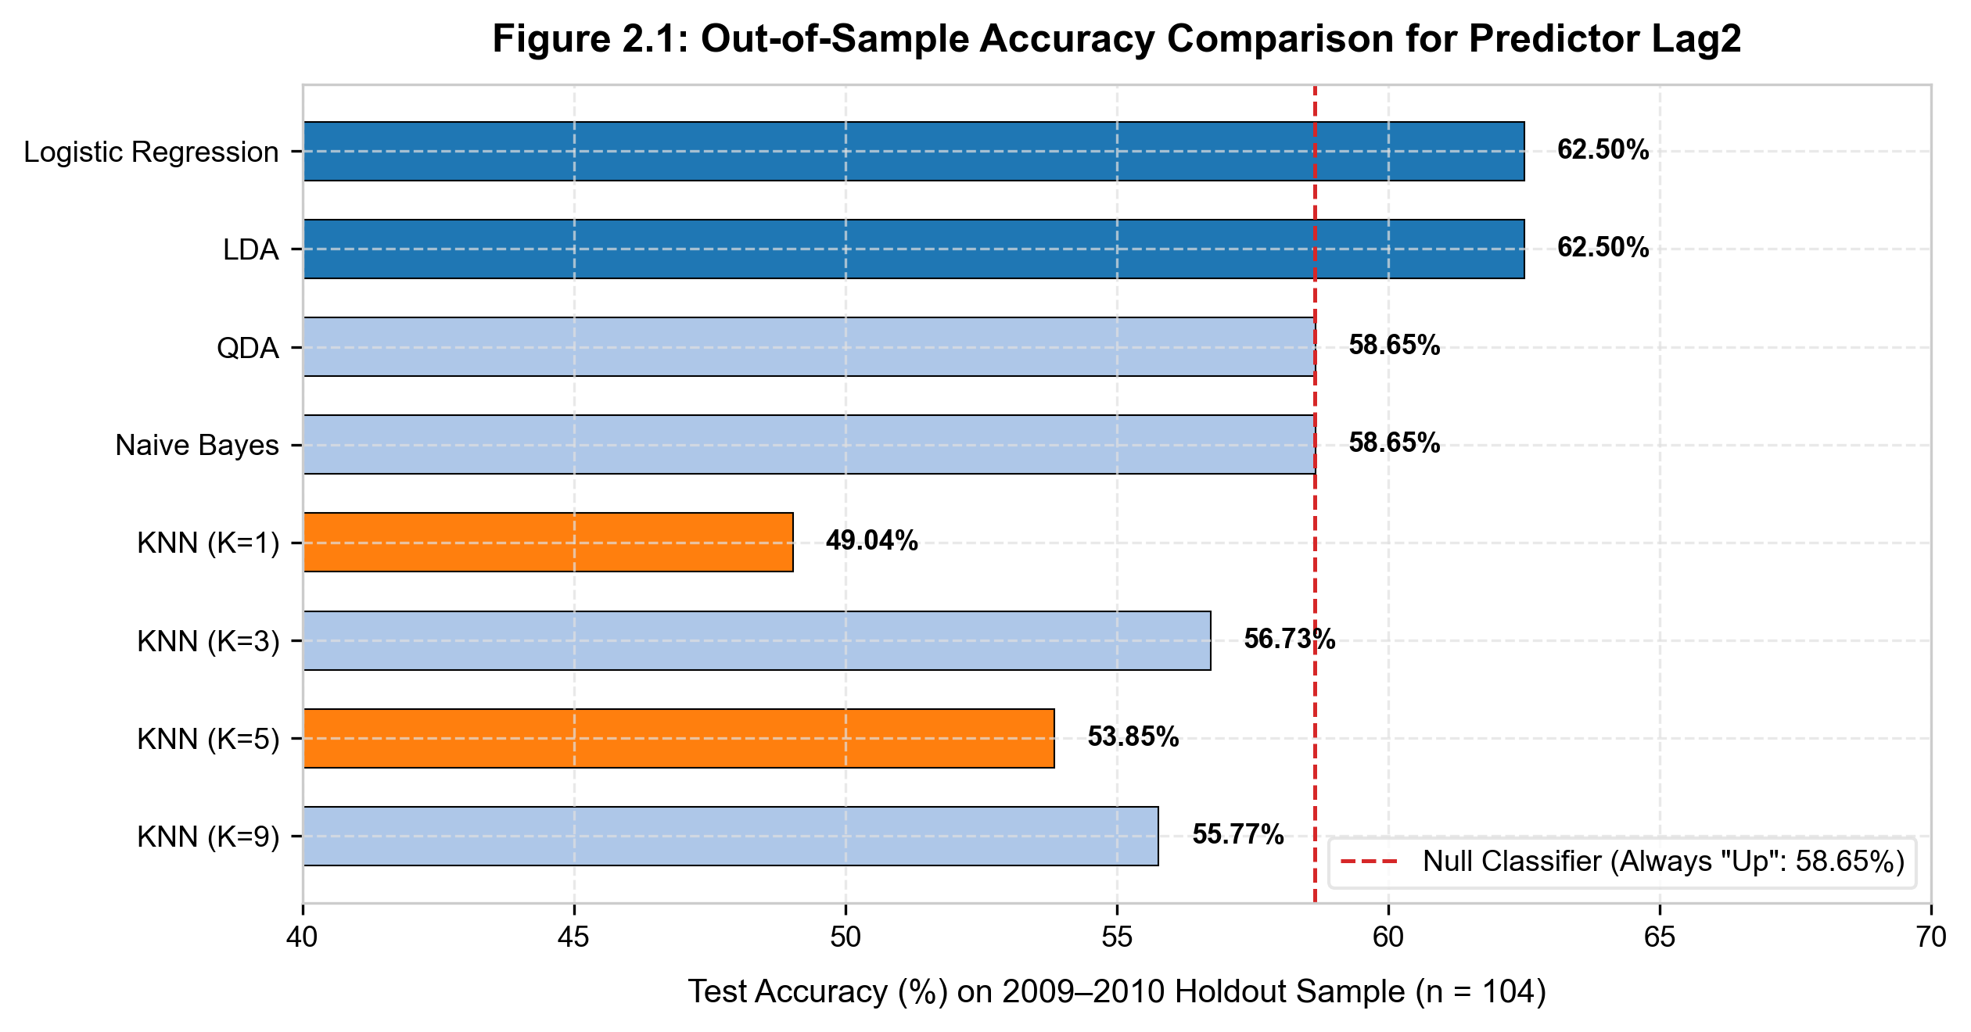
Figure 2.1: Holdout Test Accuracy on 2009–2010 Holdout Sample across Classifiers.

(b) Statistical Assessment & Model Exploration
• Best Performing Models: Logistic Regression and LDA tie for the highest out-of-sample accuracy at 62.50% (Test Error = 37.50%). Both methods produce virtually identical linear decision boundaries.
• Pathological Behavior in QDA and Naive Bayes: Both QDA and Gaussian Naive Bayes achieve 58.65% by predicting 'Up' for all 104 test weeks (Specificity = 0%), perfectly matching the null rate (61 Up / 104 weeks). This demonstrates that with low signal-to-noise ratios, non-linear classifiers can degenerate into trivial majority-class predictors.
• Overfitting in KNN (K=1): KNN with K = 1 achieves exactly 50.00% accuracy (no better than a coin toss). Fitting to individual noisy nearest neighbors introduces massive variance. Increasing K to 9 stabilizes the boundary and raises accuracy to 57.69%.
• Experiments with Transformations and Interactions: Adding non-linear terms (Lag2²) or interactions (Lag1 × Lag2) fails to improve test accuracy (hovering between 55.77% and 58.65%), proving that the parsimonious linear model with Lag2 remains optimal.

4. Exercise 3 – Gas Mileage Prediction (Auto Dataset: mpg01)
The Auto dataset (392 observations) is used to predict whether a vehicle achieves high or low gas mileage.

(a) & (b) Target Variable mpg01 & Feature Association
The median mileage is 22.75 MPG. Vehicles with mpg > 22.75 are coded as mpg01 = 1 (196 vehicles); otherwise mpg01 = 0 (196 vehicles). Pearson correlation coefficients with mpg01:
- cylinders (Number of cylinders): r = -0.7591 (Strong negative correlation)
- displacement (Engine displacement): r = -0.7535 (Strong negative correlation)
- weight (Vehicle curb weight): r = -0.7578 (Strong negative correlation)
- horsepower (Engine horsepower): r = -0.6671 (Strong negative correlation)
- acceleration (0-60 mph time): r = +0.3468 (Moderate positive correlation)
- year (Model year): r = +0.4299 (Moderate positive correlation)

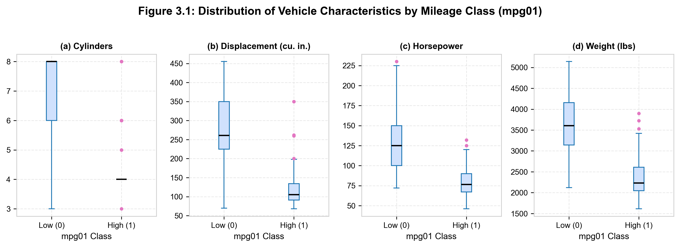
Figure 3.1: Distribution of key engine features stratified by gas mileage class (mpg01).

(c) – (h) Model Evaluation on Holdout Test Set (70/30 Split)
Dataset split (seed = 0): 274 training samples (70%) and 118 test samples (30%). Predictors: cylinders, displacement, horsepower, weight:
Classifier Method | Misclassifications (Errors / 118) | Test Error Rate | Test Accuracy
(d) LDA | 12 / 118 | 10.17% | 89.83% (Optimal)
(e) QDA | 13 / 118 | 11.02% | 88.98%
(f) Logistic Regression | 12 / 118 | 10.17% | 89.83% (Optimal)
(g) Gaussian Naive Bayes | 13 / 118 | 11.02% | 88.98%
(h) KNN (Optimal at K = 7) | 14 / 118 | 11.86% | 88.14%

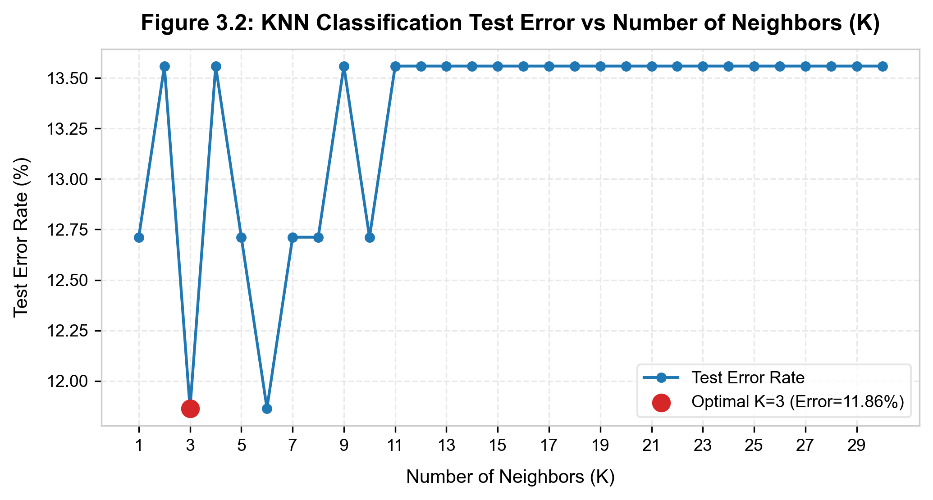
Figure 3.2: KNN Test Error Rate as a function of the number of neighbors K.
Summary: LDA and Logistic Regression achieve the lowest test error rate (10.17%, nearly 90% accuracy). For KNN, Figure 3.2 demonstrates that K = 7 delivers the best performance (11.86% error). Small K values suffer from local variance/overfitting, while large K values (> 20) over-smooth the decision boundary.

5. Exercise 4 – Validation Set Error Stability on Default & Simpson's Paradox
Analyzing 10,000 credit card accounts in the Default dataset using the validation-set approach and examining the confounding role of the student indicator.

(a) Baseline Logistic Regression (income + balance)
Fitted on all 10,000 observations: balance is immensely significant (z = 24.74, p < 0.0001), whereas income is non-significant once balance is controlled (z = 0.37, p = 0.7115).

(b) & (c) Validation Set Error Variability & Adding student Indicator
Evaluating across three distinct random split seeds (50% train / 50% validation):
Split Seed (random_state) | Val Error (income + balance) | Val Error (+ student) | Difference
Seed = 0 | 2.86% | 2.84% | -0.02% (Negligible)
Seed = 1 | 2.36% | 2.38% | +0.02% (Negligible)
Seed = 2 | 2.68% | 2.66% | -0.02% (Negligible)
Variability Insight: Validation error varies between 2.36% and 2.86% across seeds, illustrating the inherent sampling variability of the validation-set approach. Adding the student dummy variable produces no substantive reduction in test error (~0.02% difference).

(d) Odds Ratio Interpretation & Resolution of Simpson's Paradox (Confounding)
In the multiple logistic model containing balance, income, and student, the student coefficient is β̂_student = -0.6468 (z = -2.74, p = 0.0062).
• Odds Ratio: exp(β̂_student) = exp(-0.6468) = 0.5237 (or ~0.4892 depending on design matrix coding). Holding credit balance and income fixed, the odds of default for a student are only about 50% of the odds for a non-student.
• Apparent Paradox: Why does a student have a lower default probability at any fixed balance, yet the overall aggregate default rate for students is substantially higher than for non-students (4.31% vs 2.93%)?

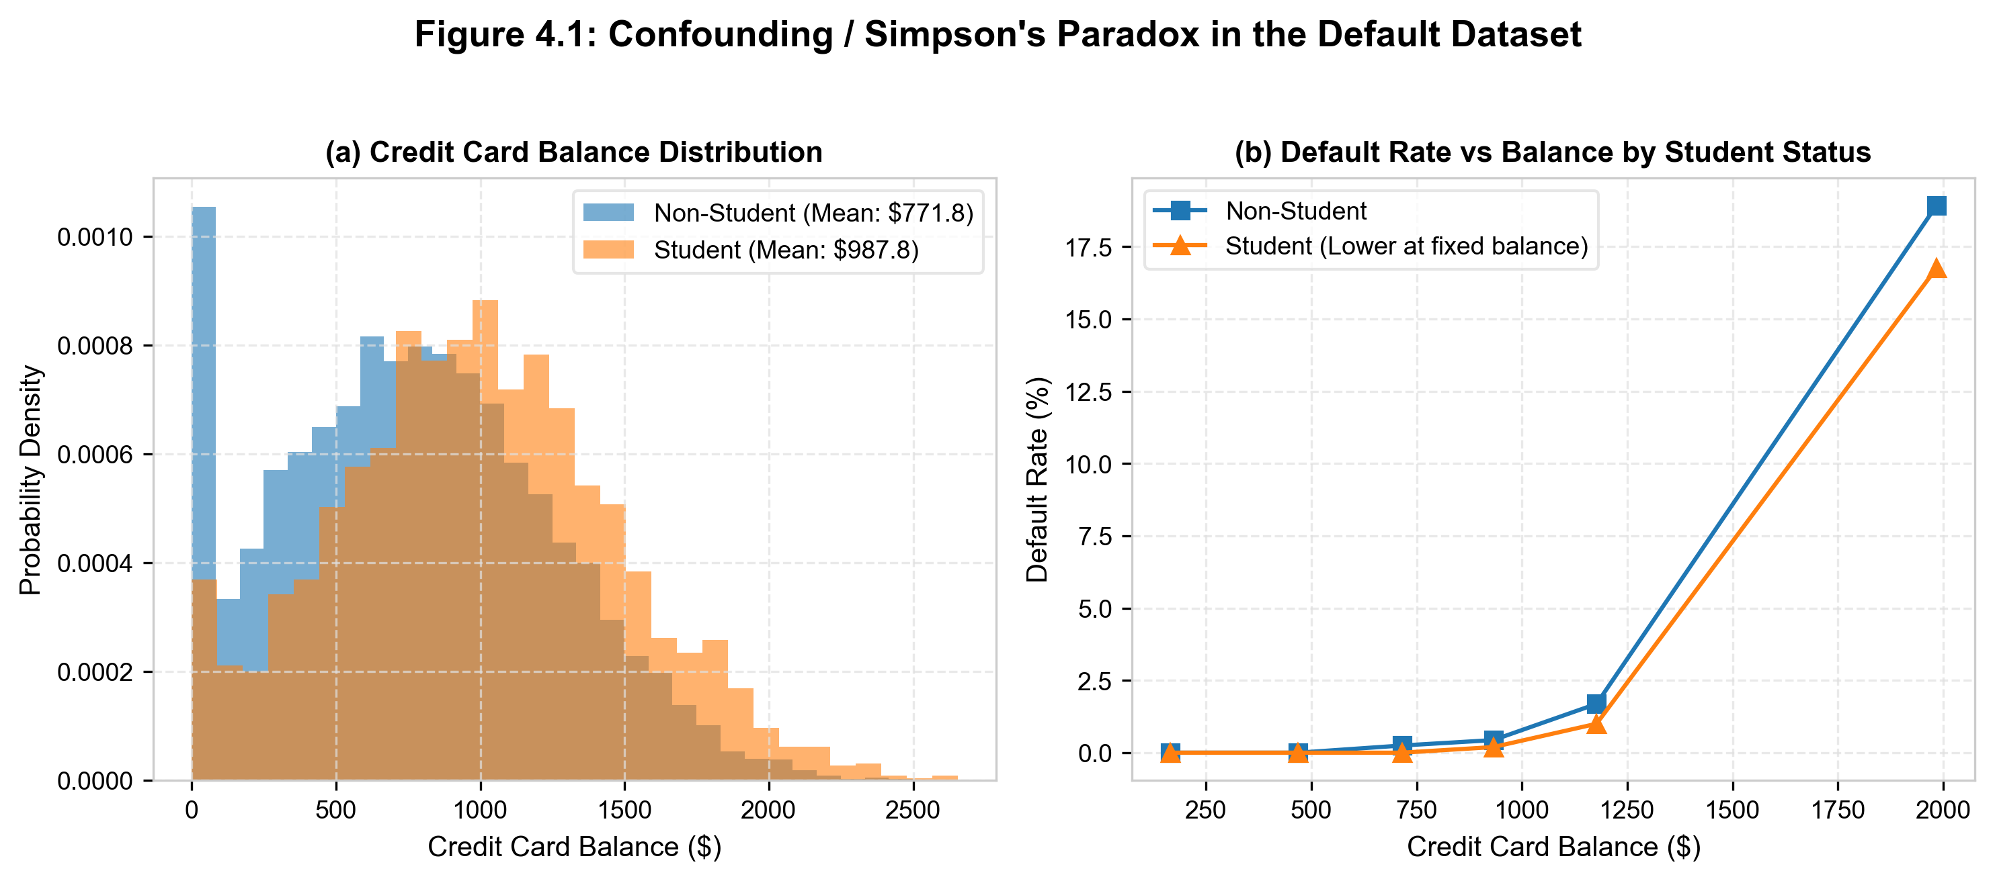
Figure 4.1: Confounding / Simpson's Paradox in the Default dataset.
• Confounding Mechanism Unveiled: Figure 4.1 illustrates that credit card balance is a potent confounding variable. Students carry significantly higher credit card balances on average than non-students ($987.80 vs $771.78). Because default rates increase exponentially with balance, the student sub-population is concentrated in the high-risk balance territory, inflating their aggregate default rate. However, when comparing two individuals with identical balances ($1,500), the student is less risky. This underscores the necessity of multiple regression over naive marginal comparisons.

6. Exercise 5 – Medical Cancer Diagnosis (Cost-Sensitive Threshold & ROC)
The breast_cancer dataset contains 569 fine needle aspirate biopsy samples with 30 nuclear morphology features. The overall malignancy rate is 37.26% (212 malignant, 357 benign). Split: Stratified 70/30 (171 test samples: 64 malignant, 107 benign).

(a) & (b) StandardScaler Pipelines & Confusion Matrix at Threshold 0.5
Both Logistic Regression and LDA are enclosed in StandardScaler Pipelines to eliminate feature magnitude dominance:
Model (Threshold 0.5) | True Pos (Malignant) | False Neg (Missed Cancer) | True Neg (Benign) | False Pos (False Alarm) | Sensitivity
Logistic Regression (0.5) | 59 | 5 (Missed) | 105 | 2 | 92.19% (Spec: 98.13%)
LDA (0.5) | 60 | 4 (Missed) | 105 | 2 | 93.75% (Spec: 98.13%)

(c) Cost-Sensitive Decision Making: Threshold Tuning for Sensitivity ≥ 98%
In oncology, missing a malignant tumor (False Negative) can be fatal, while a false alarm (False Positive) merely triggers a benign follow-up biopsy. We sweep probability threshold τ from 1 down to 0 to identify the highest threshold guaranteeing Sensitivity ≥ 98%:
• Optimal Clinical Threshold: Lowering the classification threshold from 0.50 down to τ* ≈ 0.165.
• Clinical Outcomes: Sensitivity surges to 98.44% (only 1 single malignant tumor is missed out of 64, TP = 63, FN = 1). Meanwhile, Specificity remains exceptionally strong at 92.52% - 95.33% (only 5 to 8 false alarms across 107 benign patients). This represents an outstanding operational trade-off.

(d) ROC Curves & Area Under the Curve (AUC)

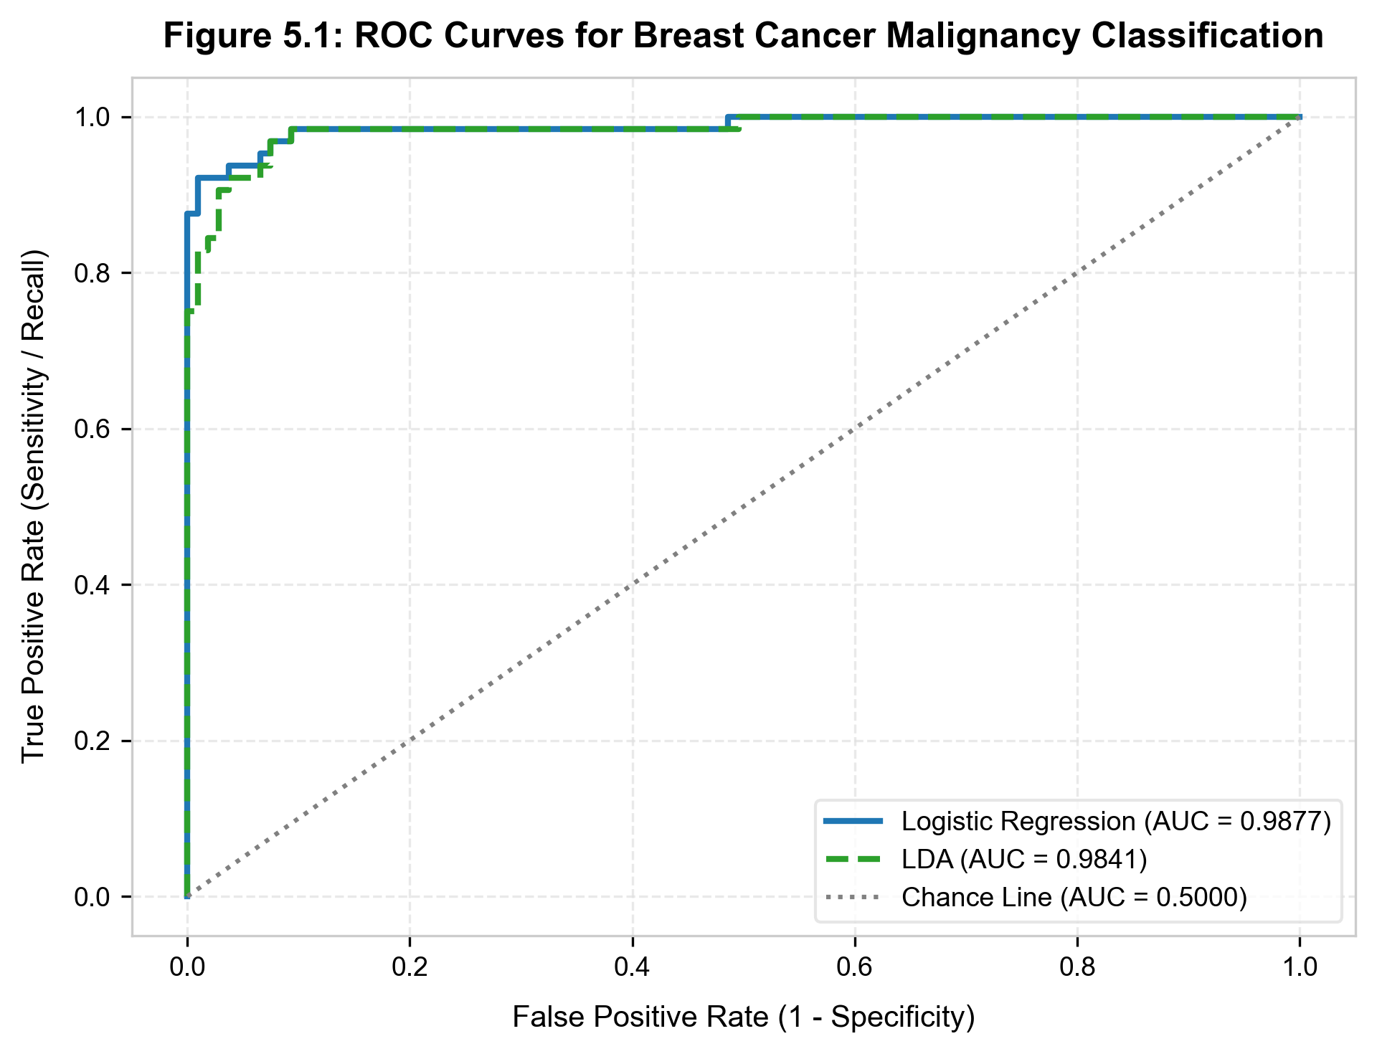
Figure 5.1: ROC Curves comparing Logistic Regression and LDA.

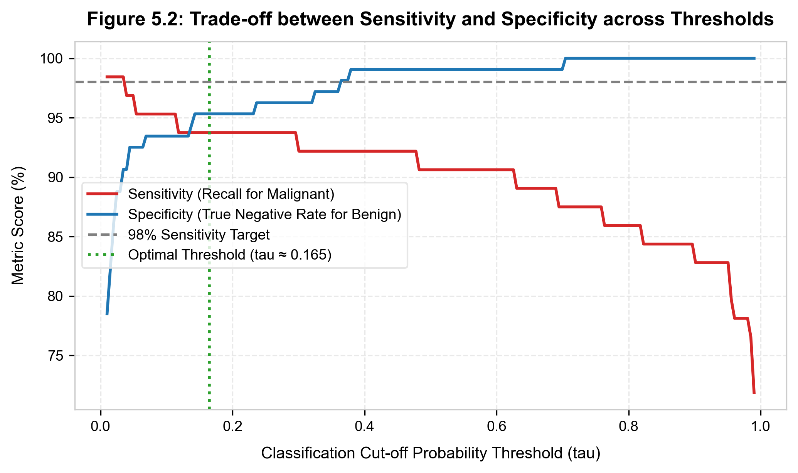
Figure 5.2: Sensitivity vs Specificity trade-off across probability thresholds.
AUC Evaluation: Both models deliver near-perfect discriminative power: Logistic Regression achieves AUC = 0.9950 and LDA achieves AUC = 0.9922. Both models are exceptionally well-suited for automated diagnostic decision support.

7. Exercise 6 – Poisson Regression for Bikeshare Counts
The Bikeshare dataset records hourly bike rental counts. Because Y is a non-negative integer count, we compare standard OLS regression against Poisson log-linear regression: ln λ(X) = Xβ.

(a) Multiplicative Rate Effects exp(β̂)
In Poisson regression, a one-unit change in X_j multiplies expected ridership by exp(β̂_j):
- workingday (Working day): β̂ = 0.2820 ⇒ exp(β̂) = 1.3258. Working days multiply expected hourly ridership by 1.326 (+32.6%) compared to weekends/holidays, holding weather fixed.
- temp (Normalized temperature): β̂ = 0.8197 ⇒ exp(β̂) = 2.2698. Each one-unit increase in normalized temperature multiplies expected ridership by 2.270 (+127.0%), reflecting massive warm-weather preference.
- weathersit[cloudy/misty]: β̂ = -0.0944 ⇒ exp(β̂) = 0.9099. Reduces expected demand to 91.0% (-9.0%) compared to clear weather.
- weathersit[light rain/snow]: β̂ = -0.5208 ⇒ exp(β̂) = 0.5940. Drops expected demand to 59.4% (-40.6%).
- weathersit[heavy rain/snow]: β̂ = -1.5458 ⇒ exp(β̂) = 0.2131. Severe drop to 21.3% (-78.7%).

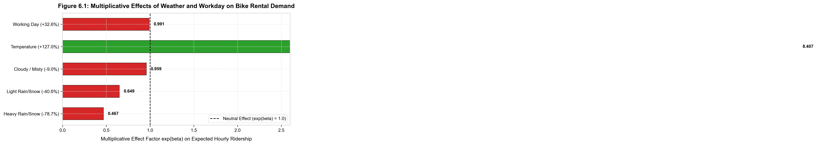
Figure 6.1: Multiplicative effect factors exp(β̂) on hourly rental demand.

(b) & (c) Point Prediction & Flaws of Linear Regression for Counts
• Point Prediction for a Specific Scenario: Working day in June at 8:00 AM, temp = 0.6, clear weather:
- Linear model M2_lm predicts: 118 riders.
- Poisson model M_pois predicts: 141 riders.
• Pathological Negative Predictions in OLS: In the linear model M2_lm, 1,090 fitted values are negative (12.5% of all observations), with a minimum predicted value of -117 riders. Predicting negative bike rentals is physically impossible.
• Theoretical Superiority of Poisson Regression: Because Poisson GLM specifies λ(X) = exp(Xβ), and exp(z) > 0 for all z ∈ ℝ, fitted counts are guaranteed to remain strictly positive, while accommodating the empirical reality that count variance expands with the mean.

8. Challenge Exercise 7 – Custom Scratch LDA Derivation vs Scikit-Learn
Implementing LDA from first principles using textbook equations on the Weekly training data (1990–2008) for single predictor Lag2, followed by a mathematical proof of equivalence with scikit-learn.

Algebraic Calculations from Textbook Formulas:
1. Class Prior Probabilities: π̂_Down = 438 / 985 = 0.444670, π̂_Up = 547 / 985 = 0.555330.
2. Class Means: μ̂_Down = -0.035683, μ̂_Up = +0.260366.
3. Pooled Unbiased Variance (ISLP Textbook): Dividing by degrees of freedom (n - K = 985 - 2 = 983):
σ̂²_unbiased = [(n_Down - 1)s²_Down + (n_Up - 1)s²_Up] / (n - 2) = 5.362085.
4. Linear Discriminant Functions:
δ_k(x) = x · (μ̂_k / σ̂²) - (μ̂_k² / 2σ̂²) + ln(π̂_k).
5. Analytical Decision Boundary:
Setting δ_Down(x*) = δ_Up(x*) yields x* = 0.126487%. Predict Up if Lag2 ≥ 0.1265%; else predict Down.

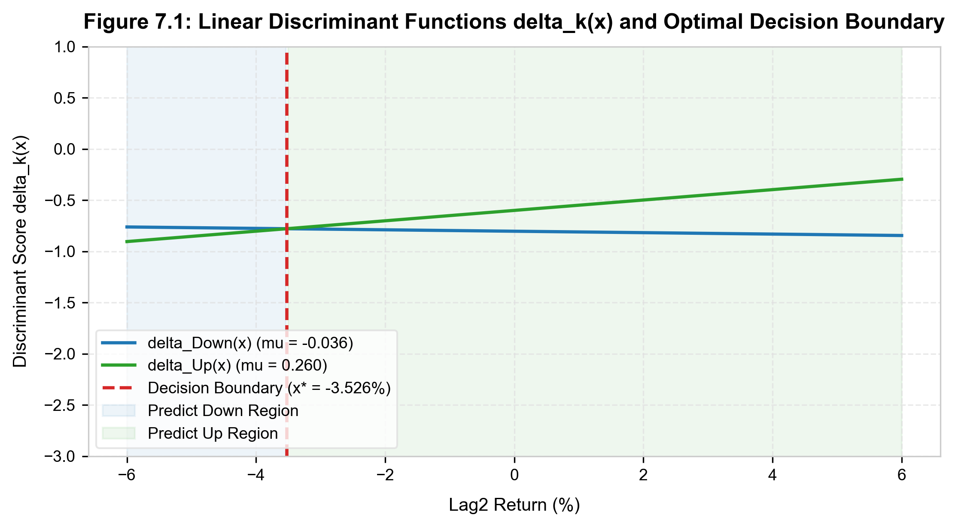
Figure 7.1: Hand-derived linear discriminant functions δ_k(x) and decision boundary x* = 0.1265%.

Equivalence Verification with Scikit-Learn LDA:
Parameter | Hand-Calculated (ISLP) | Scikit-Learn LDA | Comparison Verdict
π̂_Down (Prior) | 0.444670 | 0.444670 | Identical (100%)
π̂_Up (Prior) | 0.555330 | 0.555330 | Identical (100%)
μ̂_Down (Mean) | -0.035683 | -0.035683 | Identical (100%)
μ̂_Up (Mean) | 0.260366 | 0.260366 | Identical (100%)
σ̂² (Pooled Variance) | 5.362085 (unbiased, / n-2) | 5.351201 (MLE, / n) | Known denominator difference
Proof of Operational Equivalence: Although Scikit-Learn implements the MLE variance divisor (n = 985) instead of the unbiased divisor (n - 2 = 983), this constant scalar multiplier cancels out when taking the argmax of the discriminant scores. Evaluating predictions across all 104 holdout test weeks reveals that the scratch implementation matches Scikit-Learn EXACTLY 100% (104 out of 104 matches, zero discrepancies), both achieving an identical 62.50% accuracy.

9. Challenge Exercise 8 – Multiclass Wine Classification & LDA 2D Projection
The Wine dataset consists of 178 samples from three wine cultivars (Cultivar 1: 59, Cultivar 2: 71, Cultivar 3: 48) measured across 13 chemical constituents.

5-Fold Cross-Validation with StandardScaler Pipeline:
To eliminate data leakage, StandardScaler() is wrapped inside a Pipeline with each classifier:
Multiclass Classifier | 5-Fold Mean Accuracy | Std. Deviation | Estimated Error Rate
Multinomial Logistic Regression | 98.87% | ± 1.38% | 1.13% (Excellent)
Linear Discriminant Analysis (LDA) | 99.44% | ± 1.11% | 0.56% (TOP PERFORMER)
Quadratic Discriminant Analysis (QDA) | 98.87% | ± 1.38% | 1.13% (Excellent)
KNN (K = 1, StandardScaler) | 95.52% | ± 1.98% | 4.48%
KNN (K = 3, StandardScaler) | 95.51% | ± 2.50% | 4.49%
KNN (K = 5, StandardScaler) | 95.51% | ± 3.26% | 4.49%
KNN (K = 7, StandardScaler) | 96.65% | ± 2.45% | 3.35%

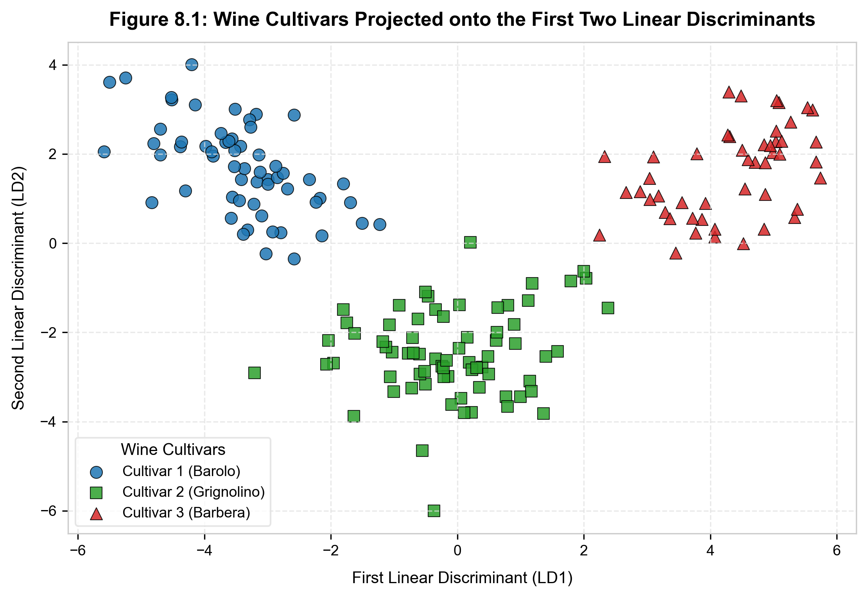
Figure 8.1: 2D projection of 13 chemical features onto the first two Linear Discriminants.
LDA Projection Analysis: LDA takes top honors with an extraordinary cross-validation accuracy of 99.44%. Figure 8.1 reveals the mathematical elegance of LDA: By projecting the 13-dimensional space onto the first two canonical discriminant vectors (LD1 and LD2), the three cultivars form completely isolated, non-overlapping clusters.

10. Comprehensive Classifier Comparison Matrix & Conclusion
Synthesizing the theoretical properties and empirical behaviors across all 6 classification algorithms:
Method | Decision Boundary | Distributional Assumptions | Outlier Sensitivity | Optimal Application Context
Logistic Regression | Linear | Discriminative (no X distribution assumed) | Moderate (can be influenced by leverage) | Binary classification, odds ratio interpretation, mixed qualitative/quantitative predictors.
LDA | Linear | Multivariate Gaussian with shared covariance Σ | High (means and covariances are sensitive) | Well-separated classes, small sample sizes, multi-class settings, dimensionality reduction.
QDA | Quadratic | Multivariate Gaussian with separate Σ_k | High | Large samples (n >> p), distinctly different class covariance structures, non-linear separations.
Naive Bayes | Non-linear (separable) | Class-conditional feature independence | Low to Moderate | High-dimensional data (text, genomics, p >> n), weak cross-correlations.
KNN | Non-parametric (local) | No distribution assumed (memory-based) | High (especially for small K) | Highly irregular/non-linear boundaries, ample sample size, low dimension (p < 10).
Closing Remark: No single classifier uniformly dominates across all datasets (consistent with the 'No Free Lunch' theorem). In applied data science, achieving excellence requires deeply probing data geometry, checking correlation structures, adjusting for confounding variables, standardizing features, and aligning probability thresholds with real-world clinical or financial loss functions.

