

Auto-ID Middleware

Auto-ID Middleware
Installation Guide
Document Version 1.0

2005-03-31
Contents

1 Product Overview 1
1.1 Installation Guide 1
2 Pre-installation Requirement 1
2.1 Hardware Requirement 1
2.2 Software Requirement 1
2.3 Auto-ID Reader (Device) 2
3 JRE installation 2
4 Application Server Installation 4
4.1 Tomcat 4
4.2 JBoss 8
5 Database Installation 8
5.1 MySQL 8
5.1.1 Install MySQL 8
5.1.2 Install MySQL Connector for Java 16
5.1.3 Create Middleware Database 17
5.2 PostgreSQL 17
5.2.1 Install PostgreSQL 17
5.2.2 Install PostgreSQL JDBC Driver 21
5.2.3 Create Middleware Database 21
5.3 MS SQL Server 21
5.3.1 Install MS SQL Server 21
5.3.2 Install Sql2kSP3 21
5.3.3 Install SQL Server 2000 Driver for JDBC Service Pack3 22
5.3.4 Install MS SQL Server JDBC Driver 22
5.3.5 Create Middleware Database 22
5.4 MaxDB 25
5.4.1 Install MaxDB 25
5.4.2 Install MaxDB JDBC Driver 25
5.4.3 Create Middleware Database 26
5.5 Oracle 26
5.5.1 Install Oracle 26
5.5.2 Install Oracle JDBC Driver 26
5.5.3 Create Middleware Database 26
6 Middleware WAR Deployment and Configuration 26
6.1 Tomcat 26
6.1.1 MySQL 27
6.1.2 PostgreSQL 27
6.1.3 MS SQL Server 27
6.1.4 MaxDB 27
6.1.5 Oracle 28
6.2 JBoss 28
6.2.1 MySQL 28
6.2.2 PostgreSQL 28
6.2.3 MS SQL Server 28
6.2.4 MaxDB 28
6.2.5 Oracle 28
6.3 JavaComm Installation for Serial Connection to Device 28
7 Product License Key 28
8 System Starting and Stopping 28
8.1 Tomcat 28
8.2 JBoss 30
9 Troubleshooting 30
9.1 Middleware Started Successfully 30
9.2 Database Service Eerror or Database URL Configuration Error 31
9.3 Database Name Configuration Error 31

Product Overview
Ubipass Auto-ID Middleware is a middleware system, it can connect different barcode & RFID devices, collect and store EPC/bar-code information detected by readers, and it can also provide interface which can connect with SAPAII、CIP and other ERP systems. Its main characters are:
- Connects with multiple devices supplied by different hardware providers simultaneously;
- Uses Plug-in and Agent mechanism to aggregate bar-codes and RFID electric labels、label readers and label printers、mobile and fixed R/W devices into one platform through TCP/IP or COM;
- Supports various real-time or unreal-time Tag data collect logics flexible by task user-defined mechanism;
- Supports various open and standard external interfaces transmit Tag information synchronously or asynchronously, such as SOAP、HTTP、JMS、FTP etc, so that Tag information can be encapsulated in a PML document uniformly and delivered to outer systems;
- Provides Web UI for users to configure and monitor system and execute label read/write logic intuitively and expediently;
- Supports multiple database systems such as Oracle、MS SQL Server、MySQL、MaxDB and PostgreSQL;
- Middleware is coded by Java so it can run on different OS and Application Sever

Installation Guide
Four directories can be found in Auto-ID Middleware Installation CD:
- War: the Web-Application file of the Middleware
- Conf: configuration files of the Middleware
- Database: Different Database scripts
- Lib: Different JDBC Drivers of the databases supported by the Middleware
- Agent: Various hardware’s Agent program

Pre-installation Requirement

Hardware Requirement
Hardware required to install Ubipass Auto-ID Middleware are described as bellow

CPU | At least 1GHz Pentium III
Hard Disk | At least 1G free space
RAM | At least 512MB

Software Requirement
Confirm these software had been installed before install Ubipass Auto-ID Middleware
 | 名称Name | URL
Database | MySQL 4.1 | http://dev.mysql.com/downloads/mysql/4.1.html
Database | MaxDB | http://dev.mysql.com/downloads/MaxDB/7.5.00.html
Database | PostgreSQL 8.0 | http://www.postgresql.org/ftp/binary/
Database | Oracle | N/A
Database | MS SQL Server 2000 SP3 | N/A
JRE | JRE 5.0 Update 2 | http://java.sun.com/j2se/1.5.0/download.jsp
Application Server | Tomcat 5.5 | http://apache.justdn.org/jakarta/tomcat-5/v5.5.7/bin/jakarta-tomcat-5.5.7.exe
Application Server | JBoss 4.1 | http://www.jboss.com/downloads/index#as

Auto-ID Reader (Device)
Reader Name | Antenna | Frequency | Plug-in Class
Alien Class1 Reader | 2/4 | 915MHz | com.ubipass.middleware.plugin.alien.AlienClass1ReaderPlugin

JRE installation
- Download JRE 5.0 Update 2 from Sun website(refer to 2.2)
- Double click “jre-1_5_0_02-windows-i586-p.exe” to launch the installer
- In the Install Shield installation wizard, choose “Accept the items of the license” and click “Next”
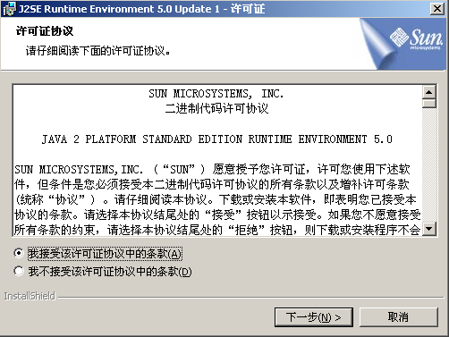

- Choose “Typical” and click “Next”
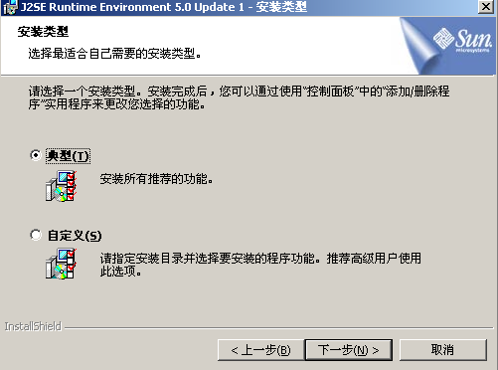

- Waiting for the installation

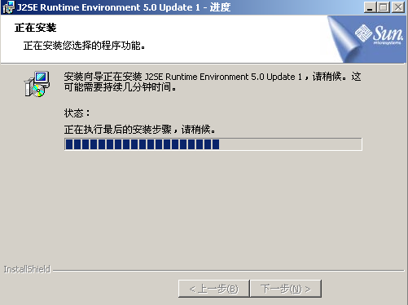

- Click “Finish” to finish the JRE installation
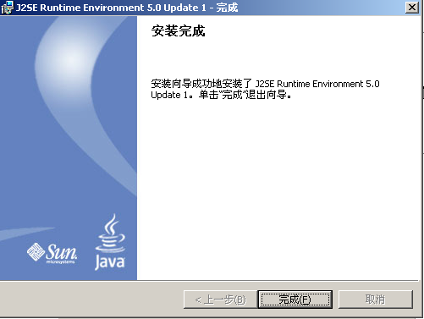

Application Server Installation

Tomcat
- Download Tomcat 5.5 from Apache website(refer to 2.2)
- Double click “jakarta-tomcat-5.5.7.exe” to launch the installer, click “Next”
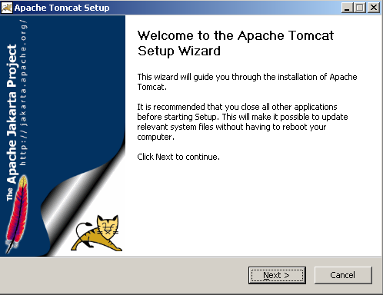

- Click “I Agree” to accept the items of the license
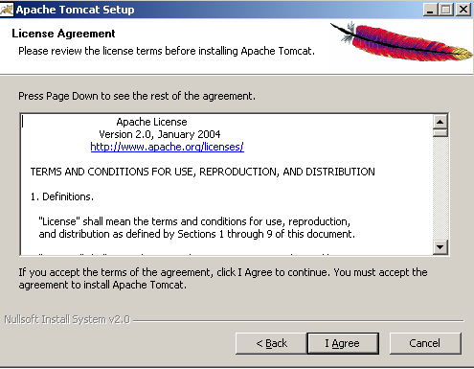

- Select “Normal” install and click “Next>”
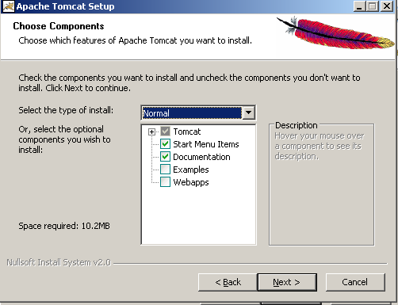

- Choose the destination folder and click “Next>”(default folder is recommended)
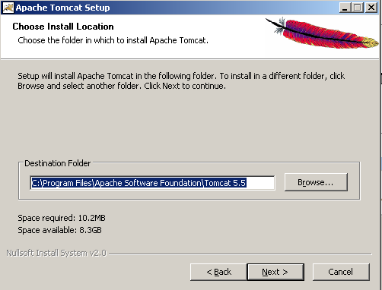

- Input basic configuration options and click “Next>”, the default Http/1.1 Connector Port 8080 is recommended
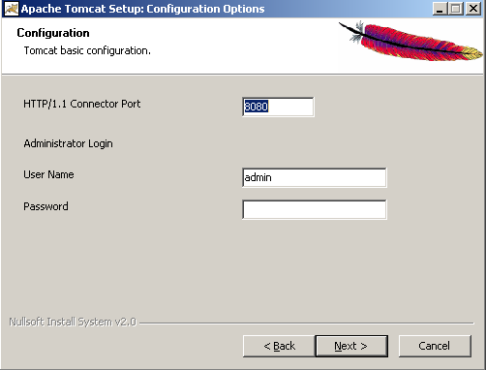

- Select the path of JVM installed on you system(installer can detect the path automatically, so the default configuration is recommended ) and click “Install”
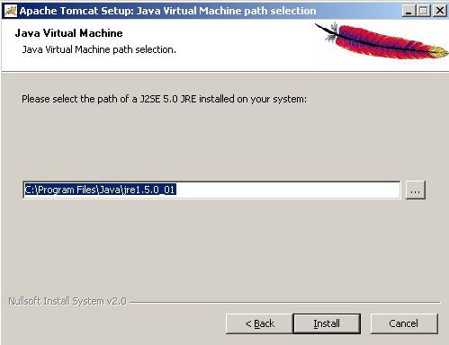

- Waiting for the installation
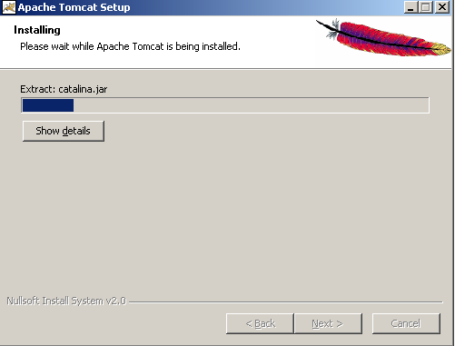

- Disable the “Run Tomcat” and “Show Readme” checkboxes and click “Finish” to finish the installation
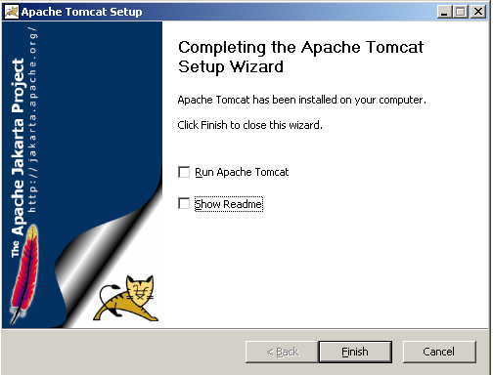

JBoss
N/A

Database Installation
Auto-ID Middleware supports MySQL, MaxDB, PostgreSQL, Oracle, MS SQL Server; you can install any of these databases for your convenience.

MySQL

Install MySQL
- Download MySQL4.1 based on Windows from MySQL website(refer to 2.2)
- Double click “setup.exe” to launch the installer, click “Next>”
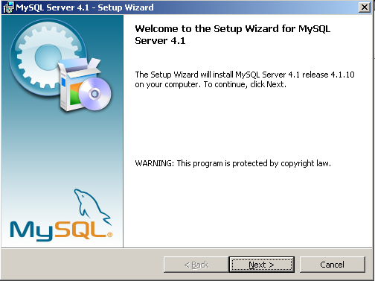

- Choose “Typical” and click “Next>”
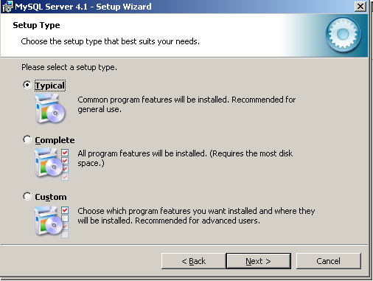

- Click “Install” to begin the installation
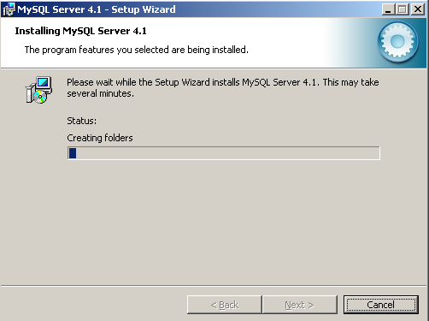

- Choose “Skip Sign-Up” and click “Next>”
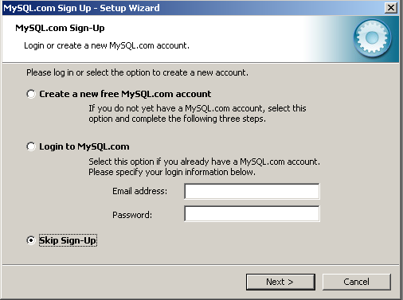

- Choose “Configure MySQL Server Now” to configure the database and click “Finish”
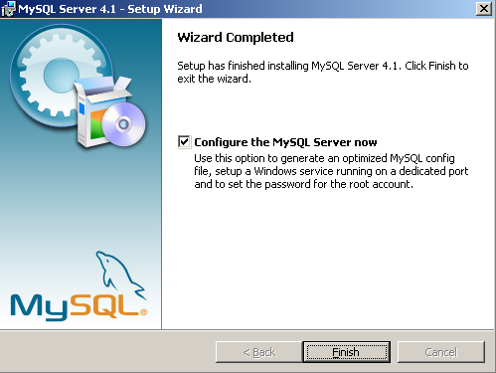

- Click “Next>” in the MySQL Sever Instance Configuration Wizard
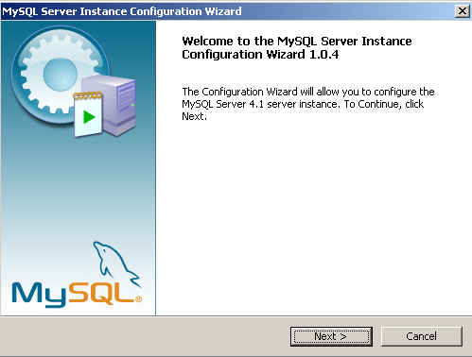

- Choose “Detailed configuration” and click “Next>”
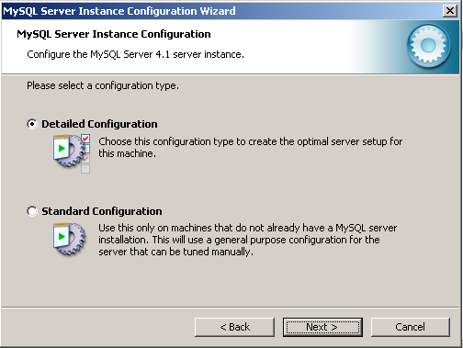

- Choose “Server Machine” and click “Next>’
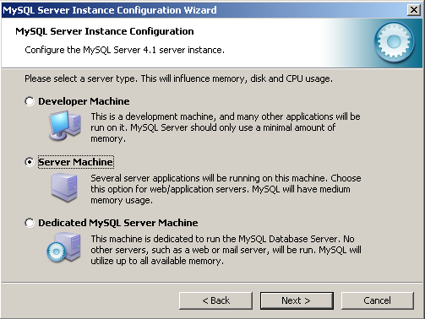

- Choose “Transactional Database Only” and click “Next>”
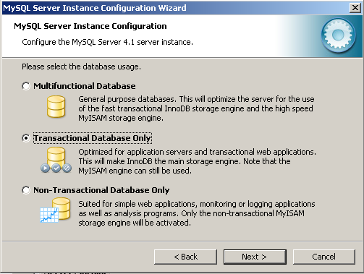

- Choose the driver and directory where the InnoDB tablespace should be placed
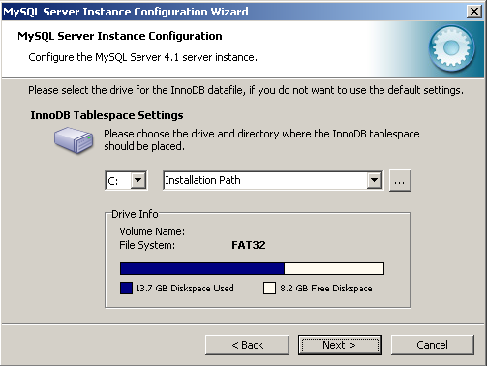

- Select “Online Transaction Processing(OLTP)” and click “Next>”
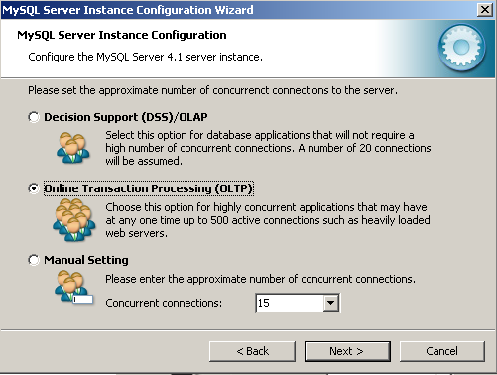

- Use default configurations of the networking options and click “Next>”
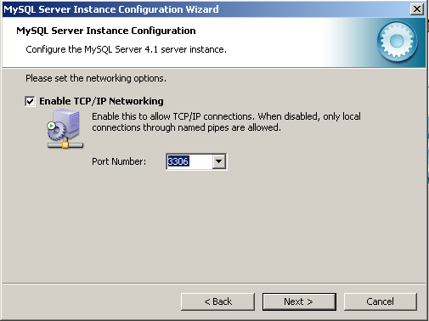

- Select the default character set, here we choose “Best Support For Multilinggualism” and click “Next>” 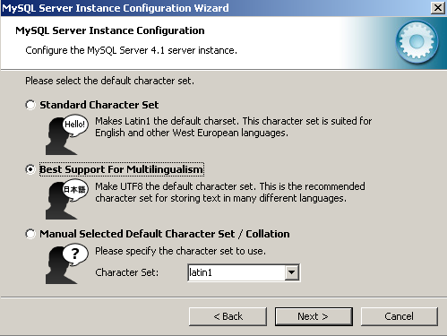

- Set the Windows options, we can just use the default then click “Next>”
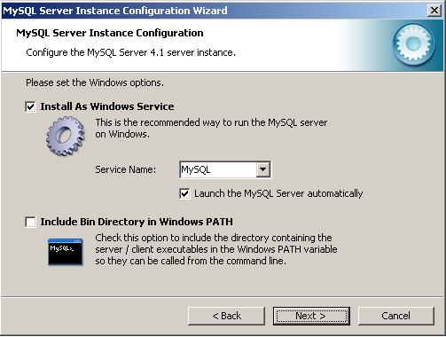

- Input the password of the root and click “Next>”
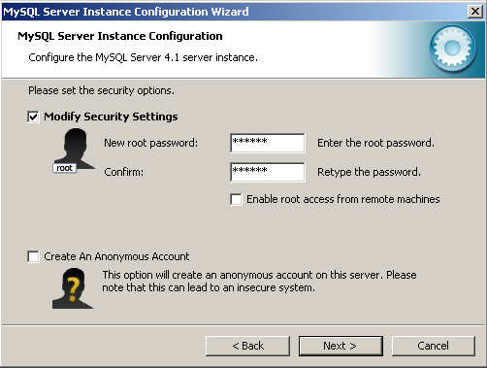

- Click “Execute” to start the configuration
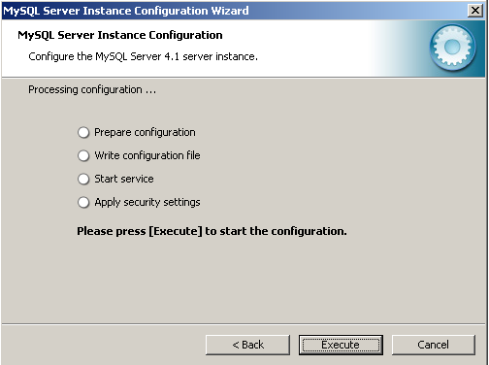

- Click “Finish’ to finish the installation

Install MySQL Connector for Java
Copy the file of “\lib\mysql-connector.jar” from the install disk to the directory of “<Tomcat Home>/common/lib”

Create Middleware Database
- Choose “Start” menu → MySQL →MySQL Server4.1 → MySQL Command Line Client
- Input the password
- Input “CREATE DATABASE middleware;” (confirm the command ended with “;”)
- After the command execute successfully, input “USE middleware” and press “Enter”, the MySQL Command window will give you the response “Database Changed”
- Input “SOURCE C:\middleware\database\middleware-mysql.sql”(notice that the “C:\middleware\database\” is the path of the file “middleware-mysql.sql” in your computer or installation CD)
- Finish the database creation

PostgreSQL

Install PostgreSQL
Notice: The disk used to install PostgreSQL must be NTFS formated
- Download PostgreSQL Server from PostgreSQL website(refer to 2.2)
- Double click “postgresql-8.0.msi ” to launch the installer, choose “English/English” and click “Start>”
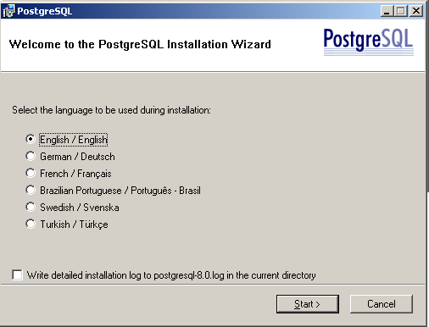

- Exit all the other windows programs and click “Next>”
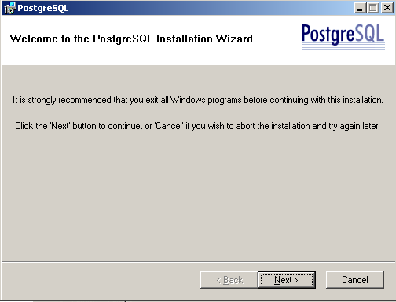

- Choose the destination folder(default directories are recommended)
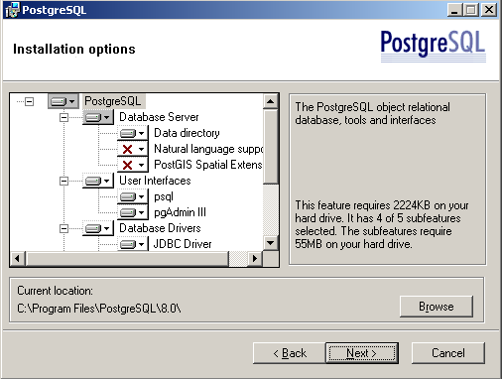

- Configure the service(it is recommended that we only configure the password and leave the others as default) and click “Next>”
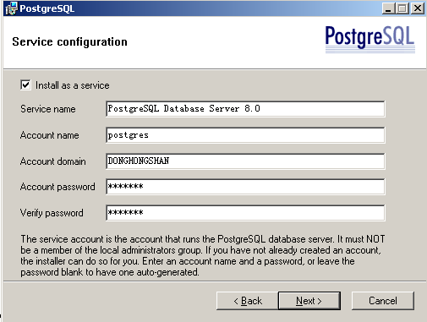

- Click “Yes” when pop the Account error dialog as bellow
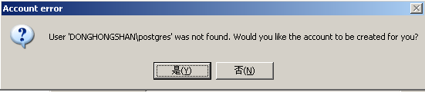

- Input super user name and password (it is recommended to leave other as default) and click “Next>”
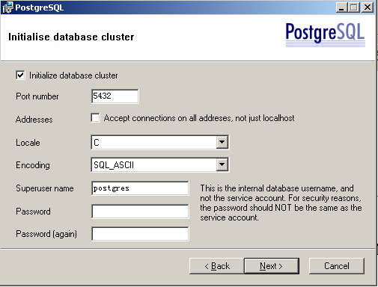

- Waiting for the installation to be finished
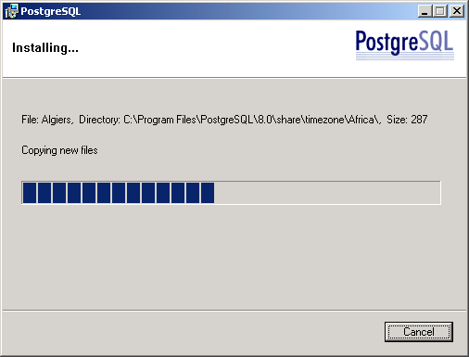

- Click “Finish” to finish the installation
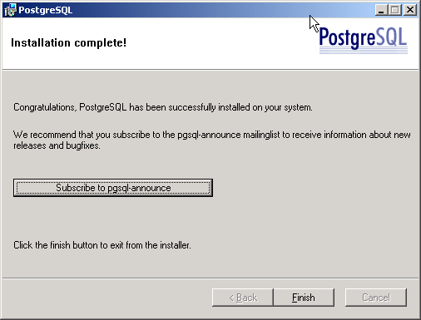

Install PostgreSQL JDBC Driver
Copy the file of “\lib\postgresql-jdbc.jar” from the install disk to the directory of “<Tomcat Home>/common/lib”

Create Middleware Database
- Run windows command
- Change the directory to the bin of PostgreSQL installation folder, for example D:\Program Files\PostgreSQL\8.0\bin
- Input “createdb middleware” to create database during which you will be asked to input the password
- Input “psql –d middleware –f c:\middleware\database\middleware-postgresql.sql,”(notice that the “C:\middleware\database\” is the path of the file “middleware- postgresql.sql” in your computer)
- Input the password
- Finish the creation

MS SQL Server

Install MS SQL Server
- Install the MS SQL Server in the server from the install disk

Install Sql2kSP3
- Install the Sql2kSP3 on the server

Install SQL Server 2000 Driver for JDBC Service Pack3
- Download “SQL Server 2000 Driver for JDBC Service Pack 3” from Microsoft website
URL:http://www.microsoft.com/downloads/info.aspx?na=46&p=5&SrcDisplayLang=en&SrcCategoryId=&SrcFamilyId=07287b11-0502-461a-b138-2aa54bfdc03a&genscs=&u=http%3a%2f%2fdownload.microsoft.com%2fdownload%2f4%2f1%2fd%2f41d3e9c0-64d1-451e-947b-7a4cba273b2d%2fsetup.exe
- Run “setup.exe” to perform the installation

Install MS SQL Server JDBC Driver
- Download “MS SQL Server JDBC Driver” from Microsoft website
URLhttp://www.microsoft.com/downloads/info.aspx?na=46&p=3&SrcDisplayLang=en&SrcCategoryId=&SrcFamilyId=07287b11-0502-461a-b138-2aa54bfdc03a&genscs=&u=http%3a%2f%2fdownload.microsoft.com%2fdownload%2f4%2f1%2fd%2f41d3e9c0-64d1-451e-947b-7a4cba273b2d%2fmssqlserver.tar
- Unzip the file then copy msbase.jar、msutil.jar and mssqlserver.jar from the directory lib to <Tomcat Home>/common/lib

Create Middleware Database
- Choose “Start” menu→ Programs→ Microsoft SQL Server → Enterprise Manager
- Create a new database
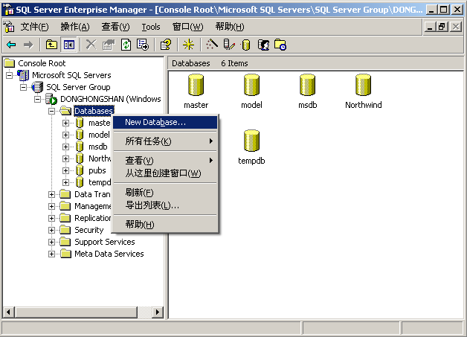
- Input “middleware” in the name text field and click “OK”
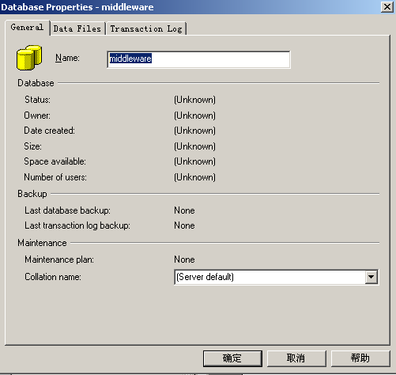
- Choose “Start” menu→ All Programs→ Microsoft SQL Server → Query Analyzer
- Choose “[local]” as the SQL Server and “SQL Server authentication” with Login name and Password
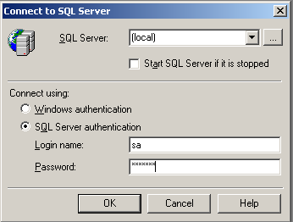
- Select “middleware” database
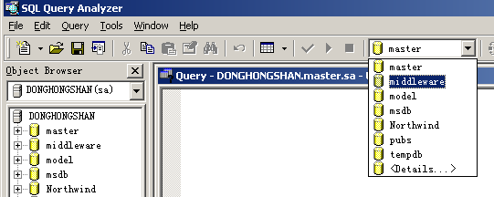
- Select “File”→ “Open” to import script file “middleware-mssql2000.sql”
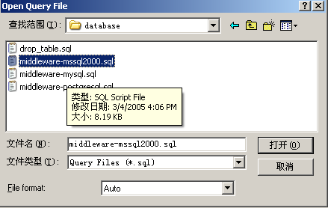
- Select Query → Execute
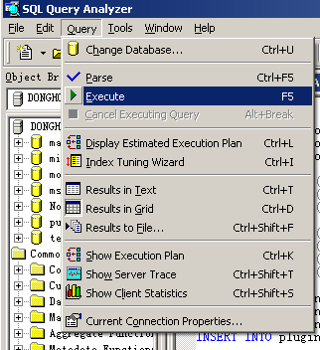
- Finish the creation

MaxDB

Install MaxDB
- Double click “SDBINST.exe” to launch the installer
- Choose the install options, “Server” profile
- Configure path for storing the data, configurations, and run directories of database instances and database applications (the system default is C:\Program Files\sdb\data)
- Configure path for storing the programs and libraries shared by the database instances and database applications (the system default is C:\Program Files\sdb\programs)
- Configure path for storing the server software that depends on the database version.
This path must be unique. Multiple directories with different versions can exist alongside each other (the system default is C:\Program Files\sdb\<version>).
- Press any key to finish the installation and restart the OS

Install MaxDB JDBC Driver
Copy the file of “\lib\ sapdbc.jar” from the install disk to the directory of “<Tomcat Home>/common/lib”

Create Middleware Database
- First you need to install two database operating tools: Database Manager and SQL Studio
- Start Database Manager to create a database instance
  - Select “Medium” as the template
  - Input the database name(make sure the length of the name less than 8) such as “mware”, we use default configuration as the value of database sever and the port
  - Select “Set the startup type for the database service to automatic”
  - Leave the others as default
- Start SQL Studio to create tables of “mware”
  - Connect to the database “mware”
  - Import the script file “middleware-maxdb.sql”
  - Execute the script file and finish the creation

Oracle

Install Oracle
Install the Oracle in the server from the install disk

Install Oracle JDBC Driver
- Visit Oracle website: http://www.oracle.com/technology/software/tech/java/sqlj_jdbc/index.html
- Download the JDBC Driver according to the edition
- Save the jar file to the directory of “<Tomcat Home>/common/lib”

Create Middleware Database
Start “Oracle SQL*PLUS”, input the user name and the password to login the database. Execute “SQL> @e:\database\middleware-oracle.sql”(suppose the path of the Database directory on the install disk is “e:\database”)

Middleware WAR Deployment and Configuration

Tomcat
- Copy the Middleware.war from the directory “War” to directory “webapp” of Tomcat install folder
- Copy the special configure file from the directory “conf” to directory “<tomcat home>/conf” to override the old file “server.xml” according to the database
- Open “sever.xml” and notice a segment as bellow
Table 1
<Resource name="jdbc/middlewareDB" auth="Container" type="javax.sql.DataSource"
maxActive="100" maxIdle="30" maxWait="10000"
username="*****" password="*****"
driverClassName="***************" url="****************************************"/>

- The configuration of table 1 should be modified according to the database used, details are referred as 6.1.1—6.1.5

MySQL
Database IP: 192.168.0.1
Database Name: middleware
User Name: ubipass
Password: autoid
Table 1 can be modified as bellow
<Resource name="jdbc/middlewareDB" auth="Container" type="javax.sql.DataSource"
maxActive="100" maxIdle="30" maxWait="10000"
username="ubipass" password="autoid"
driverClassName="com.mysql.jdbc.Driver" url="jdbc:mysql://192.168.0.1/middleware?autoReconnect=true"/>

PostgreSQL
Database IP: 192.168.0.1
Database Name: middleware
User Name: ubipass
Password: autoid
Table 1 can be modified as bellow
<Resource name="jdbc/middlewareDB" auth="Container" type="javax.sql.DataSource"
maxActive="100" maxIdle="30" maxWait="10000"
username="ubipass" password="autoid"
driverClassName="org.postgresql.Driver" url="jdbc:postgresql://192.168.0.1:5432/middleware?autoReconnect=true"/>

MS SQL Server
Database IP: 192.168.0.1
Database Name: middleware
User Name: sa
Password: ubipass
Table 1 can be modified as bellow
<Resource name="jdbc/middlewareDB" auth="Container" type="javax.sql.DataSource"
maxActive="100" maxIdle="30" maxWait="10000"
username="sa" password="ubipass"
driverClassName="com.microsoft.jdbc.sqlserver.SQLServerDriver" url="jdbc:microsoft:sqlserver://192.168.0.1:1433;
DatabaseName=middleware;SelectMethod=cursor"/>

MaxDB
Database IP: 192.168.0.1
Database Name: mware
User Name: dba
Password: ubipass
Table 1 can be modified as bellow
<Resource name="jdbc/middlewareDB" auth="Container" type="javax.sql.DataSource"
maxActive="100" maxIdle="30" maxWait="10000"
username="dba" password="password"
driverClassName="com.sap.dbtech.jdbc.DriverSapDB" url="jdbc:sapdb://192.168.0.1/mware"/>

Oracle
Database IP: 192.168.0.1
Database Name: mware
User Name: sa
Password: ubipass
Table 1 can be modified as bellow
<Resource name="jdbc/middlewareDB" auth="Container" type="javax.sql.DataSource"
maxActive="100" maxIdle="30" maxWait="10000"
username="sa" password="ubipass" driverClassName="oracle.jdbc.OracleDriver" url="jdbc:oracle:thin:@192.168.0.1:1521:mware"/>

JBoss
N/A

MySQL
N/A

PostgreSQL
N/A

MS SQL Server
N/A

MaxDB
N/A

Oracle
N/A

JavaComm Installation for Serial Connection to Device
  - Visit “http://java.sun.com/products/javacomm/downloads/index.html”
  - Click the “download” button bellow “Download Version 2.0 for Microsoft Windows and Solaris/x86” to download “javacomm20-win32.zip”
  - Unzip file “javacomm20-win32.zip”, make sure you find these three files: “comm.jar”、 “javax.comm.properties”、 “win32com.dll”
  - Copy “comm.jar” and “javax.comm.properties” to the directory “Lib” under the installation directory of JRE, such as “C:\Program Files\Java\jre1.5.0\lib”
  - Copy the file “win32com.dll” to the directory “C:\WINNT\system32”

Product License Key
N/A

System Starting and Stopping

Tomcat
  - Start Service
Select “Control Panel”→ “Administrative Tools”→ “Service”, double click the “Apache Tomcat” service
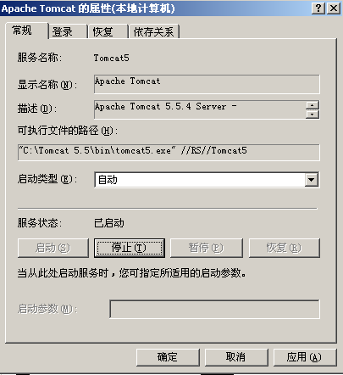
If the start type is “Automatic” it needs not to start the service, if it is “Manual”, the service can be started by click the button “Start”
Or right click the tomcat service icon on the right corner of the windows desktop task bar to start the service
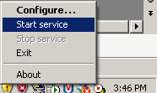
If the service has already been started, the button of “Start service” is disabled.
  - Stop Service
Select “Control Panel”→ “Administrative Tools”→ “Service”, double click the “Apache Tomcat” service

Press “Stop” to stop the service, if the service has already been stopped, the button of stop is disabled
Or right click the tomcat service icon on the right corner of the windows desktop task bar to stop the service
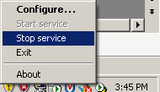
If the service has already been stopped, the item of “Stop service” is disabled.

JBoss
N/A

Troubleshooting
When the service has been started, you can check the middleware log to make sure weather the Middleware is started or not. The file used to keep the log information is saved in the directory “<tomcat home>/webapp/middewre/log” named “Middleware.log”.

Middleware Started Successfully
Middleware is started successfully if the log file shows the information as bellow

2005-05-10 09:36:59 [INFO ] Middleware is starting...
2005-05-10 09:37:00 [INFO ] [EMS] EMS is starting...
2005-05-10 09:37:00 [INFO ] [EMS] EMS started successfully
2005-05-10 09:37:00 [INFO ] [TMS] TMS starting...
2005-05-10 09:37:00 [INFO ] [TMS] TMS started successfully
2005-05-10 09:37:00 [INFO ] Middleware started successfully

Database Service Eerror or Database URL Configuration Error
Database connective errors occur when the log file shows the information as bellow. Make sure weather the database server has been started or the configuration of database URL in the file “Server.xml” is correct.

2005-02-18 16:39:40 [INFO ] Middleware is starting...
2005-02-18 16:41:37 [ERROR] [DBConnPool] getConnection() Cannot create PoolableConnectionFactory (Server connection failure during transaction. Due to underlying exception: 'java.net.SocketException: java.net.ConnectException: Connection timed out: connect'.

** BEGIN NESTED EXCEPTION **

java.net.SocketException
MESSAGE: java.net.ConnectException: Connection timed out: connect

STACKTRACE:

java.net.SocketException: java.net.ConnectException: Connection timed out: connect
……………………..

** END NESTED EXCEPTION **

Attempted reconnect 3 times. Giving up.)
2005-02-18 16:41:37 [ERROR] [EMS] Database access error: don't connect server
2005-02-18 16:41:37 [ERROR] [EMS] Cannot setup database connection
2005-02-18 16:41:37 [FATAL] EMS startup failed

Database Name Configuration Error
The configuration of the database name in the file “server.xml” may be wrong when the log file shows the information as bellow
2005-02-18 16:31:56 [INFO ] Middleware is starting...
2005-02-18 16:32:10 [ERROR] [DBConnPool] getConnection() Cannot create PoolableConnectionFactory (Server connection failure during transaction. Due to underlying exception: 'java.sql.SQLException: Unknown database 'hello''.

** BEGIN NESTED EXCEPTION **

java.sql.SQLException
MESSAGE: Unknown database 'hello'

STACKTRACE:

java.sql.SQLException: Unknown database 'hello'

…………………….

** END NESTED EXCEPTION **

Attempted reconnect 3 times. Giving up.)
2005-02-18 16:32:10 [ERROR] [EMS] Database access error: don't connect server
2005-02-18 16:32:10 [ERROR] [EMS] Cannot setup database connection
2005-02-18 16:32:10 [FATAL] EMS startup failed

