

Auto-ID Middleware

Auto-ID Middleware
User Guide
Document Version 1.0

2005-04-07
Contents
1 Auto-ID Middleware Overview 1
1.1 User Login 1
1.2 Service 2
1.3 Device 3
1.4 User 3
1.5 Task 4
1.6 Logout 4
2 User Configuration 5
2.1 List User 5
2.2 Add User 5
2.2.1 Roles 5
2.2.2 Assign Devices 6
2.3 Delete User 7
2.4 Edit User 8
2.5 Change password 8
3 Device/Device Group Configuration 8
3.1 Device Configuration 8
3.1.1 List Device 8
3.1.2 Add Device 9
3.1.3 Delete Device 10
3.1.4 Edit Device 11
3.2 Device Operation 11
3.2.1 Device Startup 11
3.2.2 Device Stop 11
3.2.3 View Tag 11
3.2.4 Monitor Device 12
3.2.5 Print Tag 13
3.3 Device Group configuration 14
3.3.1 Device Group List 14
3.3.2 Add Device Group 14
3.3.3 Delete Device Group 16
4 Task configuration 16
4.1 List Task 16
4.2 Add Task 16
4.2.1 Task Type 18
4.2.2 Startup Type 18
4.2.3 Trigger Mode 18
4.2.4 Encoding Scheme 19
4.2.5 PML Format Type 19
4.2.6 Command 19
4.2.7 Reader Symbol 19
4.2.8 Top Level Symbol 19
4.2.9 Http Destination 20
4.2.10 File Destination 20
4.3 Delete Task 20
4.4 Task Operation 21
4.4.1 Startup automatic task 21
4.4.2 Stop automatic task 21
4.4.3 Startup manual task 21
4.5 PML File that Task Created 22
4.5.1 PML File Naming Criterion 22
4.5.2 Full PML 23
4.5.3 Simple PML 23
5 Server 24
5.1 System Configuration 24
5.2 HTTP Command Interface 24
5.2.1 HTTP Command Interface 24
5.2.2 Add HTTP Command Interface 24
5.2.3 Delete HTTP Command Interface 24
5.2.4 License Key Management 25
6 HTTP Command Interface 25
7 Internationalization 26
8 Best Practice 27
8.1 Create a Device 27
8.2 Create Device Group and assign Devices 27
8.3 Create/Startup automatic Task 28
8.4 Packing results 29
8.5 Create Manual Task 29
8.6 Manual Packing results 31

Auto-ID Middleware Overview

User Login
Open IE, and input Middleware’s URL, such as: http://192.168.0.1:8080/middleware; go to the login page, input the right user name and password
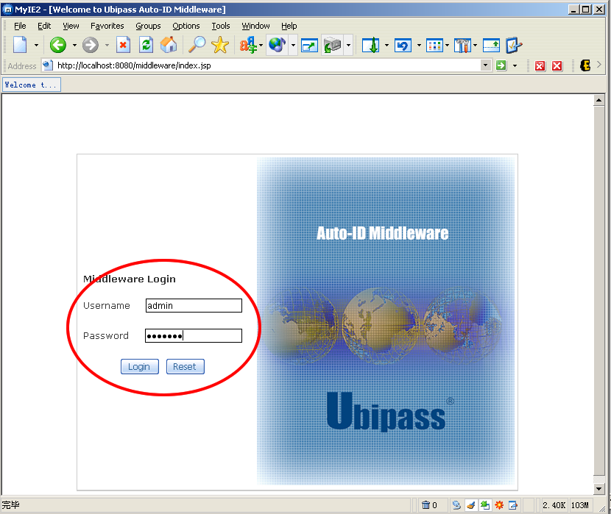

This is the main page after login:
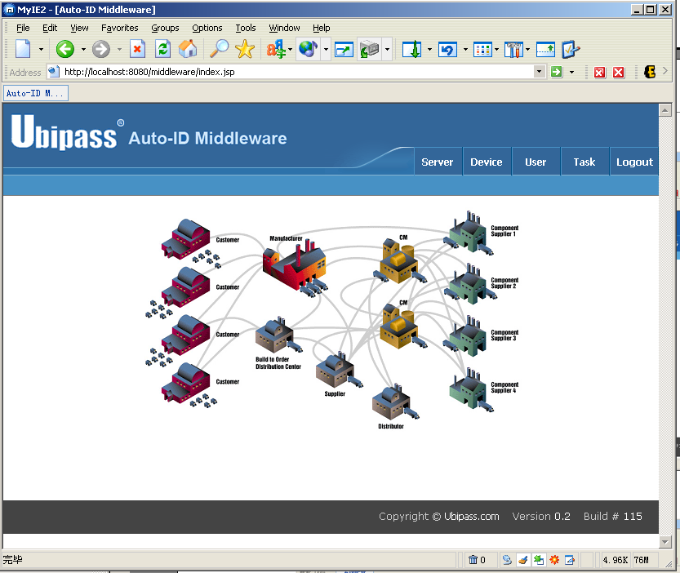

Service
Click “Server”, and then go to the server configuration page
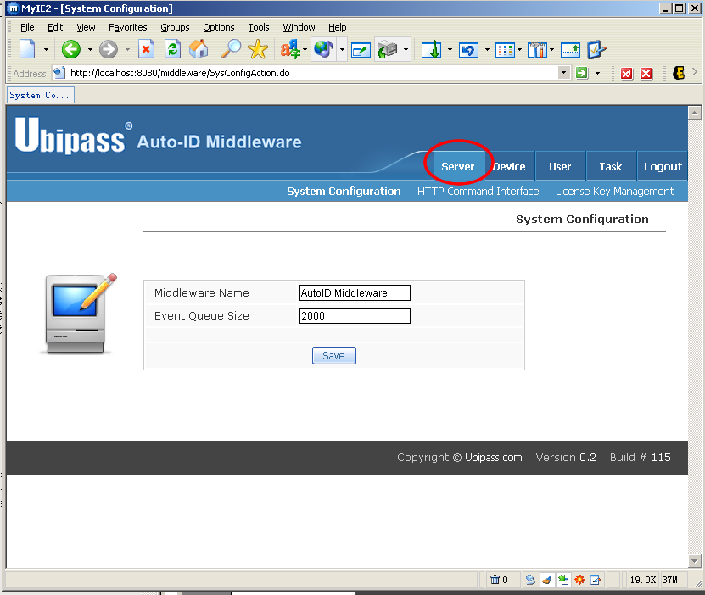
You can configure System, HTTP Command Interface, and License Key Management in this page

Device
Click “Device” button, then go to the device and device group management page
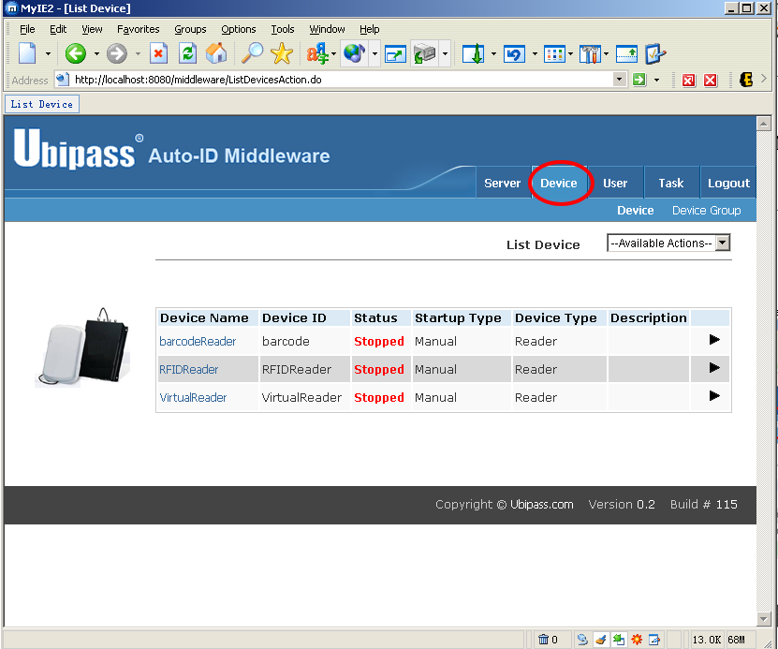
You can list, add, delete, modify device (device group) in this page.

User
Click “user” button, then go to the User Management Page
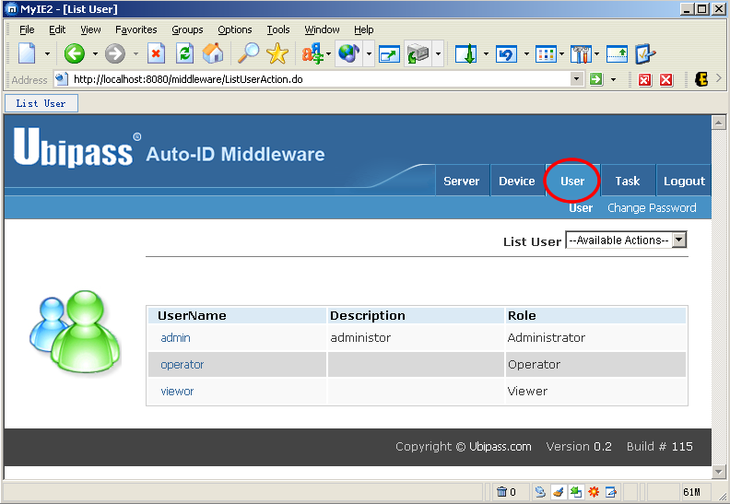
In this page, you can add, modify, delete a user, or you can modify you own password

Task
Click “Task” button, then go to task management page
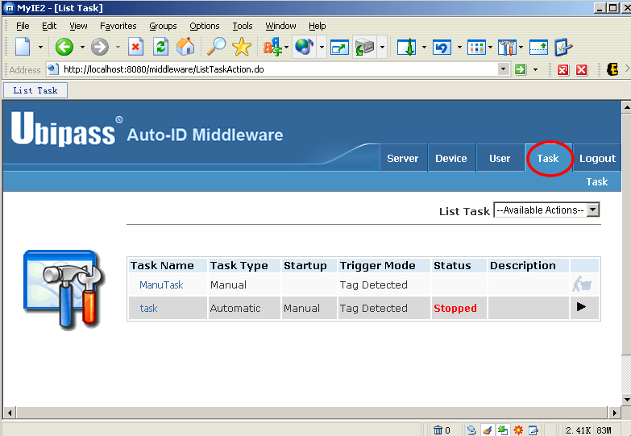
In this page, you can add, delete, and modify a certain task.

Logout
Click “Logout” button, then logout to middleware
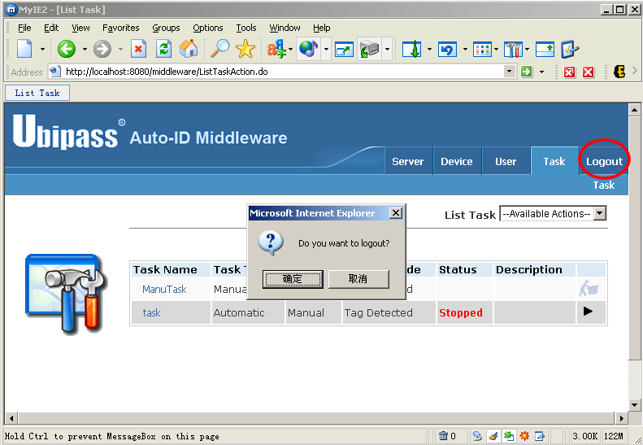

User Configuration

List User
Click the “user” button in first level, or click “List user” in “available action” list box, below the first level menu “user”
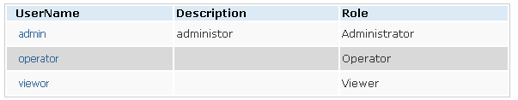
All system users are listed in “List User” page, click the username you can edit a certain user.

Add User
Click “add user” in “available action” list box, below the first level menu “user”
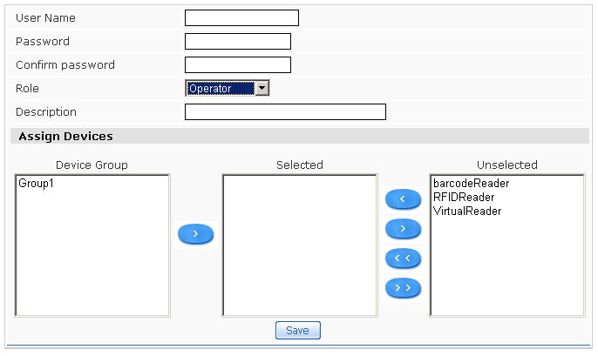

Roles
Roles | Authorization
Administrator | Top level authorization of the system  - User Management  - Co figurate System Service  - Device/ Device Group management  - Task Management
External User | Can not directly access system via web browser, but can integrate with middleware via external application
Operator | Can operate the Device which administrator granted to him  - Start Device  - Stop Device  - Monitor Device  - View Tag  Can operate the tasks whose device is granted to him  - Start Task  - Stop task  Can modify his own password
viewer | Can only operate the Device which administrator grant to him  - Monitor Device  - View Tag  Can modify his own password

Assign Devices
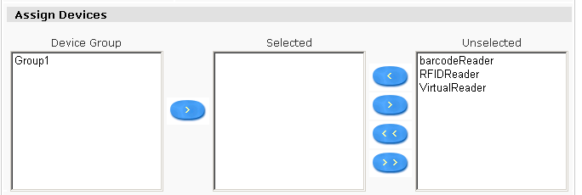
All Device group are Listed In Device Group list box, selected list box list all devices assigned to the user, unselected list box list all the devices which did not assign to the user
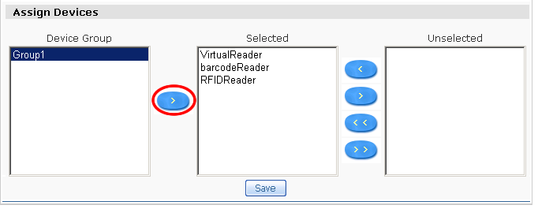
Select a certain device group, click “add” button; you can assign all devices in this device group to the user.

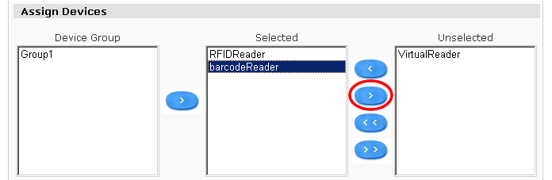
Select a device in selected list box, click “remove” button; you can move this device from “selected” area to “unselected” area

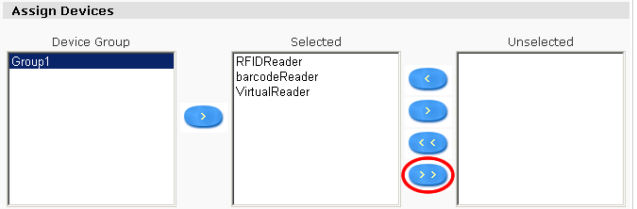
Click “Remove All Devices”button，you can remove all selected devices to unselected area

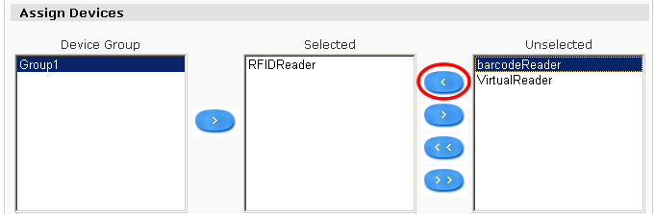
Select a device in unselected list box, click “add” button; you can move an unselected device to selected area

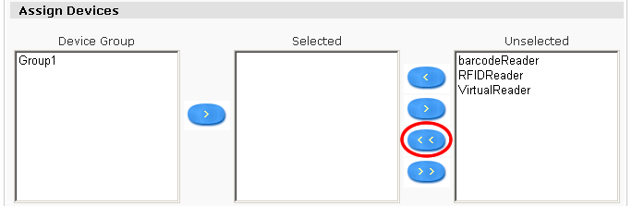
Click “Add All Devices”button，you can move all unselected devices to selected area

Delete User
Click “delete user” in “available action” list box, below the first level menu “user”
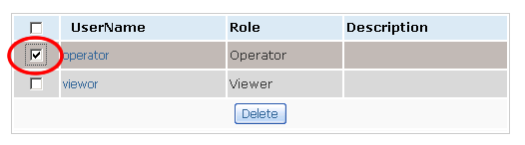
Select the user (users) you want to delete, click the delete button, you can delete the selected users.

Edit User
Click user name in list user page, you can edit a certain user
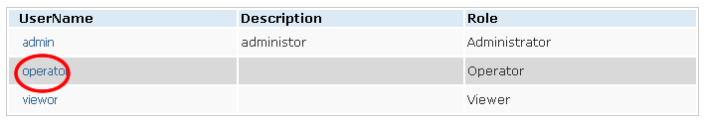

User Edit page:
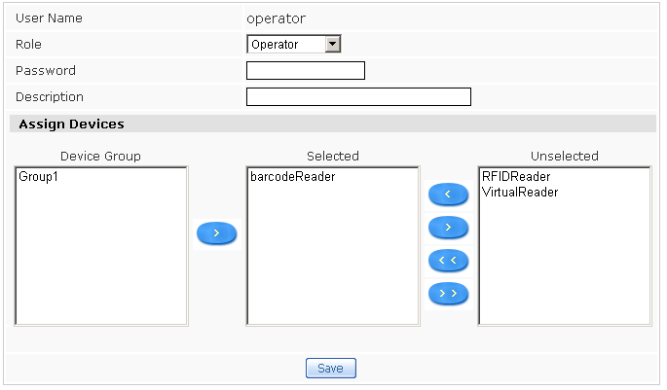
You can edit user’s role, password, and reassign devices to user.

Change password
Click “Change Password” below the first level menu “user”
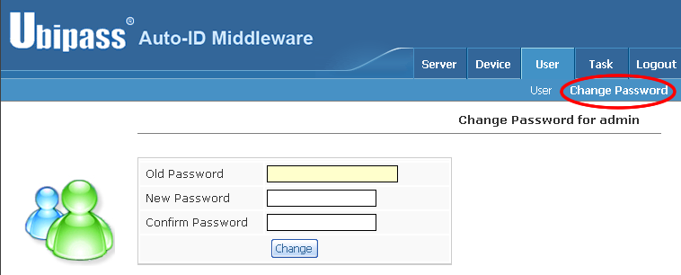

Device/Device Group Configuration

Device Configuration

List Device
Click the “Device” button in first level menu, or click “List Device” in “available action” list box, below the first level menu “Device”
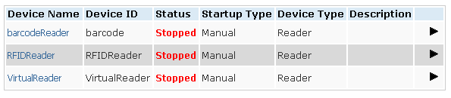
“List Device” page list all devices assigned to user, Click the device name you can edit a certain device.

Add Device
Click “Add device” in “available action” list box, below the first level menu “Device”
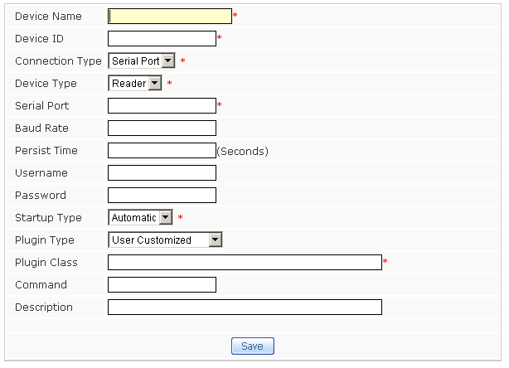

Connection Type
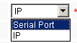
- Serial Port: Device connects to middleware via Serial port.
If device use serial port connect to the middleware, you need to configure the Serial Port and Baud Rate, Serial port is the name of COM port in computer, such as (COM1 or COM2), and baud rate is related to different devices, for Alien Class1 Reader, its baud rate is 115200.
- IP: Device connects to middleware via network
If device’s connection type is IP, you need to configure the device’s IP address

Device Type
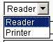
  - Reader： Device is a RFID/barcode Reader
  - Printer： Device is a RFID Printer

Startup Type
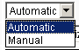
- Automatic：Device will automatically startup while middleware starting
- Manual：Device should startup by operator

Persist Time
The time space that device keep the EPC for one time.

User Name
Some devices need user name while connect to it

password
Some devices need password while connect to it

Plugin Type
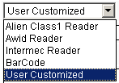
You should use different type of plugin for different type of devices, if you select “User Customized”, you should input the driver class name that user defined.

Delete Device
Click “Delete device” in “available action” list box, below the first level menu “Device”
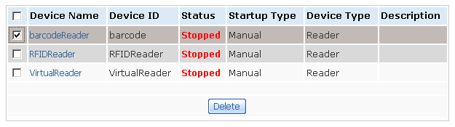
Select the device (devices) you want to delete, and click “delete” button

Edit Device
Click a certain device name in List device page; you can go to the edit device page.
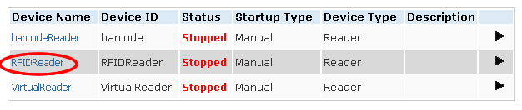

Edit device page
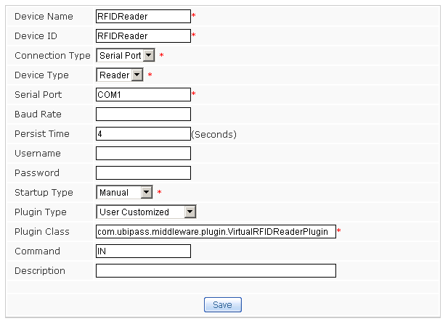

Device Operation

Device Startup
Click the “startup” button, you can start the device

Device Stop
Click the “stop” button, you can stop the device

View Tag
Click the “View Tag” button, you can view EPC that device detected at certain time point

This is the EPC List at certain time point
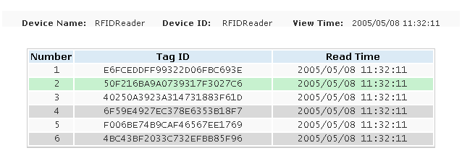

Monitor Device
Click “Monitor Device” button, you can Monitor the Device in real time

The Dynamic EPC List of Monitor device page
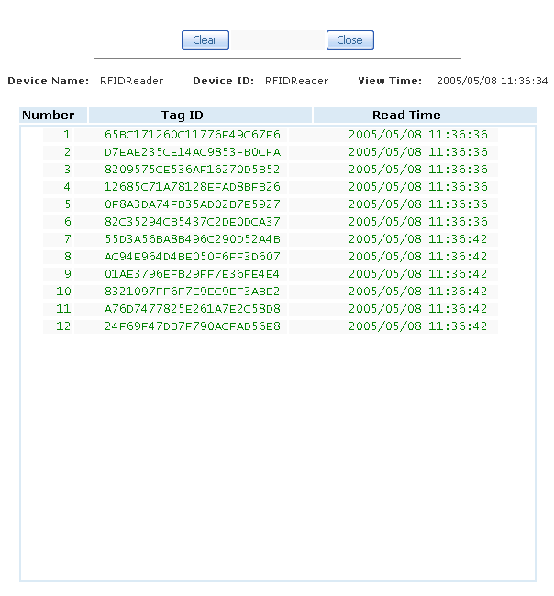

Print Tag
Click the Print Tag button, you can print EPC tags

Print Tag page
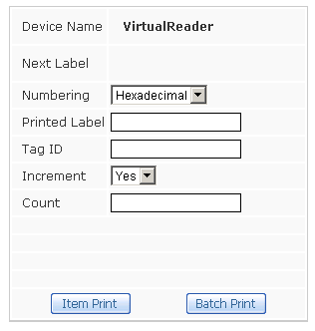

Numbering
There are two Numbering methods, Hexadecimal and Decimal

Printed Label
This is and additional function for the RFID printers which can print RFID tag and print label on the tag.
If you add % in Printed Label, Printer will replace % with tagID, for example, if you want to print label Ubipass-%, and the next tag Id is 8D2F2233445566F0, you can get the label that printer printed Ubipass-8D2F2233445566F0

Tag ID
The EPC code to print next step

Increment
Set the EPC need increment or not while printing

Count
The number of EPC tag need to print

Item Print
Click this button once; printer will print one EPC tag

Batch Print
Click this button, printer will print number of EPC tags that user defined.

Device Group configuration

Device Group List
Click “Device Group” below the first level menu “Device”
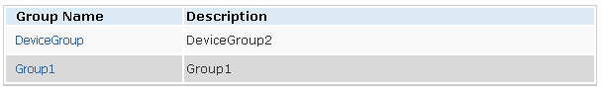

Add Device Group
Click “Add device Group” in “available action” list box, below the second level menu “Device Group”
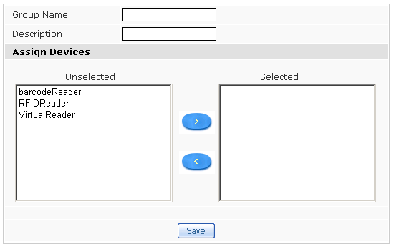

Select device (devices) form Unselected Device area, click “ADD” button, you can assign device to new device group
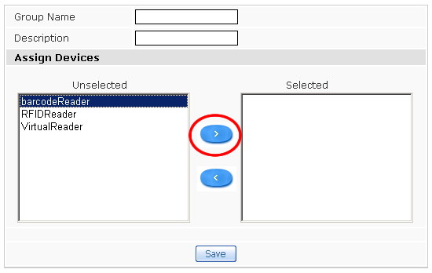

Select device (devices) in selected area, Click “remove” button, you can move selected device to unselect area.
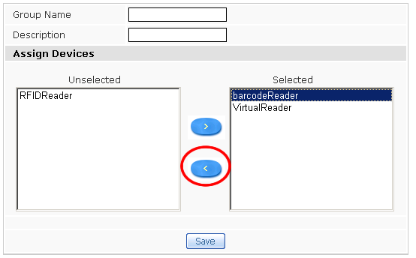

Delete Device Group
Click “Delete device Group” in “available action” list box, below the second level menu “Device Group”
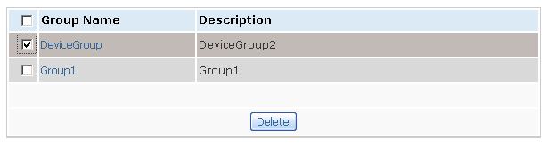
Select device group (groups), click delete button, you can delete the device group (groups) selected.

Task configuration

List Task
Click the “Task” button in first level, or click “List Task” in “available action” list box, below the first level menu “Task”
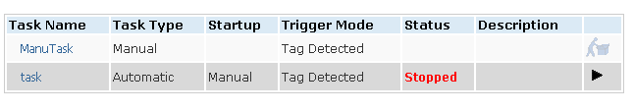

Add Task
Click “Add Task” in “available action” list box, below the first level menu “Task”
Step 1: Task attributes configuration 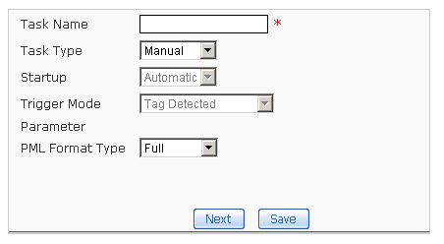

Step 2：: Task attributes configuration & Device assignment
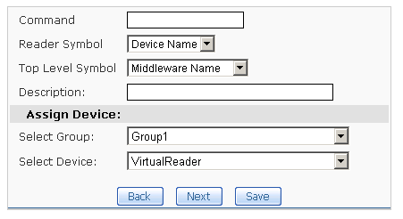

Step 3：HTTP Destination configuration
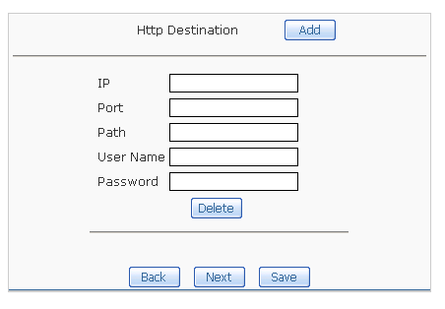

Step 4：File Destination Configuration
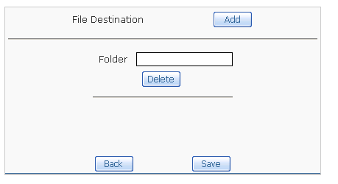

Task Type
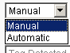
- Automatic：Task run automatically
- Manual：Task run manually

Startup Type
- Automatic：Task can automatically startup when middleware starting
- Manual：Task should startup by operator

Trigger Mode
Trigger mode is enable only when the task type set to automatic
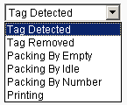

Tag Detected
New tag detecting Task, return all new detected tags.

Tag Removed
Detect removed tag Task, return all removed tags.

Packing By Empty
If the device can not detect any tag, return all the tags detected before

Packing By Idle
Specify an Idle Period; return all the detected tags in this period.

Packing By Number
Specify a read number, if the device detected specified number of tags, return all these tags.

Printing
Tag printing Task

Encoding Scheme
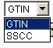
Encoding scheme is based on EPC; this setting is enable only the Trigger mode set to Printing

PML Format Type
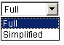
Task’s sending data format
- FULL：Full PML format information
- Simplified：Simplified PML format information

Command
This parameter is according to the high level application‘s business logic command, such as: IN for GR, OUT for GI.

Reader Symbol
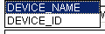
The device title in PML document, you can use device’s name or device’s id.

Top Level Symbol
The top level symbol of the PML document, you can use middleware name or device group name.

Http Destination
Define the Integration application’s connection parameter via HTTP.
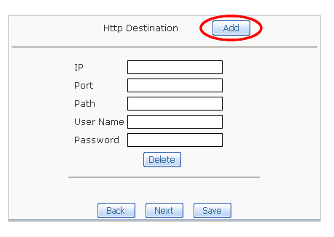

File Destination
Define the local file destination for middleware sending PML information.
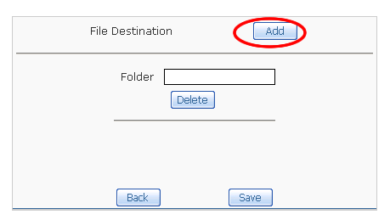

Delete Task
Click “Delete Task” in “available action” list box, below the first level menu “Task”
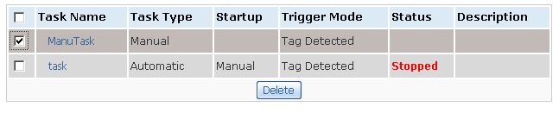
Select task(s) you want to delete, and click delete button, task(s) can be deleted.

Task Operation

Startup automatic task
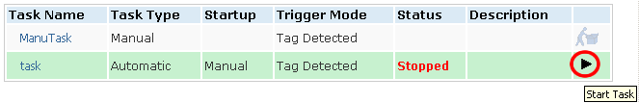

Stop automatic task
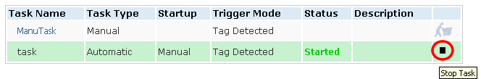

Startup manual task
Before you can startup manual task, you should first startup the device related with the manual task; otherwise the manual task’s start button is disabled.
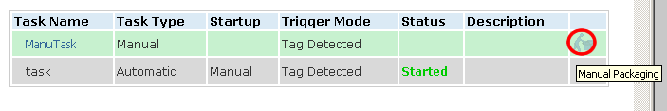

If you startup the device related with the manual task, the start button will become available.
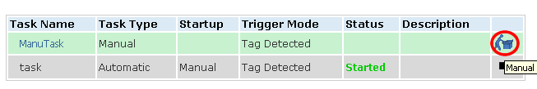

Start the manual packing task, you can see manual packing task page below.
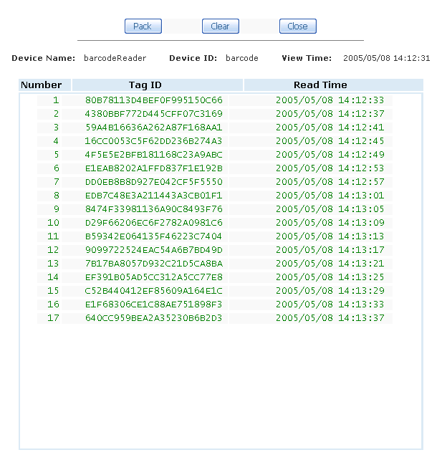
Click “Pack” button, you can do pack for all the list tags, Click “clear” to clear all the tags detected, click “close” to stop the manual packing task.

PML File that Task Created

PML File Naming Criterion
PML File name is [Task Name]_Year_Month_Date_Hour_Minute_Second.xml

Full PML
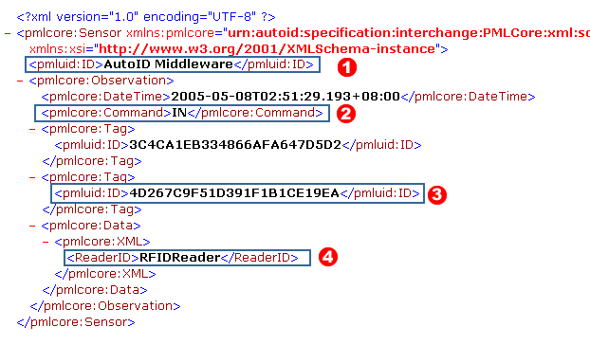
- The content of this label is defined by Task’s Top level Symbol
- The content of this label is defined by Task’s Command
- he content of this label is EPC that device captured
- The content of this label is defined by Task’s Reader Symbol

Simple PML
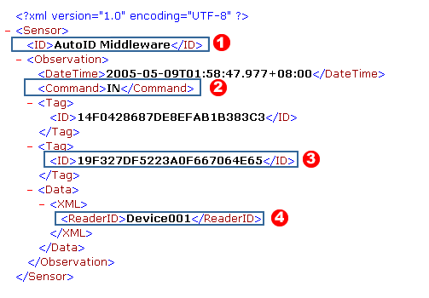
（1）The content of this label is defined by Task’s Top level Symbol
（2）The content of this label is defined by Task’s Command
（3）he content of this label is EPC that device captured
（4）The content of this label is defined by Task’s Reader Symbol

Server

System Configuration
Click the “Server” button in first level, or click “System Configuration” below the first level menu “Server”
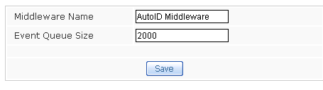

HTTP Command Interface

HTTP Command Interface
Click “Http Command Interface” below the first level menu “Server”
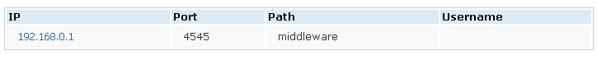

Add HTTP Command Interface
Click “Add Http Command Interface” in “available action” list box, below the second level menu “HTTP Command Interface”
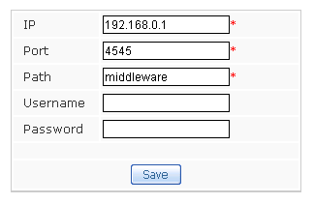

Delete HTTP Command Interface
Click “Delete Http Command Interface” in “available action” list box, below the second level menu “HTTP Command Interface”
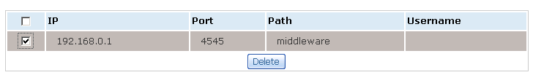
You can select one or more HTTP Command Interface to delete.

License Key Management
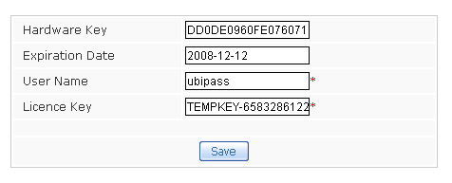
Input the right user name & License Key for the middleware

HTTP Command Interface
External Application can access middleware’s HTTP Command Interface Server, and make the Printer to print tag by post XML command. HTTP Server need authentication, external interface need send user name and password for authentication. If authentication error occurs, server returns Status Code 401. Operator can only send command to the devices under his/her control, otherwise return Status Code 403.
Pls. refer SAP AII-DC Interface Description 1.0: 3.1 Command Message for the XML Command that HTTP POST
The xml block underside is the XML Command the external request RFID Printer: Writer_Device to print a EPC code 3074024220403B8000000008
<?xml version="1.0" encoding="UTF-8" ?>
<Command xmlns:xsi="http://www.w3.org/2001/XMLSchema-instance" xsi:noNamespaceSchemaLocation="Command.xsd">
<WriteTagData readerID="Writer_Device">
<Item>
<FieldList>
<Field name="EPC">3074024220403B8000000008</Field>
</FieldList>
</Item>
</WriteTagData>
</Command>
The xml block underside is the XML Command the external request RFID Printer: Barcode to print a GTIN code00037000567394
<?xml version="1.0" encoding="UTF-8" ?>
<Command xmlns:xsi="http://www.w3.org/2001/XMLSchema-instance" xsi:noNamespaceSchemaLocation="Command.xsd">
<WriteTagData readerID="Barcode_Printer">
<Item>
<FieldList>
<Field name="GTIN">00037000567394</Field>
</FieldList>
</Item>
</WriteTagData>
</Command>
HTTP Command Interface Server will quickly return HTTP 200 OK response if it received XML command; if the had rightly written the tag, Interface Server will send XML to external application as below:
<?xml version="1.0" encoding="UTF-8" ?>
<pmlcore:Sensor xmlns:pmlcore="urn:autoid:specification:interchange:PMLCore:xml:schema:1" xmlns:pmluid="urn:autoid:specification:universal:Identifier:xml:schema:1" xmlns:xsi="http://www.w3.org/2001/XMLSchema-instance">
<pmluid:ID>DEVICE_CONTROLLER_NAME</pmluid:ID>
<pmlcore:Observation>
<pmlcore:DateTime>2004-11-12T02:00:00.762+01:00</pmlcore:DateTime>
<pmlcore:Command>IN</pmlcore:Command>
<pmlcore:Tag>
<pmluid:ID>3074024220403B8000000008</pmluid:ID>
<pmlcore:Data>
<pmlcore:XML>
<EPCStatus>WS</EPCStatus>
</pmlcore:XML>
</pmlcore:Data>
</pmlcore:Tag>
<pmlcore:Data>
<pmlcore:XML>
<ReaderID>Writer_Device</ReaderID>
</pmlcore:XML>
</pmlcore:Data>
</pmlcore:Observation>
</pmlcore:Sensor>
The element EPCStatus may have the following values:
- ‘WS’ to indicate that the tag was written and verified successfully
- ‘WU’ to indicate that the tag was written, but not verified successfully

Internationalization
Auto-ID Middleware have two types of language (Chinese & English) for internationalization, Middleware’s user interface language is associate with “languages” of your IE’s internet options.
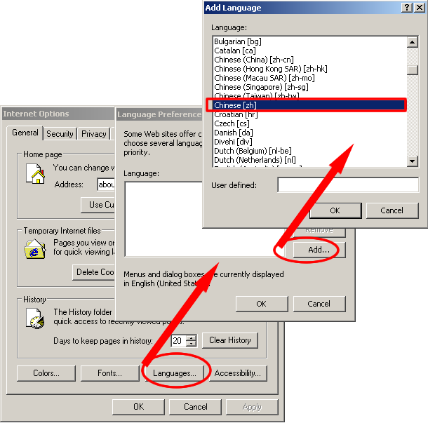
If you set Language Preference as “Chinese [zh]” in your “Internet options”, you will get Chinese User Interface while accessing, otherwise you will get English User Interface.

Best Practice

Create a Device
- Click “Add device” in “available action” list box, below the first level menu “Device”
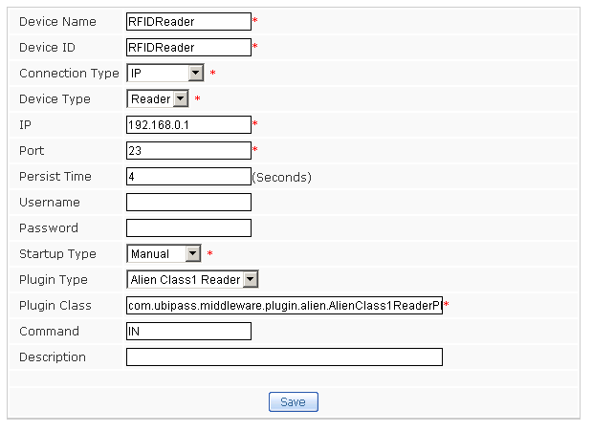
Connection Type is IP (network); IP address is: 192.168.0.1
Persist Time is 4 seconds
Startup Type is Manual
Plugin Type is Alien Class1 Reader
(com.ubipass.middleware.plugin.alien.AlienClass1ReaderPlugin)

Create Device Group and assign Devices
- Click “Add device Group” in “available action” list box, below the second level menu “Device Group”
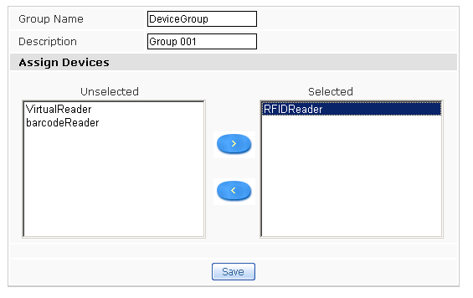
Select the new created device and clicks save.

Create/Startup automatic Task
- Click “Add Task” in “available action” list box, below the first level menu “Task”
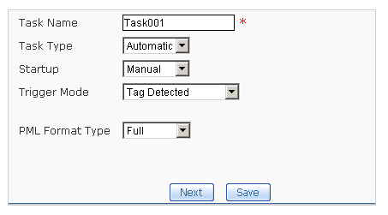

- Assign device
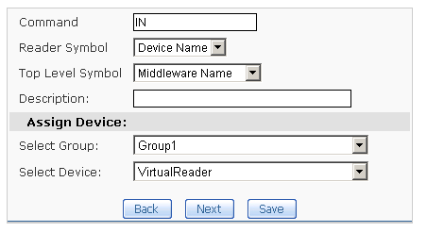

- Add a file destination

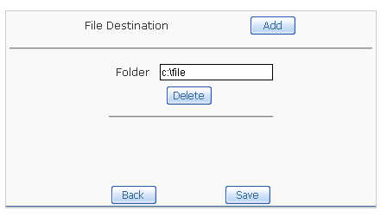

- Startup the new created device
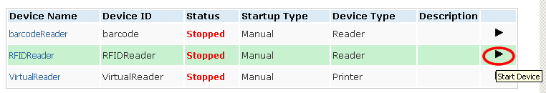

- Device startup successfully.
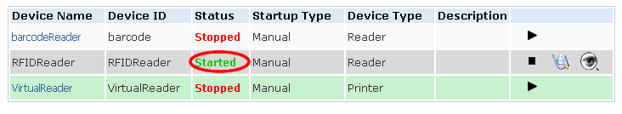

- Go to the Task List page, startup the new created task
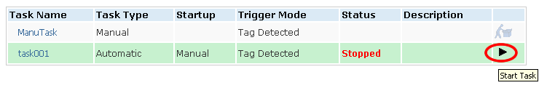

Packing results
- Task will create the PML file after the device detected new tags.
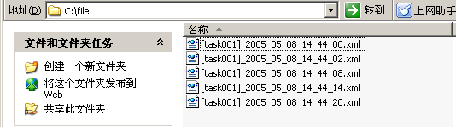

Create Manual Task

- Create a new Manual task
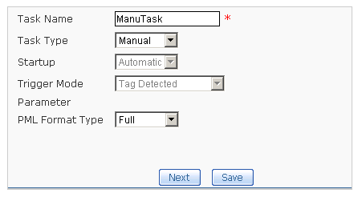

- Assign device

- Add a file destination
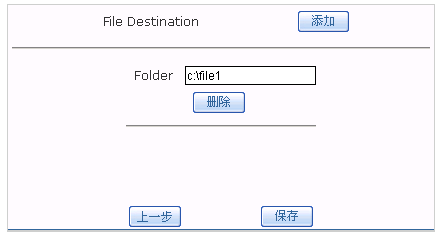

- Startup manual Task
[Hint] before startup the manual task, you should first startup the device related to this task
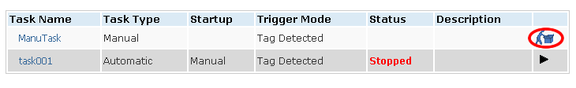

- Click packing then go to the manual packing page.
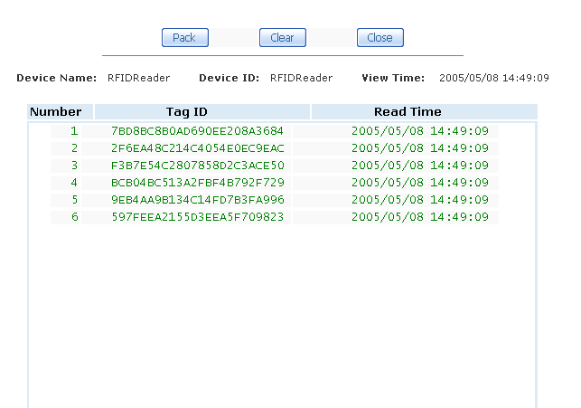
Click “pack” to pack the tags detected, or click “clear” to clear all the list tags, click close to finish the manual packing task

Manual Packing results

- The PML file that Manual packing task created.

