小米手环10Pro · 良米 每日订单及环比分析
数据范围：2026-07-30 ~ 2026-08-19 环比 =（今日订单数 − 前一日订单数）÷ 前一日订单数 × 100%
1. 直播间
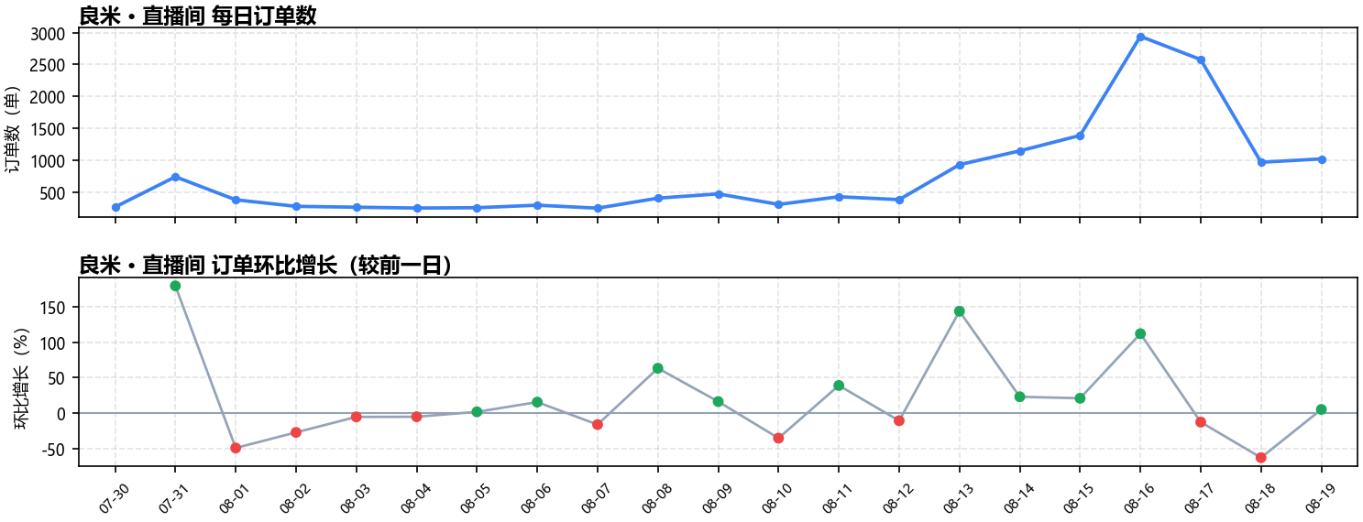
日期 | 订单数（单） | 环比增长
07-30 | 265 | —
07-31 | 740 | +179.2%
08-01 | 379 | -48.8%
08-02 | 277 | -26.9%
08-03 | 263 | -5.1%
08-04 | 250 | -4.9%
08-05 | 255 | +2.0%
08-06 | 295 | +15.7%
08-07 | 248 | -15.9%
08-08 | 405 | +63.3%
08-09 | 472 | +16.5%
08-10 | 307 | -35.0%
08-11 | 427 | +39.1%
08-12 | 382 | -10.5%
08-13 | 930 | +143.5%
08-14 | 1146 | +23.2%
08-15 | 1388 | +21.1%
08-16 | 2941 | +111.9%
08-17 | 2577 | -12.4%
08-18 | 968 | -62.4%
08-19 | 1020 | +5.4%
2. 商品卡
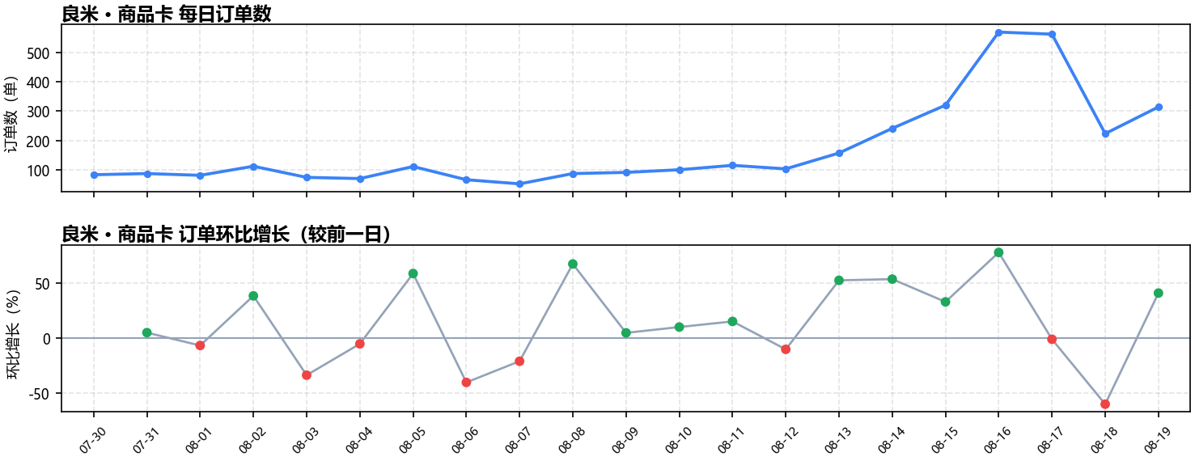
日期 | 订单数（单） | 环比增长
07-30 | 83 | —
07-31 | 87 | +4.8%
08-01 | 81 | -6.9%
08-02 | 112 | +38.3%
08-03 | 74 | -33.9%
08-04 | 70 | -5.4%
08-05 | 111 | +58.6%
08-06 | 66 | -40.5%
08-07 | 52 | -21.2%
08-08 | 87 | +67.3%
08-09 | 91 | +4.6%
08-10 | 100 | +9.9%
08-11 | 115 | +15.0%
08-12 | 103 | -10.4%
08-13 | 157 | +52.4%
08-14 | 241 | +53.5%
08-15 | 320 | +32.8%
08-16 | 569 | +77.8%
08-17 | 562 | -1.2%
08-18 | 223 | -60.3%
08-19 | 314 | +40.8%
3. 直播间 + 商品卡（总计）
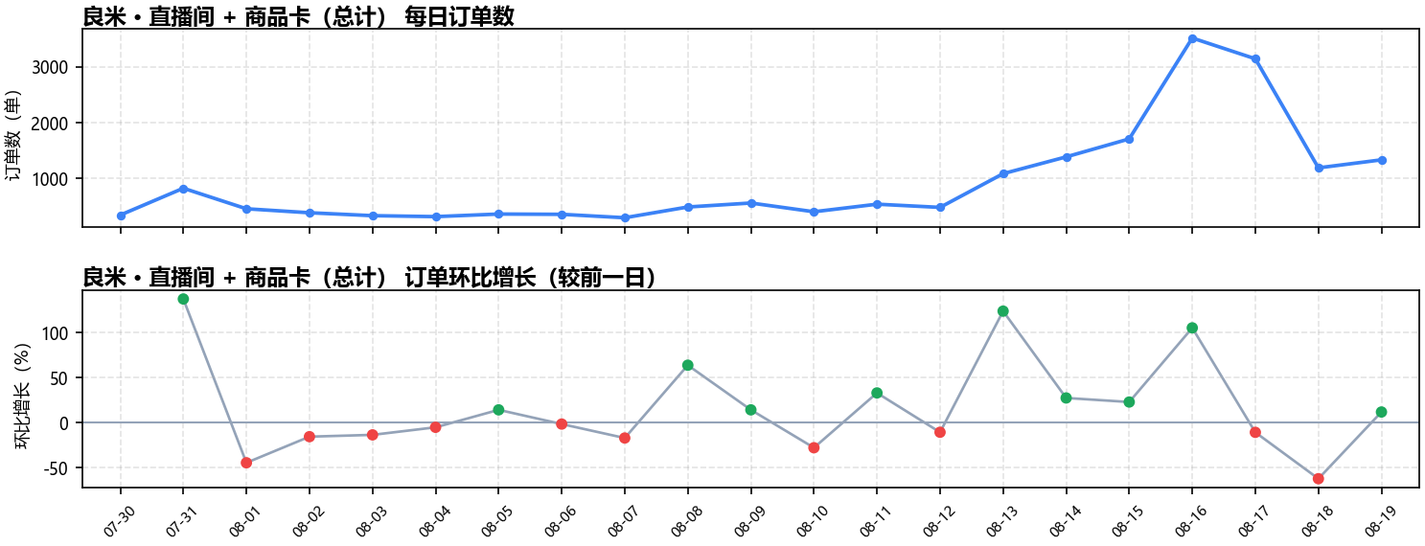
日期 | 订单数（单） | 环比增长
07-30 | 348 | —
07-31 | 827 | +137.6%
08-01 | 460 | -44.4%
08-02 | 389 | -15.4%
08-03 | 337 | -13.4%
08-04 | 320 | -5.0%
08-05 | 366 | +14.4%
08-06 | 361 | -1.4%
08-07 | 300 | -16.9%
08-08 | 492 | +64.0%
08-09 | 563 | +14.4%
08-10 | 407 | -27.7%
08-11 | 542 | +33.2%
08-12 | 485 | -10.5%
08-13 | 1087 | +124.1%
08-14 | 1387 | +27.6%
08-15 | 1708 | +23.1%
08-16 | 3510 | +105.5%
08-17 | 3139 | -10.6%
08-18 | 1191 | -62.1%
08-19 | 1334 | +12.0%

