**ALICE**

In 2016 LHC continued to collect pp data at 13 TeV with very high luminosity and particularly CMS and ATLAS experiments recorded impressive amount of data. At the end the year the LHC delivered proton-lead collisions first at 5.02 TeV, as in the previous run, but at the end also with the record pPb center-of-mass energy of 8 TeV. The collection of the pPb data went well with the ALICE. One highlight of our group was the excellent performance of the level-0 (L0) single photon EMCal trigger system used in the rare trigger data taking throughout the year.

At the hardware side, our group is also deeply involved in the upgrade of the Time Projection Chamber (TPC), and the Fast Interaction Trigger (FIT) system, the successor of the T0 detector. Our main task within the TPC upgrade is to perform quality assurance studies of about 300 m2 of Gas Electron Multiplier (GEM) foils, which will replace the old TPC readout chambers. Particularly, we measure gain uniformity and leakage currents via optical measurements in the HIP clean room. These studies have been successful and Wigner Institute in Budapest decided to copy the same test setup to their facilities. Our PhD student Marton Vargyas has participated in building and performing measurements in Hungary.

The current main directions of the physics analysis performed by our group involve high-pT triggered correlations and studies of the jet transverse structure. When studied in pp, pPb and PbPb collisions, the results provide insight of the QCD radiation and its modifications in the cold nuclear matter and in the quark gluon plasma. We study also flow patters via correlations among Fourier coefficients of detailing the azimuthal anisotropies of the final hadron momentum distributions in PbPb collisions. These correlations are used to constraint the transport properties of the strongly interacting matter, like shear viscosity to entropy ratio of QGP.

Jussi Viinikainen presented his studies on transverse structure on jet via two-particle correlations in pp and pPb collisions at the Hard Probes 2016 conference in Wuhan, China. DongJo Kim will present studies on flow correlations in the Quark Matter 2017 conference in February in Chicago, USA. These two conferences are both large and highly valued in our field. Both Jussi and DongJo will chair the paper committee on these results once ALICE will publish them.

One of the highlights of ALICE scientific program is the detailed study of correlation functions among identified particles in pp collisions at 7 TeV [1].

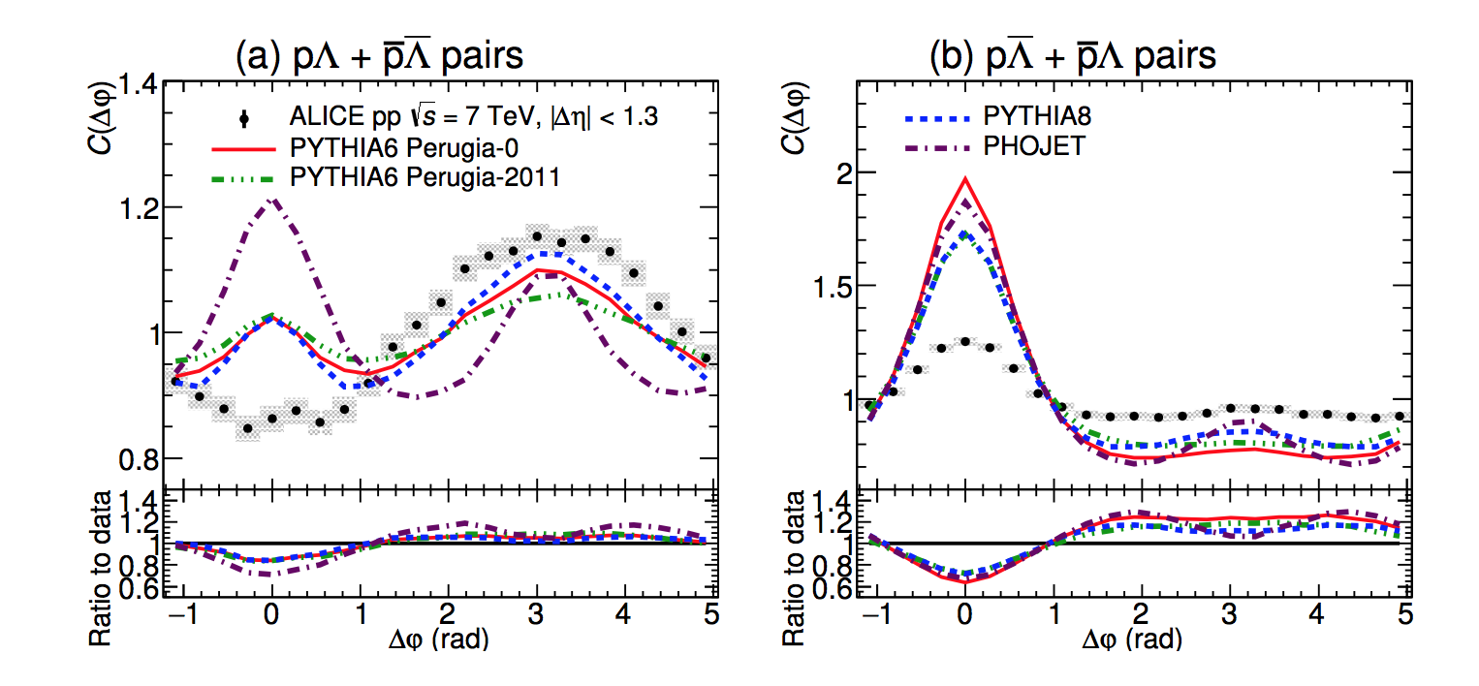

Figure 1: Azimuthal correlation functions of identified baryon-baryon and baryon-anti-baryon pairs in proton-proton collisions compared to event generators.

Left panel of Figure 1 shows the depletion of the near side in the baryon-baryon correlations that none of the standard event generators can produce. This depletion is not seen in the baryon-anti-baryon correlations shown in the right panel. It turned out that the most used event generators, PYTHIA and Phojet, cannot reproduce these correlation functions although they provide a good description of the meson correlations. This implies that baryon production mechanisms need to be revised in the event generators and can provide insight to baryon production in fragmentation.

Selected publications

[1] *ALICE Collaboration*, arXiv:1612.08975 [nucl-ex]