**ALICE**

In 2016 ALICE operated during the entire running period of the LHC collider at CERN. The bulk of the data, totalling the equivalent 70 days, were taken for proton-proton collisions at the center of mass energy of 13 TeV. At that time ALICE collected 822 million events at the minimum bias trigger and 514 million of high-multiplicity events. Especially important for ALICE were the three heavy ion (HI) runs at the end of the year: the 5.8 day equivalent p-Pb run at 5 TeV followed by 5.6 days of p-Pb collisions at 8 TeV.

Our group has running and maintenance responsibilities in two detector systems. The T0 timing detector operated very well throughout 2016. The time resolution stayed below 50 ps even for 1 MIP events and the time alignment was 5 ps for HI and 10 ps for all pp runs. T0 also operated as the main vertex and luminosity meter, importance of which was underlined during the HI runs. The other highlight relevant to our contribution to ALICE was the excellent performance of the level-0 (L0) single photon EMCal trigger system used in the rare trigger data taking throughout the year.

A significant part of our work is committed to the upgrade of the ALICE detector. During the Long Shutdown scheduled for 2019 – 2020 the LHC luminosity will be increased substantially and the interaction rate in heavy ion collisions will rise to 50 kHz. To cope with these new requirements, all the major subsystems of ALICE need significant improvements. In particular a new Fast Interaction Trigger (FIT) has to be designed and build. In addition to T0, our team (W.H.Trzaska) is also the CERN Project Leader for FIT coordinating the work of about 50 scientists from 14 institutions in 6 countries. In 2016 the R&D on FIT made a significant progress by completing two in-beam tests of the prototypes at CERN PS and continuously operating a full-chain prototype in the actual position inside of the ALICE magnet and taking real LHC data. FIT has also successfully met all the milestones and passed all the scheduled CERN reviews. The detector concept and performance were reported at major conferences including the *14th Vienna Conference on Instrumentation*(**VCI 2016**) and the *38th International Conference on High Energy Physics* (**ICHEP 2016**).

Our group is also involved in the upgrade of the Time Projection Chamber (TPC). Our main task within the TPC upgrade is to perform quality assurance studies of about 300 m2 of Gas Electron Multiplier (GEM) foils, which will replace the old TPC readout chambers. We measure gain uniformity and leakage currents via optical measurements in the clean room at the Helsinki Institute of Physics. Our instrumentation has worked very well and the Wigner Institute in Budapest decided to copy the same test setup to their facilities. Our PhD student Marton Vargyas helped in starting the new setup and performed measurements in Hungary. The QA production of the ALICE TPC ROC GEM foils has been officially launched in the end of 2016. The first batches of in total 42 GEM foils were processed at twice the foreseen production rate of 18 GEM foils per month.

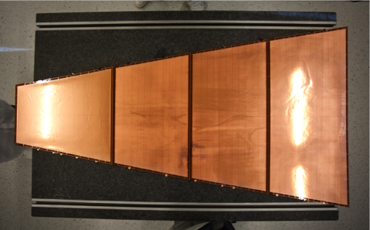

Figure 1: Complete set of GEM foils for one layer of the ALICE TPC ROC that is built out of 4 separate chambers. The active area is ~0.9 m^2. The TPC consists of 36 such sectors

The current main directions of the physics analysis performed by our group involve high-pT triggered correlations and studies of the jet transverse structure. When studied in pp, pPb and PbPb collisions, the results provide insight of the QCD radiation and its modifications in the cold nuclear matter and in the quark gluon plasma. We study also flow patterns via correlations among Fourier coefficients of detailing the azimuthal anisotropies of the final hadron momentum distributions in PbPb collisions. These correlations are used to constraint the transport properties of the strongly interacting matter, like shear viscosity to entropy ratio of QGP.

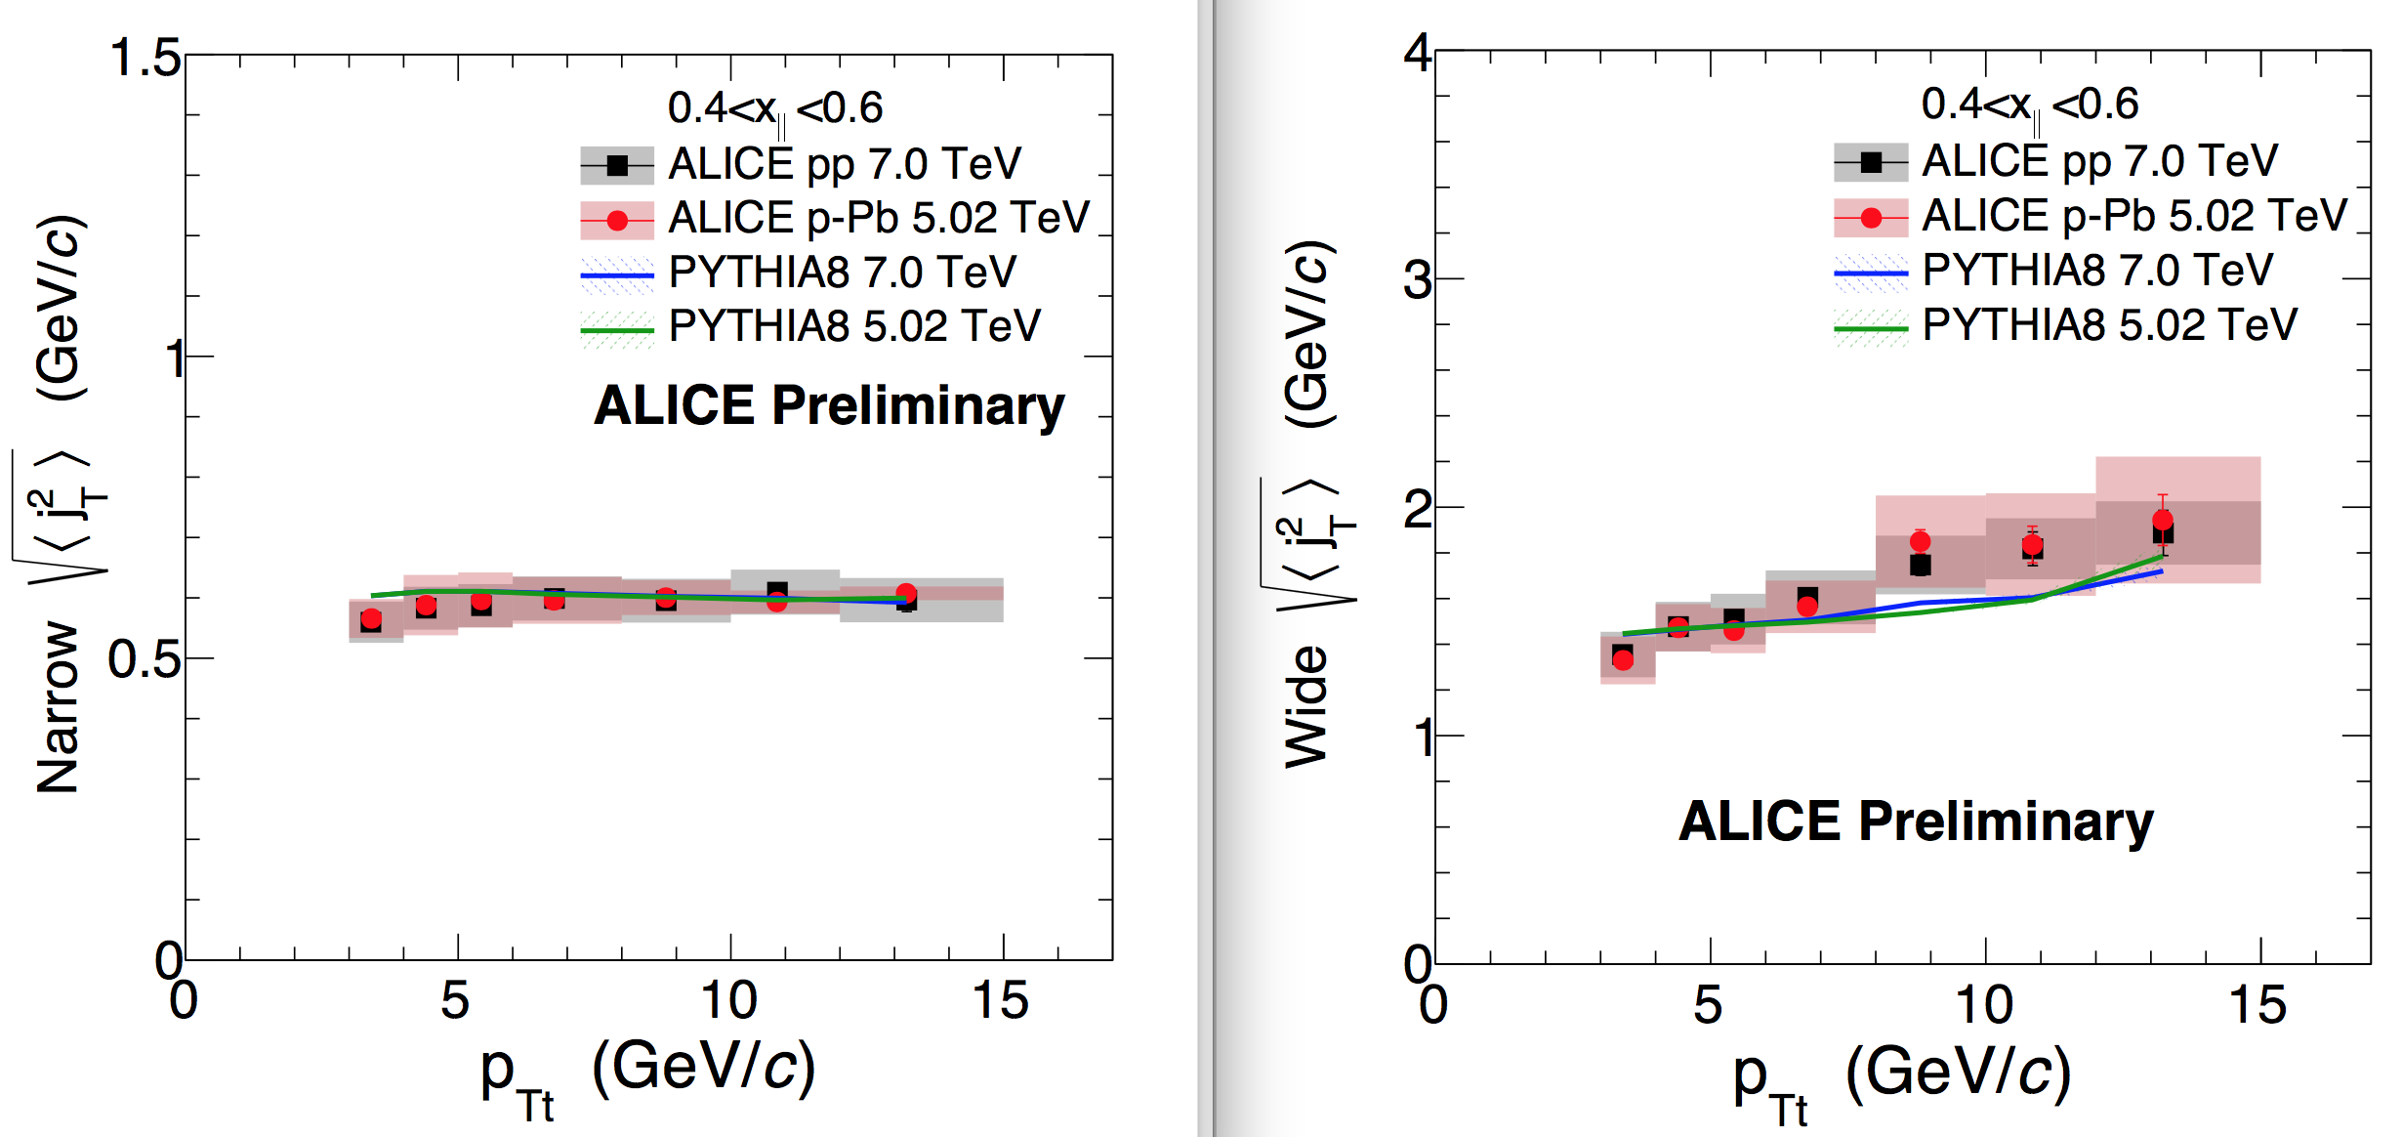

Figure 2: Narrow (left) and wide (right) component of the jet transverse width using two-particle correlations.

Jussi Viinikainen finished his analysis on transverse structure of jets via two-particle correlations in pp and pPb collisions. Earlier studies at CCOR and PHENIX have showed that transverse momentum spread of the final hadrons around the jet axis can be described using a single Gaussian with a width of roughly 600 MeV [1] and with very little dependence on momentum of the trigger particle at the event. A new finding in Jussi’s analysis was that at the LHC energies the transverse spread clearly has two distinct components, narrow and wide. Left (right) panel in Figure 2 show the narrow (wide) component as a function of trigger particle momentum. The narrow component, again of the order of 600 MeV, does not show trigger momentum dependence and is associated with non-perturbative component in jet fragmentation. The wide component, related to gluon radiation, increases with the trigger momentum. Jussi presented his results in the Hard Probes 2016 conference, Wuhan, China [2].

One of the highlights of ALICE scientific program is the detailed study of correlation functions among identified particles in pp collisions at 7 TeV [3].

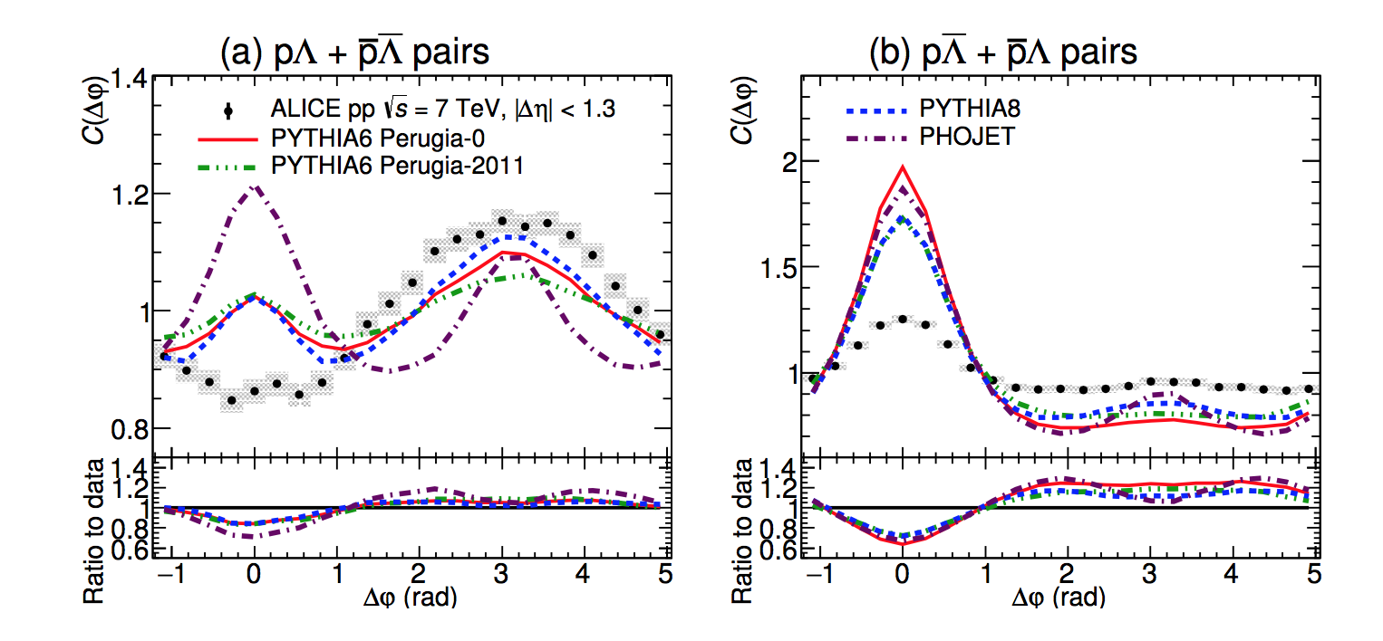

Figure 3: Azimuthal correlation functions of identified baryon-baryon and baryon-anti-baryon pairs in proton-proton collisions compared to event generators.

Left panel of Figure 3 shows the depletion of the near side in the baryon-baryon correlations that none of the standard event generators can produce. This depletion is not seen in the baryon-anti-baryon correlations shown in the right panel. It turned out that the most used event generators, PYTHIA and Phojet, cannot reproduce these correlation functions although they provide a good description of the meson correlations. This implies that baryon production mechanisms need to be revised in the event generators and can provide insight to baryon production in fragmentation.

[1] *PHENIX Collaboration*, Phys. Rev. D74 (2006) 072002

[2] *Jussi Viinikainen for the ALICE Collaboration*, arXiv: 1612.05475 [hep-ex]

[3] *ALICE Collaboration*, arXiv:1612.08975 [nucl-ex]