ALICE

In 2017 LHC continued to collect pp data at 13 TeV with very high luminosity and delivered 2 hours of xeon-xeon collisions at 5.44 TeV in October. This half size of system compared to Pb ions allows us to study the system size dependence of observables, which in turn permit to test the predictive power of hydrodynamics by changing the geometry of quark gluon plasma (QGP) formed in heavy-ion collisions. One highlight of our group was the excellent performance of the level-0 (L0) single photon EMCal trigger system used in the rare trigger data taking throughout the year.
At the hardware side, our group is also deeply involved in the upgrade of the Time Projection Chamber (TPC), and the Fast Interaction Trigger (FIT) system, the successor of the T0 detector. Our main task within the TPC upgrade is to perform the quality assurance of about 128 m² of Gas Electron Multiplier (GEM) foils, which will replace the old TPC readout chambers. Particularly, we measure the leakage currents under high voltages and the diameters of the holes in GEM foils in the HIP clean room facilities. The high voltage test system for the leakage current measurements and the high definition optical scanning robot for the hole diameter measurements were developed at HIP. We have successfully finished the testing of ~52% of all GEM foils. This task will be finished by summer 2018.
The current main directions of the physics analysis performed by our group involve high-pT triggered correlations and studies of the jet transverse structure. The detailed analysis of pp, pPb and PbPb collisions data provides a deep insight into the QCD radiation processes and their modifications in the cold nuclear matter and in QGP. We study also flow patterns via correlations among Fourier coefficients by detailing the azimuthal anisotropies of the final hadron momentum distributions in PbPb collisions. These correlations provide new observational probes to study initial conditions and microscopic transport properties of the QGP. Comparison of such measurements with viscous hydrodynamic calculation should, in particular, enable the study of the temperature dependence of shear viscosity to entropy density ratio (η/s).

Jussi Viinikainen finished his studies on transverse structure on jet via two-particle correlations in pp and pPb collisions for his PhD. thesis. DongJo Kim presented studies on flow correlations in the Quark Matter 2017 and Initial Stages 2017 conferences. These two conferences are both large and highly valued in our field. Both Jussi and DongJo chaired the paper committee on these results.

The highlights of ALICE scientific program are the detailed study of higher order flow correlations [1] and quantifying the nonlinear hydrodynamic response of their correlations [2].
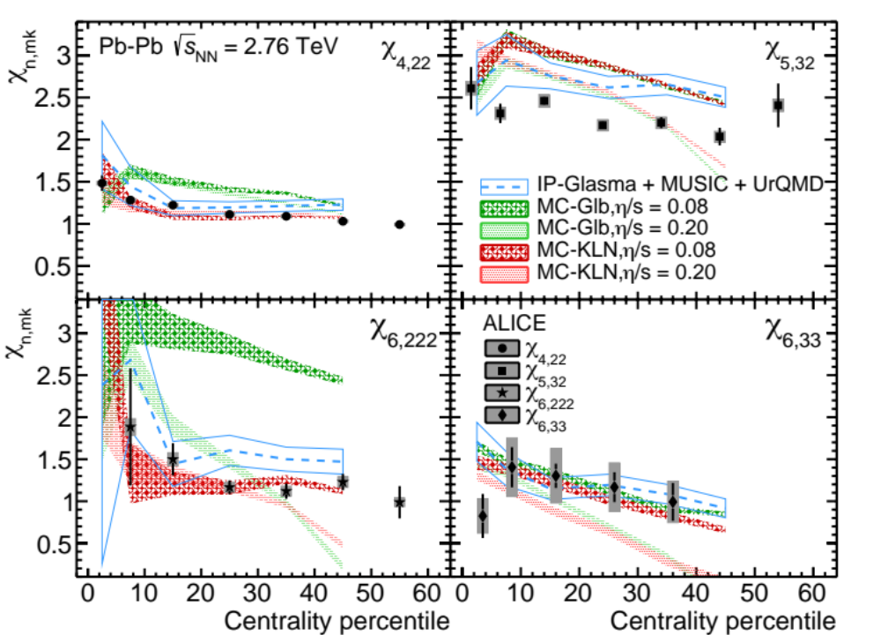
Figure 1: Non-linear flow mode coefficients measured in Pb-Pb Collisions are compared to various hydrodynamic calculations.
The non-linear mode coefficients originating from different order harmonic correlations are compared to various hydrodynamic calculations in Figure 1. The different order non-linear mode coefficients show different sensitivities to η/s and the initial conditions. Comparisons to hydrodynamic calculations suggest that the data is described better by hydrodynamic calculations with smaller η/s. These results provide further constraints on the initial conditions and η/s of the system produced in heavy-ion collisions.

.

Selected publications
[1] ALICE Collaboration, arXiv:1709.01127 [nucl-ex]
[2] ALICE Collaboration, Phys. Lett. B773 (2017) 68-80

