The Apparatus and the Cut: Visualizing the Mechanics of 19C Children's Literature

Stephen Krewson

Table of Contents

## Intro

Placeholder for plaintext build system for dissertation. Here is an example illustration:

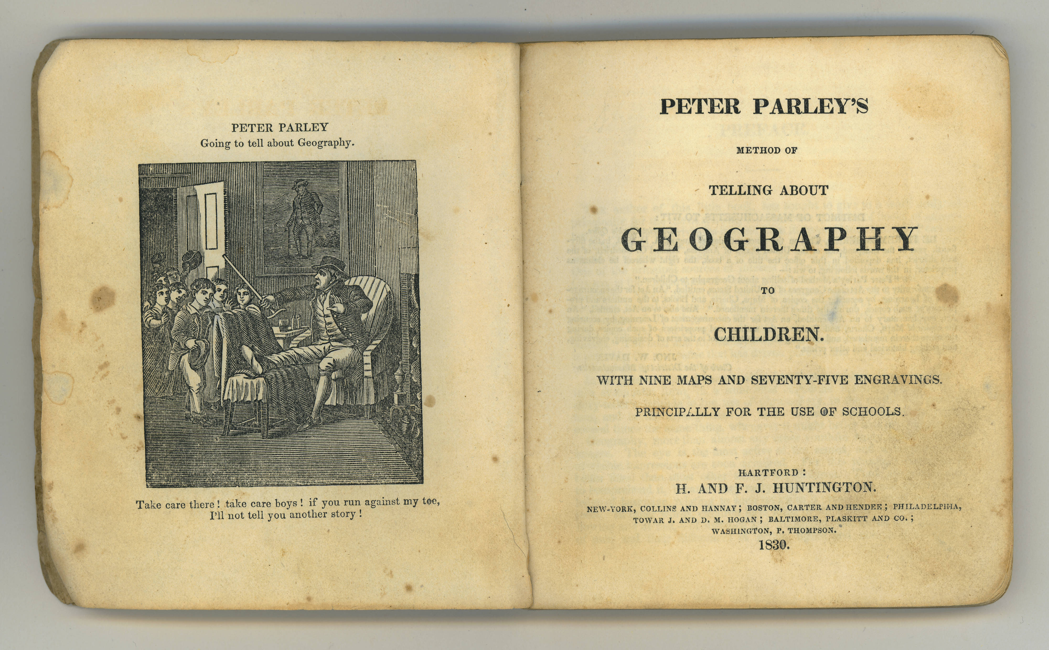

Method of telling about geography (1830).

And here is an inline footnote.[1] Here is a citation (See Arora and Kaur 30–32). General principles are to use Sublime for the writing since it will be way cleaner. Keep track of dependencies, whether for Pandoc or WSL setup.

Keep styling to separate CSS sheet (for image widths, etc.). Here is a test of a line that should surely overflow. But hopefully it is capped in a nice way.

## Context

A second section.

## Works Cited

Arora, Anupama, and Rajender Kaur. “Writing India in Early American Women’s Fiction.” *Early American Literature*, vol. 52, no. 2, 2017, pp. 363–388.

1. Always stick to these. Keep them to one paragraph.