1. 为新用户“**bcsap**”开启远程访问的权限，并刷新权限。

mysql> create user 'test2' identified by '123456';

mysql> grant all privileges on *.* to test2@'%' identified by '123456' with grant option;

mysql> flush privileges;

可以通过

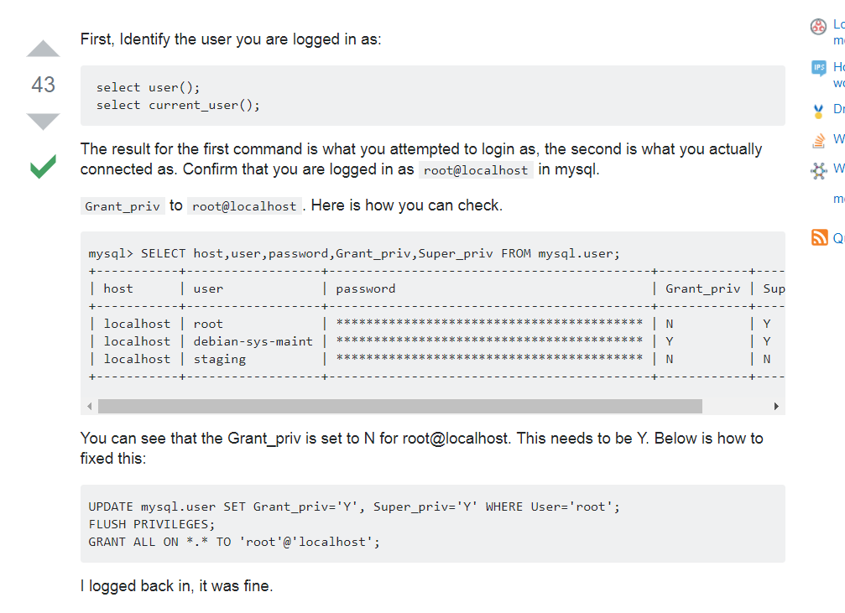

异常：

Caused by: com.mysql.jdbc.exceptions.jdbc4.MySQLSyntaxErrorException: Access denied for user 'root'@'%' to database 'bcsap'