232243414212016000023

432243414212017000001

532243414212017000001

632243414212017000001-001

按赔案100%赔付

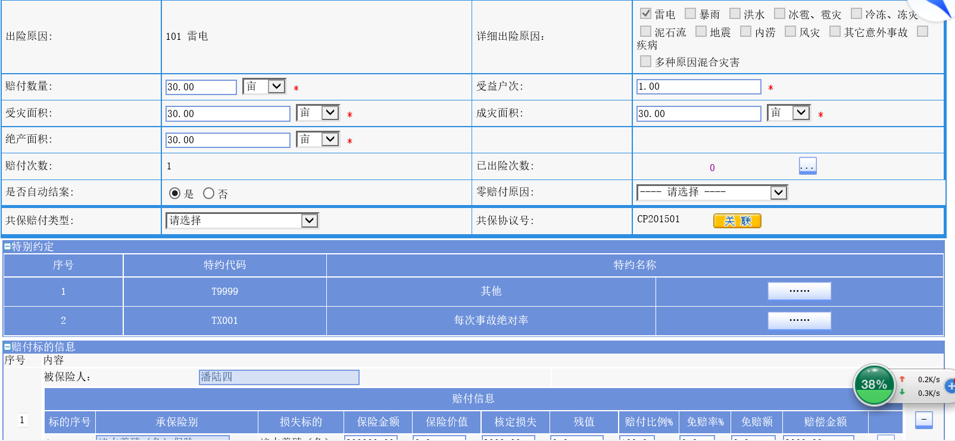

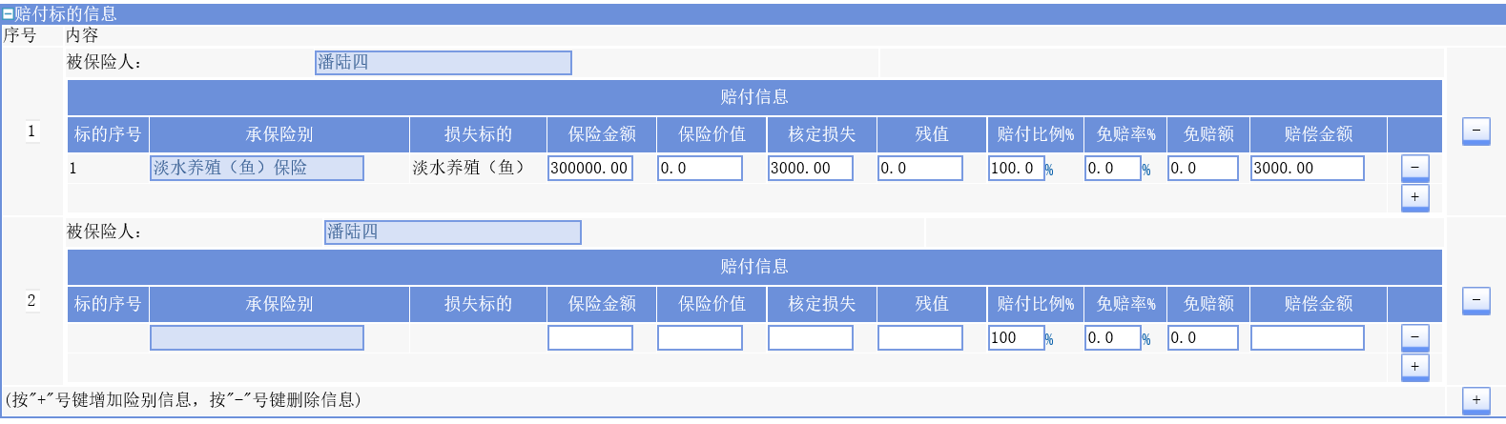

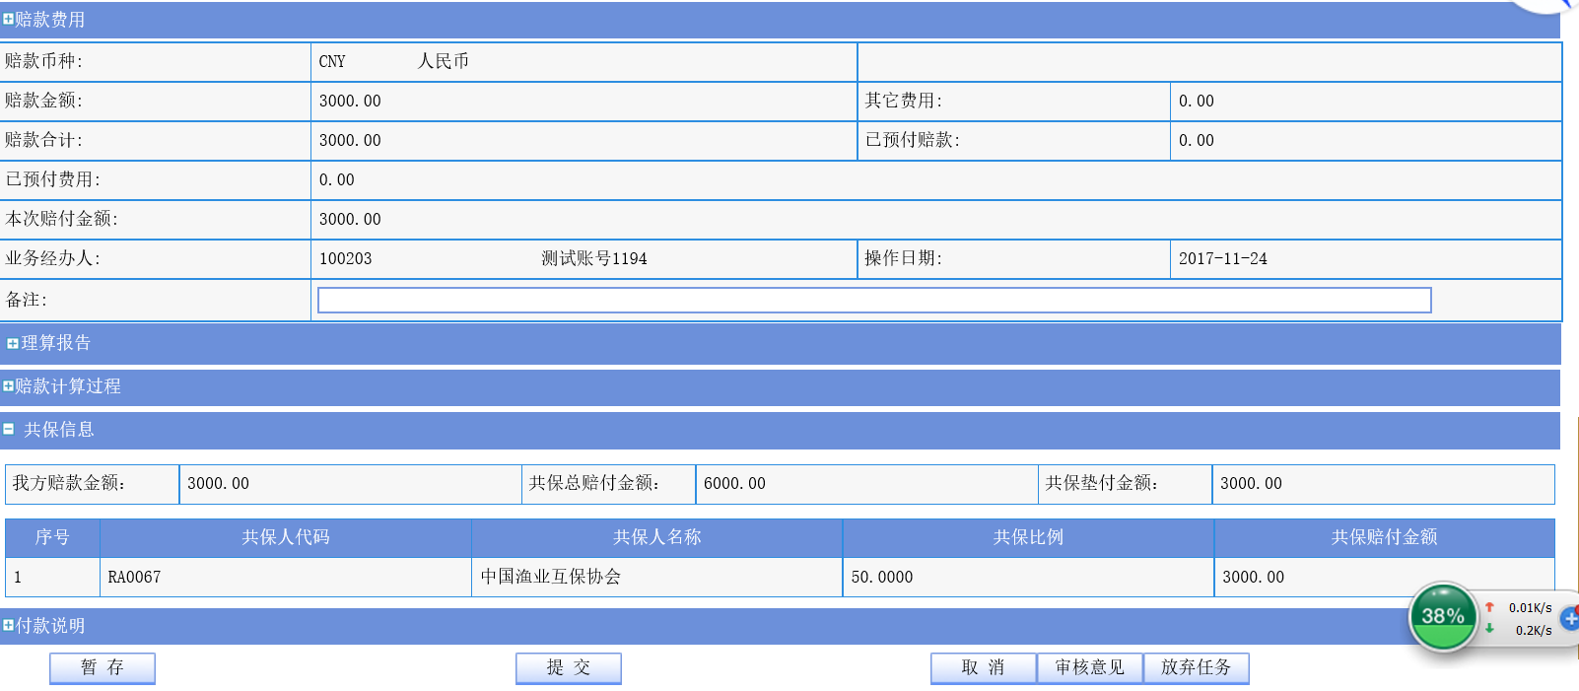

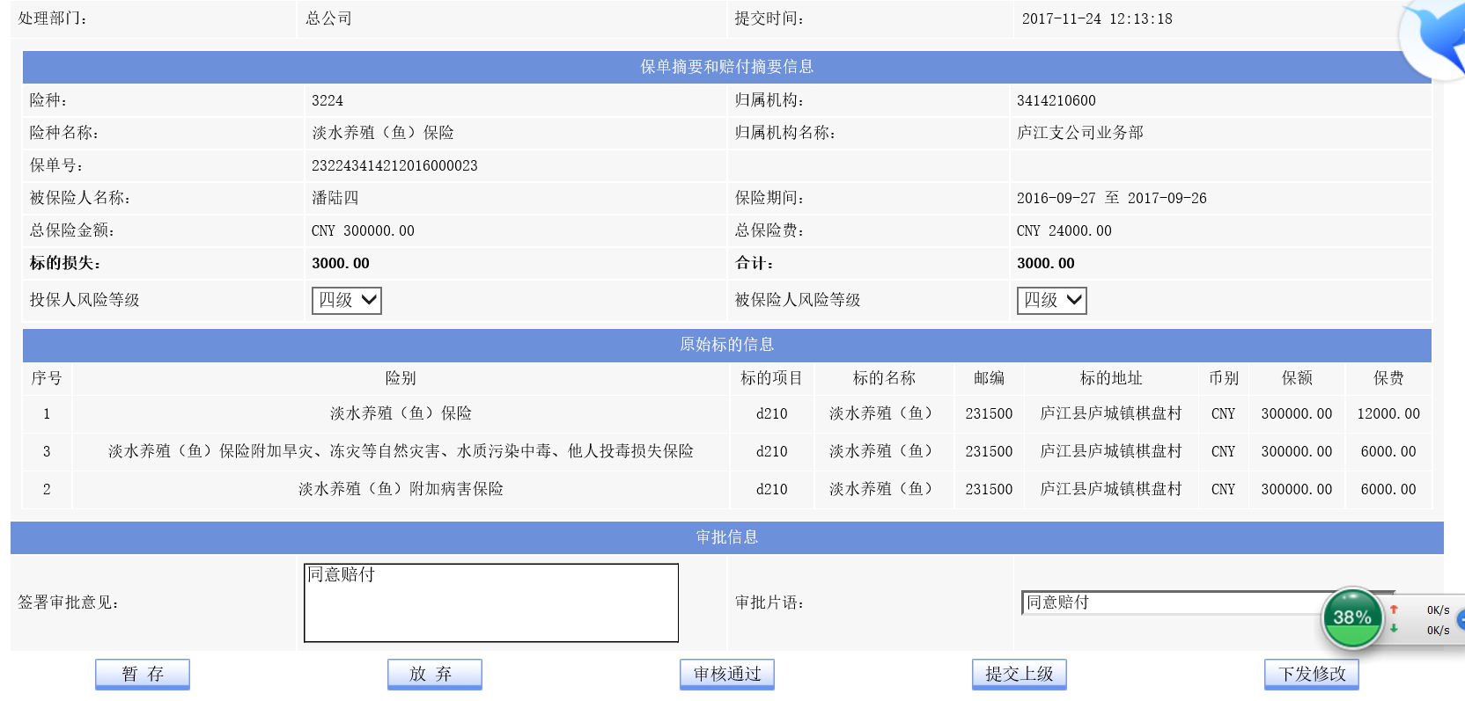

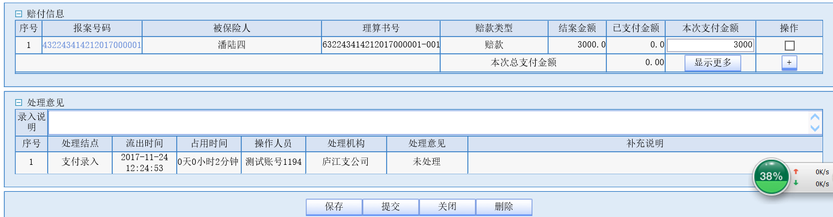

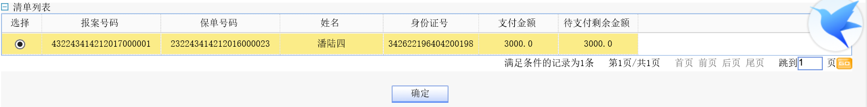

232243414212016000021

432243414212017000002

532243414212017000002

632243414212017000002-001

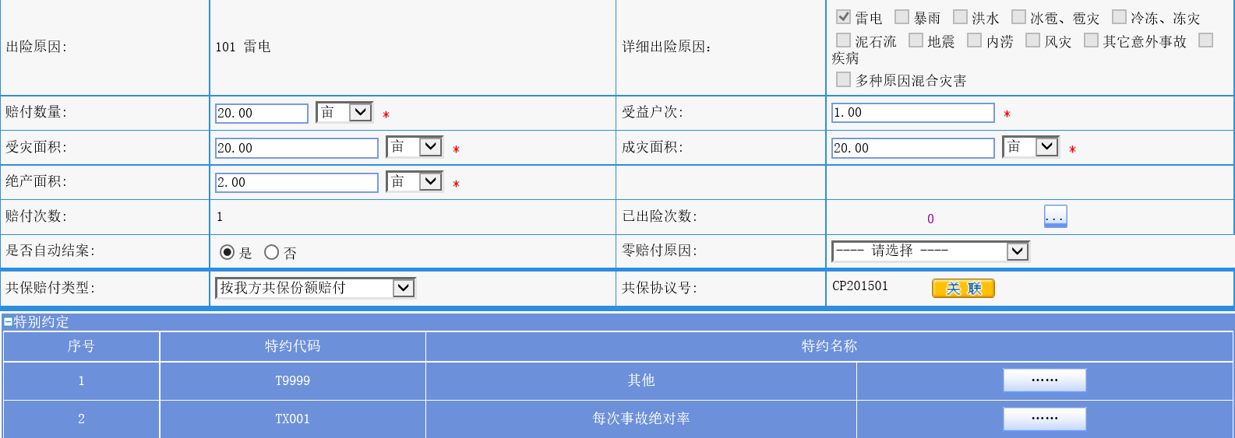

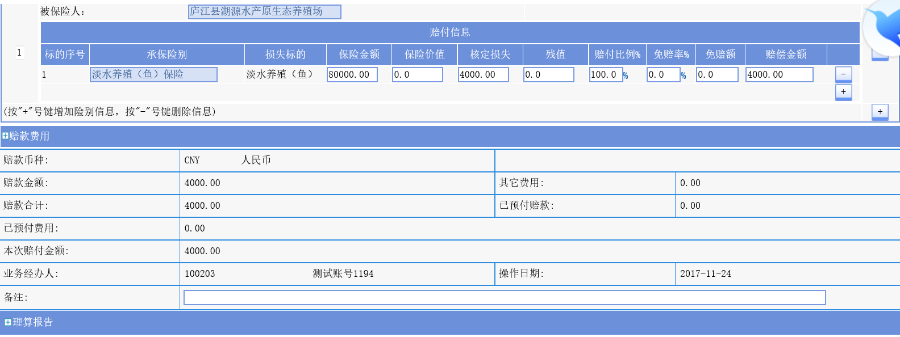

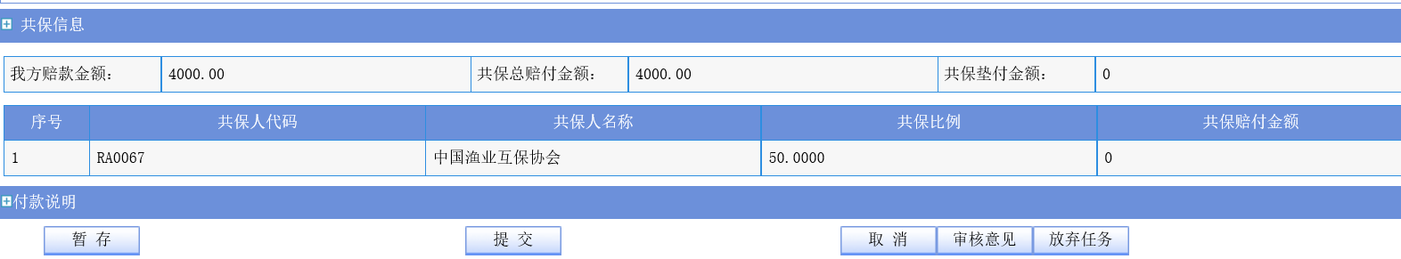

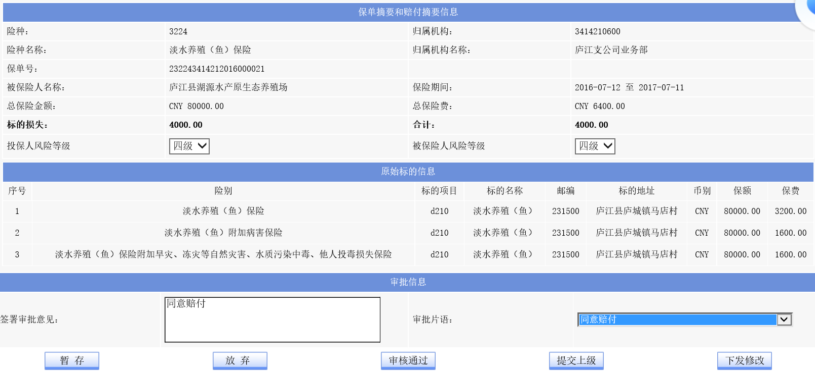

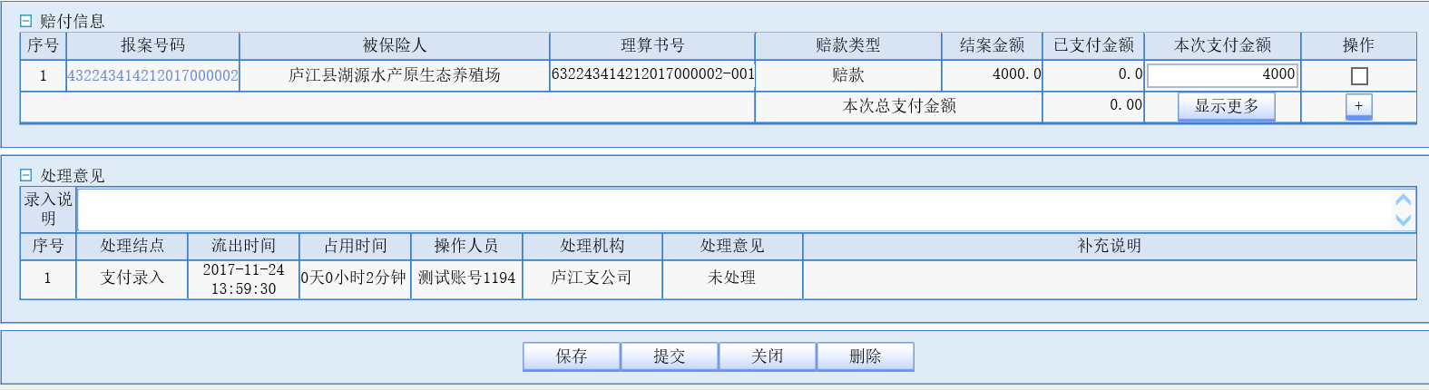

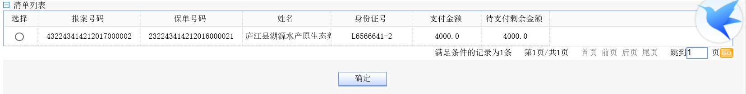

232243414212016000022

432243414212017000003

532243414212017000003