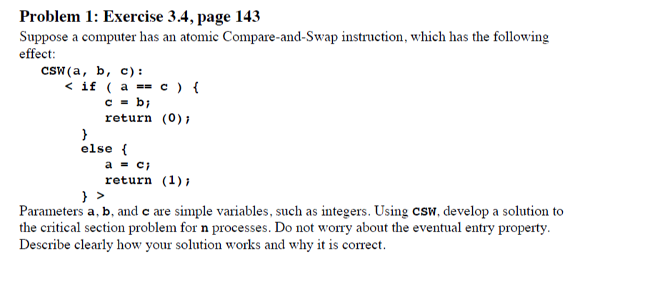

**int a;**

**Enter:**

**while(CSW(a,0,1) == 0)**

**Critical Section**

**Exit:**

**a=0;**

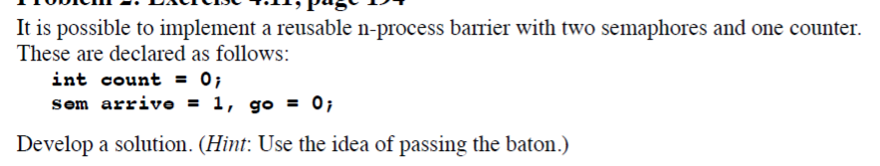

**arrive.wait();**

**count ++;**

**arrive.signal();**

**if (count ==n)**

**go.signal();**

**go.wait();**

**go.signal();**

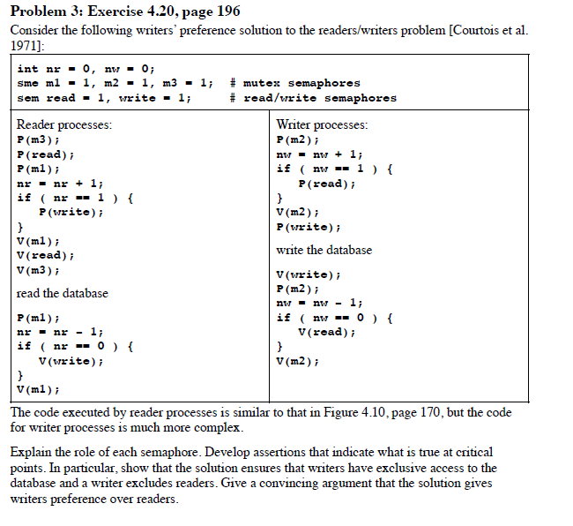

**The m2 makes sure that when a writer is writing to the database, there is no reader allowed to read from the database.**

**The m1 and m3 makes multiple reader processes can get access to(read) the database.**

**In this case, when a reader arrives after a writer, it must wait even if the writer is also waiting. This makes sure that the writers have exclusive access to the database and a writer always excludes readers.**

**Additionally, any writer that is going to write the database must perform as soon as possible based on the use of m2 in the writer process.**